

PROG6212 PoE USER MANUAl

ST10091324



EN MWema

bca2 group 2

VC WATERFALL

Table of Contents

**LOGIN PAGE** 2

**REGISTRATION PAGE** 4

**HOME PAGE** 5

**ADD NEW MODULE INFORMATION PAGE** 6

**EDIT MODULE PAGE** 8

**MODULE DETAILS PAGE** 10

**VIEW CHART PAGE** 14

**LOGGING OUT** 15

**REFERENCE LIST** 16

# **LOGIN PAGE**

*Figure 1: User login screen*

This page is where you (the user) can log into the website application once you have created an account using the registration page (see figure 2). This is also the first page you will see once you click on the program’s run button and all the resources have been loaded up by the system.

Element number 1: This is where you will input your username. Once you have entered your username, the system will check the validity of what you have entered to make sure it meets the minimum complexity and format requirements such as a length of at least 3 characters.

Element number 2: This is where you will input your password. Once you’ve entered your password, the system will check the validity of what you have entered to make sure it meets the minimum complexity and format requirements such as a length of at least 8 characters.

Element number 3: You can click on the tick box to make sure the system “remembers” your credentials. This will allow you to access the website application without having to login again for the next 14 days. However, if you decide to clear your browser cookies, the system will prompt you to log in again.

Element number 4: After filing out the form, you can click on this button to log in. If the credentials you entered are correct, the system will redirect you to the home page where you can view, add, and manage modules.

# **REGISTRATION PAGE**

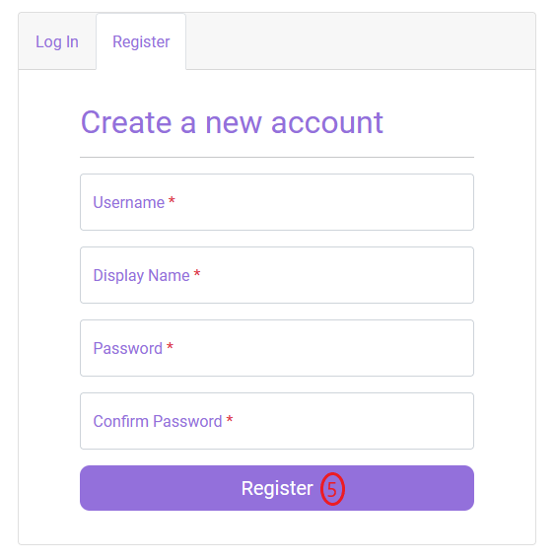

Using this page, you can create a new account to access the website application. Once you have filled out the form above and clicked on the Element number 5 (button), the system will validate the information you have entered for formatting errors and complexity requirements. If there are any issues with the information you have provided the system will inform you. Otherwise, the system will create your account, and will automatically log you in and redirect you to the home page (see figure 3). All fields that have a “*” indicate that you must fill them out.

# **HOME PAGE**

Figure 3: Web Application Home Page

This is where you will view and access all your created module information. All the details associated with that module can be found on home page as well as on the details page (see figure 7) accessible by clicking on the details link on the middle right side of figure 3.

# **ADD NEW MODULE INFORMATION PAGE**

Figure 4: Home Page Add Button Hover

To add new module information, click on element number 6. When you hover over element number 6, its color will turn green to indicate you are focusing on it. The system will redirect you to the add new module information page (see figure 5).

*Figure 5: Form to add new module information*

Before clicking on element number 7 (button) make sure to fill out all the fields that have a “*” next to them. Once you have clicked on element number 7 and filled out the form, the system will validate the information you have provided. If there are no issues with the information you have provided, the module information will be added to the local database, and you will be redirected to the home page to view your newly added module information.

# **EDIT MODULE PAGE**

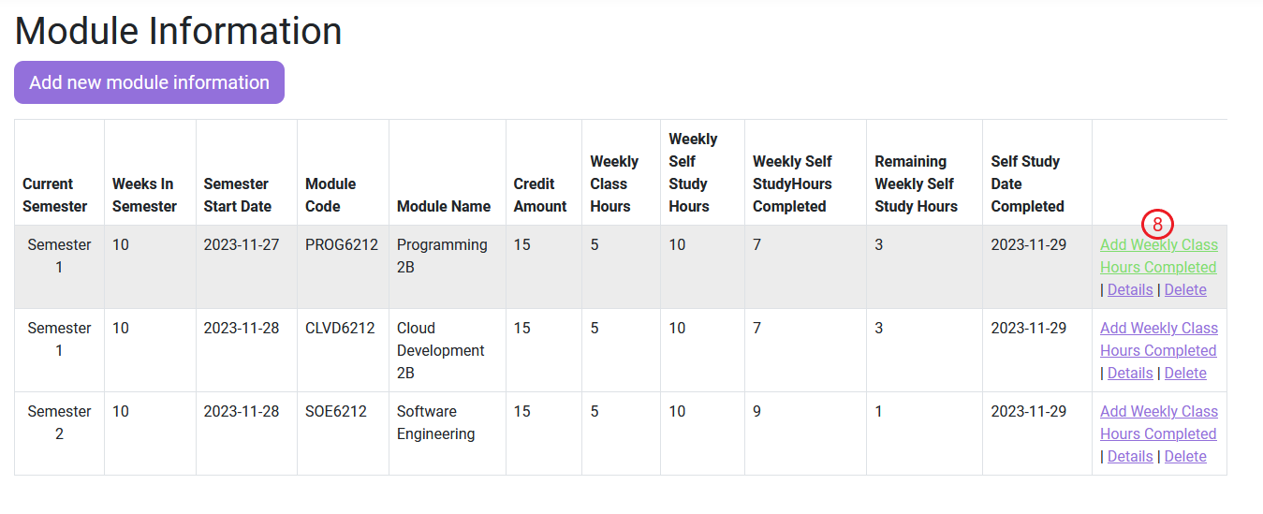

*Figure 6: Hovering over edit page link*

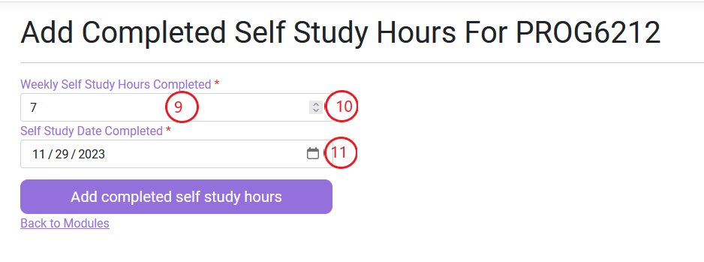

*Figure 7: Editing weekly self-study hours completed*

To add your completed self-study module information, click on the green highlight element number 8 (see figure 6). You will redirected to the edit module page, where you can enter the amount of self-study hours you have completed by entering it into element number 9 or by using element number 10 to increase or decrease the number of hours you have completed. You can also select when you completed those hours by clicking on the calendar icon (element number 11). Your completed self-study hours cannot be more than your remaining self-study hours. The system will inform you if you have entered a value greater than your remaining self-study hours.

# **MODULE DETAILS PAGE**

*Figure 8: Hovering over details link*

*Figure 9: Details of module displayed*

To view the details page, click on element number 12 and the system will redirect you to this page (See figure 9). The details module page gives you a detailed view of the module you choose in figure 3. Once you are done viewing the module details, you can either go back to the home page (figure 3) by clicking on element number 14 and the system will redirect you to figure 3 or you can edit the module by clicking on element number 13 and the system will redirect you to figure 3.

**DELETE MODULE PAGE**

*Figure 10: Hovering over the delete link*

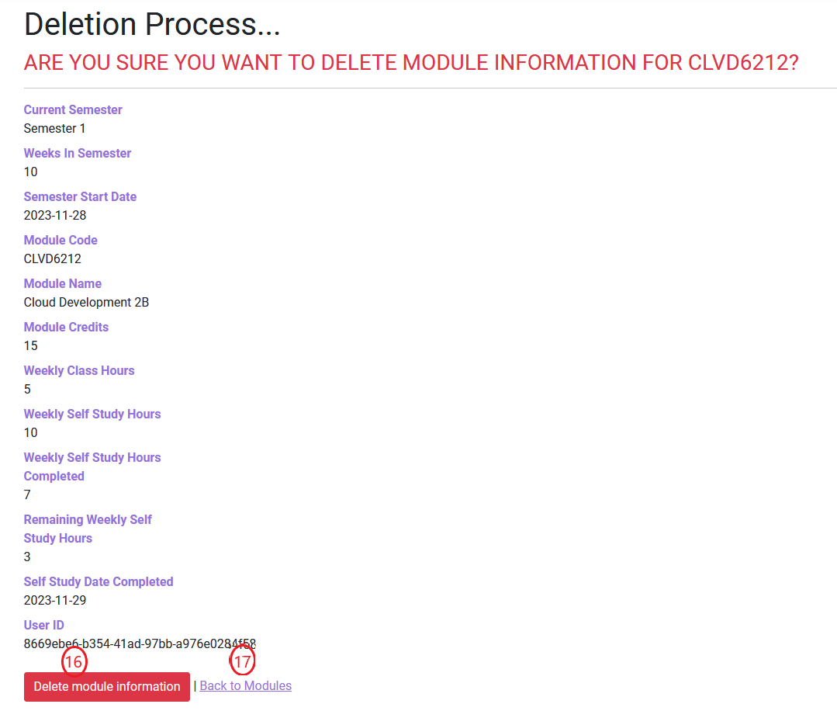

Figure 11: View of delete page

After clicking on the delete link (element 15) on the home page (See figure 3), the system will redirect you to this page (See figure 11) and give you one final chance to view the details of the module you are about to delete. If you proceed to click on element 16, the module information will be deleted from the database and will no longer be visible on figure 3. If you change your mind, you can click on element 17 to cancel the deletion process and go back to figure 3.

# **VIEW CHART PAGE**

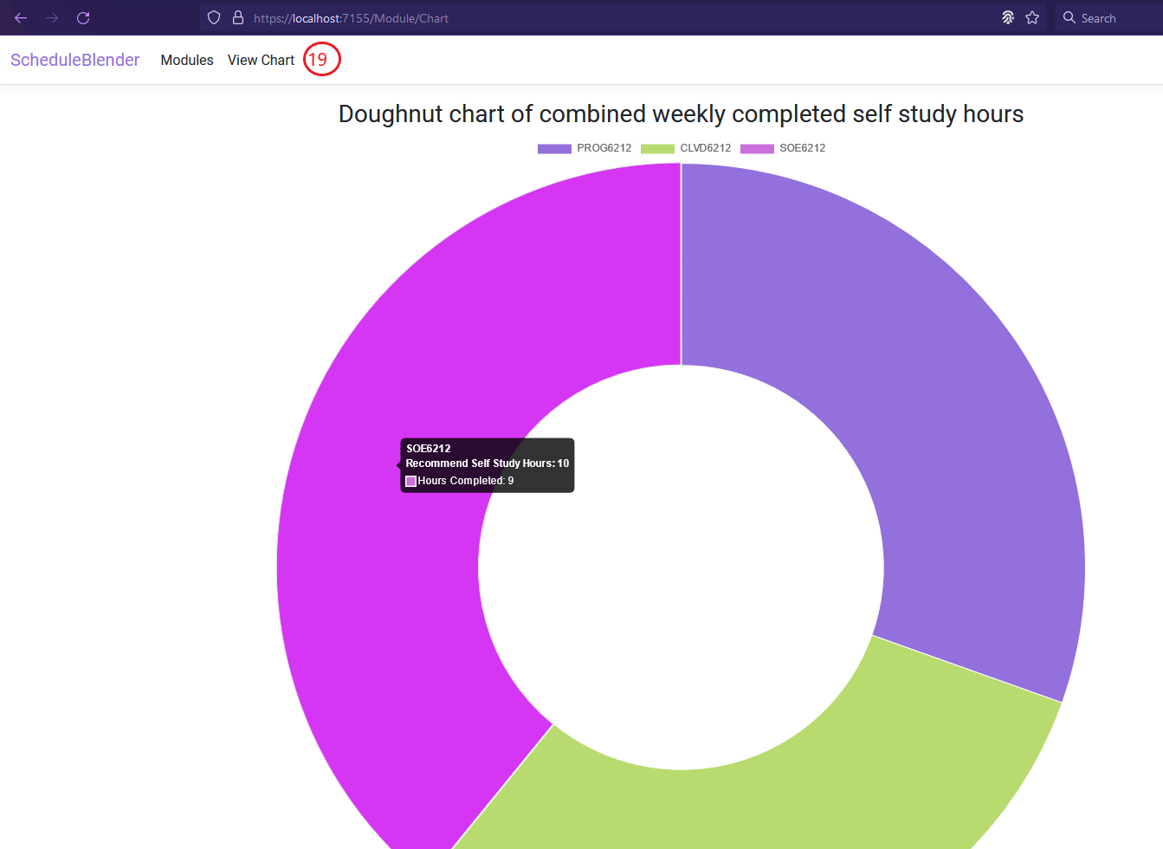

*Figure 12: populated doughnut pie chart with information of modules*

*Figure 13: view chart page, no module information added alert*

Once you have added the module information, you can click on element number 19 and the system will redirect you to this page (See figure 13). If no module information was added, a red alert will be displayed, informing you that no module information was added and that you need to add some module information before a chart can be created. There will also be a button below the alert message (See figure 13) that once clicked, will redirect you to figure 4. Once you have added the necessary module information, you can come back to this page (See figure 12) to see the created chart. You can also filter out which module appear on the doughnut chart by clicking the legend with the corresponding module name and that module will be temporarily removed from the chart. To include the filtered module back into the chart, click on the legend with the corresponding module name again. Hover over a specific piece of the doughnut chart to see information specific to that module. The information that will be displayed once you hover a specific piece will be the recommended self-study hours as well as how many self-study hours you have completed.

# **LOGGING OUT**

*Figure 14: Location of logout tab*

To log out of your account or switch to a different user account, you can click on the logout tab located at the top right of the page (element number 20). Once clicked, the system will redirect you to login screen (See figure 1). To safely close the program, close your entire browser.

# **REFERENCE LIST**

All relevant references in the form of commented code attribution (See program code) or plain text in diagrams (See UML diagram).