N1081B DT1081B SDK  
WEB SOCKET API REFERENCE GUIDE AND PYTHON SDK

# Introduction

N1081B use a JSON based Web Socket API to both configure the device and retrieve data from the instrument.

Web Socket protocol provides a full-duplex communication channel over a single TCP connection. Most browsers support the Web Socket protocol and provide a client to easily communicate with the Web Socket server on the device.

The URL that has to be used to open the web socket communication is: ws://<N1081B_ip>:8080/

The N1081B_ip is shown on the instrument display home page.

All the request that can be sent to the device and all the messages received by the device are in a JSON format.

N1081B API support multiple users simultaneously connected to the instrument. During the developing, it is possible to keep the browser open on the N1081B page in order see in live the effect of the performed operation.

# General Rules

There are two kind of requests that the user can send to the instrument: the commands to set the instruments configuration and the commands to get the instrument data. The instrument replays at every request.

The JSON messages to be sent to the instrument should always contain the “command” field that specifies the type of request and the “callback” filed that can be defined by the user and is used in the response to understand the origin of the message. All the parameters are defined in the “params” field, which usually contains the “section” parameter that can assume the value 0, 1, 2 or 3 referring to the section A, B, C and D of the instrument.

The JSON messages received from the instrument consist of a “Result” field which value can be True or False depending on the success of the communication and a “Response” describing the eventual error. The “missing command”, “missing callback” and “missing paramters” indicate respectively that in the request the “command”, the “callback” or some parameters in the “params” field are missing. The “invalid command” result means that the sent “command” is not valid. The reported “callback” and “command” fields are the same of the request that has determined the instrument answer. If the sent request is a get command, the required information is enclosed in the “data” field.

API Reference

# Function Configuration and Data Acquisition Commands

This section describes the commands used to set and to get the function configuration of each section and to retrieve the data generated by the defined functions.

SET SECTION FUNCTION

This command allows to assign a specific function to a determined device section.

{"command":"select_section_function","callback":"set_fn","params":{"section":0,"function":"and"}}

|  |  |  |
| --- | --- | --- |
| PARAMETERS | VALID VALUES | FUNCTION |
| section | 0/1/2/3 | Section A/B/C/D of the instrument |
| function | "wire", "and", "or", "or_veto", "veto", "majority", "majority_veto", "lut", "coincidence_gate", "scaler", "counter", "counter_timer", "chronom", "rate_meter", "rate_meter_advanced", "time_tag", "tof", "tot", "pulse_generator", "digital_generator", "pattern_generator" | Name of the function to be assigned to a section |

GET SECTIONS FUNCTION

This command allows to get the name of the function assigned to each device section.

# {"command":"get_all_sections_function","callback":"get_fn"}

# The retrieved information is organized in the following way, with the “data” containing the function name of each section.

# {"Response":"","Result":true,"callback":"get_fn","command":"get_all_sections_function","data":[{"section":0,"function_name":"counter"},{"section":1,"function_name":"rate_meter_advanced"},{"section":2,"function_name":"pulse_generator"},{"section":3,"function_name":"digital_generator"}]}

CONFIGURE FUNCTION

Each function, in addition to some general settings, has specific parameters to be configured. Here are reported all the commands needed to configure all the functions. In these commands it is specified only the section number and not the function to be configured. As a result, it is necessary to first set the function of a section and then configure it using the correct configuration command.

CONFIGURE WIRE

This command allows to configure the WIRE function. The “lemo_enables” is an array of four elements, corresponding to the available input channels for this function, whose number should be in increasing order.

{"command":"configure_function","callback":"wire","params":{"section":0,"lemo_enables":[{"lemo":0,"enable":true},{"lemo":1,"enable":true},{"lemo":2,"enable":true},{"lemo":3,"enable":true}]}}

|  |  |  |
| --- | --- | --- |
| PARAMETERS | VALID VALUES | FUNCTION |
| section | 0/1/2/3 | Section A/B/C/D of the instrument |
| lemo | 0/1/2/3 | Input channel number |
| enable | true/false | Enable/disable the correspondent input channel |

CONFIGURE AND

This command allows to configure the AND function. The “lemo_enables” is an array of six elements, corresponding to the input channels, whose number should be in increasing order.

{"command":"configure_function","callback":"and","params":{"section":0,"lemo_enables":[{"lemo":0,"enable":true},{"lemo":1,"enable":true},{"lemo":2,"enable":true},{"lemo":3,"enable":true},{"lemo":4,"enable":true},{"lemo":5,"enable":true}],"bypass_enable":false,"bypass_section":0}}

|  |  |  |
| --- | --- | --- |
| PARAMETERS | VALID VALUES | FUNCTION |
| section | 0/1/2/3 | Section A/B/C/D of the instrument |
| lemo | 0/1/2/3/4/5 | Input channel number |
| enable | true/false | Enable/disable the correspondent input channel |
| bypass_enable | true/false | Enable/disable the function bypass |
| bypass_section | 0/1/2/3/4 | Bypass section OFF/A/B/C/D (No the current section) |

CONFIGURE OR

This command allows to configure the OR function. The “lemo_enables” is an array of six elements, corresponding to the input channels, whose number should be in increasing order.

{"command":"configure_function","callback":"or","params":{"section":0,"lemo_enables":[{"lemo":0,"enable":true},{"lemo":1,"enable":true},{"lemo":2,"enable":true},{"lemo":3,"enable":true},{"lemo":4,"enable":true},{"lemo":5,"enable":true}],"bypass_enable":true,"bypass_section":2}}

|  |  |  |
| --- | --- | --- |
| PARAMETERS | VALID VALUES | FUNCTION |
| section | 0/1/2/3 | Section A/B/C/D of the instrument |
| lemo | 0/1/2/3/4/5 | Input channel number |
| enable | true/false | Enable/disable the correspondent input channel |
| bypass_enable | true/false | Enable/disable the function bypass |
| bypass_section | 0/1/2/3/4 | Bypass section OFF/A/B/C/D (No the current section) |

CONFIGURE OR + VETO

This command allows to configure the OR+VETO function. The “lemo_enables” is an array of five elements, corresponding to the available input channels for this function, whose number should be in increasing order.

{"command":"configure_function","callback":"or_veto","params":{"section":0,"lemo_enables":[{"lemo":0,"enable":true},{"lemo":1,"enable":true},{"lemo":2,"enable":true},{"lemo":3,"enable":true},{"lemo":4,"enable":true}],"bypass_enable":false,"bypass_section":0}}

|  |  |  |
| --- | --- | --- |
| PARAMETERS | VALID VALUES | FUNCTION |
| section | 0/1/2/3 | Section A/B/C/D of the instrument |
| lemo | 0/1/2/3/4 | Input channel number |
| enable | true/false | Enable/disable the correspondent input channel |
| bypass_enable | true/false | Enable/disable the function bypass |
| bypass_section | 0/1/2/3/4 | Bypass section OFF/A/B/C/D (No the current section) |

CONFIGURE VETO

This command allows to configure the VETO function. The “lemo_enables” is an array of four elements, corresponding to the available input channels for this function, whose number should be in increasing order.

{"command":"configure_function","callback":"veto","params":{"section":0,"lemo_enables":[{"lemo":0,"enable":true},{"lemo":1,"enable":true},{"lemo":2,"enable":true},{"lemo":3,"enable":true}]}}

|  |  |  |
| --- | --- | --- |
| PARAMETERS | VALID VALUES | FUNCTION |
| section | 0/1/2/3 | Section A/B/C/D of the instrument |
| lemo | 0/1/2/3 | Input channel number |
| enable | true/false | Enable/disable the correspondent input channel |

CONFIGURE MAJORITY

This command allows to configure the MAJORITY function. The “lemo_enables” is an array of six elements, corresponding to the input channels, whose number should be in increasing order.

{"command":"configure_function","callback":"majority","params":{"section":0,"lemo_enables":[{"lemo":0,"enable":true},{"lemo":1,"enable":true},{"lemo":2,"enable":true},{"lemo":3,"enable":true},{"lemo":4,"enable":true},{"lemo":5,"enable":true}]}}

|  |  |  |
| --- | --- | --- |
| PARAMETERS | VALID VALUES | FUNCTION |
| section | 0/1/2/3 | Section A/B/C/D of the instrument |
| lemo | 0/1/2/3/4/5 | Input channel number |
| enable | true/false | Enable/disable the correspondent input channel |

CONFIGURE MAJORITY + VETO

This command allows to configure the MAJORITY+VETO function. The “lemo_enables” is an array of five elements, corresponding to the available input channels for this function, whose number should be in increasing order.

{"command":"configure_function","callback":"majority_veto","params":{"section":0,"lemo_enables":[{"lemo":0,"enable":true},{"lemo":1,"enable":true},{"lemo":2,"enable":true},{"lemo":3,"enable":true},{"lemo":4,"enable":true}]}}

|  |  |  |
| --- | --- | --- |
| PARAMETERS | VALID VALUES | FUNCTION |
| section | 0/1/2/3 | Section A/B/C/D of the instrument |
| lemo | 0/1/2/3/4 | Input channel number |
| enable | true/false | Enable/disable the correspondent input channel |

CONFIGURE LUT

The LOOKUP TABLE function requires a file to define all the combinations of the values assumed by each input and output channel. It is possible to configure the function by passing the content of the file to be stored and used or by specifying the file name if it is already stored into the device. The “lemo_in_enables” is an array of 6 elements, corresponding to the input channels, whose number should be in increasing order. The “lemo_out_enables” is an array of 4 elements, corresponding to the output channels, whose number should be in increasing order.

{"command":"configure_function","callback":"lut","params":{"section":0,"lemo_out_enables":[{"lemo":0,"enable":true},{"lemo":1,"enable":true},{"lemo":2,"enable":true},{"lemo":3,"enable":true}],"lemo_in_enables":[{"lemo":0,"enable":true},{"lemo":1,"enable":true},{"lemo":2,"enable":true},{"lemo":3,"enable":true},{"lemo":4,"enable":true},{"lemo":5,"enable":true}],"file_mode":1,"file_name":"lut","lut_values":[{"input":63,"output":0},{"input":0,"output":15},{"input":21,"output":0},{"input":63,"output":0}],"total_number":4}}

{"command":"configure_function","callback":"lut","params":{"section":0,"lemo_out_enables":[{"lemo":0,"enable":true},{"lemo":1,"enable":true},{"lemo":2,"enable":true},{"lemo":3,"enable":true}],"lemo_in_enables":[{"lemo":0,"enable":true},{"lemo":1,"enable":true},{"lemo":2,"enable":true},{"lemo":3,"enable":true},{"lemo":4,"enable":true},{"lemo":5,"enable":true}],"file_mode":0,"file_name":"lut"}}

|  |  |  |
| --- | --- | --- |
| PARAMETERS | VALID VALUES | FUNCTION |
| section | 0/1/2/3 | Section A/B/C/D of the instrument |
| lemo | 0/1/2/3/4/5 | Input or output channel number |
| enable | true/false | Enable/disable the correspondent channel |
| file_mode | 0/1 | Use an existing/create a new LUT file |
| file_name | At maximum 20 characters. Characters allowed: letters, numbers, _, + and - | LUT file name to be used (existing file or file to be created) |
| lut_values | [{},…,{}] | Content of the LUT file to be created: array of elements containing an input and an output value describing the logic state of the input and output channels with a binary value expressed as a decimal |
| total_number | Integer | Number of combinations in the LUT file to be created |

CONFIGURE COINCIDENCE GATE

This command allows to configure the COINCIDENCE GATE function. The “lemo_enables” is an array of five elements, corresponding to the available input channels for this function, whose number should be in increasing order.

# {"command":"configure_function","callback":"coinc","params":{"section":0,"lemo_enables":[{"lemo":0,"enable":true,"coincidence":true},{"lemo":1,"enable":true,"coincidence":true},{"lemo":2,"enable":true,"coincidence":true},{"lemo":3,"enable":true,"coincidence":true},{"lemo":4,"enable":true,"coincidence":true}],"gate":true,"close_on_coincidence":true,"delay":0,"width":300,"trigger":0}}

|  |  |  |
| --- | --- | --- |
| PARAMETERS | VALID VALUES | FUNCTION |
| section | 0/1/2/3 | Section A/B/C/D of the instrument |
| lemo | 0/1/2/3/4 | Input channel number |
| enable | true/false | Enable/disable the correspondent input channel |
| coincidence | true/false | Enable coincidence/anticoincidence mode |
| gate | true/false | Enable/disable external gate |
| close_on_coincidence | true/false | Enable/disable closing of the coincidence gate when a coincidence occurs |
| delay | 0…100000 | Delay of the coincidence gate in ns |
| width | 0…100000 | Width of the coincidence gate in ns |
| trigger | 0/1/2/3/4/5 | Coincidence gate opening mode: first arriving signal/ signal of the correspondent input channel |

CONFIGURE SCALER

This command allows to configure the SCALER function. The “lemo_enables” is an array of four elements, corresponding to the available input channels for this function, whose number should be in increasing order.

# {"command":"configure_function","callback":"scaler","params":{"section":0,"scale":1,"lemo_enables":[{"lemo":0,"enable":true},{"lemo":1,"enable":true},{"lemo":2,"enable":true},{"lemo":3,"enable":true}],"gate":false}}

|  |  |  |
| --- | --- | --- |
| PARAMETERS | VALID VALUES | FUNCTION |
| section | 0/1/2/3 | Section A/B/C/D of the instrument |
| lemo | 0/1/2/3 | Input channel number |
| enable | true/false | Enable/disable the correspondent input channel |
| scale | 1…100000000 | Frequency divider value |
| gate | true/false | Enable/disable external gate |

CONFIGURE COUNTER

This command allows to configure the COUNTER function. The “lemo_enables” is an array of four elements, corresponding to the available input channels for this function, whose number should be in increasing order.

# {"command":"configure_function","callback":"counter","params":{"section":0,"lemo_enables":[{"lemo":0,"enable":true},{"lemo":1,"enable":true},{"lemo":2,"enable":true},{"lemo":3,"enable":true}],"gate":false}}

|  |  |  |
| --- | --- | --- |
| PARAMETERS | VALID VALUES | FUNCTION |
| section | 0/1/2/3 | Section A/B/C/D of the instrument |
| lemo | 0/1/2/3 | Input channel number |
| enable | true/false | Enable/disable the correspondent input channel |
| gate | true/false | Enable/disable external gate |

CONFIGURE COUNTER TIMER

This command allows to configure the COUNTER TIMER function. The “lemo_enables” is an array of two elements, corresponding to the available input channels for this function, whose number should be in increasing order. For the gate window and the target values it is possible to set a 64 bits number by separating the value in two 32 bits numbers.

# {"command":"configure_function","callback":"counter_timer","params":{"section":0,"lemo_enables":[{"lemo":0,"enable":true},{"lemo":1,"enable":true}],"gate":false,"auto_reset":false,"gate_width1":0,"gate_width2":0,"source":0,"time":0,"mode":0,"target1":0,"target2":0}}

|  |  |  |
| --- | --- | --- |
| PARAMETERS | VALID VALUES | FUNCTION |
| section | 0/1/2/3 | Section A/B/C/D of the instrument |
| lemo | 0/1 | Input channel number |
| enable | true/false | Enable/disable the correspondent input channel |
| gate | true/false | Enable/disable external gate |
| auto_reset | true/false | Enable/disable the autoreset of the counts when the target is reached or the window is closed |
| gate_width1 | 0…2^32 | 32 least significant bits of the window value expressed in decimal notation |
| gate_width2 | 0…2^32 | 32 most significant bits of the window value expressed in decimal notation |
| source | 0/1 | Input channel/Internal timing as counter source |
| time | 0/1/2/3 | Time value in case of internal timing counter source: 10 ns/1 us/1 ms/1 s |
| mode | 0/1/2/3 | Counting mode: FREE/COUNTDOWN/TARGET/WINDOW |
| target1 | 0…2^32‬ | 32 least significant bits of the target value expressed in decimal notation |
| target2 | 0…2^32 | 32 most significant bits of the target value expressed in decimal notation |

CONFIGURE CHRONOMETER

This command allows to configure the CHRONOMETER function. The “lemo_enables” is an array of two elements, corresponding to the available input channels for this function, whose number should be in increasing order.

# {"command":"configure_function","callback":"chronometer","params":{"section":0,"frequency":1,"mode":0,"reset_gate":false,"reset_stop":false,"lemo_enables":[{"lemo":0,"enable":true},{"lemo":1,"enable":true}],"gate":false}}

|  |  |  |
| --- | --- | --- |
| PARAMETERS | VALID VALUES | FUNCTION |
| section | 0/1/2/3 | Section A/B/C/D of the instrument |
| lemo | 0/1 | Input channel number |
| enable | true/false | Enable/disable the correspondent input channel |
| gate | true/false | Enable/disable external gate |
| frequency | 1…100000000 | Output signal frequency in Hz |
| mode | 0/1 | Chronometer mode: GATE/START-STOP |
| reset_gate | true/false | Enable/disable chronometer reset on gate closing in GATE mode |
| reset_stop | true/false | Enable/disable chronometer reset on stop signal in START-STOP mode |

CONFIGURE RATEMETER

This command allows to configure the RATEMETER function. The “lemo_enables” is an array of four elements, corresponding to the available input channels for this function, whose number should be in increasing order.

# {"command":"configure_function","callback":"ratemeter","params":{"section":0,"lemo_enables":[{"lemo":0,"enable":true},{"lemo":1,"enable":true},{"lemo":2,"enable":true},{"lemo":3,"enable":true}],"gate":false}}

|  |  |  |
| --- | --- | --- |
| PARAMETERS | VALID VALUES | FUNCTION |
| section | 0/1/2/3 | Section A/B/C/D of the instrument |
| lemo | 0/1/2/3 | Input channel number |
| enable | true/false | Enable/disable the correspondent input channel |
| gate | true/false | Enable/disable external gate |

CONFIGURE RATEMETER ADVANCED

This command allows to configure the RATEMETER ADVANCED function. The “lemo_enables” and the “thresholds” are arrays of four elements, corresponding to the available input channels for this function, whose number should be in increasing order.

# {"command":"configure_function","callback":"ratemeter_adv","params":{"section":1,"lemo_enables":[{"lemo":0,"enable":true},{"lemo":1,"enable":true},{"lemo":2,"enable":true},{"lemo":3,"enable":true}],"thresholds":[{"lemo":0,"threshold":1000},{"lemo":1,"threshold":1000},{"lemo":2,"threshold":1000},{"lemo":3,"threshold":1000}],"gate":false,"alarm":true,"filter":0,"int_time":3}}

|  |  |  |
| --- | --- | --- |
| PARAMETERS | VALID VALUES | FUNCTION |
| section | 0/1/2/3 | Section A/B/C/D of the instrument |
| lemo | 0/1/2/3 | Input channel number |
| enable | true/false | Enable/disable the correspondent input channel |
| gate | true/false | Enable/disable external gate |
| threshold | 0…100000000 | Alarm rate threshold in Hz |
| alarm | true/false | Enable/disable alarm on measured rate |
| filter | 0/1/2/3/4/5 | Measured rate filter mode: OFF/VERY SLOW/SLOW/MEDIUM/FAST/VERY FAST |
| int_time | 0/1/2/3/4/5/6/7/8/9 | Integration time for rate measurement: 1 ms/100 ms/500 ms/1 s/5 s/10 s/30 s/1 min/10 min/1 h |

CONFIGURE TIME TAGGING

This command allows to configure the TIME TAGGING function. The “lemo_enables” is an array of six elements, corresponding to the input channels, whose number should be in increasing order.

{"command":"configure_function","callback":"time_tag","params":{"section":0,"lemo_enables":[{"lemo":0,"enable":true},{"lemo":1,"enable":true},{"lemo":2,"enable":true},{"lemo":3,"enable":true},{"lemo":4,"enable":true},{"lemo":5,"enable":true}]}}

|  |  |  |
| --- | --- | --- |
| PARAMETERS | VALID VALUES | FUNCTION |
| section | 0/1/2/3 | Section A/B/C/D of the instrument |
| lemo | 0/1/2/3/4/5 | Input channel number |
| enable | true/false | Enable/disable the correspondent input channel |

CONFIGURE TIME OF FLIGHT

There are three different ways to configure the TIME OF FLIGHT function. In order to measure the signals time of flight it is possible to use fixed time values, custom time values that can be defined in a specific file that has to be created, or custom time values that are described in a file that is already stored in the device. The “lemo_enables” is an array of six elements, corresponding to the input channels, whose number should be in increasing order.

# {"command":"configure_function","callback":"tof","params":{"section":0,"lemo_enables":[{"lemo":0,"enable":true},{"lemo":1,"enable":true},{"lemo":2,"enable":true},{"lemo":3,"enable":true},{"lemo":4,"enable":true},{"lemo":5,"enable":true}],"win_mode":0,"win_value":10,"win_number":100,"t0_mode":0,"t0_value":1,"t0_reset":false}}

# {"command":"configure_function","callback":"tof","params":{"section":0,"lemo_enables":[{"lemo":0,"enable":true},{"lemo":1,"enable":true},{"lemo":2,"enable":true},{"lemo":3,"enable":true},{"lemo":4,"enable":true},{"lemo":5,"enable":true}],"win_mode":1,"file_mode":1,"file_name":"tof","win_values":[{"window":0,"value":100},{"window":1,"value":200},{"window":2,"value":150},{"window":3,"value":100},{"window":4,"value":346}],"win_number":5,"t0_mode":0,"t0_value":1,"t0_reset":false}}

# {"command":"configure_function","callback":"tof","params":{"section":0,"lemo_enables":[{"lemo":0,"enable":true},{"lemo":1,"enable":true},{"lemo":2,"enable":true},{"lemo":3,"enable":true},{"lemo":4,"enable":true},{"lemo":5,"enable":true}],"win_mode":1,"file_mode":0,"file_name":"tof","t0_mode":0,"t0_value":1,"t0_reset":false}}

|  |  |  |
| --- | --- | --- |
| PARAMETERS | VALID VALUES | FUNCTION |
| section | 0/1/2/3 | Section A/B/C/D of the instrument |
| lemo | 0/1/2/3/4/5 | Input channel number |
| enable | true/false | Enable/disable the correspondent input channel |
| win_mode | 0/1 | Use fixed/custom time windows |
| file_mode | 0/1 | Use an existing/create a new time window file |
| file_name | At maximum 20 characters. Characters allowed: letters, numbers, _, + and - | Time window file name to be used (existing file o file to be created) |
| win_value | 10…1000000000 | Fixed time window values in ns |
| win_values | [{},…,{}] | Content of the time window file to be created: array of elements containing the window index and its time value expressed in ns (valid range: 0-1000000000) |
| win_number | 0…2048 | Number of fixed or custom time windows |
| t0_mode | 0/1 | Time measurement starting mode: EXTERNAL (input channel)/INTERNAL |
| t0_value | 10…1000000000 | Frequency in Hz of the signal for the internal starting time mode |
| t0_reset | true/false | Enable/disable the timing measurement reset at starting signal occurrence |

CONFIGURE TIME OVER THRESHOLD

This command allows to configure the TIME OVER THRESHOLD function. Only fixed time window values can be used in order to measure the signals time over threshold. The “lemo_enables” is an array of six elements, corresponding to the input channels, whose number should be in increasing order.

# {"command":"configure_function","callback":"tot","params":{"section":0,"lemo_enables":[{"lemo":0,"enable":true},{"lemo":1,"enable":true},{"lemo":2,"enable":true},{"lemo":3,"enable":true},{"lemo":4,"enable":true},{"lemo":5,"enable":true}],"win_mode":0,"win_value":10,"win_number":100}}

|  |  |  |
| --- | --- | --- |
| PARAMETERS | VALID VALUES | FUNCTION |
| section | 0/1/2/3 | Section A/B/C/D of the instrument |
| lemo | 0/1/2/3/4/5 | Input channel number |
| enable | true/false | Enable/disable the correspondent input channel |
| win_value | 10…1000000000 | Fixed time window values in ns |
| win_number | 0…1024 | Number of fixed time windows |

CONFIGURE PULSE GENERATOR

This command allows to configure the PULSE GENERATOR function. The “lemo_enables” is an array of four elements, corresponding to the output channels, whose number should be in increasing order.

# {"command":"configure_function","callback":"pulse_gen","params":{"section":0,"frequency_type":0,"width":100,"frequency":100,"lemo_enables":[{"lemo":0,"enable":true},{"lemo":1,"enable":true},{"lemo":2,"enable":true},{"lemo":3,"enable":true}]}}

|  |  |  |
| --- | --- | --- |
| PARAMETERS | VALID VALUES | FUNCTION |
| section | 0/1/2/3 | Section A/B/C/D of the instrument |
| lemo | 0/1/2/3 | Output channel number |
| enable | true/false | Enable/disable the correspondent output channel |
| frequency_type | 0/1 | Deterministic/Poisson output signal frequency |
| width | 10…100000 | Output signal width |
| frequency | 1…100000000 | Output signal frequency |

CONFIGURE DIGITAL GENERATOR

This command allows to configure the DIGITAL GENERATOR function. The “lemo_enables” is an array of four elements, corresponding to the output channels, whose number should be in increasing order.

# {"command":"configure_function","callback":"dig_gen","params":{"section":0,"lemo_enables":[{"lemo":0,"enable":true},{"lemo":1,"enable":true},{"lemo":2,"enable":true},{"lemo":3,"enable":true}]}}

|  |  |  |
| --- | --- | --- |
| PARAMETERS | VALID VALUES | FUNCTION |
| section | 0/1/2/3 | Section A/B/C/D of the instrument |
| lemo | 0/1/2/3 | Output channel number |
| enable | true/false | Enable/disable the correspondent output channel |

CONFIGURE PATTERN GENERATOR

The PATTERN GENERATOR function requires a file to define the sequence of values assumed by each output channel. It is possible to configure the function by passing the content of the file to be stored and used or by specifying the file name if it is already stored into the device. The “lemo_enables” is an array of four elements, corresponding to the output channels, whose number should be in increasing order.

{"command":"configure_function","callback":"pat_gen","params":{"section":0,"lemo_enables":[{"lemo":0,"enable":true},{"lemo":1,"enable":true},{"lemo":2,"enable":true},{"lemo":3,"enable":true}],"frequency":100,"file_mode":1,"file_name":"pattern","pattern_values":[{"pattern":0,"value":10},{"pattern":1,"value":15},{"pattern":2,"value":2},{"pattern":3,"value":4}],"total_number":4}}

{"command":"configure_function","callback":"pat_gen","params":{"section":0,"lemo_enables":[{"lemo":0,"enable":true},{"lemo":1,"enable":true},{"lemo":2,"enable":true},{"lemo":3,"enable":true}],"frequency":100,"file_mode":0,"file_name":"pattern"}}

|  |  |  |
| --- | --- | --- |
| PARAMETERS | VALID VALUES | FUNCTION |
| section | 0/1/2/3 | Section A/B/C/D of the instrument |
| lemo | 0/1/2/3 | Output channel number |
| enable | true/false | Enable/disable the correspondent output channel |
| frequency | 1…100000000 | Output pattern change frequency in Hz |
| file_mode | 0/1 | Use an existing/create a new pattern file |
| file_name | At maximum 20 characters. Characters allowed: letters, numbers, _, + and - | Pattern file name to be used (existing file or file to be created) |
| pattern_values | [{},…,{}] | Content of the pattern file to be created: array of elements containing the pattern index and its value describing the logic state of the output channels with a binary value expressed as decimal |
| total_number | Integer | Number of sequences defined in pattern file |

GET FUNCTION CONFIGURATION

This command allows to obtain the configuration parameters of the function currently used in the specified section.

{"command":"get_function_config","callback":"pulse_gen","params":{"section":0}}

|  |  |  |
| --- | --- | --- |
| PARAMETERS | VALID VALUES | FUNCTION |
| section | 0/1/2/3 | Section A/B/C/D of the instrument |

The retrieved information is organized in the following way, with the “data” containing all the function configuration parameters. The meaning of each parameter is described in the correspondent configuration function command. Here is an example for the PULSE GENERATOR function.

{"Response":"","Result":true,"callback":"pulse_gen","command":"get_function_config","data":{"lemo_enables":[{"lemo":0,"enable":true},{"lemo":1,"enable":true},{"lemo":2,"enable":true},{"lemo":3,"enable":true}],"frequency_type":0,"frequency":100,"width":450}}

GET FUNCTION FILE LIST

This command allows to obtain the list of the name of the files stored in the device related to a specific function.

{"command":"get_config_file","callback":"lut","function":"lut"}

|  |  |  |
| --- | --- | --- |
| PARAMETERS | VALID VALUES | FUNCTION |
| function | "lut"/"pattern"/ "width" | Name of the function whose configuration file name list has to be retrieved: LOOKUP TABLE/PATTERN GENERATOR/TIME OF FLIGHT |

# The retrieved information is organized in the following way, with the “data” containing the list of the configuration file name divided by a semicolon.

{"Response":"","Result":true,"callback":"lut","command":"get_config_file","data":"lut.json;lut2.json;test_file.json;"}

GET FUNCTION FILE

This command allows to obtain the content of the specified configuration file stored in the device related to a specific function.

{"command":"download_config","callback":"lut","params":{"file_name":"lut","function":"lut"}}

|  |  |  |
| --- | --- | --- |
| PARAMETERS | VALID VALUES | FUNCTION |
| file_name | At maximum 20 characters. Characters allowed: letters, numbers, _, + and - | Name of an existing configuration file of the specified function stored in the device to retrieve |
| function | "lut"/"pattern"/ "width" | Name of the function whose configuration file has to be retrieved: LOOKUP TABLE/PATTERN GENERATOR/TIME OF FLIGHT |

The retrieved information is organized in the following way, with the “data” containing the content of the function configuration file. Here is an example for the LOOKUP TABLE function.

{"Response":"","Result":true,"callback":"lut","command":"download_config","data":{"section":1,"lemo_out_enables":[{"lemo":0,"enable":true},{"lemo":1,"enable":true},{"lemo":2,"enable":true},{"lemo":3,"enable":true}],"lemo_in_enables":[{"lemo":0,"enable":true},{"lemo":1,"enable":true},{"lemo":2,"enable":true},{"lemo":3,"enable":true},{"lemo":4,"enable":true},{"lemo":5,"enable":true}],"file_mode":1,"file_name":"lut","lut_values":[{"input":63,"output":0},{"input":0,"output":15},{"input":21,"output":10},{"input":42,"output":5}],"total_number":4}}

DELETE FUNCTION FILE

This command allows to delete from the device the specified configuration file stored in the device related to a specific function.

{"command":"delete_config","callback":"lut","params":{"file_name":"lut","function":"lut"}}

|  |  |  |
| --- | --- | --- |
| PARAMETERS | VALID VALUES | FUNCTION |
| file_name | At maximum 20 characters. Characters allowed: letters, numbers, _, + and - | Name of an existing configuration file of the specified function stored in the device to delete |
| function | "lut"/"pattern"/ "width" | Name of the function whose configuration file has to be deleted: LOOKUP TABLE/PATTERN GENERATOR/TIME OF FLIGHT |

FUNCTION DATA ACQUISITION

Some functions generate data that can be retrieved and reset. In addition, some other functions require a start and a stop to manage the data acquisition or the signal generation. In all these commands it is specified only the section number and not the function name.

GET FUNCTION DATA

The following command allows to get the acquired data from the COINCIDENCE GATE, SCALER, COUNTER, COUNTER TIMER, CHRONOMETER, RATEMETER, RATEMETER ADVANCED, TIME OF FLIGHT, TIME OVER THRESHOLD functions.

{"command":"get_function_results","callback":"coincidence_gate","params":{"section":0}}

|  |  |  |
| --- | --- | --- |
| PARAMETERS | VALID VALUES | FUNCTION |
| section | 0/1/2/3 | Section A/B/C/D of the instrument |

The “data” of the retrieved information contains all the function measurements, which are different for every function.

For the COINCIDENCE GATE, the “counters” is an array of six elements: the first represents the total number of coincidences counts and the other are the coincidences counts on the correspondent input channel.

{"Response":"","Result":true,"callback":"coincidence_gate","command":"get_function_results","data":{"counters":[{"value":416},{"value":416},{"value":0},{"value":0},{"value":0},{"value":0}]}}

For the SCALER, the “counters” is an array of four elements, each one consisting of a “lemo” index identifying the output channel and a “value” reporting the number of generated pulses for the corresponding output channel.

{"Response":"","Result":true,"callback":"scaler","command":"get_function_results","data":{"counters":[{"lemo":0,"value":10},{"lemo":1,"value":0},{"lemo":2,"value":35},{"lemo":3,"value":1250}]}}

For the COUNTER, the “counters” is an array of four elements, each one consisting of a “lemo” index identifying the input channel and a “value” reporting the number of incoming pulses for the corresponding input channel.

{"Response":"","Result":true,"callback":"counter","command":"get_function_results","data":{"counters":[{"lemo":0,"value":0},{"lemo":1,"value":10785},{"lemo":2,"value":0},{"lemo":3,"value":39}]}}

For the COUNTER TIMER, the “counters” is an array of two elements, each one consisting of a “lemo” index identifying the input channel, a “value” reporting the measured counts for the corresponding input channel, a “target_value” indicating the target set for that channel and a “target_type” value defining the counter mode.

{"Response":"","Result":true,"callback":"counter_timer","command":"get_function_results","data":{"counters":[{"lemo":0,"value":862,"target_value":1000,"target_type":2},{"lemo":1,"value":356,"target_value":1000,"target_type":2}]}}

For the CHRONOMETER, the “counters” is an array of two elements, each one consisting of a “lemo” index identifying the input channel and a “value” reporting the measured counts for the corresponding input channel, which must be multiplied by ten in order to obtain the correspondent time expressed in ns.

{"Response":"","Result":true,"callback":"chronometer","command":"get_function_results","data":{"counters":[{"lemo":0,"value":120},{"lemo":1,"value":500}]}}

For the RATEMETER, the “counters” is an array of four elements, each one consisting of a “lemo” index identifying the input channel and a “value” reporting the rate in Hz of incoming pulses for the corresponding input channel.

{"Response":"","Result":true,"callback":"ratemeter","command":"get_function_results","data":{"counters":[{"lemo":0,"value":50},{"lemo":1,"value":0},{"lemo":2,"value":200},{"lemo":3,"value":0}]}}

For the RATEMETER ADVANCED, the “counters” is an array of four elements, each one consisting of a “lemo” index identifying the input channel, a “value” reporting the rate in Hz of incoming pulses for the corresponding input channel and the “alarm” indicating if the rate threshold has been exceeded for that input channel.

{"Response":"","Result":true,"callback":"ratemater_adv","command":"get_function_results","data":{"counters":[{"lemo":0,"value":100.000000,"alarm":false},{"lemo":1,"value":0.000000,"alarm":false},{"lemo":2,"value":1000.000000,"alarm":false},{"lemo":3,"value":50.000000,"alarm":false}]}}

For the TIME OF FLIGHT, the “data” contains five list of data, each one of a length equal to the number of time window used for the time measurement. The first four represents the time of flight distributions for the correspondent input channel, i.e. the number of measured times of flight in each time window. The last, the “time” list, represents the duration in ns of each time window.

{"Response":"","Result":true,"callback":"tof","command":"get_function_results","data":{"spectrum1":[0,100,0,0,0,0,0,0,0,0],"spectrum2":[0,0,0,0,0,0,0,0,0,0],"spectrum3":[0,0,10,22,89,243,101,64,18,0],"spectrum4":[0,0,0,0,0,0,0,0,0,0],"time":[10,10,10,10,10,10,10,10,10,10]}}

For the TIME OVER THRESHOLD, the “data” contains five list of data, each one of a length equal to the number of time window used for the time measurement. The first four represents the time over threshold distributions for the correspondent input channel, i.e. the number of measured signal duration for each time window. The last, the “time” list, represents the duration in ns of each time window.

{"Response":"","Result":true,"callback":"tot","command":"get_function_results","data":{"spectrum1":[0,0,0,0,10000,0,0,0,0,0],"spectrum2":[0,0,256,0,0,0,964,0,0,0],"spectrum3":[0,0,0,0,0,0,0,0,0,0],"spectrum4":[0,0,0,0,0,0,0,0,0,0],"time":[10,10,10,10,10,10,10,10,10,10]}}

In order to acquire data with the TIME TAGGING function, it is necessary to start the data acquisition, as shown in the ‘START FUNCTION DATA ACQUISITON’ paragraph. Then, it will be the device itself to send data when a web socket client is connected and the data are not null. In the sent JSON message the “timetag_data” consists of a list of couples of values, one representing the input channel index and the other is the time of arrival in ns of the pulse on that input channel.

{"command":"send_data","timetag_data":[[2,530],…,[1, 1870]]}

RESET FUNCTION DATA

This command allows to reset the function acquired data (count, rate or spectrum). For the COINCIDENCE GATE, TIME OF FLIGHT and TIME OVER THRESHOLD functions the command resets all the channels measurements, while with the SCALER, COUNTER, COUNTER TIMER, CHRONOMETER and RATEMETER ADVANCED function it is possible to specify the single input channel measurement to be reset.

{"command":"reset_channel","callback":"reset","params":{"section"0,"channel":0}}

|  |  |  |
| --- | --- | --- |
| PARAMETERS | VALID VALUES | FUNCTION |
| section | 0/1/2/3 | Section A/B/C/D of the instrument |
| channel | 0/1/2/3 | For the COINCIDENCE GATE: 0  For the TIME OF FLIGHT and TIME OVER THRESHOLD: 2  For the SCALER, COUNTER, COUNTER TIMER, CHRONOMETER and RATEMETER ADVANCED: correspondent input channel |

START FUNCTION DATA ACQUISITION

This command allows to start the function data acquisition or the signal output generation. The functions that require this command are the LOOKUP TABLE, PATTERN GENERATOR, TIME TAGGING, TIME OF FLIGHT and TIME OVER THRESHOLD.

{"command":"reset_channel","callback":"start","params":{"section":0,"channel":1}}

|  |  |  |
| --- | --- | --- |
| PARAMETERS | VALID VALUES | FUNCTION |
| section | 0/1/2/3 | Section A/B/C/D of the instrument |

The TIME TAGGING function requires in addition the following command.

{"command":"start_tt_data","callback":"start","params":{"section":0}}

STOP FUNCTION DATA ACQUISITION

This command allows to stop the function data acquisition or the signal output generation. The functions that require this command are the LOOKUP TABLE, PATTERN GENERATOR, TIME TAGGING, TIME OF FLIGHT and TIME OVER THRESHOLD.

{"command":"reset_channel","callback":"stop","params":{"section":0,"channel":0}}

|  |  |  |
| --- | --- | --- |
| PARAMETERS | VALID VALUES | FUNCTION |
| section | 0/1/2/3 | Section A/B/C/D of the instrument |

The TIME TAGGING function requires in addition the following command.

{"command":"stop_tt_data","callback":"start","params":{"section":0}}

# Input/Output Channel Configuration Commands

This section describes the commands used to set and to get the configuration of the input and output channels.

SET INPUT CONFIGURATION

# This command allows to configure the common parameters of all the six inputs of each section.

# {"command":"configure_input","callback":"input","params":{"section":0,"standard":1,”standard_sub“:1, "threshold":0,"imp":true}}

|  |  |  |
| --- | --- | --- |
| PARAMETERS | VALID VALUES | FUNCTION |
| section | 0/1/2/3 | Section A/B/C/D of the instrument |
| standard | 0/1/2 | Input signal standard for lemo 1/2/4/5: NIM/TTL/discriminator |
| standard_sub | 0/1 | Input signal standard for lemo 3/6: NIM/TTL |
| threshold | 0…2000 | Threshold set on the analog input in discriminator mode expressed in mV |
| imp | true/false | Input impedance: 50 Ohm/High impedance |

GET INPUT CONFIGURATION

# This command allows to get the configuration parameters that are common for all the six inputs of each section.

{"command":"get_input_config","callback":"input","params":{"section":0}}

# The retrieved information is organized in the following way, with the “data” containing the input configuration status.

{"Response":"","Result":true,"callback":"input","command":"get_input_config","data":{"standard":0,"threshold":0,"imp":true}}

SET INPUT CHANNEL CONFIGURATION

# This command allows to configure the specific parameters of an input channel.

{"command":"configure_input_channel","callback":"in_ch","params":{"section":0,"channel":0, "status":true,"enable_gd":true,"gate":200,"delay":100,"invert":false}}

|  |  |  |
| --- | --- | --- |
| PARAMETERS | VALID VALUES | FUNCTION |
| section | 0/1/2/3 | Section A/B/C/D of the instrument |
| channel | 0/1/2/3/4/5 | Input channel of the instrument section |
| status | true/false | Enable/disable the input channel |
| enable_gd | true/false | Enable/disable the input channel gate and delay |
| gate | 0…100000 | Gate value expressed in ns |
| delay | 0…100000 | Delay value expressed in ns |
| invert | true/false | Enable/disable the input channel signal inversion |

GET INPUT CHANNEL CONFIGURATION

# This command allows to get the configuration parameters that are specific for an input channel.

{"command":"get_input_channel_config","callback":"in_ch","params":{"section":0,"channel":0}}

# The retrieved information is organized in the following way, with the “data” containing the input channel configuration status.

{"Response":"","Result":true,"callback":"in_ch","command":"get_input_channel_config","data":{"status":true,"enable_gd":false,"gate":0,"delay":0,"invert":false}}

SET OUTPUT CONFIGURATION

# This command allows to configure the common parameters of all the four outputs of each section.

# {"command":"configure_output","callback":"output","params":{"section":0,"standard":1,"imp":true}}

|  |  |  |
| --- | --- | --- |
| PARAMETERS | VALID VALUES | FUNCTION |
| section | 0/1/2/3 | Section A/B/C/D of the instrument |
| standard | 0/1 | Output signal standard: NIM/TTL |
| imp | true | Not used, must be true |

GET OUTPUT CONFIGURATION

# This command allows to get the configuration parameters that are common for all the four outputs of each section.

{"command":"get_output_config","callback":"output","params":{"section":0}}

# The retrieved information is organized in the following way, with the “data” containing the output configuration status.

{"Response":"","Result":true,"callback":"output","command":"get_output_config","data":{"standard":1,"imp":true}}

SET OUTPUT CHANNEL CONFIGURATION

# This command allows to configure the specific parameters of an output channel.

{"command":"configure_output_channel","callback":"out_ch","params":{"section":0,"channel":0, "status":true,"enable_mono":true,"mono_value":1000,"invert":false}}

|  |  |  |
| --- | --- | --- |
| PARAMETERS | VALID VALUES | FUNCTION |
| section | 0/1/2/3 | Section A/B/C/D of the instrument |
| channel | 0/1/2/3 | Output channel of the instrument section |
| status | true/false | Enable/disable the output channel |
| enable_mono | true/false | Enable/disable the output channel monostable |
| mono_value | 0…1000 | Monostable value expressed in ns |
| invert | true/false | Enable/disable the output channel signal inversion |

GET OUTPUT CHANNEL CONFIGURATION

# This command allows to get the configuration parameters that are specific for an output channel.

{"command":"get_output_channel_config","callback":"out_ch","params":{"section":0,"channel":0}}

# The retrieved information is organized in the following way, with the “data” containing the output channel configuration status.

{"Response":"","Result":true,"callback":"out_ch","command":"get_output_channel_config","data":{"status":true,"enable_mono":false,"mono_value":0,"invert":false}}

# Input/Output Channel Monitor Commands

This section shows how to set the logic analyser in order to acquire the logic status of all the input and output channel of each section. In particular, the commands allow to set and get the configuration of the logic analyser trigger, to start the acquisition and to retrieve the data.

SET LOGIC ANALYSER TRIGGER CONFIGURATION

This command allows to configure the trigger for the logic analyser acquisition. The “auto“ parameter should be equal to 0 to automatically trigger when the trigger condition is satisfied (self trigger). If the “mode_in” or “mode_out” is set equal to 2 the values assigned to the enable of the input or output channels respectively are not taken into account. A logic OR is then applied between all the inputs and all the outputs trigger signals.

# {"command":"configure_la_trigger","callback":"logic_analyser","params":{"file_content":"{"mode_in":1,"mode_out":1,"edge":0,"auto":0,"sec1_in1":false,"sec1_in2":false,"sec1_in3":false,"sec1_in4":false,"sec1_in5":false,"sec1_in6":false,"sec1_out1":false,"sec1_out2":false,"sec1_out3":false,"sec1_out4":false,"sec2_in1":false,"sec2_in2":false,"sec2_in3":false,"sec2_in4":false,"sec2_in5":false,"sec2_in6":false,"sec2_out1":false,"sec2_out2":false,"sec2_out3":false,"sec2_out4":false,"sec3_in1":false,"sec3_in2":false,"sec3_in3":false,"sec3_in4":false,"sec3_in5":false,"sec3_in6":false,"sec3_out1":true,"sec3_out2":true,"sec3_out3":true,"sec3_out4":true,"sec4_in1":true,"sec4_in2":true,"sec4_in3":true,"sec4_in4":true,"sec4_in5":true,"sec4_in6":true,"sec4_out1":false,"sec4_out2":false,"sec4_out3":false,"sec4_out4":false}"}}

|  |  |  |
| --- | --- | --- |
| PARAMETERS | VALID VALUES | FUNCTION |
| mode_in | 0/1/2 | Trigger mode applied to input channels: AND/OR/OFF |
| mode_out | 0/1/2 | Trigger mode applied to output channels: AND/OR/OFF |
| edge | 0/1 | Signal edge mode detected by trigger: RISING/FALLING |
| secX_inX | true/false | Input channel signal enabled/disabled for trigger |
| secX_outX | true/false | Output channel signal enabled/disabled for trigger |

GET LOGIC ANALYSER TRIGGER CONFIGURATION

This command allows to get the trigger configuration for the logic analyser acquisition.

{"command":"get_la_trigger_config","callback":"logic_analyser"}

The retrieved information is organized in the following way, with the “data” containing the trigger configuration status.

{"Response":"","Result":true,"callback":"logic_analyser","command":"get_la_trigger_config","data":{"mode_in":1,"mode_out":1,"edge":0,"auto":0,"sec1_in1":false,"sec1_in2":false,"sec1_in3":false,"sec1_in4":false,"sec1_in5":false,"sec1_in6":false,"sec2_in1":false,"sec2_in2":false,"sec2_in3":false,"sec2_in4":false,"sec2_in5":false,"sec2_in6":false,"sec3_in1":false,"sec3_in2":false,"sec3_in3":false,"sec3_in4":false,"sec3_in5":false,"sec3_in6":false,"sec4_in1":true,"sec4_in2":true,"sec4_in3":true,"sec4_in4":true,"sec4_in5":true,"sec4_in6":true,"sec1_out1":false,"sec1_out2":false,"sec1_out3":false,"sec1_out4":false,"sec2_out1":false,"sec2_out2":false,"sec2_out3":false,"sec2_out4":false,"sec3_out1":true,"sec3_out2":true,"sec3_out3":true,"sec3_out4":true,"sec4_out1":false,"sec4_out2":false,"sec4_out3":false,"sec4_out4":false}}

SET LOGIC ANALYSER ENABLE

# This command allows to enable the logic analyser to start a single acquisition. Each time the user wants to acquire data new data from the logic analyser this command has to be sent.

{"command":"la_arm","callback":"logic_analyser"}

GET LOGIC ANALYSER DATA

# This command allows to acquire data from the logic analyser.

{"command":"la_getdata","callback":"logic_analyser"}

# The retrieved “data” information is divided in “inputs” and “outputs”. The “inputs” is composed by 24 arrays of 2048 values, representing the logic states of the input channels. The “outputs” consists of 16 arrays of 2048 values, representing the logic states of the output channels. The values can be 0 or 1 to indicate a logic low or high signal. The sampling rate of the logic analyser is 100 MHz.

{"Response":"","Result":true,"callback":"logic_analyser","command":"la_getdata","data":{"inputs":[[0,…,0],…,[0,…,0]],"outputs":[[0,…,0],…,[0,…,0]]}}

# Settings Commands

This section contains all the commands related to ethernet configuration, file settings configuration, alarm and clock status.

SET ETHERNET CONFIGURATION

# This command allows to configure the ethernet parameters.

{"command":"set_eth_config","callback":"ethernet_config","data":{"dhcp":1,"ip":"10.128.0.77","nm":"255.255.0.0","gw":"10.128.0.1","dns":"8.8.8.8"}}

|  |  |  |
| --- | --- | --- |
| PARAMETERS | VALID VALUES | FUNCTION |
| dhcp | 0/1 | Static Internet Protocol/Dynamic Host Configuration Protocol |
| ip | 0-255.0-255.0-255.0-255 | Internet Protocol Address specified in case of Static Internet Protocol |
| nm | 0-255.0-255.0-255.0-255 | Netmask specified in case of Static Internet Protocol |
| gw | 0-255.0-255.0-255.0-255 | Gateway specified in case of Static Internet Protocol |
| dns | 0-255.0-255.0-255.0-255 | Domain Name System specified in case of Static Internet Protocol |

GET ETHERNET CONFIGURATION

# This command allows to get the ethernet configuration parameters.

# {"command":"get_eth_config","callback":"ethernet_config"}

# The retrieved information is organized in the following way, with the “data” containing the ethernet configuration status.

{"Response":"","Result":true,"callback":"ethernet_config","command":"get_eth_config","data":{"dhcp":1,"ip":"10.128.0.77","nm":"255.255.0.0","gw":"10.128.0.1","dns":"8.8.8.8"}}

SAVE CONFIGURATION FILE

# This command allows to save the current configuration parameters in a json configuration file stored in the device, including the inputs, outputs and function settings for each section.

{"command":"create_config","callback":"cfg_file","params":{"new_name":"Config_test.json"}}

|  |  |  |
| --- | --- | --- |
| PARAMETERS | VALID VALUES | FUNCTION |
| new_name | At maximum 20 characters. Characters allowed: letters, numbers, _, + and - | Name of the file (with .json extension specified) to be created into the device containing the current device configuration parameters |

GET CONFIGURATION FILE LIST

This command allows to get the list of the names of the configuration file stored in the instrument. The “function” is not a user defined parameter, but should be kept equal to “config”.

{"command":"get_config_file","callback":"cfg_file","function":"config"}

The retrieved information is organized in the following way, with the “data” containing a list of the stored configuration file names (with explicit extensions) divided by a semicolon.

{"Response":"","Result":true,"callback":"cfg_file","command":"get_config_file","data":"Config_test.json;Config_Demo.json;Config_rma_pulse.json;Config_wire.json;"}

LOAD CONFIGURATION FILE

This command allows to set all the device configuration parameters as defined in the specified file stored in the device.

{"command":"load_config","callback":"cfg_file","params":{"file_name":"Config_test.json"}}

|  |  |  |
| --- | --- | --- |
| PARAMETERS | VALID VALUES | FUNCTION |
| file_name | At maximum 20 characters. Characters allowed: letters, numbers, _, + and - | Name of the file (without .json extension specified) stored into the device containing the configuration parameters to be loaded |

UPLOAD CONFIGURATION FILE

This command allows to load a configuration file containing all the required parameters to be stored in the device. The “function” is not a user defined parameter, but should be kept equal to “config”.

{"command":"upload_config","callback":"cfg_file","params":{"file_name":"Config_test.json", "file_content":{…},"function":"config"}}

|  |  |  |
| --- | --- | --- |
| PARAMETERS | VALID VALUES | FUNCTION |
| file_name | At maximum 20 characters. Characters allowed: letters, numbers, _, + and - | Name of the file (without .json extension specified) to be created into the device containing the configuration parameters specified by the user in the “file_content” |

The “file_content” is a .json file like this:

{"Section_0": {

"input_general": {

"standard": 1,

"threshold": 0,

"imp": true

},

"input_channel_0": {

"status": true,

"enable_gd": false,

"gate": 0,

"delay": 0,

"invert": false

},…,

"output_general": {

"standard": 1,

"imp": true

},

"output_channel_0": {

"status": true,

"enable_mono": false,

"mono_value": 0,

"invert": false

},…,

"function_name": "counter",

"function_configuration": {

"lemo_enables": [

{

"lemo": 0,

"enable": true

},

{

"lemo": 1,

"enable": true

},

{

"lemo": 2,

"enable": true

},

{

"lemo": 3,

"enable": true

}

],

"gate": false

}

},

"Section_1": {…},

"Section_2": {…},

"Section_3": {…}}

DOWNLOAD CONFIGURATION FILE

This command allows to get the content of a configuration file stored in the device. The “function” is not a user defined parameter, but should be kept equal to “config”.

{"command":"download_config","callback":"cfg_file","params":{"file_name":"Config_test.json", "function":"config"}}

|  |  |  |
| --- | --- | --- |
| PARAMETERS | VALID VALUES | FUNCTION |
| file_name | At maximum 20 characters. Characters allowed: letters, numbers, _, + and - | Name of the configuration file (without .json extension specified) stored into the device to be downloaded |

The retrieved information is organized in the following way, with the “data” containing all the configuration parameters of the specified file in a .json format:

{"Response":"","Result":true,"callback":"cfg_file","command":"download_config","data":{…}}

DELETE CONFIGURATION FILE

This command allows to delete the specified configuration file stored in the device. The “function” is not a user defined parameter, but should be kept equal to “config”.

{"command":"delete_config","callback":"cfg_file","params":{"file_name":"Config_test.json", "function":"config"}}

|  |  |  |
| --- | --- | --- |
| PARAMETERS | VALID VALUES | FUNCTION |
| file_name | At maximum 20 characters. Characters allowed: letters, numbers, _, + and - | Name of the configuration file (without .json extension specified) stored into the device to be deleted |

RENAME CONFIGURATION FILE

This command allows to rename the specified configuration file stored in the device. The “function” is not a user defined parameter, but should be kept equal to “config”.

{"command":"rename_config","callback":"cfg_file","params":{"old_name":"Config_test.json","new_name":"Config_test_new.json","function":"config"}}

|  |  |  |
| --- | --- | --- |
| PARAMETERS | VALID VALUES | FUNCTION |
| old_name | At maximum 20 characters. Characters allowed: letters, numbers, _, + and - | Current name of the configuration file (without .json extension specified) to be renamed into the device |
| new_name | At maximum 20 characters. Characters allowed: letters, numbers, _, + and - | New name of the configuration file (without .json extension specified) to be renamed into the device |

SET INTERNAL CLOCK

This command allows to set the internal clock as the device clock.

{"command":"apply_int_clk","callback":"clock"}

SET EXTERNAL CLOCK

This command allows to set the valid external clock signal as the device clock.

{"command":"apply_ext_clk","callback":"clock"}

CHECK EXTERNAL CLOCK

This command allows to check if the external provided signal is a valid clock signal.

{"command":"check_clk","callback":"clock"}

If the retrieved “data” value is “0” the external signal is not a valid clock. If the retrieved “data” value is “1” the external signal can be used as the device clock.

{"Response":"","Result":true,"callback":"clock","command":"check_clk","data":"0"}

GET CLOCK STATUS

This command allows to get the clock status.

{"command":"get_clk_status","callback":"clock"}

If the retrieved “data” value is “0” it means that the clock is set as external clock but the provided signal is no more valid and the system has switched to the internal clock. If the retrieved “data” value is “1” the system is using the external signal as a clock, while if the “data” value is “2” the system is using the internal clock.

{"Response":"","Result":true,"callback":"clock","command":"get_clk_status","data":"2"}

GET DEVICE VERSION INFO

This command allows to get the device serial number, the software, the zynq and the fpga versions.

{"command":"get_version","callback":"version"}

The retrieved information is organized in the following way, with the “data” containing all the versions information.

{"Response":"","Result":true,"callback":"version","command":"get_version","data":{"serial_number":"20","software_version":"2020.5.1.0","zynq_version":"19.10.15.01","fpga_version":"18.10.09.00"}}

START SEARCH DEVICE

This command allows to start the search device procedure, in which the device display becomes red and shows the serial number, while the device emits an alarm sound.

{"command":"start_alarm","callback":"search_device"}

STOP SEARCH DEVICE

This command allows to stop the search device procedure.

{"command":"stop_alarm","callback":"search_device"}

GET SEARCH DEVICE STATUS

This command allows to know if the device search procedure is active.

{"command":"get_alarm_status","callback":"search_device"}

If the retrieved “data” value is “0” the device is not in the search procedure, while if the “data” value is “1” the search device procedure is active.

{"Response":"","Result":true,"callback":"search_device","command":"get_alarm_status","data":"0"}

Python SDK

An SDK for Python language is available. The SDK uses Web Socket API communication to interface with the N1081B.The SDK requires Python >3.2 and works both on x86/ia64/ARM processor. The SDK includes a library (N1081B_sdk.py) and an example file (N1081B_test_ sdk.py).

Python SDK files can be download from Nuclear Instruments Github:

[https://github.com/NuclearInstruments/N1081B_SDK_Python](https://github.com/NuclearInstruments/N1081A_SDK_Python)

or cloned with git:

git clone https://github.com/NuclearInstruments/N1081B_SDK_Python.git

REQUIRED MODULES

The SDK requires the following modules:

* websocket [pip install websocket-client]
* enum [pip install enum]

The example file requires the following modules:

* pprint [pip install pprint]
* matplotlib [pip install matplotlib]

LIBRARY USAGE

In order to use the library, import the class N1081B and open a connection creating a new N1081B object.

from N1081B_sdk import N1081B

N1081B_device = N1081B("10.128.2.242")

In the class N1081B are defined other classes to help the user to insert the correct parameters to the library functions.

class FunctionType(Enum):  
 FN_WIRE = "wire"  
 FN_AND = "and"  
 FN_OR = "or"  
 FN_OR_VETO = "or_veto"  
 FN_VETO = "veto"  
 FN_MAJORITY = "majority"  
 FN_MAJORITY_VETO = "majority_veto"  
 FN_LUT = "lut"  
 FN_COINCIDENCE_GATE = "coincidence_gate"  
 FN_SCALER = "scaler"  
 FN_COUNTER = "counter"  
 FN_COUNTER_TIMER = "counter_timer"  
 FN_CHRONOMETER = "chronom"  
 FN_RATE_METER = "rate_meter"  
 FN_RATE_METER_ADVANCED = "rate_meter_advanced"  
 FN_TIME_TAG = "time_tag"  
 FN_TIME_OF_FLIGHT = "tof"  
 FN_TIME_OVER_THRESHOLD = "tot"  
 FN_PULSE_GENERATOR = "pulse_generator"  
 FN_DIGITAL_GENERATOR = "digital_generator"  
 FN_PATTERN_GENERATOR = "pattern_generator"

class Section(Enum):  
 SEC_A = 0  
 SEC_B = 1  
 SEC_C = 2  
 SEC_D = 3

In order to pass to a function a value defined in these classes, it is sufficient to refers to them in the following way:

N1081B.Section.SEC_A

Some other classes have been defined for other specific functions and will be shown later.

The response of all configuration functions that contain a set command is a dictionary of the following structure:

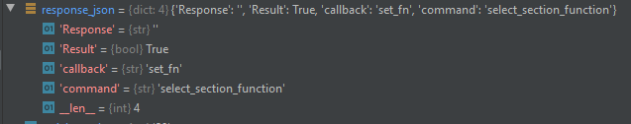

The following syntax allows to access a specific element of the dictionary (the “callback” string):

response_json["callback"]

The dictionary obtained as a response of a function that contains a get command has an additional component named “data” which is itself a dictionary. Its structure depends on the function and will be explained later.

LIBRARY FUNCTIONS

set_section_function(self, section, function)

Set a function to a device section.

|  |  |  |
| --- | --- | --- |
| PARAMETERS | VALID VALUES | FUNCTION |
| section | N1081B.Section | Section A/B/C/D of the instrument |
| function | N1081B.FunctionType | Name of the function to be assigned to a section |

configure_wire(self, section, enable0, enable1, enable2, enable3)

Configure the WIRE function.

|  |  |  |
| --- | --- | --- |
| PARAMETERS | VALID VALUES | FUNCTION |
| section | N1081B.Section | Section A/B/C/D of the instrument |
| enable0, enable1,  enable2, enable3 | bool | Enable/disable the correspondent input channel |

configure_and(self, section, enable0, enable1, enable2, enable3, enable4, enable5, bypass_enable, bypass_ind)

Configure the AND function.

|  |  |  |
| --- | --- | --- |
| PARAMETERS | VALID VALUES | FUNCTION |
| section | N1081B.Section | Section A/B/C/D of the instrument |
| enable0, enable1, enable2, enable3,  enable4, enable5 | bool | Enable/disable the correspondent input channel |
| bypass_enable | bool | Enable/disable the function bypass |
| bypass_ind | 0/1/2/3/4 | Bypass section OFF/A/B/C/D (No the current section) |

configure_or(self, section, enable0, enable1, enable2, enable3, enable4, enable5, bypass_enable, bypass_ind)

Configure the OR function.

|  |  |  |
| --- | --- | --- |
| PARAMETERS | TYPE | FUNCTION |
| section | N1081B.Section | Section A/B/C/D of the instrument |
| enable0, enable1, enable2, enable3,  enable4, enable5 | bool | Enable/disable the correspondent input channel |
| bypass_enable | bool | Enable/disable the function bypass |
| bypass_ind | int [0/1/2/3/4] | Bypass section OFF/A/B/C/D (No the current section) |

configure_or_veto(self, section, enable0, enable1, enable2, enable3, enable4, bypass_enable, bypass_ind)

Configure the OR+VETO function.

|  |  |  |
| --- | --- | --- |
| PARAMETERS | TYPE | FUNCTION |
| section | N1081B.Section | Section A/B/C/D of the instrument |
| enable0, enable1, enable2, enable3,  enable4 | bool | Enable/disable the correspondent input channel |
| bypass_enable | bool | Enable/disable the function bypass |
| bypass_ind | int [0/1/2/3/4] | Bypass section OFF/A/B/C/D (No the current section) |

configure_veto(self, section, enable0, enable1, enable2, enable3)

Configure the VETO function.

|  |  |  |
| --- | --- | --- |
| PARAMETERS | TYPE | FUNCTION |
| section | N1081B.Section | Section A/B/C/D of the instrument |
| enable0, enable1, enable2, enable3 | bool | Enable/disable the correspondent input channel |

configure_majority(self, section, enable0, enable1, enable2, enable3, enable4, enable5)

Configure the MAJORITY function.

|  |  |  |
| --- | --- | --- |
| PARAMETERS | TYPE | FUNCTION |
| section | N1081B.Section | Section A/B/C/D of the instrument |
| enable0, enable1, enable2, enable3,  enable4, enable5 | bool | Enable/disable the correspondent input channel |

configure_majority_veto(self, section, enable0, enable1, enable2, enable3, enable4)

Configure the MAJORITY+VETO function.

|  |  |  |
| --- | --- | --- |
| PARAMETERS | TYPE | FUNCTION |
| section | N1081B.Section | Section A/B/C/D of the instrument |
| enable0, enable1, enable2, enable3,  enable4 | bool | Enable/disable the correspondent input channel |

configure_lut(self, section, i_enable0, i_enable1, i_enable2, i_enable3, i_enable4, i_enable5, o_enable0, o_enable1, o_enable2, o_enable3, file_mode, file_name, file_content, file_lines)

Configure the LUT function.

|  |  |  |
| --- | --- | --- |
| PARAMETERS | TYPE | FUNCTION |
| section | N1081B.Section | Section A/B/C/D of the instrument |
| i_enable0, i_enable1, i_enable2, i_enable3,  i_enable4, i_enable5 | bool | Enable/disable the correspondent input channel |
| o_enable0, o_enable1, o_enable2, o_enable3 | bool | Enable/disable the correspondent output channel |
| file_mode | N1081B.FileMode | Use an existing/create a new LUT file |
| file_name | string [at maximum 20 characters. Characters allowed: letters, numbers, _, + and -] | LUT file name to be used (existing file or file to be created) |
| file_content | string  ‘[{“input”:X, “output”:Y},…,{}]’ | Content of the LUT file to be created: array of elements containing an input and an output value describing the logic state of the input and output channels with a binary value expressed as a decimal |
| file_lines | int | Number of combinations in the LUT file to be created |

class FileMode(Enum):  
 FILE_EXISTING = 0  
 FILE_NEW = 1

configure_coincidence_gate(self, section, enable0, enable1, enable2, enable3, enable4, coinc0, coinc1, coinc2, coinc3, coinc4, enable_gate, close_on_coinc, delay, width, trigger_mode)

Configure the COINCIDENCE GATE function.

|  |  |  |
| --- | --- | --- |
| PARAMETERS | TYPE | FUNCTION |
| section | N1081B.Section | Section A/B/C/D of the instrument |
| enable0, enable1, enable2, enable3,  enable4 | bool | Enable/disable the correspondent input channel |
| coinc0, coinc1, coinc2, coinc3, coinc4 | bool | Enable coincidence/anticoincidence mode |
| enable_gate | bool | Enable/disable external gate |
| close_on_coinc | bool | Enable/disable closing of the coincidence gate when a coincidence occurs |
| delay | int [0…100000] | Delay of the coincidence gate in ns |
| width | int [0…100000] | Width of the coincidence gate in ns |
| trigger_mode | N1081B.CoincidenceTriggerMode | Coincidence gate opening mode: first arriving signal/signal of the correspondent input channel |

class CoincidenceTriggerMode(Enum):  
 TRIGGER_FIRST = 0  
 TRIGGER_1 = 1  
 TRIGGER_2 = 2  
 TRIGGER_3 = 3  
 TRIGGER_4 = 4  
 TRIGGER_5 = 5

configure_scaler(self, section, scale, enable0, enable1, enable2, enable3, enable_gate)

Configure the SCALER function.

|  |  |  |
| --- | --- | --- |
| PARAMETERS | TYPE | FUNCTION |
| section | N1081B.Section | Section A/B/C/D of the instrument |
| scale | int [1…100000000] | Frequency divider value |
| enable0, enable1, enable2, enable3 | bool | Enable/disable the correspondent input channel |
| enable_gate | bool | Enable/disable external gate |

configure_counter(self, section, enable0, enable1, enable2, enable3, enable_gate)

Configure the COUNTER function.

|  |  |  |
| --- | --- | --- |
| PARAMETERS | TYPE | FUNCTION |
| section | N1081B.Section | Section A/B/C/D of the instrument |
| enable0, enable1, enable2, enable3 | bool | Enable/disable the correspondent input channel |
| enable_gate | bool | Enable/disable external gate |

configure_counter_timer(self, section, enable0, enable1, enable_gate, auto_reset, gate1_width, gate2_width, source_mode, time, counter_mode, target1, target2)

Configure the COUNTER TIMER function.

|  |  |  |
| --- | --- | --- |
| PARAMETERS | TYPE | FUNCTION |
| section | N1081B.Section | Section A/B/C/D of the instrument |
| enable0, enable1 | bool | Enable/disable the correspondent input channel |
| enable_gate | bool | Enable/disable external gate |
| auto_reset | bool | Enable/disable the autoreset of the counts when the target is reached or the window is closed |
| gate1_width | int [0…2^32] | 32 least significant bits of the window value expressed in decimal notation |
| gate2_width | int [0…2^32] | 32 most significant bits of the window value expressed in decimal notation |
| source_mode | N1081B.CounterTimerSource | Input channel/Internal timing as counter source |
| time | N1081B.CounterTimerTime | Time value in case of internal timing counter source: 10 ns/1 us/1 ms/1 s |
| counter_mode | N1081B.CounterTimerMode | Counting mode: FREE/COUNTDOWN/TARGET/WINDOW |
| target1 | int [0…2^32] | 32 least significant bits of the target value expressed in decimal notation |
| target2 | int [0…2^32] | 32 most significant bits of the target value expressed in decimal notation |

class CounterTimerSource(Enum):  
 CT_INPUT = 0  
 CT_TIME = 1

class CounterTimerTime(Enum):  
 CT_10ns = 0  
 CT_1us = 1  
 CT_1ms = 2  
 CT_1s = 3

class CounterTimerMode(Enum):  
 CT_FREE = 0  
 CT_COUNT_DOWN = 1  
 CT_TARGET = 2  
 CT_WINDOW = 3

configure_chronometer(self, section, frequency, chronometer_mode, enable0, enable1, enable_gate, reset_on_gate, reset_on_stop)

Configure the CHRONOMETER function.

|  |  |  |
| --- | --- | --- |
| PARAMETERS | TYPE | FUNCTION |
| section | N1081B.Section | Section A/B/C/D of the instrument |
| frequency | int [1…100000000] | Output signal frequency in Hz |
| chronometer_mode | N1081B.ChronometerMode | Chronometer mode: GATE/START-STOP |
| enable0, enable1 | bool | Enable/disable the correspondent input channel |
| enable_gate | Bool | Enable/disable external gate |
| reset_on_gate | bool | Enable/disable chronometer reset on gate closing in GATE mode |
| reset_on_stop | bool | Enable/disable chronometer reset on stop signal in START-STOP mode |

class ChronometerMode(Enum):  
 CM_GATE = 0  
 CM_START_STOP = 1

configure_rate_meter(self, section, enable0, enable1, enable2, enable3, enable_gate)

Configure the RATEMETER function.

|  |  |  |
| --- | --- | --- |
| PARAMETERS | TYPE | FUNCTION |
| Section | N1081B.Section | Section A/B/C/D of the instrument |
| enable0, enable1,  enable2, enable3 | bool | Enable/disable the correspondent input channel |
| enable_gate | bool | Enable/disable external gate |

configure_rate_meter_advanced(self, section, enable0, enable1, enable2, enable3, enable_gate, enable_alarm, threshold0, threshold1, threshold2, threshold3, filter_mode, integration_time)

Configure the RATEMETER ADVANCED function.

|  |  |  |
| --- | --- | --- |
| PARAMETERS | TYPE | FUNCTION |
| section | N1081B.Section | Section A/B/C/D of the instrument |
| enable0, enable1,  enable2, enable3 | bool | Enable/disable the correspondent input channel |
| enable_gate | bool | Enable/disable external gate |
| enable_alarm | bool | Enable/disable alarm on measured rate |
| threshold0, threshold1, threshold2, threshold3 | int [0…100000000] | Alarm rate threshold in Hz for each input channel |
| filter_mode | N1081B.FilterMode | Measured rate filter mode: OFF/VERY SLOW/SLOW/MEDIUM/FAST/VERY FAST |
| integration_time | N1081B.IntegrationTimeMode | Integration time for rate measurement: 1 ms/100 ms/500 ms/1 s/5 s/10 s/30 s/1 min/10 min/1 h |

class FilterMode(Enum):  
 FILTER_OFF = 0  
 FILTER_VERY_SLOW = 1  
 FILTER_SLOW = 2  
 FILTER_MEDIUM = 3  
 FILTER_FAST = 4  
 FILTER_VERY_FAST = 5  
class IntegrationTimeMode(Enum):  
 TIME_1ms = 0  
 TIME_100ms = 1  
 TIME_500ms = 2  
 TIME_1s = 3  
 TIME_5s = 4  
 TIME_10s = 5  
 TIME_30s = 6  
 TIME_1min = 7  
 TIME_10min = 8  
 TIME_1h = 9

configure_time_tagging(self, section, enable0, enable1, enable2, enable3, enable4, enable5)

Configure the TIME TAGGING function.

|  |  |  |
| --- | --- | --- |
| PARAMETERS | TYPE | FUNCTION |
| section | N1081B.Section | Section A/B/C/D of the instrument |
| enable0, enable1, enable2, enable3,  enable4, enable5 | bool | Enable/disable the correspondent input channel |

configure_time_of_flight(self, section, enable0, enable1, enable3, enable4, windows_mode, windows_value, windows_number, file_mode, file_name, file_content, file_windows_number, t0_mode, t0_frequency, t0_reset)

Configure the TIME OF FLIGHT function.

|  |  |  |
| --- | --- | --- |
| PARAMETERS | TYPE | FUNCTION |
| section | N1081B.Section | Section A/B/C/D of the instrument |
| enable0, enable1, enable3, enable4 | bool | Enable/disable the correspondent input channel |
| windows_mode | N1081B.WindowsMode | Use fixed/custom time windows |
| windows_value | int [10…1000000000] | Fixed time window values in ns |
| windows_number | int [0…2048] | Number of fixed time windows |
| file_mode | N1081B.FileMode | Use an existing/create a new time window file |
| file_name | string [at maximum 20 characters. Characters allowed: letters, numbers, _, + and -] | Time window file name to be used (existing file o file to be created) |
| file_content | string  ‘[{“window”:X, “value”:X},…,{}]’ | Content of the time window file to be created: array of elements containing the window index and its time value expressed in ns (valid range: 0-1000000000) |
| file_windows_number | int [0…2048] | Number of custom time windows |
| t0_mode | N1081B.T0Mode | Time measurement starting mode: EXTERNAL (input channel)/INTERNAL |
| t0_frequency | int [10…1000000000] | Frequency in Hz of the signal for the internal starting time mode |
| t0_reset | bool | Enable/disable the timing measurement reset at starting signal occurrence |

class WindowsMode(Enum):  
 WINDOWS_FIXED = 0  
 WINDOWS_CUSTOM = 1

class FileMode(Enum):  
 FILE_EXISTING = 0  
 FILE_NEW = 1

class T0Mode(Enum):  
 T0_EXTERNAL = 0  
 T0_INTERNAL = 1

configure_time_over_threshold(self, section, enable0, enable1, enable3, enable4, windows_value, windows_number)

Configure the TIME OVER THRESHOLD function.

|  |  |  |
| --- | --- | --- |
| PARAMETERS | TYPE | FUNCTION |
| section | N1081B.Section | Section A/B/C/D of the instrument |
| enable0, enable1, enable3, enable4 | bool | Enable/disable the correspondent input channel |
| windows_value | int [10…1000000000] | Fixed time window values in ns |
| windows_number | int [0…2048] | Number of fixed time windows |

configure_pulse_generator(self, section, statistics_mode, width, frequency, enable0, enable1, enable2, enable3)

Configure the PULSE GENERATOR function.

|  |  |  |
| --- | --- | --- |
| PARAMETERS | TYPE | FUNCTION |
| section | N1081B.Section | Section A/B/C/D of the instrument |
| statistics_mode | N1081B.StatisticMode | Deterministic/Poisson output signal frequency |
| width | int [10…100000] | Output signal width |
| frequency | int [1…100000000] | Output signal frequency |
| enable0, enable1, enable2, enable3 | bool | Enable/disable the correspondent output channel |

class StatisticMode(Enum):  
 STAT_DETERMINISTIC = 0  
 STAT_POISSON = 1

configure_digital_generator(self, section, enable0, enable1, enable2, enable3)

Configure the DIGITAL GENERATOR function.

|  |  |  |
| --- | --- | --- |
| PARAMETERS | TYPE | FUNCTION |
| section | N1081B.Section | Section A/B/C/D of the instrument |
| enable0, enable1, enable2, enable3 | bool | Enable/disable the correspondent output channel |

configure_pattern_generator(self, section, enable0, enable1, enable2, enable3, frequency, file_mode, file_name, file_content, file_lines)

Configure the PATTERN GENERATOR function.

|  |  |  |
| --- | --- | --- |
| PARAMETERS | TYPE | FUNCTION |
| section | N1081B.Section | Section A/B/C/D of the instrument |
| enable0, enable1, enable2, enable3 | bool | Enable/disable the correspondent output channel |
| frequency | int [1…100000000] | Output pattern change frequency in Hz |
| file_mode | N1081B.FileMode | Use an existing/create a new pattern file |
| file_name | string [at maximum 20 characters. Characters allowed: letters, numbers, _, + and -] | Pattern file name to be used (existing file or file to be created) |
| file_content | string  ‘[{“pattern”:X, “value”:X},…,{}]’ | Content of the pattern file to be created: array of elements containing the pattern index and its value describing the logic state of the output channels with a binary value expressed as decimal |
| file_lines | int | Number of sequences defined in pattern file |

class FileMode(Enum):  
 FILE_EXISTING = 0  
 FILE_NEW = 1

get_function_configuration(self, section)

Get the configuration parameters of the function currently used in the specified section.

|  |  |  |
| --- | --- | --- |
| PARAMETERS | TYPE | FUNCTION |
| section | N1081B.Section | Section A/B/C/D of the instrument |

The function response is a dictionary containing all the function configuration parameters. The meaning of each parameter is described in the correspondent configuration function. Here is an example for the PULSE GENERATOR function.

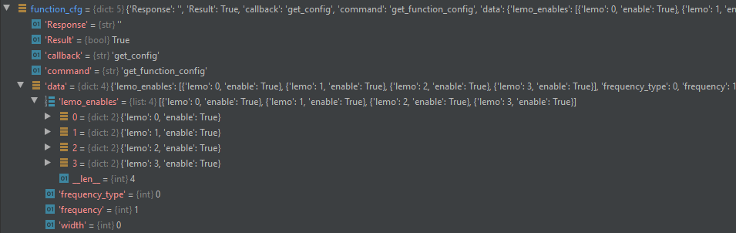

get_function_file_list(self, function)

Get the list of the name of the files stored in the device related to a specific function.

|  |  |  |
| --- | --- | --- |
| PARAMETERS | TYPE | FUNCTION |
| function | N1081B.FunctionType.FN_LUT  N1081B.FunctionType.FN_TIME_OF_FLIGHT  N1081B.FunctionType.FN_PATTERN_GENERATOR | Name of the function whose configuration file name list has to be retrieved |

The function response is a dictionary containing the list of the name of the files stored in the device of a specific function.

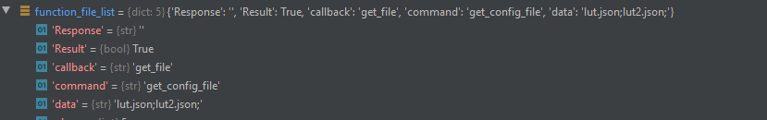

download_function_file(self, function, file_name)

Get the content of the specified configuration file stored in the device related to a specific function.

|  |  |  |
| --- | --- | --- |
| PARAMETERS | TYPE | FUNCTION |
| file_name | string [at maximum 20 characters. Characters allowed: letters, numbers, _, + and -] | Name of an existing configuration file of the specified function stored in the device to retrieve |
| function | N1081B.FunctionType.FN_LUT  N1081B.FunctionType.FN_TIME_OF_FLIGHT  N1081B.FunctionType.FN_PATTERN_GENERATOR | Name of the function whose configuration file has to be retrieved |

The function response is a dictionary reporting the content of the specified configuration file of the desired function. Here is reported an example from the LUT function.

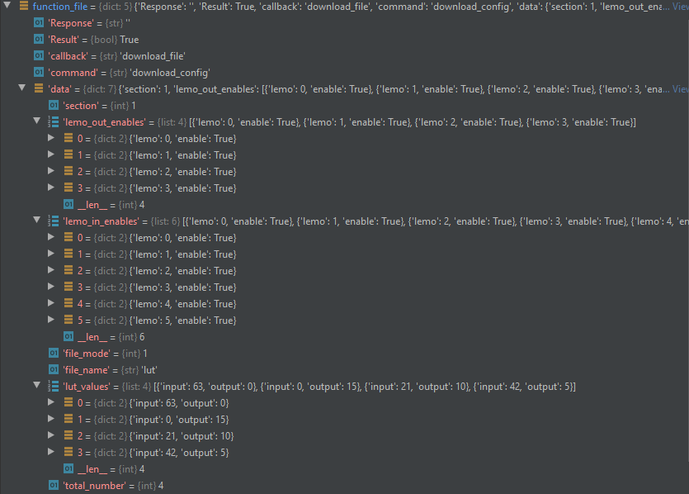

delete_function_file(self, function, file_name)

Delete from the device the specified configuration file stored in the device related to a specific function.

|  |  |  |
| --- | --- | --- |
| PARAMETERS | TYPE | FUNCTION |
| file_name | string [at maximum 20 characters. Characters allowed: letters, numbers, _, + and -] | Name of an existing configuration file of the specified function stored in the device to delete |
| function | N1081B.FunctionType.FN_LUT  N1081B.FunctionType.FN_TIME_OF_FLIGHT  N1081B.FunctionType.FN_PATTERN_GENERATOR | Name of the function whose configuration file has to be deleted |

get_function_results(self, section)

Get the acquired data from the COINCIDENCE GATE, SCALER, COUNTER, COUNTER TIMER, CHRONOMETER, RATEMETER, RATEMETER ADVANCED, TIME OF FLIGHT, TIME OVER THRESHOLD functions.

|  |  |  |
| --- | --- | --- |
| PARAMETERS | TYPE | FUNCTION |
| section | N1081B.Section | Section A/B/C/D of the instrument |

For the COINCIDENCE GATE, the response function is a dictionary containing six elements: the first represents the total number of coincidences counts and the other are the coincidences counts on the correspondent input channel.

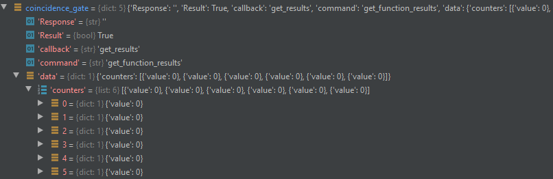

For the SCALER, COUNTER and RATEMETER, the response function is a dictionary containing four elements, each one consisting of a “lemo” index identifying the channel and a “value” reporting the counts/ rate for the corresponding channel.

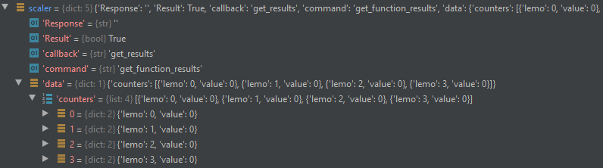

For the COUNTER TIMER, the response function is a dictionary containing two elements, each one consisting of a “lemo” index identifying the input channel, a “value” reporting the measured counts for the corresponding input channel, a “target_value” indicating the target set for that channel and a “target_type” value defining the counter mode.

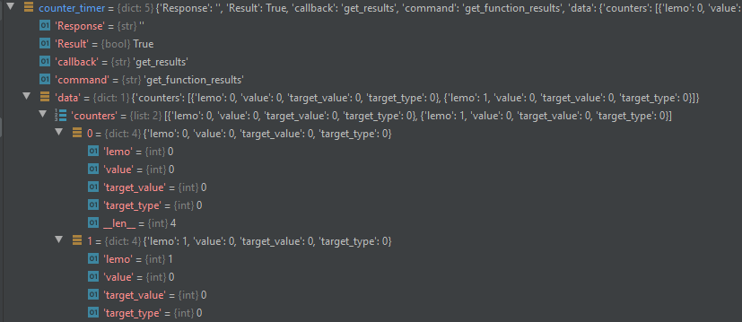

For the CHRONOMETER, the response function is a dictionary containing two elements, each one consisting of a “lemo” index identifying the input channel and a “value” reporting the measured counts for the corresponding input channel, which must be multiplied by ten in order to obtain the correspondent time expressed in ns.

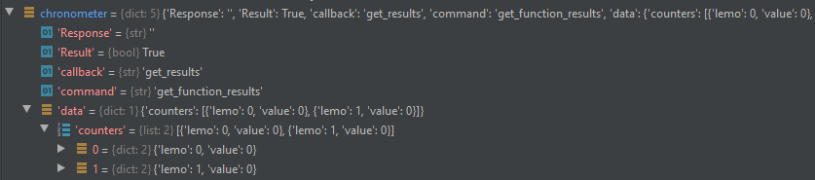

For the RATEMETER ADVANCED, the response function is a dictionary containing four elements, each one consisting of a “lemo” index identifying the input channel, a “value” reporting the rate in Hz of incoming pulses for the corresponding input channel and the “alarm” indicating if the rate threshold has been exceeded for that input channel.

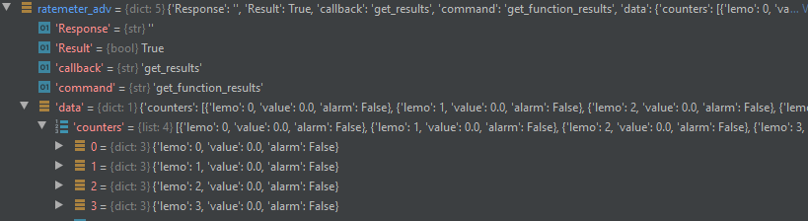

For the TIME OF FLIGHT and the TIME OVER THRESHOLD, the response function is a dictionary containing five list of data, each one of a length equal to the number of time window used for the time measurement. The first four represents the time of flight/ time over threshold distributions for the correspondent input channel, i.e. the number of measured times of flight/ signal duration in each time window. The last, the “time” list, represents the duration in ns of each time window.

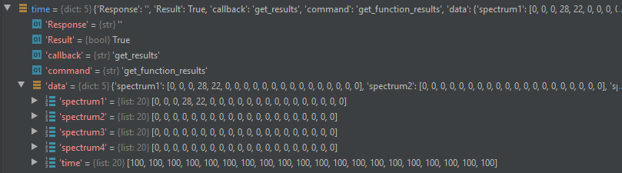

reset_channel(self, section, channel, function)

Reset the function acquired data. For the COINCIDENCE GATE, TIME OF FLIGHT and TIME OVER THRESHOLD functions all the channels measurements are reset, while for the SCALER, COUNTER, COUNTER TIMER, CHRONOMETER and RATEMETER ADVANCED functions it can be specified the input channel measurement to be reset.

|  |  |  |
| --- | --- | --- |
| PARAMETERS | TYPE | FUNCTION |
| section | N1081B.Section | Section A/B/C/D of the instrument |
| channel | 0/1/2/3 | Channel measurement to be reset for the SCALER, COUNTER, COUNTER TIMER, CHRONOMETER and RATEMETER ADVANCED |
| function | N1081B.FunctionType.FN_COINCIDENCE_GATE  N1081B.FunctionType.FN_TIME_OF_FLIGHT  N1081B.FunctionType.FN_TIME_OVER_THRESHOLD  N1081B.FunctionType.FN_SCALER  N1081B.FunctionType.FN_COUNTER  N1081B.FunctionType.FN_COUNTER_TIMER  N1081B.FunctionType.FN_CHRONOMETER  N1081B.FunctionType.FN_RATE_METER_ADVANCED | Name of the function whose acquired data has to be reset |

start_acquisition(self, section, function)

Start the function data acquisition or the signal output generation.

|  |  |  |
| --- | --- | --- |
| PARAMETERS | TYPE | FUNCTION |
| section | N1081B.Section | Section A/B/C/D of the instrument |
| function | N1081B.FunctionType.FN_LUT  N1081B.FunctionType.FN_TIME_TAGGING  N1081B.FunctionType.FN_TIME_OF_FLIGHT  N1081B.FunctionType.FN_TIME_OVER_THRESHOLD  N1081B.FunctionType.FN_PATTERN_GENERATOR | Name of the function whose data acquisition or signal generation starts |

stop_acquisition(self, section, function)

Stop the function data acquisition or the signal output generation.

|  |  |  |
| --- | --- | --- |
| PARAMETERS | TYPE | FUNCTION |
| section | N1081B.Section | Section A/B/C/D of the instrument |
| function | N1081B.FunctionType.FN_LUT  N1081B.FunctionType.FN_TIME_TAGGING  N1081B.FunctionType.FN_TIME_OF_FLIGHT  N1081B.FunctionType.FN_TIME_OVER_THRESHOLD  N1081B.FunctionType.FN_PATTERN_GENERATOR | Name of the function whose data acquisition or signal generation stops |

set_input_configuration(self, section, standard, standard_sub, threshold, impedance)

Configure the common parameters of all the six inputs of each section.

|  |  |  |
| --- | --- | --- |
| PARAMETERS | TYPE | FUNCTION |
| section | N1081B.Section | Section A/B/C/D of the instrument |
| standard | N1081B.SignalStandard | Input signal standard (lemo 1/2/4/5): NIM/TTL/discriminator |
| standard_sub | N1081B.SignalStandard | Input signal standard (lemo 3/6): NIM/TTL |
| threshold | int [-800…2000] | Threshold set on the analog input in discriminator mode expressed in mV |
| impedance | bool | Input impedance: 50 Ohm/High impedance |

class SignalStandard(Enum):  
 STANDARD_NIM = 0  
 STANDARD_TTL = 1  
 STANDARD_DISCRIMINATOR = 2

get_input_configuration(self, section)

Get the configuration parameters that are common for all the six inputs of each section.

|  |  |  |
| --- | --- | --- |
| PARAMETERS | TYPE | FUNCTION |
| section | N1081B.Section | Section A/B/C/D of the instrument |

The function response is a dictionary containing all the common input channel configuration parameters.

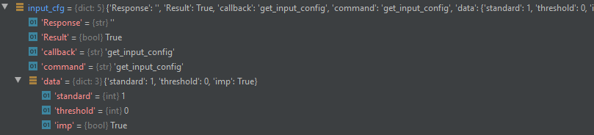

set_input_channel_configuration(self, section, channel, status, enable_gate_delay, gate, delay, invert)

Configure the specific parameters of an input channel.

|  |  |  |
| --- | --- | --- |
| PARAMETERS | TYPE | FUNCTION |
| section | N1081B.Section | Section A/B/C/D of the instrument |
| channel | 0/1/2/3/4/5 | Input channel of the instrument section |
| status | bool | Enable/disable the input channel |
| enable_gate_delay | bool | Enable/disable the input channel gate and delay |
| gate | int [0…100000] | Gate value expressed in ns |
| delay | int [0…100000] | Delay value expressed in ns |
| invert | bool | Enable/disable the input channel signal inversion |

get_input_channel_configuration(self, section, channel)

Get the configuration parameters that are specific for an input channel.

|  |  |  |
| --- | --- | --- |
| PARAMETERS | TYPE | FUNCTION |
| section | N1081B.Section | Section A/B/C/D of the instrument |
| channel | 0/1/2/3/4/5 | Input channel of the instrument section |

The function response is a dictionary containing all the specific input channel configuration parameters.

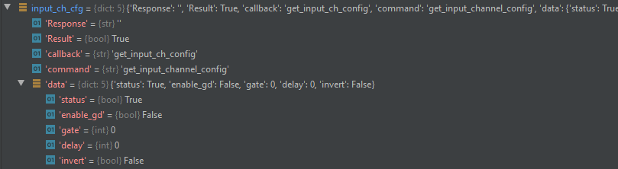

set_output_configuration(self, section, standard, impedance)

# Configure the common parameters of all the four outputs of each section.

|  |  |  |
| --- | --- | --- |
| PARAMETERS | TYPE | FUNCTION |
| section | N1081B.Section | Section A/B/C/D of the instrument |
| standard | N1081B.SignalStandard | Output signal standard: NIM/TTL |
| impedance | bool | Output impedance: 50 Ohm/High impedance |

class SignalStandard(Enum):  
 STANDARD_NIM = 0  
 STANDARD_TTL = 1  
 STANDARD_DISCRIMINATOR = 2

get_output_configuration(self, section)

Get the configuration parameters that are common for all the four outputs of each section.

|  |  |  |
| --- | --- | --- |
| PARAMETERS | TYPE | FUNCTION |
| section | N1081B.Section | Section A/B/C/D of the instrument |

The function response is a dictionary containing all the common output channel configuration parameters.

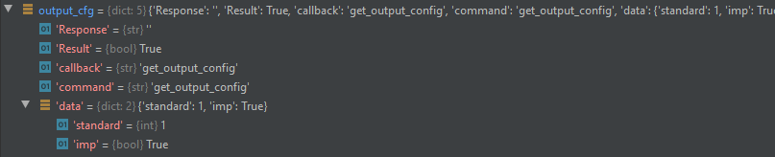

set_output_channel_configuration(self, section, channel, status, enable_monostable, monostable, invert)

Configure the specific parameters of an output channel.

|  |  |  |
| --- | --- | --- |
| PARAMETERS | TYPE | FUNCTION |
| section | N1081B.Section | Section A/B/C/D of the instrument |
| channel | 0/1/2/3 | Output channel of the instrument section |
| status | bool | Enable/disable the output channel |
| enable_monostable | bool | Enable/disable the output channel monostable |
| monostable | int [0…1000] | Monostable value expressed in ns |
| invert | bool | Enable/disable the output channel signal inversion |

get_output_channel_configuration(self, section, channel)

Get the configuration parameters that are specific for an output channel.

|  |  |  |
| --- | --- | --- |
| PARAMETERS | TYPE | FUNCTION |
| section | N1081B.Section | Section A/B/C/D of the instrument |
| channel | 0/1/2/3 | Output channel of the instrument section |

The function response is a dictionary containing all the specific output channel configuration parameters.

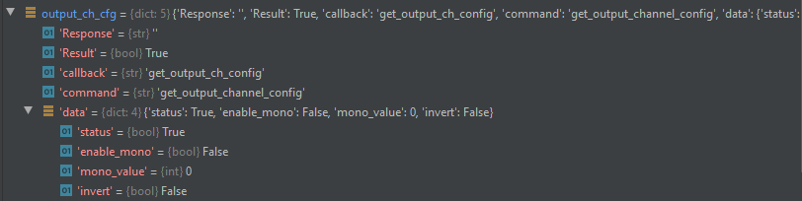

set_logic_analyzer_trigger(self, trigger_mode_in, trigger_mode_out, edge, sec1_in1, sec1_in2, sec1_in3, sec1_in4, sec1_in5, sec1_in6, sec1_out1, sec1_out2, sec1_out3, sec1_out4, sec2_in1, sec2_in2, sec2_in3, sec2_in4, sec2_in5, sec2_in6, sec2_out1, sec2_out2, sec2_out3, sec2_out4, sec3_in1, sec3_in2, sec3_in3, sec3_in4, sec3_in5, sec3_in6, sec3_out1, sec3_out2, sec3_out3, sec3_out4, sec4_in1, sec4_in2, sec4_in3, sec4_in4, sec4_in5, sec4_in6, sec4_out1, sec4_out2, sec4_out3, sec4_out4)

Configure the trigger for the logic analyser acquisition. If the “trigger_mode_in” or “trigger_mode_out” is set to OFF the values assigned to the enable of the input or output channels respectively are not taken into account. A logic OR is then applied between all the inputs and all the outputs trigger signals.

|  |  |  |
| --- | --- | --- |
| PARAMETERS | TYPE | FUNCTION |
| trigger_mode_in | N1081B.LogicAnalyzerTriggerMode | Trigger mode applied to input channels |
| trigger_mode_out | N1081B.LogicAnalyzerTriggerMode | Trigger mode applied to output channels |
| edge | N1081B.LogicAnalyzerTriggerEdge | Signal edge mode detected by trigger |
| secX_inX | bool | Input channel signal enabled/disabled for trigger |
| secX_outX | bool | Output channel signal enabled/disabled for trigger |

class LogicAnalyzerTriggerMode(Enum):  
 LA_TRIGGER_AND = 0  
 LA_TRIGGER_OR = 1  
 LA_TRIGGER_OFF = 2  
class LogicAnalyzerTriggerEdge(Enum):  
 LA_EDGE_RISING = 0  
 LA_EDGE_FALLING = 1

get_logic_analyzer_trigger(self)

Get the trigger configuration for the logic analyser acquisition.

The function response is a dictionary containing all the logic analyser trigger parameters, whose meaning is explained in the ‘set_logic_analyzer_trigger’ function.

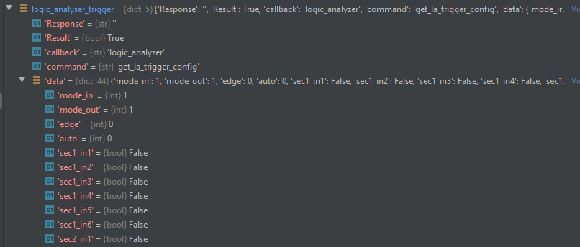

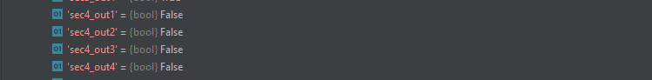

start_logic_analyzer(self)

Enable the logic analyser to start a single acquisition. Each time the user wants to acquire new data from the logic analyser this command has to be sent.

get_logic_analyzer_data(self)

Acquire data from the logic analyser.

# The response function is a dictionary containing “inputs” and “outputs” lists. The “inputs” is composed by 24 lists of 2048 values, representing the logic states of the input channels. The “outputs” consists of 16 lists of 2048 values, representing the logic states of the output channels. The values can be 0 or 1 to indicate a logic low or high signal. The sampling rate of the logic analyser is 100 MHz.

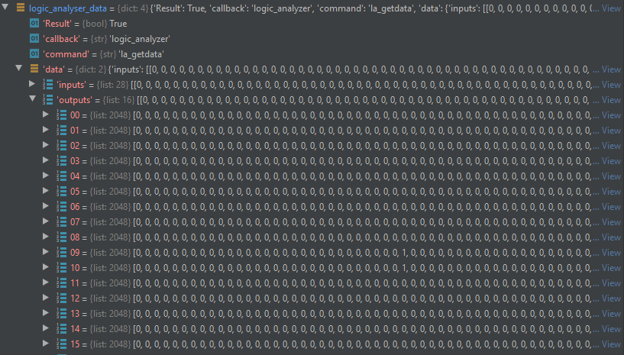

set_ethernet_configuration(self, dhcp, ip, netmask, gateway, dns)

Configure the ethernet parameters.

|  |  |  |
| --- | --- | --- |
| PARAMETERS | TYPE | FUNCTION |
| dhcp | 0/1 | Static Internet Protocol/Dynamic Host Configuration Protocol |
| ip | 0-255.0-255.0-255.0-255 | Internet Protocol Address specified in case of Static Internet Protocol |
| netmask | 0-255.0-255.0-255.0-255 | Netmask specified in case of Static Internet Protocol |
| gateway | 0-255.0-255.0-255.0-255 | Gateway specified in case of Static Internet Protocol |
| dns | 0-255.0-255.0-255.0-255 | Domain Name System specified in case of Static Internet Protocol |

get_ethernet_configuration(self)

Get the ethernet configuration parameters.

The function response is a dictionary containing the ethernet parameters.

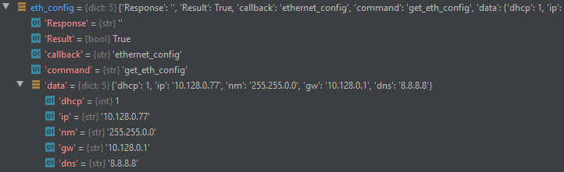

get_configuration_file_list(self)

Get the list of the names of the configuration file stored in the instrument.

The function response is a dictionary containing the list of the name of the configuration files stored in the device.

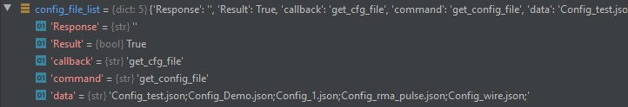

save_configuration_file(self, file_name)

Save the current configuration parameters in a json configuration file stored in the device, including the inputs, outputs and function settings for each section.

|  |  |  |
| --- | --- | --- |
| PARAMETERS | TYPE | FUNCTION |
| file_name | string [at maximum 20 characters. Characters allowed: letters, numbers, _, + and -] | Name of the file (with .json extension specified) to be created into the device containing the current device configuration parameters |

load_configuration_file(self, file_name)

Set all the device configuration parameters as defined in the specified file stored in the device.

|  |  |  |
| --- | --- | --- |
| PARAMETERS | TYPE | FUNCTION |
| file_name | string [at maximum 20 characters. Characters allowed: letters, numbers, _, + and -] | Name of the file (without .json extension specified) stored into the device containing the configuration parameters to be loaded |

upload_configuration_file(self, file_name, file_content)

Load a configuration file containing all the required parameters to be stored in the device.

|  |  |  |
| --- | --- | --- |
| PARAMETERS | TYPE | FUNCTION |
| file_name | string [at maximum 20 characters. Characters allowed: letters, numbers, _, + and -] | Name of the file (without .json extension specified) to be created into the device containing the configuration parameters specified by the user in the “file_content” |

The “file_content” is a string like this:

‘{"Section_0": { "input_general": { "standard": 1, "threshold": 0, "imp": true }, "input_channel_0": { "status": true, "enable_gd": false, "gate": 0, "delay": 0, "invert": false },…, "output_general": { "standard": 1, "imp": true }, "output_channel_0": { "status": true, "enable_mono": false, "mono_value": 0, "invert": false },…, "function_name": "counter", "function_configuration": { "lemo_enables": [ { "lemo": 0, "enable": true }, { "lemo": 1, "enable": true }, { "lemo": 2, "enable": true }, { "lemo": 3, "enable": true } ], "gate": false } }, "Section_1": {…}, "Section_2": {…}, "Section_3": {…}}’

download_configuration_file(self, file_name)

Get the content of a configuration file stored in the device.

|  |  |  |
| --- | --- | --- |
| PARAMETERS | TYPE | FUNCTION |
| file_name | string [at maximum 20 characters. Characters allowed: letters, numbers, _, + and -] | Name of the configuration file (without .json extension specified) stored into the device to be downloaded |

The function response is a dictionary reporting the content of the specified configuration file stored in the device.

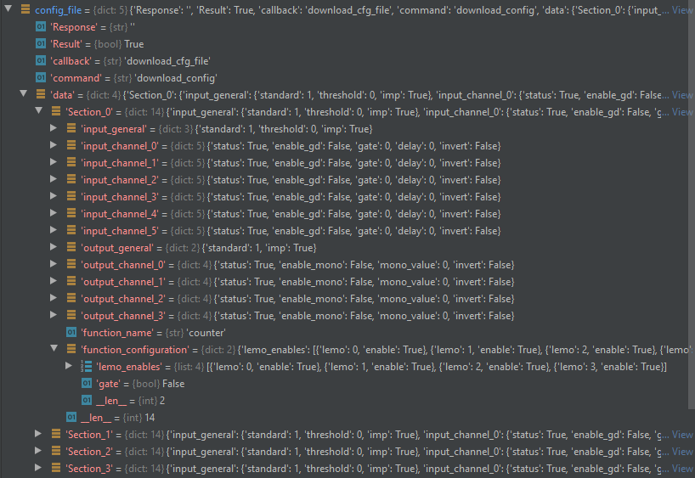

delete_configuration_file(self, file_name)

Delete the specified configuration file stored in the device.

|  |  |  |
| --- | --- | --- |
| PARAMETERS | TYPE | FUNCTION |
| file_name | string [at maximum 20 characters. Characters allowed: letters, numbers, _, + and -] | Name of the configuration file (without .json extension specified) stored into the device to be deleted |

rename_configuration_file(self, old_file_name, new_file_name)

Rename the specified configuration file stored in the device.

|  |  |  |
| --- | --- | --- |
| PARAMETERS | TYPE | FUNCTION |
| old_file_name | string [at maximum 20 characters. Characters allowed: letters, numbers, _, + and -] | Current name of the configuration file (without .json extension specified) to be renamed into the device |
| new_file_name | string [at maximum 20 characters. Characters allowed: letters, numbers, _, + and -] | New name of the configuration file (without .json extension specified) to be renamed into the device |

set_internal_clock(self)

Set the internal clock as the device clock.

check_clock(self)

Check if the external provided signal is a valid clock signal.

The function response is a dictionary where the “data” value represents the signal validity: if it is “0” the external signal is not a valid clock, if it is “1” the external signal can be used as the device clock.

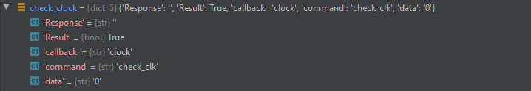

set_external_clock(self)

Set the valid external clock signal as the device clock.

get_clock_status(self)

Get the clock status.

The function response is a dictionary where the “data” value represents the clock status: if it is “0” the clock is set as external clock but the provided signal is no more valid and the system has switched to the internal clock, if it is “1” the system is using the external signal as a clock, while if it is “2” the system is using the internal clock.

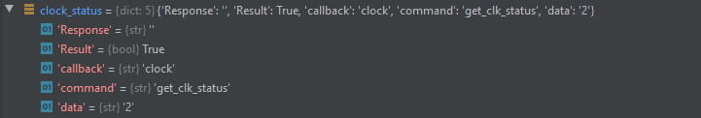

get_version(self)

Get the device serial number, the software, the zynq and the fpga versions.

The function response is a dictionary containing the device serial number, the software, the zynq and the fpga versions.

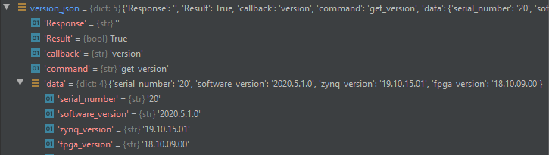

start_search_device(self)

Start the search device procedure, in which the device display becomes red and shows the serial number, while the device emits an alarm sound.

stop_search_device(self)

Stop the search device procedure.

get_search_device_status(self)

Get the device search procedure status.

The function response is a dictionary where the “data” value represents the search device status: if it is “0” the device is not in the search procedure, while if it is “1” the search device procedure is active.

