ESP32-S3 Mini-1 & SIM868 Smart Safety Band Architecture, AT Command Analysis, and State Machines
———————————————————————————————————————————————————————————Executive Summary
This document provides an in-depth technical analysis and system architecture breakdown of the Smart Safety Band firmware running on the ESP32-S3 Mini-1 module integrated with the SIM868 (GSM/GPRS + GNSS) cellular modem. It details the FreeRTOS multi-tasking architecture, hardware-software peripheral mapping, emergency safety event processing pipelines, AT command communication handling, error mitigation strategies, and state machine implementations.
———————————————————————————————————————————————————————————
1. System Hardware & Component Architecture
Hardware Pin Mapping (ESP32-S3 Mini-1 & SIM868)
Peripheral / Function | ESP32-S3 GPIO | Configuration / Interface | Notes
I2C SDA | GPIO8 | Master I2C (400 kHz) | Shared sensor bus (LSM6DSOX, legacy LIS3DH, environmental/health sensors)
I2C SCL | GPIO9 | Master I2C (400 kHz) | Shared sensor bus
Status LED | GPIO47 | Push-Pull Output | System status indicator & emergency rapid flasher
SIM868 UART TX | GPIO17 | UART1 TX (115200 baud) | Connected to SIM868 RXD
SIM868 UART RX | GPIO18 | UART1 RX (115200 baud) | Connected to SIM868 TXD
SIM868 Power Control | GPIO42 | Push-Pull Output | Hardware power cycle control line
SOS Push Button | GPIO41 / GPIO4 | Input Pull-Up (GPIO_INTR_NEGEDGE) | Active-Low emergency button interrupt source
Motion Interrupt | GPIO2 | Input | Motion sensor interrupt line
Battery ADC | ADC1_CH0 (GPIO1) | Analog Input | Battery voltage monitoring

———————————————————————————————————————————————————————————
———————————————————————————————————————————————————————————
2. ESP32-S3 Firmware Architecture & Task Model
The firmware utilizes a layered, concurrent, event-driven FreeRTOS architecture designed on top of ESP-IDF.
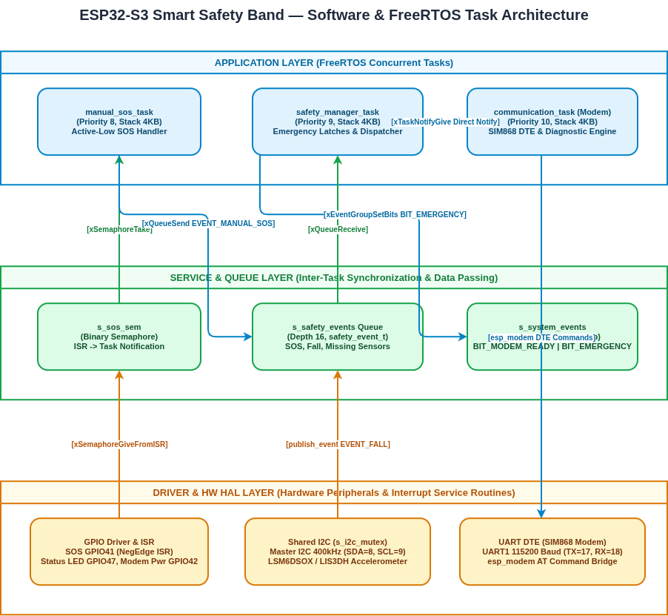
Active & Target Task Distribution
- `communication_task` (Priority 10, Stack 4KB):
- Highest application priority to guarantee instant access to the SIM868 modem.
- Manages power-cycling, UART DTE initialization, AT command execution, diagnostic routines, SMS dispatch, and voice call placement.

———————————————————————————————————————————————————————————
———————————————————————————————————————————————————————————
- `safety_manager_task` (Priority 9, Stack 4KB):
- High priority safety event processor. Consumes `safety_event_t` from `s_safety_events` queue.
- Latches the emergency state (`s_emergency_latched`), sets `BIT_EMERGENCY` in `s_system_events`, notifies `communication_task`, and invokes modem emergency routines.
- `manual_sos_task` (Priority 8, Stack 4KB):
- Blocked on `s_sos_sem`. When the user presses the SOS button (`GPIO41 / GPIO4` interrupt), `sos_isr()` yields the binary semaphore.
- Publishes `EVENT_MANUAL_SOS` into `s_safety_events`.
- Motion / Sensor Task (Target / Extensible):
- 20 ms period task reading LSM6DSOX/LIS3DH accelerometer data under `s_i2c_mutex` protection.
- Detects fall impact vectors and posts `EVENT_FALL` to `s_safety_events`.
3. Emergency Alert Use Cases & Execution Workflows
Use Case 1: Manual SOS Trigger -
- User Action: User depresses active-low SOS button on `GPIO41 / GPIO4`.
- ISR Level: `sos_isr()` triggers on the negative edge, executes `xSemaphoreGiveFromISR(s_sos_sem)`, performing `portYIELD_FROM_ISR()`.
- Task Level: `manual_sos_task` unblocks from `s_sos_sem` and calls `publish_event(EVENT_MANUAL_SOS, 0, "SOS button")`.
- Safety Pipeline: `safety_manager_task` dequeues `EVENT_MANUAL_SOS`.
- Checks `!s_emergency_latched`.
- Sets `s_emergency_latched = true`.
- Set `BIT_EMERGENCY` bit in `s_system_events`.
- Call `gl868_modem_trigger_emergency("SOS button", 0)`.
Use Case 2: Fall Detection Alert -
- Sensor Level: Accelerometer reports magnitude delta exceeding `FALL_DELTA_MG` (1800 mg threshold).
- Queue Push: Motion monitor calls `publish_event(EVENT_FALL, delta_mg, "LSM6DSOX")`.
- Safety Dispatch: `safety_manager_task` latches emergency and triggers SIM868 notification sequence.

———————————————————————————————————————————————————————————
———————————————————————————————————————————————————————————
Emergency Alert Notification Sequence (`gl868_modem_trigger_emergency`)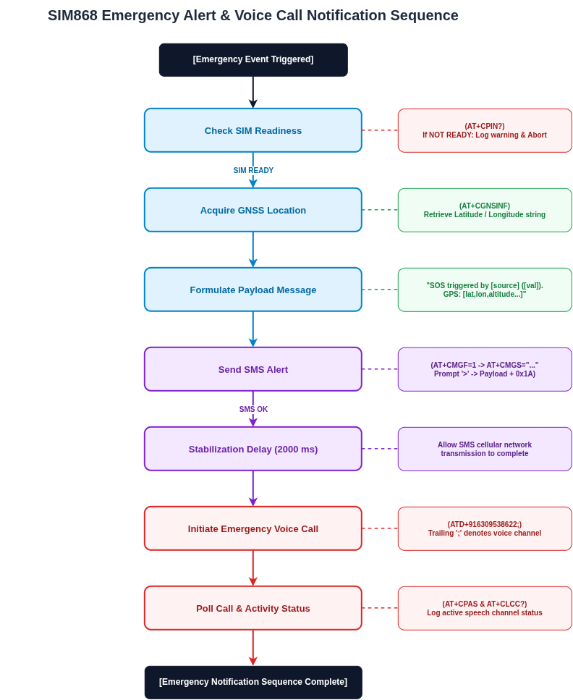
———————————————————————————————————————————————————————————
———————————————————————————————————————————————————————————4. In-Depth AT Command Suite Analysis & Issue Investigation
The SIM868 modem is controlled via UART AT commands using the ESP-IDF `esp_modem` component (`DTE` pattern). Below is the comprehensive analysis of all AT commands used in the codebase, their purpose, responses, and potential issues.
Complete AT Command Breakdown
AT Command | Category | Purpose | Success Marker / Response | Timeout
AT\r | Handshake | Verify modem UART baud rate & responsiveness | OK | 3000 ms
ATI\r | Identification | Retrieve modem model details (SIM868) | SIM868 ... OK | 4000 ms
AT+CMEE=2\r | Error Config | Enable verbose numeric & text error codes | OK | 3000 ms
AT+CPIN?\r | SIM Status | Query SIM PIN/READY status | +CPIN: READY | 5000 ms
AT+CCID?\r | SIM Info | Read SIM card ICCID number | +CCID: <iccid> | 6000 ms
AT+CSQ\r | Network | Query Received Signal Strength Indicator (RSSI) | +CSQ: <rssi>,<ber> | 6000 ms
AT+COPS?\r | Network | Query current cellular network operator | +COPS: <mode>,<format>,"<oper>" | 4000 ms
AT+CREG?\r | Network | Check GSM network registration status | +CREG: <n>,<stat> | 4000 ms
AT+CGREG?\r | Network | Check GPRS network registration status | +CGREG: <n>,<stat> | 4000 ms
AT+CGSN\r | SIM Info | Read modem IMEI number | <imei> OK | 4000 ms
AT+CIMI\r | SIM Info | Read SIM IMSI identifier | <imsi> OK | 4000 ms
AT+CNUM\r | SIM Info | Read subscriber phone number | +CNUM: ... | 4000 ms
AT+CSCA?\r | SMS Config | Read SMS Service Center Address | +CSCA: "<number>",<type> | 4000 ms
AT+CMGF=1\r | SMS Config | Set SMS messaging to Text Mode | OK | 5000 ms
AT+CMGS="<num>"\r | SMS Send | Initiate SMS send to destination number | Prompt > | 10000 ms
<msg>\x1A | SMS Payload | Submit SMS text body + CTRL+Z (0x1A) terminator | +CMGS: <mr> OK | 15000 ms
ATD<num>;\r | Voice Call | Initiate voice call (trailing ; denotes voice) | OK / VOICE CALL | 6000 ms
AT+CPAS\r | Call Status | Query phone activity status (0=ready, 3=ring, 4=call) | +CPAS: <pas> | 4000 ms
AT+CLCC?\r | Call Status | List current active call connections | +CLCC: <id>,<dir>,<stat>,... | 5000 ms
AT+CGNSPWR=1\r | GNSS / GPS | Turn ON internal SIM868 GNSS power | OK | 3000 ms
AT+CGNSSEQ="RMC"\r | GNSS / GPS | Set NMEA sentence sequence to RMC | OK | 3000 ms
AT+CGNSINF\r | GNSS / GPS | Read GNSS fix, lat/lon, altitude, speed, UTC | +CGNSINF: 1,1,<UTC>,<lat>,<lon>,... | 5000 ms
AT+CBC\r | Power / Battery | Query battery charge state & voltage | +CBC: <bcs>,<bcl>,<voltage> | 4000 ms
AT+CIPGSMLOC=1,1\r | Location | Retrieve GSM cell tower location & time | +CIPGSMLOC: 0,<lon>,<lat>,<date> | 10000 ms

———————————————————————————————————————————————————————————
———————————————————————————————————————————————————————————5. State Machine Diagram Implementation
1. System Safety State Machine
This state machine governs the overall operation of the Smart Safety Band on the ESP32-S3, managing transitions from initial power-on through sensing, emergency latching, notification dispatch, and recovery.
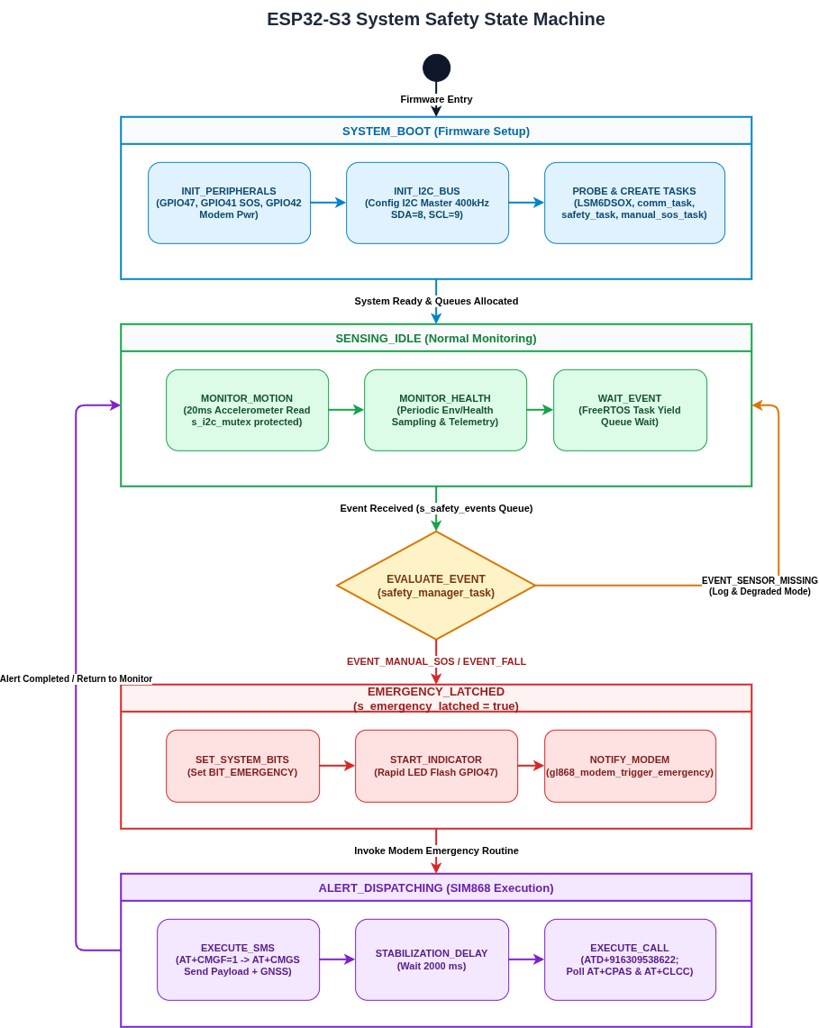

———————————————————————————————————————————————————————————
———————————————————————————————————————————————————————————
2. SIM868 Modem & Communication Engine State Machine
This state machine controls the UART modem DTE bridge, handling power management, handshakes, SIM verification, GNSS setup, SMS/Voice execution, and error retries.

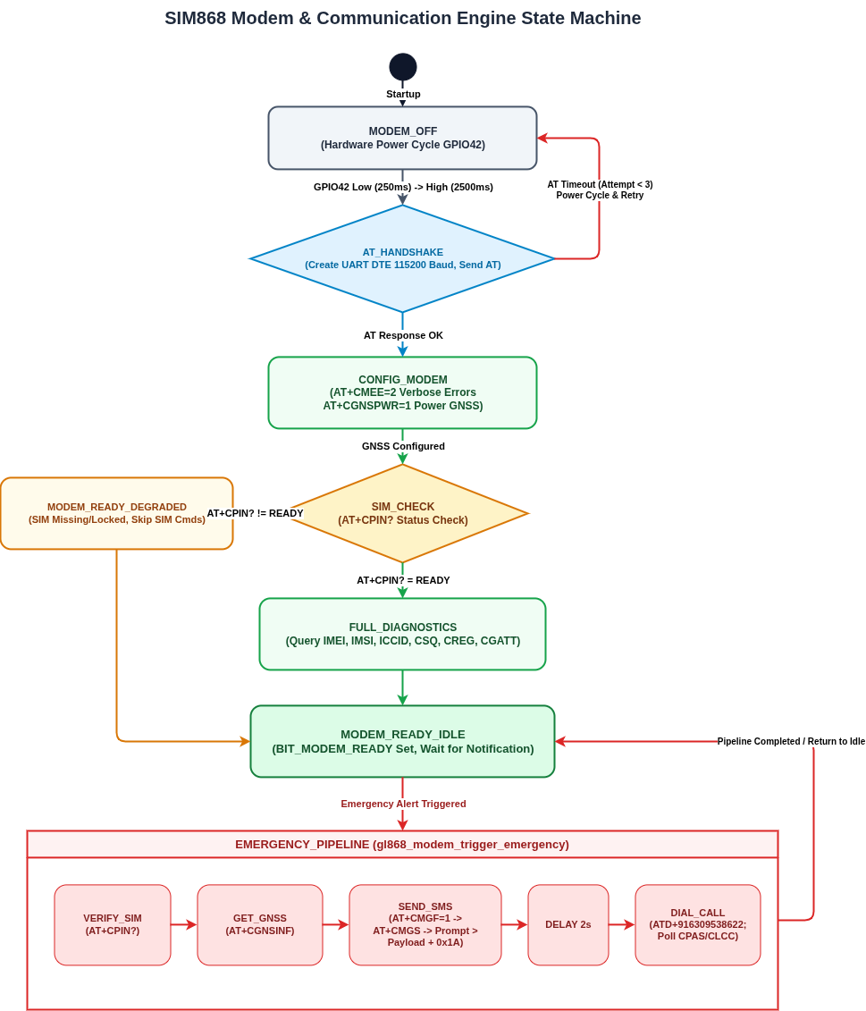
———————————————————————————————————————————————————————————
———————————————————————————————————————————————————————————
6. Circuit Diagram
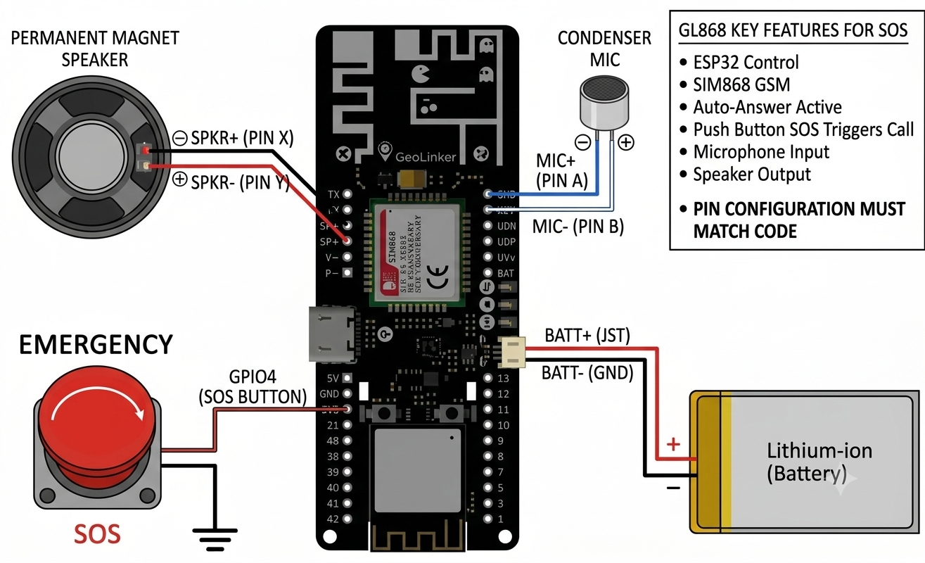
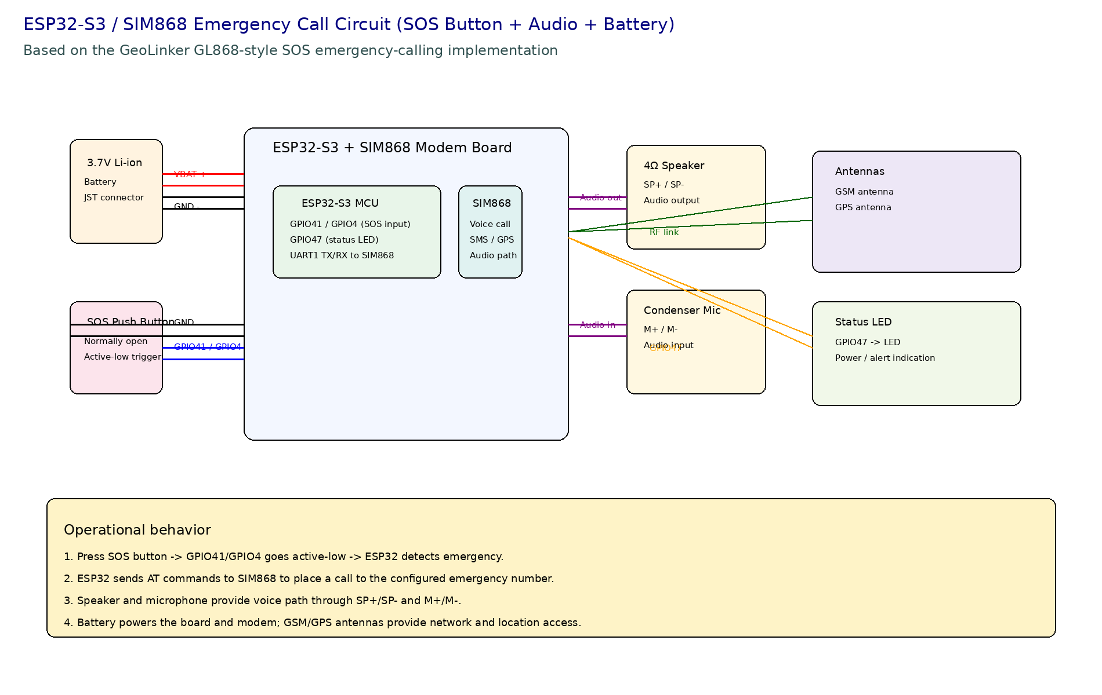

———————————————————————————————————————————————————————————
———————————————————————————————————————————————————————————Summary & Key Recommendations
- Hardware Power Key Integration: GPIO42 power cycling provides reliable hardware-level recovery when the modem becomes unresponsive to serial AT commands.
- SIM Readiness Guarding: Checking `AT+CPIN?` before firing SIM-dependent commands prevents cluttering the logs with spurious CME errors during modem registration.
- Dedicated Emergency Task Prioritization: Running `communication_task` at Priority 10 and `safety_manager_task` at Priority 9 ensures zero preemption delay during life-safety alerts.
- Non-Blocking Execution: All UART interactions use `esp_modem::DTE` asynchronous callbacks with explicit timeouts, preventing kernel stalls or task starvation.
In modem terminology, a “DTE” is the Data Terminal Equipment side of the link - basically the host endpoint that talks to the modem. The modem itself is the “DCE” (Data Circuit-terminating Equipment). In the ESP-IDF esp_modem world, DTE is the object that:
- Owns the transport to the modem (UART, USB, socket, etc).
- Sends AT commands
- Reads responses and unsolicited result codes
- Manages command v/s data mode and secondary data terminals
- Recovers from connection issues
So a “DTE bridge” is the layer that bridges your firmware / application logic to the physical modem transport. It translates your high-level modem actions into bytes on the wire, and it turns modem replies into usable callbacks / results.
Why it’s useful:
- It hides low-level serial / terminal details
- It gives you a single API for modem commands and data
- It lets you swap the underlying transport without rewriting command logic
- It supports dual-terminal setups (command terminal + data / PPP terminal) and mode switching
In this repo, the SIM868 modem integration uses an esp_modem::DTE style bridge for the UART link, so the firmware can focus on AT command sequences, emergency alert flow, and stat machines instead of raw UART framing and parsing.

———————————————————————————————————————————————————————————

