Curriculum Vitaé
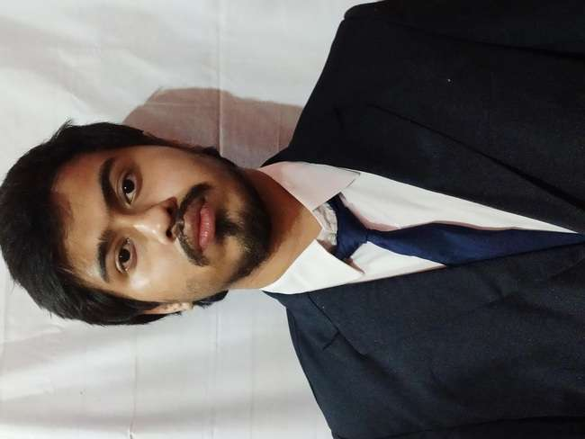

Name : Sabyasachi dutta
Address : E.V.pally,hakimpara,Siliguri.
Mobile No :7908287103

E-mail : bbpond457@gmail.com

Academic Qualifications:

Degree / Certificate | Degree | Discipline | Institute | Board /  University | Year of Passing | Aggregate % / CGPA
Graduation | B.Tech | CSE | University of Engineering & Management, Kolkata | University of Engineering & Management,  Kolkata | 2023 | 8.6 (Upto 5th Semester)
12th | Higher Secondary | Science | Techno India Group Public School | CBSE | 2019 | 74%
10th | Secondary | General | Don Bosco School | ISCE | 2016 | 83%

* Aggregate Marks mean Summation of the marks obtained in all the subjects (including optional subjects) divided by the total marks in all subjects.

Trainings / Projects Undertaken:

Name of Institute / Organization | Project Title | Duration
Talakunchi Networks pvt. ltd. | OWASP Zap  Network scanning  Authentication bypass  Vulnerability scanning | 6 weeks

Additional Qualification / Achievements / Certifications:

- Python course (by skillup)
- Cybersecurity Fundamentals (IBM skillbuild)
- Google cloud fundamentals (by coursera)
- ATT&CK SOC Assessments (by cybrary)
- html and css (front end ) (by devtown)

Personal Projects:
- Chatbot A.I
- web scrapper (github.com/ENSANITYel/WEBIN)
- Hotstar clone (front-end)(https://rwdr39.csb.app/)
- Login portal using node js (github.com/ENSANITYel/Login-portal)
- Portfolio using js, html and css (https://u17dq7.csb.app/home)

Subjects of Interest:

- Operatings systems
- Linux

Programming Language Proficiency:

- C ++
- Python

Hobbies:

- Reading books( fiction and non-fiction)
- Painting
- Photography

Family Details:

Details | Name | Occupation
Father | Late. Dlilp Dutta | Buisness
Mother | Runu dutta | Home-maker
Siblings | Tuli Dutta | Teacher

Personal Details:

Date of Birth : 22-12-1999
Gender : M
Languages Known : Hindi, Bengali, English
Date : 26.06.2020

