Group G - ENSE 471

Jinpeng Chen

Mason Lane

Zuoxiu Xing

People Centered Design

09/04/2020

This document outlines our attempts at developing with people centered design in mind. Namely, our work on the dialing page. Note that all buttons offer quality levels of “clickability”, as we use bootstrap css to standardize our buttons. Images of our interface at at the end of this document for reference.

For starters, the main menu is simple - however our button uses the phone to signify its purpose. You are going to call 911. We also positioned the phone so it appeared like the 9 was using the phone - or was in a call. Children should recognize the imagery. However, a rotary phone may lose its meaning as we go further into digital/mobile smart devices. We would have prefered to use something else - however we were limited to the symbols we could find. The rotary phone is still used by real smart phones however, so we believe the button affords enough information to the child.

When clicking 911, the child is redirected to our mock-up dialing interface. Here, they are presented with little instructions at first. This is per Ms Giblett’s request. She wanted the child to get a chance at dialing 911 on their own - without a crutch. We had considered adding a starting popup window telling the child to dial 911. However, we believed the firefighter instructing the children would have already communicated this.

Children are allowed several interactions apart from simply dialing. They may also click the home button, returning to index.html. We’ve attempted to disguise the home button as an unimportant button one would casually see on any phone interface. There is little incentive to press it. Likewise, the delete button across the screen is also drawing less attention - as it is only there for mistakes. People using phones rarely press the buttons beside the call button, so we thought it would be a good way to add more functionality without disturbing the visuals of the simulation. Afterall, this is supposed to feel like a phone. We cannot afford to add buttons where they would not reasonably go. Hence, we disguise the exit to home. IN doing this, we signify the buttons purpose and unimportance (children shouldn't need to leave. It's more for adults) without hurting the form of the interface.

Note, that we do make one exception in our attempts at maintaining the form of a dialing interface. What to Expect is a button which children and firefighters may use to get a shared understanding of what conversation might ensue. Firefighters may read off the script, or use their own. Children may use it to prepare themselves. Our aim was to make the button usable by both children and adults as they reenacted a 911 call. The button is intended to be used by all individuals. Firemen will use this button if they like, to read the script with the child. Ths button is placed at the top of the page to avoid confusing the child. This button is not a part of the dialing interface, but is nevertheless important. Therefore, it is blue to signify its equal importance to other digits. Keeping the button out of the way maintains the phone interface we are aiming for, while allowing the functionality of a “help me” button.

Now, as a child tries to dial 911, some may inevitably make mistakes. If a child makes a mistake, the number currently dialed will jiggle as if erasing itself. This is to add some entertainment, as the app is for children. This is done alongside traditional signifiers, like a red dashed box indicating bad input. Typing sets the box back to its normal state. Note that this validation is a constraint. The child cannot proceed until they correctly dial and call 911.

If the child dials the wrong number 3 times, a popup appears. The popup reminds the child that they must dial 911, but makes attempts at being kind and supportive. While this is happening, the buttons shift colors. All digits are turned grey, while 9 and 1 turn an even lighter blue. We allow the what to expect button to also turn lighter blue - but only because it is useful, and we don’t want to discourage children from pressing it.

If the child dials the wrong number 3 more times, 9 and 1 will ‘bounce’ - attempting to draw further attention from the child. This is a signifier often used in video game interfaces. Which after a period of little/no input, elements will bounce to catch the user’s eye. It is wordlessly saying “over here”.

Finally, dialing the wrong number another 3 times will make the tool disable all digits but 9 and 1. This is another constraint, which disallows the child from inputting anything but groups of 1 and 9. It is up to them to enter 911 in the end, however. Errors of 3 will now loop, causing the bounce function over and over.

Children are redirected to the call session page after successfully entering 911. Here, we’ve maintained the what to expect button. This is simply here to remind the child of what to say. We considered making it pop up by default, but did not want to disturb the flow of the call process (assuming firefighter begins right away). The interface is a lightweight replica of a standard call. You cannot leave to index.html from here. Simply end the call.

After finishing, children are rewarded with a stream of confetti. This is to bolster their enjoyment, and signify that they have reached the end of the activity. They are allowed only one action, and that is to go home. We maintain the button from earlier, to ensure understanding of each button’s purpose is not confused. Clicking the home button brings you home.

**Appendix**

911 Home Page

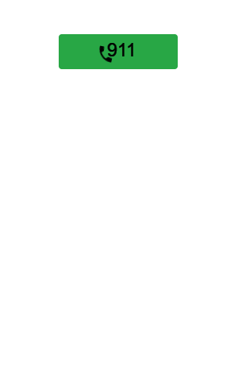

911 dialing interface

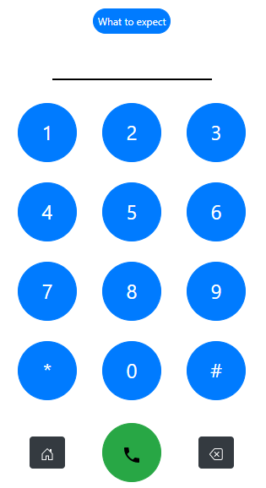

What to expect popup

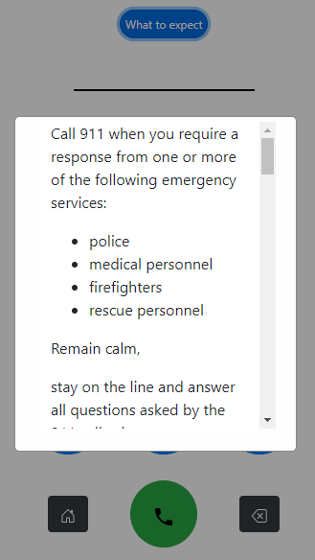

Error

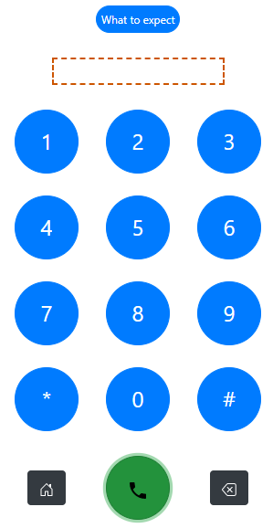

Popup after 3 tries

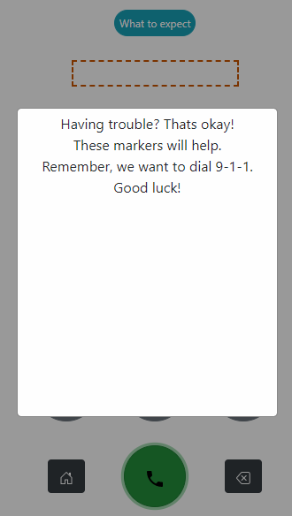

Recolor after 3 tries

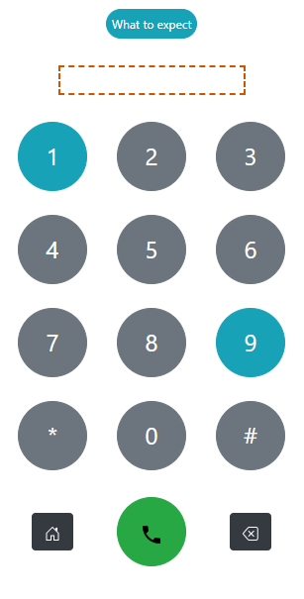

Disabling buttons

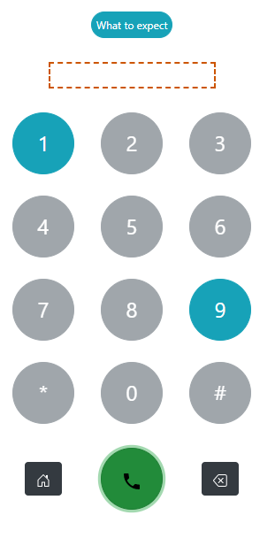

Bouncing buttons

