TABLE OF CONTENTS

1. Introduction 3
1.1 Scope 3
1.2 Related Documents 3
1.3 External Requirements 3
1.4 Internal Requirements 3
1.5 Design issues 3
2. Internal Design 3
2.1 Data Flows 3
3. Unit Test Strategy 3
4. Additional Information 3
5. References 3
6. Acronyms 3

Introduction
This lab assignment focuses on the habitat of the animals living in a virtual world and surviving solely on their prey or food source. The animals have to move in order to find food. If an animal does not eat enough food they will die. The user is able to specify the dimensions of the virtual world as well as the maximum number of animals that can start inside the simulation. The user has the option to iterate a day at a time or skip ahead by a select day or just go until there are no animals left. The user also has the option to print the animals in a list or on a map. The user has the option to remove or add animals of their choosing. The user can also focus on a certain animal by selecting them using the provided method.

Scope
The scope of this assignment is to provide a simulation of the animals indicated in the image 1.2.a. The simulation is to provide a virtual example of a habitat with the animals in the image. It needs to provide the user a way to see the animals moving, eating, and dying in the world. Also what the lifeform eats and the way it dies must be specified.

Related Documents
1.2.a
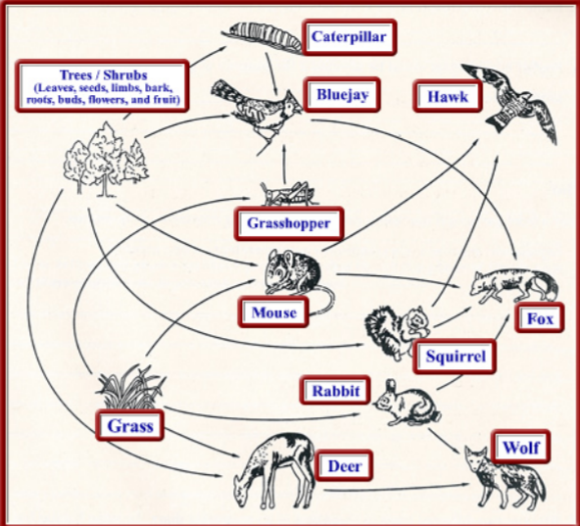

1.2.b Old Class Diagram:

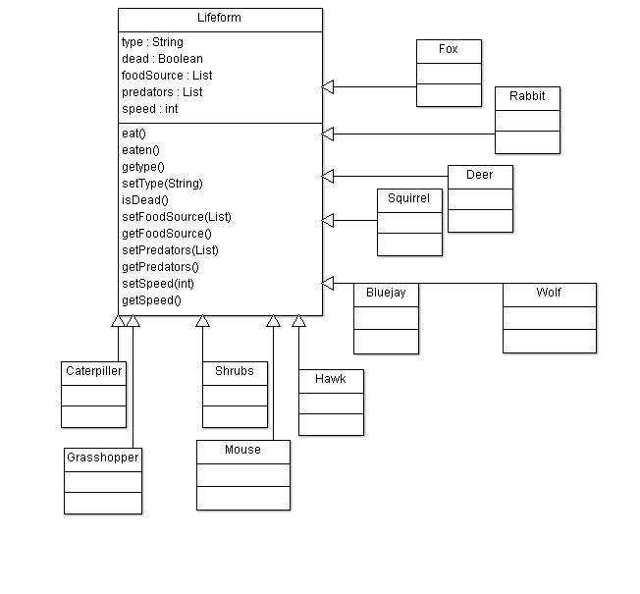

1.2.c New Class Diagram:
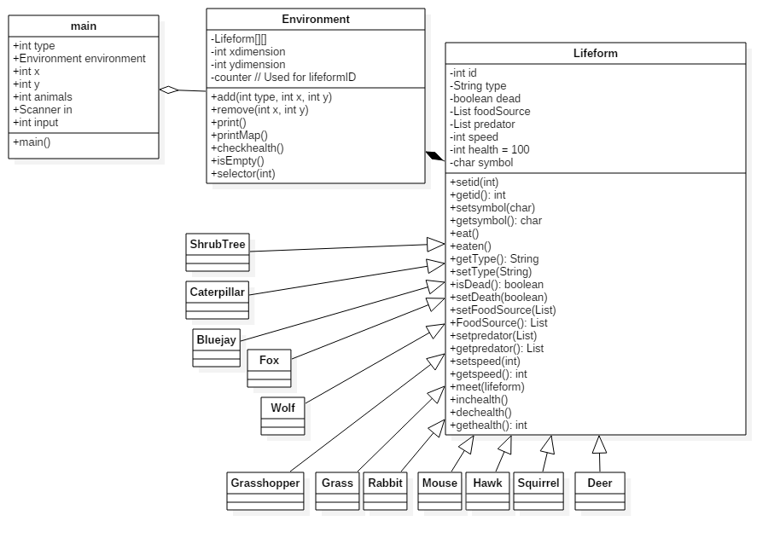

External Requirements
- Are there any inputs into your system:
The User inputs all the information they need for the simulation to work. Such as whether the simulation will run at the default dimensions or at a specified size. As well as adding or removing animals to the simulation. The rest of the input will be to check how to print the data and how many days to iterate the simulation by.

Internal Requirements (List Requirements)
- Life Form information related to what they eat.
- Expected life span for individual animal to live without food.
- Rate of depletion of vegetation.
- Determining if an animal is dead or alive.
- Predicator and prey information of the included animals.

Design issues (List unknowns)

Internal Design
Detail Class Diagram and the Classes you are using.

Classes used:
Lifeform: Main class where anything related to a lifeform is at.
Methods are as follows:
Setters and Getters for all the attributes of the class.
isDead() checks if an animal is dead.
Inchealth() and Dechealth() increase and decrease health respectively based on a set value.
Meet(lifeform) is used when 2 lifeforms are on the same tile to determine the action they will take. Whether it be eating a lifeform or being eaten by another or just ignoring one another.
Environment: Class of the habitat. It is where all the functions used in main are at.
Add/remove functions are used to add/remove a lifeform to/from the simulation.
Print() prints a list of lifeform providing their id, Type, Position and health as a percentage.
printMap() prints a map of the habitat.
checkHealth() is used to check the health of each lifeform to determine whether they are dead or not.
isEmpty() checks if the habitat has any lifeforms in it
select() is used by main to select a lifeform based on their id and display their full information.

Data Flows
Sequence Diagrams

Unit Test Strategy

Additional Information

References

Acronyms

