ENSF 608- Fall 2020

Assignment:2

Ziad Chemali

October 30 ,2020

# Exercise 1:

Note:

* IN is the identifying relationship for Port, so both Pname and CountryName must be included in any relation that has for foreign keys to Port

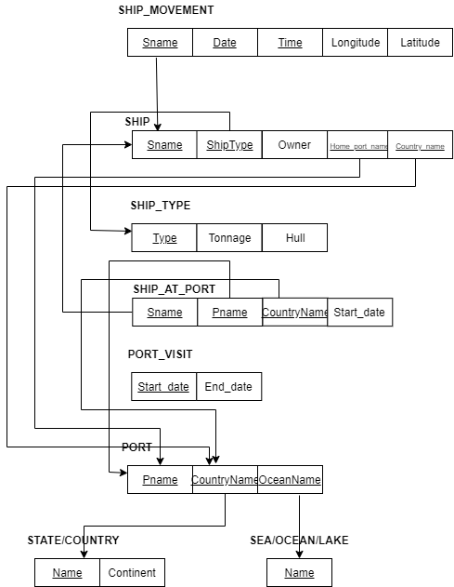

# Exercise 2:

## 8a Option:

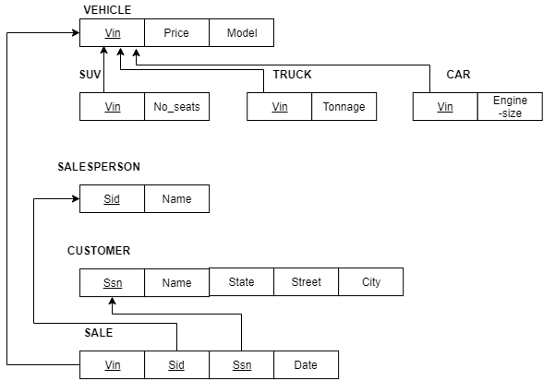

## 8b Option:

Note: its illegal to have three arrows from SALE Vin .

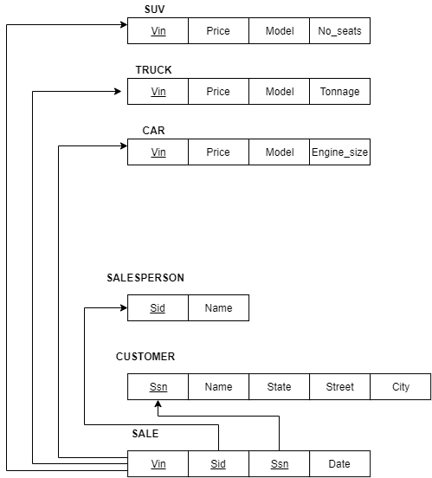

## 8c Option:

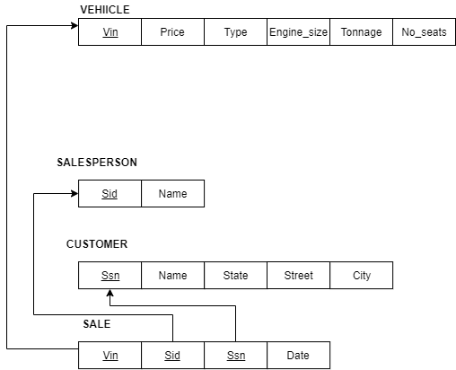

## 8d Option:

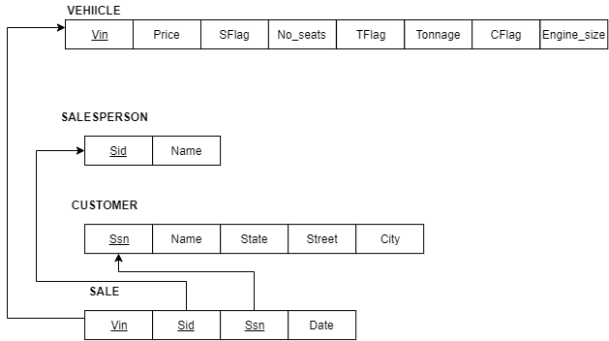

# Exercise 3:

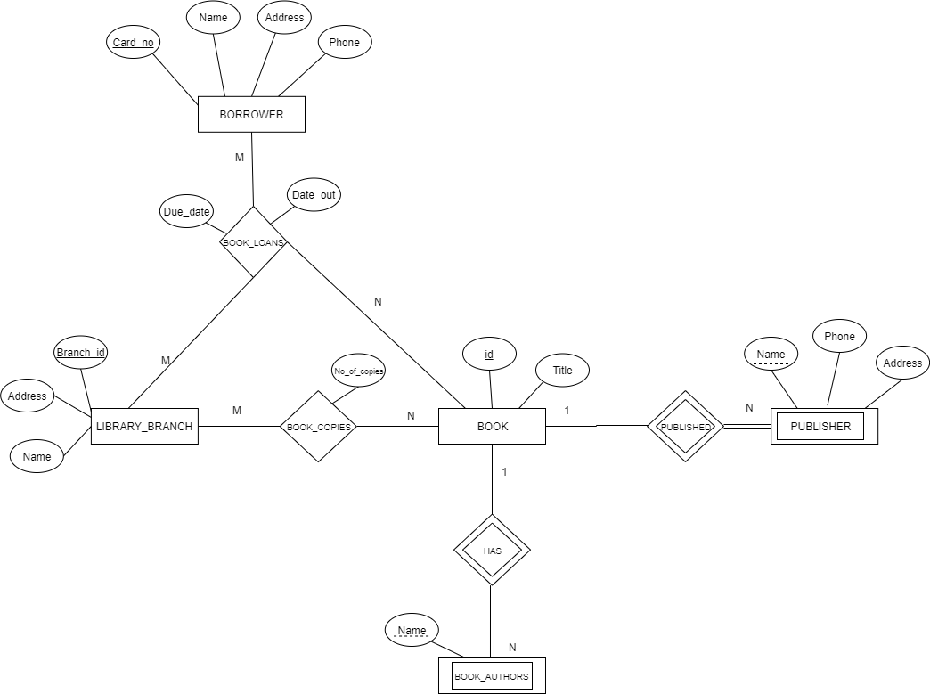

Assumptions:

* BOOK_AUTHORS is a weak entity and not a multi-value attribute of BOOK
* PUBLISHER and BOOK_AUTHORS are a weak entity since Name is not a unique identifier
* BOOK_LOANS is a 3-ary Relation since it has foreign keys to BOOK, LIBRARY_BRANCH, and BORROWER primary keys
* BOOK, LIBRARY_BRANCH, and BORRWER are strong entities since they have unique identifiers such as id, Branch_id, and Card_no.