ENSF 608-Fall 2020

Ziad Chemali

Assignment 4

December 7, 2020

# Question 1:

π FName,LName (σ CompetitorID!=0 (COMPETITOR))

# Question 2:

π FName,LName (σ Age<12 AND Instrument=’oboe’ (COMPETITOR))

# Question 3:

STUDIO_TEACHER ←TEACHER ⨝TEACHER.StudioName=STUDIO.Name STUDIO

STUDIO_COMPETITOR ← COMPETITOR ⨝COMPETITOR.TeacherID=STUDIO_TEACER.TeacherID STUDIO_TEACHER

π FName,LName (σ CompetitorID!=0(STUDIO_COMPETITOR))

# Question 4:

PERFORMANCE_COMP ←PERFORMANCE ⨝PERFORMANCE.CompetitorID=COMPETITOR.CompetitorID COMPETITOR

π FName,Score (PERFORMANCE_COMP)

# Question 5:

PERFORMED_TITLES ← π CategoryID,Title(PERFORMANCE ⨝PERFORMANCE.MusicID=COMPOSITION.MusicIDCOMPOSITION)

PERFORMED_TITLE_TIME←CATEGORY⨝CATEGORY.CategoryID=PERFORMED_TITITLES.CategoryID PERFORMED_TITLES )

SCHEDULED_1PM_COMPOSITIONS← πTitle(σCompTime=’13:00:00’(PERFORMED_TITLE_TIME))

# Question 6:

SELECTED_COMPOSITIONS ← π MusicID,Title(PERFORMANCE ⨝PERFORMANCE.MusicID=COMPOSITION.MusicIDCOMPOSITION)

ALL_COMPOSITIONS← π MusicID,Title(σMusicID!=null(COMPOSITION))

NOT_SELECTED_COMPOSITIONS← ALL_COMPOSITIONS- SELECTED_COMPOSITIONS

# Question 7:

π TeacherID(TEACHER⨝TEACHER.StudioName=STUDIO.Name(σName=’Music Mastery’( STUDIO)))

MUSIC_MASTERY_STUDIO← π TeacherID(σStudioName=’Music Mastery’( TEACHER⨝TEACHER.StudioName=STUDIO.NameSTUDIO))

COMPETITORS_IN_MUSIC_MASTERY← π CompetitorID (COMPETITOR ⨝COMPETITOR.TeacherID= MUSIC_MASTERY_STUDIO.TeacherID MUSIC_MASTERY_STUDIO)

COMPETITORS_SCORES_IN_MUSIC_MASTERY← π CompetitorID,Score(PERFORMANCE⨝PERFORMANCE.CompetitorID= COMPETITORS_IN_MUSIC_MASTERY.CompetitorIDCOMPETITORS_IN_MUSIC_MASTERY)

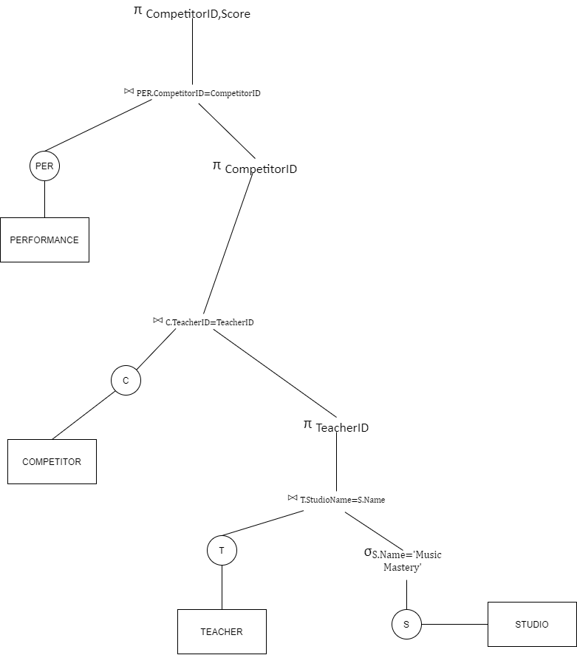

# Question 8: