Course: ENSF 619- Fall 2020

Lab: 2

Student Name: Ziad Chemali

Submission Date: October 2, 2020

# 1) Exercise: A

## a) Point-1

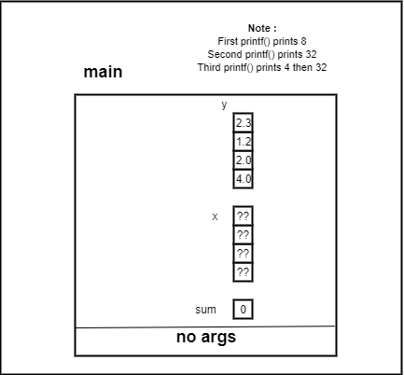

Size of 4 bytes

Size of 32 bytes

Size of 32 bytes

## b)Point-2:

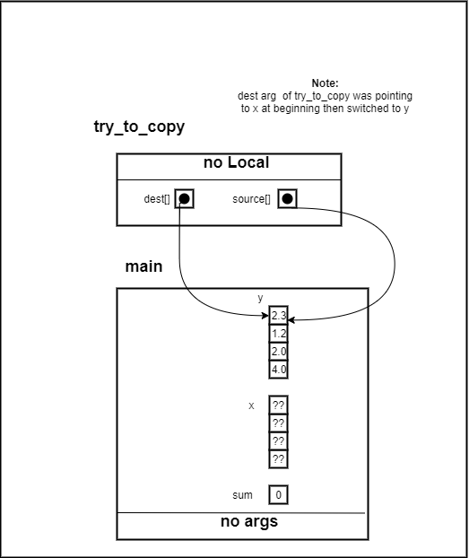

Size of 4 bytes

Size of 4 bytes

## c) Point-3:

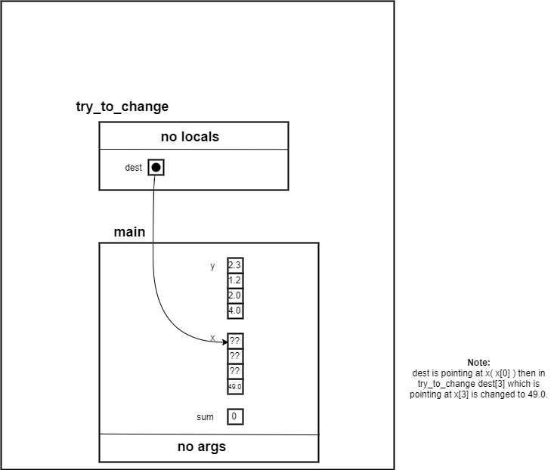

Size of 4 bytes

## d) Point-4:

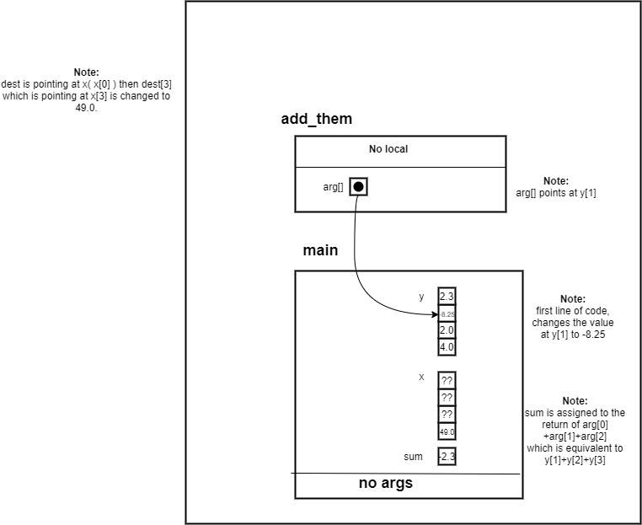

Size of 4 bytes

# 2) Exercise: B

## Code:

/*

* File Name: lab2exe_B.c

* Lab:2

* Completed by: Ziad Chemali

* Submission Date: 02,10,2020

*

* ENSF 619 Fall 2020 Lab 2 Exercise B

*

*/

int my_strlen(const char *s);

/* Duplicates strlen from <string.h>, except return type is int.

* REQUIRES

* s points to the beginning of a string.

* PROMISES

* Returns the number of chars in the string, not including the

* terminating null.

*/

void my_strncat(char *dest, const char *source, int);

/* Duplicates strncat from <string.h>, except return type is void.

*/

int my_strcmp(const char* str1, const char* str2);

#include <stdio.h>

#include <string.h>

#pragma warning(disable:4996)

int main(void)

{

char str1[7] = "banana";

const char str2[] = "-tacit";

const char* str3 = "-toe";

/* point 1 */

char str5[] = "ticket";

char my_string[100]="";

int bytes;

int length;

/* using my_strlen C libarary function */

length = (int) my_strlen(my_string);

printf("\nLine 1: my_string length is %d.", length);

/* using sizeof operator */

bytes = sizeof (my_string);

printf("\nLine 2: my_string size is %d bytes.", bytes);

/* using strcpy C libarary function */

strcpy(my_string, str1);

printf("\nLine 3: my_string contains: %s", my_string);

length = (int) my_strlen(my_string);

printf("\nLine 4: my_string length is %d.", length);

my_string[0] = '\0';

printf("\nLine 5: my_string contains:\"%s\"", my_string);

length = (int) my_strlen(my_string);

printf("\nLine 6: my_string length is %d.", length);

bytes = sizeof (my_string);

printf("\nLine 7: my_string size is still %d bytes.", bytes);

/* my_strncat append the first 3 characters of str5 to the end of my_string */

my_strncat(my_string, str5, 3);

printf("\nLine 8: my_string contains:\"%s\"", my_string);

length = (int) my_strlen(my_string);

printf("\nLine 9: my_string length is %d.", length);

my_strncat(my_string, str2, 4);

printf("\nLine 10: my_string contains:\"%s\"", my_string);

/* my_strncat append ONLY up ot '\0' character from str3 -- not 6 characters */

my_strncat(my_string, str3, 6);

printf("\nLine 11: my_string contains:\"%s\"", my_string);

length = (int) my_strlen(my_string);

printf("\nLine 12; my_string has %d characters.", length);

printf("\n\nUsing my_strcmp - C library function: ");

printf("\n\"ABCD\" is less than \"ABCDE\" ... my_strcmp returns: %d",

my_strcmp("ABCD", "ABCDE"));

printf("\n\"ABCD\" is less than \"ABND\" ... my_strcmp returns: %d",

my_strcmp("ABCD", "ABND"));

printf("\n\"ABCD\" is equal than \"ABCD\" ... my_strcmp returns: %d",

my_strcmp("ABCD", "ABCD"));

printf("\n\"ABCD\" is less than \"ABCd\" ... my_strcmp returns: %d",

my_strcmp("ABCD", "ABCd"));

printf("\n\"Orange\" is greater than \"Apple\" ... my_strcmp returns: %d\n",

my_strcmp("Orange", "Apple"));

return 0;

}

int my_strlen(const char* s) {

int i = 0;

while (*s!='\0'){

i++;

s += sizeof(char);

}

return i;

}

void my_strncat(char* dest, const char* source, int size) {

int k = 0;

while(dest [k]!='\0')

{

k++;

}

for (int i = 0;i < size;i++) {

dest[k+i] = source[i];

}

dest[k + size] = '\0';

}

int my_strcmp(const char* str1, const char* str2) {

int value_str1 = 0;

int value_str2 = 0;

int k = 0;

while (str1[k] != '\0')

{

value_str1 += (int)str1[k];

k++;

}

k = 0;

while (str2[k] != '\0')

{

value_str2 += (int)str2[k];

k++;

}

if (value_str1 > value_str2)

return 1;

else if (value_str1 < value_str2)

return -1;

else

return 0;

}

## Output:

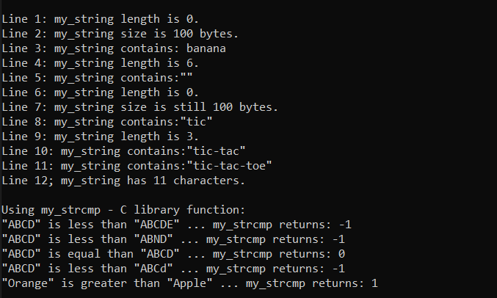

# 3) Exercise: C

# AR for **first call** of what function until //point one:

## AR for **Second call** of what function until //point one

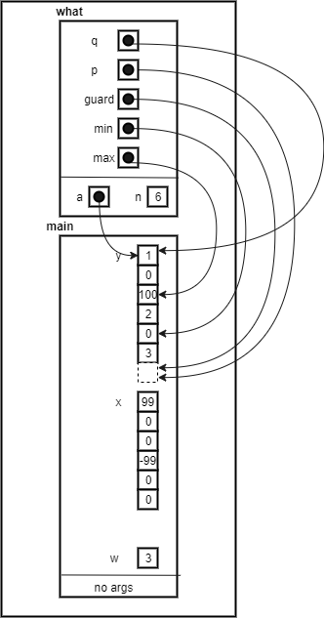

# 4) Exercise E:

## a) Code:

struct cplx

cplx_add(struct cplx z1, struct cplx z2)

{

struct cplx result;

result.real = z1.real + z2.real;

result.imag = z1.imag + z2.imag;

return result;

}

void

cplx_subtract(struct cplx z1, struct cplx z2, struct cplx* difference) {

struct cplx result;

difference->real= z1.real - z2.real;

difference->imag = z1.imag - z2.imag;

}

void

cplx_multiply(const struct cplx* pz1,const struct cplx* pz2,struct cplx* product)

{

product->real = (pz1->real * pz2->real) - (pz1->imag * pz2->imag);

product->imag = (pz1->real * pz2->imag) + (pz1->imag * pz2->real);

}

## b) Output:

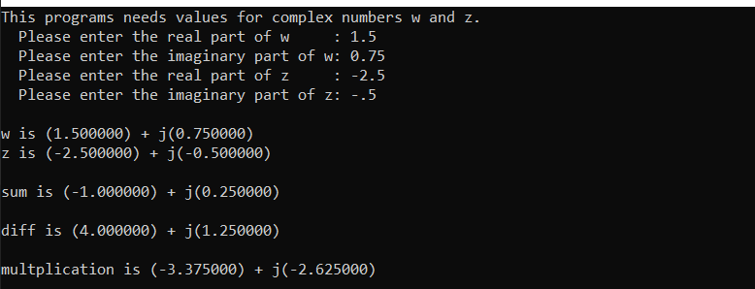

# 4) Exercise F:

## a) Code:

double distance(const struct point* p1, const struct point* p2)

{

return sqrt(pow(p1->x-p2->x,2)+ pow(p1->y - p2->y, 2)+ pow(p1->z - p2->z, 2));

}

## b) Output:

