ENSF 619-Fall 2020

Lab# 3

Ziad Chemali

October 9, 2020

# I] Exercise: A

## 1) Point-1

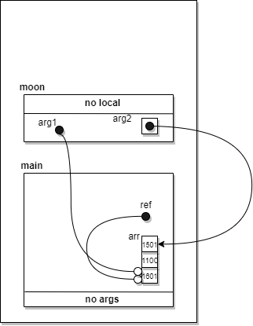

## Point-2

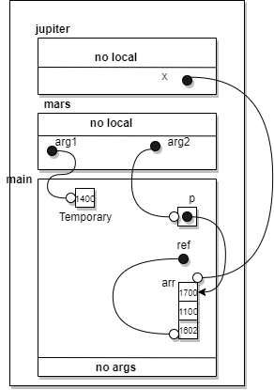

# II] Exercise: B

## Point-1

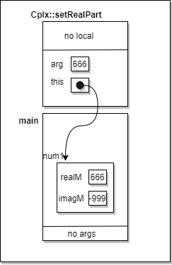

## Point-2

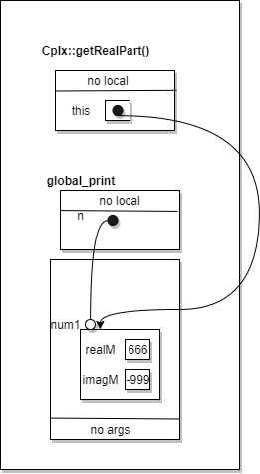

## Point-3

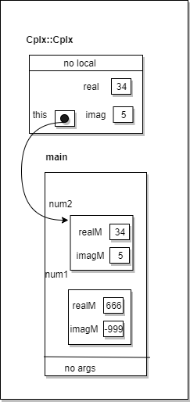

## Point-4

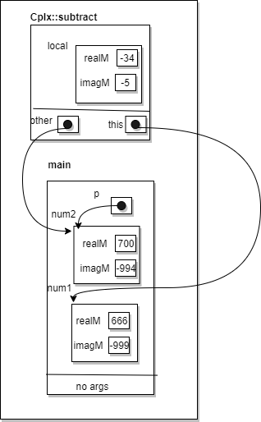

# III] Exercise: C

## Code:

### Header file:

/*

* File Name: lab3Clock.h

* Lab #3

* Completed by: Ziad Chemali

* Submission Date: October 9,2020

*/

#ifndef lab3_exe_C_Clock

#define lab3_exe_C_Clock

/* The following class definition is for Clock that represents 24 hour, and is able to

* create a clock, increment time by one second, or decrement time by one second.

*

*/

class Clock {

public:

Clock();

// PROMISES: initializes hours,minutes, and seconds to zero

Clock(int s);

// PROMISES: initialize the clock data members with values for hour,minute, and second in this

// argument

Clock(int h, int m, int s);

// PROMISES: initialize the data members hour, minute, and second with h,m, and s

int get_hour() const;

// PROMISES: returns hour

int get_minute() const;

// PROMISES: return minute

int get_second() const;

// PROMISES: return seconds

void set_hour(int h);

// PROMISES: updates hour data member with h

void set_minute(int m);

// PROMISES: updates the minute data member with m

void set_second(int s);

// PROMISES: updates the second data member with s

void increment();

// PROMISES: increments the value of clocks time by one second

void decrement();

// PROMISES: decrements the value of the clocks time by one second

void add_seconds(int s);

// PROMISES: adds the value of s to the value of current time

private:

int hms_to_sec();

// PROMISES: returns the total value of data members in a Clock

void sec_to_hms(int s);

// PROMISES: sets the data members of clock to the value of s

int hour;

int minute;

int second;

};

#endif

### Cpp file:

/*

* File Name: lab3Clock.cpp

* Lab #3

* Completed by: Ziad Chemali

* Submission Date: October 9,2020

*/

#include<iostream>

#include <iomanip>

# include "lab3Clock.h"

Clock::Clock() : hour(0), minute(0), second(0) {}

Clock::Clock(int s) {

if (s < 0) {

hour = 0;

minute = 0;

second = 0;

}

else {

sec_to_hms(s);

}

}

Clock::Clock(int h, int m, int s) {

if ((h >= 0 && h <= 23) && (m >= 0 && m <= 60) && (s >= 0 && s <= 60)) {

this->hour = h;

this->minute = m;

this->second = s;

}

else

{

hour = 0;

minute = 0;

second = 0;

}

}

int Clock::get_hour() const {

return this->hour;

}

int Clock::get_minute() const {

return this->minute;

}

int Clock::get_second() const {

return this->second;

}

void Clock::set_hour(int h) {

if (h >= 0 && h <= 23)

this->hour = h;

}

void Clock::set_minute(int m) {

if (m >= 0 && m <= 60)

this->minute = m;

}

void Clock::set_second(int s) {

if (s >= 0 && s <= 60)

this->second = s;

}

void Clock::increment() {

if (this->second < 59)

this->second++;

else if (this->second == 59)

{

this->second = 0;

if (this->minute < 59)

this->minute++;

else if (this->minute == 59)

{

this-> minute = 0;

if (this->hour < 23)

this->hour++;

else if (hour == 23)

{

hour = 0;

}

}

}

}

void Clock::decrement() {

if (this->second >0)

this->second--;

else if (this->second == 0)

{

this->second = 59;

if (this->minute >0)

this->minute--;

else if (this->minute == 0)

{

this->minute = 59;

if (this->hour >0)

this->hour--;

else if (hour == 0)

{

hour = 23;

}

}

}

}

void Clock::add_seconds(int s) {

if (s >= 0)

{

int local = hms_to_sec();

local += s;

sec_to_hms(local);

}

}

void Clock::sec_to_hms(int s) {

double local = double(s) / (24.0 * 60 * 60);

int day = local;

double h = local - day;

h *= 24;

this->hour = h;

double min = h - int(h);

min *= 60;

this->minute = min;

long double sec = min - int(min);

second = sec*60;

}

int Clock::hms_to_sec() {

std::cout << "hms to sec " << (this->second) << " \n";

return (second+60*minute+hour*3600);

}

## Output:

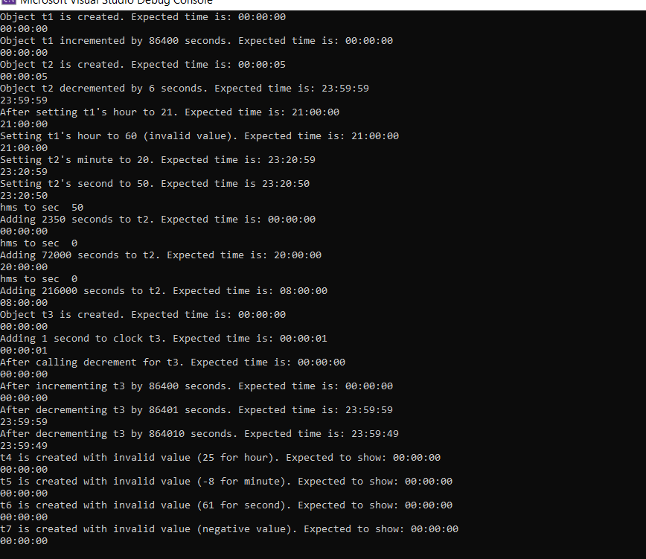

# IV] Exercise: D

## Part-One:

### Point One: First Time

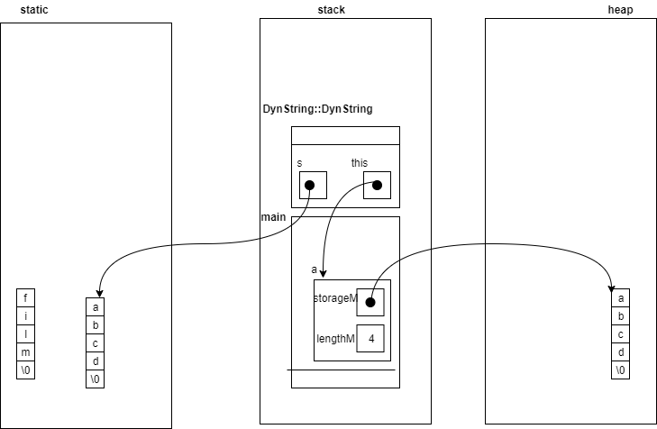

### Point One: Second Time

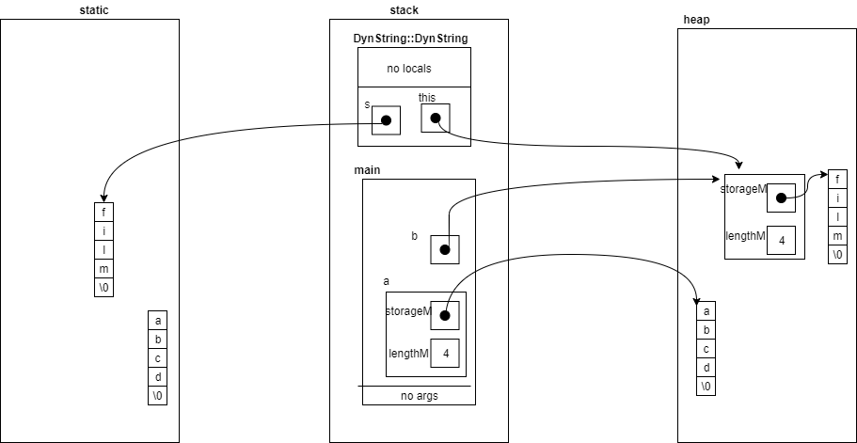

### Point Three:

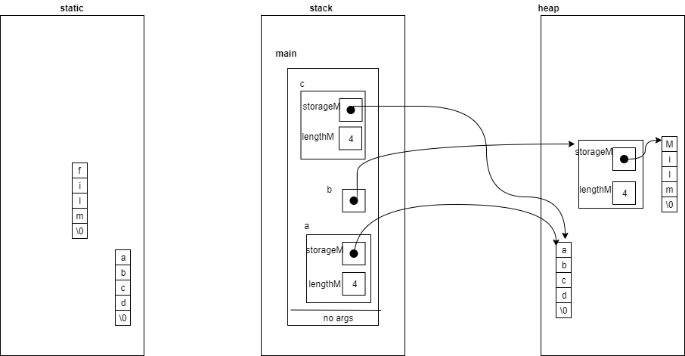

### Point Four:

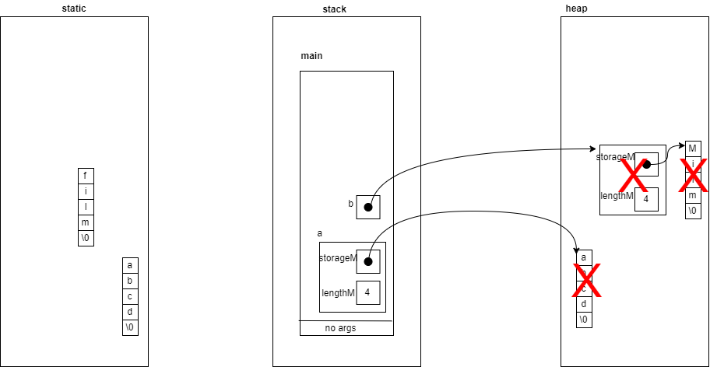

### Questions

1. At point 4 the constructor has been called two times
2. At point 4 the destructor has been called two times
3. Overall, the destructor has been called three times
4. Error is because the destructor at the end of main is trying to deallocate the char array “abcd” which already been deallocated when the inner bracket is finished.

## Part-Two:

### Code

void DynString::append(const DynString& tail) {

char* updated = new char [this->lengthM + tail.lengthM+1];

strcpy(updated, storageM);

strcat(updated, tail.storageM);

this->lengthM += tail.lengthM;

delete[] this->storageM;

storageM = updated;

}

### Output

