ENSF 619- Fall 2020

Group: 2

Team members: Evan Boerchers, Ziad Chemali, Myles Borthwick, Chetana Bijoor

**Actors:**

User: Ordinary user who is able to search for a movie, select a specific theater, view available showtimes, view graphically available seats, select the desired seat, make payment by credit card, receive a copy of the ticket and the receipt, via email

Registered User: Subclass of User. This class inherits from User and also includes login functionality, they don't have to pay a 15% admin fee for canceling their tickets and will receive the movie news before public announcement. They can purchase up to 10% of the seats prior to public announcements.

Database: This is the database that stores all movie information and user information.

Financial Institution: This is where payment information is sent and verified.

**Use Cases:**

Browse Movie: This use case is when the user is able to browse for a specific movie. The user can then choose a theatre, find a showtime.

Browse Theatre: This use case is when the user is able to browse a specific theatre. The user can then choose a movie, and find a showtim..

Create Account: This use case takes place when the User creates an account and enters his payment information. This information will be stored in the database, and the User will become a Registered User who has to pay a 20$ annual fee for new perks.

Select Seats: The user is prompted by a GUI to select their seats from the given showtime. Once seats are selected they can proceed to purchasing.

Payment: This is when the user has already selected seats. The user will fill out a payment form and submit this form to receive tickets.

Cancel Ticket: User can cancel existing ticket purchase. Registered users complete this action free of charge. New users pay a 15% admin fee.

Register: The user can select registration and then enter their info and complete the form in order to become a registered user.

Login: This use case happens when a registered user does an account login with their account information.

CancelMembership: A registered user can cancel their membership anytime after login.

View News: This use case allows registered users to view exclusive movie news. Users must be logged in to use this feature.

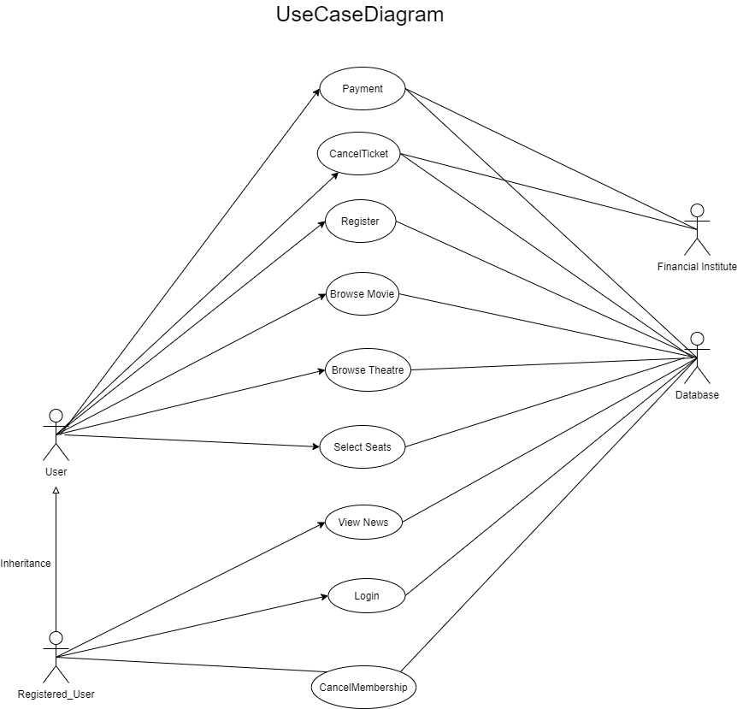

**Scenarios:**

Scenario 1 - Browse Movie:

This scenario begins when the user selects the “Browse Movie” option from the main menu. In this step, the user can browse a movie of his choice. The movie information is retrieved from the database. The user can select a theatre after completing this step and then select from showtimes available. The user can then choose to select seats

Scenario 2 - Browse Theatre:

This scenario begins when the user selects the “Browse Theatre” option from the main menu. In this step, the user can select a theatre and showtime of his choice. He can then move forward to select the seats.

Scenario 3 - Select Seats:

This scenario begins once the user has selected a showtime and is now ready to choose a seat they would like to occupy for their viewing. At this point, the system will display a top-down grid-layout view of all seats in the theatre with color-coding based on their availability and row/column numbers corresponding to their position in the theatre. Once the user has selected a seat they will then have to confirm their choice taking them to the payment use case. Right after seat confirmation, the system temporarily saves the user’s selection without updating the grid the seat to reserved until the payment use case is successfully completed.

Scenario 4 - Payment

This scenario begins after the user has successfully selected a movie, theatre, showtime, and seat. At this point, the system presents the user with a payment form window in which the user must fill out all required fields including credit card information, first/last name, and email to continue. This window will also show the amount the user must pay. For a registered user who has logged in, this window will have auto-populated these fields as read-only. Once fields are populated, the user then has the option to confirm the purchase. The payment is then verified and a notice that a receipt has been sent is given. The selected seats are set to reserved and a ticket object is generated with a seat number and generated ticket number.

Scenario 5 - Cancel ticket:

This scenario begins once the user selects the “Cancel Ticket” option from the main menu of the program. At this point, the user will be prompted to input the ticket number of their purchased ticket and confirm cancellation. The ticket number will be checked to see if it exists in the database and removed if true. The User will then be shown a confirmation message.The user will receive a voucher with 15% fee taken off but registered users do not pay this.

Scenario 6 - Register:

The users who are not registered have an option of registering by selecting “Register” from the main menu. When the user selects this option, the system asks for user information such as First name, Last name, Email, and Credit card number. The system stores the collected information in the database. After completing this step, the user is considered to be a registered user.

Scenario 7 - Login:

This scenario applies only in the case of a Registered user. The registered user can login to their profile by providing their username and password. The details provided are validated against the details stored in the database. If the details entered are correct, the system allows the user to login. Otherwise, it asks for the details to be re-entered.

Scenario 8 - View News:

This scenario applies only in the case of a Registered user. They have the option of viewing exclusive news about movies before public announcement. The news information is stored in the database and is retrieved when the user selects this option.

Scenario 9: Cancel Membership:

This scenario applies only in the case of a Registered user. They have the option of cancelling their membership. the user can login into his profile and choose this option. This information is updated in the database.

**Candidate Objects:**

Ticket:

Variables:

* Ticket Id
* User Name
* Number of tickets
* Seat selected
* Movie selected
* Theater Location
* Date and Time

Functions

* Payment Info
* Email_confirmation

User:

Variables

* Name
* CreditCard
* Status
* Purchased Tickets
* User Address

Functions:

* Cancel Ticket
* Browse Movie
* Create Account

RegisteredUser:

Variables:

* MemberId

Potential Operations:

* CancelTicket
* DeleteAccount
* View Movie News

Movie

Variables

* List of theatres
* MovieId
* MovieName

Operations

* Display Theatres
* Add Theatre
* Remove Theatre

Theatre

Variables

* TheatreId
* TheatreName
* List of Showtimes

Operations

* Display Showtimes
* Add showtime
* Remove Showtime

Showtime

Variables

* Capacity
* Movie Showing
* Time
* Date
* Ticket List

Operations

* View Seats

Payment:

Variables

* FName
* LName
* CardNumber
* Price
* Tickets

Operations

* Verify

News:

Variables

* Date
* NewsList

Functions

* Display

Seat:

Variables

* Status
* Row
* Column

Functions

* UpdateStatus