Experiment B
  - Aggregation Waiting Time and Timeout
CoAP over BPv7 with Three-Component IPN Addressing

Executive summary
Four controlled functional trials used fixed 100-byte Science POSTs from Rover to Earth through a continuously connected Satellite relay. In B1–B3, a second request arrived before the 10-second aggregation timeout, so one two-member BPv7 Aggregate was transmitted. The first member remained buffered for 2.953, 4.643 and 6.723 seconds, while the request-side serialized TCP data was 352 bytes rather than 392 bytes for two Singles: a consistent 40-byte (10.20%) saving. In B4, the first and second requests timed out independently and were sent as separate Singles; no byte saving was achieved despite approximately 10 seconds of recorded wait per message.
Interpretation: fixed-pair aggregation makes a measurable byte–delay trade-off. Waiting longer did not yield more byte saving in the observed successful Aggregates, while timeout fallback incurred delay without savings. The first B4 response event is timestamped 87.180 ms earlier than its submission event, so event instrumentation must be reviewed before publication-quality latency claims.

1. Research objective
Research question: How does the time between consecutive CoAP Science observations influence local buffering delay, aggregation outcome, and request-side serialization efficiency?
Working hypothesis: two observations arriving within MAX_AGGR_DELAY can be combined at the cost of delaying the first. If the second arrives too late, the timeout sends Singles and eliminates the aggregation saving.

2. Setup and measurement definition
Configuration | Value
Testbed | Rover → Satellite → Earth; continuously connected
Source / destination | ipn:0.1.11 → ipn:0.3.64
CoAP | NON POST /science/observations; JSON payload = 100 B each
Modes | Rover Aggregate mode; NSTART=2; MAX_AGGR_DELAY=10 s
Measured bytes | Wireshark Reassembled TCP Segments; request side only
Capture | Earth enp0s8, tcp port 4673; display bpv7
Software | µD3TN / AAP2, TCPCLv3, Draft-05 IPN / no proxy

Measure W_i = t(submitted event for message i) − t(queued event for message i) using a single Rover event clock. This is a recorded queue-to-submission interval and should only be equated with physical buffering time if the event instrumentation is validated. Earth packet timestamps are not subtracted from Rover timestamps.

3. Results overview
Trial | Observed gap | First wait | Second wait | Mode | TCP bytes | Saved
B1 | 2.952 s | 2.953 s | 0.000 s | Aggregate | 352 | 40
B2 | 4.643 s | 4.643 s | 0.000 s | Aggregate | 352 | 40
B3 | 6.723 s | 6.723 s | 0.000 s | Aggregate | 352 | 40
B4 | 15.621 s | 9.850 s | 10.009 s | Two Singles | 392 | 0

All four trials returned two token-matched 2.01 Created responses. B1–B3 used one 302-byte Aggregate request (352 bytes reassembled TCP data); B4 used two separate 147-byte BP payloads (196 bytes reassembled TCP data each).
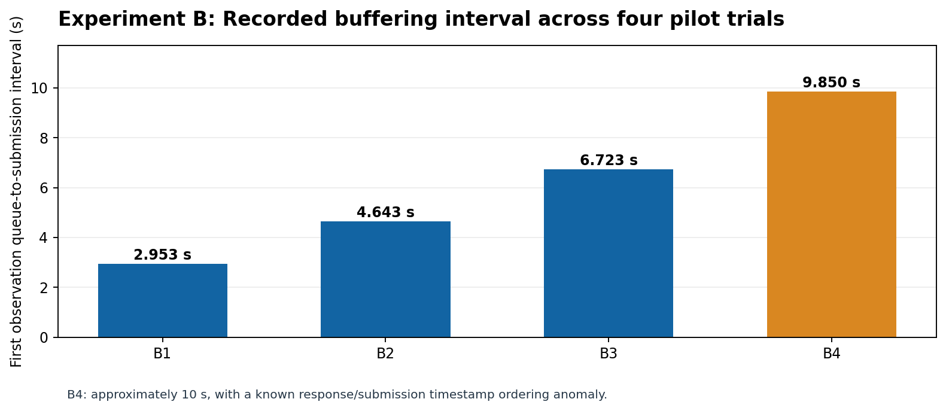
Figure 1. Queue-to-submission interval for the first observation. B4 is flagged as a timing-quality caveat.

4. Request-side byte efficiency
Measured baseline from Experiment A: two separate 100-byte observations used 196 + 196 = 392 B of reassembled request TCP data. For a successful Aggregate: BP payload 302 B + BPv7/TCPCL serialization 50 B = 352 B. Byte saving = 392 − 352 = 40 B; relative saving = (40 / 392) × 100 = 10.204%.
After timeout (B4), each request remained a Single: 196 + 196 = 392 B, so the saving relative to immediate Singles was 0 B. These TCP data figures are not a claim about total link-level bytes or congestion.
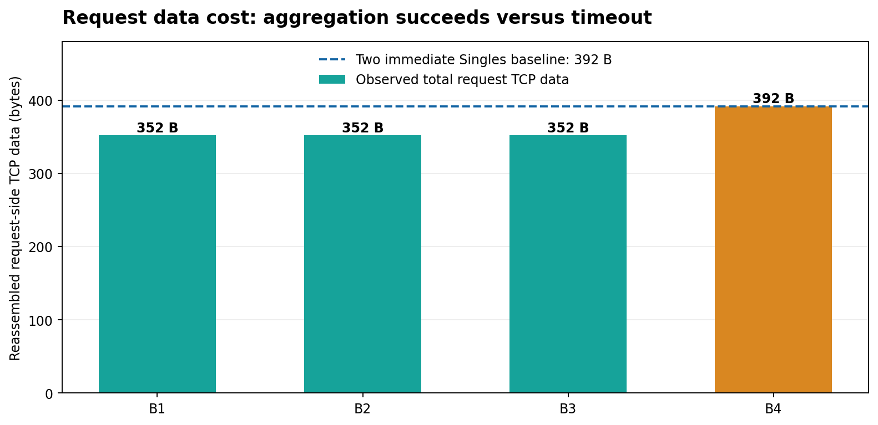
Figure 2. Request-side TCP data required for each pair of messages.
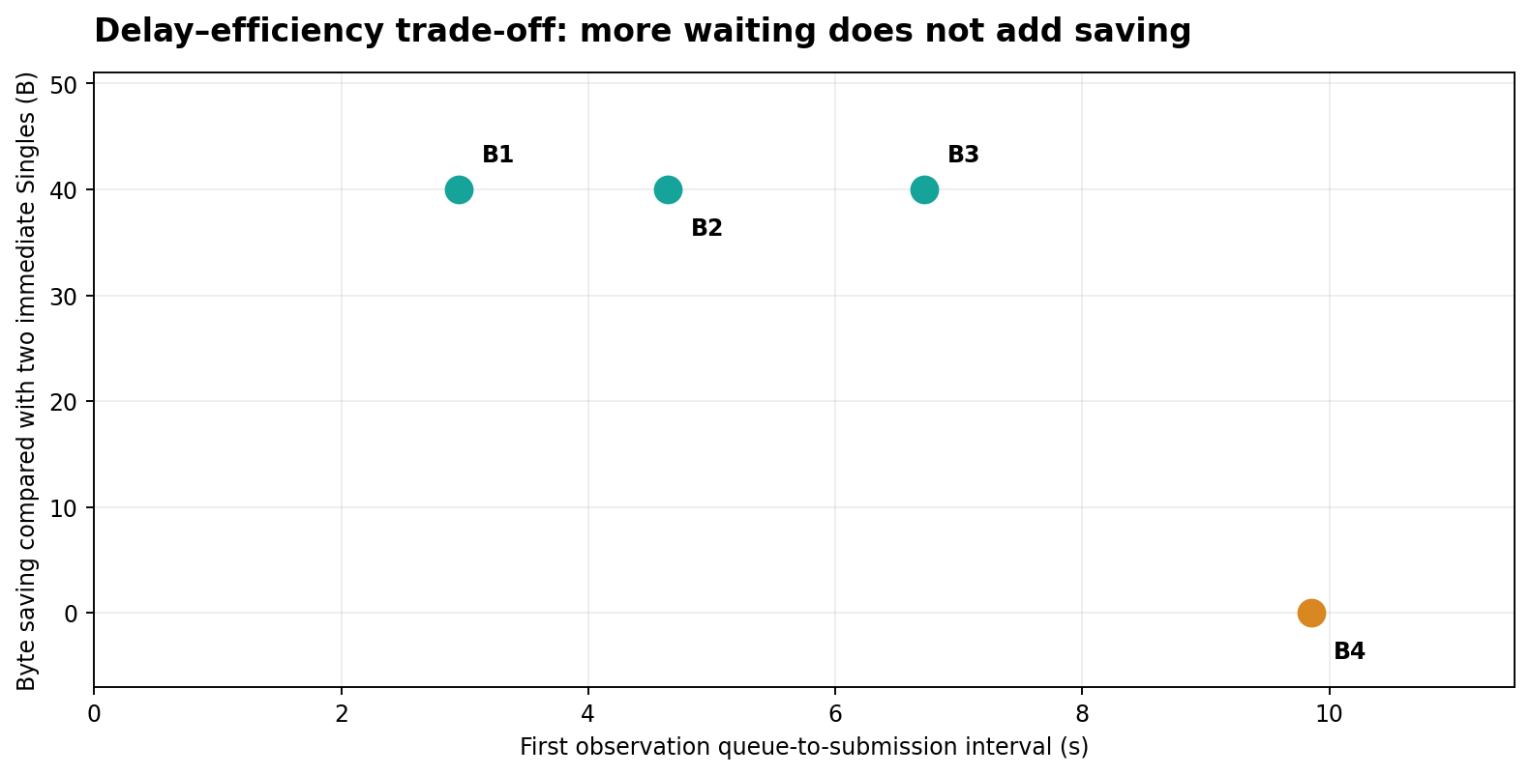
Figure 3. Longer buffering did not improve saving for fixed-size, two-member Aggregates; timeout removed the saving.

5. Exact timing calculations
For the successful B3 trial (timestamps are seconds since epoch, from Rover log):
First wait = 1794129512.7615855 − 1794129506.0386162 = 6.7229693 s.
Second wait = 1794129512.7615855 − 1794129512.7613018 = 0.0002837 s (0.284 ms).
For B4, where both requests were sent as Singles after timer expiry:
First recorded wait = 1794129793.6897304 − 1794129783.8392909 = 9.8504395 s.
Second recorded wait = 1794129809.4696455 − 1794129799.4603777 = 10.0092678 s.
The B4 first response log occurs at 1794129793.602550, before the first submitted event at 1794129793.6897304. Difference = −0.0871804 s (−87.180 ms). Because receipt-before-submission is causally inconsistent for this request, do not interpret the first B4 logged wait as exact physical buffering. Check the placement/order of instrumentation and logging.

6. Earth Wireshark corroboration
Test | Requests (frames) | Responses (frames) | BP payload | TCP data
B1 | 10 Aggregate | 13, 33 | 302 B | 352 B
B2 | 19 Aggregate | 36, 54 | 302 B | 352 B
B3 | 16 Aggregate | 34, 51 | 302 B | 352 B
B4 | 16 & 44 Singles | 27, 60 | 147 B each | 196 + 196 B

Use the Reassembled TCP Segments field, not the 67-byte packet-list Length column. The Earth captures corroborate one Aggregate in B1–B3 versus two Singles in B4. Screenshots are retained under evidence/; the original PCAPNG files were not supplied for this package.

7. Representative packet evidence
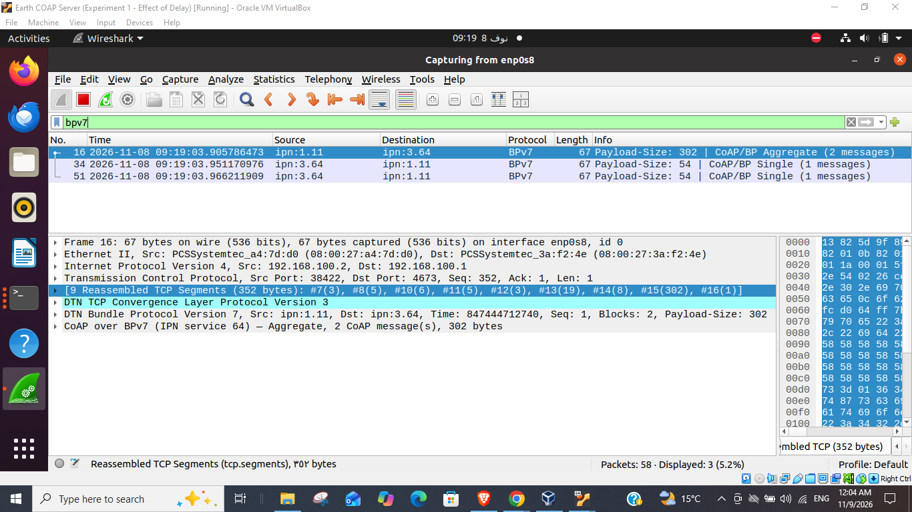
Evidence A. B3: BP payload 302 bytes and reassembled TCP data 352 bytes.
B4: Wireshark Single-request screenshots are archived as B4_earth_first_single.png and B4_earth_second_single.png in evidence/. They show 147-byte BP payloads and 196-byte reassembled TCP data each.

8. Discussion and limitations
- Evidence supports a local buffering-vs-serialization-efficiency trade-off for two fixed 100-byte CoAP requests. A larger gap between requests increased the first member’s waiting time, but did not increase the absolute byte saving in successful Aggregates.
- For B4, the waiting timer expired twice and the cost reverted to the two-Single baseline. The difference from immediate Singles is extra buffering delay, not a byte reduction.
- Manual request timing, one run per scenario and a known event-ordering anomaly mean this is a functional pilot rather than a statistical study. The GUI’s RTT values and the Rover epoch event differences should not be conflated.
- No safety conclusion about NSTART=2, network load, congestion or throughput follows from these low-rate successes. Draft-05 Section 6 calls for a separate congestion-control safety assessment.

9. Reproducibility and next work
- Preserve original Rover Results/raw/*_events.jsonl and Earth *.pcapng captures. This repository contains copied screenshots and verbatim user-pasted event-log excerpts, but not the original complete logs.
- Repair or clarify the order of the submitted and response event timestamps. Use a monotonic clock for durations within a process and instrument queue-entry, buffer flush, AAP2 submission, matching reply independently.
- Automate accurately scheduled inter-arrival gaps and repeat each condition (e.g., at least 10 times). Report median, p95, standard deviation, timeout probability, actual saved bytes, and queue-to-response completion time.
- Compare with immediate Single mode under the same traffic and separately assess NSTART/congestion safety before proposing adaptive aggregation policies.

References
- IETF CoRE. draft-ietf-core-coap-bp-05, CoAP over Bundle Protocol. https://datatracker.ietf.org/doc/draft-ietf-core-coap-bp-05/
- RFC 9171. Bundle Protocol Version 7. https://www.rfc-editor.org/rfc/rfc9171
- RFC 9758. IPN Naming Scheme. https://www.rfc-editor.org/rfc/rfc9758
- RFC 7252. The Constrained Application Protocol. https://www.rfc-editor.org/rfc/rfc7252
- Experiment B pilot: user-supplied Rover event excerpts, GUI output, and Earth Wireshark screenshots dated 2026-11-08.

