Alerta Joven Architecture Guide

This guide is intended to document the overall architecture of the Alerta Joven system.

**Revision History**

|  |  |  |  |
| --- | --- | --- | --- |
| **Number** | **When** | **Changes** | **Who** |
| 1.0 | 12/8/2014 | Initial creation of this doc merging in the metadata architecture guide into this doc  and adding in additional content. | Randy Eckhoff |
|  |  |  |  |
|  |  |  |  |

# Technology Stack

1. Drupal ([www.drupal.org](http://www.drupal.org/)). Used as the content management system driving the overall website, it uses a MySQL database server. Critical Drupal modules used:
   1. Coconut – to integrate coconut into Drupal
   2. Entity Construction Kit – to manage the metadata
   3. Forena Reports – for creating the reports
   4. Form Tagger – to customize various aspects of Drupal, especially in the admin area for defining the metadata.
   5. Hierarchical Select – select a hierarchy of items as 1 option
   6. PDF using mPDF – HTML to PDF conversion
   7. Views – Create customized queries from the database
2. Coconut ([www.ictedge.org/coconut](http://www.ictedge.org/coconut)). Used as the data collection system for collecting Alerta Joven Participant and Survey information.
   1. CouchDB ([couchdb.apache.org](http://couchdb.apache.org/)), a document based database, for the form generation and data storage.
   2. backbone.js ([backbonejs.org](http://backbonejs.org))
   3. CoffeeScript ([coffeescript.org](http://www.coffeescript.org))
   4. JSON ([www.json.org](http://www.json.org/))
3. Amazon Web Services ([aws.amazon.com/](http://aws.amazon.com/)) – for hosting the system in the cloud
4. Apache HTTP Server ([httpd.apache.org/](http://httpd.apache.org/)) – the HTTP server
5. Bitnami ([bitnami.com](https://bitnami.com/)) – The application store from which the drupal bundle was installed.
6. Linux – The operating system running the stack

# Useful Links

1. See above for technology stack
2. CoffeeScript Cookbook - [coffeescriptcookbook.com](http://coffeescriptcookbook.com/)
3. CouchDB Cookbook for SQL Jockeys - [guide.couchdb.org/draft/cookbook.html](http://guide.couchdb.org/draft/cookbook.html)

# System

You don’t see Coconut called out in the below diagram as its delivery vehicle is CouchDB.



All webpages start with the Drupal Content Management System. Participant data entry includes an iFrame for the coconut form that comes from CouchDB. All participant data is stored in CouchDB and an Extract, Transform, and Load (ETL) crontab moves the data from CouchDB into MySQL for reporting. This ETL crontab is setup via a Drupal module. All metadata about the website is administered via Drupal and is described later in this document.

For development purposes, there is a development version of this system to try out new ideas and concepts before implementing them on production.

# Utilities

<to be filled in by Vessie>

# Drupal Metadata

The Alerta Joven website allows for youth to participate in activities. These activities are organized in a hierarchical structure:

1. Providers (Organización) – the top most tier.
2. Programs – Providers provide programs of various types like health and education. A program is sponsored by only one provider.
3. Activities – Within a program there can be many activities of various types. Activities are tied to only one program.

In addition to the above data elements, other metadata elements to support the website are:

* Program Names – used to help organize Programs.
* Activity Types – used to help organize Activities.
* Users – Who has access to the administrative features for editing Alerta Joven metadata.

Since there are different data elements that need management, a number of user roles have been created. This allows for control over what users can edit what data. Users without the below roles can only use the site; they cannot make changes to the site.

1. **Drupal System Administrator** – Has full access to the entire Drupal system
2. **Evaluator** – Can manage all the metadata that the website requires.

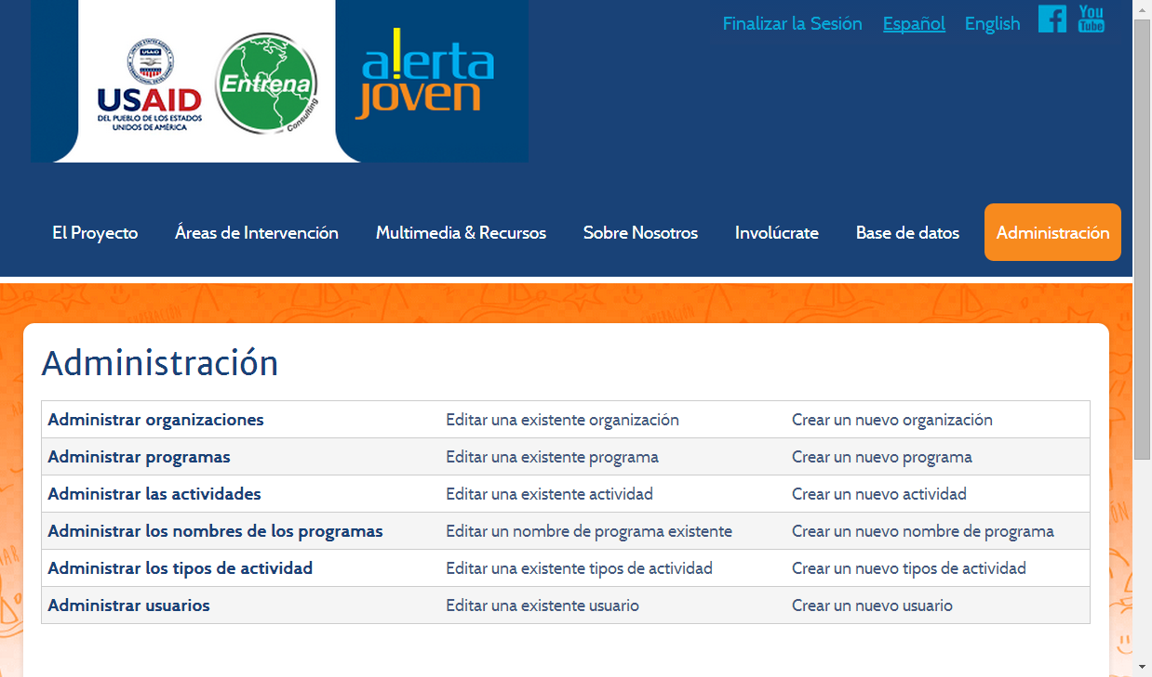

1. **Provider Administrator** – Can manage the metadata only for the provider they are assigned to for Programs, Activities and Users.

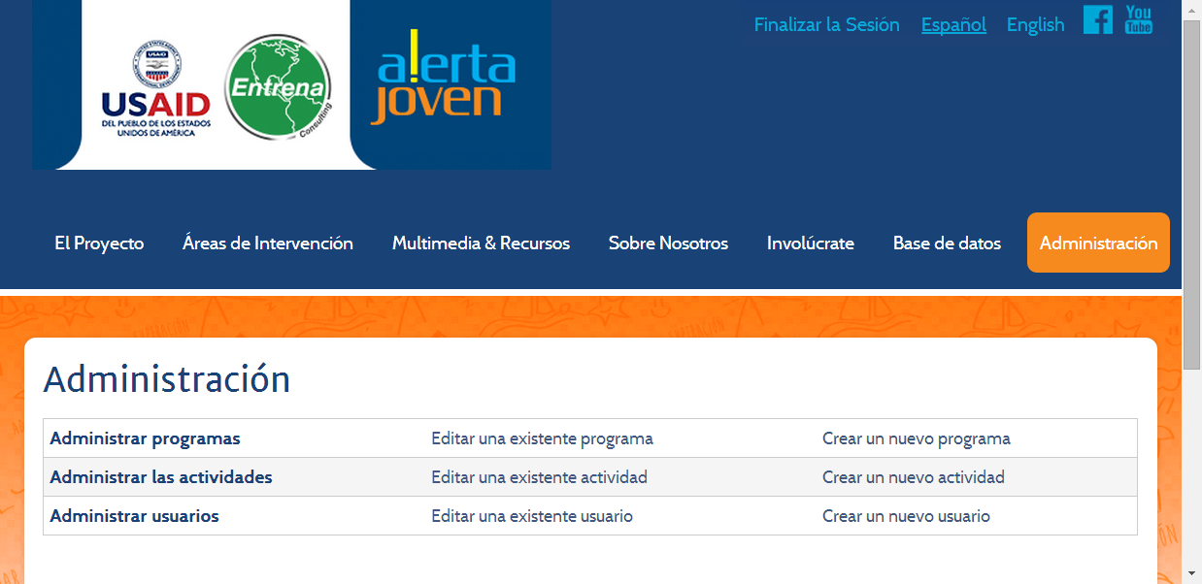

1. **Case Manager** – Can only manage activities for the provider they are assigned to, typically the attendance list.
2. **Data Entry** – This role was created to assist with the input of the existing paper registration forms. Can only manage activities for the provider they are assigned to, typically the attendance list.

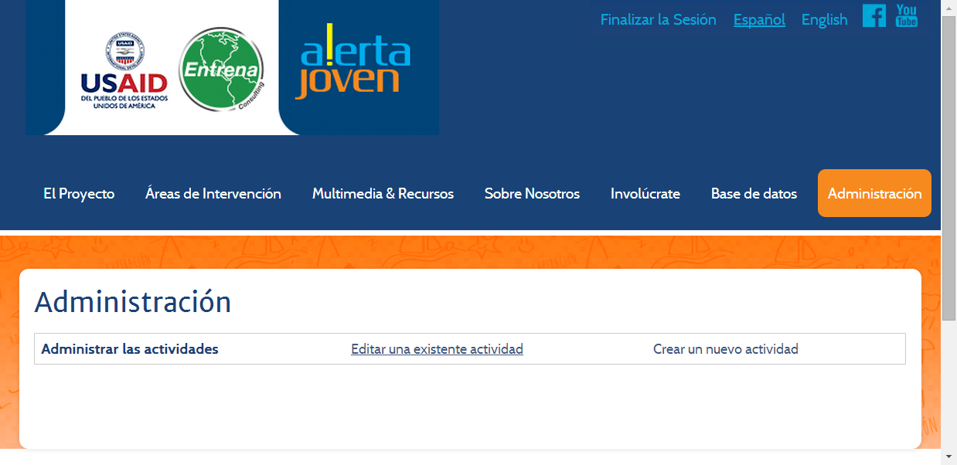

Most of the metadata fields should be self-explanatory (name, telephone, etc). One field that is not obvious is the **Active** field. Data should never be deleted for historical purposes. Instead, the active field exists so that a record can be marked as inactive if it is no longer needed.

## Managing Providers

The edit and create provider pages are identical with their content.

The **Area Served** field is interesting in that it lets you select a Provincia, Municipio, and a Barrio.

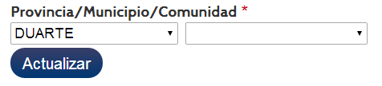

The first dropdown list is the Provincia. The 2nd dropdown list is for Municipio and its contents are dependent on the selection in the 1st dropdown list. Selecting an item in the “previous” dropdown list doesn’t force a refresh of the subsequent dropdown lists. After selecting the Provincia, click the Update button and the Municipio (2nd dropdown list) will be refreshed. Select your Municipio and click the Update button again. A 3rd dropdown list for Barrio is displayed. This control is rather odd in that sometimes, just selecting in the dropdown list is enough and sometimes it isn’t and you have to use the Update button.

## Managing Programs and Program Names

The edit and create program pages are identical. Program Names are utilized to provide organization to the programs. When you create a program, instead of giving it a freeform name, you select from a list of program names. You then tie that program to a specific provider.

The provider dropdown list displays all providers unless the person logged in is a Provider Administrator. Then, only their provider is displayed as they can only create programs for the provider they are tied to.

## Managing Activities and Activity Types

The edit and create activity pages are identical. Activity types are utilized to provide organization to the Activities. When you create an activity, you select the activity type from the list of predefined types instead of entering a freeform type.

The Program dropdown list displays all Programs if the logged in person is an Evaluator. Otherwise, only the programs associated to that logged in user is shown.

## Activity Attendance

To manage the list of participants who attended a particular activity, display all the activities and select “Listado de Participantes”.

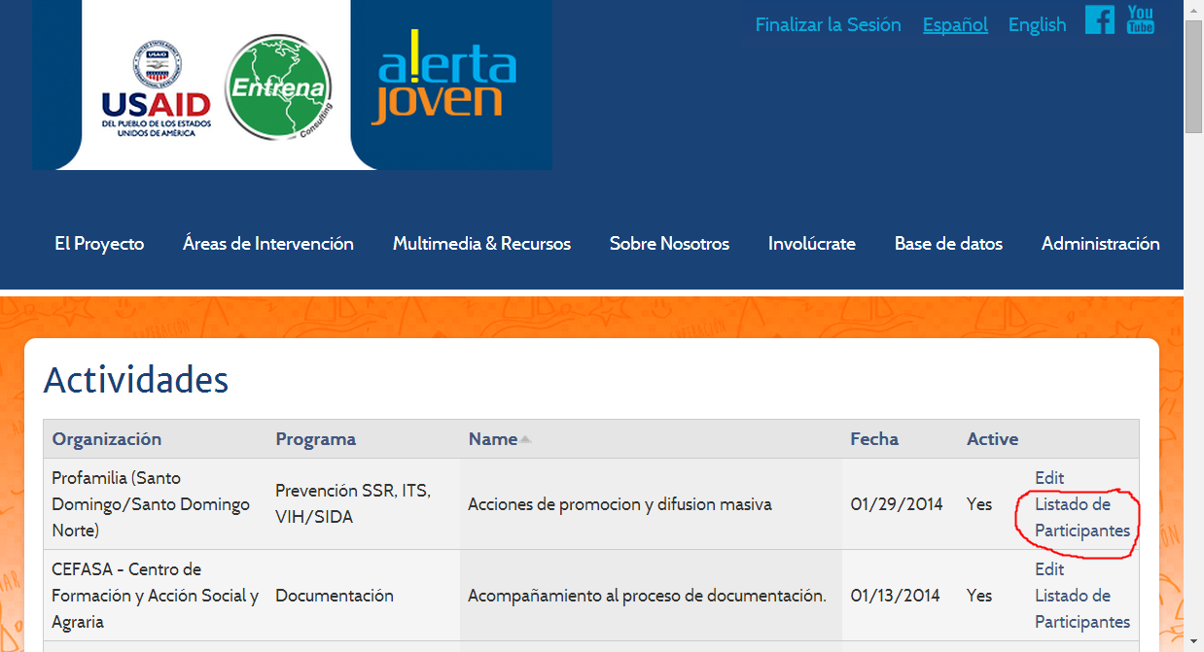

The resulting page displays all the participants tied to the Activity’s provider. Select the checkbox next to each participant who attended the activity and save.

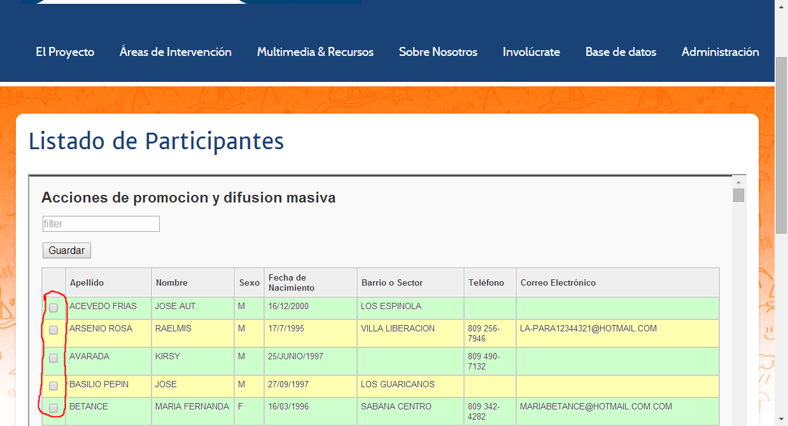

## Managing Users

This is not managing the youth participants but rather managing the users who can log in to the Alerta Joven System. Creating a user here is creating a user in the Drupal System. As described above in the overview section, you can assign a role to a user giving them permissions to do different things on the website.

Each user must be assigned to a provider.