Configure Forena Reports with PDF

1. Download mpdf library from here (<http://www.mpdf1.com/mpdf/index.php?page=Download>)

Copy the library to DRUPAL_DIR\htdocs\sites\all\libraries\mpdf.

1. Download and install libraries module from here (https://www.drupal.org/node/1041618).
2. Download from here (<https://www.drupal.org/project/PDF_using_mPDF> )and install PDF_using_mPDF Drupal module. Read and follow the instructions inside README.txt.
3. Go to Configuration->Forena Reports and check MPDF options (vs the commercial PINCE XML).

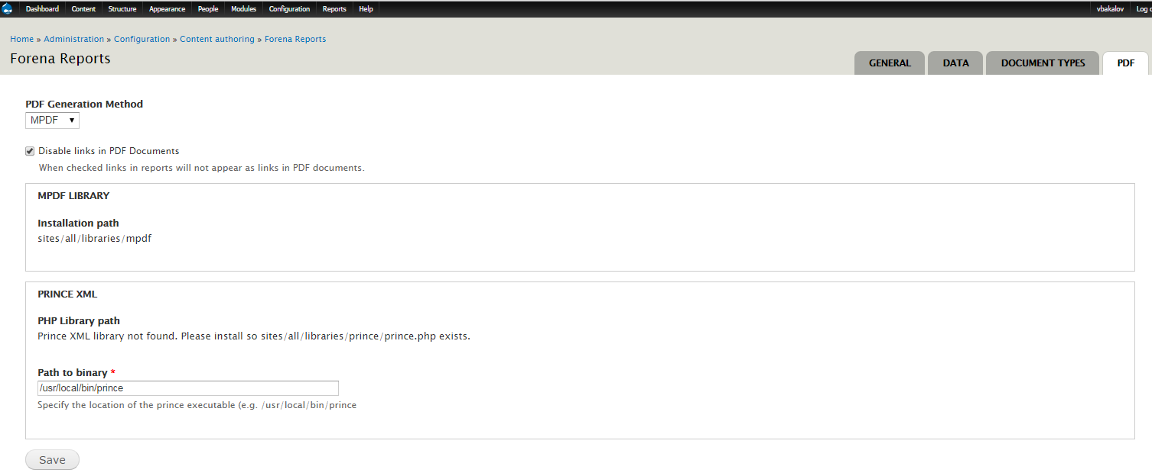

1. Clear Forean cache from Structure->Forena Reports.

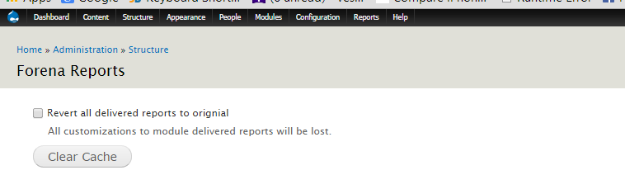

1. To show PDF option in the reports select the report ->EDIT->Format tab and check the PDF option.

