Data Analysis

# Why this course now?

“The word of the year in the world of water is digital.”

1. Increased recognition that access to water data and analytics is essential to better inform public policies and business decisions.
2. Technological advancements in satellites, drones, sensors and so on create more data that can be transformed into actionable information for water management.
3. Cultural, academic, and legislative shift towards open water data and transparency.

Sources: [Imagine an Internet of Water](https://www.aspeninstitute.org/aspen-journal-of-ideas/imagine-internet-water/),

[3 Ways the course of water sustainability changed in 2017](https://www.greenbiz.com/article/3-ways-course-water-sustainability-changed-2017)

# Current pulse on water data

“Currently, we are unable to answer fundamental questions about our water system in a timely way:

* How much water is there?
* What is its quality?
* How is it used (withdrawn, consumed, or returned for different purposes)?

The data needed to answer these questions often exist, although collected by multiple agencies across different scales of government and non-government organizations for different purposes.” – Internet of Water report

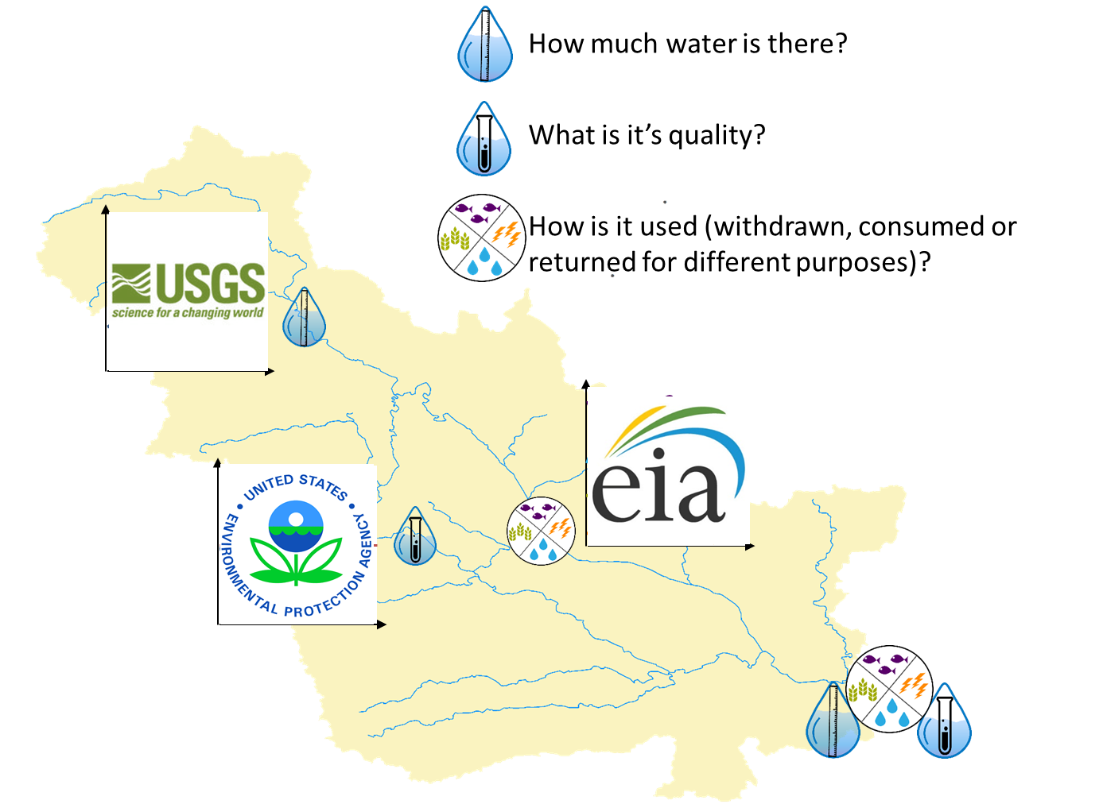

**Figure:** Different sources of data needed to be compiled together for a water budget.

# Why working with water data is challenging

1. Water is complex, fragmented, and local

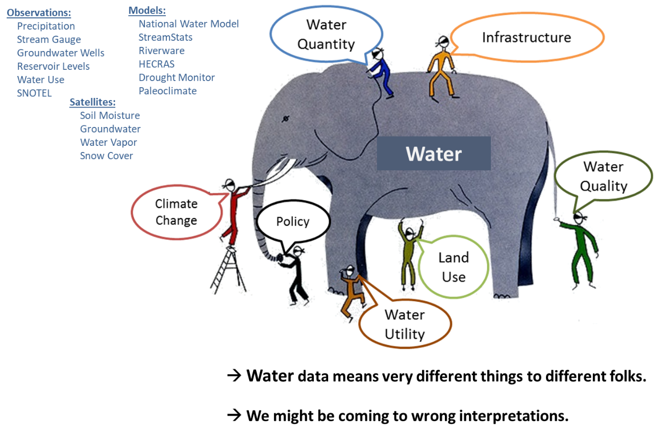

**Figure:** Blind persons and the elephant. Water data means something different to each of us and we often only look at small pieces of the puzzle. Either because that is the only data we can find or it is the data we know (as indicated by the diversity of data sources and types available for water quantity observations alone).

1. Primary versus secondary data users
   1. Primary data users 🡪 they are collecting the data for a specific purpose (often regulatory).
   2. Secondary data users 🡪 that’s us. We are trying to find data that can be repurposed and reused to address a question.
2. Data are not actionable information
   1. Analyses are needed to transform data into actionable information for decision-making

# Moving from question to solution, from data to information.

