Rmarkdown

Ben Best

2016-01-07

## Inspiration

Gandrud (2013) [Reproducible Research with R and Rstudio](http://christophergandrud.github.io/RepResR-RStudio/)

## What is Rmarkdown?

Rmarkdown = R + markdown

* ***input*** simple text:
  + **markdown**: simple formatting of text (bold, links, headers, images, ...)
  + **R**: execute chunks of code (figures, tables...)
* ***output*** various formats:
  + **html**: share on public website
  + **pdf**: polished publication
  + **docx**: share with co-authors to track changes

## First Example of Rmarkdown

In RStudio, menu File > New File > Rmarkdown... Document, HTML. Knit HMTL button to render the right.

## Markdown

"easy" HTML

Github renders (with [flavor](https://help.github.com/articles/github-flavored-markdown)), eg README.md

## R in Rmarkdown

* **chunks**: text, tables, figures

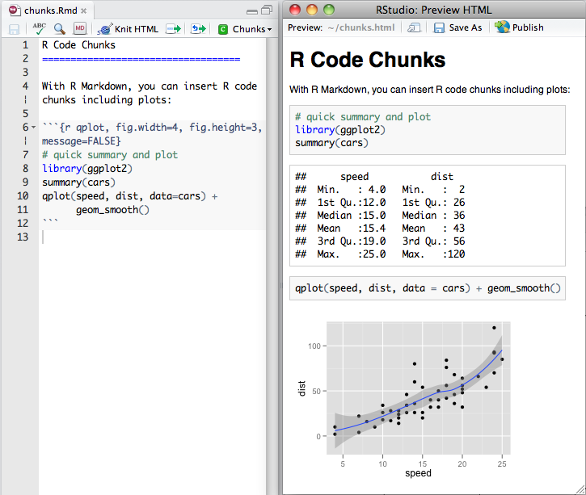

* **inline**: pi=`r pi` evaluates to "pi=3.1415927"

## Equations in Rmarkdown - Chunk

Uses [Latex](https://en.wikibooks.org/wiki/LaTeX) markup language for equations as input. Outputs using [MathJax](https://www.mathjax.org/) JavaScript library for HTML output, native Tex for PDF.

$$  
\frac{1}{n} \sum_{i=i}^{n} x_{i}  
$$

$$\frac{1}{n}\sum_{i=i}^{n}{x_{i}}$$

## Equations in Rmarkdown - Inline

The Arithmetic mean is equal to $\frac{1}{n} \sum_{i=i}^{n} x_{i}$, or the summation of n numbers divided by n.

The Arithmetic mean is equal to $\frac{1}{n}\sum_{i=i}^{n}{x_{i}}$, or the summation of n numbers divided by n.

## Github Friendly

* Rmarkdown (*.Rmd) renders as markdown (*.md)
* easy to see change in simple text files (vs binary / proprietary formats)

## Demo

in Rstudio...

menu File > New File > Rmarkdown... Document, HTML. Knit HMTL button.

* [first.**Rmd**](https://github.com/ucsb-bren/env-info/blob/gh-pages/wk01_github/first.Rmd)
* [first.**html**](https://ucsb-bren.github.io/env-info/wk01_github/first.html)

## Help

* Rstudio menu Help > Markdown Quick Reference

## Further Resources

* [rmarkdown.rstudio.com](http://rmarkdown.rstudio.com/)

## hadley_4ds: Recommendations for learning more about communication:

For writing: [Style: Lessons in Clarity and Grace](http://amzn.com/0321898680), <http://www.americanscientist.org/issues/id.877,y.0,no.,content.true,page.1,css.print/issue.aspx>

For presentations: [slide:ology](http://amzn.com/0596522347), <http://www.howtogiveatalk.com>, <https://github.com/jtleek/talkguide> (academic), <http://speaking.io>, <https://www.coursera.org/learn/public-speaking>

For expository visulisations: WSJ guide?

Design: [The Non-Designer's Design Book](http://amzn.com/0133966151)