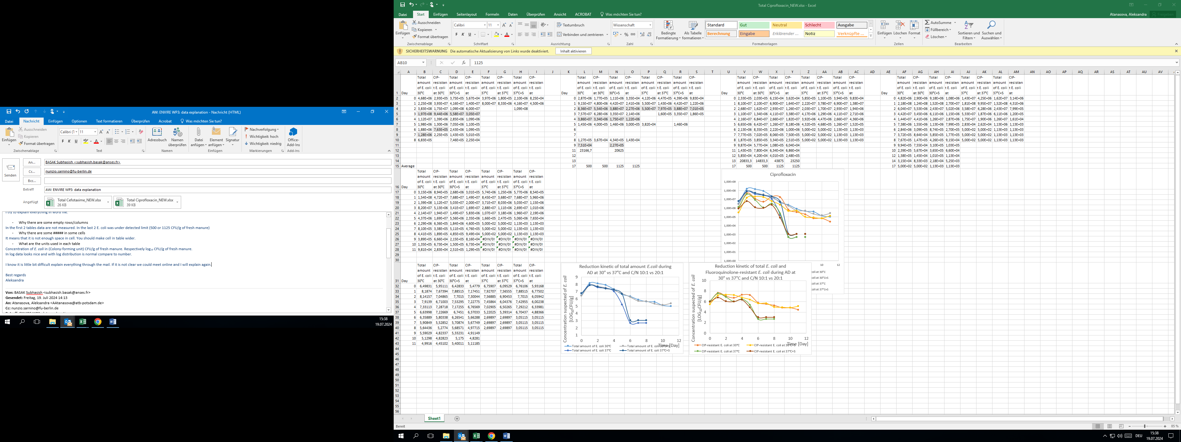

Average in LOG

Average

4.trail in March

3.trail in February

2.trail in December

1.trail in November

|  |  |  |  |  |
| --- | --- | --- | --- | --- |
| Name | 1 setup | 2 setup | 3 setup | 4 setup |
| Temperature | 30 °C | 30 °C | 37 °C | 37 °C |
| Adding Sawdust (in the excel written straw) | - | + | - | + |

I detected total amount of *E. coli* (resistant + non-resistant) and *E. coli* (resistant) for every setup.

I did anaerobic digestion. It is processes for around 1 month. I stopped the experiment when *E. coli* was not detected.