The main interventions are:

1. Flock thinning - Mechanical (% check online) or Manual (% check online) – Worker 1

2. Flock clearing – Catching & loading in cages (Worker 1)

Worker 1 : 10,000 chicken 6-8  
30-40 animals per crate ~ 333 Cretes

*Inside farm – equipements and practices*

**Arrival at slaughterhouse**3.1 Chickens are unloaded: Worker 2 (walk around the cages to check their health)

3.2 Kept in the stable:

2 Worker 2 will check 333 crates.

Truck driver cleans the container/Truck – high speed water – no mask

Cutting place (more people) than stable

3. Slaughterhouse practices -

No published papers were found on the microbial risk on E. coli and thinning in European settings. All papers found are focused on Campylobacter spp.

# Scalding – hanging

# Portioning – cutting (manual or mechanical) 20-30 Worker 3 process 50k-150k chickens per day – divide by upto 15 the exposure.

# Price et al. (2007) - At the end of the grow-out period, chickens are captured by people called “catchers,” placed into cages, and transported to the slaughtering facilities. Once delivered to the slaughterhouse, the broilers are removed from the cages and shackled to semi-automated slaughter lines by people called “live hangers.” Thus, growing, catching, and hanging are the three tasks with the most intensive live-animal exposures. For example, a catcher will capture and cage thousands of chickens in a single workday ([Goodman 2006](https://www.ncbi.nlm.nih.gov/pmc/articles/PMC2137113/#b11-ehp0115-001738)).

# Racicot et al., (2013) - Assessing most practical and effective protocols to sanitize hands of poultry catching crew members. When hands were highly contaminated, the alcohol-based gel alone was less effective than the degreasing cream combined with the alcohol-based gel.

Youssef et al. (2020) - The effectiveness of biosecurity interventions in reducing the transmission of bacteria from livestock to humans at the farm level: A systematic literature review Two main types of biosecurity interventions in poultry farms:

(a) hand washing, sanitization and hygienic measures;

(b) personal protective equipment (PPE);

Ridley et al. (2011) - Enhanced biosecurity measures in poultry farms (Campylobacter):

(a) Cleaning and disinfection

(b) Provision of a mobile mess ⁄ changing room for the catching crew

(c) A requirement for catchers to bring with them fresh clothing, dedicated footwear and any ancillary equipment, including face masks and gloves

Mo et al. (2016) – Norwagien poultry farm questionnaire on hygiene practices

# Wadepohl et al. (2020) Association of intestinal colonization of ESBL-producing *Enterobacteriaceae* in poultry slaughterhouse workers with occupational exposure—A German pilot study This study is the first of its kind to collect data on the occupational exposure of slaughter house workers to ESBL-producing Enterobacteriaceae in Europe.

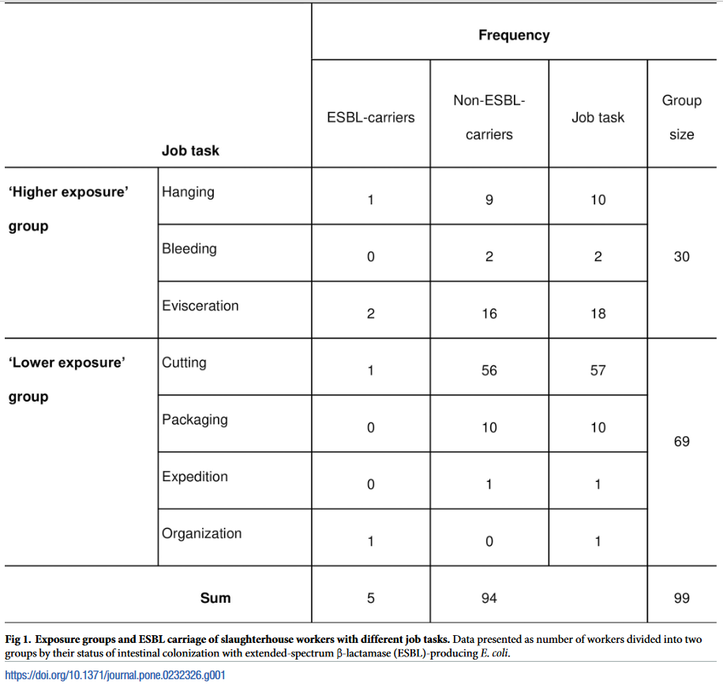

Dohmen et al. (2017) Air exposure as a possible route for ESBL in pig farmers Possibility of Air transmission but no quantitative exposure measurement

Franceschini et al.(2019) Assessment of the Exposure of Turkey Farmers to Antimicrobial Resistance Associated with Working Practices semi-quantitative analysis for ranking of fam practices

Fastl et al. (2023) Animal sources of antimicrobial-resistant bacterial infections in humans: a systematic review. Review paper.

Opatowski et al. (2021) A One-Health Quantitative Model to Assess the Risk of Antibiotic Resistance Acquisition in Asian Populations: Impact of Exposure Through Food, Water, Livestock and Humans   
Per contact acquisition risk based on Probability of human ARB acquisition during a contact with a colonized animal (figure below) but no rates/parameter values.  
  
 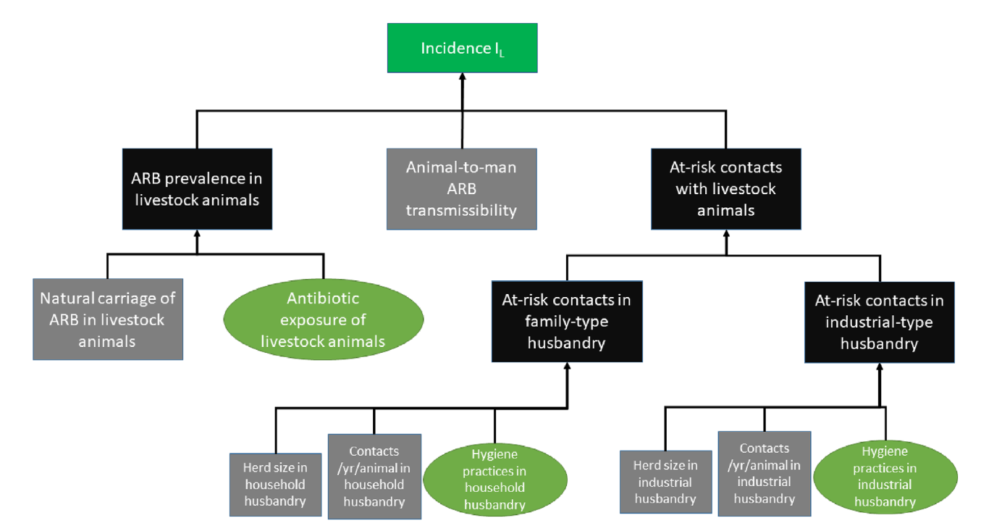

# De Freitas Costa (2022) Multidirectional dynamic model for the spread of extended-spectrum-β-lactamase-producing Escherichia coli in the Netherlands Risk of AMR colonization of Farmers from chickens using the probability of colonization from the below paper.

# Huijbers et al. (2014) Extended-spectrum and AmpC b-lactamase-producing Escherichia coli in broilers and people living and/or working on broiler farms: prevalence, risk factors and molecular characteristics Questionnaire sampling of farms to estimate the prevalence of different group of farmers/employees and study the relation of their respective exposure time/contact time to broilers.

# Hsuan-Lu et al. (2024) One Health-based management for sustainably mitigating tetracycline-resistant Aeromonas hydrophila-induced health risk. QMRA with amount of water ingested for each step multiplied by Exposure Frequency (EF).

# Adhikari et al. (2020) Quantitation of Risk Reduction of E. coli Transmission after Using Antimicrobial Hand Soap.

# 

Chen et al. (2001) Quantification and Variability Analysis of Bacterial Cross-Contamination Rates in Common Food Service Tasks Transfer rate from chicken to finger tips: the normal distributions in log percent transfer rate from chicken to hand (0.94 +- 0.68). These turns out to be lognormal parameters.

# Lopez et al. (2013) Transfer Efficiency of Bacteria and Viruses from Porous and Nonporous Fomites to Fingers under Different Relative Humidity Conditions Transfer rate form cutting board/knife to finger tips

Gibson et al. (2002) Quantitative assessment of risk reduction from hand washing with antibacterial soaps Transfer rate from finger tips to lips

Depoorter et al. (2012) Assessment of human exposure to 3rd generation cephalosporin resistant E. coli (CREC) through consumption of broiler meat in Belgium QMRA farm to fork, with meat to hand transfer rate from the following paper, assuming *Salmonella* and *E. coli* has same attaching properties

Montville et al. (2000) Glove barriers to bacterial cross-contamination between hands to food chicken to hand transfer rate (%) through gloves, gamma (5.91, 0.40, -5) and chicken to bare hand, normal (0.71, 0.42); for *Salmonella* substitute

Leonas et al. (2003) The Relationship of Fabric Properties and Bacterial Filtration Efficiency for Selected Surgical Face Masks Average over the 6 different Bacterial Filtration Efficiency (BFT) was used as the q_mask parameter in the model

# King et al. (2020) Bacterial transfer to fingertips during sequential surface contacts with and without gloves Although previous studies have investigated the transfer efficiency of various microorganisms during a single contact from fomite to finger[18](https://onlinelibrary.wiley.com/doi/full/10.1111/ina.12682#ina12682-bib-0018), [19](https://onlinelibrary.wiley.com/doi/full/10.1111/ina.12682#ina12682-bib-0019), [23](https://onlinelibrary.wiley.com/doi/full/10.1111/ina.12682#ina12682-bib-0023) and finger to fomite,[23](https://onlinelibrary.wiley.com/doi/full/10.1111/ina.12682#ina12682-bib-0023)-[25](https://onlinelibrary.wiley.com/doi/full/10.1111/ina.12682#ina12682-bib-0025) only a small number of studies have considered more than one surface contact.[21](https://onlinelibrary.wiley.com/doi/full/10.1111/ina.12682#ina12682-bib-0021), [26](https://onlinelibrary.wiley.com/doi/full/10.1111/ina.12682#ina12682-bib-0026) Repeated contact with a surface covered in fluorescent powder shows that skin became saturated after six contacts,[27](https://onlinelibrary.wiley.com/doi/full/10.1111/ina.12682#ina12682-bib-0027) while a separate study using fluorescent particles found an equilibrium after five contacts.

Julian et al. (2009) A Model of Exposure to Rotavirus from Nondietary Ingestion Iterated by Simulated Intermittent Contacts stochastic-mechanistic model of exposure to rotavirus from nondietary ingestion iterated by simulated intermittent fomes-mouth, hand-mouth, and hand-fomes contacts typical of a child

### [An Examination of Broiler Growth](https://getd.libs.uga.edu/pdfs/morris_jonathan_a_201505_ms.pdf) gives the constant for the Meeh’s formula used to compute the broilers surface area from its weight.