**Fill Pocket: A Reward-Driven Clinical Trial Ecosystem**

**Introduction:**

**Fill Pocket** is a revolutionary platform that aims to transform the field of Biotechnology by improving and expediting the clinical trial procedure. In addition to promoting user engagement through a reward-based system, it provides pharmaceutical businesses and organizations with an additional layer of trust when introducing new pharmaceuticals. The platform allows users to participate in clinical trials to test newly developed drugs before they are released onto the market, addressing the general reluctance of individuals who fear harmful side effects from untested medicines. To encourage participation, users receive tokens as rewards for their involvement.

Another key feature of the platform is a tamper-proof review system, enabling users to share their experiences and provide insightful feedback. This layer of transparency ensures that others can trust the medicine, as it has been tried and tested by real users.

By promoting openness, trust, and user engagement, Fill Pocket bridges the gap between pharmaceutical innovation and practical testing, guaranteeing safer and more dependable drug development. The combination of rewards, reviews, and real-world validation helps build confidence in new medicines, ensuring they are both reliable and trusted.

**Keywords:**

**Biotechnology, Blockchain, Tokens, tamper-proof, trust.**

**System Architecture:**

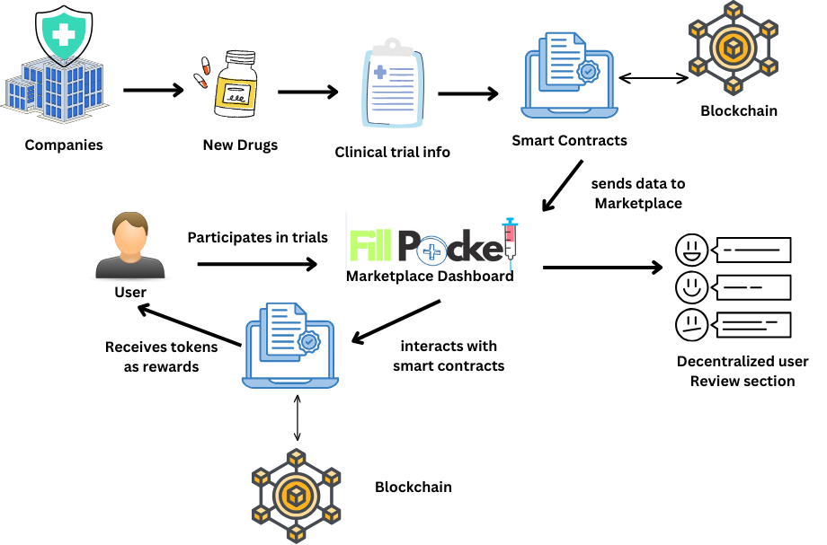

**Workflow:**

**Case 1: Organizations/Companies**

* Creates Trial Information form.
* Uploads it on the Fill Pocket Portal.
* Clicks on Submit.
* Smart Contracts interaction takes place.
* Metamask wallet pops up for uploading data to blockchain.
* Smart contracts uploads the Clinical trial Information on the Marketplace Dashboard .

**Case 2: Users**

* Logs in to Portal
* See list of available clinical trials on dashboard with the amount of reward listed.
* Sees account balance.
* Clicks on the trials to participate and after they complete the trials they receive tokens as reward.

**Rewards:**

Tokens are the sort of prizes offered on Fill Pocket, which encourages users to take part in clinical trials. These tokens may use pre-existing digital tokens that are supported by well established systems, or they may be specially created for the platform.

The Practicality of these tokens is what gives them value. Tokens may be exchanged for actual money or other advantages allowing participants to make sure that their contributions and hard work are valued. In addition to promoting increased user engagement, this compensation scheme makes the platform dynamic and interesting, which promotes cooperation and confidence between users and pharmaceutical companies.

Fill Pocket encourages people to actively contribute to the advancement of pharmaceutical research while making sure their efforts are significant by providing incentives with tangible benefits.

**Future Plans:**

* Use Zero Knowledge Proof Verification to verify Organizations that can get rights to announce clinical trials.
* Use World ID log in for User authentication to enhance the security and genuineness.