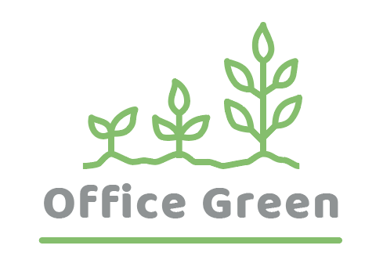
Project Plant Pals
Operations & Training Plan
August 2021

Document Status: Draft | In Review | Approved

Executive Summary:

Project Goal
SMART: Specific, Measurable, Attainable, Relevant, and Time-bound

Deliverables

Business Case / Background
Why are we doing this?

Benefits, Costs, and Budget
Benefits:
- Support new service leading to 5% revenue increase, reduce late shipments and related costs, increase customer satisfaction
- Additional benefits (optional):

Costs:
- Price of software, installation fees, time spent on hiring and training
- Additional cost areas (optional):

Budget needed:
- $75,000

Scope and Exclusion
In-Scope:
- Customer service standards, delivery processes, training protocols
- Other in-scope items (optional):

Out-of-Scope:
- Product development, vendor contracts
- Other out-of-scope items (optional):

Project Team
Project Sponsor: Director of Operations

Project Lead: Project Manager (You!)

Project Team: Fulfillment Director, Quality Assurance Tester, Inventory Manager, Financial Analyst, Human Resources Specialist, Training Manager

Additional Stakeholders: VP of Customer Success, Account Manager, Receptionist, Sales Director, Sales Team, Marketing Director, Investors

Measuring Success
What is acceptable:

