PostFlightDTT
Post-Flight Data Transfer Tool
User Guide

Overview
PostFlightDTT automates the data transfer workflow after a drone flight. Instead of manually downloading and copying files, two portable executables handle the complete pipeline — from drone to hard drive, and from hard drive to NAS.

More Information: PostFlightDataTransferTool · Issue #7 · EOA-team/026_dpa

Usage

Mode 1: Drone to Hard Drive (after landing)
⚠ Run this immediately after each flight, before starting a new one. The tool expects exactly one flight folder in the recordings directory.

- Connect the external hard drive to the drone computer.
- Open folder “drone_to_hd” on Desktop
- Double-click PostFlightDTT.exe.
- The tool will: check the hard drive is connected → identify the flight folder → scrape *.t04 files from APX-20 → transfer recordings to the hard drive → clean up the drone computer.
- When complete, the console shows "All transfers complete" and reminds you to safely unmount the drive.
- Press Enter to close.

Mode 2: Hard Drive to NAS (back at the office)
- Connect the hard drive to the FoLa Computer.
- Open folder “hd_to_nas” on Desktop
- Double-click PostFlightDTT.exe.
- The tool will: check the NAS is mounted → back up source data on Hard Disk→ transfer all recordings folders to the NAS → clean up the hard drive.
- When complete, the console shows "All transfers complete" and reminds you to safely unmount the drive.
- Press Enter to close when done.

Installation
The tool is distributed as a self-contained folder. No installation is required.

Expected folder structure:
PostFlightDTT/
├── PostFlightDTT.exe
├── config.yaml
├── bin/
└── docs/
└── README.docx

Configuration
⚠ Do only adjust configuration.yaml if you know what you are doing. Talk to Francesco Argento , Helge Aasen, Pascal Ackermann before any change.

⚠ In case you have any technical questions about the config file you can contact: pascal.ackermann@agroscope.admin.ch

Example config.yaml

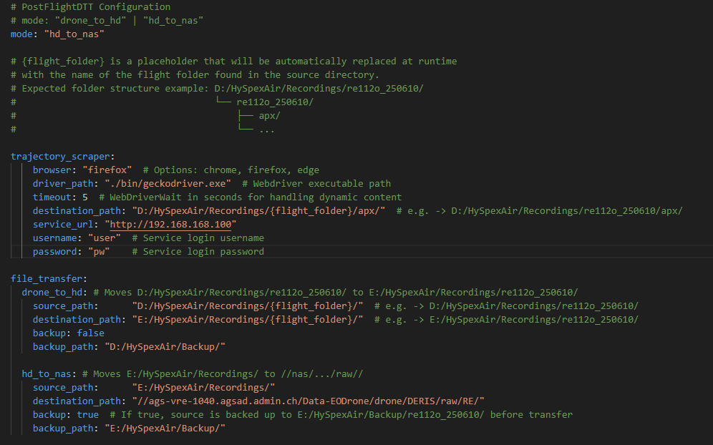

Troubleshooting
Error message | Likely cause & fix
Drive or mount point not accessible | Hard drive or NAS is not connected. Connect the drive and try again.
No flight folder found | HySpexAir did not record, or source_path in config.yaml is wrong.
Expected exactly one flight folder | A previous flight folder was not transferred. Run PostFlightDTT after every flight before starting a new one, or handle the folders manually.
Invalid mode in config | mode in config.yaml is misspelled. Must be drone_to_hd or hd_to_nas.
Multiple Flight Folders Found | If you started a new flight without running PostFlightDTT first, the tool will abort and list the folders it found. You must manually sort and transfer the data in this case before using the tool again.

⚠ If you need support: copy and paste the logs in the windows console and send it to pascal.ackermann@agroscope.admin.ch with the Subject “PostFlightDTT Issue ”

Tips & Best Practices
- Always run drone_to_hd immediately after landing, before starting the next flight.
- The console window stays open after completion — read the output to confirm everything transferred correctly before pressing Enter.

PostFlightDTT — Automated Post-Flight Data Transfer Tool

