PYGEOVISION · GEOSPATIAL ANALYSIS REPORT
Solar Potential (terrain illumination)
2024-12-21 · 1,278.8 km²

0.336  Mean relative irradiance | 22.1 %  Cells facing away from the sun | 70.0°  Sun zenith angle | 180.0°  Sun azimuth

Executive summary
- At 12 h on 2024-12-21 the sun is 70.0° from the zenith (azimuth 180°). Mean relative irradiance on the terrain is 0.34 (1 = sun directly overhead of a surface facing it).
- 22.1 % of cells face away from the sun at that moment.
Single-instant relative factor; no terrain shadowing, no atmosphere.

Study area and inputs
Area of interest (west, south, east, north) | 7.8000, 46.4000, 8.3000, 46.7000
Centre | 46.5500°, 8.0500°
Area of interest | 1,278.78 km²
Period | 2024-12-21
Output grid | 1,800 × 1,080 pixels, EPSG:4326
Raster extent area | 1,278.78 km²

Inputs: a digital elevation model (srtm1arc) from OpenTopography.

Results
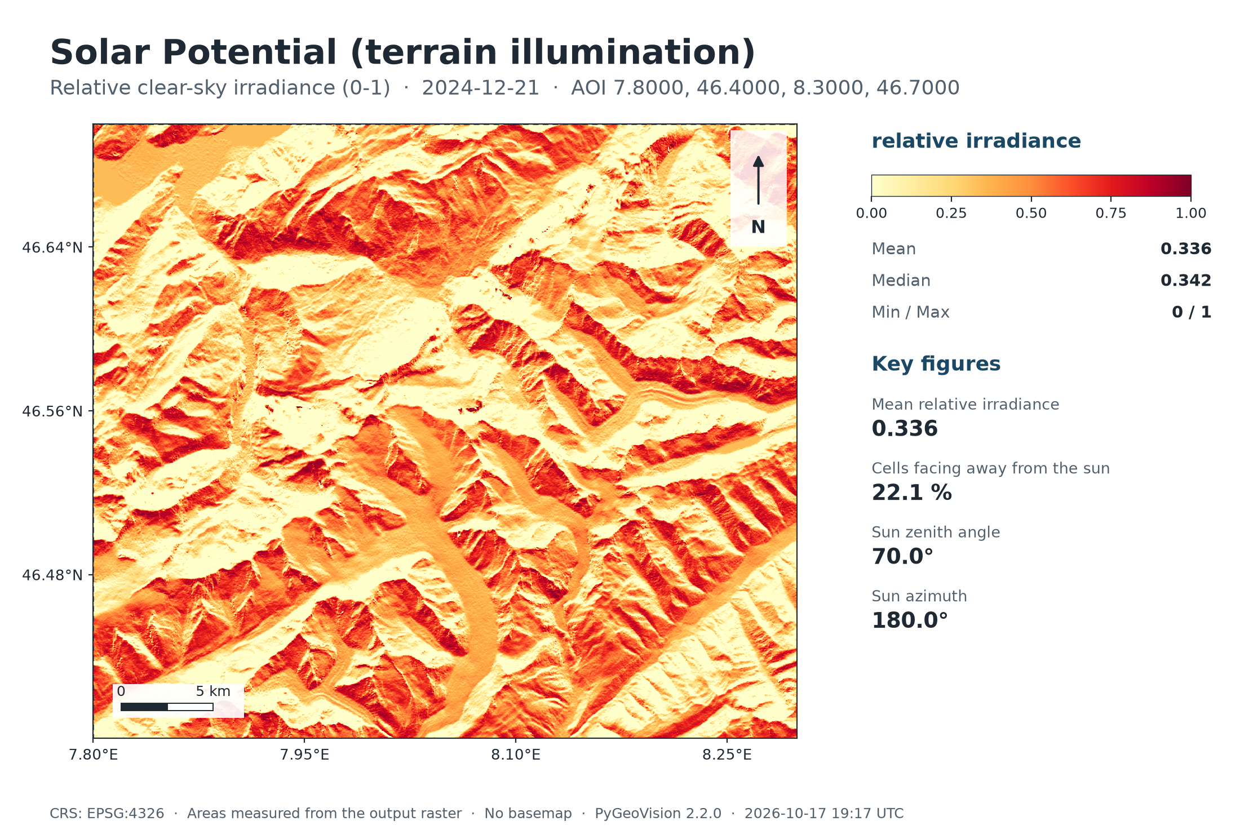
Map: Solar Potential (terrain illumination)
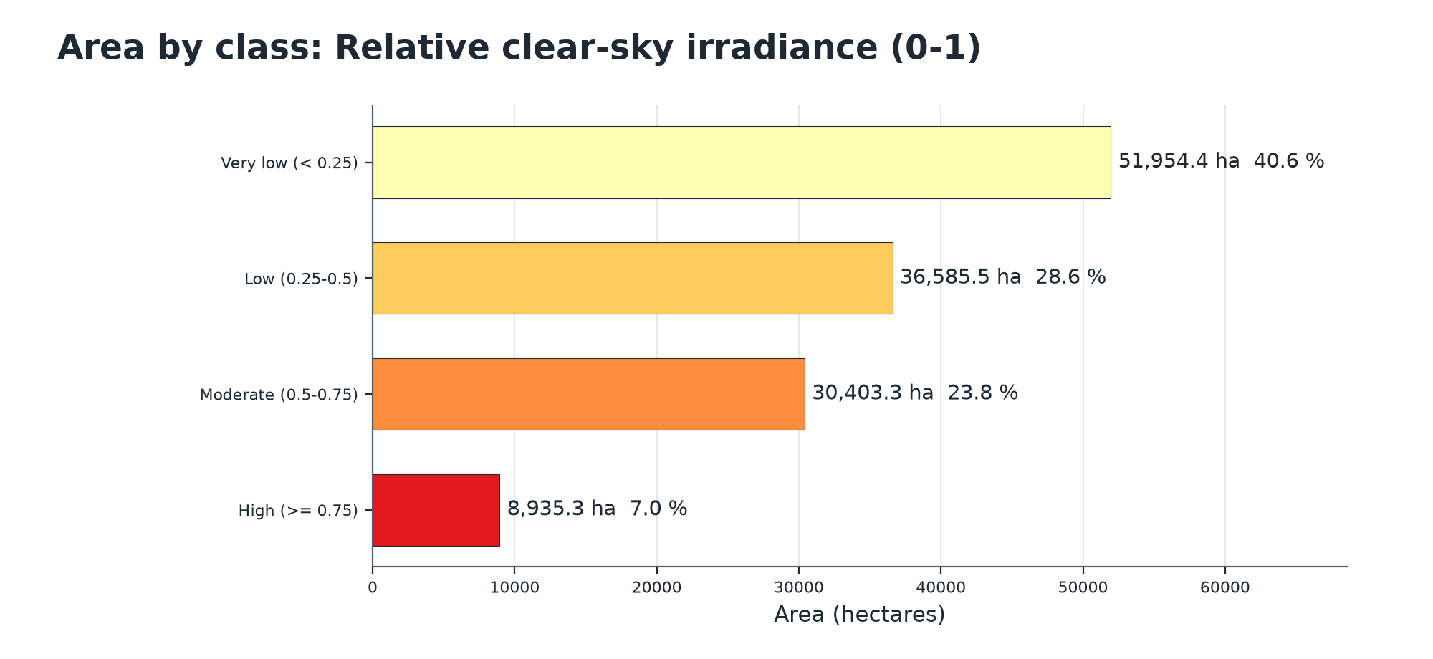
Summary chart
Class areas: Relative clear-sky irradiance (0-1)
 | Class | Value | Pixels | Area (ha) | Share of valid area | Share of AOI
 | Very low (< 0.25) | 0 | 789,910 | 51,954.4 | 40.6 % | 40.6 %
 | Low (0.25-0.5) | 1 | 556,162 | 36,585.5 | 28.6 % | 28.6 %
 | Moderate (0.5-0.75) | 2 | 462,110 | 30,403.3 | 23.8 % | 23.8 %
 | High (>= 0.75) | 3 | 135,818 | 8,935.3 | 7.0 % | 7.0 %
Valid area 127,878.5 ha of 127,878.5 ha (1,944,000 of 1,944,000 pixels). Areas are measured from the output raster.
Key statistics (reported by the pipeline)
Measure | Value
Mean relative irradiance | 0.336
Cells facing away from the sun | 22.1 %
Sun zenith angle | 70.0°
Sun azimuth | 180.0°
Date | 2024-12-21
Hour (solar time) | 12.0
DEM product | srtm1arc

Value statistics: Relative clear-sky irradiance (0-1)
Statistic | Value
Minimum | 0.000
5th percentile | 0.000
25th percentile | 0.040
Median | 0.342
Mean | 0.336
75th percentile | 0.556
95th percentile | 0.781
Maximum | 1.000
Standard deviation | 0.269
Over 1,944,000 valid pixels.
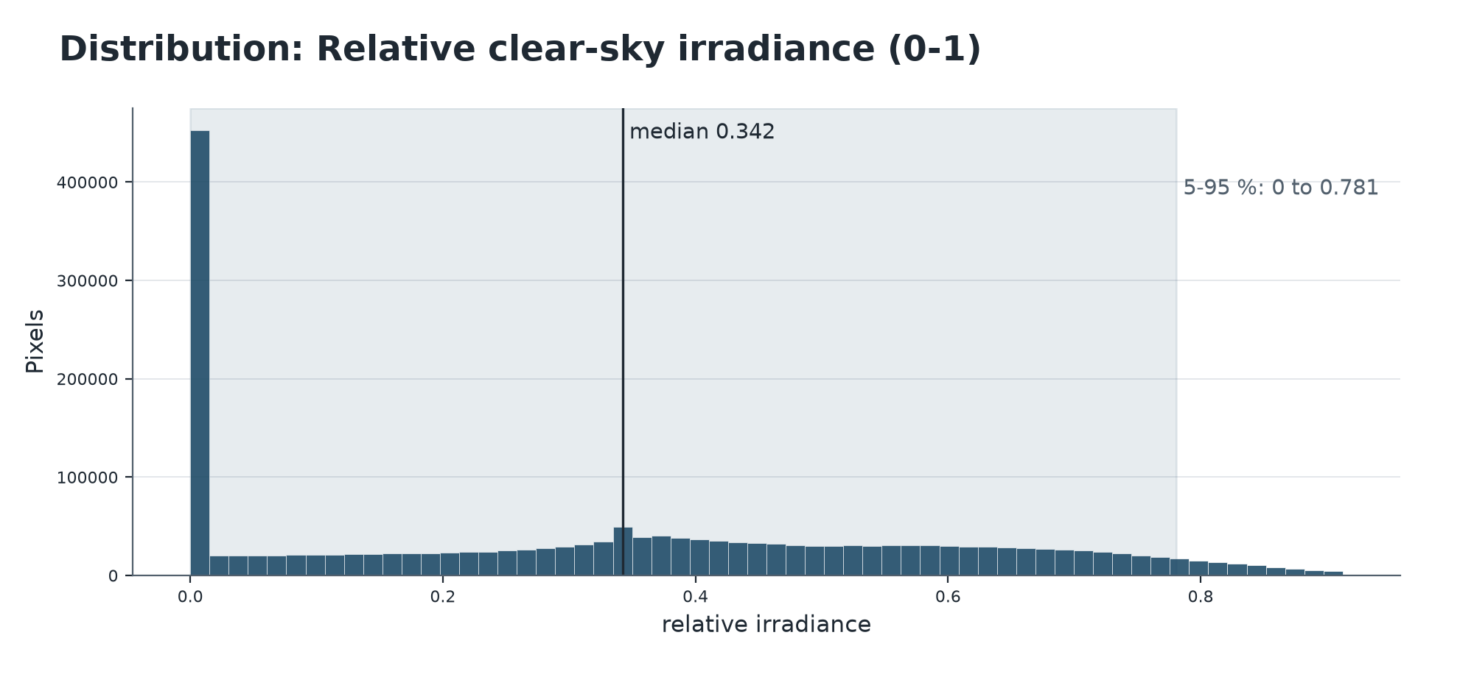
Distribution of values

Method and parameters
How much does terrain slope and aspect help or hinder sunlight at a given date and hour?
Slope and aspect come from the DEM (Horn's method). The sun position follows the standard declination and hour-angle equations.
The output is the cosine of the sun's incidence angle on each cell (0-1), for one instant.
Pipeline | solar_potential
Area of interest | 7.8000, 46.4000, 8.3000, 46.7000
cloud_mask | True
date | 2024-12-21
hour | 12

Interpretation and limitations
Limitations
- A single-instant relative factor: no terrain shadowing by neighbouring ridges, no atmosphere, no clouds, and not kWh/m2.
- Annual yield needs a time-integrated model with measured or modelled irradiance.

Deliverables
Files
File | Type | Contents
alps_winter_sun/solar_potential.tif | GeoTIFF raster | Relative clear-sky irradiance (0-1)
alps_winter_sun/deliverables/solar_potential_report.pdf | PDF report | Complete analysis report
alps_winter_sun/deliverables/solar_potential_report.xlsx | Excel workbook | Complete analysis report
alps_winter_sun/deliverables/solar_potential_report.docx | Word report | Complete analysis report
alps_winter_sun/deliverables/maps/solar_potential_map.png | PNG image | Map or chart for slides and documents
alps_winter_sun/deliverables/maps/solar_potential_chart.png | PNG image | Map or chart for slides and documents
alps_winter_sun/deliverables/maps/solar_potential_histogram.png | PNG image | Map or chart for slides and documents
alps_winter_sun/deliverables/vectors/solar_potential.gpkg | GeoPackage (all layers) | Vector features with attributes
alps_winter_sun/deliverables/vectors/geojson/solar_potential_aoi.geojson | GeoJSON, EPSG:4326 | Vector features with attributes
alps_winter_sun/deliverables/vectors/geojson/solar_potential_irradiance_classes.geojson | GeoJSON, EPSG:4326 | Vector features with attributes
run_summary.json | JSON | Machine-readable record of this run

Vector layers
Layer | Features | Total area (ha) | Note
irradiance_classes | 26,301 | 127,878.5

Vector layers made from rasters carry class_id, class_name, color_hex, area_ha, area_m2 (equal-area projection), pct_aoi, cx, cy, pipeline and period; layers a pipeline wrote itself (buildings, roads, streams, fire points) keep their own attributes. Coordinates are WGS 84 (EPSG:4326). The GeoPackage also holds the 'aoi' outline and, for raster-derived layers, a dissolved '<layer>_classes' summary.

References
- Duffie, J.A. & Beckman, W.A. Solar Engineering of Thermal Processes (Wiley); Spencer, J.W. (1971). Fourier series representation of the position of the sun. Search 2(5), 172.
- Horn, B.K.P. (1981). Hill shading and the reflectance map. Proceedings of the IEEE 69(1), 14-47.

