PYGEOVISION · GEOSPATIAL ANALYSIS REPORT
Forest Change (JAXA PALSAR forest / non-forest)
2018 to 2020 · 3,039.1 km²

171,519.6 ha  Forest, first year | 180,995.9 ha  Forest, second year | 6,820.8 ha  Forest loss | 16,297.0 ha  Forest gain

Executive summary
- Forest went from 171,519.6 ha in 2018 to 180,995.9 ha in 2020: loss 6,820.8 ha, gain 16,297.0 ha.
- The loss is 4.0 % of the 2018 forest (3,410.4 ha per year).
JAXA global PALSAR/PALSAR-2 forest/non-forest map (25 m, L-band radar, yearly 2015-2020; in this product 'forest' is natural forest with at least 90% canopy cover unless include_open_forest is set). Each year is mapped separately, so gains and losses include mapping disagreement; plantations count as forest.

Study area and inputs
Area of interest (west, south, east, north) | -62.8000, -9.4000, -62.3000, -8.9000
Centre | -9.1500°, -62.5500°
Area of interest | 3,039.15 km²
Period | 2018 to 2020
Output grid | 2,201 × 2,215 pixels, EPSG:32720
Raster extent area | 3,047.01 km²
Valid (cloud-free) share | 99.6 %

Results
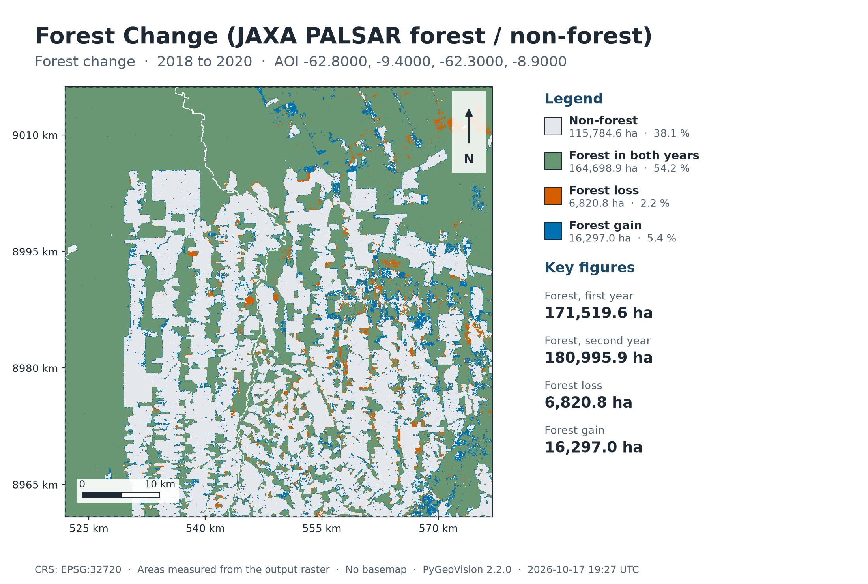
Map: Forest Change (JAXA PALSAR forest / non-forest)
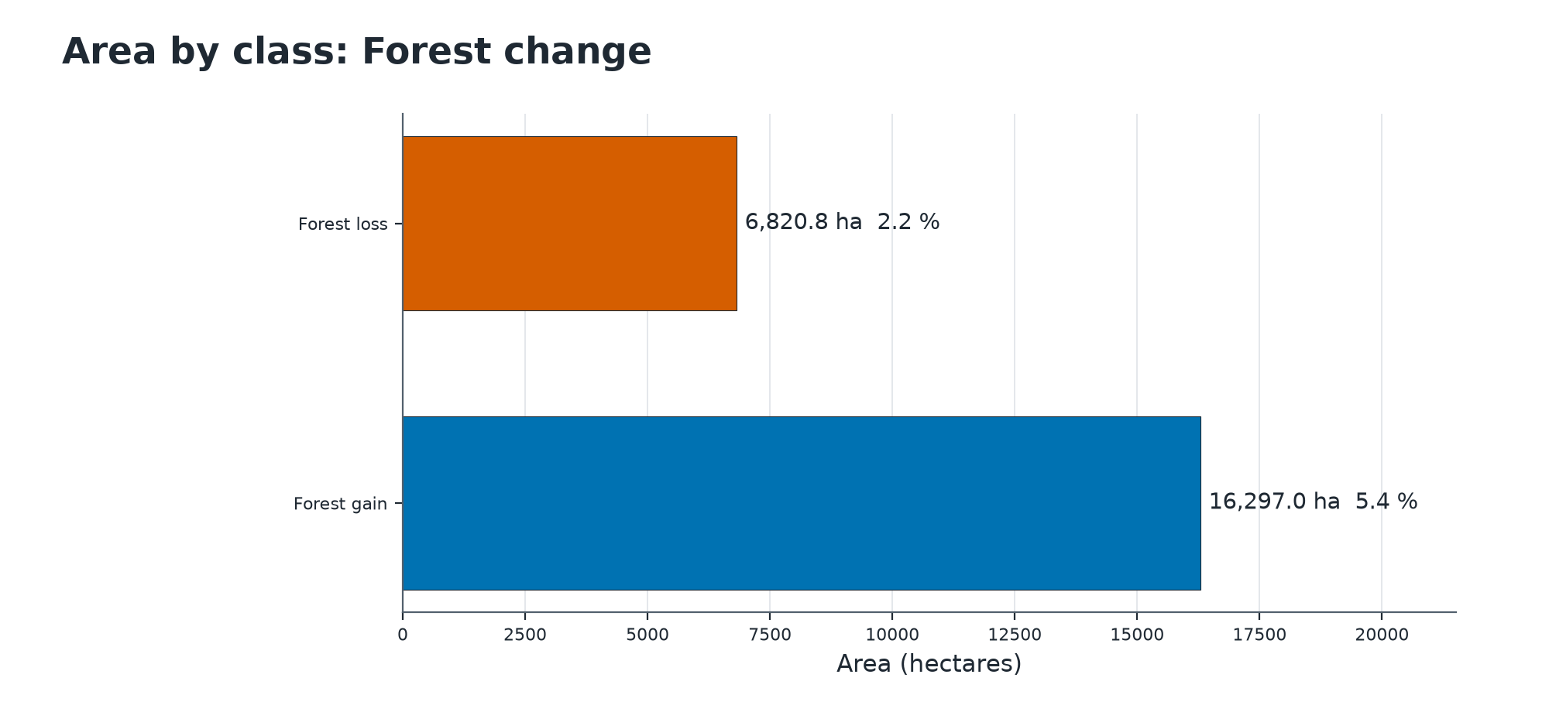
Summary chart
Class areas: Forest change
 | Class | Value | Pixels | Area (ha) | Share of valid area | Share of AOI
 | Non-forest | 0 | 1,852,554 | 115,784.6 | 38.1 % | 38.0 %
 | Forest in both years | 1 | 2,635,182 | 164,698.9 | 54.2 % | 54.1 %
 | Forest loss | 2 | 109,132 | 6,820.8 | 2.2 % | 2.2 %
 | Forest gain | 3 | 260,752 | 16,297.0 | 5.4 % | 5.3 %
Valid area 303,601.2 ha of 304,700.9 ha (4,857,620 of 4,875,215 pixels). Areas are measured from the output raster.
Key statistics (reported by the pipeline)
Measure | Value
Forest, first year | 171,519.6 ha
Forest, second year | 180,995.9 ha
Forest loss | 6,820.8 ha
Forest gain | 16,297.0 ha
Net change | 9,476.2 ha
Loss per year | 3,410.4 ha
Loss as share of first-year forest | 4.0 %
Valid share of the area | 99.6 %

Other statistics
Measure | Value
Year before | 2,018
Year after | 2,020
Forest share before | 56.5 %
Forest share after | 59.6 %
Include open forest | no
Resolution m | 25.000
Resolution coarsened | no

Method and parameters
How much forest was lost or gained between two years from the radar-based forest map?
The JAXA global PALSAR forest / non-forest map (25 m, 2015-2020) is read for both years from the Microsoft Planetary Computer and resampled onto one UTM grid.
'Forest' is class 1 (canopy cover above 90 %) by default, or classes 1 and 2 (above 10 %) with include_open_forest.
Pixels that are water or no-data in either year are nodata. Loss is forest then, non-forest now; gain is the reverse.
Pipeline | forest_change
Area of interest | -62.8000, -9.4000, -62.3000, -8.9000
cloud_mask | True
date_after | 2020
date_before | 2018
period | 2018 to 2020

Interpretation and limitations
How to read the result
- Radar backscatter responds to structure and moisture, so plantations count as forest and flooded or very dry conditions can move pixels between classes. Treat small, scattered changes as noise.
Limitations
- Each year is mapped separately: gains and losses include mapping disagreement, not only change on the ground.
- Covers 2015-2020 only; it says nothing about later forest loss.
- It cannot tell the cause of loss (logging, fire, farming, natural dieback).

Deliverables
Files
File | Type | Contents
rondonia_forest/forest_change.tif | GeoTIFF raster | Forest change
rondonia_forest/deliverables/forest_change_report.pdf | PDF report | Complete analysis report
rondonia_forest/deliverables/forest_change_report.xlsx | Excel workbook | Complete analysis report
rondonia_forest/deliverables/forest_change_report.docx | Word report | Complete analysis report
rondonia_forest/deliverables/maps/forest_change_map.png | PNG image | Map or chart for slides and documents
rondonia_forest/deliverables/maps/forest_change_chart.png | PNG image | Map or chart for slides and documents
rondonia_forest/deliverables/vectors/forest_change.gpkg | GeoPackage (all layers) | Vector features with attributes
rondonia_forest/deliverables/vectors/geojson/forest_change_aoi.geojson | GeoJSON, EPSG:4326 | Vector features with attributes
rondonia_forest/deliverables/vectors/geojson/forest_change_forest_change.geojson | GeoJSON, EPSG:4326 | Vector features with attributes
run_summary.json | JSON | Machine-readable record of this run

Vector layers
Layer | Features | Total area (ha) | Note
forest_change | 36,685 | 23,134.3

Vector layers made from rasters carry class_id, class_name, color_hex, area_ha, area_m2 (equal-area projection), pct_aoi, cx, cy, pipeline and period; layers a pipeline wrote itself (buildings, roads, streams, fire points) keep their own attributes. Coordinates are WGS 84 (EPSG:4326). The GeoPackage also holds the 'aoi' outline and, for raster-derived layers, a dissolved '<layer>_classes' summary.

References
- Shimada, M. et al. (2014). New global forest/non-forest maps from ALOS PALSAR data (2007-2010). Remote Sensing of Environment 155, 13-31. (JAXA global PALSAR-2/PALSAR forest/non-forest map, Microsoft Planetary Computer.)

