VPR Viewer: FAQ & Troubleshooting

Prepared by Emily O’Grady, April 2022

## Introduction

This document attempts to capture some basics of using the VPR Viewer (VPRv), shiny app, developed to assist in the visualization of Video Plankton Recorder (VPR) data during a field mission. This is laid out in FAQ style to pre-empt potential questions and issues. It is intended to be a living document, with information added as users experience issues or raise questions.

How do I download VPRv?

VPRv is available for download from GitHub (<https://github.com/EOGrady21/VPR_viewer>). It is easiest to ‘clone’ (download) the entire repository through GitHub Desktop and open the app in RStudio.

For more detailed instructions, see <https://docs.github.com/en/desktop/contributing-and-collaborating-using-github-desktop/adding-and-cloning-repositories/cloning-and-forking-repositories-from-github-desktop>

How do I open VPRv?

VPRv can currently be opened from within RStudio, either in the viewer pane or in a separate web browser window. Use the ‘Run App’ button to launch the app, or the small downward arrow to change the location in which the app will launch (Screenshot 1).

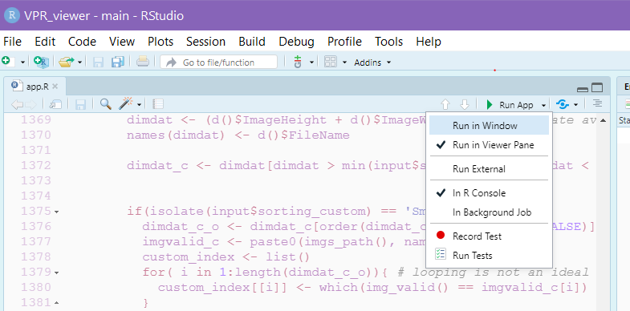

Screenshot 1 Use the Run App button to launch the shiny app. The small downward arrow brings up this menu and allows you to adjust the window in which the app will launch (viewer pane within RStudio or web browser).

I am seeing blue boxes where output should be displayed, why?

Blue loading icons are displayed while the data is processing. If you are seeing them for an extended period, it may be because your dataset is very large, or something is wrong. If your data is taking more than 30 minutes to load please refresh the app and retry. Try loading a smaller test dataset to ensure that the app is working properly.

What format should my data be in to load to VPRv?

CTD data should be loaded in .dat format files. These files are output from AutoDeck. VPRv is designed to work with multiple versions of the VPR which have slightly different CTD data formatting. Please use the dropdown menu next to the CTD data loading slot to indicate which version of VPR you are using (Screenshot 2).

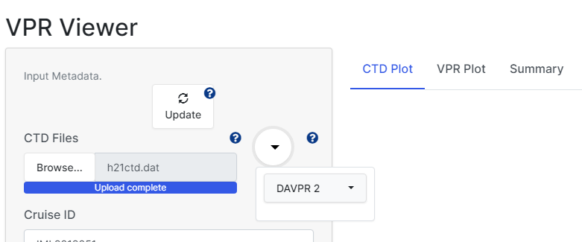

Screenshot 2 The dropdown menu to the left of the CTD data loading slot can be used to identify which version of the VPR is being used, which dictates the formatting of the CTD data.

There is an error about the ‘names’ attribute not being the right length, and none of my plots are loading!

Please double check that you have selected the right VPR CTD file version. Using the dropdown menu next to your CTD file upload, please select the correct Instrument. Different VPR models have slightly different CTD data file formats which is causing this error.

How should my data be organized in folders?

Data should be organized in directories, as described by the VPR manual. Directory naming in **bold** should not be changed.

/**data**

/cruise-name

/**rois**

**/vpr**# (where # is a tow-ID)

/**d**### (where ### is Julian Day)

/**h**## (where ## is hour of data collection)

What can VPRv display?

VPRv displays plots of CTD data, as well as VPR data which has been binned. The VPR data includes some initial calculated variables such as density and concentration of ROI images. The app can also display the entire CTD dataset with associated ROI data as a table. In the gallery tab, ROI images themselves are displayed.

How can I look at a subset of my data?

The left hand side of the app, at the bottom of the page (Screenshot 3) contains an array of variables which can be subset to narrow the visible data range. These variables each have a minimum and maximum value input. Narrowing the range of an individual variable will subset the entire dataset. This subset will be propagated through the VPR plots, summary, table and image gallery tabs. Note that the CTD plot tab will always show the full dataset range. These ranges take an initial default value (Screenshot 3), once data is loaded they should automatically adjust to capture the actual range of the data. A user can then manually adjust the ranges and use the ‘Update’ button (top of left hand menu) to refresh plots. The ‘Reset Ranges’ button can be used to reset the ranges back to the maximum available range of the loaded data.

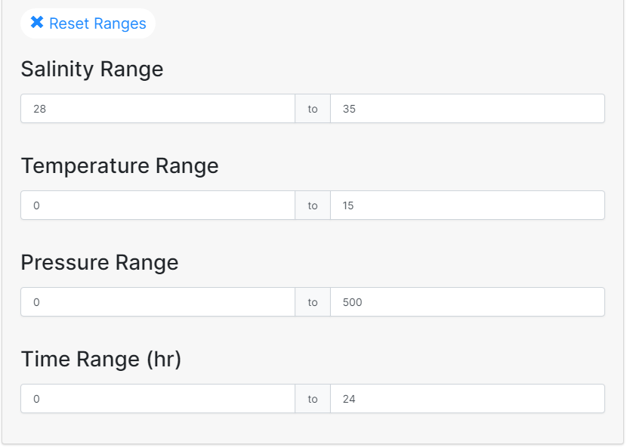

Screenshot 3 Minimum and maximum values for variable ranges.

I subset my data and now I cannot expand the range displayed! How can I get the full dataset back?

This can happen if you subset the data, eg. to 0-50m, then want to expand the pressure range back to 0-150m. You may see plots which do not reflect the full data range, you may not be able to get the full dataset ‘back’. In this case, you must use the ‘reset ranges’ button located at the top of the metadata range section in the left hand menu. The ‘Reset Ranges’ button will reset the ranges to the full value of the dataset, then when you ‘Update’ you should be able to see the entire dataset.

I made changes to the metadata/ settings but the plots are not refreshing!

After any updates are made in the left hand menu of the app, you must click the ‘Update’ button at the top of the menu before changes will be propagated through the app.

Why am I getting an error message about too few data points?

If there are not enough data points within your selected range, the app will throw an error, rather than display plots with no data. The app requires at least 10 data points within your selected range. Please expand the variable ranges you have selected and try to ‘update’ the app again.

My image tab has an error, ‘No valid ROI images found’, why?

This means that the app has not been able to locate any ROI images based on the metadata and file path information you have provided. Please check that your ‘basepath’ variable in the left hand menu is correct and that all other metadata is correct. You should also confirm that your files are organized in the expected directory structure (see How should my data be organized in folders?)

How can I quality control my data?

Data can be quality controlled by subsetting the variable ranges in the left hand menu.

How can I sort the images displayed in the gallery?

There are multiple options for sorting the images displayed in the Gallery tab (Screenshot 4). Initial sorting can be either by time, or size (small to large or large to small). In custom sorting options a user can specify a custom size range, and then within that custom size range, images can be sorted again by time, or size (small to large, or large to small). The custom size range input is expected in pixels. Please see the small blue question mark next to the custom size index for more details.

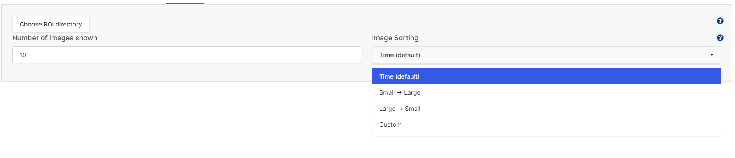

Screenshot 4 Image sorting options in the Gallery tab

Can I save outputs from VPRv?

There are save buttons located at the top right hand corner of each plot displayed in VPRv. Clicking on the save button will save an image of the plot, with a default naming scheme based on provided metadata. Note that you can edit the plot name if you have VPRv open in an R viewer (as opposed to a web browser).

How can I change a default value in the metadata inputs?

Changing one of the default metadata values could be useful in saving you time, for example you could update the cruise name to the current cruise so you do not have to edit this input each time you load VPRv. In order to update a default value you will have to edit the source code of the app within R. The default values are set between line 70 and 100 of the R code in ‘app.R’ (Screenshot 5)

To change a default, you will need to edit the `value` of a `textInput()` function. For example if you wanted to change the cruise name, you would edit line 74 (Screenshot 5) to the following:

textInput(‘cruise’, ‘Cruise ID’, placeholder = ‘eg. IML2018051’, value = ‘CAR2022299’) %>%

Once you make an edit to the source code, you will need to click ‘Reload App’ in the top right corner of the R window (circled in red on Screenshot 5).

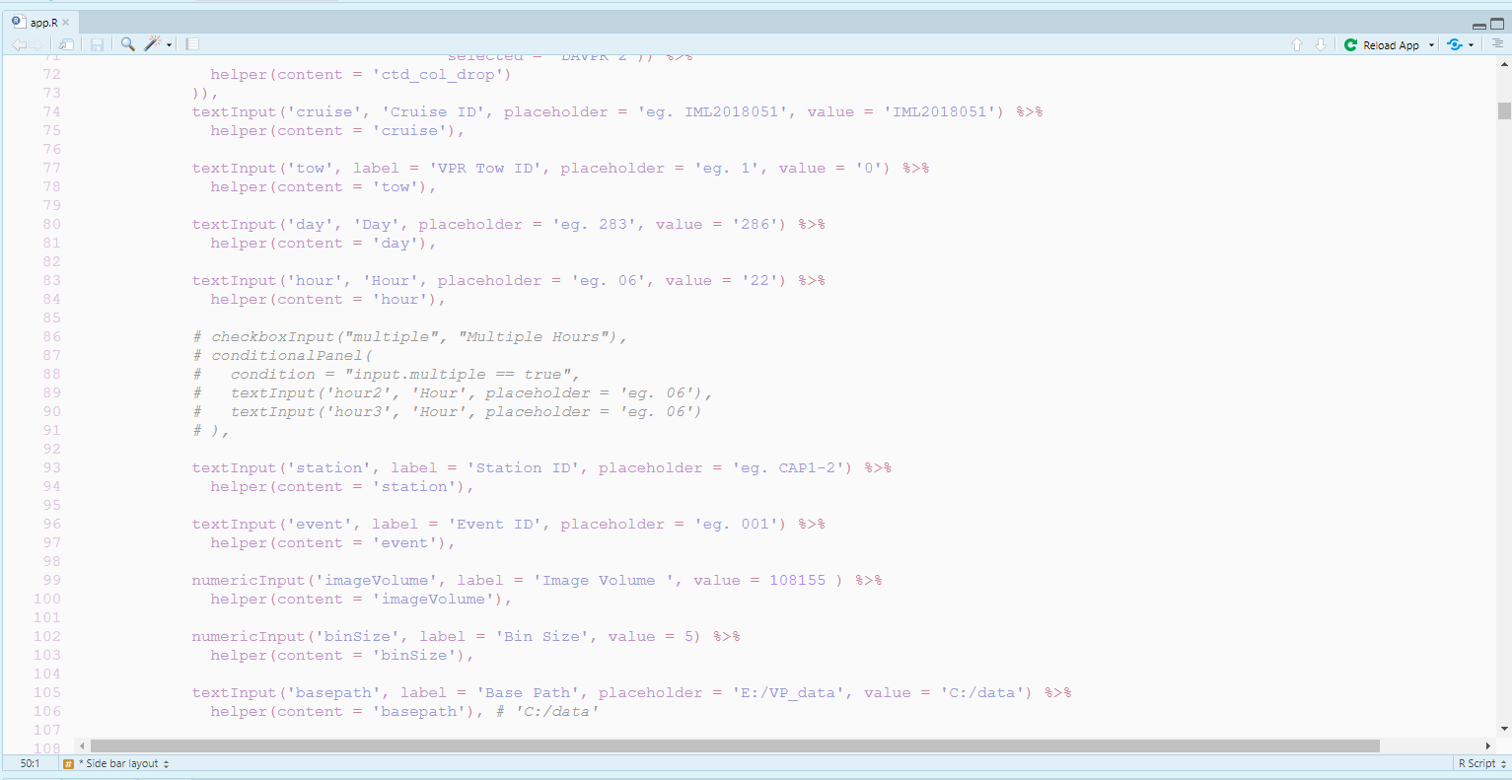

Screenshot 5 The section of source code where metadata default values are set.

How do I update the app if a change was made remotely?

If a change was made remotely that you would like to incorporate into your local version of the app (eg. Emily updated a bug!), please use the following steps.

1. Open the VPRv project in RStudio
2. Navigate to the ‘Git’ tab in the top right pane of RStudio (where your environment variables are typically displayed)
3. Use the blue downward arrow to initiate a ‘pull’ request. This will access the remote version of VPRv and bring any changes to your local machine.

**Note:** If you have made any changes locally you may be prompted to ‘merge’ the different versions of code. If there are any conflicts they may have to be resolved. This may require you manually editing the affected files, or ‘pushing’ (upwards green arrow in the Git tab) your local changes to the remote before incorporating remote changes.