**Supplementary text**

**Supplementary tables**

Table S1: Variables included in the Newfoundland Principal Component Analyses.

|  |  |  |
| --- | --- | --- |
| **Variable** | **Group** | **Period** |
| Deep temperature (3Ps, 3LNO spring, 2J, 3K, 3LNO fall) | Physical | 1985–2016 |
| Sea-surface temperature (St. Lawrence Estuary, western, eastern, & southern Gulf of St. Lawrence) | Physical | 1985–2016 |
| North Atlantic Oscillation (NAO) index | Physical | 1985–2016 |
| Atlantic Multi-decadal Oscillation (AMO) index | Physical | 1985–2016 |
| Cold Intermediate Layer (CIL) area (Seal Island, White Bay, Bonavista, Flemish Cap) | Physical | 1985–2016 |
| Mean ice volume (January-February-March)  (Gulf of St. Lawrence + Scotian Shelf) | Physical | 1985–2016 |
| *Calanus finmarchicus* | Zooplankton | 1999–2016 |
| *Calanus hyperboreus* | Zooplankton | 1999–2016 |
| *Calanus glacialis* | Zooplankton | 1999–2016 |
| *Pseudocalanus* spp | Zooplankton | 1999–2016 |
| *Metridia longa* | Zooplankton | 1999–2016 |
| *Metridia lucens* | Zooplankton | 1999–2016 |
| *Metridia* spp | Zooplankton | 1999–2016 |
| *Temora longicornis* | Zooplankton | 1999–2016 |
| *Microcalanus* spp*.* | Zooplankton | 1999–2016 |
| *Oithona* spp | Zooplankton | 1999–2016 |
| *Scolecithricella minor* | Zooplankton | 1999–2016 |
| Larvacea | Zooplankton | 1999–2016 |
| Gastropoda | Zooplankton | 1999–2016 |
| Bivalvia | Zooplankton | 1999–2016 |
| Euphausiacea | Zooplankton | 1999–2016 |
| Cnidaria | Zooplankton | 1999–2016 |
| Hydrozoa | Zooplankton | 1999–2016 |
| Sea-surface temperature warming (St. Anthony Basin, Northeast Newfoundland Shelf, Hibernia, Flemish Pass, Southeast Shoal) | Phenology | 1999–2016 |
| Final day of sea ice (Newfoundland Shelf) | Phenology | 1999–2016 |
| Mean ice area (Newfoundland Shelf) | Phenology | 1999–2016 |
| Annual peak in *Calanus finmarchicus* abundance (Station 27) | Phenology | 1999–2016 |
| Annual peak in proportion of *Calanus finmarchicus* life stages I+II+III relative to total population (Station 27) | Phenology | 1999–2016 |
| Annual peak in *Calanus hyperboreus* abundance (Station 27) | Phenology | 1999–2016 |
| Annual peak in proportion of *Calanus hyperboreus* life stages I+II+III relative to total population (Station 27) | Phenology | 1999–2016 |
| Annual peak in total zooplankton biomass (Station 27) | Phenology | 1999–2016 |
| Start of phytoplankton bloom (St. Anthony Basin, Northeast Newfoundland Shelf, Hibernia, Flemish Pass, Southeast Shoal) | Phenology | 1999–2016 |
| Duration of phytoplankton bloom (St. Anthony Basin, Northeast Newfoundland Shelf, Hibernia, Flemish Pass, Southeast Shoal) | Phenology | 1999–2016 |

Table S2: Variables included in the Gulf of St. Lawrence Principal Component Analyses.

|  |  |  |
| --- | --- | --- |
| **Variable** | **Group** | **Period** |
| Deep (300m) temperature (St. Lawrence Estuary, western, eastern, & southern Gulf of St. Lawrence) | Physical | 1985–2016 |
| Sea-surface temperature (St. Lawrence Estuary, western, eastern, & southern Gulf of St. Lawrence) | Physical | 1985–2016 |
| North Atlantic Oscillation (NAO) index | Physical | 1985–2016 |
| Atlantic Multi-decadal Oscillation (AMO) index | Physical | 1985–2016 |
| Annual mean St. Lawrence river flux | Physical | 1985–2016 |
| Cold Intermediate Layer (CIL) minimum temperature index  (Gulf of St Lawrence) | Physical | 1985–2016 |
| Mean ice volume (January-February-March)  (Gulf of St. Lawrence + Scotian Shelf) | Physical | 1985–2016 |
| *Calanus finmarchicus* | Zooplankton | 1999–2016 |
| *Calanus hyperboreus* | Zooplankton | 1999–2016 |
| *Calanus glacialis* | Zooplankton | 1999–2016 |
| *Pseudocalanus* spp | Zooplankton | 1999–2016 |
| *Metridia longa* | Zooplankton | 1999–2016 |
| *Metridia lucens* | Zooplankton | 1999–2016 |
| *Metridia* spp | Zooplankton | 1999–2016 |
| *Temora* spp | Zooplankton | 1999–2016 |
| *Microcalanus* spp*.* | Zooplankton | 1999–2016 |
| *Oithona* spp | Zooplankton | 1999–2016 |
| *Scolecithricella minor* | Zooplankton | 1999–2016 |
| Larvacea | Zooplankton | 1999–2016 |
| Gastropoda | Zooplankton | 1999–2016 |
| Bivalvia | Zooplankton | 1999–2016 |
| Euphausiacea | Zooplankton | 1999–2016 |
| Cnidaria | Zooplankton | 1999–2016 |
| Sea-surface temperature warming (Northwest Gulf of St. Lawrence, Northeast Gulf of St. Lawrence, Magdalen Shallows, Cabot Strait) | Phenology | 1999–2016 |
| Final day of sea ice (Gulf of St. Lawrence + Scotian Shelf) | Phenology | 1999–2016 |
| Mean ice area (Gulf of St. Lawrence + Scotian Shelf; Jan-Mar) | Phenology | 1999–2016 |
| Annual peak in *Calanus finmarchicus* CI+II+III generation 1 (Rimouski Station) | Phenology | 1999–2016 |
| Annual peak in Calanus finmarchicus CI+II+III generation 2 (Rimouski Station) | Phenology | 1999–2016 |
| Annual peak in ratio of generations 2 and 1 for Calanus finmarchicus CI+II+ III (Rimouski Station) | Phenology | 1999–2016 |
| Start of phytoplankton bloom (Northwest Gulf of St. Lawrence, Northeast Gulf of St. Lawrence, Magdalen Shallows, Cabot Strait) | Phenology | 1999–2016 |
| Duration of phytoplankton bloom (Northwest Gulf of St. Lawrence, Northeast Gulf of St. Lawrence, Magdalen Shallows, Cabot Strait) | Phenology | 1999–2016 |

Table S3: Variables included in the Scotian Shelf Principal Component Analyses.

|  |  |  |
| --- | --- | --- |
| **Variable** | **Group** | **Period** |
| July bottom temperature (4X, 4W, 4V) | Physical | 1985–2016 |
| Sea-surface temperature, Jan-Dec, except 4V Apr-Dec  (4XSS, 4W, 4V, Gulf of Maine + Bay of Fundy) | Physical | 1985–2016 |
| North Atlantic Oscillation (NAO) index | Physical | 1985–2016 |
| Atlantic Multi-decadal Oscillation (AMO) index | Physical | 1985–2016 |
| Annual mean St. Lawrence river flux | Physical | 1985–2016 |
| Cold Intermediate Layer (CIL) volume (August-September)  (Scotian Shelf) | Physical | 1985–2016 |
| Mean ice volume (January-February-March)  (Gulf of St. Lawrence + Scotian Shelf) | Physical | 1985–2016 |
| Stratification (Scotian Shelf) | Physical | 1985–2016 |
| *Calanus finmarchicus* | Zooplankton | 1999–2016 |
| *Calanus hyperboreus* | Zooplankton | 1999–2016 |
| *Calanus glacialis* | Zooplankton | 1999–2016 |
| *Pseudocalanus* spp | Zooplankton | 1999–2016 |
| *Metridia longa* | Zooplankton | 1999–2016 |
| *Metridia lucens* | Zooplankton | 1999–2016 |
| *Metridia* spp | Zooplankton | 1999–2016 |
| *Temora* spp | Zooplankton | 1999–2016 |
| *Microcalanus* spp*.* | Zooplankton | 1999–2016 |
| *Oithona* spp | Zooplankton | 1999–2016 |
| *Oithona similis* | Zooplankton | 1999–2016 |
| *Oithona atlantica* | Zooplankton | 1999–2016 |
| *Paracalanus* spp | Zooplankton | 1999–2016 |
| *Centropages typicus* | Zooplankton | 1999–2016 |
| *Centropages* spp | Zooplankton | 1999–2016 |
| *Scolecithricella minor* | Zooplankton | 1999–2016 |
| Larvacea | Zooplankton | 1999–2016 |
| Gastropoda | Zooplankton | 1999–2016 |
| Bivalvia | Zooplankton | 1999–2016 |
| Euphausiacea | Zooplankton | 1999–2016 |
| Sea-surface temperature warming (Mar-May) | Phenology | 1999–2016 |
| Final day of sea ice (Gulf of St. Lawrence + Scotian Shelf) | Phenology | 1999–2016 |
| Mean ice area (Gulf of St. Lawrence + Scotian Shelf; Jan-Mar) | Phenology | 1999–2016 |
| Annual peak in *Calanus finmarchicus* abundance (Station HL2) | Phenology | 1999–2016 |
| Annual peak in proportion of *Calanus finmarchicus* life stages I+II+III relative to total population (Station HL2) | Phenology | 1999–2016 |
| Annual peak in total zooplankton biomass (Station HL2) | Phenology | 1999–2016 |
| Start of phytoplankton bloom  (Eastern, Central, and Western Scotian Shelf) | Phenology | 1999–2016 |
| Duration of phytoplankton bloom  (Eastern, Central, and Western Scotian Shelf) | Phenology | 1999–2016 |

Table 2: Variables included in the Quebec Principal Component Analyses.

Table S4: Metrics used as response variables in the Generalised Additive Models.

|  |  |  |  |
| --- | --- | --- | --- |
| **Region** | **Fish** | **Attribute** | **Metric** |
| NL | Capelin | Recruitment | Abundance of 2 year olds (2 year lag) |
| NL | Capelin | Condition | Weight at 15 cm |
| NL | Capelin | Abundance | Mean abundance of adults |
| GSL | Capelin | Condition | Fulton’s coefficient |
| GSL | Herring 4R/4T | Abundance | Spawning stock biomass |
| GSL | Herring 4R/4T | Recruitment | Abundance of 1 year olds (1 year lag) |
| GSL | Herring 4R/4S | Condition | Fulton’s coefficient |
| GSL | Mackerel | Abundance | Spawning stock biomass |
| GSL | Mackerel | Condition | Fulton’s coefficient |
| GSL | Mackerel | Recruitment | Abundance of 1 year olds (Lagged?) |
| SS | Herring | Recruitment | Change in acoustically-determined biomass |
| SS | Herring | Abundance | Stratified mean abundance |
| SS | Herring | Condition | Stratified mean relative weight at 28 cm |
| SS | Silver Hake | Condition | Stratified random mean weight at 25 cm |
| SS | Silver Hake | Abundance | Stratified random mean adult abundance |
| SS | Silver Hake | Recruitment | Stratified random mean abundance 10-18cm (1 year lag) |

**Supplementary figures**

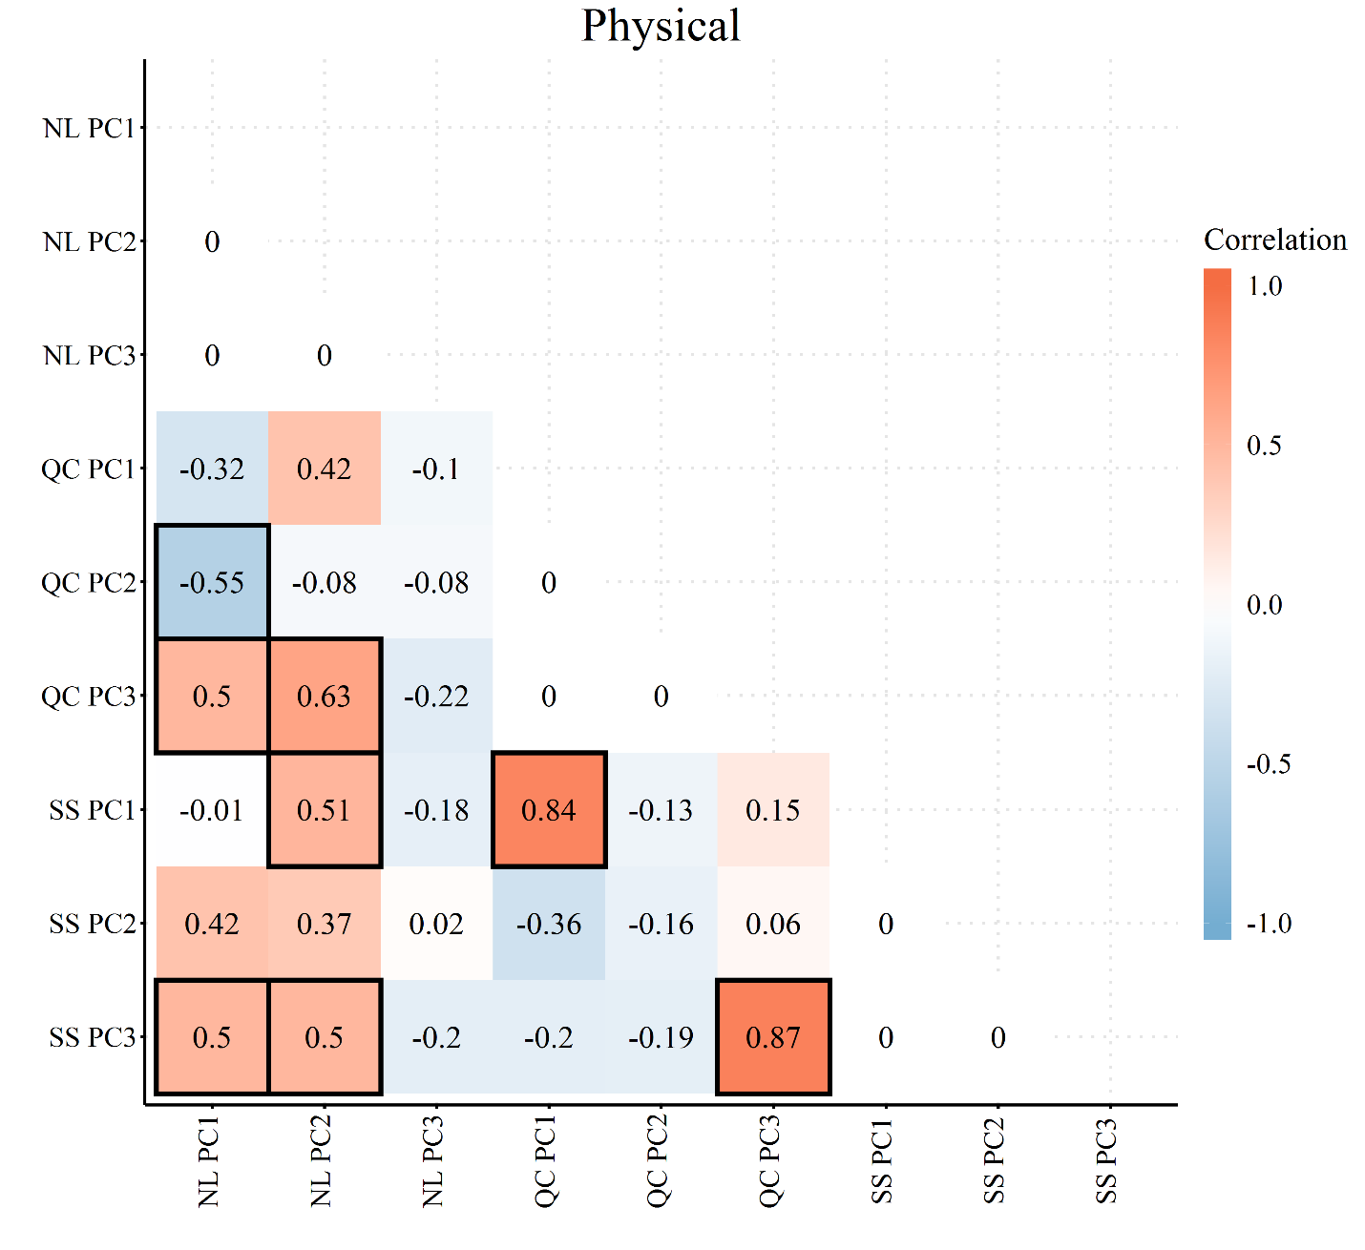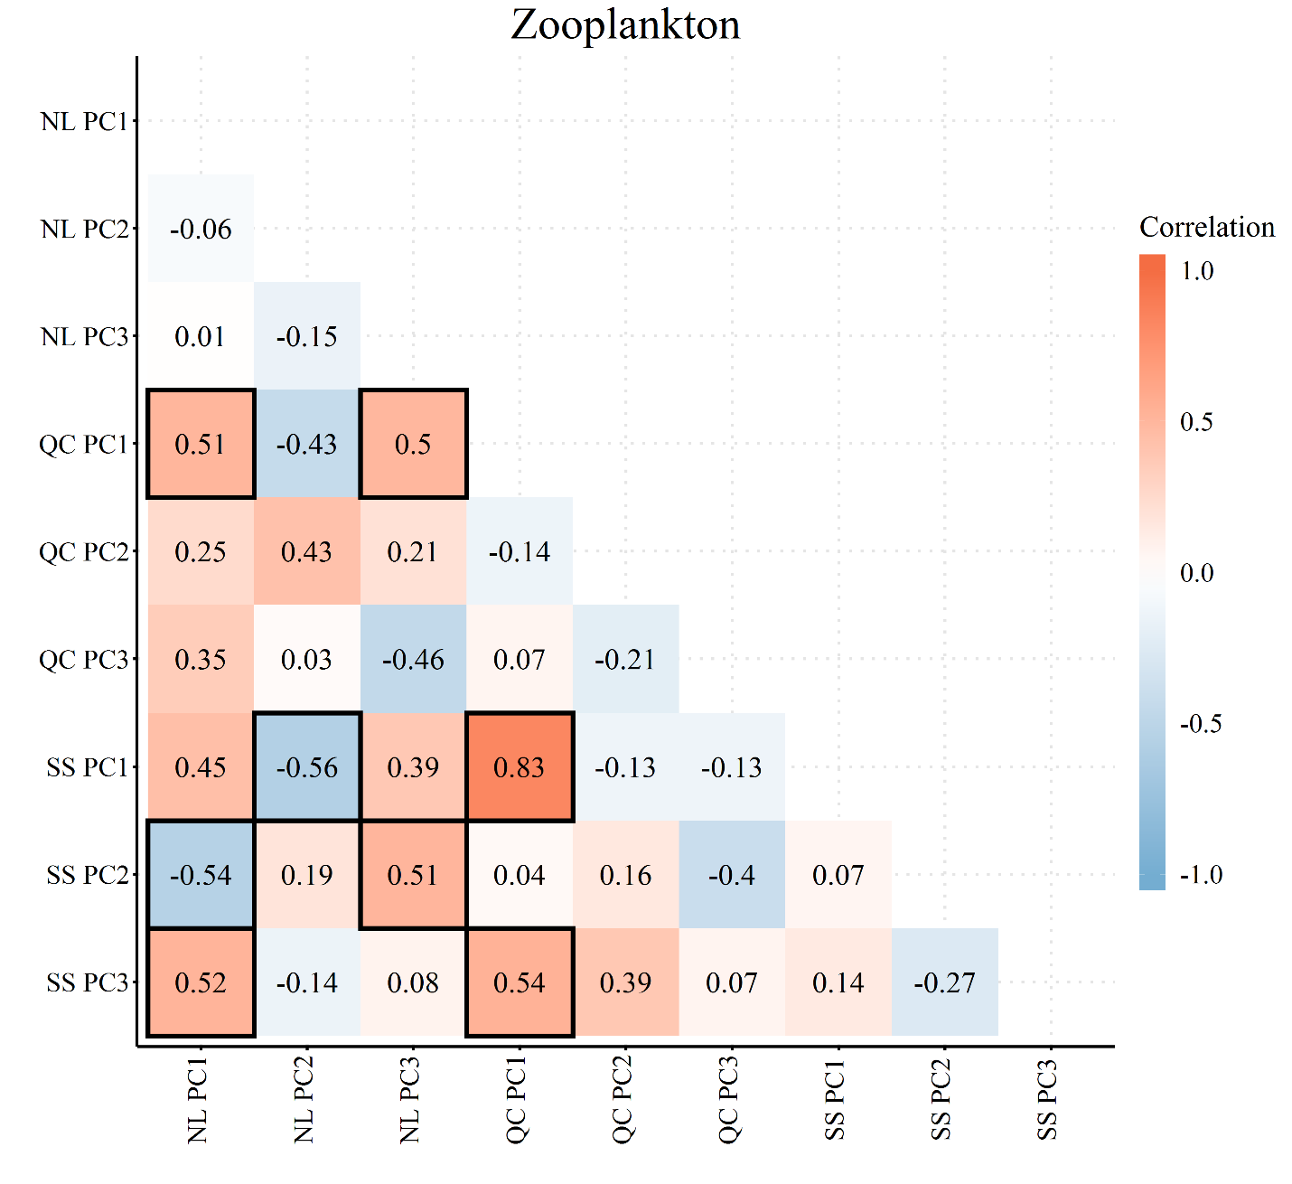**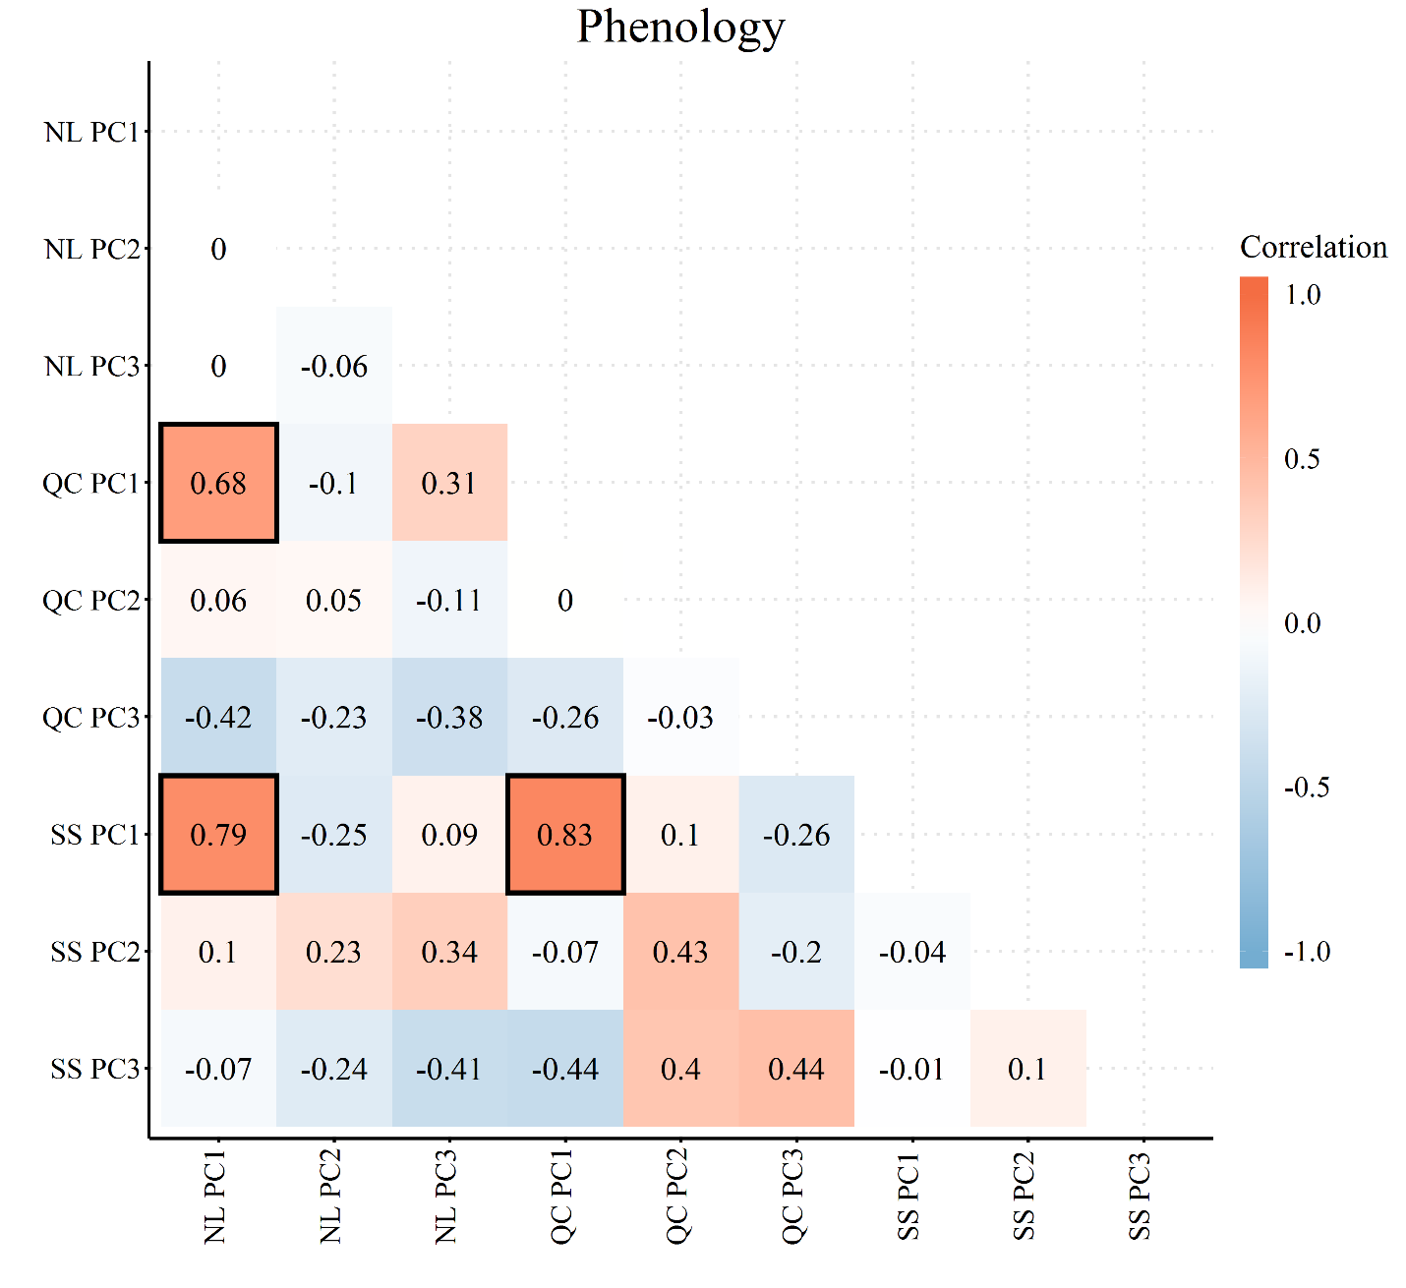**

**Newfoundland Shelf**

E:\Reed\Fish\output\NL_scores.tiff

E:\Reed\Fish\output\NL_loadings.tiff

**Gulf of St. Lawrence**

E:\Reed\Fish\output\QC_scores.tiff

E:\Reed\Fish\output\QC_loadings.tiff

**Scotian Shelf**

**E:\Reed\Fish\output\SS_scores.tiff**

**E:\Reed\Fish\output\SS_loadings.tiff**