|  |  |
| --- | --- |
| [Team logo, car picture (optional)] | |
| **University Name** | Ecole Centrale de LYON |
| **Team Name** | Ecurie Piston Sport Auto |
| **Car Number** | 181 |
| **Main Team Contact (e-mail) for ESF related questions** | Guillaume.brault@ecl20.ec-lyon.fr |

|  |
| --- |
| **NOTE: For Alternative Fuelled Vehicles and Hybrids please raise an FSQD question on the specific requirements for your ESF before beginning to complete the form**  **\*\*\*\* Requirements & Guidance on completion of ESF \*\*\*\***  **This section should be deleted before submission of your ESF** Note that deletion of this section indicates that you have read, understood and complied with it.  Read the document “How to complete ESF” which is available at: <https://www.fsaeonline.com/content/How-to-Complete-ESF.pptx>  Maximum number of pages for the ESF is 120 pages without the Appendix and Changelog.  Links to video or audio data are prohibited.  Every section of the ESF Template must be filled with content. If the respective part is not relevant for your concept, briefly describe why not. For EVs, if you do not fill out the tables or if you change the format of the ESF Template, you will fail by default.  The table of contents must be hyperlinked.  Use internal reference links. For example, when describing wiring and mentioning a figure in the text then link it to the figure.  Do not just copy all of your datasheets in the appendix, e.g. we do not need to know what you have to do to program your motor controller; we do not need the whole user manuals of microcontrollers to review your ESF, etc. However, do not just paste only a link to the entire data sheet. ***We should not need an internet connection to obtain the information necessary to review your ESF.***  Single pages/figures/tables extracted from the complete datasheet showing the important parameters, figures, etc. are usually sufficient, but the source/link to the complete datasheet must be provided. If the datasheet describes more than one type, clearly mark in the datasheet to which type you are referring / which type you plan to use (e.g. if you copy a datasheet describing a complete range of relays. If you selected the 24V SPDT monostable version, you must highlight the information referring to this specific version).  Datasheets should only be used as a reference. Please cover the important data in your text by using tables, figures, etc.  If you refer to parts of a data sheet, then you need to provide an internal document links from the text to the respective datasheet and another internal document link back from the datasheet to the text section.  For example a link in the motor controller section “The datasheet can be found here (clickable)” and a link above the motor controller datasheet in the appendix “The section covering the motor controller can be found here (clickable)”.  If you are unsure with respect to feedback of the reviewer, do not hesitate to write an e-mail and ask.  Parts of the ESF which are changed because of reviewer’s feedback must be noted in the Changelog  Following these guidelines will guarantee a swift review process |

Table of Contents

Table of Contents ii

I Changelog vii

II List of Figures viii

III List of Tables ix

IV List of Abbreviations x

1 System Overview 1

2 Electrical Systems 1

2.1 Shutdown Circuit 1

2.1.1 Description/concept 1

2.1.2 Wiring / additional circuitry 2

2.1.3 Position in car 3

2.1.4 Failure control, detection and mitigation 3

2.2 IMD 3

2.2.1 Description (type, operation parameters) 3

2.2.2 Wiring/cables/connectors/ 3

2.2.3 Position in car 3

2.2.4 Failure detection, control and mitigation 4

2.3 Inertia Switch 4

2.3.1 Description (type, operation parameters) 4

2.3.2 Wiring/cables/connectors/ 4

2.3.3 Position in car 4

2.3.4 Failure detection, control and mitigation 4

2.4 Reset / Latching for IMD and AMS 4

2.4.1 Description/circuitry 4

2.4.2 Wiring/cables/connectors 5

2.4.3 Position in car 5

2.4.4 Failure detection, control and mitigation 5

2.5 Brake Over-Travel Switch (BOTS) 5

2.5.1 Description/circuitry 5

2.5.2 Wiring/cables/connectors 5

2.5.3 Position in car 5

2.5.4 Failure detection, control and mitigation 5

2.6 Brake System Plausibility Device (BSPD) 6

2.6.1 Description/additional circuitry 6

2.6.2 Schematic 6

2.6.3 Connection with the shutdown circuit 6

2.6.4 Position in car/mechanical fastening/mechanical connection 6

2.6.5 Disconnection of BSPD sensors 6

2.6.6 Failure detection, control and mitigation 7

2.7 Shutdown System Interlocks 7

2.7.1 Description/circuitry 7

2.7.2 Wiring/cables/connectors 7

2.7.3 Position in car 7

2.7.4 Failure detection, control and mitigation 7

2.8 Measurement points 7

2.8.1 Description 7

2.8.2 Wiring, connectors, cables 7

2.8.3 Position in car 8

2.8.4 Failure detection, control and mitigation 8

2.9 HV Disconnect (HVD) 8

2.9.1 Description 8

2.9.2 Wiring, cables, current calculations, connectors 8

2.9.3 Position in car 8

2.9.4 Failure detection, control and mitigation 8

2.10 Pre-Charge circuitry 8

2.10.1 Description 8

2.10.2 Wiring, cables, current calculations, connectors 9

2.10.3 Position in car 9

2.10.4 Failure detection, control and mitigation 10

2.11 Discharge circuitry 10

2.11.1 Description 10

2.11.2 Wiring, cables, current calculations, connectors 10

2.11.3 Position in car 11

2.11.4 Failure detection, control and mitigation 11

2.12 Tractive System Active Light (TSAL) 11

2.12.1 Description/circuitry 11

2.12.2 Wiring/cables/connectors 12

2.12.3 TSAL Power 12

2.12.4 Position in car 12

2.12.5 Failure detection, control and mitigation 12

2.13 Activating the tractive system 12

2.13.1 Description 12

2.13.2 Wiring, cables, current calculations, connectors 12

2.13.3 Position in car 12

2.13.4 Failure detection, control and mitigation 12

2.14 Ready-To-Drive Mode 13

2.14.1 Description 13

2.14.2 Ready to Drive Sound (RTDS) 13

2.14.3 Wiring, cables, current calculations, connectors 13

2.14.4 Position in car 13

2.14.5 Failure detection, control and mitigation 13

3 Accumulators 13

3.1 TS Accumulator pack(s) 13

3.1.1 Overview/description/parameters 13

3.1.2 Cell description 14

3.1.3 Cell configuration 14

3.1.4 Cell temperature monitoring 14

3.1.5 Accumulator Materials 15

3.1.6 Accumulator Management System 15

3.1.7 Accumulator indicator 16

3.1.8 Wiring, cables, current calculations, connectors 16

3.1.9 Maintenance Plugs 17

3.1.10 Accumulator isolation relays 17

3.1.11 Fusing 17

3.2 GLV Accumulator 18

3.2.1 Description 18

3.2.2 Wiring, cables, current calculations, connectors 19

3.2.3 Position in car 19

3.3 DC/DC Converters (if used) 19

4 Charging 19

4.1.1 Mechanical Configuration/materials 20

4.1.2 Position in car 20

4.1.3 Charging Shutdown Circuit 20

4.1.4 Failure detection, control and mitigation 20

5 Data Logger 20

5.1 Description 20

5.2 Wiring, cables, current calculations, connectors 20

5.3 Position in car 21

6 Motors and controllers 21

6.1 Motor controller(s) 21

6.1.1 Description, type, operation parameters 21

6.1.2 Wiring, cables, current calculations, connectors 21

6.1.3 Position in car 22

6.1.4 Failure detection, control and mitigation 22

6.2 Motors 22

6.2.1 Description, type, operating parameters 22

6.2.2 Wiring, cables, current calculations, connectors 23

6.2.3 Position in car 23

6.2.4 Failure detection, control and mitigation 23

7 Overall Grounding Concept 23

7.1 Description of the Grounding Concept 23

7.2 Grounding Measurements 23

7.3 Failure detection, control and mitigation 23

8 Firewall(s) 23

8.1 Description/materials 23

8.2 Position in car 24

9 Torque and Brake Encoders 24

9.1 Torque Encoders 24

9.1.1 Description/additional circuitry 24

9.1.2 Torque Encoder Plausibility Check 24

9.1.3 Wiring 24

9.1.4 Position in car/mechanical fastening/mechanical connection 25

9.1.5 Failure detection, control and mitigation 25

9.2 Brake encoder 25

9.2.1 Description/additional circuitry 25

9.2.2 Brake Encoder Plausibility Check 25

9.2.3 Wiring 25

9.2.4 Position in car/mechanical fastening/mechanical connection 25

9.2.5 Failure detection, control and mitigation 26

10. Additional LV-parts interfering with the tractive system 26

10.1. LV part 1 26

10.1.1. Description 26

10.1.2. Wiring, cables, 26

10.1.3. Position in car 26

10.2. LV part 2 26

10.2.1. Description 26

10.2.2. Wiring, cables, 26

10.2.3. Position in car 26

Appendix 1

# Changelog

|  |  |
| --- | --- |
| **Chapter** | **Change** |
|  |  |

# List of Figures

Figure 1 : Shutdown Circuit Schematic 3

Figure 2: IMD intermediate circuit schematic 6

# List of Tables

Table 1.1 General parameters 1

Table 2.1 List of switches in the shutdown circuit 2

Table 2.2 Wiring – Shutdown circuit 2

Table 2.3 Parameters of the IMD 3

Table 2.4 Parameters of the Inertia Switch 4

Table 2.5 BSPD data 6

Table 2.6 General data of the pre-charge resistor 9

Table 2.7 General data of the pre-charge relay 9

Table 2.8 General data of the discharge circuit 10

Table 2.9 General data of the dis-charge relay 11

Table 2.10 Parameters of the TSAL 12

Table 3.1 TS accumulator parameters 14

Table 3.2 Main cell specification 14

Table 3.3 Cell temperature monitoring 15

Table 3.4 Accumulator Materials 15

Table 3.5 Cell voltage limits 15

Table 3.6 Wire data 17

Table 3.7 Basic AIR data 17

Table 3.8 Basic fuse data 18

Table 3.9 Fuse Protection Table 18

Table 3.10 GLV accumulator data 19

Table 4.1 General charger data 20

Table 6.1 General motor controller data 21

Table 6.2 Wire data 21

Table 6.3 General motor data 22

Table 9.1 Torque encoder data (add additional rows for each type of torque encoder used) 24

Table 9.2 Brake encoder data 25

Must be hyperlinked!

# List of Abbreviations

Define any abbreviations/acronyms which are not listed in the rules.

|  |  |
| --- | --- |
| Abbreviation/ Acronym | Definition |
| ACC AIR  AMS BMS  BOTS BSPD  GLV GLVMP GLVMS HV HV+ HV- IC  IMD MaxTSVolt PCB SC TS TSAC TSAL TSMP TSMS | Accumulator (High voltage battery) Accumulator Insulation Relay Accumulator Management System Battery Monitoring System Brake-Over-Travel-Switch Brake System Plausibility Device Grounded Low Voltage Ground Low Voltage Measurement Point Ground Low Voltage Master Switch High Voltage  Positive terminal of the HV battery (at the vehicle side of the AIR) Negative terminal of the HV battery (at the vehicle side of the AIR) Integrated Circuit Insulation Monitoring Device Maximum Tractive System Voltage Printed Circuit Board Shutdown Circuit Tractive System Tractive System Accumulator Container Tractive System Active Light Tractive System Measurement Point Tractive System Master Switch |

# System Overview

|  |
| --- |
| This electric vehicle is designed for a race environment where it must have high acceleration, good stability, and the ability to run for 30 minutes continuously with safety as the highest priority. The vehicle is driven by a single electric motor driving our two rear wheel, the motor is control via our VCU. Our battery pack is in 140s5p configuration composed of ten 14s5p segments in series with total available energy of 7,56kWh and nominal voltage of 504 VDC.   * Rough Schematic (blocks) showing all parts affected with the electrical systems and function of the tractive system * No detailed wiring |

Complete the following table, replacing the values with your specifications:

|  |  |  |  |  |  |  |  |  |  |  |  |
| --- | --- | --- | --- | --- | --- | --- | --- | --- | --- | --- | --- |
| Maximum Tractive-system voltage: | Nominal Tractive-system voltage: | Control-system voltage: | Accumulator configuration: | Total Accumulator capacity: | Nominal TS Accumulator current: | Maximum TS Accumulator current: | TS accumulator cell type: | GLV Accumulator cell type: | Motor type: | Number of motors: | Maximum combined motor power in kW |
| 588VDC | 504VDC | 12VDC | 140s5p | 15Ah | 100A | 175A | Lithium nickel manganese cobalt oxides (NMC) | Lithium-Ion Polymer | synchronous permanent magnet electric motor | Total 1, one for the 2 rear wheel | 100kW |

Table 1.1 General parameters

# Electrical Systems

## Shutdown Circuit

### Description/concept

|  |
| --- |
| The shutdown circuit is a series of relays and switches cutting the power of the AIRs coils in case of a problem or when the vehicle is disabled on purpose via one of the Master Switches. When the Shutdown Circuit is open, the AIRs coils are not powered and the TS is desactivate. |

Complete the following table replacing the values with your specification and append additional switches from your setup:

| **Part** | **Function** |
| --- | --- |
| Main Switch (for control and tractive system; GLMS, TSMS) | Normally open |
| Brake over travel switch (BOTS) | Normally closed |
| Shutdown buttons (SCBs) | Normally closed |
| Insulation Monitoring Device (IMD) | Normally open |
| Accumulator Management System (AMS) | Normally open |
| Inertia Switch | Normally closed |
| HVD interlock | Closed when HVD is connected |
| Brake System Plausibility Device (BSPD) | Normally Opened |
| TS Activation relays | Normally Opened |
| VCU Fault relays and Inverter Fault relays | Normally Opened |
| Precharge circuit relays | Normally Opened |

Table 2.1 List of switches in the shutdown circuit

### Wiring / additional circuitry

|  |
| --- |
| To comply with the FSUK rules the SC is composed of 2 main switches : the GLVMS and the TSMS, 3 SCBs, an inertia switch, a BOTS, 3 relays controlled respectively by the BSPD, the AMS and the IMD, the HVD interlock. We also add 2 relays in parallel for the AIR+ and the precharge contactor, 2 relays controlled by the VCU and the Inverter and a relays ensuring activation of the TS in compliance with FSUK rules.  In this Shutdown circuit except for the SCBs, the inertia switches, the BOTS and HVD (when connected) all systems are in Normally Opened configuration.    Figure : Shutdown circuit schematic |

Fill out and add information to the following table:

|  |  |  |  |  |
| --- | --- | --- | --- | --- |
| Total Number of AIRs: | Current per AIR: | Additional parts consumption within the shutdown circuit: | Total current: | Cross sectional area of the wiring used: |
| 2 | 1,5A | 0,5A | 3,5A | 1.31 mm² |

Table 2.2 Wiring – Shutdown circuit

### Position in car

|  |
| --- |
| Provide CAD renderings showing the relevant parts. Mark the parts in the renderings, if necessary. |

### Failure control, detection and mitigation

|  |
| --- |
| Key failure of the SC usually comes from a sensor (current or pressure sensor for BSPD, temperature sensor for AMS, ground sensor for IMD) being short circuit or open circuit. SC circuit (AMS, IMD, BSPD) are designed to pulled down the signal at fault, immediately cutting the power to the respective relays coil resulting in an open SC. Each of these circuit are controlled during the scrutineering by disconnecting each sensor and verifying it open the SC. |

## IMD

### Description (type, operation parameters)

|  |
| --- |
| To comply with FSUK rules we used a Bender IR155-3203 IMD with a setpoint of 300kOhms because it ensure an isolation superior to 500Ohms/Volt for our MaxTSVolt which is 588V. In our vehicle, the IMD is connected to the HV+ and HV- at the vehicle side of the AIR and to the grounded roll hoop which is in direct connection with the GLV, thus the IMD can detect an isolation fault between the HV and the GLV. When a fault is detected, the Output signal is pulled low which open the Shutdown Circuit by an intermediate circuit which is place outside of the TSAC. The IMD indicator light is power on by the intermediate circuit when the IMD fault signal is pulled down.  The datasheet of the IMD can be found here. |

Complete the following table replacing the values with your specification:

|  |  |  |  |  |  |  |  |
| --- | --- | --- | --- | --- | --- | --- | --- |
| Supply voltage range: | Supply voltage | Environmental temperature range: | Self-test interval: | High voltage range: | Set response value: | Max. operation current: | Approximate time to shut down at 50% of the response value: |
| 10..36VDC | 24VDC | -40..105°C | Always at startup, then every 20 minutes | DC 0..1000V | 300kΩ (500Ω/Volt) | 500mA | 27s |

Table 2.3 Parameters of the IMD

### Wiring/cables/connectors/

|  |
| --- |
| The IMD itself is place in an housing inside the TSAC, the HV+ and HV- are wired directly from the AIR to the IMD housing. The IMD signal output is wired from the IMD to an intermediate circuit which is place in an housing outside of the TSAC. The IMD intermediate circuit is shown below, the SC can be seen in green. To ensure proper connection trough IMD housing and TSAC we use 8STA SOURIAU connectors. Datasheet of the connectors can be found here.    Figure : IMD intermediate circuit schematic |

### Position in car

|  |
| --- |
| Provide CAD renderings showing the relevant parts. Mark the parts in the rendering, if necessary. |

### Failure detection, control and mitigation

|  |
| --- |
| A failure of the IMD usually comes from an opened circuit or a short circuit to ground of the output fault wire, it cause the intermediate circuit to opened the SC and powered on the IMD Indicator Light. Proper verification is perform during scrutineering by disconnecting the IMD fault wire. |

## Inertia Switch

### Description (type, operation parameters)

|  |
| --- |
| The inertia switch used is a Sensata Technologies’ 360° Resettable Crash Sensors, it meets the FSUK 2022 regulations. Ratings of the inertia switch can be found here. |

Complete the following table replacing the values with your specification:

|  |  |  |  |  |  |
| --- | --- | --- | --- | --- | --- |
| Inertia Switch type: | Supply voltage range: | Supply voltage: | Environmental temperature range: | Max. operation current: | Trigger characteristics: |
| Sensata Technologies’ 360° Resettable Crash Sensors | 10..36VDC | 12VDC | **e.g.** -40..105°C | 10A | 8g for 50ms / 13g for 20ms |

Table 2.4 Parameters of the Inertia Switch

### Wiring/cables/connectors/

|  |
| --- |
| The Inertia Switch wiring is shown in Figure 1. |

### Position in car

|  |
| --- |
| Provide CAD renderings showing the relevant parts. Mark the parts in the rendering, if necessary. |

### Failure detection, control and mitigation

|  |
| --- |
| The Inertia Switch is tested during scrutineering by shaking it. |

## Reset / Latching for IMD and AMS

### Description/circuitry

|  |
| --- |
| Describe the concept and circuitry of the latching/reset system for a tripped IMD or AMS. Describe the method for resetting the IMD and AMS. |

### Wiring/cables/connectors

|  |
| --- |
| Describe wiring, show schematics, describe connectors and cables used and show useful data regarding the wiring. If not detailed in section 2.1, be sure to show how the device opens the shutdown circuit. |

### Position in car

|  |
| --- |
| Provide CAD renderings showing the relevant parts. Mark the parts in the rendering, if necessary. |

### Failure detection, control and mitigation

|  |
| --- |
| Briefly describe the causes and consequences of key failures of your latching/reset system, its inputs or outputs and how they are detected, mitigated and controlled. |

## Brake Over-Travel Switch (BOTS)

### Description/circuitry

|  |
| --- |
| Describe the concept and circuitry of the BOTS. Describe the method how your BOTS solution fulfils T6.2.1. |

### Wiring/cables/connectors

|  |
| --- |
| Describe wiring, show schematics, describe connectors and cables used and show useful data regarding the wiring. If not detailed in section 2.1, be sure to show how the device opens the shutdown circuit. |

### Position in car

|  |
| --- |
| Provide CAD renderings showing the relevant parts. Mark the parts in the rendering, if necessary. |

### Failure detection, control and mitigation

|  |
| --- |
| Briefly describe the causes and consequences of key failures of your BOTS, its inputs or outputs and how they are detected, mitigated and controlled. |

## Brake System Plausibility Device (BSPD)

### Description/additional circuitry

|  |
| --- |
| Describe how your electronic hardware brake plausibility system works (this is in addition to your ECU controlled brake plausibility software), provide tables with main operation parameters, and describe additional circuitry used to check or for an implausibility. Describe how the system reacts if an implausibility or error is detected. |

|  |  |  |  |  |  |  |  |  |
| --- | --- | --- | --- | --- | --- | --- | --- | --- |
| Brake sensor used: | Brake sensor physical response value: | Tractive system power sensor type | Tractive system sensor physical response value: | Tractive System power sensor current threshold (5kW/Nominal TS voltage): | Supply voltages: | Maximum supply currents: | Operating temperature: | Output used to control AIRs: |
| **e.g.** ABC Sensor |  |  |  |  | **e.g.** 5V | **e.g.** 20mA | **e.g.** -20..180 °C | **e.g.** Open a relay |

Table 2.5 BSPD data

### Schematic

|  |
| --- |
| Describe the wiring, show schematics including the circuit board, show data regarding the cables and connectors used. |

### Connection with the shutdown circuit

|  |
| --- |
| Show how the device open the shutdown circuit. |

### Position in car/mechanical fastening/mechanical connection

|  |
| --- |
| Provide CAD renderings showing all relevant parts and discuss the mechanical connection of the sensors to the pedal assembly. Mark the parts in the rendering, if necessary. |

### Disconnection of BSPD sensors

|  |
| --- |
| Show how the current sensor and brake system pressure sensor can be disconnected from the BSPD. Describe the BSPD operation if any sensor is disconnected. Provide CAD renderings showing all relevant parts if necessary. |

### Failure detection, control and mitigation

|  |
| --- |
| Briefly describe the causes and consequences of key failures of your BSPD, its inputs or outputs and how they are detected, mitigated and controlled. |

## Shutdown System Interlocks

### Description/circuitry

|  |
| --- |
| Describe the concept and circuitry of the Shutdown System Interlocks. *Note: Interlocks are circuits used to open the shutdown circuit if a connector is disconnected or enclosure is opened. This is not the entire shutdown circuit.* |

### Wiring/cables/connectors

|  |
| --- |
| Describe wiring, show schematics, describe connectors and cables used and show useful data regarding the wiring. |

### Position in car

|  |
| --- |
| Provide CAD renderings showing the relevant parts. Mark the parts in the rendering, if necessary. |

### Failure detection, control and mitigation

|  |
| --- |
| Briefly describe the causes and consequences of key failures of your interlocks, their inputs or outputs and how they are detected, mitigated and controlled. |

## Measurement points

### Description

|  |  |
| --- | --- |
| Describe the housing used and how it can be accessed, etc. Describe how the measurement points are protected/covered when not in use and how the electrical connections on the back of the measurement points are protected when the measurement points are being used. | |
| Current limiting resistor Value: |  |

### Wiring, connectors, cables

|  |
| --- |
| Describe wiring, show schematics, and describe connectors and cables used and show useful data regarding the wiring. Include details on the protection resistor including resistance, voltage and power rating. |

### Position in car

|  |
| --- |
| Provide CAD renderings showing the relevant parts. Mark the parts in the rendering, if necessary. |

### Failure detection, control and mitigation

|  |
| --- |
| Briefly describe the causes and consequences of key failures of your measurement points or their inputs and how they are detected, mitigated and controlled. |

## HV Disconnect (HVD)

### Description

|  |
| --- |
| Describe your concept of the HVD and how it can be operated. |

### Wiring, cables, current calculations, connectors

|  |
| --- |
| Describe wiring, show schematics, describe connectors and cables and show useful data regarding the wiring. Include information on the working voltage and current rating of the HVD. |

### Position in car

|  |
| --- |
| Provide CAD renderings showing all relevant parts. Mark the parts in the rendering, if necessary. |

### Failure detection, control and mitigation

|  |
| --- |
| Briefly describe the impact of failures of your HVD and how they are detected, mitigated and controlled. |

## Pre-Charge circuitry

### Description

|  |
| --- |
| Describe your concept of the pre-charge circuitry. |

### Wiring, cables, current calculations, connectors

|  |
| --- |
| Describe wiring, show schematics, describe connectors and cables used and show useful data regarding the wiring.   * Give a plot “Percentage of Maximum Voltage” vs. time * Give a plot Current vs. time * For each plot, give the basic formula describing the plots |

Additionally, fill out the tables:

|  |  |  |  |  |  |  |  |
| --- | --- | --- | --- | --- | --- | --- | --- |
| Resistor Type: | Resistance: | Continuous power rating: | Overload power rating (1 sec): | Overload power rating (5 sec): | Overload power rating (15 sec): | Voltage rating: | Cross-sectional area of the wire used: |
| **e.g.** ABC Resistor | **e.g.** 680Ω | **e.g.** 60W |  |  |  | **e.g.** 1500V | **e.g.** 0.205 mm² |

Table 2.6 General data of the pre-charge resistor

|  |  |  |  |  |  |  |  |  |  |
| --- | --- | --- | --- | --- | --- | --- | --- | --- | --- |
| Relay Type: | Contact arrangement: | Continuous DC current: | Voltage rating | Nominal Coil Voltage: | FET type: | Maximum Drain-Source Current: | Drain-Source Breakdown Voltage: | On Characteristics Gate Threshold Voltage: | Cross-sectional area of the wire used: |
| **e.g.** DEF Relay | **e.g.** SPDT, SPST, SPCO, SPTT, DPST, …. | **e.g.** 25A | **e.g.** 2000VDC |  |  |  |  |  | **e.g.** 0.205 mm² |

Table 2.7 General data of the pre-charge relay

### Position in car

|  |
| --- |
| Provide CAD renderings showing all relevant parts. Mark the parts in the rendering, if necessary. |

### Failure detection, control and mitigation

|  |
| --- |
| Briefly describe the causes and consequences of key failures of your pre-charge system, its inputs or outputs and how they are detected, mitigated and controlled. |

## Discharge circuitry

### Description

|  |
| --- |
| Describe your concept of the discharge circuitry. |

### Wiring, cables, current calculations, connectors

|  |
| --- |
| Describe wiring, show schematics, describe connectors and cables used and show useful data regarding the wiring. |
| Plot “Voltage” vs. time and show the formula describing this behaviour |
| Plot “Discharge current” vs. time and show the formula describing your plot |

Additionally, fill out the table:

|  |  |  |  |  |  |  |  |  |  |
| --- | --- | --- | --- | --- | --- | --- | --- | --- | --- |
| Resistor Type: | Resistance: | Continuous power rating: | Overload power rating (1 sec): | Overload power rating (5 sec): | Overload power rating (15 sec): | Voltage rating: | Maximum expected current: | Average current: | Cross-sectional area of the wire used: |
| **e.g.** ABC Resistor | **e.g.** 680Ω | **e.g.** 350W | **e.g.** 600W |  |  | **e.g.** 1500V | **e.g.** 0.7A | **e.g.** 0.3A | **e.g.** 0.205 mm² |

Table 2.8 General data of the discharge circuit

|  |  |  |  |  |  |  |  |  |  |
| --- | --- | --- | --- | --- | --- | --- | --- | --- | --- |
| Relay Type: | Contact arrangement: | Continuous DC current: | Voltage rating | Nominal Coil Voltage: | FET type: | Maximum Drain-Source Current: | Drain-Source Breakdown Voltage: | On Characteristics Gate Threshold Voltage: | Cross-sectional area of the wire used: |
| **e.g.** DEF Relay | **e.g.** SPDT, SPST, SPCO, SPTT, DPST, …. | **e.g.** 25A | **e.g.** 2000VDC |  |  |  |  |  | **e.g.** 0.205 mm² |

Table 2.9 General data of the dis-charge relay

### Position in car

|  |
| --- |
| Provide CAD renderings showing all relevant parts. Mark the parts in the rendering, if necessary |

### Failure detection, control and mitigation

|  |
| --- |
| Briefly describe the causes and consequences of key failures of your discharge system, its inputs or outputs and how they are detected, mitigated and controlled. |

## Tractive System Active Light (TSAL)

### Description/circuitry

|  |
| --- |
| Describe the tractive system active light and additional circuitry. Show a state-machine diagram describing the operation modes of the TSAL. Provide schematic how the TS voltages are measured (DC-link capacitors and AIR vehicle side) and how the mechanical relay states (2 AIRs + pre-charge relay) are detected. |

Additionally, fill out the table:

| Indication | Supply voltage | Max. operational current | Lamp type | Power consumption: | Brightness | Frequency: | Size (length x height x width): |
| --- | --- | --- | --- | --- | --- | --- | --- |
| **RED** | **e.g.** 12VDC | **e.g.** 700mA | **e.g.** LED | **e.g.** 4.5W | **e.g.** 100 Lumen | **e.g.** 1.5Hz | **e.g.** 20mm x 10mm x 50mm |
| **GREEN** |  |  |  |  |  |  |  |

Table 2.10 Parameters of the TSAL

### Wiring/cables/connectors

|  |
| --- |
| Describe wiring, show schematics, describe connectors and cables used and show useful data regarding the wiring. Include gauge, voltage and temperature rating of wiring used and any fuses or other overcurrent protection used. |

### TSAL Power

|  |
| --- |
| Describe how your TSAL is powered to ensure it can remain active for at least 15 minutes after the LVs is switched off. Describe the method used (if any) to deactivate the TSAL when the LVS is switched off and the TS is confirmed to be deactivated. |

### Position in car

|  |
| --- |
| Provide CAD renderings showing the relevant parts. Mark the parts in the rendering, if necessary. |

### Failure detection, control and mitigation

|  |
| --- |
| Briefly describe the causes and consequences of key failures of your TSAL system, its inputs or outputs and how they are detected, mitigated and controlled. |

## Activating the tractive system

### Description

|  |
| --- |
| Describe the process for activating the tractive system and explain how the TS cannot be activated closing the shutdown circuit (EV4.11.3). |

### Wiring, cables, current calculations, connectors

|  |
| --- |
| Describe wiring, show schematics, describe connectors and cables and show useful data regarding the wiring. |

### Position in car

|  |
| --- |
| Provide CAD renderings showing all relevant parts. Mark the parts in the rendering, if necessary. |

### Failure detection, control and mitigation

|  |
| --- |
| Briefly describe the causes and consequences of key failures of your TS activation system, its inputs or outputs and how they are detected, mitigated and controlled. |

## Ready-To-Drive Mode

### Description

|  |
| --- |
| To activate Ready-To-Drive mode, the pilot must press to brake pedal and a dedicated button on the dashboard for 1 second. The Ready-To-Drive mode can’t be activated unless the shutdown circuit is closed. The VCU is constantly looking for the input on the dashboard and the pressing on the brake pedal. The Ready-To-Drive mode is deactivated when any of this is detected: the shutdown circuit is opened, a fault from the APPS is detected, the pilot presses both the accelerator and the brake pedals, an error is detected by the inverter. When the Ready-To-Drive mode is activated, a sound of approximately 90 dB is produced for 2 seconds by a buzzer located on the top of the main hoop. This buzzer is directly powered by a logic output of the VCU (12 VDC). |

### Ready to Drive Sound (RTDS)

|  |
| --- |
| A continuous sound is produced by a buzzer located on the top of the main hoop. This buzzer is powered by the VCU. This sound is produced during 2 second when the Ready-To-Drive mode is activated. |

### Wiring, cables, current calculations, connectors

|  |
| --- |
| Describe wiring, show schematics, describe connectors and cables and show useful data regarding the wiring. |

### Position in car

|  |
| --- |
| Provide CAD renderings showing all relevant parts. Mark the parts in the rendering, if necessary. |

### Failure detection, control and mitigation

|  |
| --- |
| Briefly describe the causes and consequences of key failures of your ready to drive system or the RTDS, its inputs or outputs and how they are detected, mitigated and controlled. |

# Accumulators

## TS Accumulator pack(s)

### Overview/description/parameters

|  |  |
| --- | --- |
| 1 | Describe the concept of the TS accumulator pack, provide table with main parameters like number of cells, cell stacks separated by maintenance plugs, cell configuration, resulting voltages (minimum, maximum, nominal), currents, capacity etc. |
| 2 | Where more than one TS accumulator is used, add additional rows describing any differences, etc. (if identical parts are used, just refer to the corresponding sections, do not copy and paste) |

Fill out the following table (add additional rows for additional accumulators if required):

|  |  |  |  |  |  |  |  |  |  |  |
| --- | --- | --- | --- | --- | --- | --- | --- | --- | --- | --- |
| Accumulator | Maximum Voltage: | Nominal Voltage: | Minimum Voltage: | Maximum output current: | Maximum nominal current: | Maximum charging current: | Total numbers of cells: | Cell configuration: | Total Capacity: | Number of cell stacks < 120VDC |
| **1** | **e.g.** 550VDC | **e.g.** 500VDC | **e.g.** 300VDC | **e.g.** 405A for 10s | **e.g.** 250A | **e.g.** 50A | **e.g.** 200 | **e.g.** 100s2p | **e.g.** 21.6 MJ | **e.g.** 5 |
|  |  |  |  |  |  |  |  |  |  |  |

Table 3.1 TS accumulator parameters

### Cell description

|  |
| --- |
| Describe the cell type(s) used and the chemistry, provide table with main parameters |

Fill out the following table:

| Cell Manufacturer and Type | Cell nominal capacity: | Maximum Voltage: | Nominal Voltage: | Minimum Voltage: | Maximum output current: | Maximum nominal output current: | Maximum charging current: | Maximum Cell Temperature | | Cell chemistry: |
| --- | --- | --- | --- | --- | --- | --- | --- | --- | --- | --- |
| Discharging | Charging |
| **e.g.** Kokam XYZ | **e.g.** 5.4 Ah | **e.g.** 4.2 V | **e.g.** 3.7V | **e.g.** 2.8V | **e.g.** 20C for 10s | **e.g.** 15C | **e.g.** 5C | **e.g.** 65°C | **e.g.** 55°C | **e.g.** LiFePO4 |

Table 3.2 Main cell specification

### Cell configuration

|  |  |
| --- | --- |
| 1 | Describe cell configuration, cell interconnect, show schematics of electrical configuration and CAD rendering of connection techniques, cover additional parts like internal cell fuses etc. |
| 2 | Where more than one TS accumulator is used, add additional rows describing any differences in cell configuration, cell interconnection, etc. (if identical parts are used, just refer to the corresponding sections, do not copy and paste) |

### Cell temperature monitoring

|  |  |
| --- | --- |
| 1 | Describe how the temperature of the cells is monitored, where the temperature sensors are placed, how many cells are monitored, etc. Show schematics, cover additional parts, etc. |
| 2 | Where more than one TS accumulator is used, add additional rows describing any differences (if identical parts and configurations are used, just refer to the corresponding sections, do not copy and paste) |

|  |  |  |  |  |  |
| --- | --- | --- | --- | --- | --- |
| Temperature sensor accuracy: | Total number of cells: | Total number of sensors: | Max. distance from monitored negative cell terminal: | AMS opens AIRs during dis-charging if cell temperature is above: | AMS opens AIRs during charging if cell temperature is above: |
|  |  |  |  |  |  |

Table 3.3 Cell temperature monitoring

### Accumulator Materials

Complete the table below, identifying the materials used within the accumulator(s)

| Material | Usage | Fire Retardancy | Data Sheet Reference |
| --- | --- | --- | --- |
| e.g. 2.5mm x 100mm Cable Ties | e.g. Sense wire looms | e.g. UL94 V-0 | (link to appendix) |

Table 3.4 Accumulator Materials

### Accumulator Management System

|  |  |  |
| --- | --- | --- |
| Minimum cell voltage (shutdown limit): | Maximum cell voltage (shutdown limit): | Measurement precision (mV): |
|  |  |  |

Table 3.5 Cell voltage limits

|  |
| --- |
| Describe the AMS used including at least the following:   * Sense wiring protection (fusing / fusible link wire used) * What upper and lower voltage does the AMS react at and how does it react? * What cell temperature does the AMS react at and how does it react? * Show tables of operation parameters * Describe how many cells are sensed by each AMS board, the configuration of the cells, the configuration of the boards and how any comms wiring between boards is protected * Describe how the AMS is able to open the AIRs if any error is detected * Describe where galvanic isolation occurs between TS and GLV system connections. |

#### Failure detection, control and mitigation

|  |
| --- |
| Briefly describe the causes and consequences of key failures of your AMS, its inputs or outputs and how they are detected, mitigated and controlled. |

### Accumulator indicator

|  |  |
| --- | --- |
| 1 | Describe the indicator, show wiring, provide tables with operation, PCB design, etc. |
| 2 | Where more than one TS accumulator is used, add additional rows describing any differences in the accumulator indicators (if identical parts are used, just refer to the corresponding sections, do not copy and paste). |

#### Failure detection, control and mitigation

|  |
| --- |
| Briefly describe the causes and consequences of key failures of your Accumulator Indicator, its inputs or outputs and how they are detected, mitigated and controlled. |

### Wiring, cables, current calculations, connectors

|  |
| --- |
| Describe the internal wiring, show schematics, provide calculations for currents and voltages and show data regarding the cables and connectors used.   * Discuss maximum expected current, DC and AC how long will this be provided? * Compare the maximum values to nominal currents * Describe your maintenance plugs, provide pictures |

Complete the table below for each type of wire in your tractive system

| Wire type | Continuous current rating: | Cross-sectional area | Maximum operating voltage: | Temperature rating: | Wire connects the following components: |
| --- | --- | --- | --- | --- | --- |
| **e.g.** Company A, 0.205 mm² | **e.g.** 150A | **e.g.** 0.205mm² | **e.g.** 800VDC | **e.g.** 150°C | **e.g.** Cell and AMS |
|  |  |  |  |  |  |

Table 3.6 Wire data

### Maintenance Plugs

|  |
| --- |
| Describe your maintenance plugs, provide images and explain how the design ensures that it is physically impossible to electrically connect them in an incorrect configuration. |

### Accumulator isolation relays

|  |
| --- |
| Describe the AIRs used and their main operation parameters, how their state is monitored, etc. |

Additionally, fill out the following table:

| Relay Type: | Contact arrangement: | Continuous DC current rating: | Overload DC current rating: | Maximum operation voltage: | Nominal coil voltage: | Normal Load switching: | Maximum Load switching |
| --- | --- | --- | --- | --- | --- | --- | --- |
| **e.g.** ABC Relay | **e.g.** SPST | **e.g.** 100A | **e.g.** 200A for 10sec | **e.g.** 800VDC | **e.g.** 24VDC | **e.g.** Make and break up to 300A | 10 times at 1500A |

Table 3.7 Basic AIR data

#### Failure detection, control and mitigation

|  |
| --- |
| Briefly describe the causes and consequences of key failures of your AIRs, their inputs or outputs and how they are detected, mitigated and controlled. |

### Fusing

|  |
| --- |
| Describe the fuses used and their main operation parameters, use tables, etc. |

Additionally, fill out the following table for each fuse type used:

| Fuse manufacturer and type | Continuous current rating | Maximum operating voltage | Type of fuse | I2t rating | Interrupt Current (maximum current at which the fuse can interrupt the current) |
| --- | --- | --- | --- | --- | --- |
| **e.g.** ABC Fuse company, MNO Fuse | **e.g.** 150A | **e.g.** 500VDC | **e.g.** High speed | **e.g.** 1500A2s at 450VDC | **e.g.** 10000A |
|  |  |  |  |  |  |

Table 3.8 Basic fuse data

Create a table with components and wires protected by the fuse(s) and the according continuous current rating. There is an example table below with some potential entries. Complete this table with information for your design and add / remove additional locations as applicable. Ensure that the rating of all the components is greater than the rating of the fuse such that none of the other components become the fuse.

| Location | Wire Size | Wire Ampacity | Fuse type | Fuse rating |
| --- | --- | --- | --- | --- |
| e.g. Cells to AIRs | e.g. 2 AWG |  | e.g. MNO Fuse |  |
|  |  |  |  |  |

Table 3.9 Fuse Protection Table

#### Failure detection, control and mitigation

|  |
| --- |
| Briefly describe the causes and consequences of key failures of your fuses and how they are detected, mitigated and controlled. |

## GLV Accumulator

### Description

|  |
| --- |
| Describe your concept of the GLV Accumulator. |

| Cell/ Accumulator: | Accumulator configuration – parallel: | Accumulator configuration – series: | Maximum Voltage: | Nominal Voltage: | Minimum Voltage: | Max. Continuous Discharge Current: | Peak Discharge Current: | Peak Discharge Current Time: | Max. Continuous Charge Current | Total capacity [MJ]: |
| --- | --- | --- | --- | --- | --- | --- | --- | --- | --- | --- |
|  |  |  |  |  |  |  |  |  |  |  |

Table 3.10 GLV accumulator data

### Wiring, cables, current calculations, connectors

|  |
| --- |
| Describe wiring, show schematics, describe connectors and cables and show useful data regarding the wiring. Include information on the working voltage and current rating of the accumulator. Show how the GLV battery fulfils T11.7.6 regulation on overcurrent protection. |

### Position in car

|  |
| --- |
| Provide CAD renderings showing all relevant parts. Mark the parts in the rendering, if necessary. |

## DC/DC Converters (if used)

|  |
| --- |
| If you use a DC/DC converter, describe it here. Provide details about its overcurrent, overtemperature protection and main operating parameters. Introduce how it is turned on and off and how it is ensured that it is turned off by deactivating the GLVS system as described in T11.3.1. Use tables or figures, etc. |

# Charging

|  |
| --- |
| Describe how the accumulator will be charged. How will the charger be connected? How will the accumulator be supervised during charging? Show schematics, CAD renderings, etc., if needed. |

Additionally, fill out the table:

| Charger Type: | Maximum charging power: | Maximum charging voltage: | Maximum charging current: | Interface with accumulator | Input voltage: | Input current: |
| --- | --- | --- | --- | --- | --- | --- |
| **e.g.** ABC Charger | **e.g.** 3kW | **e.g.** 550V | **e.g.** 20A | **e.g.** CAN-Bus, proprietary, serial communication... | **e.g.** 230VAC | **e.g.** 16A |

Table 4.1 General charger data

### Mechanical Configuration/materials

|  |
| --- |
| Describe the concept of the container, show how the cells are mounted, use CAD renderings, show data regarding materials used, etc. |

### Position in car

|  |
| --- |
| Provide CAD renderings showing the relevant parts. Mark the parts in the rendering, if necessary. Ensure that the required mechanical structure to protect the accumulator and other electrical components are clearly identified. |

### Charging Shutdown Circuit

|  |
| --- |
| Describe your charging shutdown circuit |

### Failure detection, control and mitigation

|  |
| --- |
| Briefly describe the causes and consequences of key failures of your charger, its inputs and outputs and how they are detected, mitigated and controlled. |

# Data Logger

## Description

|  |
| --- |
| Describe where the data logger, current sensor and voltage sensor are mounted, etc. |

## Wiring, cables, current calculations, connectors

|  |
| --- |
| Describe the wiring, show schematics, provide calculations for currents and voltages, and show data regarding the cables and connectors used. |

## Position in car

|  |
| --- |
| Provide CAD renderings showing positions of Data logger, current sensor and voltage sensor. Mark the parts in the rendering, if necessary. |

# Motors and controllers

## Motor controller(s)

### Description, type, operation parameters

|  |  |
| --- | --- |
| 1 | Describe important functions; provide table with main parameters like resulting voltages (minimum, maximum, nominal), currents etc. |

Fill out the following table (add additional rows where more than one motor controller is used):

| Motor controller | Motor controller type | Maximum continuous power | Maximum peak power | Maximum Input voltage | Output voltage | Maximum continuous output current | Maximum peak current | Control method | Cooling method | Auxiliary supply voltage |
| --- | --- | --- | --- | --- | --- | --- | --- | --- | --- | --- |
| 1 | Unitek Bamocar 700-400 | - | 135 kVA | 700 VDC | max 3x450Vrms | 285 Arms | 200 Arms | PWM | Water | 12 VDC |

Table 6.1 General motor controller data

### Wiring, cables, current calculations, connectors

|  |
| --- |
| Describe the wiring, show schematics, provide calculations for currents and voltages and show data regarding the cables and connectors used. |

Additionally, fill out table:

| Wire type | Continuous current rating: | Cross-sectional area | Maximum operating voltage: | Temperature rating: | Wire connects the following components: |
| --- | --- | --- | --- | --- | --- |
| **e.g.** Company A, 0.205 mm² | **e.g.** 150A | **e.g.** 0.205mm² | **e.g.** 800VDC | **e.g.** 150°C | **e.g.** Motor controller and torque encoder signal |
|  |  |  |  |  |  |

Table 6.2 Wire data

### Position in car

|  |
| --- |
| Provide CAD renderings showing the relevant parts. Mark the parts in the rendering, if necessary. |

### Failure detection, control and mitigation

|  |
| --- |
| Briefly describe the causes and consequences of key failures of your motor controllers(s), their inputs and outputs and how they are detected, mitigated and controlled. |

## Motors

### Description, type, operating parameters

|  |  |
| --- | --- |
| 1 | Describe the motor used, provide table with main parameters like resulting voltages (minimum, maximum, nominal), currents, resulting motor power, use figures to show important characteristics. |

Additionally, fill out table:

| Motor | Motor Manufacturer and Type: | Motor principle | Maximum continuous power: | Peak power: | Input voltage: | Nominal current: | Peak current: | Maximum torque: | Nominal torque: | Cooling method: |
| --- | --- | --- | --- | --- | --- | --- | --- | --- | --- | --- |
| 1 | Emrax 228 MV | Synchronous | 53 kW | 109 kW | max 500 V | 160 Arms | 340 Arms | 230 Nm | 102 Nm | Water |

Table 6.3 General motor data

| Motor | Give a plot of Power vs. RPM including a line for nominal and maximum power | Give a plot of Torque vs. RPM including a line for nominal and maximum torque |
| --- | --- | --- |
| 1 |  |  |

### Wiring, cables, current calculations, connectors

|  |
| --- |
| Describe the wiring, show schematics, provide calculations for currents and voltages and show data regarding the cables and connectors used. |

### Position in car

|  |
| --- |
| Provide CAD renderings showing all relevant parts. Mark the parts in the rendering, if necessary and clearly identify the structure used to protect all relevant parts. If you use outboard motors, show how it fulfils all points of EV4.4.3. |

### Failure detection, control and mitigation

|  |
| --- |
| Briefly describe the causes and consequences of key failures of your motor(s), their inputs and outputs and how they are detected, mitigated and controlled. |

## Regenerative Braking Systems

### Description

|  |
| --- |
| Describe any regenerative braking systems fitted to the vehicle and how they are activated. |

### Brake Light Activation

|  |
| --- |
| If the regenerative braking system can initiate a deceleration of 1 ms-² ± 0.3 ms-² without operation of the brake pedal describe the system for illuminating the brake light. |

### Wiring, cables, current calculations, connectors

|  |
| --- |
| Describe wiring, show schematics, describe connectors and cables and show useful data regarding the wiring. |

### Position in car

|  |
| --- |
| Provide CAD renderings showing all relevant parts. Mark the parts in the rendering, if necessary. |

### Failure detection, control and mitigation

|  |
| --- |
| Briefly describe the causes and consequences of key failures of your regenerative braking system, its inputs or outputs and how they are detected, mitigated and controlled. |

# Overall Grounding Concept

## Description of the Grounding Concept

|  |
| --- |
| Describe how you intend to achieve the resistances between components at the required levels as defined in rules. |

## Grounding Measurements

|  |
| --- |
| Describe which measurements you will take to ensure that low resistance described in rules is achieved. |

## Failure detection, control and mitigation

|  |
| --- |
| Briefly describe the impact of grounding failures and how they are detected, mitigated and controlled. |

# Firewall(s)

## Description/materials

|  |  |
| --- | --- |
| 1 | Describe the concept, layer structure and the materials used for the firewall. Show how the low resistance Control System ground connection is achieved. |
| 2 | Where more than one firewall is used, add additional rows describing the differences (where structure, materials, etc. are the same, refer to the corresponding sections, do not copy and paste) |

## Position in car

|  |
| --- |
| Provide CAD renderings showing all relevant parts. Mark the parts in the rendering, if necessary. |

# Torque and Brake Encoders

## Torque Encoders

### Description/additional circuitry

|  |
| --- |
| Describe the type of the torque encoder(s) used, provide tables with main operation parameters, and describe additional circuitry used to check or manipulate the signal going to the motor controller. Describe how the system reacts if an implausibility or error (e.g. short circuit or open circuit or equivalent) is detected. If analog sensors are used, introduce their transfer functions and describe how you solve to have different transfer functions. |

| Torque encoder manufacturer: | Torque encoder type: | Torque encoder principle: | Total number of Torque Encoder Sensors: | Supply voltage: | Maximum supply current: | Operating temperature: | Used output: |
| --- | --- | --- | --- | --- | --- | --- | --- |
| **e.g.** ABC Encoder |  | **e.g.** potentiometer |  | **e.g.** 5V | **e.g.** 20mA | **e.g.** -20..180 °C | **e.g.** 0-5V |
|  |  |  |  |  |  |  |  |

Table 9.1 Torque encoder data (add additional rows for each type of torque encoder used)

### Torque Encoder Plausibility Check

|  |
| --- |
| Describe additional circuitry used to check or manipulate the signal going to the motor controller. Describe how failures (e.g. Implausibility, short circuit or open circuit or equivalent) are detected and how the system reacts if an implausibility or errors is detected. |

### Wiring

|  |
| --- |
| Describe the wiring, show schematics, show data regarding the cables and connectors used. |

### Position in car/mechanical fastening/mechanical connection

|  |
| --- |
| Provide CAD renderings showing all relevant parts and discuss the mechanical connection of the sensors to the pedal assembly. Mark the parts in the rendering, if necessary. |

### Failure detection, control and mitigation

|  |
| --- |
| Briefly describe the causes and consequences of key failures of your torque encoder(s), their inputs and outputs and how they are detected, mitigated and controlled. |

## Brake encoder

### Description/additional circuitry

|  |
| --- |
| Describe the type of the Brake system encoder(s) used for regenerative braking (if any). |

| Brake encoder manufacturer: | Brake encoder type: | Brake encoder principle: | Total number of Brake Encoder Sensors: | Supply voltage: | Maximum supply current: | Operating temperature: | Used output: |
| --- | --- | --- | --- | --- | --- | --- | --- |
| **e.g.** ABC Encoder |  | **e.g.** potentiometer |  | **e.g.** 5V | **e.g.** 20mA | **e.g.** -20..180 °C | **e.g.** 0-5V |

Table 9.2 Brake encoder data

### Brake Encoder Plausibility Check

|  |
| --- |
| Describe additional circuitry used to check or manipulate the signal going to the motor controller. Describe how failures (e.g. Implausibility, short circuit or open circuit or equivalent) are detected and how the system reacts if an implausibility or errors is detected. |

### Wiring

|  |
| --- |
| Describe the wiring, show schematics, show data regarding the cables and connectors used. |

### Position in car/mechanical fastening/mechanical connection

|  |
| --- |
| Provide CAD renderings showing all relevant parts and discuss the mechanical connection of the sensors to the pedal assembly. Mark the parts in the rendering, if necessary. |

### Failure detection, control and mitigation

|  |
| --- |
| Briefly describe the causes and consequences of key failures of your torque encoder(s), their inputs and outputs and how they are detected, mitigated and controlled. |

# Additional LV-parts interfering with the tractive system

Describe those parts here which interfere or influence the tractive system, for example a controlling unit that measures wheel speeds and steering angle and calculates a target torque for each motor or a DC/DC Converter providing power for the LV-system from the HV-system, etc.

## LV part 1

### Description

Describe the parts used and their circuitry, and provide main operation parameters, use tables or figures, etc.

### Wiring, cables,

Describe the wiring, show schematics, etc.

### Position in car

Provide CAD renderings showing the relevant parts. Mark the parts in the rendering, if necessary.

## LV part 2

### Description

Describe the parts used and their circuitry, and provide main operation parameters, use tables or figures, etc.

### Wiring, cables,

Describe the wiring, show schematics, etc.

### Position in car

Provide CAD renderings showing the relevant parts. Mark the parts in the rendering, if necessary.

# 

# Appendix

11.1 – Bender IR155-3203 IMD ratings

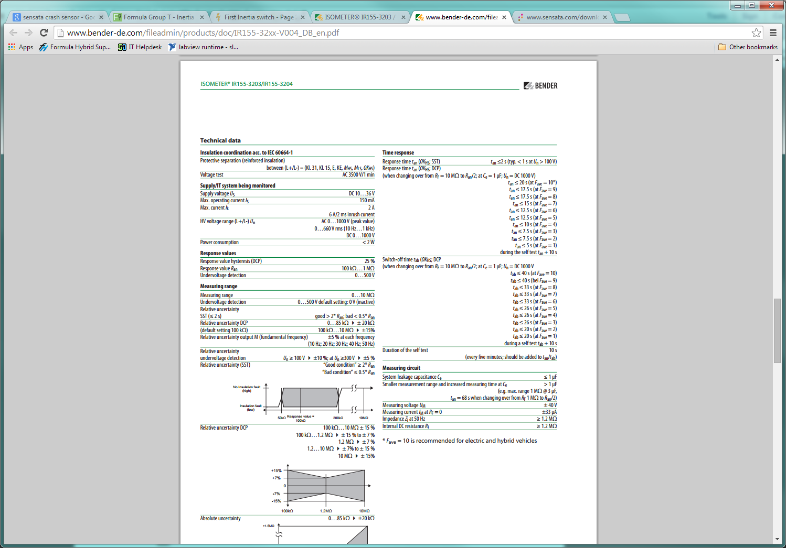

Complete data sheet located at:   
<https://www.bender.de/fileadmin/content/Products/d/e/IR155-32xx-V004_D00115_D_XXEN.pdf>

11.2 – 8STA SOURIAU connectors ratings

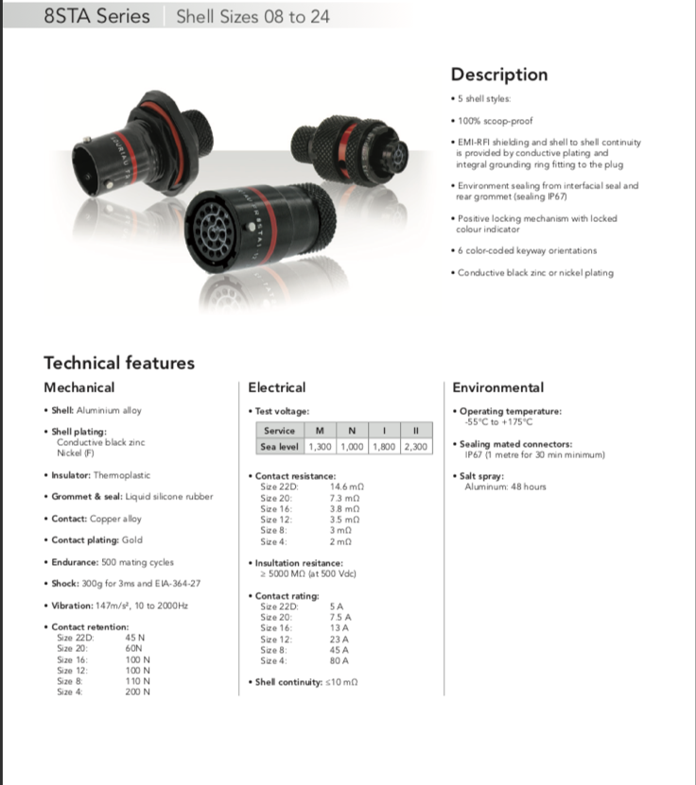

Complete data sheet located at: <https://ipaper.ipapercms.dk/SOURIAU/catalog-motorsport/?>

11.3 Inertia switch ratings

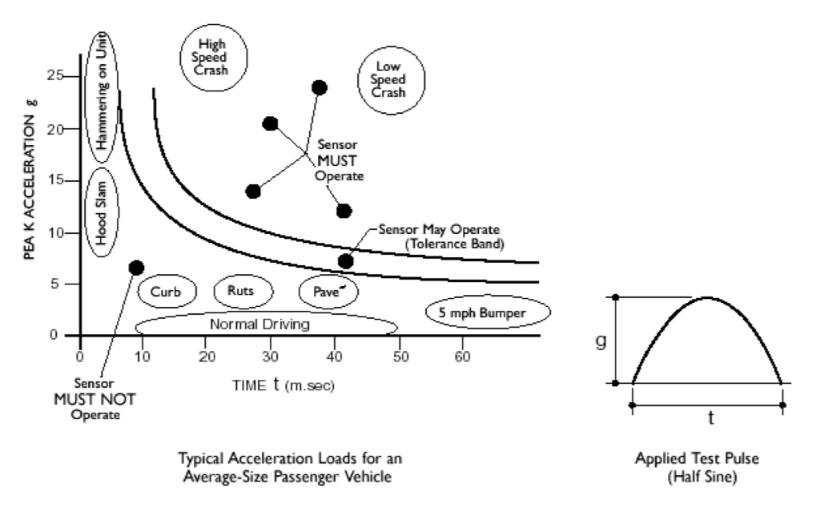

Complete data sheet located at: <https://www.jsae.or.jp/formula/jp/SFJ/docu/STJ_resettable-crash-sensor.pdf>