

Impact Attenuator Data Form - Standard IA Design

This form must be completed and uploaded to the “My Team” area on the FSG website **no later than the date specified** in the Action Deadlines. A printed copy of this form must be presented together with the vehicle at Technical Inspection.

The Impact Attenuator Data (IAD) and supporting calculations must be submitted electronically in Adobe Acrobat format (*.pdf).

## Contact Details

Car Number University Name

Ecole Centrale de Lyon

81

## Team Contact Person

|  |
| --- |
| Jacquet Mathieu |
| (+33) 6 49 51 06 51 |
| [mathieu.jacquet@ecl18.ec-lyon.fr](mailto:mathieu.jacquet@ecl18.ec-lyon.fr) |

Last name, First Name Telephone Number

E-mail address

Please NOTE: FS Germany accepts only dynamic test as mentioned in T3.19.1!

Please NOTE: In case a dynamic test is performed, a certificate including contact details of and signed by either the institute where the test was performed, or a responsible of the university must be included in the report.

## Attach Proof of Impact Attenuator

**If the IA (Impact Attenuator) is a “Standard IA Design”, the following points must be included:**

1. The first page must always be this FSG Impact Attenuator Data Form
2. The report must be written in „engineering style“ (e.g. contents, captions, symbols and abbreviations, page numbers)
3. Design of IA and positioning on the AIP (dimensions in mm)
4. Method for attachment of the IA to the AIP (including data sheets e.g. if it bonded together)
5. Dimensions of the front bulkhead (dimensions in mm)
6. Design of the AIP (material, thickness and dimension in mm) and method for attachment to the front bulk- head
7. Receipt of the material, a packing slip or letter of donation of the IA
8. Pictures (or sketches) of the attachment on the car
9. Please comply with the particular rules for front wings, if applicable

2019-01-15 | [iad@formulastudent.de](mailto:iad@formulastudent.de) | Rev-ffec46e 1 of 1

This form must be completed and submitted by **all teams no later than the date specified in the Action Deadlines on specific event website**.Impact Attenuator Data (IAD) and supporting calculations must be submitted electronically in Adobe Acrobat Format (*.pdf). The submissions must be named as follows: schoolname_IAD.pdf using the complete school name. **Submit the IAD report as instructed on the event website.**

University Name: _Ecole Centrale de Lyon Car Number(s) & Event(s): Car #181, FSN

Team Contact: JACQUET Mathieu E-mail Address: [mathieu.jacquet@ecl18.ec-lyon.fr](mailto:mathieu.jacquet@ecl18.ec-lyon.fr) Faculty Advisor: SERRAFERO Patrick E-mail Address: [patrick.serrafero@ec-lyon.fr](mailto:patrick.serrafero@ec-lyon.fr)

|  |  |
| --- | --- |
| Material(s) Used | Impaxx 700 Foam |
| Description of form/shape | Prismatic |
| IA to Anti-Intrusion Plate mounting method | Stuctural adhesive, 3M DP490 |
| Anti-Intrusion Plate to Front Bulkhead mounting method | Welding |
| Peak deceleration (<= 40 g's) | Standard Impact Attenuator |
| Average deceleration (<= 20 g's) | Standard Impact Attenuator |

Confirm that the attenuator contains the minimum volume 200mm wide x 100mm high x 200mm long



X

Standard Impact Attenuator

Figure 1: Force-Displacement Curve (dynamic tests must show displacement during collision and after the point v=0

and until force becomes = 0)

## ATTACH PROOF OF EQUIVALENCY

TECHNICAL COMMITTEE DECISION/COMMENTS

Approved by Date

## NOTE: THIS FORM AND THE APPROVED COPY OF THE SUBMISSION MUST BE PRESENTED AT TECHNICAL INSPECTION AT EVERY FORMULA SAE EVENT ENTERED

University Name: Ecole Centrale de Lyon Car Number(s) & Event(s): Car #181, FSN

Energy Displacement Curve.

Figure 2: Energy-Displacement Curve (dynamic tests must show displacement during collision and after v=0)

Insert Picture of IA, Anti-Intrusion Plate which also shows the method of spacing it at least 50mm from any rigid structure

Insert Picture of IA, Anti-Intrusion Plate which shows the deflection was less than 25.4mm

Figure 3: Attenuator as Constructed Figure 4: Attenuator after Impact

|  |  |  |  |
| --- | --- | --- | --- |
| Energy Absorbed (J): Must be >= 7350 J | N/A | Vehicle includes front wing in front of front bulkhead? | ~~Yes~~/No |
| IA Max. Crushed Displacement (mm): | N/A | Wing structure included in test? | ~~Yes~~/No |
| IA Post Crush Displacement - demonstrating any return (mm): | N/A | Test Type: (e.g. barrier test, drop test, quasi-static crush) | N/A |
| Anti-Intrusion Plate Deformation (mm) | N/A | Test Site: | N/A |

University Name: Ecole Centrale de Lyon Car Number(s) & Event(s): Car #181, FSN

Insert Required Calculation T3.21.3 note 2 and T3.21.4

University Name: Ecole Centrale de Lyon Car Number(s) & Event(s): Car #81, FSA

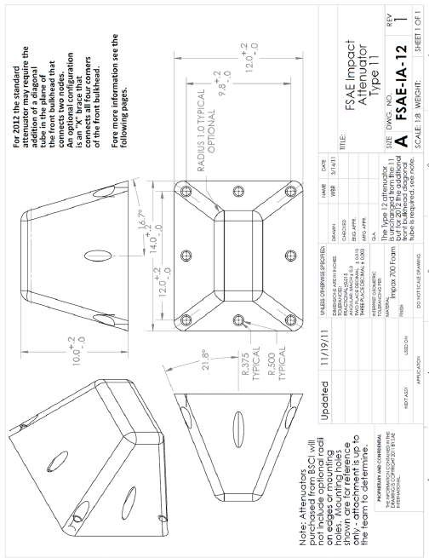

Length (fore/aft direction): 254 mm (>=200mm) Width (lateral direction): 355.6 mm (>=200mm) Height (vertical direction): 304.8 mm (>=100mm)

Attenuator is at least 200mm wide by 100mm high for at least 200mm: **Yes**/~~No~~

***Attach additional information below this point and/or on additional sheets***

Test schematic, photos of test, design report including reasons for selection and advantages/disadvantages, etc. Additional information shall be kept concise and relevant.

# Introduction:

We decided to use the standard impact attenuator (IA) and an anti-intrusion plate (AIP) made from a 1.5mm steel sheet weld to the chassis.

**Design of the Impact attenuator, anti-intrusion plate and front**

**bulkhead:**

**Positioning of the impact attenuator:**

The standard impact attenuator was chosen as impact attenuator for our car. We bought it at Berschella and the receipt for the purchase can be found in Appendix 1. The orientation of the IA on the AIP is vertical as shown on Figure 1.

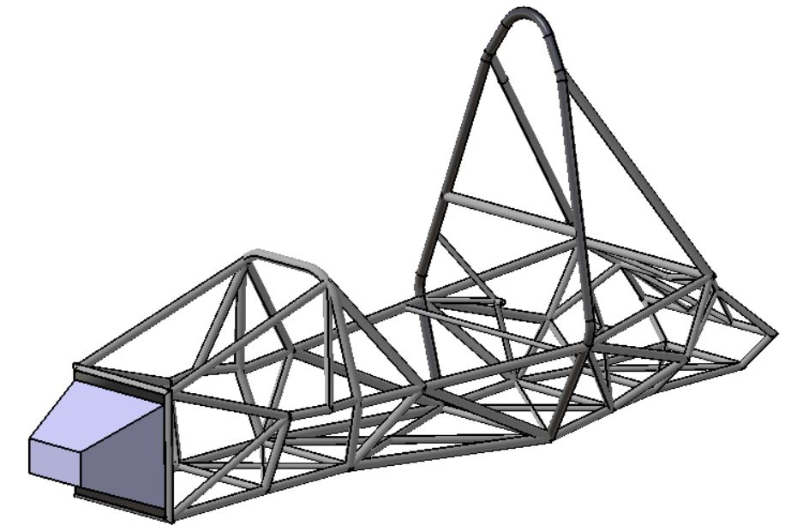

Figure 1 : Positioning of the IA in our frame

As shown on the Figure 2 below, the distance between the impact attenuator and the outside profile of the anti-intrusion plate is greater than 25mm, we added a diagonal brace made from 28mmx1.5mm steel tube.

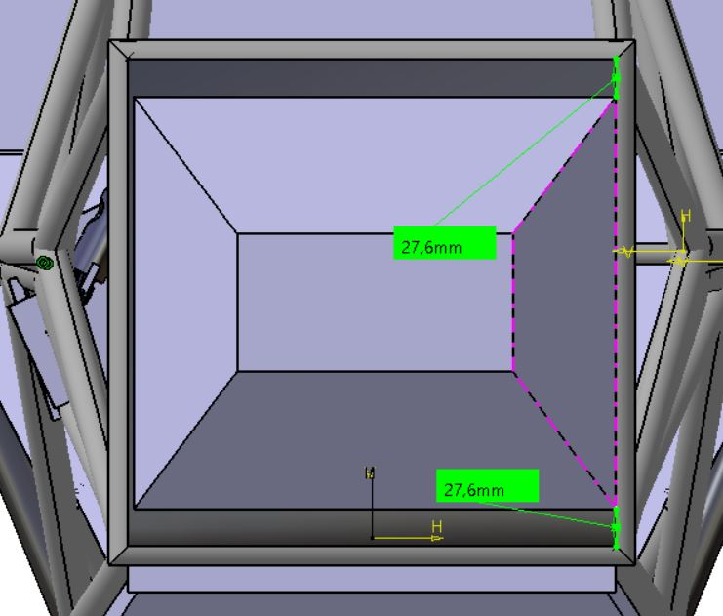

Figure 2: Distance between the IA and the outside

profile of the AIP.

**Design of the front bulkhead:**

To be in compliance with the rule T3.20.8, we added a diagonal brace made from a 28mmx1.5mm steel tube.

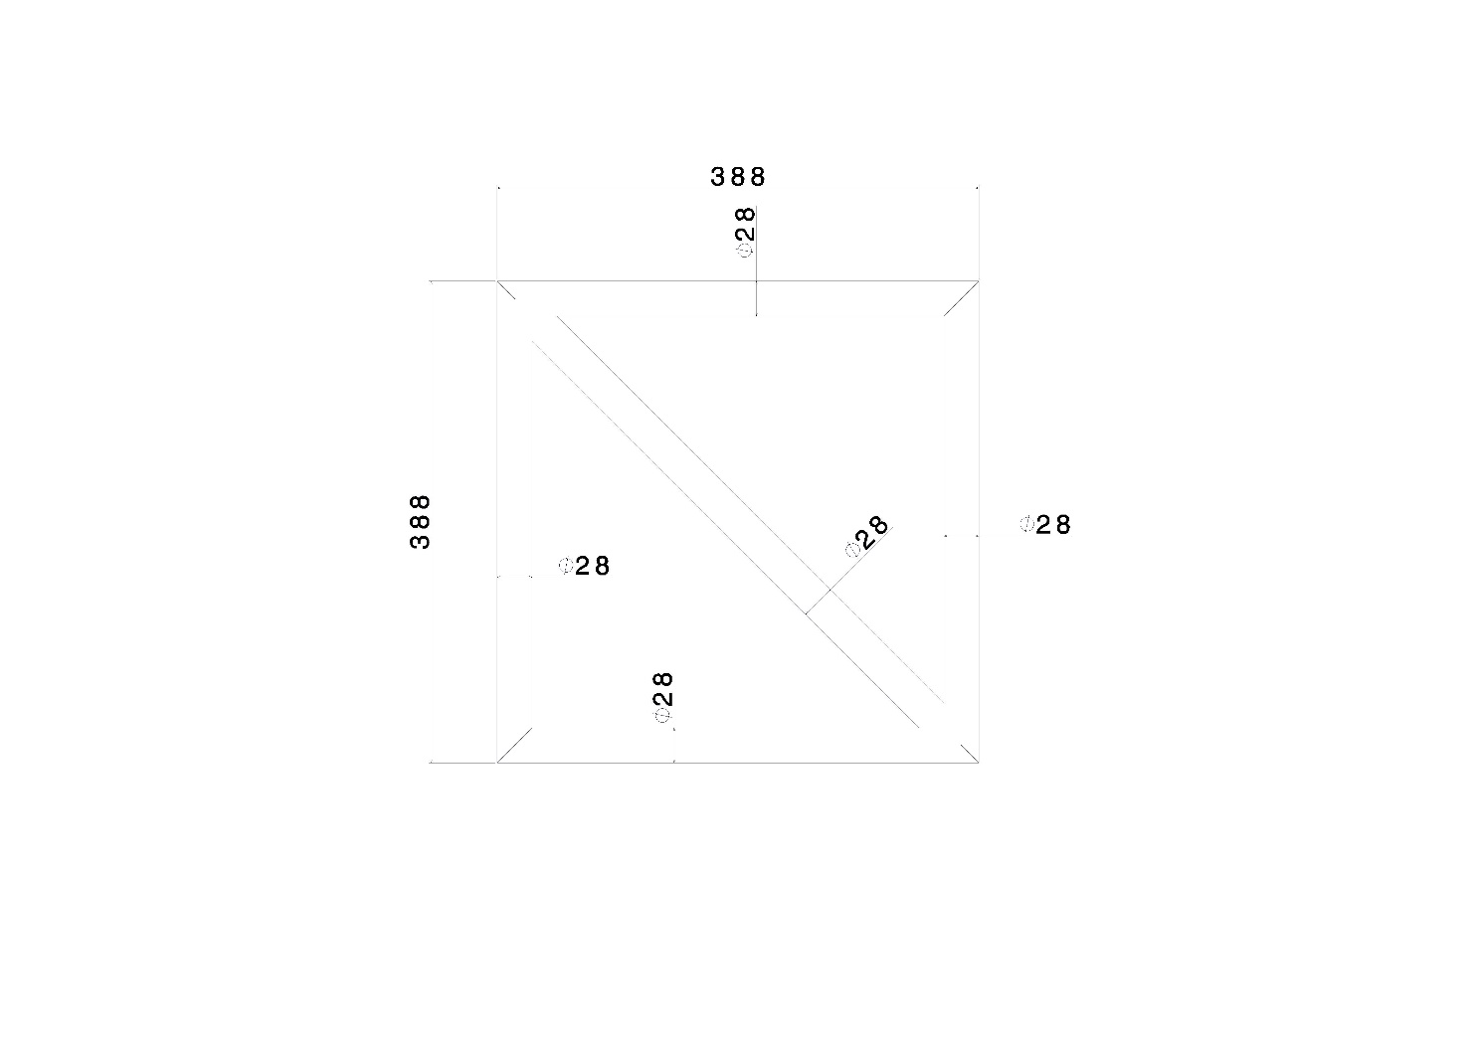

Figure 3: Design of the front bulkhead.

**Design of the Anti-Intrusion Plate:**

The AIP is welded to the frame and is made from a 1.5mm steel plate as per rule

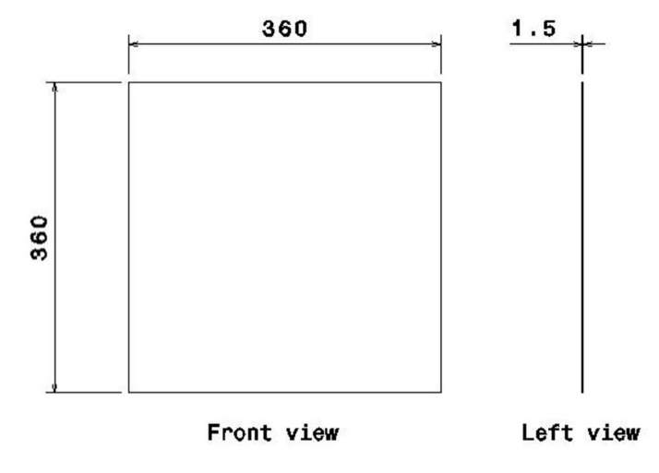

Figure 4: Design of the anti-intrusion plate.

T3.20.3. The AIP goes to the centerline of the front bulkhead tubes on all sides.

**Attachment method of the impact attenuator**

The Impact Attenuator is bonded to the anti-intrusion plate with 3M Scotch-Weld EPX Adhesive DP490. This product is an epoxide structural adhesive. It was chosen for its very high shear resistance of 28.7MPa on aluminium, and it shows good adhesion on several surfaces including plastics.

**Surface preparation**

We prepare the surface of the AIP following the technical data of the 3M DP490. Firstly, we used a surface cleaner (Loctite SF 7061) and then we use sandpaper and a other spray of the cleaner.

**Calculations for the glued connection between the IA and the AIP**

The IA is glued on the AIP with the structural adhesive 3M DP490. The glue was applied on at least 50% of the IA area in contact with the AIP, which represent:

50% × (360𝑚𝑚 × 360𝑚𝑚) = 64 800𝑚𝑚²

Therefore, the shear strength developed by the 3M DP490 is:

28.7𝑀𝑃𝑎 × 64 800𝑚𝑚2 = 1 860 𝑘𝑁

**Appendix 1: Certificate of conformity of our Impact Attenuator**

