Data and analytical reproducibility
All analyses were conducted in R using the analysis-ready datasets available in the project repository. Pilot 1 data are provided in data/pilot_1_data_.xlsx and are analysed by scripts/Pilot1_complete_analysis_repository.R. Pilot 2 data are provided in data/pilot_2_data_.xlsx and are analysed by scripts/Pilot2_complete_analysis_repository.R. Each script imports the corresponding Excel workbook, verifies the expected sample size and within-participant structure, reproduces all reported statistical analyses, generates the supplementary tables and figures, and saves a final verification summary together with the R session information. All data, analysis scripts, numerical outputs and publication-quality figures are available at [repository link].

Introduction

The project builds on two behavioural pilot studies designed to validate the procedure and identify the most informative olfactory contrast for the main experiment. We used an Air Up bottle, a water bottle that delivers aromas through scented pods positioned on the mouthpiece. As participants drink plain water, the aromas reach the olfactory receptors via the retronasal route, creating the perception of flavour, without altering the ingested liquid. This allows olfactory expectations to be manipulated while keeping the physical and nutritional properties of the drink constant.

The pilots tested whether calorie-related retronasal olfactory cues could indeed alter the perceived sensory and nutritional properties of water ingestion. In both studies, participants drank 200 ml of water from a covered Air Up bottle, preventing visual identification of the scented pod while keeping the ingested water constant.
Pilot 1: comparison of two calorie-related olfactory cues
Pilot 1 (N = 28) compared two candidate calorie-related olfactory cues, chocolate-orange and peach smoothie. The two pods were presented in random order, with a 15-min interval between drinks. In each condition, participants consumed 200 ml of plain water from the covered Air Up bottle. After ingestion, they rated the perceived intensity and pleasantness of the drink and estimated its calorie, sugar and fat content. They also provided open-ended descriptions of the perceived beverage identity and presumed ingredients.
One-sample Wilcoxon tests against zero confirmed that both pods elicited reliable nutritional associations. Ratings of perceived calories, sugar and fat were significantly greater than zero for both chocolate-orange and peach smoothie, with all six comparisons surviving Holm correction, all pHolm < .001. Thus, although the ingested liquid was plain water and contained no calories or nutrients, both retronasal olfactory cues led participants to attribute nutritional properties to the beverage.
Paired Wilcoxon tests were then used to determine whether the two cues differed in their perceptual or nutritional effects. No reliable differences emerged between peach smoothie and chocolate-orange in perceived intensity, pleasantness, calories, sugar or fat after Holm correction. The adjusted p-values were 1.000 for intensity, .853 for pleasantness, .235 for calories, 1.000 for sugar and .443 for fat. The two calorie-related cues were therefore perceived as comparably intense and pleasant and produced similar levels of nutritional attribution, rather than generating a clearly differentiated experimental contrast. The complete distributions and paired participant-level observations are shown in Figure S1.
Open-ended responses to questions about perceived beverage identity and presumed ingredients provided an additional manipulation check. Responses were coded into three categories: plain water; flavoured, infused or low-calorie beverage; and caloric or nutrient-related beverage. Unclear or non-classifiable responses were treated as missing and excluded from the categorical analyses.
Across the two olfactory-cue conditions, 52 of the 56 responses were classifiable. Only 4 of these 52 responses (7.7%) identified the liquid as plain water, whereas 48 responses (92.3%) attributed a beverage-like identity to it. Moreover, 22 of the 52 classifiable responses (42.3%) explicitly referred to caloric or nutrient-related beverages or ingredients. These open-ended reports therefore converged with the rating data, showing that the retronasal cues frequently led participants to infer sensory and nutritional properties that were not present in the ingested water.
To test whether the two olfactory cues produced different qualitative interpretations, paired response categories were compared using Bowker’s test of symmetry. The distribution of responses did not differ significantly between peach smoothie and chocolate-orange, χ²(3) = 4.67, p = .198. A planned binary analysis further recorded responses as caloric or nutrient-related versus non-caloric. This comparison also showed no reliable difference between the two cues, exact McNemar p = .125.
The distribution of open-ended response categories for each cue and across cues is shown in Figure S2.
Overall, Pilot 1 demonstrated that retronasal food-related aromas could alter the perceived identity and nutritional meaning of plain water. Both candidate pods induced beverage-like and calorie-related interpretations, but the two cues produced closely comparable effects across structured ratings and open-ended descriptions (Figures S1–S2). Their direct comparison therefore offered limited leverage for isolating the contribution of olfactory expectations. On this basis, Pilot 2 tested the more informative contrast between an active Olfactory Pod and a Water Control condition. All Pilot 1 results and figures can be reproduced using pilot_1_data_.xlsx and Pilot1_complete_analysis_repository.R.

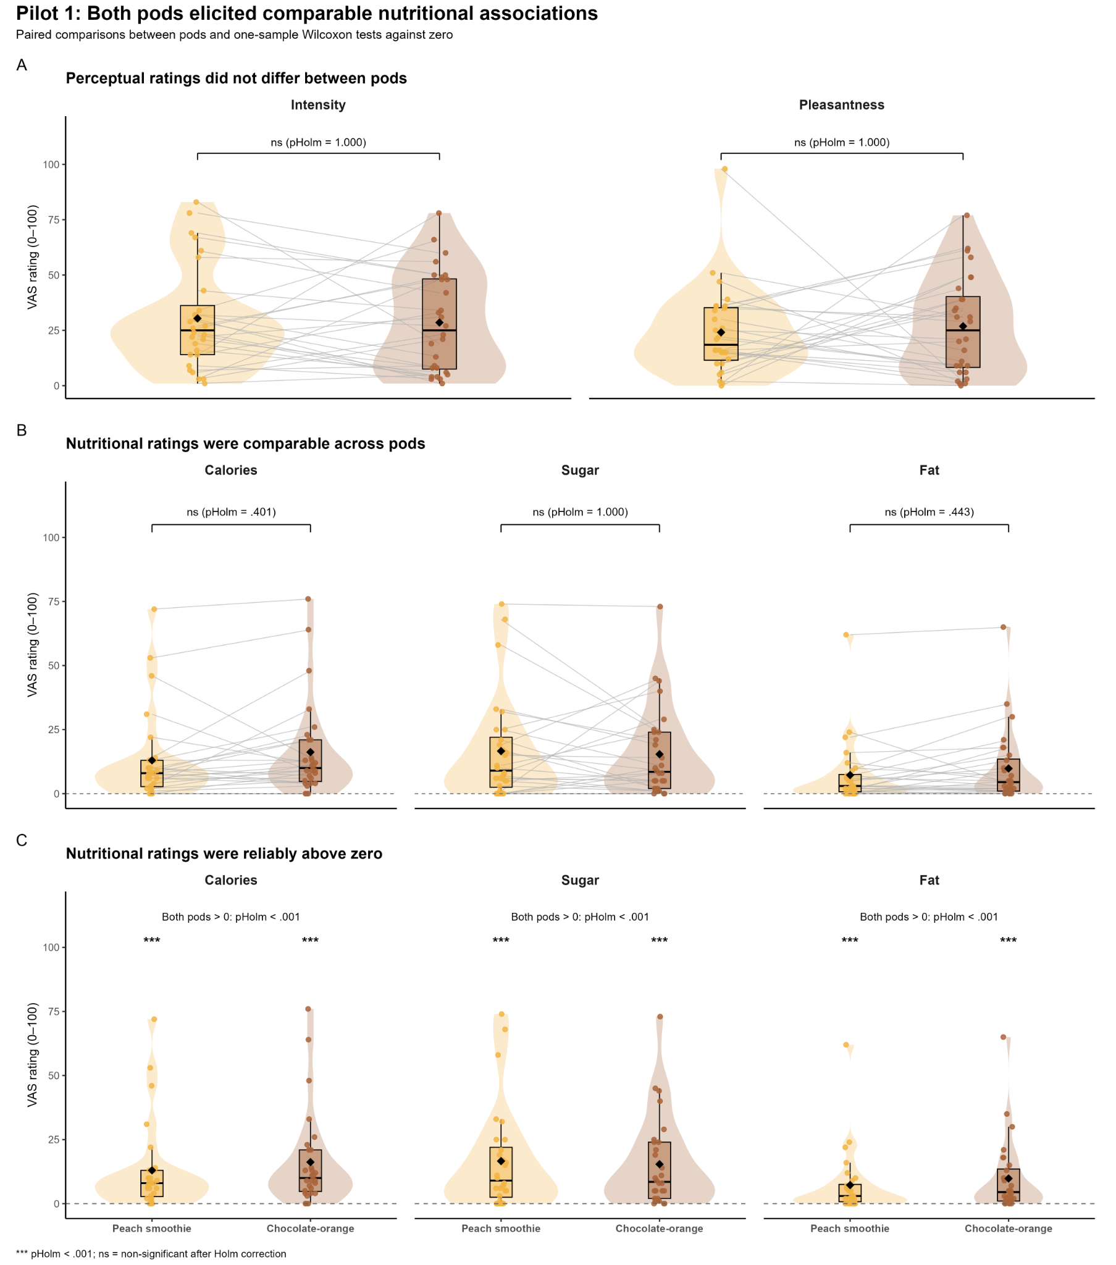
Figure S1. Perceptual and nutritional ratings in Pilot 1. Participants consumed 200 ml of plain water paired with either the peach-smoothie or chocolate-orange retronasal olfactory cue. Panel A shows perceived intensity and pleasantness. Panel B shows perceived calorie, sugar and fat content for the two cues. Paired Wilcoxon signed-rank tests revealed no reliable differences between cues after Holm correction. Panel C shows the same nutritional ratings relative to the scale value of zero. Perceived calories, sugar and fat were significantly greater than zero for both cues, with all one-sample Wilcoxon tests surviving Holm correction, all pHolm < .001. Individual observations are shown together with paired participant-level trajectories, distributional summaries and condition means. *** pHolm < .001; ns = non-significant.
File generated by the script: outputs/Pilot1/figures/Pilot1_combined_panels.pdf

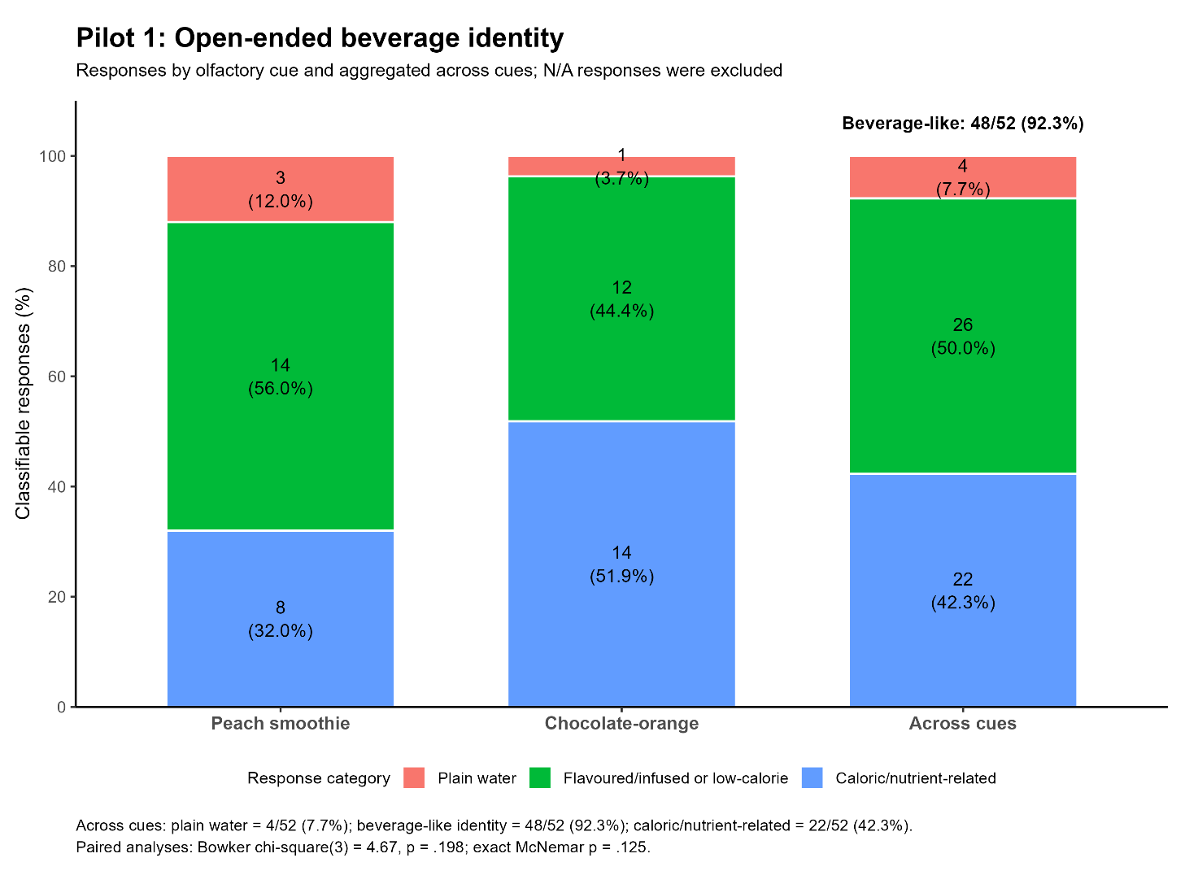
Figure S2. Open-ended beverage-identity responses in Pilot 1. Responses were coded as plain water, flavoured/infused or low-calorie beverage, or caloric/nutrient-related beverage. Bars show the percentage and number of classifiable responses separately for the peach-smoothie and chocolate-orange cues and aggregated across cues. Of the 52 classifiable responses, 48 (92.3%) attributed a beverage-like identity to the ingested water and 22 (42.3%) explicitly referred to caloric or nutrient-related properties. The distribution of response categories did not differ reliably between cues, Bowker’s χ²(3) = 4.67, p = .198; exact McNemar p = .125 for the planned binary comparison.
File generated by the script: outputs/Pilot1/figures/Pilot1_open_responses_with_across_cues.pdf

Pilot 2: validation of the Olfactory Pod versus Water Control contrast
Pilot 2 (N = 47) tested the critical contrast between the Olfactory Pod and Water Control conditions. Participants consumed 200 ml of plain water in both conditions, allowing the effects of the retronasal olfactory cue to be examined while actual intake and the physical and nutritional properties of the ingested liquid remained constant.
Perceived nutritional content showed a significant Condition × Nutritional Property interaction, F(2, 230) = 22.02, p < .001. Planned ART-C comparisons confirmed that the Olfactory Pod increased attributed fat, calories and sugar relative to Water Control, with all comparisons surviving Holm correction, all pHolm < .001. Pod-related changes across the three nutritional dimensions were positively associated, with pairwise Pearson correlations ranging from r = .481 to .739 and standardized α = .816, indicating coherent pod-induced nutritional effects.
Taste ratings also showed a significant Condition × Taste interaction, F(3, 138) = 82.25, p < .001. Relative to Water Control, the Olfactory Pod increased perceived sweetness, sourness and bitterness, with all three comparisons surviving false-discovery-rate correction, all significant pFDR ≤ .011. Perceived saltiness did not differ between conditions, pFDR = .900.
The effects of the Olfactory Pod on nutritional attribution and perceived taste profile are shown in Figure S3A–B.
An exploratory multiple regression tested whether pod-related changes in sweetness, saltiness, sourness and bitterness predicted a composite nutritional-attribution index. The full taste-modulation model explained 38.1% of the variance in this index, R² = .381, F(4, 42) = 6.46, p < .001. Sweetness, b = .019, t = 4.23, p < .001, and bitterness, b = .030, t = 2.24, p = .031, emerged as significant predictors, whereas saltiness and sourness did not.
When the nutritional dimensions were examined separately, sweetness predicted pod-related changes in perceived fat, b = .231, p = .009, calories, b = .322, p = .003, and sugar, b = .526, p < .001. Bitterness selectively predicted perceived fat, b = .637, p = .011, but not calories or sugar, both p ≥ .124. Bootstrap 95% confidence intervals for the sweetness and bitterness coefficients in the fat model excluded zero. Although exploratory, the selective bitterness–fat association is consistent with previous evidence suggesting that bitter and fat sensitivity may be partially related (Graham et al., 2021; Khan et al., 2019; Mattes, 2011).
The corresponding exploratory associations are visualised in Figure S4. The plotted lines represent descriptive bivariate associations, whereas the coefficients reported here and in the figure annotations derive from the corresponding multiple-regression models.
The pod also produced a preliminary cue-dependent distortion in estimated ingestion amount: although participants always consumed 200 ml, they estimated having consumed 31.05 ml less in the pod condition than in the water-control condition, t(46) = −2.27, p = .028. However, absolute estimation error relative to the actual 200 ml did not differ between conditions, Wilcoxon V = 605, p = .668, indicating that the cue shifted estimated amount without reliably changing overall estimation accuracy. This effect on ingestion was not associated with MAIA subscales (all |ρ| ≤ .203, all p ≥ .171), TAS scores (ρ = −.237, p = .109), individual nutritional indices (all |r| ≤ .180, all p ≥ .226), or the composite nutritional index, r = −.109, p = .465. Finally, the pod was rated as more intense than water alone, Wilcoxon V = 166, p < .001, whereas pleasantness did not differ between conditions, V = 585, p = .631. Thus, the effects of the manipulation were not attributable to greater liking. Overall, Pilot 2 showed that the retronasal cue altered the perceived taste, nutritional meaning and estimated amount of plain water, without these effects being robustly explained by olfactory discrimination, self-reported interoception or absorption.
Participant-level estimated intake, intensity and pleasantness ratings are shown in Figure S3C–D.
Exploratory analyses further examined whether pod-related effects varied according to olfactory identification performance, interoceptive awareness measured using the MAIA, or absorptive tendency measured using the TAS. None of these associations remained significant after correction for multiple comparisons. The principal perceptual effects were therefore not robustly explained by these individual-difference measures.
Open-ended responses to the questions about perceived beverage identity and ingredients provided an additional manipulation check for the critical pod-versus-water contrast. Because Pilot 2 no longer compared two calorie-related pods, responses were recoded using a binary scheme distinguishing plain water from nutrient/caloric or added-ingredient beverage identities. This coding was chosen to test whether the olfactory pod made participants interpret the same ingested water as something other than plain water.
In the Water Control condition, 31 of 47 participants (66.0%) identified the ingested liquid as plain water. In the Olfactory Pod condition, only 2 of 47 participants (4.3%) identified it as plain water, whereas 45 of 47 participants (95.7%) attributed it to a beverage identity.
At the paired-participant level, 30 of 47 participants (63.8%) shifted from identifying the liquid as plain water in the Water Control condition to attributing a beverage identity in the Olfactory Pod condition. Only one participant (2.1%) showed the reverse pattern. This asymmetry was significant, exact McNemar p < .001. Among the 16 participants who did not show the expected shift, 15 attributed a beverage identity in both conditions, whereas only one identified both samples as plain water. Thus, the absence of a shift predominantly reflected an already altered interpretation of the control water rather than a failure of the olfactory manipulation.
The condition-specific distribution of open-ended beverage-identity responses is shown in Figure S3E.
Overall, Pilot 2 showed that the retronasal olfactory cue altered the perceived identity, taste profile, nutritional meaning and estimated amount consumed of plain water. The convergence of structured ratings, estimated-consumption judgements and open-ended descriptions supports the Olfactory Pod versus Water Control contrast as a robust manipulation of calorie-related beverage expectations (Figures S3–S4). All Pilot 2 analyses, numerical outputs and figures can be reproduced using the analysis-ready dataset data/pilot_2_data_.xlsx and the R script scripts/Pilot2_complete_analysis_repository.R, available in the project repository.
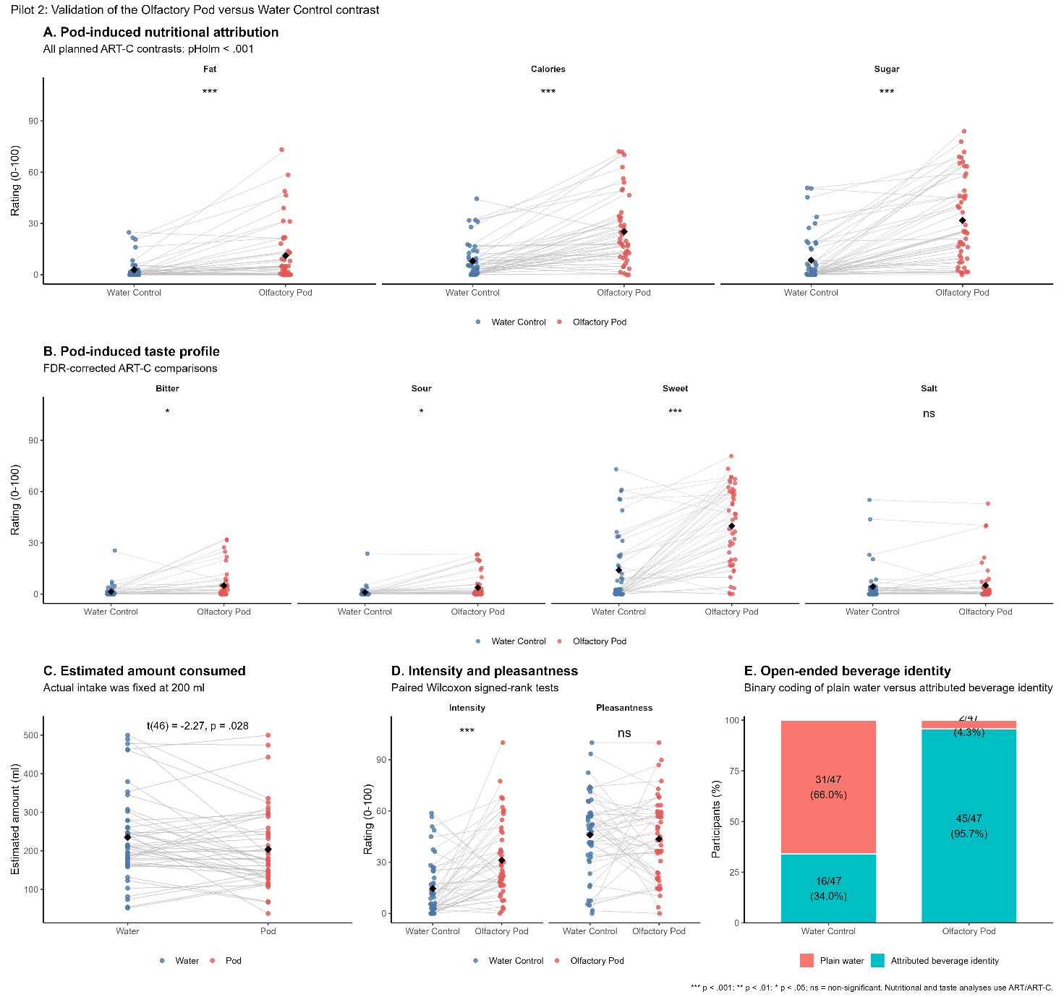
Figure S3. Validation of the Olfactory Pod versus Water Control contrast in Pilot 2. Participants consumed 200 ml of plain water in both conditions. A, perceived fat, calorie and sugar content. Planned ART-C comparisons indicated greater nutritional attribution in the Olfactory Pod condition for all three properties, all pHolm < .001. B, perceived taste profile. The Olfactory Pod increased perceived sweetness, sourness and bitterness after false-discovery-rate correction, whereas saltiness did not differ between conditions. C, estimated amount consumed. Although actual intake was fixed at 200 ml in both conditions, participants estimated having consumed less in the Olfactory Pod condition than in the Water Control condition, t(46) = −2.27, p = .028. D, perceived intensity and pleasantness. The Olfactory Pod was rated as more intense than Water Control, Wilcoxon V = 166, p < .001, whereas pleasantness did not differ, V = 585, p = .631. E, binary coding of open-ended beverage-identity responses. Plain-water identifications were more frequent in the Water Control condition, whereas most participants attributed a beverage identity in the Olfactory Pod condition. Individual paired observations and condition means are shown for continuous outcomes; bars report counts and percentages for open-ended responses. *** p < .001; ** p < .01; * p < .05; ns = non-significant. Nutritional and taste analyses used ART and ART-C procedures.

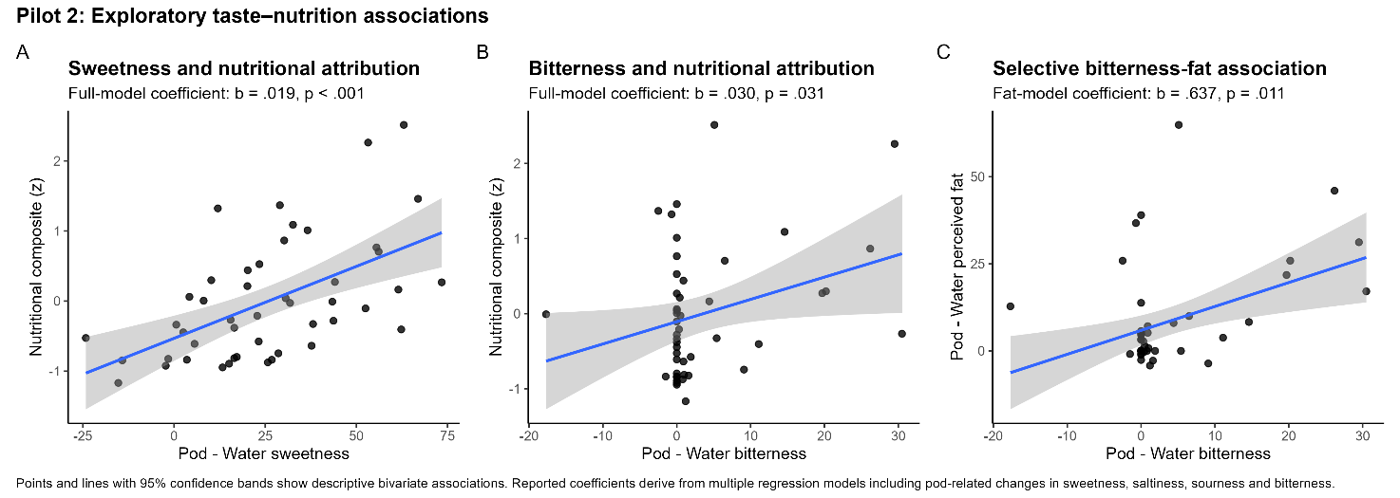
Figure S4. Exploratory associations between pod-related taste modulation and nutritional attribution in Pilot 2. Panel A shows the association between the pod-related change in perceived sweetness and the composite nutritional-attribution index. Panel B shows the association between the change in perceived bitterness and the composite nutritional-attribution index. Panel C shows the selective association between the change in perceived bitterness and the change in perceived fat attribution. Points represent individual participants, and lines with 95% confidence bands show descriptive bivariate linear associations. The coefficients reported in the panel subtitles derive from multiple-regression models that simultaneously included pod-related changes in sweetness, saltiness, sourness and bitterness. The coefficients in Panels A and B derive from the model predicting the composite nutritional-attribution index, whereas the coefficient in Panel C derives from the model predicting perceived fat.

