

Grant agreement no. 675451
CompBioMed

Research and Innovation Action
H2020-EINFRA-2015-1
Topic: Centres of Excellence for Computing Applications

PolNet Computational Offload Service

Work Package: 3

Due date of deliverable: Month 02

Actual submission date: 30 / November / 2016

Start date of project: October, 01 2016 Duration: 36 months

Lead beneficiary for this deliverable: CBK
Contributors: CBK, UCL, UvA
Project co-funded by the European Commission within the H2020 Programme (2014-2020)
Dissemination Level
PU | Public | YES
CO | Confidential, only for members of the consortium (including the Commission Services)
CI | Classified, as referred to in Commission Decision 2001/844/EC
Disclaimer

The content of this deliverable does not reflect the official opinion of the European Union. Responsibility for the information and views expressed herein lies entirely with the author(s).

Table of Contents

1 Version Log 3
2 Contributors 3
3 Definition and Acronyms 4
4 Purpose of document 5
5 Architecture and Design 5
6 Workflow 6
6.1 Authentication 6
6.2 REST endpoints 7
7 Job Description 7
7.1 Filter 8
7.2 Templates 8
8 Input Sets 9
9 Database schema 9
10 Adding additional saga-python compatible services 9
11 Adding additional cloud resources 10
12 Bibliography / References 10

List of Tables and Figures

Figure 1 High Level Architecture 6

Version Log

Version | Date | Released by | Nature of Change
V0.1 | 11/12/2018 | Malcolm Illingworth | First Draft

Contributors

Name | Institution | Role
Malcolm Illingworth | EPCC | Author

Definition and Acronyms

Acronyms | Definitions
SaaS | Software as a service
REST | Representational State Transfer
HPC | High Performance Computing

Purpose of document

This document describes the implementation of a service that provides access to high performance computing (HPC) applications on EPCC’s Cirrus supercomputer via a set of REST interfaces on an intermediary web service. The implementation has been focused on supporting a client workflow used by the PolNet project to run HemelB simulations but is sufficiently general to support other applications and potentially other execution hosts.

Architecture and Design

The original design intended to provide access to computational resources provided on EPCC’s CIRRUS service, SurfSARA’s LISA service and Microsoft’s Azure service. During the implementation period access was granted to CIRRUS only. This has inevitably resulted in an implementation based primarily on CIRRUS.

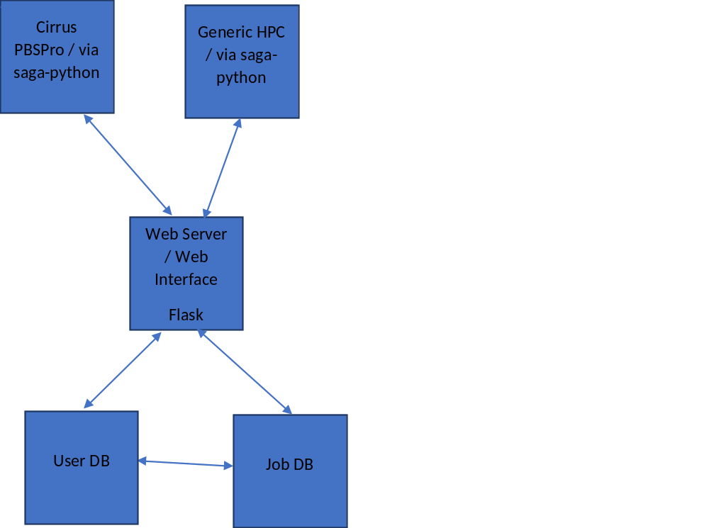
Figure 1: Architecture
Figure 2 High Level Architecture

Workflow

A client creates a new job by posting a payload containing the job description. The job description contains details of the resource on which to execute the application and information such as reservation details and wallclock time. In response the web service creates a new job locally in the job database with status “NEW” and returns the job’s identifier to the client. A staging area for the job is created on the web server. The client may then use the returned job identifier to post input files to the web service.

Once file upload is complete, the client requests submission of the job by sending a POST to the job identifier. In response the web service returns a response of “SUBMITTED” and begins the workflow of creating an execution resource and executing the job. A service thread creates a working directory on the execution host, then stages over the input files and/or contents of an input set if specified. The job is then submitted on the remote host.

A separate service thread within the web service periodically monitors the remote job states of any jobs submitted via the web interface and updates the local job database accordingly.
When a job has reached a “final” state, e.g. “Done”, “Failed”, output files are automatically retrieved from the execution resource to the webserver and any remote resources released. Output files can subsequently be downloaded by the client from the web service via GET requests.

The job and any output files / resources can be deleted by issuing a DELETE request using the web server job identifier. This will cancel the job if it is running, and free any resource and file space. The details of the job and its final state (DELETED) will remain in the web server job database.

To enforce fair usage, a limit is applied to the number of active jobs which any user may have. Any job which is in a state other than ‘DELETED’ is considered as active. Deleted jobs are not counted towards a user’s limit.

Authentication

The web service maintains a database of users for access to the gateway itself via the flask-admin microservices framework and a MariaDB database. Clients authenticate with the web service and create a session by posting their username and password to the login url for the web service, over an https connection.

A single credential / account is used per computational resource and users of the gateway have no access to the underlying resources other than via the gateway. Users do not have actual accounts on the computational resources. Using the saga-python library, the credential can be either username/password or keystore/password.

REST endpoints

The web service exposes the following RESTful endpoints to clients.

endpoint | method | Description
/jobs | GET | Lists all jobs known by the web service
/jobs | POST | Create a new job and return its identifier
/jobs/<job_id>/files | POST | Upload one or more input files for a job
/jobs/<job_id>/submit | POST | Submit a job for execution
/jobs/<job_id>/state | GET | Get the job’s current state
/jobs/<job_id>/retrieved | GET | Returns a flag indicating if the job’s output files have been retrieved from the execution host
/jobs/<job_id>/files | GET | Return a list of output files produced by the job
/jobs/<job_id>/filename | GET | Download a specific output file
/jobs/<job_id> | DELETE | Kill the job if in a running state, delete any resources held by the job and any files
/services | GET | Return a list of known execution hosts / services
/inputsets | POST | Create a set of related input files, return an id for the set
/inputsets/<id> | POST | Upload a file to an input set
/inputsets/<id>/hash | GET | Return a hash calculated from the inputset files
/templates | GET | Return a list of job template names

Job Description

Jobs are specified by posting a job description as a JSON payload, following the definitions provided within the SAGA specification. A job description may contain the following properties:

Name | Description | Mandatory
name | A name for the job | Yes
executable | The full path to the script or executable to be run | Yes
service | The name of the host or service on which to execute the job (e.g. “CIRRUS”) | Yes
arguments | Command line arguments to be passed to the executable | No
num_total_cpus | The total number of cores to be reserved for the job | No
total_physical_memory | The total memory to be reserved for the job | No
working_directory | The working directory for the job | No
wallclock_limit | The wallclock time for the job | No
project | The project or budget code against which to charge the job | No
queue | A specific queue into which to place the job | No
filter | A filter to apply when retrieving output files (see below) | No
template_name | The name of an existing job template (see below) | No
input_set_id | The id of an input set for the job | No

Filter
By default, all files in the job’s output directory are retrieved from the execution host to the web server. To override this, a filter can be specified such that only those files which match the filter will be retrieved. Filters must be valid python regular expressions; submitting a job with an invalid filter will result in the job being rejected.

Templates
In addition to fully specifying jobs, clients may submit jobs by specifying an existing template in the job description. In this case, all the job parameters are taken from the specified job template record in the database (see schema diagram). Clients may also specify both a job template and additional parameters as per a normal submission. For example, a client could specify the name of a job template and the name of an input file as a command line argument (via the ‘arguments’ parameter). Template specifications are managed in the JOB_TEMPLATE table, either directly via the MariaDB command line or the Template Management form in the web GUI.

Input Sets
In addition to uploading input files for a job, users may also create input sets. An input set acts as a container for a set of files that can be collectively specified as input for a job, by setting input_set_id in the job description. On submission, all the files in the input set are copied to the job’s working directory on the execution host. Input sets may also be specified in job templates.

Clients may need to check if the contents of an input set have changed between simulations; a REST endpoint is provided to allow a hash value to be generated from the file contents.

Database schema
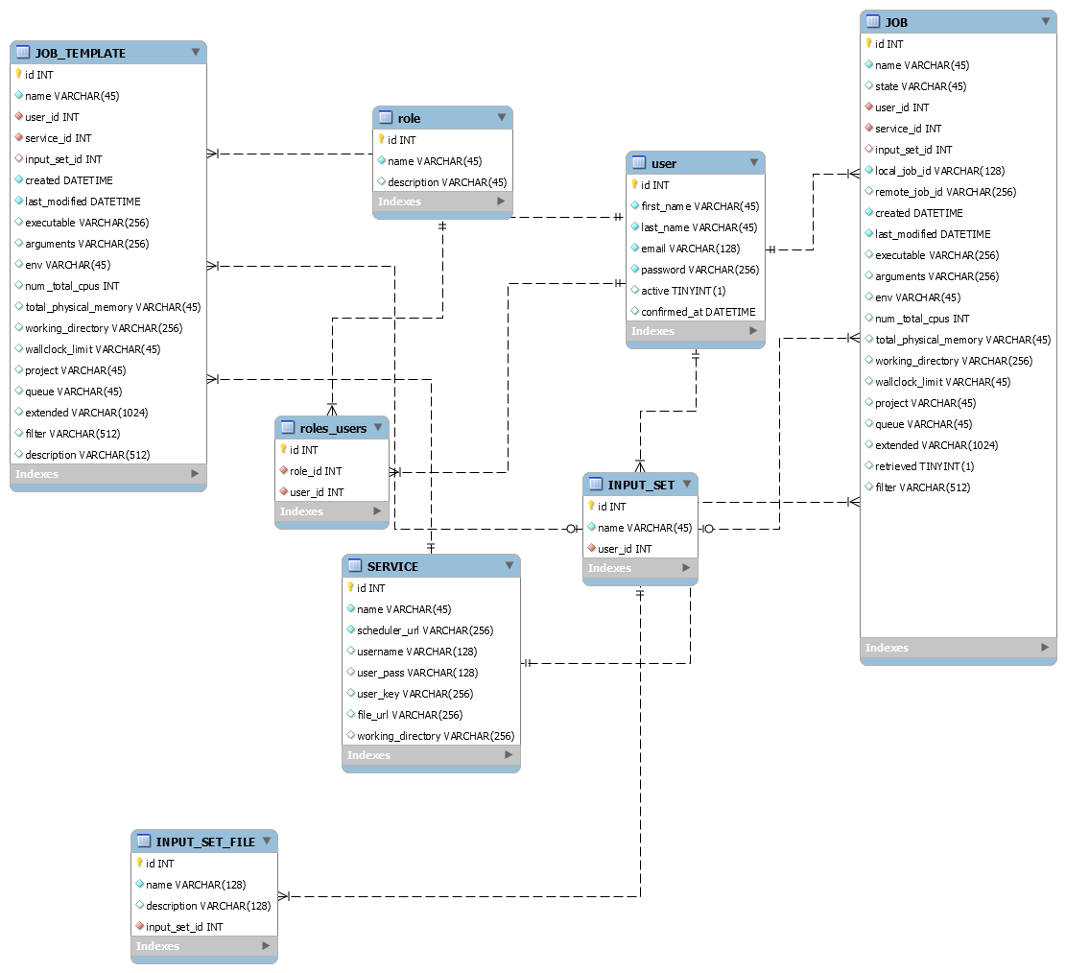
Figure 3 Database schema

Adding additional saga-python compatible services
Adding additional conventional HPC resources should be reasonably straightforward, provided that the host’s scheduler is supported by saga-python. (Please refer to the saga-python documentation for further information.)
Services are configured via the SERVICE table in the database. Access credential may be either a username / password (not recommended), or a keystore and password

name | The name of the service as referred to by clients in job descriptions
scheduler_url | The url for access to the host’s batch scheduler (saga-python includes the scheduler type in the url)
file_url | The url of the host’s file transfer node
username | Username on the remote host
user_pass | Either the user’s remote password on the execution host (not recommended) or a keystore password
user_key | A keystore containing an access key

It is anticipated that managing services will be a very infrequent task, hence this is possible only via the MariaDB command line.

Adding additional cloud resources

Bibliography / References
Include Bibliographical references, if applicable

