# Detector Noise

## 1. Noise evaluation

Please provide a table with the different means and standard deviations including parameters for each image and each color, for blue, green and red. (4 dark noise, 2 nearly saturated).

|  |  |  |  |  |  |  |  |
| --- | --- | --- | --- | --- | --- | --- | --- |
|  |  | RED | | GREEN | | BLUE | |
|  |  | Mean | STD | Mean | STD | Mean | STD |
| Dark | Low Gain – Short exposure | 11.23 | 2.20 | 13.36 | 1.20 | 9.58 | 2.68 |
| High Gain – Short exposure | 146.99 | 23.60 | 117.60 | 12.33 | 106.7 | 25.51 |
| Low Gain – Long exposure | 12.75 | 2.28 | 13.12 | 1.28 | 7.74 | 2.98 |
| High Gain – Long exposure | 174.13 | 26.70 | 100.44 | 13.19 | 134.75 | 24.95 |
| Bright | Low Gain – adjusted exposure | 181.59 | 3.70 | 182.63 | 2.91 | 181.97 | 2.76 |
| High Gain – adjusted exposure | 235.54 | 13.72 | 218.52 | 14.11 | 196.01 | 28.69 |

Give example line plots with a width of one line taken in the middle of the image for the measurement. (select one channel – red, green or blue, **six plots** (4 dark noise, 2 nearly saturated, select one channel – red, green or blue).

Channel color: green

Dark noise plots

Picture 1 - Low Gain – Short exposure

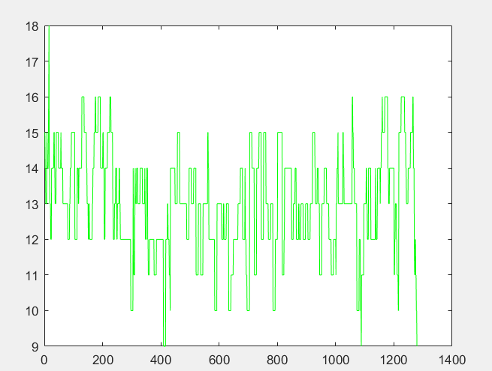

Horizontal = [px]

Vertical = intensity (0-255)

Picture 2 - High Gain – Short exposure

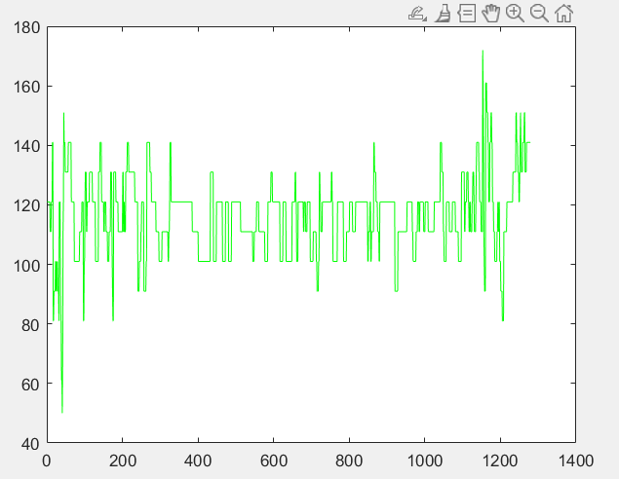

Horizontal = [px]

Vertical = intensity (0-255)

Picture 3 - Low Gain – Long exposure

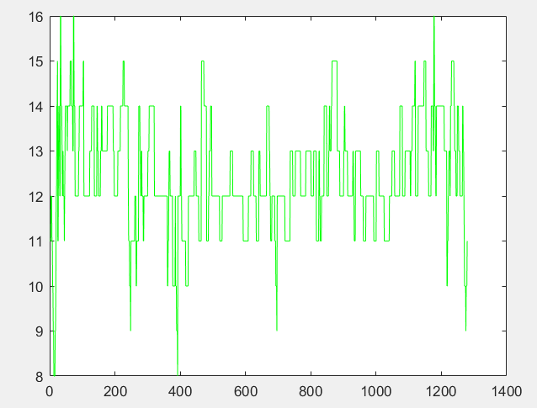

Horizontal = [px]

Vertical = intensity (0-255)

Picture 4 - High Gain – Long exposure

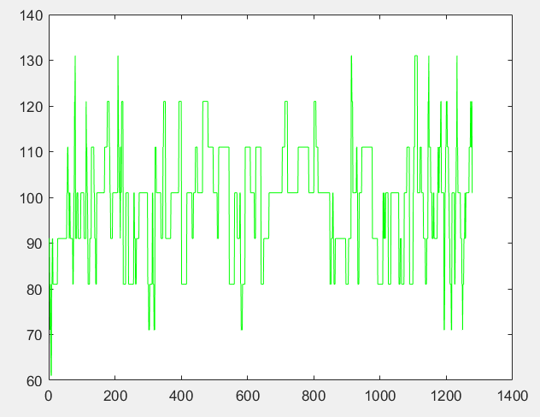

Horizontal = [px]

Vertical = intensity (0-255)

Bright images

Picture 1 - Low Gain – adjusted exposure

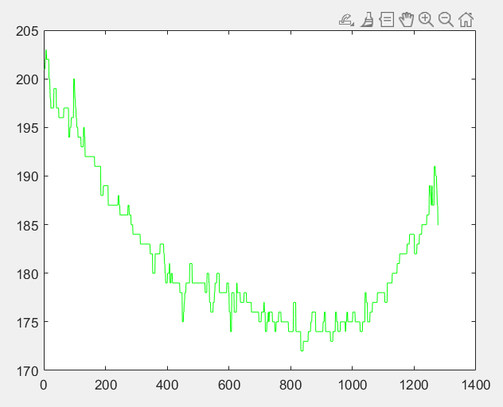

Horizontal = [px]

Vertical = intensity (0-255)

Picture 1 - High Gain – adjusted exposure

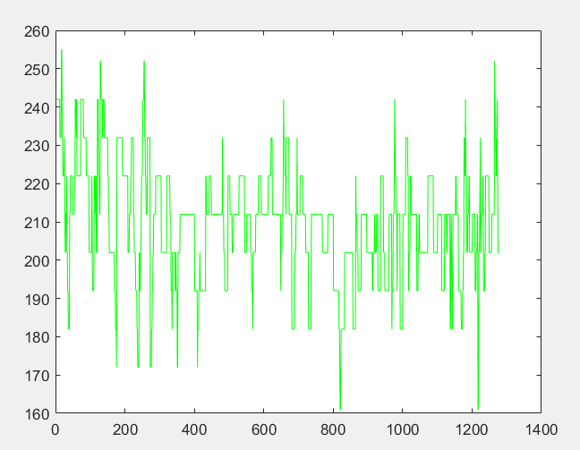

Horizontal = [px]

Vertical = intensity (0-255)

Comments: Nous avons essayé de réduire la non uniformité sur le capteur au maximum mais même dans l’obscurité total il persiste une forme circulaire sur le capteur que le prof nous as expliqué comme étant un défaut du à la qualité de la caméra. Nous pouvons tout de même constaté qu’il y as un bruit sombre et qu’il est plus intense quand on as un grand gain ou que l’exposition est plus longue car le bruit est aussi amplifié et accumulé

## 2. Noise reduction by averaging (45 min)

Show one set of example images like in Figure 14 for the high gain! (one channel – red, **four plots**). Make a table with the values for single line for low and high gain.

Picture 1 – Step image



Picture 2 – Line plot

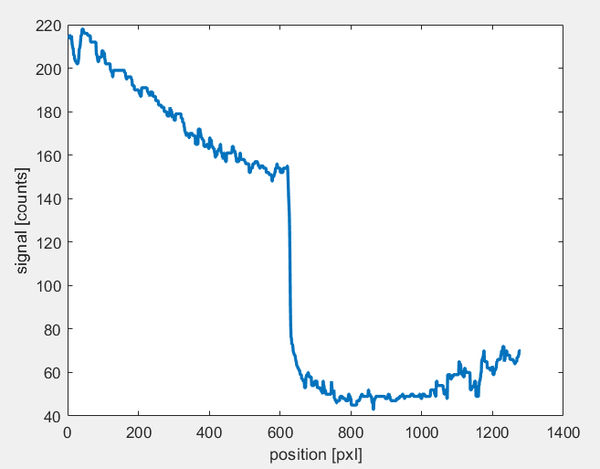

Picture 3 – cropped line plot low signal

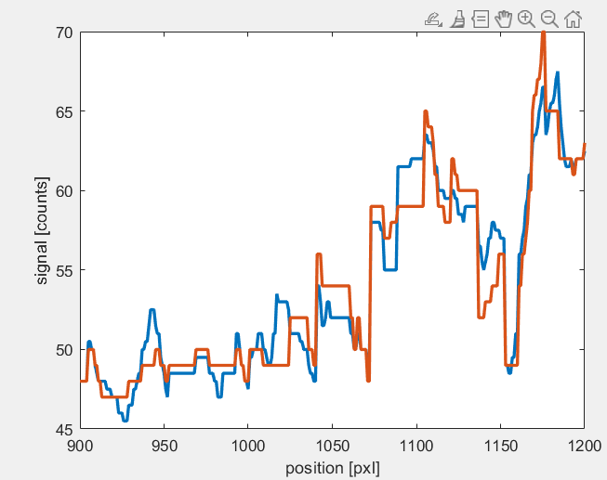

Picture 5 – cropped line high signal

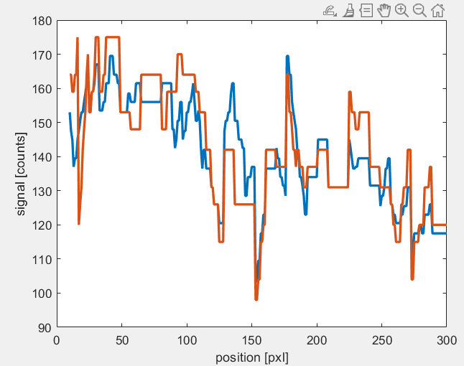

Find out how many lines (N = 15) from the high gain image have to be averaged to compensate the noise added by the gain!

|  |  |  |  |
| --- | --- | --- | --- |
|  | Low gain N=1 | High gain N=1 | High Gain N =15 |
| MEAN_red_left | 197.11 | 140.87 | 142.25 |
| STD_red_left | 10.52 | 15.06 | 14.17 |
| MEAN_red_right | 53.82 | 65.55 | 67.15 |
| STD_red_right | 6.76 | 8.03 | 6.88 |

Comments: Nous avons cherché une valeur de N tel qu’elle ramène le niveau de bruit (STD) a niveau comparable à celui sans amplification. Nous n’avons pas totalement réussis a réduire l’erreur. C’est probablement du au variation de luminosité d’une ligne a l’autre. Mais nous avons tout de même réussis à réduire l’erreur.

## 3. High dynamic range imaging (45 min)

Show the images with the ROI (**two plots**).

Picture 1 – High Gain exposure setting

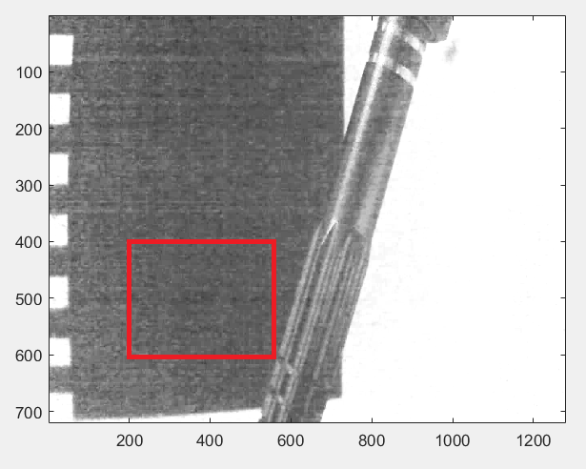

Picture 2 – Low Gain exposure setting

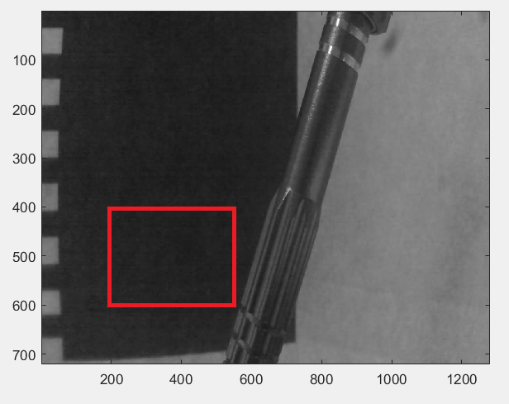

Indicate the **measurement zone** in the images!! Find the values as below

Image **high gain**: **MEAN_ROI = 97.45**

**STD_ROI = 8.60**

Image **low gain**: **MEAN_ROI = 34.62**

**STD_ROI = 2.33**

Evaluate the dynamic range increase obtained by the changing of the gain from low to high and **c**alculate the dynamic range factor G with its error! (use the standard deviations as errors for the input values)

The dynamic range factor G is

= 2.8148.

Error calculation

= 0.088+0.0673=0.1555

Give the final result

Show an example of high dynamic range imaging and provide the **three images** as shown in the example. Indicate in the image in which area one can gather supplementary information.

Picture 1 - bright

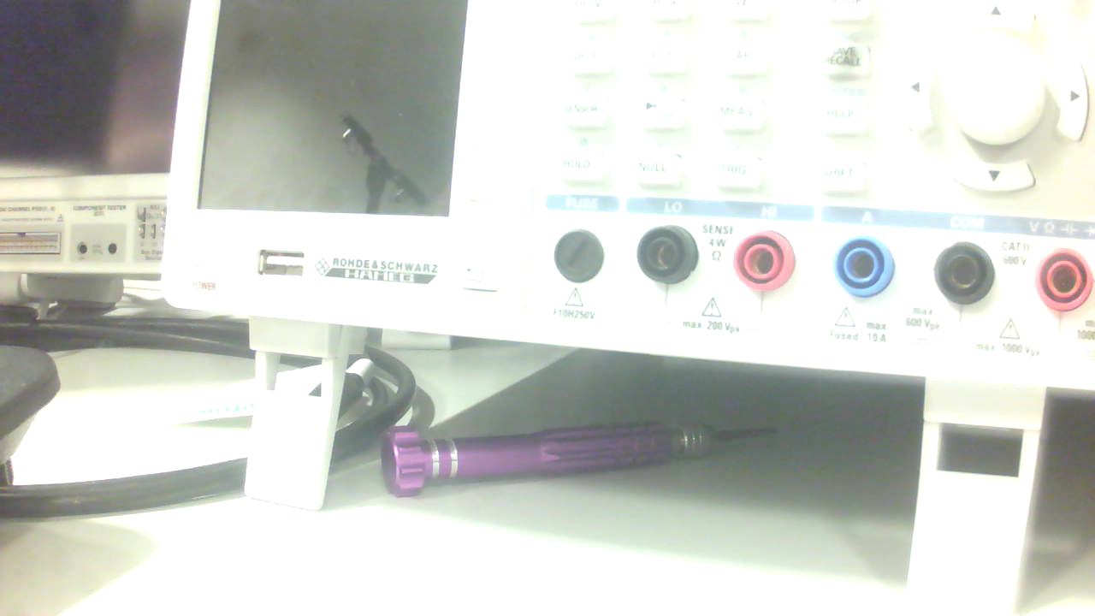

Picture 2 - dark

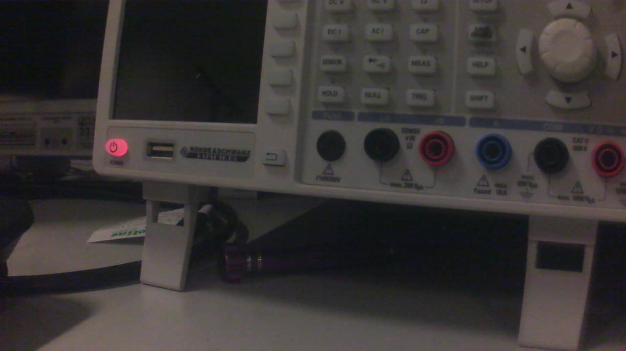

Picture 3 – HDR combined

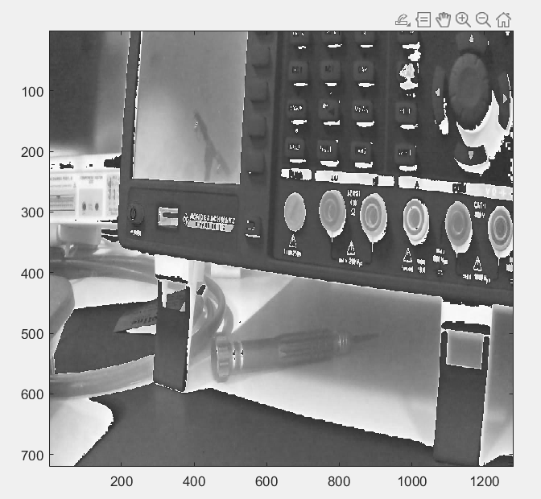

Describe below what are your observations.

Comments: Le programme compose une nouvelle image en prenant les partie non saturé de chaque image mais la discontinuité est bien visible et rend l’image peu agréable a regarder. Si fait avec un bon algorithme il est tout de même possible d’obtenir de bon résultat. Il faut tout de même que le principe de base est validé dans la mesure ou il est possible de distingué l’outils dans la partie sombre de l’image tout en voyant l’oscilloscope qui n’est pas saturé.

## 4. Web example for HDR

Find a HDR example image on the web and cite correctly!

Picture 1 – example image

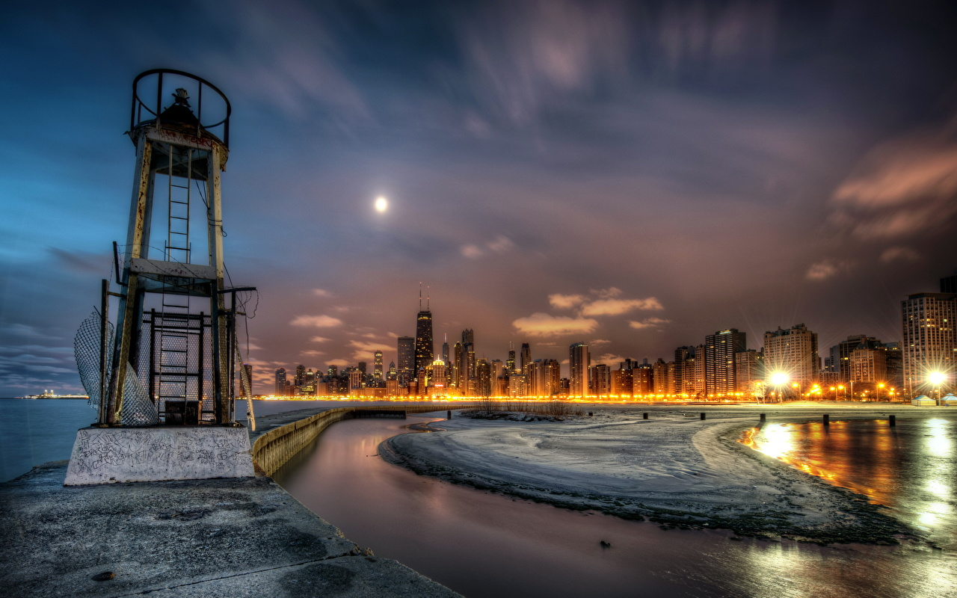

[“https://s1.1zoom.me/big0/355/327678-svetik.jpg”](https://www.fotor.com/features/hdr.html), viewed on 14.10.2023

What is your opinion about such images?

Comments: l’HDR permet d’obtenir un cliché qui donne plus d’information permettant de distingué les détail des zone sombre et clair à la fois. Ça permet de faire de joli fond d’écrans même si prise naturellement, la scène ne ressemble pas du tout à ça.

**(Optional) Personal feedback:**

Was the amount of work adequate?

Oui, il nous à fallu 4 heures au total. Pas plus mais c’est acceptable.

What is difficult to understand?

Nothing in this TP

What did you like about it?

I never took the time to see what HDR meant. Now we know

How can we do better?

Improve the HDR algorithm in matlab.