# Diffraction

## 1. Diffraction with a collimated beam setup and verification

**Take pictures of the diffraction pattern for the 100 microns pinhole and 100 microns rectangle. Measure the distance from the diffracting object to the camera chip. Calculate the theoretical 2-dimensional diffraction pattern with Matlab and plot it next to the measured ones. Give your simulation parameters in the report.**

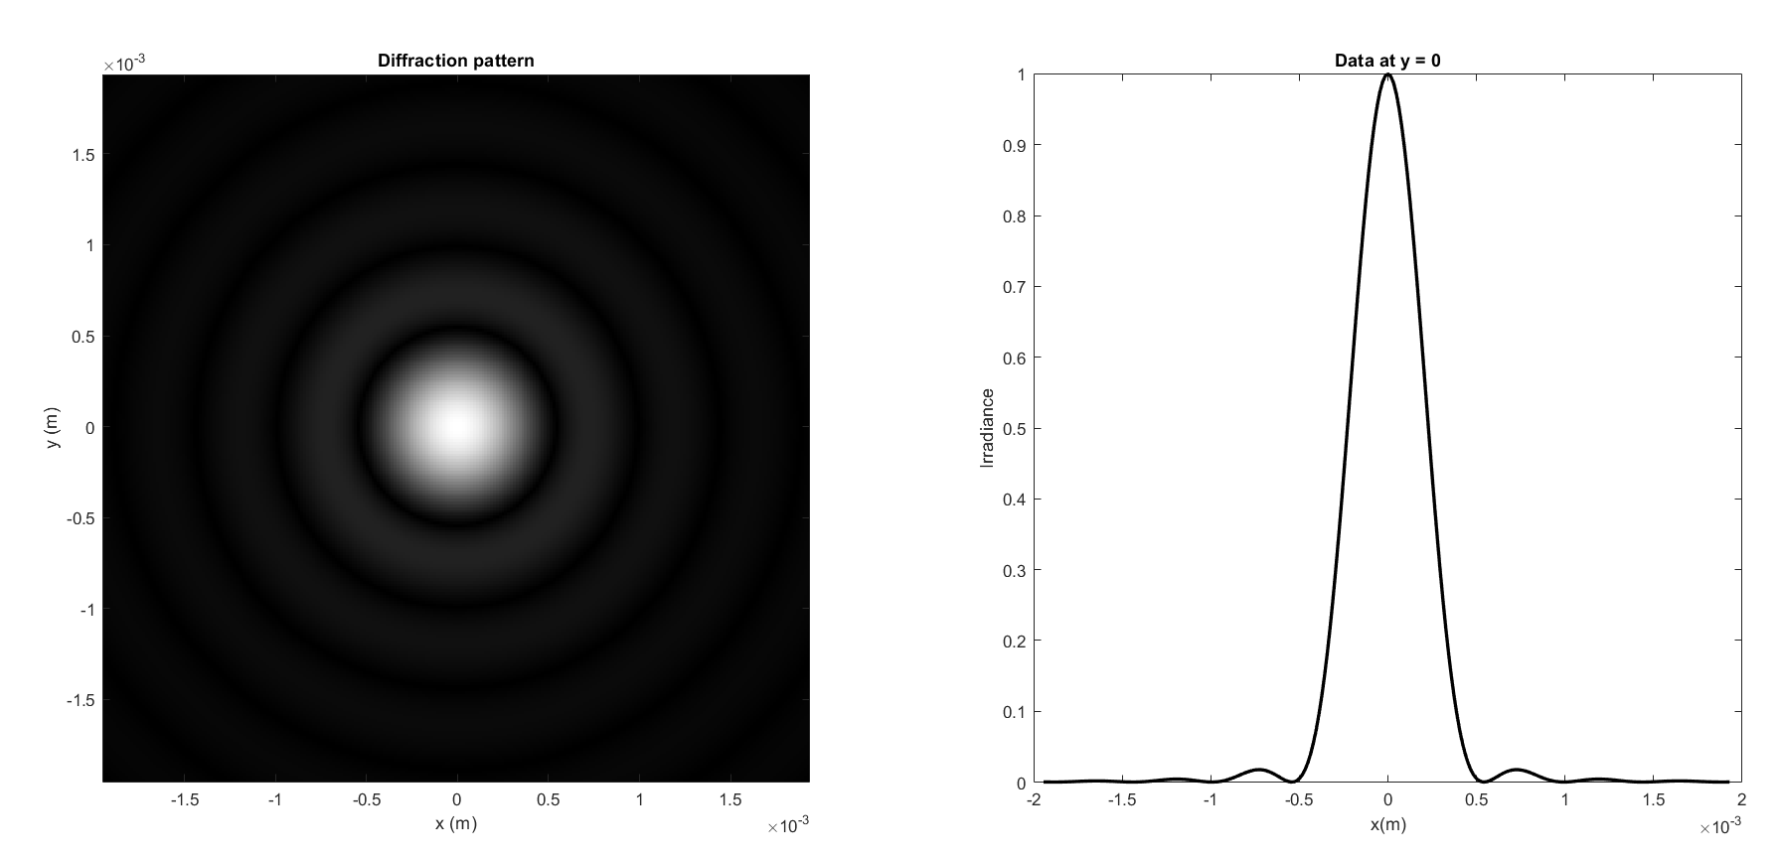

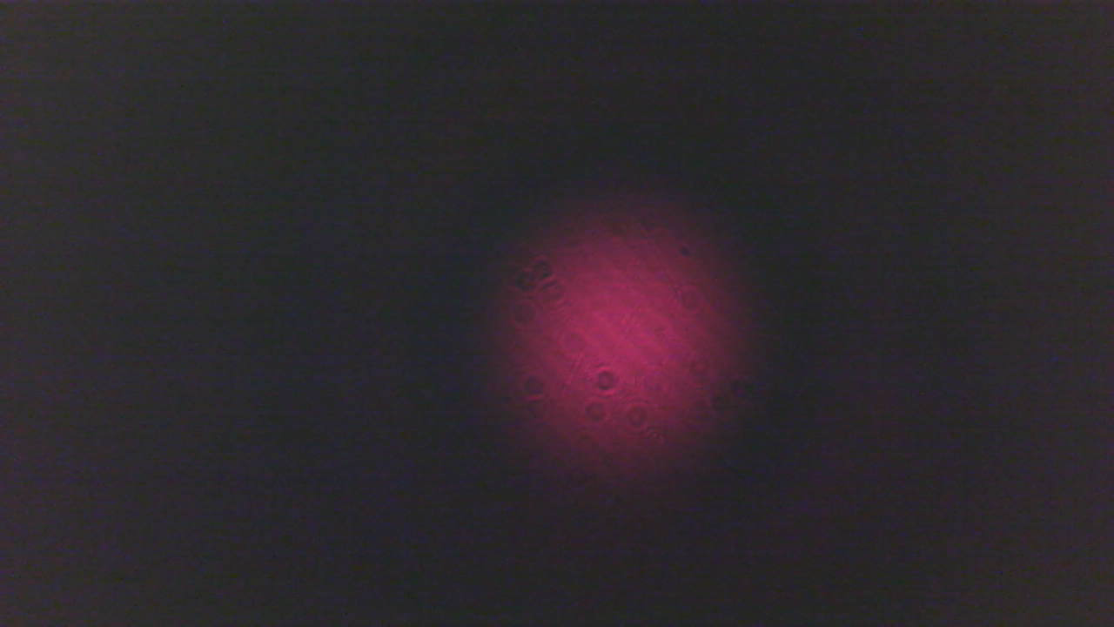

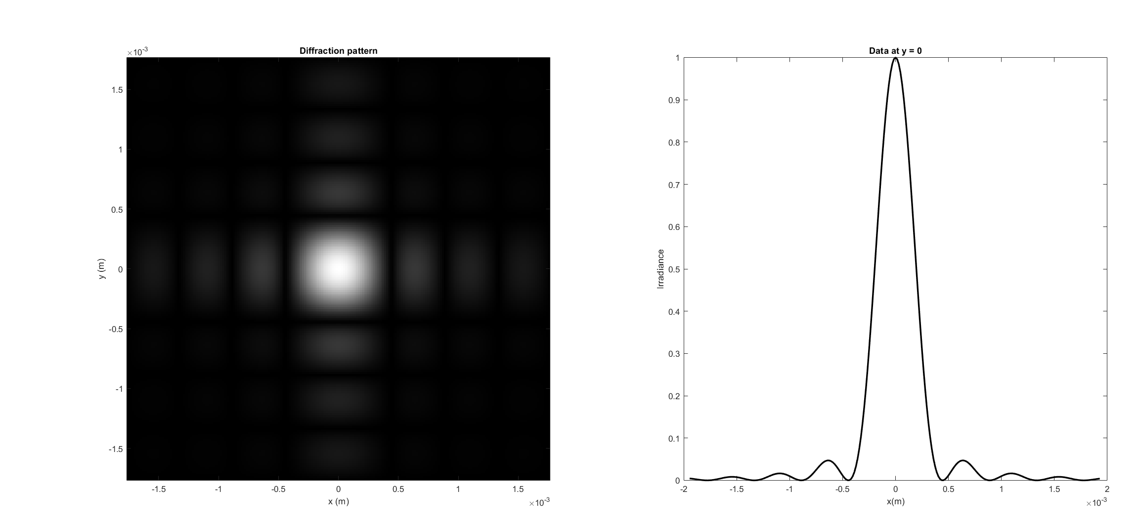

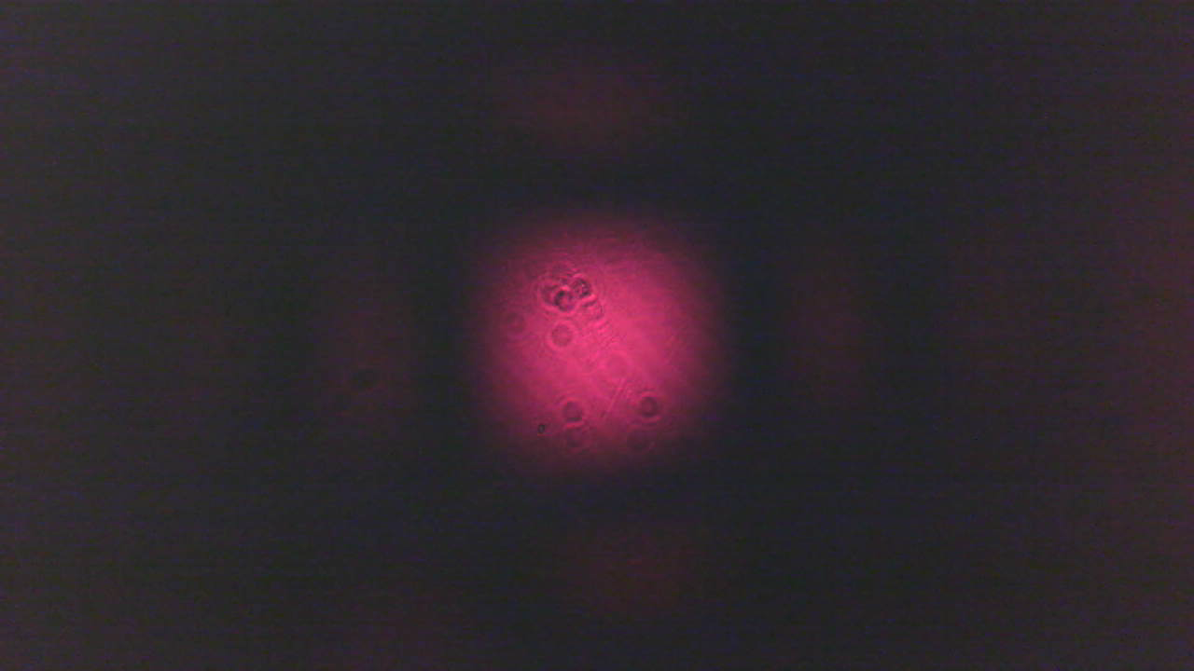

**Simulation parameters**

**w (half slit width) = 50 [um]**

**z (propagation distance)= 90 [mm]**

** (wavelength) = 635 [nm]**

Trou circulaire :

Nous pouvons constater que nos simulations match bien avec la mesure et que les dimensions mesurer sont similaire (diamètre de 1 mm simulé et de 0.9 mm mesuré) et qu’on peut bien distinguer les cercles concentriques dans la simulation mais ceux-ci sont plus difficile à distinguer sur la photo car le contraste est faible.

Trou rectangulaire :

Nous pouvons constater que nos simulations match bien avec la mesure et que les dimensions mesurer sont similaire (diamètre de 0.8 mm simulé et de 0.75 mm mesuré) et qu’on peut mieux distinguer le pattern de rectangles verticaux et horizontaux.

## 2. Fraunhofer diffraction and application of the Fourier transform

**Take a picture of the diffraction pattern for the 100 microns slit, show an image of the pattern and center lines (raw and average data). Measure the distance of the slit to the camera chip. Simulate the diffraction pattern with Fraunhofer diffraction theory based on Fourier transforms using Matlab and plot the results next to the measured ones.**

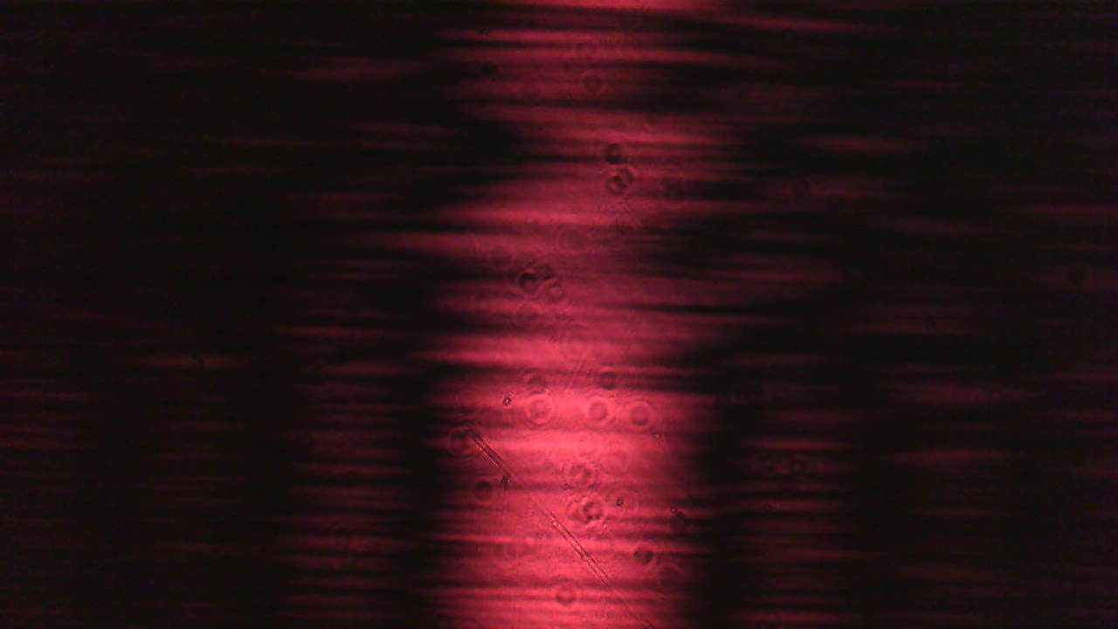

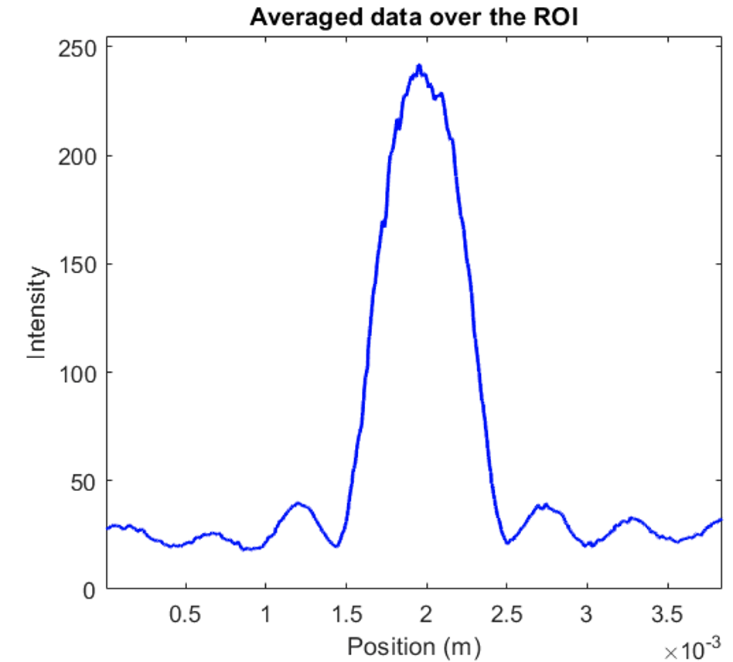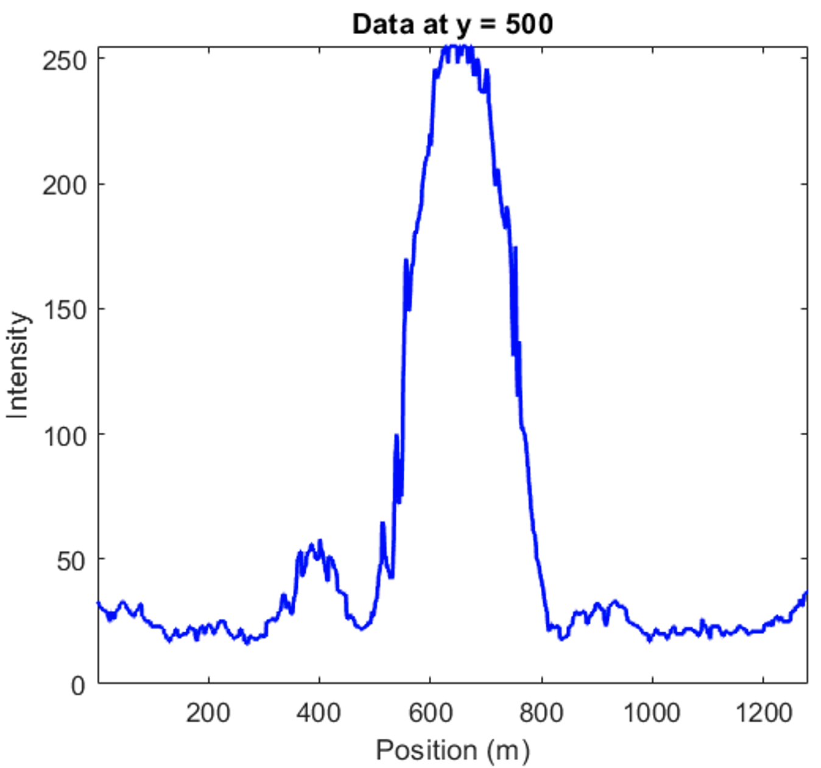

**raw data single line averaged data**

**Calculate the Fresnel number for your experiment and write your simulation parameters in the report.**

**Fresnel number**

**w = 50 [um]**

**z = 85 [mm]**

**M (number of averages) = 100**

** (wavelength) = 635 [nm]**

**NF = 0.0414**

**With the help of the Fresnel number judge if the Fraunhofer approximation is valid in our case.**

**Is the Fraunhofer approximation valid? YES, (NF<<1)**

**Present diffraction pattern line-plots and compare the position of minimum intensity for measurement and theory. Compare the first minimum of measured diffraction curve with theory.**

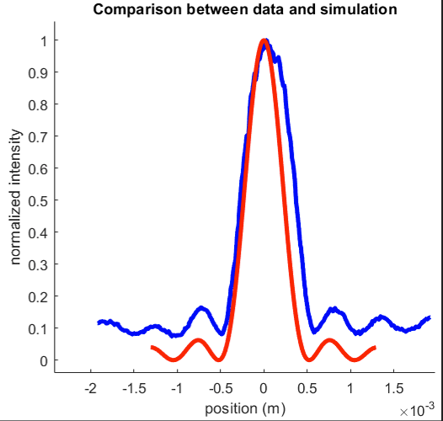

**For the slit we can use the analytical diffraction equation to verify our results. The zeros of intensity for the first order diffraction minima of a slit are given by the equation**

where  is the diffraction angle, W is the slit width and  is the wavelength.

**In the experiment, the distance from the slit to the camera is z. On our camera image, the positions x of the minima are given by the relation and with the diffraction angle  from above, we have**

Calculate the values for x and compare them with your measurement and simulation!

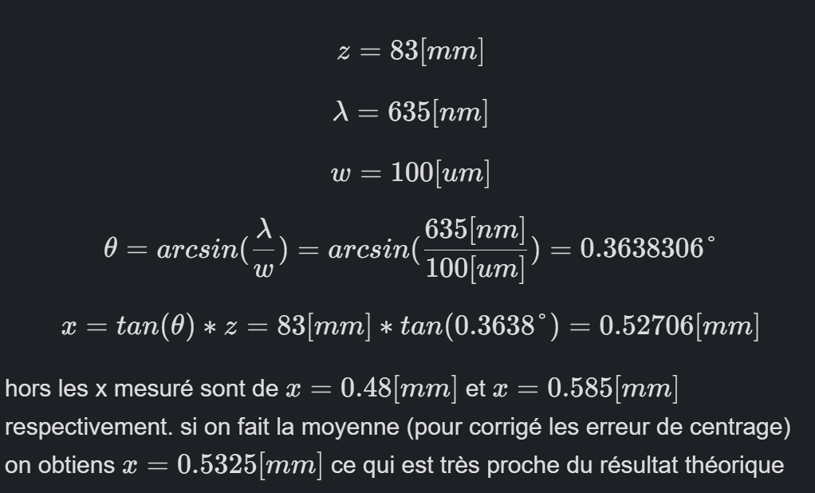

## 3. Grating diffraction and Fourier transform

**Present images of the measured diffracted intensity for each grating as shown below.**

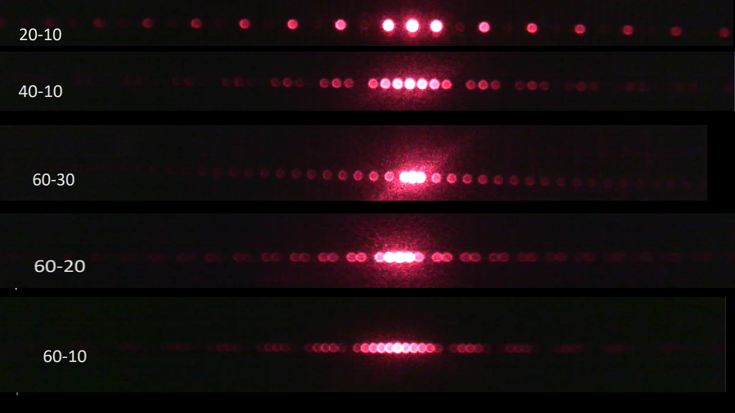

**Simulate the diffraction patterns for the grating geometries and show your own simulation results similar to the one below for the following parameters:**

(☹=40m, w=10 m), (☹=60m, w=10 m), (☹=60m, w=20 m) and (☹=60m, w=30 m)

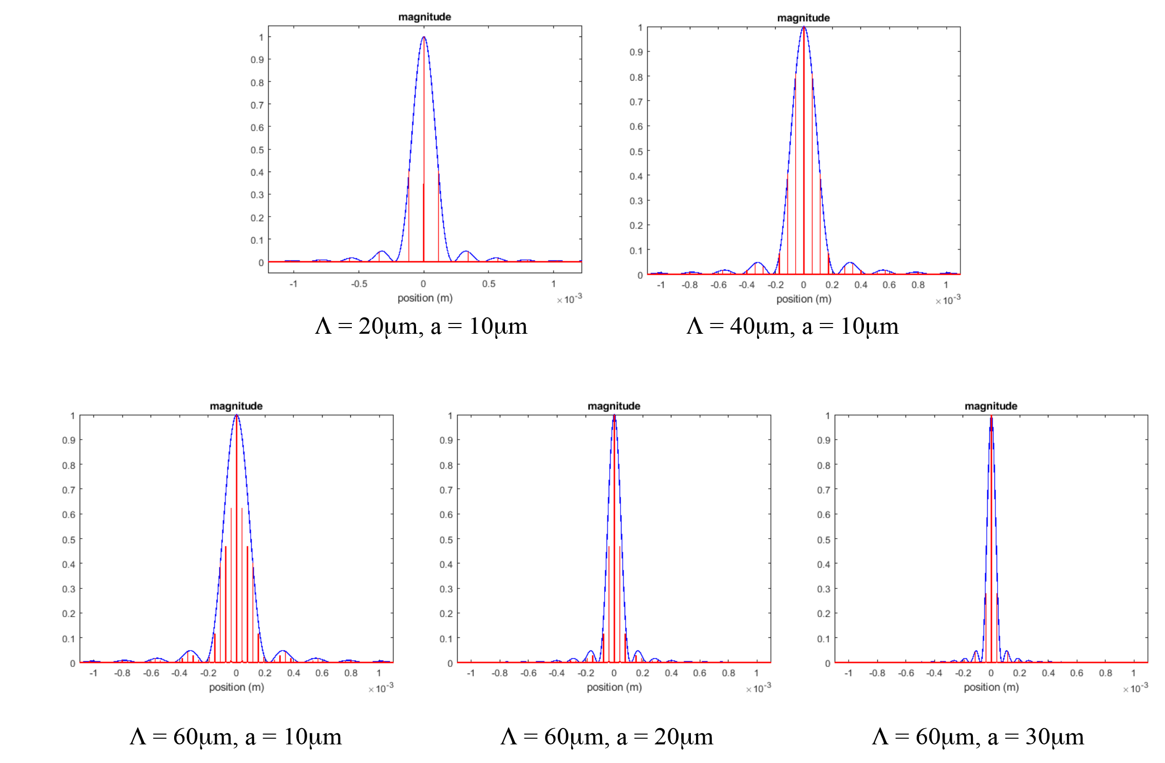

**Explain what happens if you change the period of the grating at constant rectangle (slit) width. (one or two sentences)**

Si on change la période du gratting en gardant la largeur du rectangle constante, la distance entre les point diminue en suivant la relation 1/p mais l’intensité des pic augmente. L’enveloppe et donc la distance entre les minimums reste inchangé.

**Explain what happens if you change the rectangle (slit) width and keep the period of the grating constant. (one or two sentences)**

**Si on change la largeur de la fente en gardant la période du gratting constante on peut voir que la courbe d’intensité devient plus étroite alors que la distance entre les pics reste constante. Il en résulte que les minimums d’intensité se rapproche.**

**Compare the measurements with simulations for two grating configurations and plot the figures.**

☹=40m and w=10 m ☹=60m and w=30 m

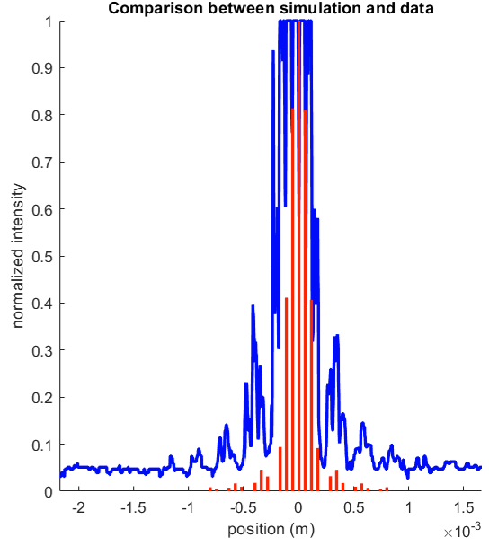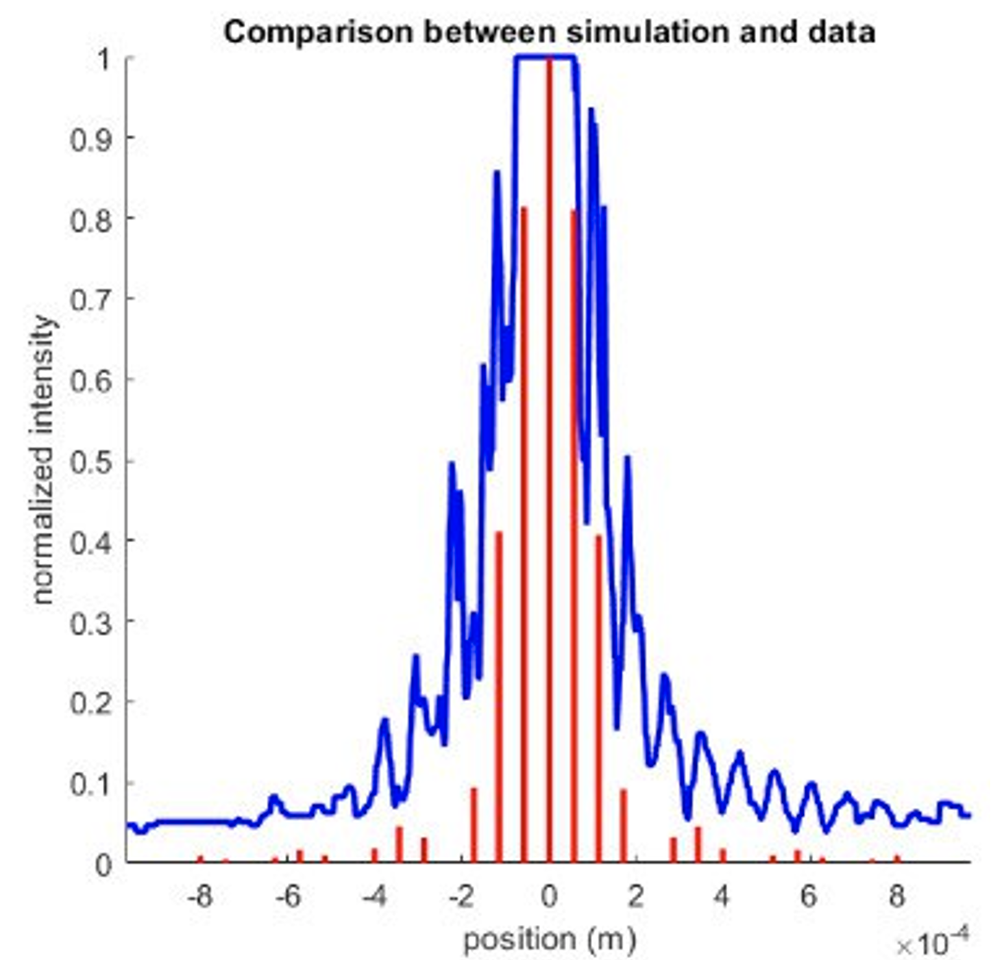

**Discuss briefly features like spacing and height of diffraction peaks.**

On peut voir que les deux graphiques suivre approximativement la courbe prédite par la théorie mais on peut voir que l’intensité absolu est biaisée par la lumière extérieur et la saturation (malgré l’emploi de polariseur) On peut tout de même noter que les pics se superpose au bon endroit ce qui nous indique que la théorie et la pratique colle bien. (Mais plus on s’éloigne du centre plus l’erreur s’accumule et on voit que les pics ne sont plus autant superposés. C’est nettement plus visible dans le graph de droite car il y as plus de pic donc plus d’erreur accumulé)

**(Optional) Personal feedback:**

Was the amount of work adequate?

Yes. A bit long

What is difficult to understand?

No, and it was interesting

What did you like about it?

interesting

How can we do better?

Improve the explanation on the usage of the matlab script