# Aberrations

## 1. Imaging with a plan-convex lens for different orientations

**Make three images at different de-focalization positions (-300, 0, 300 micron) for each orientation of the lens (object curvature - landscape) and place them in the report.**

**Landscape orientation Object curvature orientation**

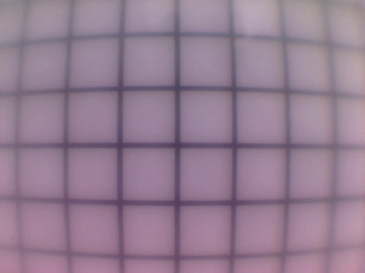 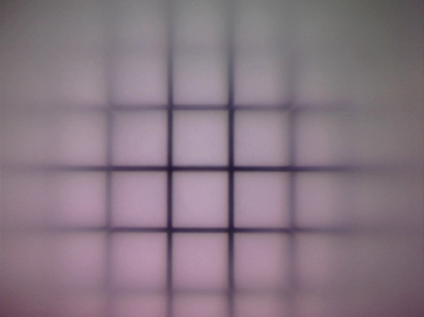

In focus

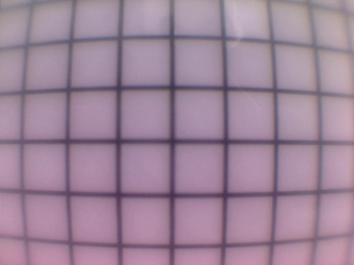 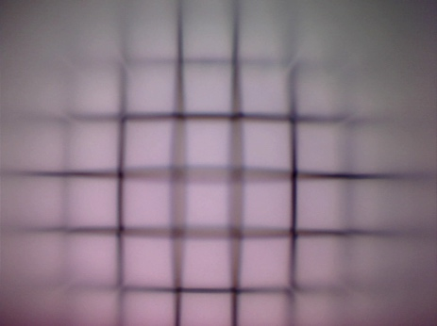

-300 micron – smaller distance lens detector

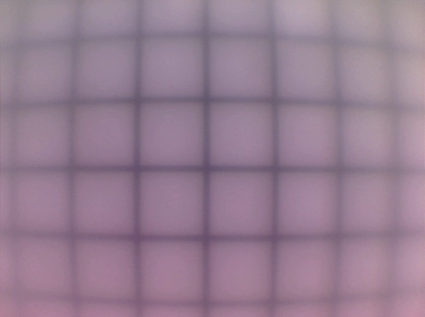 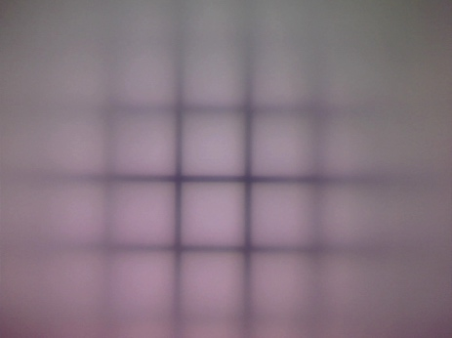

+300 micron – larger distance lens detector

**Comment what you see (image quality, focalization over the field of view, aberrations...)**

Nous pouvons voir qu’en orientation paysage, nous somme plus tolérant aux erreurs d’ajustement contrairement a l’orientation objet ou une petite erreur influence plus dramatiquement la netteté. De plus, en orientation Objet, on note que le champ de vue est plus restreint et qu’en dehors l’image deviens très vite floue la ou l’orientation paysage est plus tolérante mais induis une déformation similaire à celle d’un fish-eye.

## 2. Direct measurement of the field curvature by defocusing of a test image

**Show three images (for instance focusing of rings 1,3,5). Measure the field curvature resulting in de-focalization for a minimum of 7 rings. Plot the de-focalization distance (to be read at the linear stage) as a function of the position in the image (to be read in the image).**

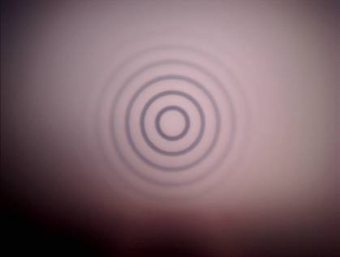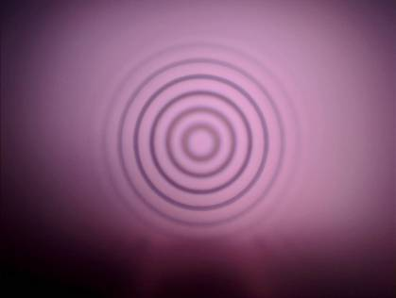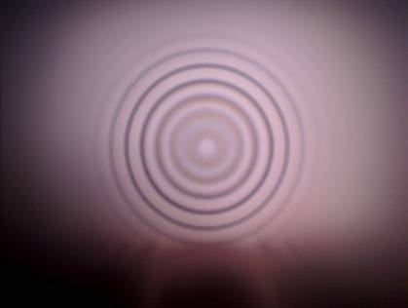

The diameter of each ring is doubled for advancing ring number on the card. To get the right scaling, you need to MEASURE the first ring diameter in the image and calculate all the others.

Measured diameter of first ring in image: d0 = 0,501 mm

|  |  |  |  |  |
| --- | --- | --- | --- | --- |
| Ring No | Radius | Calculated theoretical Radius in image space (mm) | Absolute Focus position on linear stage (mm) | Relative distance in mm |
| 1 | d0/2 | 0.255 | 3 | 0 |
| 2 | d0/2+d0/2 | 0.51 | 3.1 | 0.1 |
| 3 | d0/2+d0 | 0.765 | 3.3 | 0.2 |
| 4 | d0/2+3d0/2 | 1.02 | 3.7 | 0.4 |
| 5 | d0/2+2d0 | 1.275 | 4.3 | 0.6 |
| 6 | d0/2+5d0/2 | 1.53 | 5.05 | 0.75 |
| 7 | d0/2+3d0 | 1.785 | 6 | 0.95 |
|  |  |  |  |  |

Defocalization [mm] (axe vertical)

Position in image space [mm]

**NOTE: the plot for the report needs to be done in mm and not in normalized units!!**

**Calculate the radius of curvature at the center (0,0) of your data. This can be done by fitting a function y=ax2 on the curve and calculate the radius of curvature with the equation R=1/(2a).**

**Radius of curvature: R = 0.9957 [mm] avec a = 1.0002**

**Compare it with the Petzval curvature of the lens: Rp= f n (f-focal lengths, n-refractive index of the lens)**

**Petzval curvature: Rp= f n = 7,2 [mm] avec f=4 mm et n=1.808**

**Comment on why the Petzval radius is so different from your measurement?**

La prédiction de Petzval est légèrement supérieure à nos mesures car Petzval ne prend pas en compte l’erreur d’astigmatie.



Simulated field curvature for the planoconvex lens used in the experiments. On the left, in landscape orientation, the maximum field curvature is smaller than 0.5 mm and on the right values larger than 0.75 mm could be found. (T – tangential, S – sagittal)

**Compare your result also with data given in the figure above!**

On peut voir que les graphs fournis sont plus précis et match mieux avec nos donné que la formule de petzeval et cela car il tienne compte de l’orientation de notre lentille.

## 3. Distortion and its correction by coordinate transformation

**Show a series of images as given below. Try to find the best correction and give the following values:**

* **Position of the center of the transformation (called center_point_x; center_point_y in the matlab script)**
* **value of the correction (called “a” in the matlab script).**

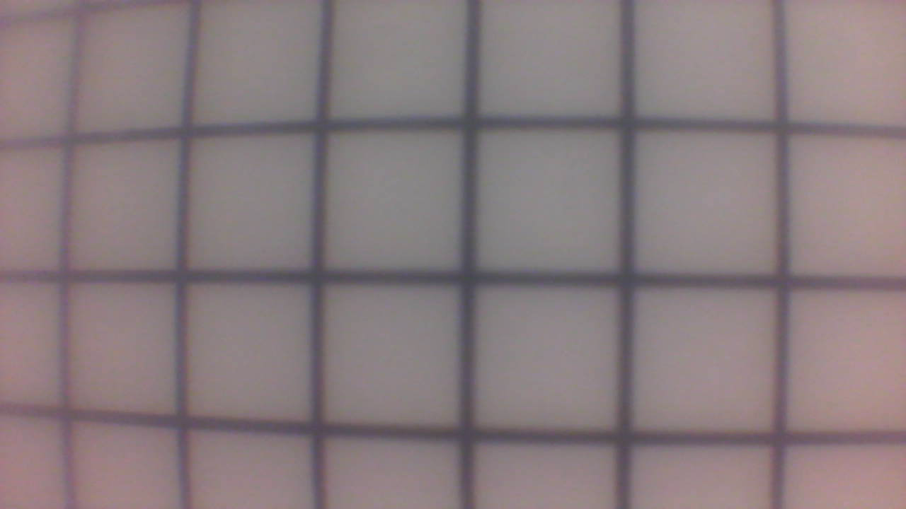

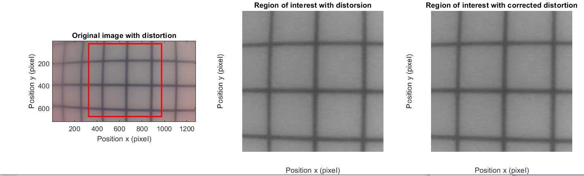

**Comment on the meaning of the sign of the correction value.**

Le programme nous permet de corriger la distorsion en appliquant l’inverse de celle-ci. Dans notre cas nous avons une distorsion positive (Barrel distorsion) c’est pourquoi nous devons appliquer l’inverse (Pincushion distorsion). Ce qui se traduit dans notre programme à mettre une valeur négative.

Dans le cas contraire nous appliquons une distorsion positive dans notre programme pour compenser la Pincushion distorsion.

**Give a real image example by taking an image of a scene and make the correction.**

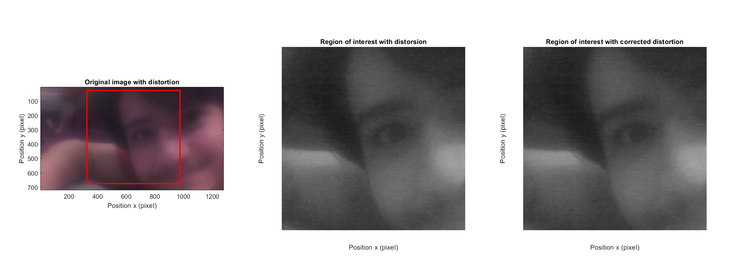

## 4. Observation of transversal chromatic aberrations for large field of views

**Present two images and show transversal aberrations. Choose a convenient position in the image (middle) and plot the normalized line plot as given below. Use averaging to improve the quality of the measurement. Demonstrate the shift of the peaks for two positions (peaks) within the field of view by showing two graphs. Present a table that gives the peak positions for red, green and blue.**

 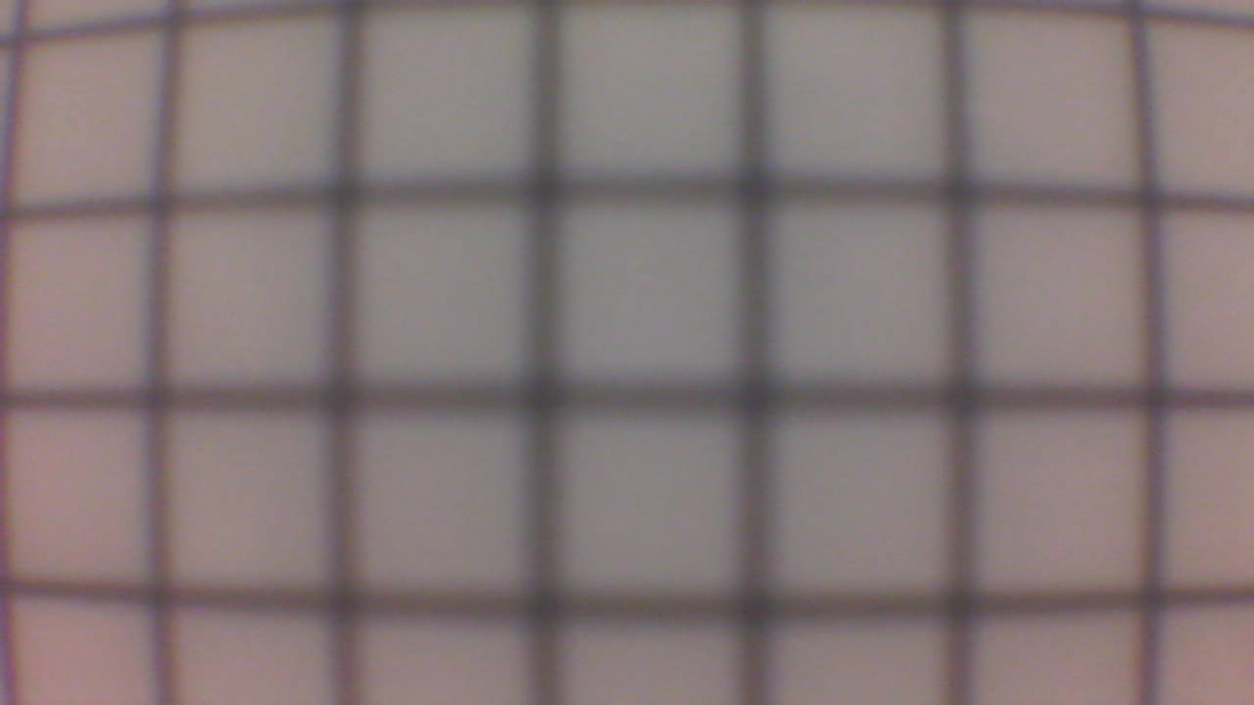

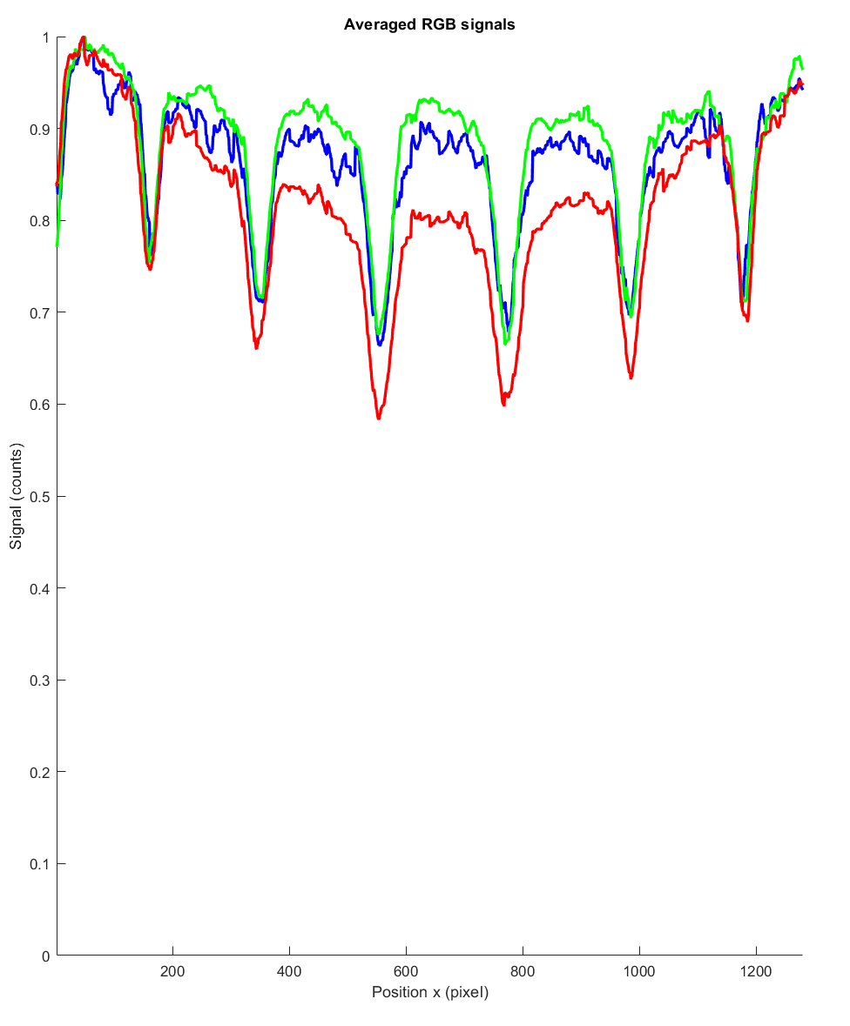

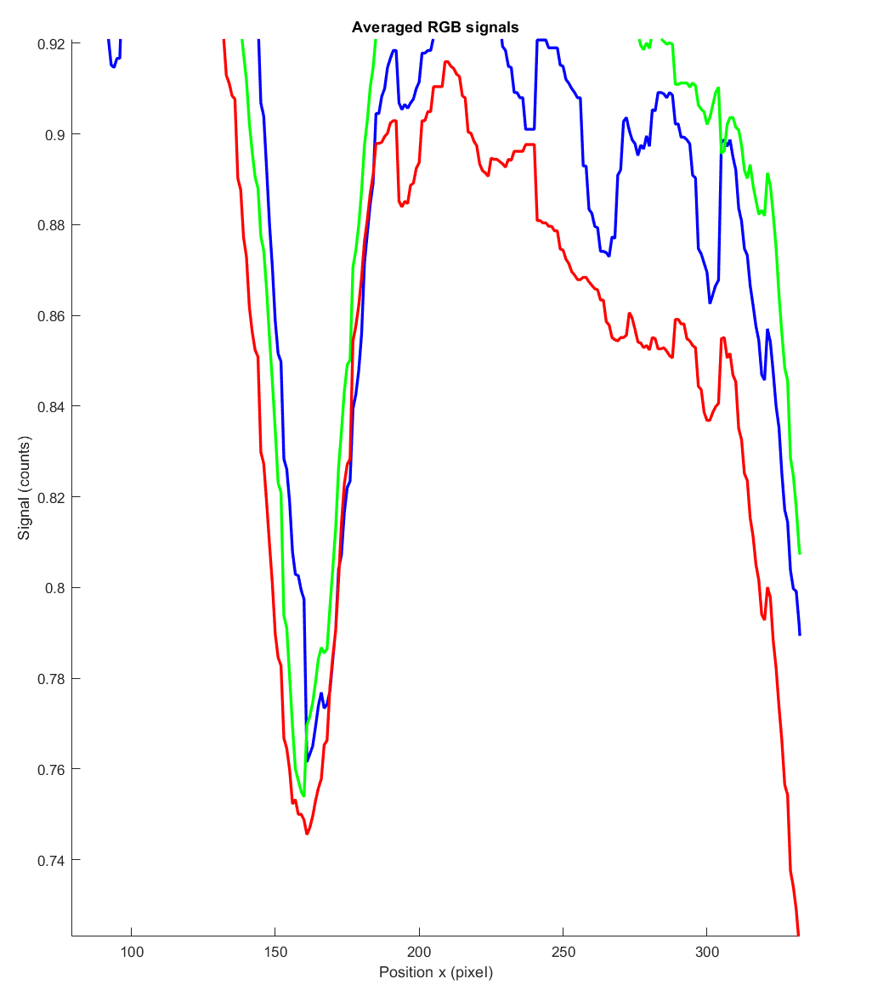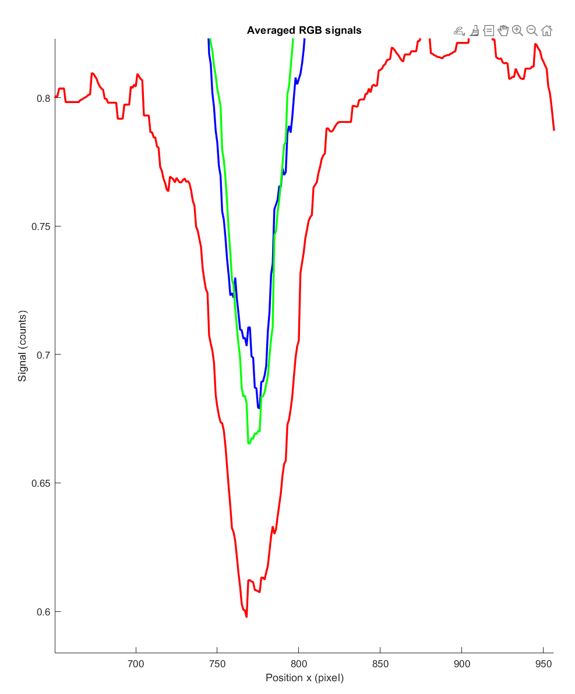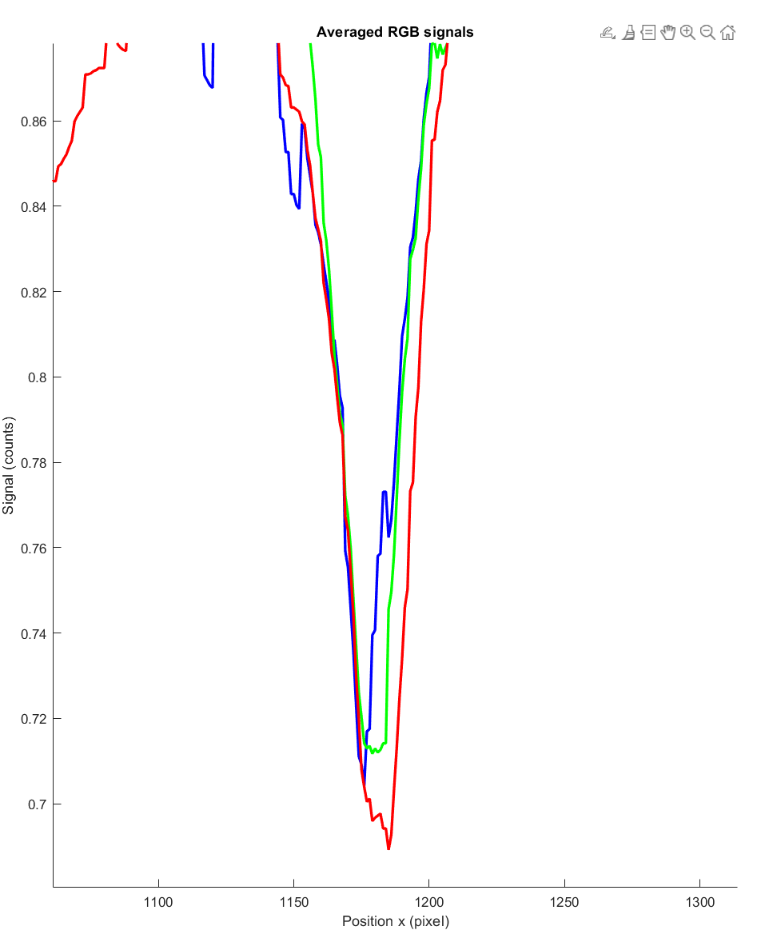

**left middle right**

**NOTE: Your images might look different!!!**

|  |  |  |  |  |  |  |
| --- | --- | --- | --- | --- | --- | --- |
| direction | Blue peak pixel position | Green peak  pixel  position | Red peak  pixel  position | Blue peak relative to position of center peak | Green peak relative to position of center peak | Red peak relative to position of center peak |
| left | 161 | 160 | 156 | 595 | 596 | 600 |
| right | 1176 | 1179 | 1185 | 408 | 411 | 417 |

**Interpret your results!**

**Nous pouvons voir que les longueurs d’onde plus faible (rouge) sont plus déviées sur l’extérieur. Ce phénomène nous montre que la déviation dépend aussi de la longueur d’onde.**

## 5. Example from the web

**Find an image taken with a fisheye lens and print it into your report. Print also an image of the lens model as shown below so that one can read the parameters of the lens! Cite correctly!**

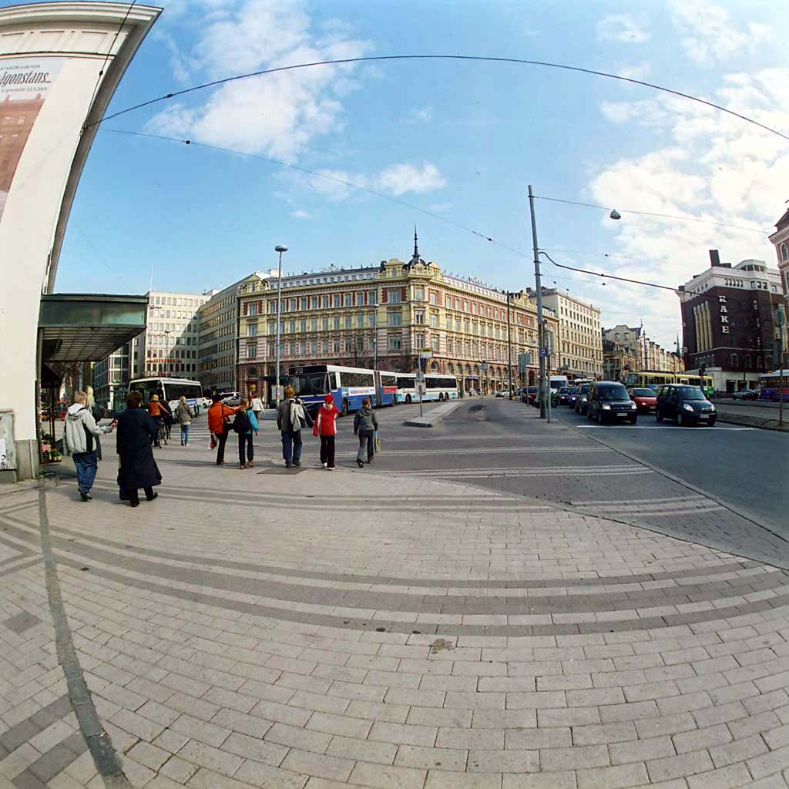 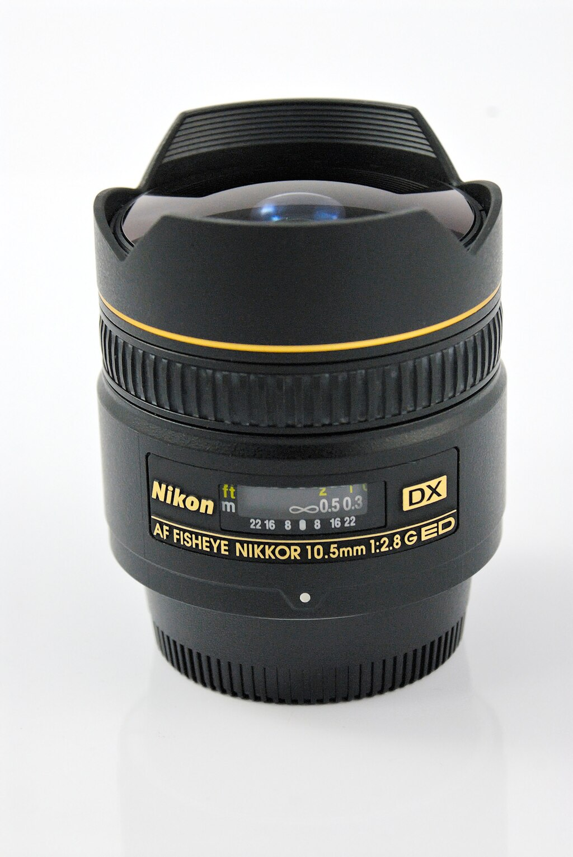

<https://commons.wikimedia.org/wiki/File:Fisheye-helsinki.jpg> (visited on 16.11.23)

<https://commons.wikimedia.org/wiki/File:Nikon_DX_fisheye_DSC7315EC.jpg> (visited on 16.11.23)

**(Optional) Personal feedback:**

Was the amount of work adequate?

Yes

What is difficult to understand?

Nothing specials this time

What did you like about it?

The operation to correct the distortion in matlab

How can we do better?