Témoin (Preliminary Flight Simulation)
96.798 242.68124682042853 242.63904903656697 0.9012818783579469 2.7337289251844044 0.003299023417521535
masse totale de eth : 8.512522086306488
masse totale de Lox : 11.482306082229018
=== Computed Results ===
Thrust curve mode: constant
Total Impulse (courbe complète, avant troncature hold-down): 35500.45 N·s (cible: 35500.00)
Warning: Adding spherical caps to the tank will not modify the total height of the tank 0.4463509195850538 m. Its cylindrical portion height will be reduced to 0.2747509195850538 m.
Tank height: 0.38510080748133463 m
Copv height: 0.4463509195850538 m
Impulse (nominale, hold-down inclus): 35500.0 [Ns]
Burn time: 5.126 [s]
Dry mass: 96.80 [kg]
Wet mass: 122.00 [kg]
Apogee (AGL): 3222.5 [m]
Out of rail time: 0.785 [s]
Burn out time: 5.220 [s]
Time to apogee: 27.338 [s]
Disreef time: 107.394 [s]
Time of impact: 143.286 [s]
Max Mach: 0.745 [-]
Max velocity: 257.16 [m/s]
Max acceleration: 65.43 [m/s^2]
Out of rail velocity: 32.85 [m/s]
Rail departure angle of attack: 1.643 [°]
Baseline (new fins, ECMWF)
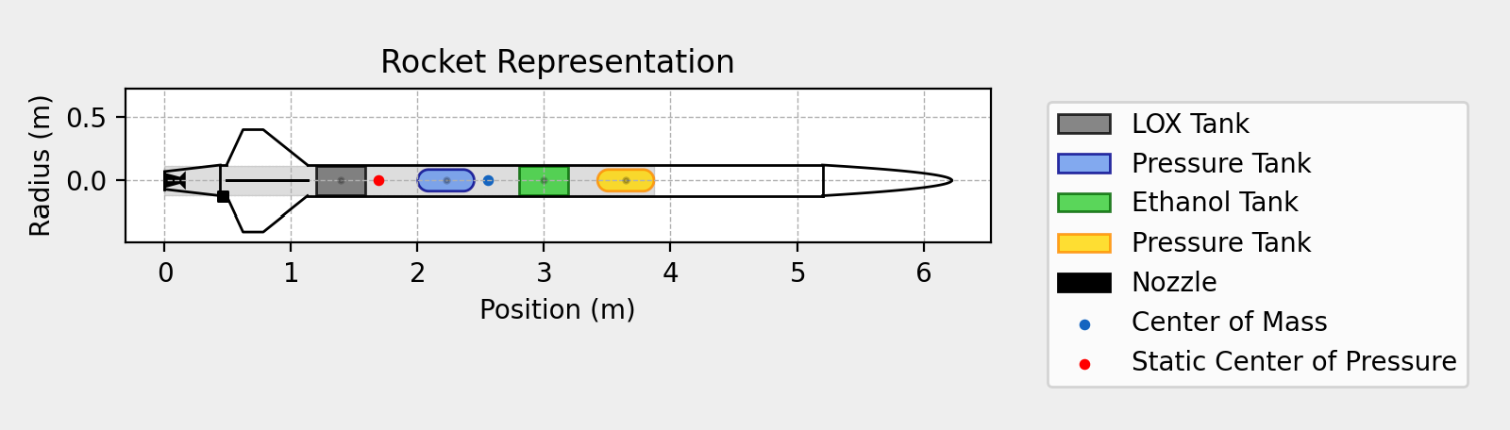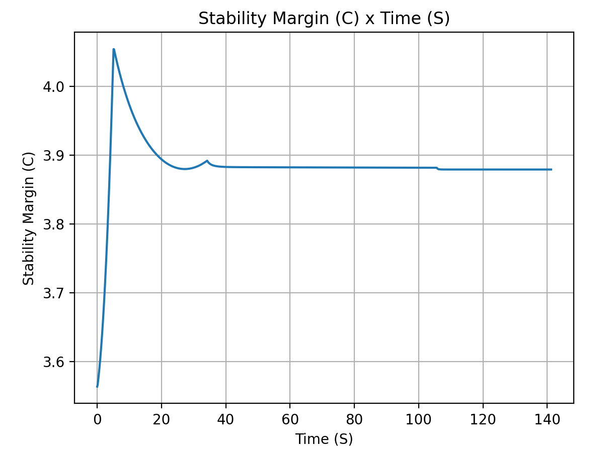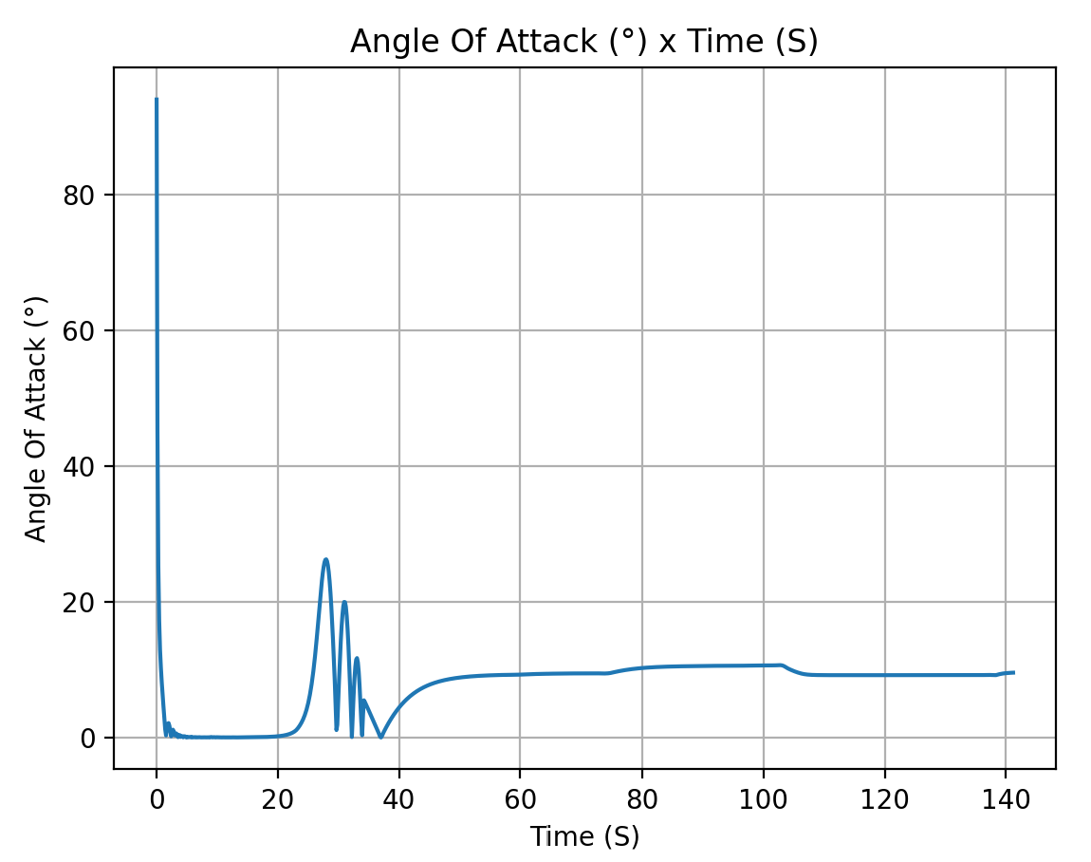
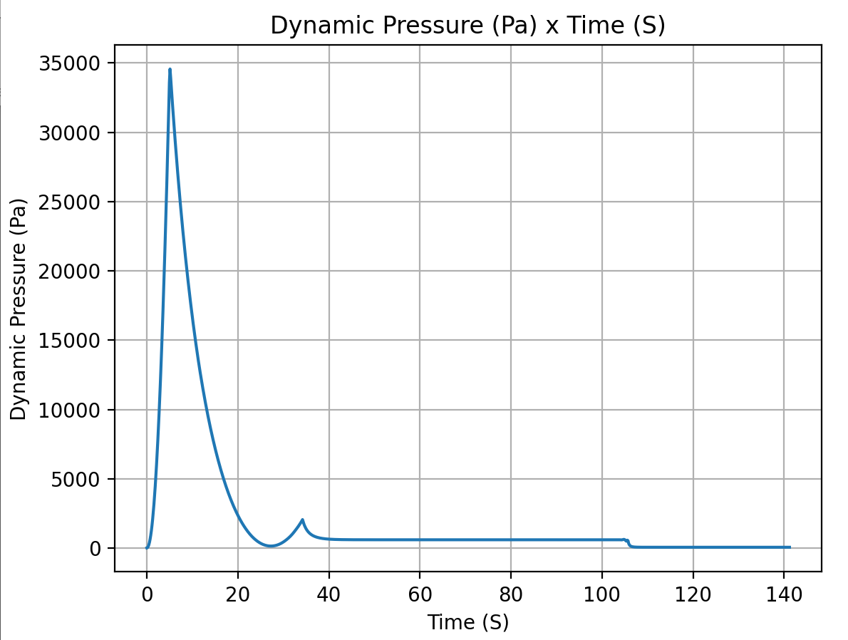
masse totale de eth : 8.188221202854228
masse totale de Lox : 11.783869113149848
=== Computed Results ===
Thrust curve mode: constant
Total Impulse (courbe complète, avant troncature hold-down): 35500.45 N·s (cible: 35500.00)
Impulse (nominale, hold-down inclus): 35500.0 [Ns]
Burn time: 5.126 [s]
Dry mass: 98.59 [kg]
Wet mass: 123.77 [kg]
Apogee (AGL): 3190.1 [m]
Out of rail time: 0.791 [s]
Burn out time: 5.220 [s]
Time to apogee: 27.302 [s]
Disreef time: 105.774 [s]
Time of impact: 141.280 [s]
Max Mach: 0.727 [-]
Max velocity: 252.07 [m/s]
Max acceleration: 65.66 [m/s^2]
Out of rail velocity: 32.55 [m/s]
Rail departure angle of attack: 10.473 [°]

Stability Margin

Initial Stability Margin: 3.564 c at 0.00 s
Out of Rail Stability Margin: 3.591 c at 0.70 s
Maximum Stability Margin: 4.056 c at 5.13 s
Minimum Stability Margin: 3.564 c at 0.05 s
Rail exit velocity: 32.54995402796609
Rail exit stability: 3.5906418063845167
Max Q: 34559.944973680955
Max Q time: 5.086857675326119
AoA at max-Q: 0.021383811658534015
SM at max-Q: 4.053659346483668

No Wind
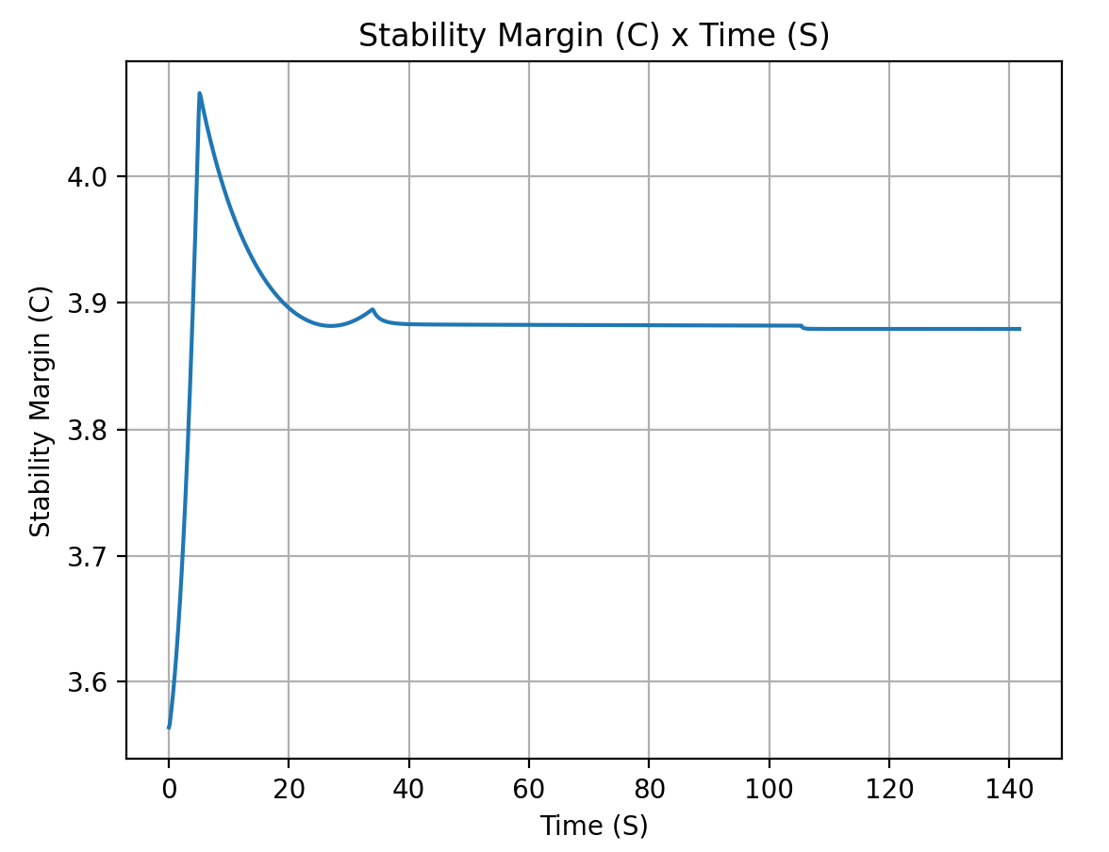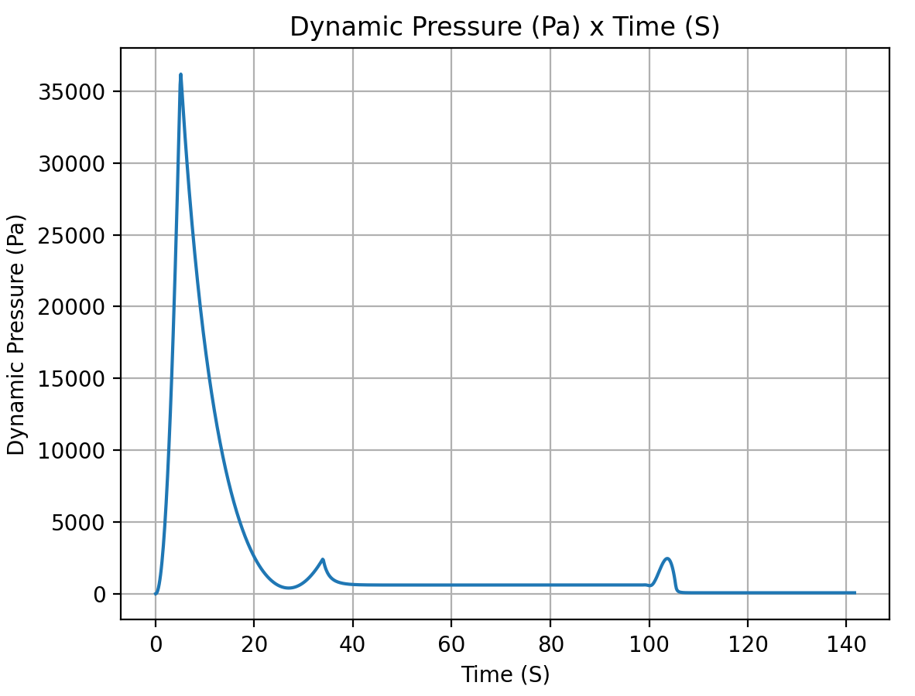
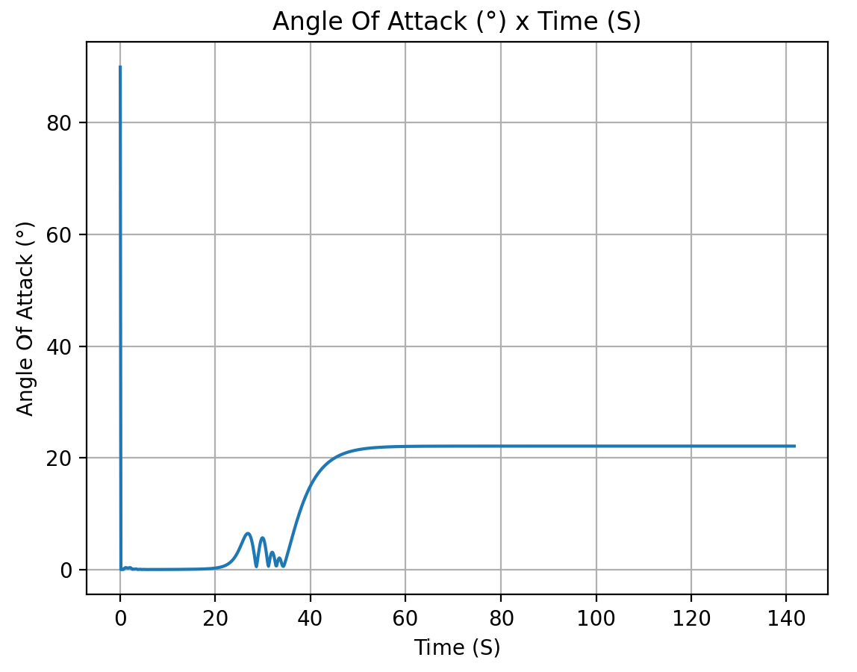
masse totale de eth : 8.188221202854228
masse totale de Lox : 11.783869113149848
=== Computed Results ===
Thrust curve mode: constant
Total Impulse (courbe complète, avant troncature hold-down): 35500.45 N·s (cible: 35500.00)
Impulse (nominale, hold-down inclus): 35500.0 [Ns]
Burn time: 5.126 [s]
Dry mass: 98.59 [kg]
Wet mass: 123.77 [kg]
Apogee (AGL): 3137.1 [m]
Out of rail time: 0.791 [s]
Burn out time: 5.220 [s]
Time to apogee: 27.058 [s]
Disreef time: 105.454 [s]
Time of impact: 141.755 [s]
Max Mach: 0.748 [-]
Max velocity: 252.26 [m/s]
Max acceleration: 65.17 [m/s^2]
Out of rail velocity: 32.56 [m/s]
Rail departure angle of attack: -0.000 [°]

Stability Margin

Initial Stability Margin: 3.564 c at 0.00 s
Out of Rail Stability Margin: 3.591 c at 0.70 s
Maximum Stability Margin: 4.067 c at 5.13 s
Minimum Stability Margin: 3.564 c at 0.05 s
Rail exit velocity: 32.555199543842264
Rail exit stability: 3.590741963885068
Max Q: 36222.5472495492
Max Q time: 5.077353358640214
AoA at max-Q: 0.011260796961999267
SM at max-Q: 4.064223275686094

Max allowable crosswind (8m/s) 90°
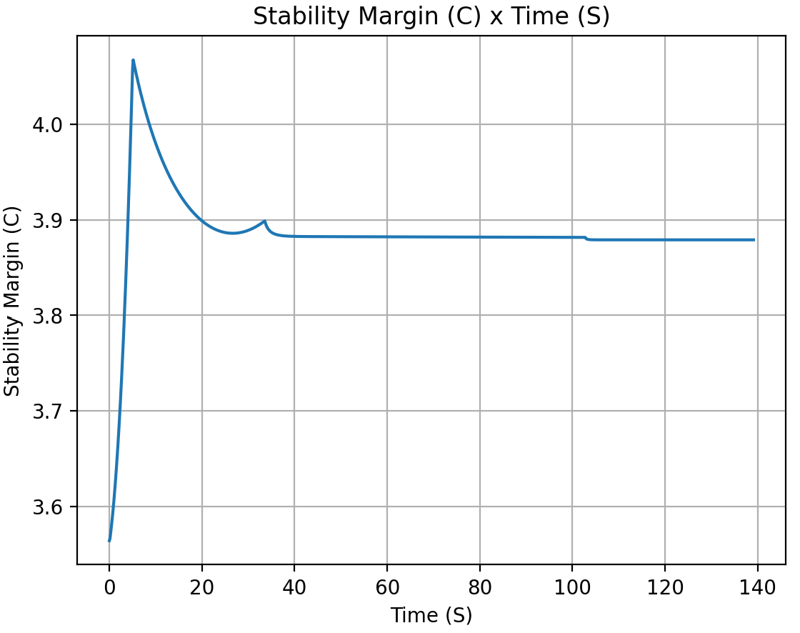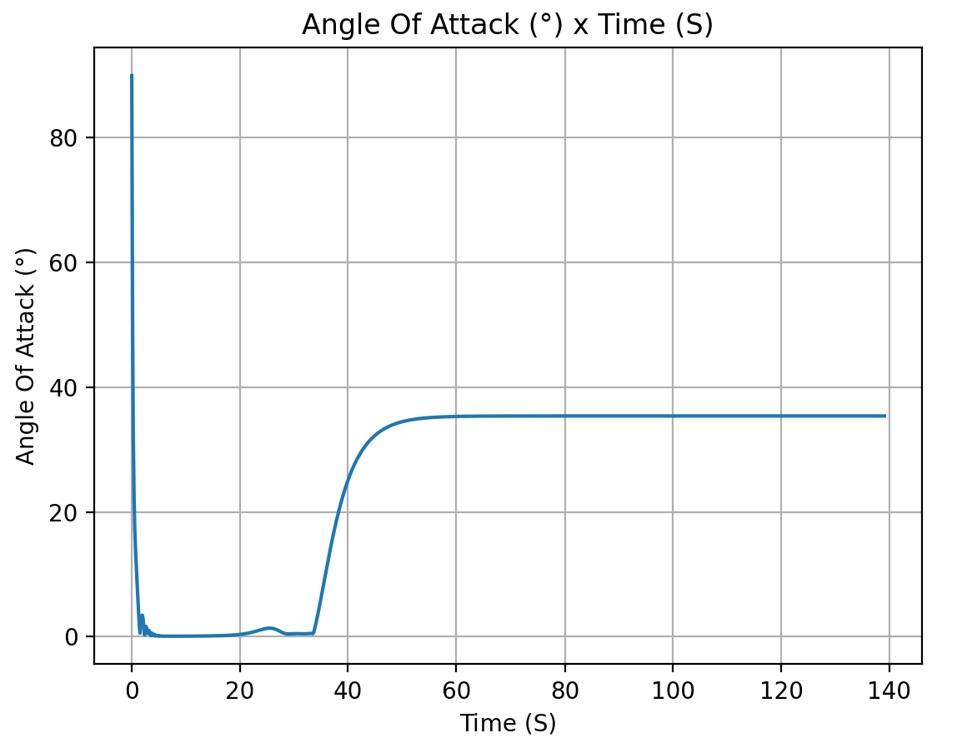
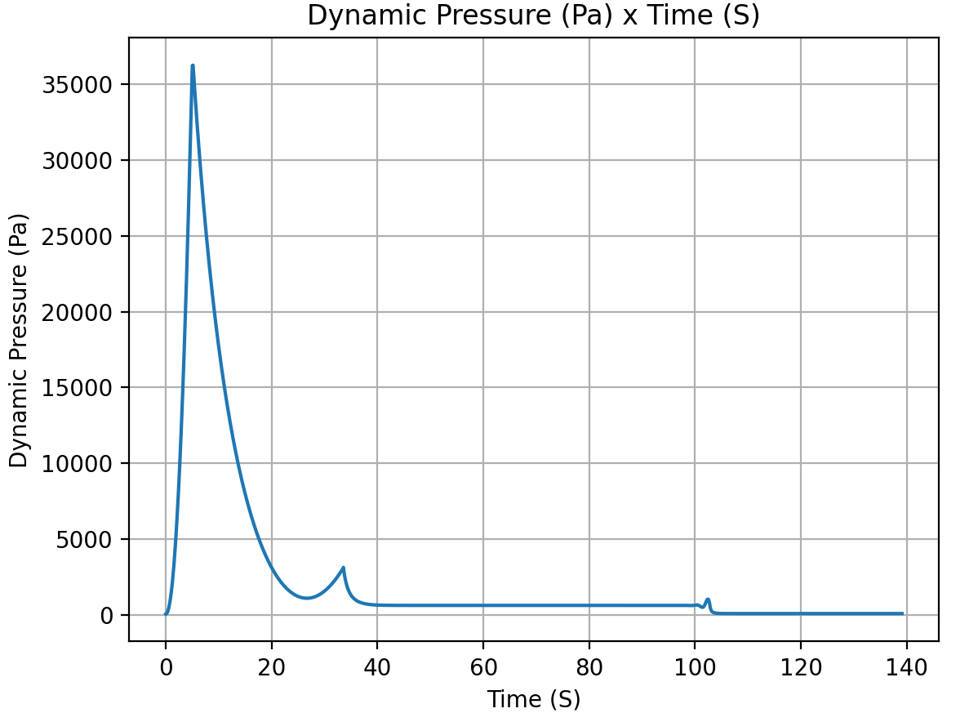
masse totale de eth : 8.188221202854228
masse totale de Lox : 11.783869113149848
=== Computed Results ===
Thrust curve mode: constant
Total Impulse (courbe complète, avant troncature hold-down): 35500.45 N·s (cible: 35500.00)
Impulse (nominale, hold-down inclus): 35500.0 [Ns]
Burn time: 5.126 [s]
Dry mass: 98.59 [kg]
Wet mass: 123.77 [kg]
Apogee (AGL): 3046.4 [m]
Out of rail time: 0.791 [s]
Burn out time: 5.220 [s]
Time to apogee: 26.651 [s]
Disreef time: 102.884 [s]
Time of impact: 139.176 [s]
Max Mach: 0.751 [-]
Max velocity: 251.74 [m/s]
Max acceleration: 65.18 [m/s^2]
Out of rail velocity: 32.55 [m/s]
Rail departure angle of attack: 13.806 [°]

Stability Margin

Initial Stability Margin: 3.564 c at 0.00 s
Out of Rail Stability Margin: 3.591 c at 0.70 s
Maximum Stability Margin: 4.068 c at 5.13 s
Minimum Stability Margin: 3.564 c at 0.05 s
Rail exit velocity: 32.553310295247
Rail exit stability: 3.5909200030983306
Max Q: 36517.33148367493
Max Q time: 5.075603441003417
AoA at max-Q: 0.05069720976154044
SM at max-Q: 4.065547162283626

Max allowable crosswind (8m/s) -90°
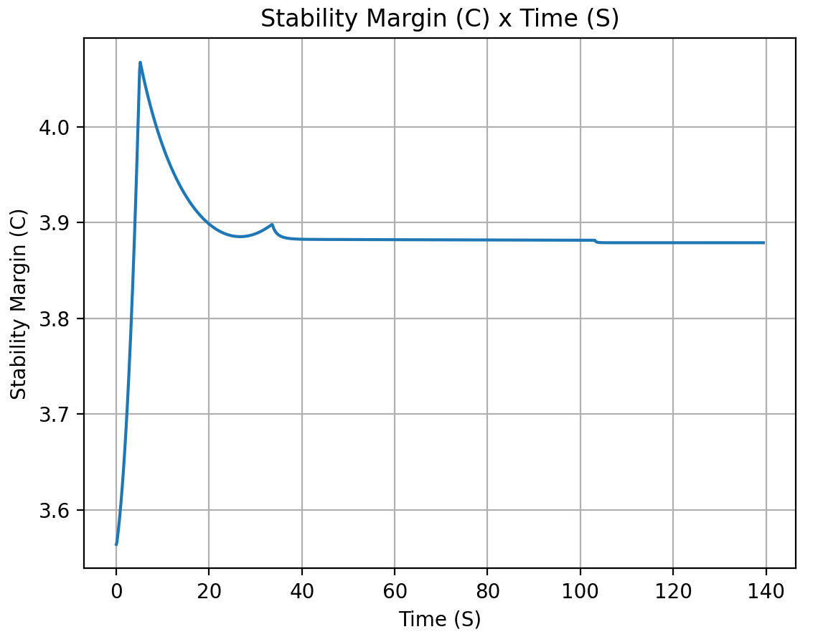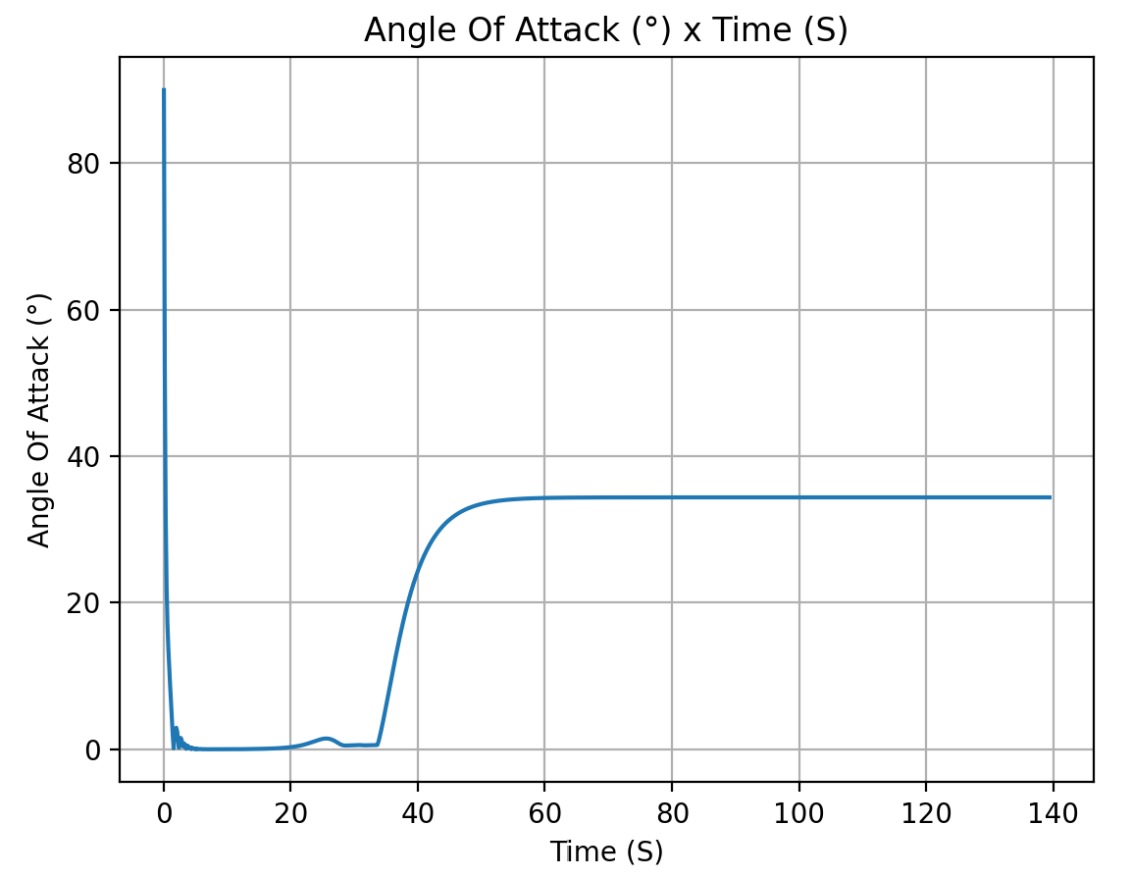
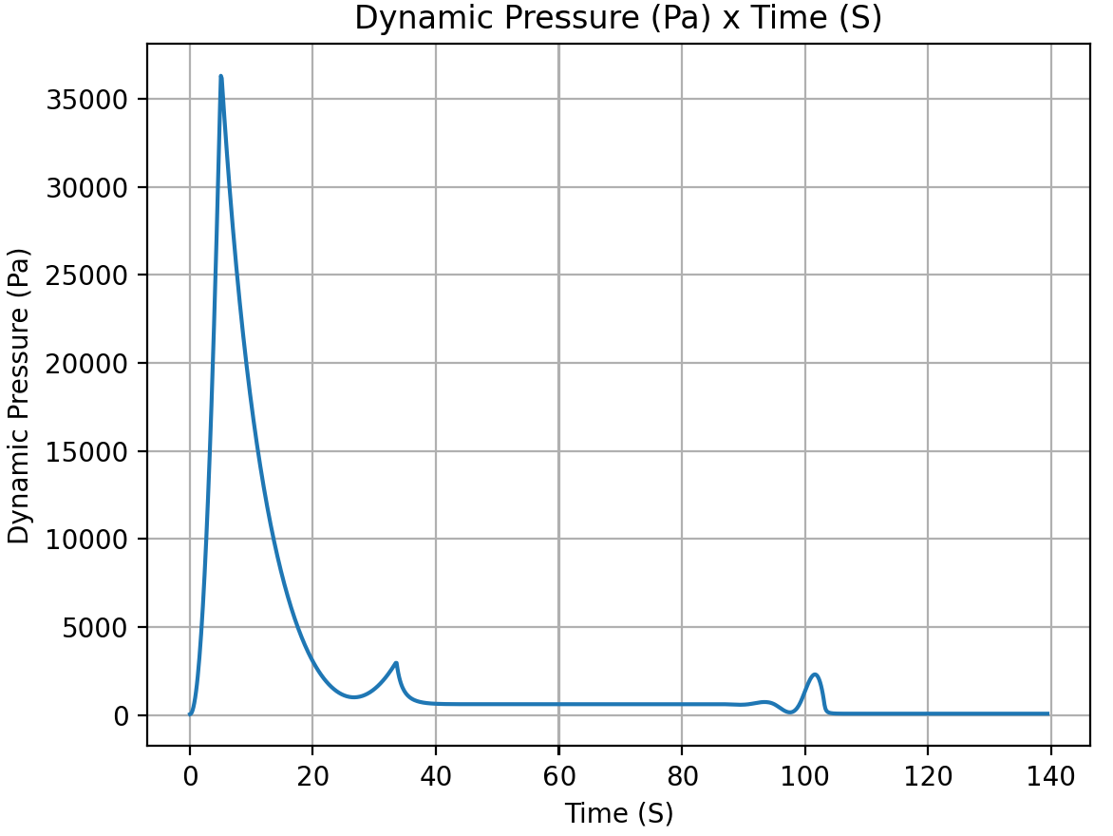
masse totale de eth : 8.188221202854228
masse totale de Lox : 11.783869113149848
=== Computed Results ===
Thrust curve mode: constant
Total Impulse (courbe complète, avant troncature hold-down): 35500.45 N·s (cible: 35500.00)
Impulse (nominale, hold-down inclus): 35500.0 [Ns]
Burn time: 5.126 [s]
Dry mass: 98.59 [kg]
Wet mass: 123.77 [kg]
Apogee (AGL): 3058.5 [m]
Out of rail time: 0.791 [s]
Burn out time: 5.220 [s]
Time to apogee: 26.703 [s]
Disreef time: 103.234 [s]
Time of impact: 139.534 [s]
Max Mach: 0.751 [-]
Max velocity: 251.79 [m/s]
Max acceleration: 65.18 [m/s^2]
Out of rail velocity: 32.55 [m/s]
Rail departure angle of attack: 13.806 [°]

Stability Margin

Initial Stability Margin: 3.564 c at 0.00 s
Out of Rail Stability Margin: 3.591 c at 0.70 s
Maximum Stability Margin: 4.068 c at 5.13 s
Minimum Stability Margin: 3.564 c at 0.05 s
Rail exit velocity: 32.55331034238646
Rail exit stability: 3.5909199975247
Max Q: 36497.79458351471
Max Q time: 5.074591181578851
AoA at max-Q: 0.0586958473657844
SM at max-Q: 4.065396304373691

+10cm CG at worst crosswind (8m/s) 90°
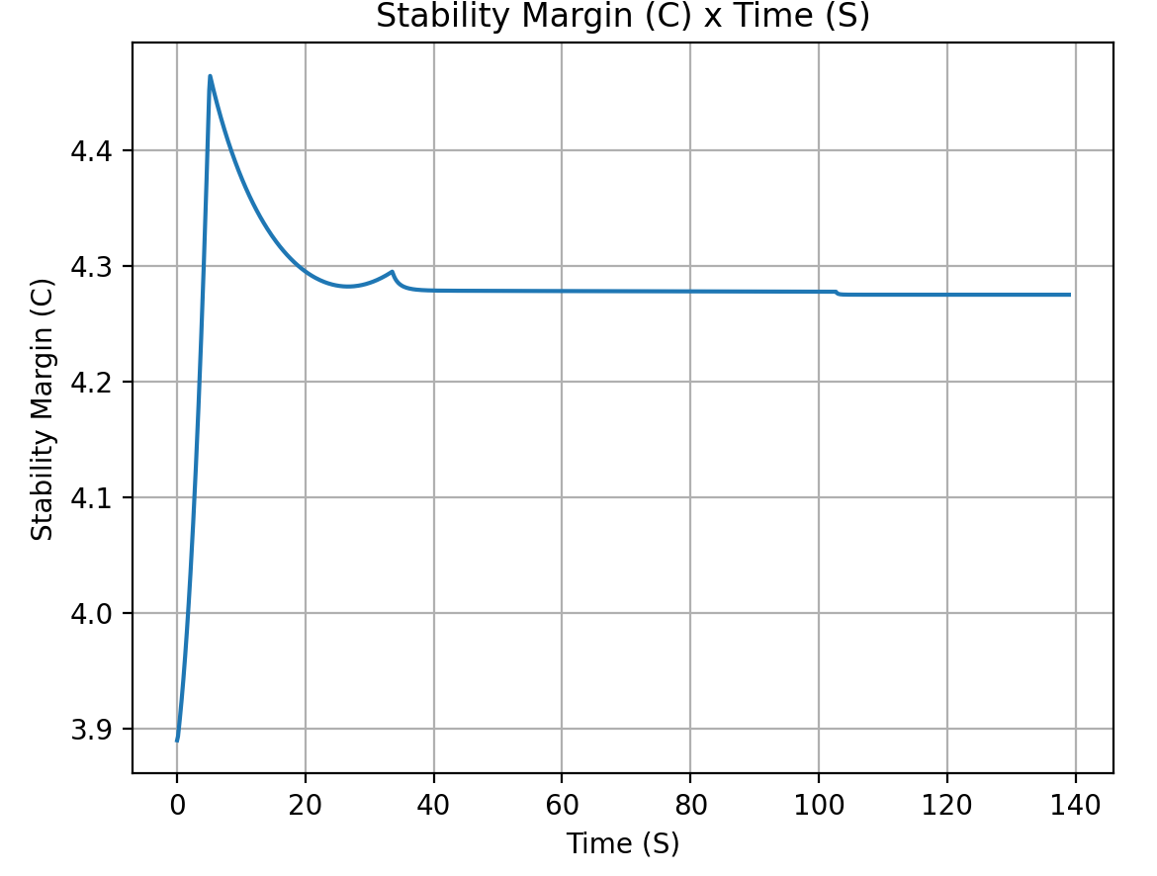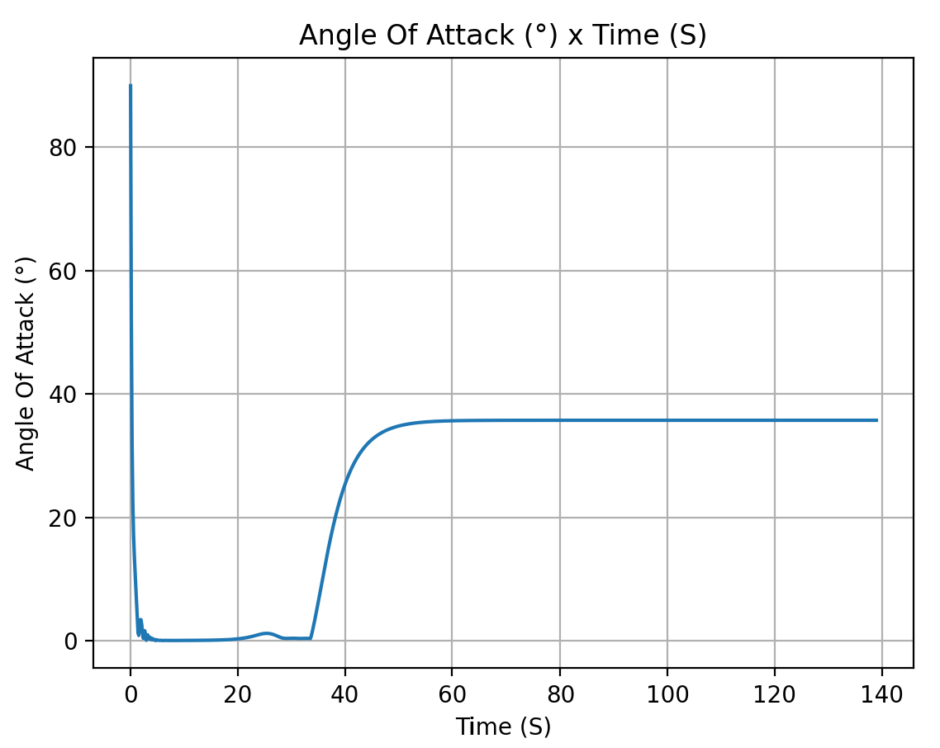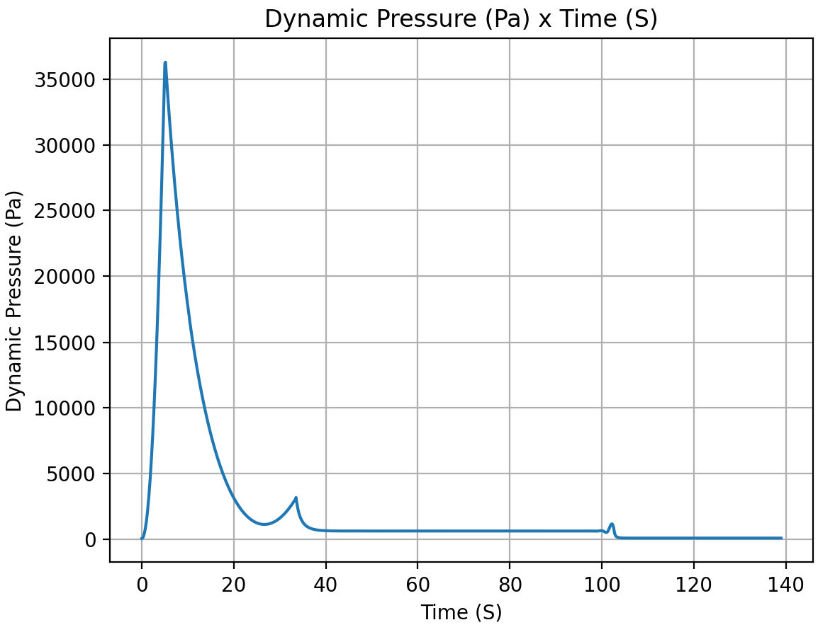
masse totale de eth : 8.188221202854228
masse totale de Lox : 11.783869113149848
=== Computed Results ===
Thrust curve mode: constant
Total Impulse (courbe complète, avant troncature hold-down): 35500.45 N·s (cible: 35500.00)
Impulse (nominale, hold-down inclus): 35500.0 [Ns]
Burn time: 5.126 [s]
Dry mass: 98.59 [kg]
Wet mass: 123.77 [kg]
Apogee (AGL): 3042.8 [m]
Out of rail time: 0.791 [s]
Burn out time: 5.220 [s]
Time to apogee: 26.629 [s]
Disreef time: 102.774 [s]
Time of impact: 139.052 [s]
Max Mach: 0.751 [-]
Max velocity: 251.74 [m/s]
Max acceleration: 65.18 [m/s^2]
Out of rail velocity: 32.55 [m/s]
Rail departure angle of attack: 13.806 [°]

Stability Margin

Initial Stability Margin: 3.890 c at 0.00 s
Out of Rail Stability Margin: 3.924 c at 0.70 s
Maximum Stability Margin: 4.464 c at 5.13 s
Minimum Stability Margin: 3.890 c at 0.00 s
Rail exit velocity: 32.553310295247
Rail exit stability: 3.924342824514011
Max Q: 36530.229165024444
Max Q time: 5.077833679128569
AoA at max-Q: 0.08574721061874065
SM at max-Q: 4.461062692354269

-10cm CG at worst crosswind (8m/s) 90°
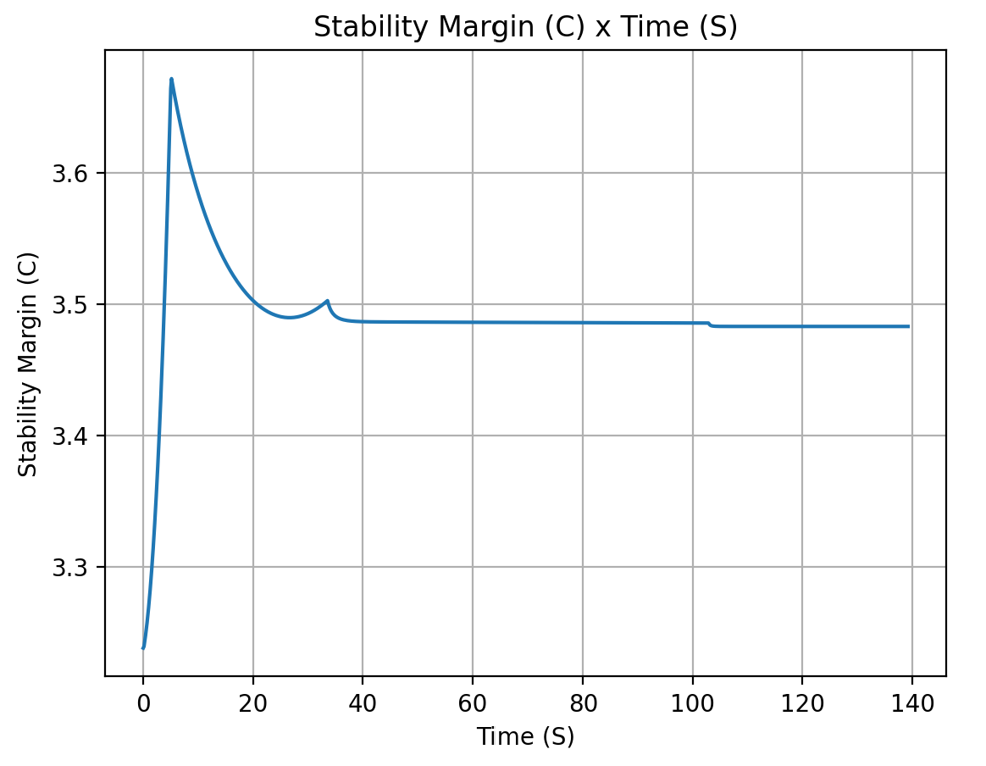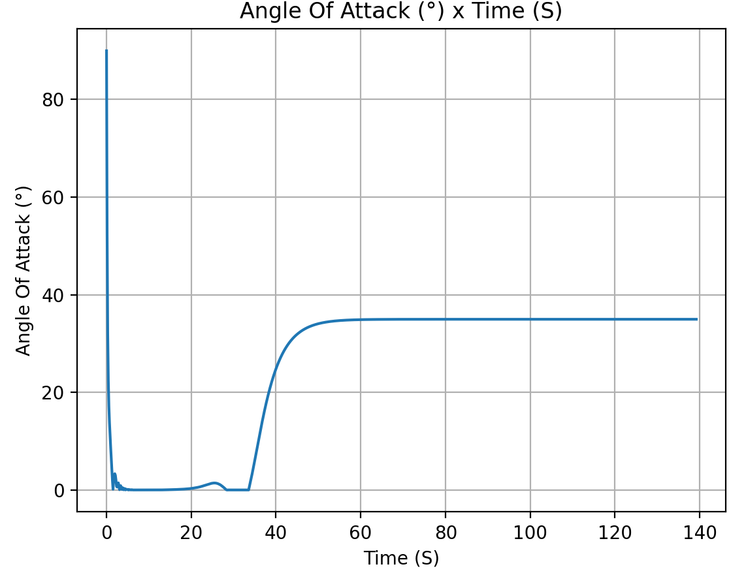
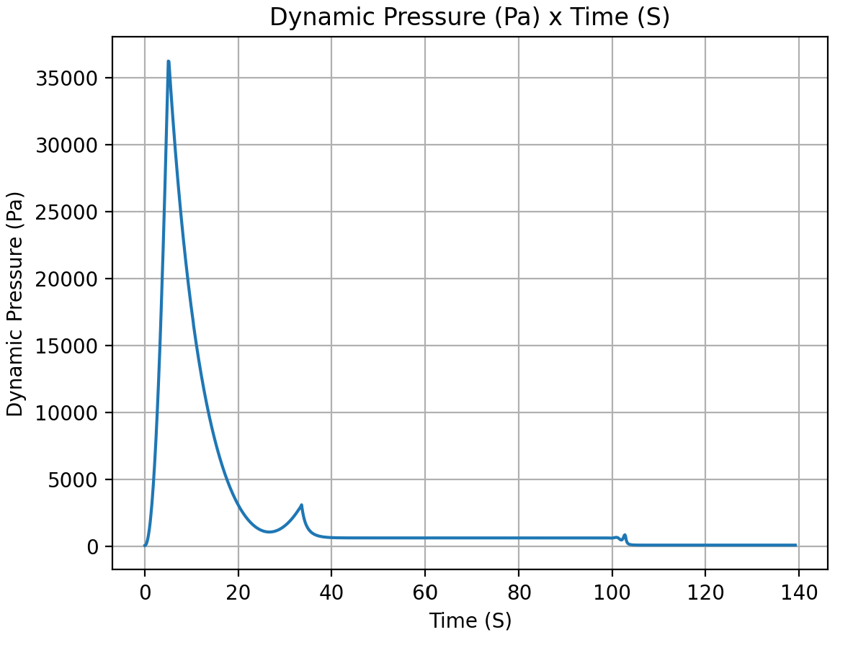
masse totale de eth : 8.188221202854228
masse totale de Lox : 11.783869113149848
=== Computed Results ===
Thrust curve mode: constant
Total Impulse (courbe complète, avant troncature hold-down): 35500.45 N·s (cible: 35500.00)
Impulse (nominale, hold-down inclus): 35500.0 [Ns]
Burn time: 5.126 [s]
Dry mass: 98.59 [kg]
Wet mass: 123.77 [kg]
Apogee (AGL): 3050.6 [m]
Out of rail time: 0.791 [s]
Burn out time: 5.220 [s]
Time to apogee: 26.677 [s]
Disreef time: 103.004 [s]
Time of impact: 139.311 [s]
Max Mach: 0.751 [-]
Max velocity: 251.73 [m/s]
Max acceleration: 65.18 [m/s^2]
Out of rail velocity: 32.55 [m/s]
Rail departure angle of attack: 13.806 [°]

Stability Margin

Initial Stability Margin: 3.238 c at 0.00 s
Out of Rail Stability Margin: 3.257 c at 0.70 s
Maximum Stability Margin: 3.672 c at 5.13 s
Minimum Stability Margin: 3.238 c at 0.05 s
Rail exit velocity: 32.553310295247
Rail exit stability: 3.25749718168265
Max Q: 36507.03250660204
Max Q time: 5.082090660505557
AoA at max-Q: 0.06310214074379086
SM at max-Q: 3.670593146796688

Fins PDS
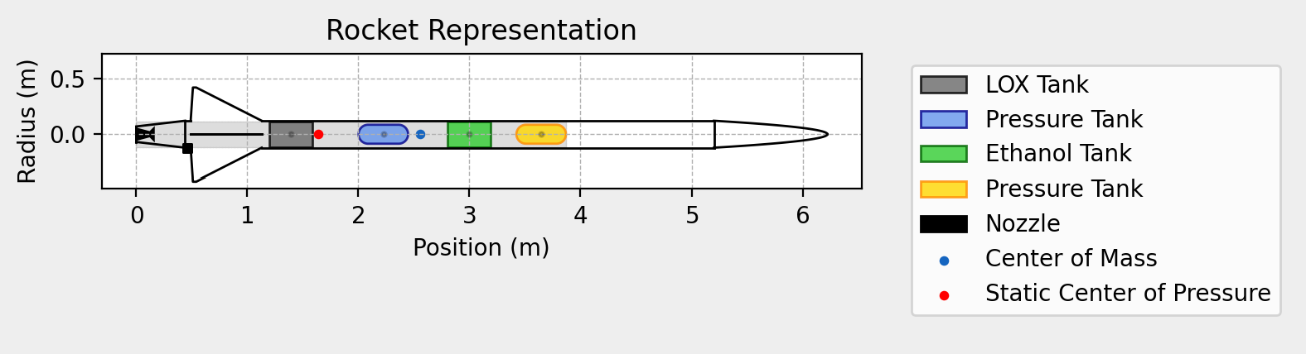
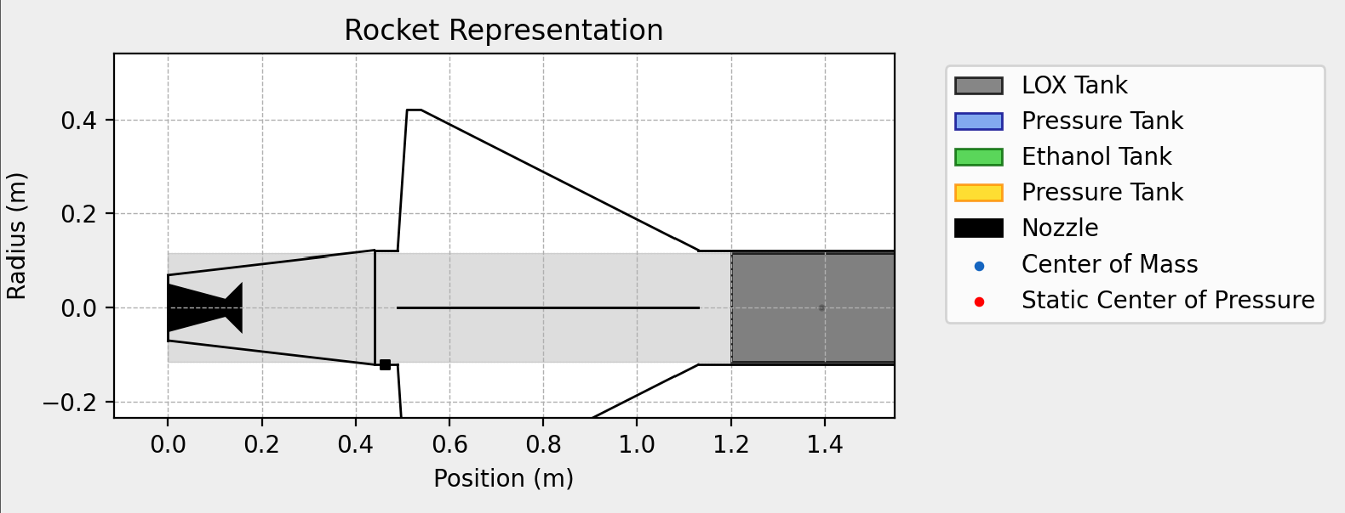
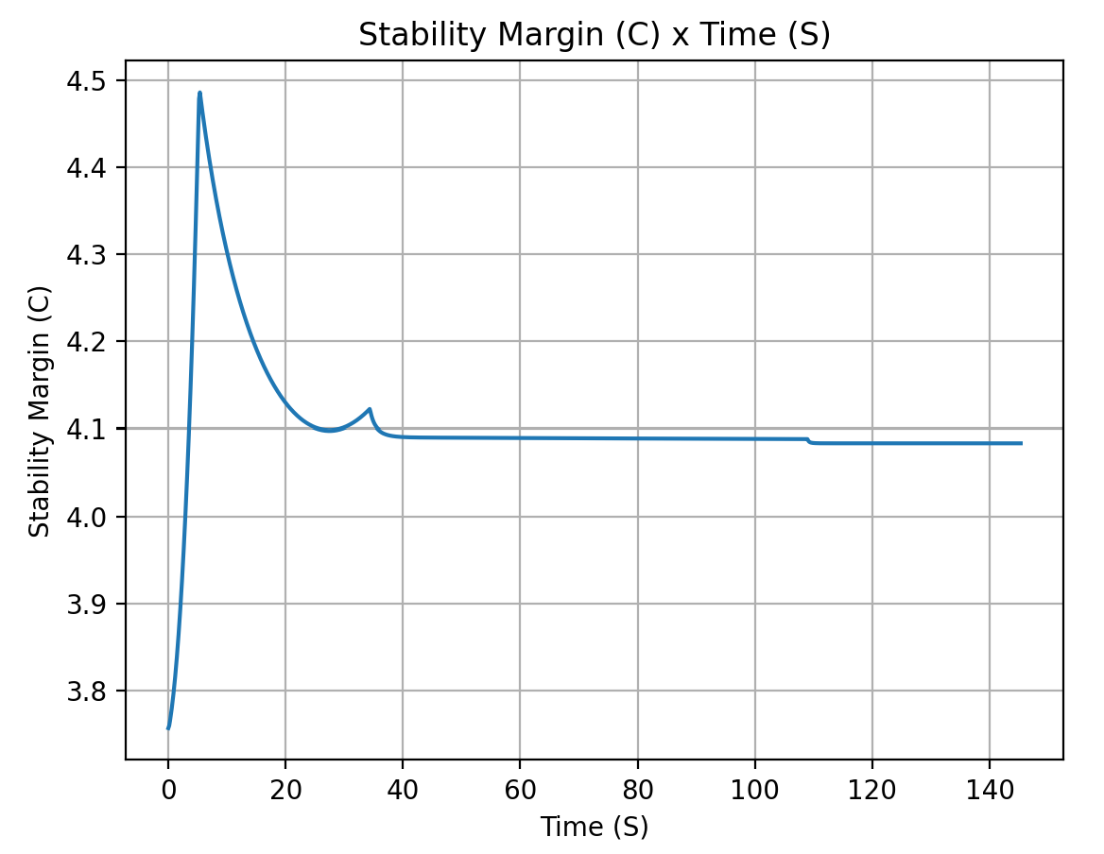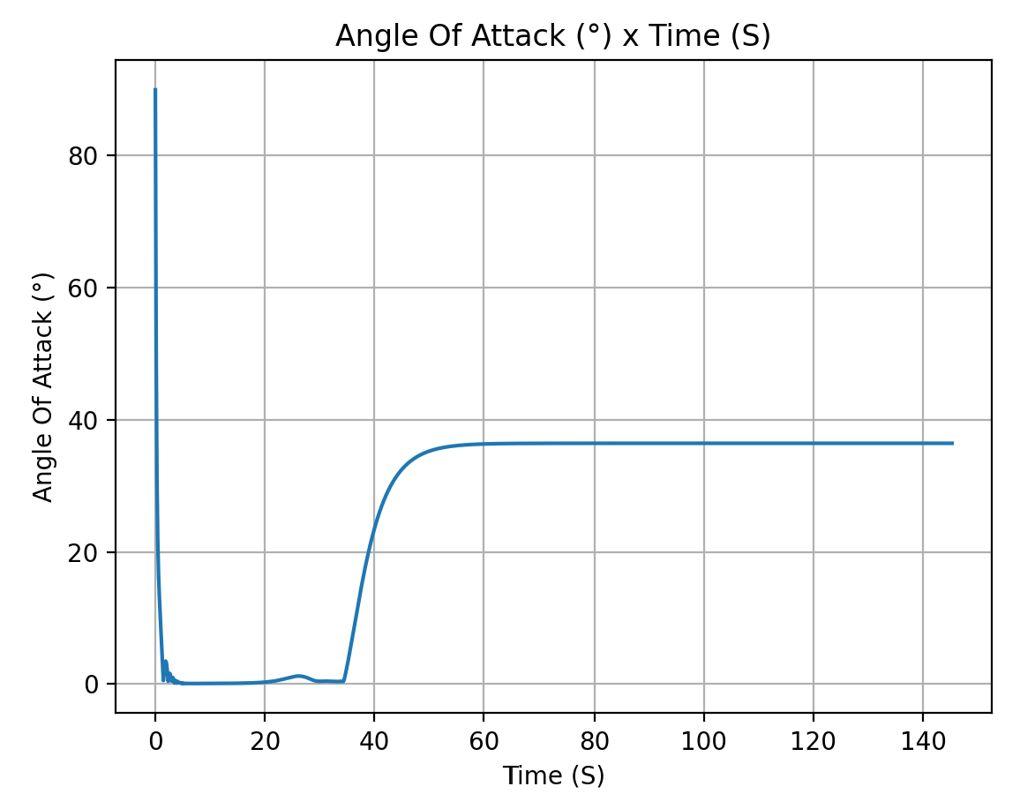
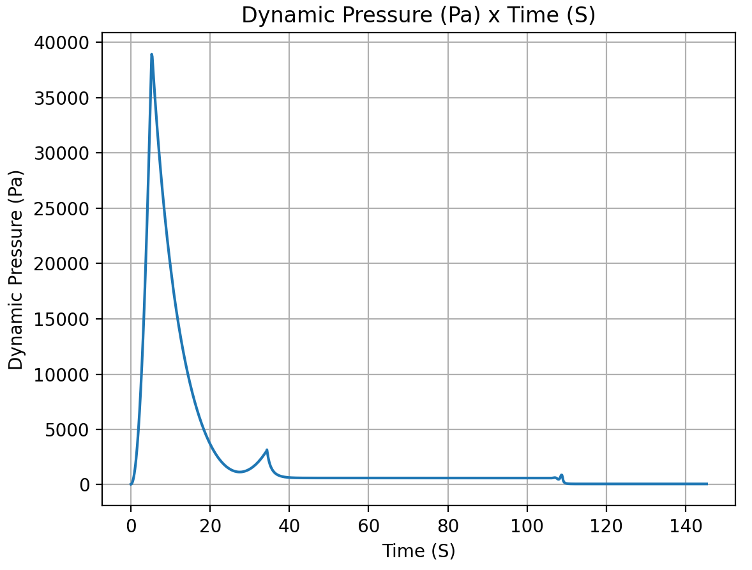
masse totale de eth : 8.517089704383281
masse totale de Lox : 12.242584709480123
=== Computed Results ===
Thrust curve mode: constant
Total Impulse (courbe complète, avant troncature hold-down): 37000.56 N·s (cible: 37000.00)
Impulse (nominale, hold-down inclus): 37000.0 [Ns]
Burn time: 5.337 [s]
Dry mass: 98.44 [kg]
Wet mass: 124.41 [kg]
Apogee (AGL): 3240.5 [m]
Out of rail time: 0.796 [s]
Burn out time: 5.435 [s]
Time to apogee: 27.452 [s]
Disreef time: 109.078 [s]
Time of impact: 145.408 [s]
Max Mach: 0.779 [-]
Max velocity: 261.12 [m/s]
Max acceleration: 65.16 [m/s^2]
Out of rail velocity: 32.46 [m/s]
Rail departure angle of attack: 13.846 [°]

Stability Margin

Initial Stability Margin: 3.757 c at 0.00 s
Out of Rail Stability Margin: 3.785 c at 0.70 s
Maximum Stability Margin: 4.489 c at 5.34 s
Minimum Stability Margin: 3.757 c at 0.03 s
Rail exit velocity: 32.4565869175717
Rail exit stability: 3.7854851333406194
Max Q: 39097.861983776114
Max Q time: 5.283570535233809
AoA at max-Q: 0.04398921971318075
SM at max-Q: 4.485740289841389

