RF Form

Team name, Country, Person Responsible, email
EPFL Xplore, Switzerland, Aurelio Noca, aurelio.noca@epfl.ch

Photo of rover / ground station
Insert here and here

There are 2 different communication systems.

5GHz communication system
System name (SSID): Xplore_5GHz
Description: Communication system on a 5 GHZ frequency. The system is used to communicate data (videos, images, measurements) and control the rover and the different subsystems.
Transceivers: The two transceivers used are the Rocket R5AC-Lite from Ubiquiti. They are both on software version XC.v8.7.1 as of 28/04/21.
Frequency / Bandwidth / Power / Modulation: The center frequency is 5535MHz, with a channel width of 80MHz. The maximum output power of the transceivers is 19dBm. Combined with the gain of 10 dBi of the antennas, the total EIRP is 29 dBm. This is assuming no loss in the cable. The transceiver auto-regulates such that the total EIRP is always smaller than 30 dBm. The modulation is airMax ac (a proprietary modulation of airMax by Ubiquiti).
Antennas: The two antennas are AMO-5G10 by Ubiquiti. They are omnidirectional.They both have 10 dBi of gain. They can also emit in two polarizations. The radiation patterns are given in the images hereunder.

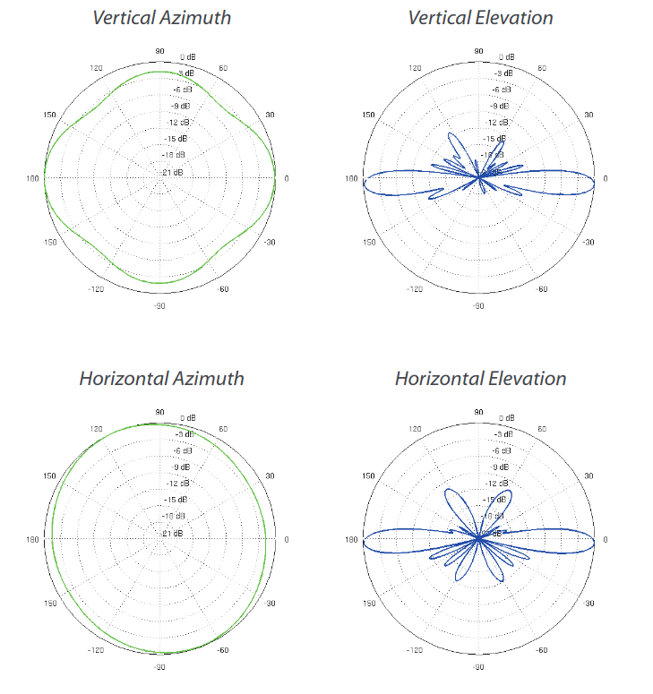
amo-5g10

2.4GHz communication system
System name (SSID): Xplore_5GHz
Description: Communication system on a 2.4 GHZ frequency. The system is used to communicate with the power supply controller. This allows to turn on or shut down certain subsystems remotely. The use of the 2.4GHz band should allow for control of the power supply at all times.
Transceivers: The transceiver used on the ground station side is the Nanostation loco M2. The transceiver used on the rover is ____________.
Frequency / Bandwidth / Power / Modulation: The center frequency is 2424MHz, with a channel width of 20MHz. The maximum output power of the loco M2 is 12dBm. It also has an included 8 dBi gain antenna. Here the maximum total EIRP is 20dBm or 100mW.The power_supply antenna ____________. The modulation is airMax.
Antennas: The antenna in the NanoStation loco M2 is included with the transceiver. It has an 8 dBi gain. The radiation patters are found hereunder. The antenna of the power supply _____________.
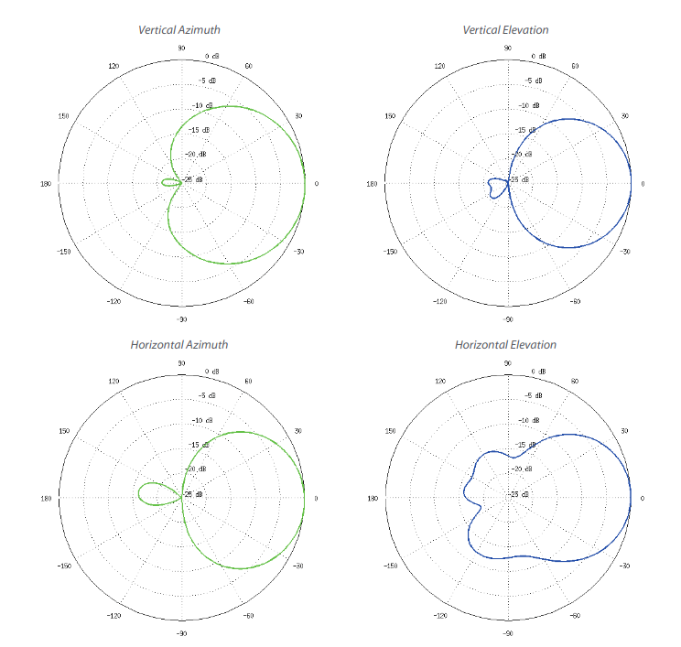
NanoStation loco M2

