Bucky++ Power Layout Considerations

When designing a high current board, trace width plays a very important role in the reliability and stability of the board. The board is designed to handle up to 35A of current at the input and up to 10A at each rail without heating up more than 20 degrees Celsius. To achieve this, there are three main considerations:
- Trace Width
- Connector Thermal Relief Thickness
- Via Current Capacity

Board stack up
To maximise current carrying capacity, a stack up with 6 layers and 2oz outer layers is required. This results in a total thickness of about 1.6mm. By default, these PCB are manufactured with 0.6/0.3 vias meaning the via diameter is 0.6mm and the hole diameter is 0.3mm. According to the manufacturer via barrel plating is 18um.
All computation below were based on these considerations.

Trace Width
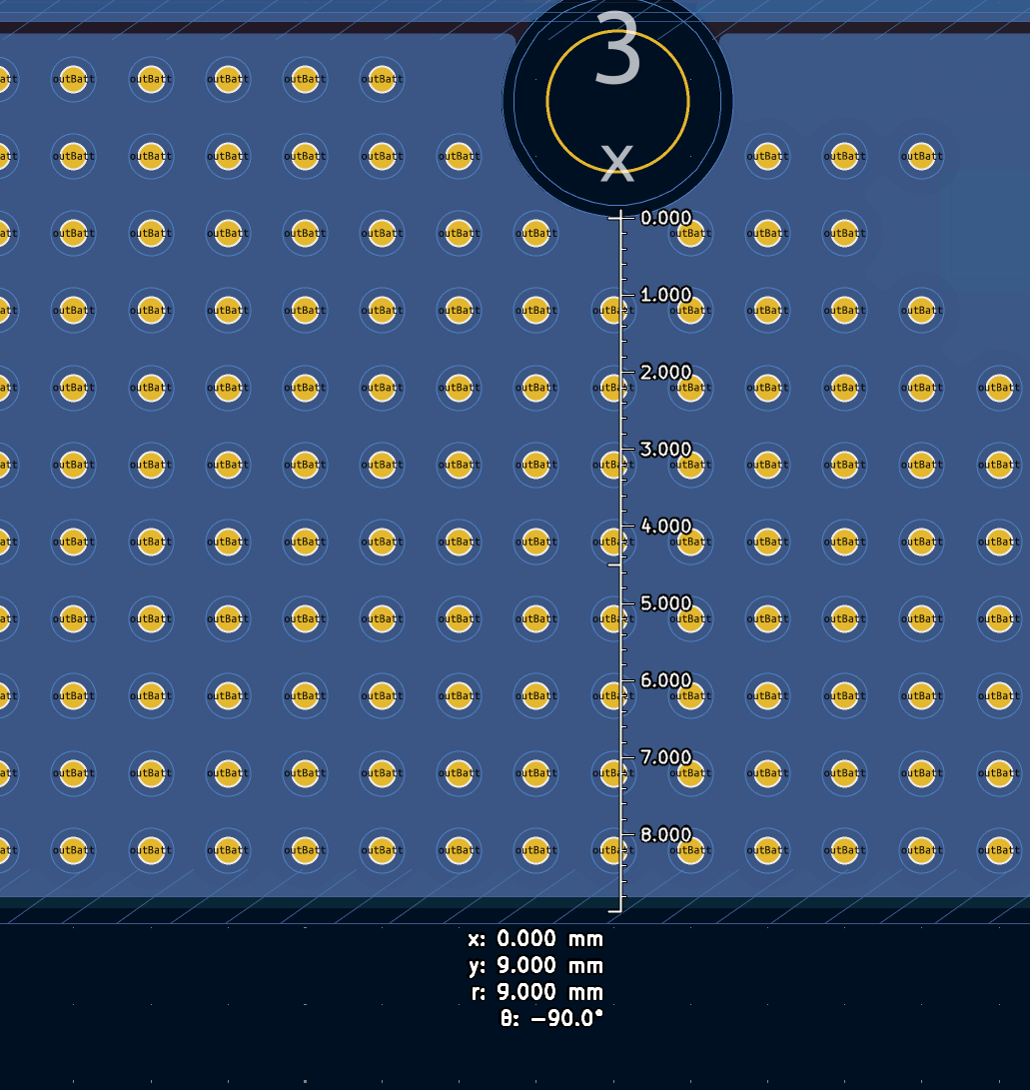
Using the design requirements, the stack up can hold up to 20A for an outer trace width of 7mm. L1 and L6 can therefore without any problem carry 35A without any thermal issues as the main current goes through a minimum of 6.9mm distributed over 3 layers (L1, L3 and L6).

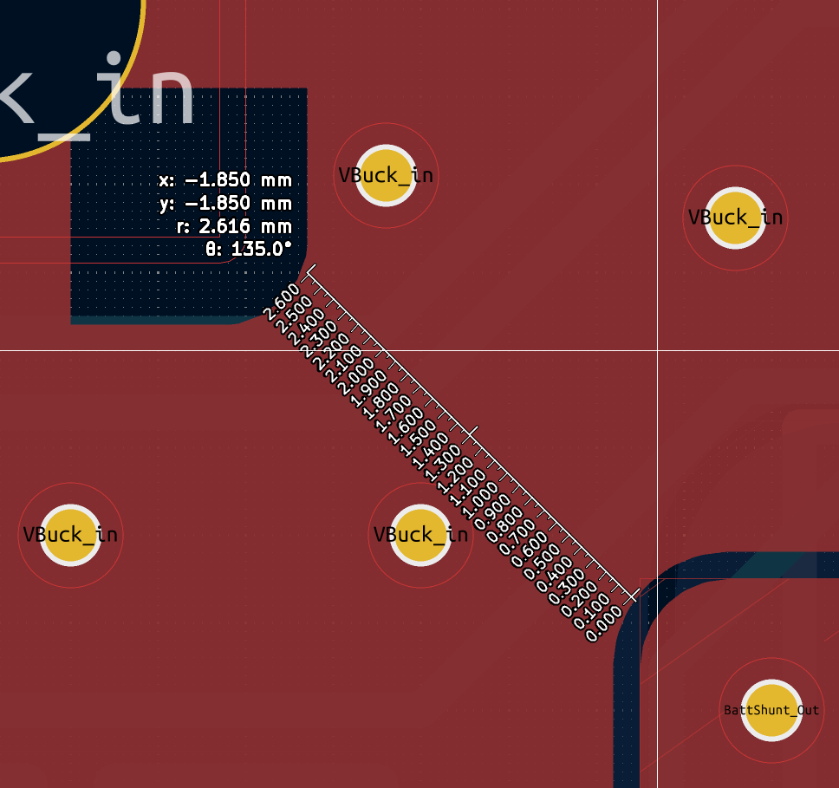
Before reaching the 24V connector, the current goes through a 2.616mm choke between the shunt pad and the 15V OUT connector. This width is enough to pass up to 10A on a single outer layer on the current stack up without heating up more than 15 degrees Celsius.

No trace or plane less than 2.5mm carries the full 10A current of the rails. Thickness measurements were taken at the pads of the components.

Connectors Thermal Relief Thickness
Current must also get through the connectors to the power planes without overheating. This is especially important at the input where the connectors must hold 30A.

Thermal Relief is important in to make it easier to solder the connectors by hand.

For the input, using the current stack up, a spoke width of 1.25mm is enough to pass 17A for each connection (4 times 1.25mm) with a temperature rise of less than 20 degrees Celsius on the outer layers.
The inner layer can hold an additional 5A giving us a total of 39A.

For the rails, a spoke width of 0.8mm was selected as 3.2mm is more than enough to hold 10A on the outer layers.

All ground connections have a spoke width of 1mm on the outer layers and a solid connection at the inner layers. This guarantees than the connector hold the required current without overheating.

Via Current Capacity
The standard 06/03 via can hold about 1.5A for a 20-degree Celsius temperature rise. This means at least 25 via are required in the input traces and 7 on the rails.
At least 40 vias were added at the input copper pours to dissipate the expected 35A peak current.
For the rails, at least 15 vias were added for each plane carrying the full 10A current.

Computations
Trace width computations were made using this website:
https://www.digikey.com/en/resources/conversion-calculators/conversion-calculator-pcb-trace-width

Via current capacity computations were made using this website:
https://camptechii.com/tools-pcb-via-calculator/

