 | EPI Quantum Crypto team  Applied cryptography and entropy source assessment

TECHNICAL NOTE · VERSION 5.1
NIST SP 800-90B entropy assessment as a C library
libsp80090b: measuring the min-entropy of a noise source on the target machine, deciding whether it conforms and sizing a hybrid generator
REFERENCE | NT-01
SUBJECT | libsp80090b: method for assessing an entropy source according to SP 800-90B
VERSION | 5.1 — September 2026
AUTHORS | EPI Quantum Crypto team
DISTRIBUTION | Technical note — public release
STANDARDS | NIST SP 800-90A, SP 800-90B, SP 800-90C; FIPS 140-3 (IG D.K)
RELATED DOCUMENTS | NT-02 User guide (API and labs); NT-03 Good-practice guide; French version: NT-01 (fr)
SUPERSEDES | NT-01 v5.0

ABSTRACT
For a physical random number generator (TRNG), assessing the entropy takes rigorous effort: modelling the noise source, capturing millions of raw samples under real operating conditions, then running long statistical tests. This effort is essential, because a deterministic random bit generator (DRBG) does not create entropy: it stretches the entropy of its seed. The security of the whole cryptographic chain therefore rests on a single quantity, the min-entropy per sample H of the noise source, which the NIST SP 800-90B recommendation [1] estimates with four tests.
libsp80090b is a C99 port of the NIST reference tool [2] as a library: its four functions assess an in-memory buffer, directly on the target machine. It gives the same values as the NIST tool, and a campaign of 52 cases on 22 datasets confirms that each test behaves as the theory predicts, with its limits: no statistical test can tell a DRBG output from real noise. The note explains the method, from the measurement to the sizing of the seed and of the health tests of a hybrid generator.
Keywords: SP 800-90B; min-entropy; IID; non-IID; restart; conditioning; health tests; hybrid generator; DRBG; SP 800-90C
Contents
1 Introduction and context 3
1.1 Goals of the SP 800-90B assessment 3
1.2 Vocabulary 3
2 Why a library 3
2.1 The need: measuring on the target machine 3
2.2 Limits of the NIST reference tool 3
2.3 What libsp80090b provides 4
3 The SP 800-90B qualification framework 4
3.1 Model first, then measure 5
3.2 Offline assessment and continuous monitoring 6
4 The four tests of SP 800-90B 6
4.1 Test 1: the IID assumption (section 5) 6
4.2 Test 2: the non-IID estimators (section 6.3) 6
4.3 Test 3: restart (section 3.1.4) 7
4.4 Test 4: conditioning (section 3.1.5) 7
5 Deciding whether a source conforms 7
6 Integration into a hybrid generator 8
6.1 Entropy to supply to the DRBG 8
6.2 Number of raw samples 8
6.3 Health test cutoffs 8
7 Lessons from the labs 9
8 Conclusion 9
9 References 9

1 Introduction and context
A failing entropy source never reports its own failure. A biased, correlated or frozen source feeds the DRBG just like a good source, and the DRBG produces an output that passes every statistical test. The weakness only shows when an attacker manages to reconstruct the seed. The only protection is to measure the min-entropy of the raw noise before any processing, then to monitor the source continuously.

1.1 Goals of the SP 800-90B assessment
- Guarantee cryptographic security. Make sure that the required entropy, for example 256 bits for the seed, is really present.
- Detect hardware failures. Ageing, temperature or voltage variations, environmental disturbances.
- Size the generator. Derive from H the number of samples N = ⌈E / H⌉ to collect to seed the DRBG, and the cutoffs of the RCT and APT health tests.

1.2 Vocabulary
Table 1. Terms used in this document.
Term | Definition
Noise source | Non-deterministic physical or logical component: clock jitter, ring oscillator, thermal noise
Sample (symbol) | Digitised value produced by the source, 1 to 8 bits, stored one sample per byte
Raw noise | Samples before any processing or conditioning. The only legitimate subject of an assessment
Min-entropy H | H = −log₂(p_{max}), where p_{max} is the probability of the most likely value: the difficulty of an adversary's best guess
IID | Independent and identically distributed samples
H_{original}, H_{bitstring} | Min-entropy of the samples as they are, and of the sequence of their bits
H_{I} | Initial entropy: min(H_{original}, n × H_{bitstring}) for n-bit samples
Conditioning | Deterministic function (SHA-256, HMAC, CBC-MAC) that concentrates entropy without creating any
Security strength s | Effort, in bits, to predict the DRBG output: s = 256 in our generators

2 Why a library

2.1 The need: measuring on the target machine
Entropy is not a constant of a component: it varies with the processor frequency, the load, the temperature and virtualisation. On a virtual machine, the same jitter source gave 2.67 bits per sample in one campaign, then 1.16 bits in another [10]. An assessment made once, in the laboratory, on a captured file therefore does not guarantee the value on the production machine.

2.2 Limits of the NIST reference tool
The NIST tool, SP800-90B_EntropyAssessment [2], is the reference: it produces the results of a validation submission. But it is a set of C++11 executables that work offline:
- it requires the data to be written to disk, then read back;
- it provides no API: the result has to be extracted from a text or JSON output;
- it depends on heavy libraries (libstdc++, jsoncpp, bzip2, gmp, mpfr, OpenSSL), often missing from embedded environments.

2.3 What libsp80090b provides
libsp80090b performs the four tests of the standard through four C99 functions that work directly on an in-memory buffer:
Non-IID assessment of a buffer of 1,000,000 samples
#include "sp80090b.h"

sp80090b_options_t opt = sp80090b_default_options();
sp80090b_result_t res;
opt.bits_per_symbol = 8;

/* non-IID track on 1,000,000 raw samples held in memory */
if (sp80090b_non_iid_evaluate_ex(buffer, 1000000, &opt, &res) == SP80090B_OK
&& res.warnings == 0)
printf("Assessed min-entropy H_I = %.5f bits per sample\n", res.h_assessed);

Table 2. The four API functions.
Function | Test | Role
sp80090b_iid_evaluate_ex() | 1 (§5) | Checks the IID assumption: chi-square, longest repeated substring, 10,000 permutations
sp80090b_non_iid_evaluate_ex() | 2 (§6.3) | Computes the ten non-IID estimators
sp80090b_restart_evaluate() | 3 (§3.1.4) | Sanity check and entropy at restart, on a 1,000 × 1,000 matrix
sp80090b_conditioning_evaluate() | 4 (§3.1.5) | Output entropy of a conditioning function

The _ex suffix (extended) marks the version 2 functions, which take an options structure. The four labs of the validation campaign call these functions through small programs (test_iid, test_non_iid, test_restart, test_conditioning); their use is described in NT-02.
Conformity. On the eleven NIST reference datasets, the non-IID track is identical to the NIST tool to within 7.2 × 10⁻¹⁴, and the IID track reproduces all of its deterministic statistics bit for bit (make check, NT-02).
The library does not replace three things: the modelling of the source, which is the designer's work; the health tests, which stay in the product; and the ESV validation submission, built with the NIST tool and assessed by NIST itself [5].

3 The SP 800-90B qualification framework
SP 800-90B splits an entropy source into three stages: the noise source, where the entropy comes from; the health tests, which check that it still works; and an optional conditioning stage. Figure 1 places each test in the complete chain of a generator, from the source to the SP 800-90A DRBG [12], within an SP 800-90C construction [3].
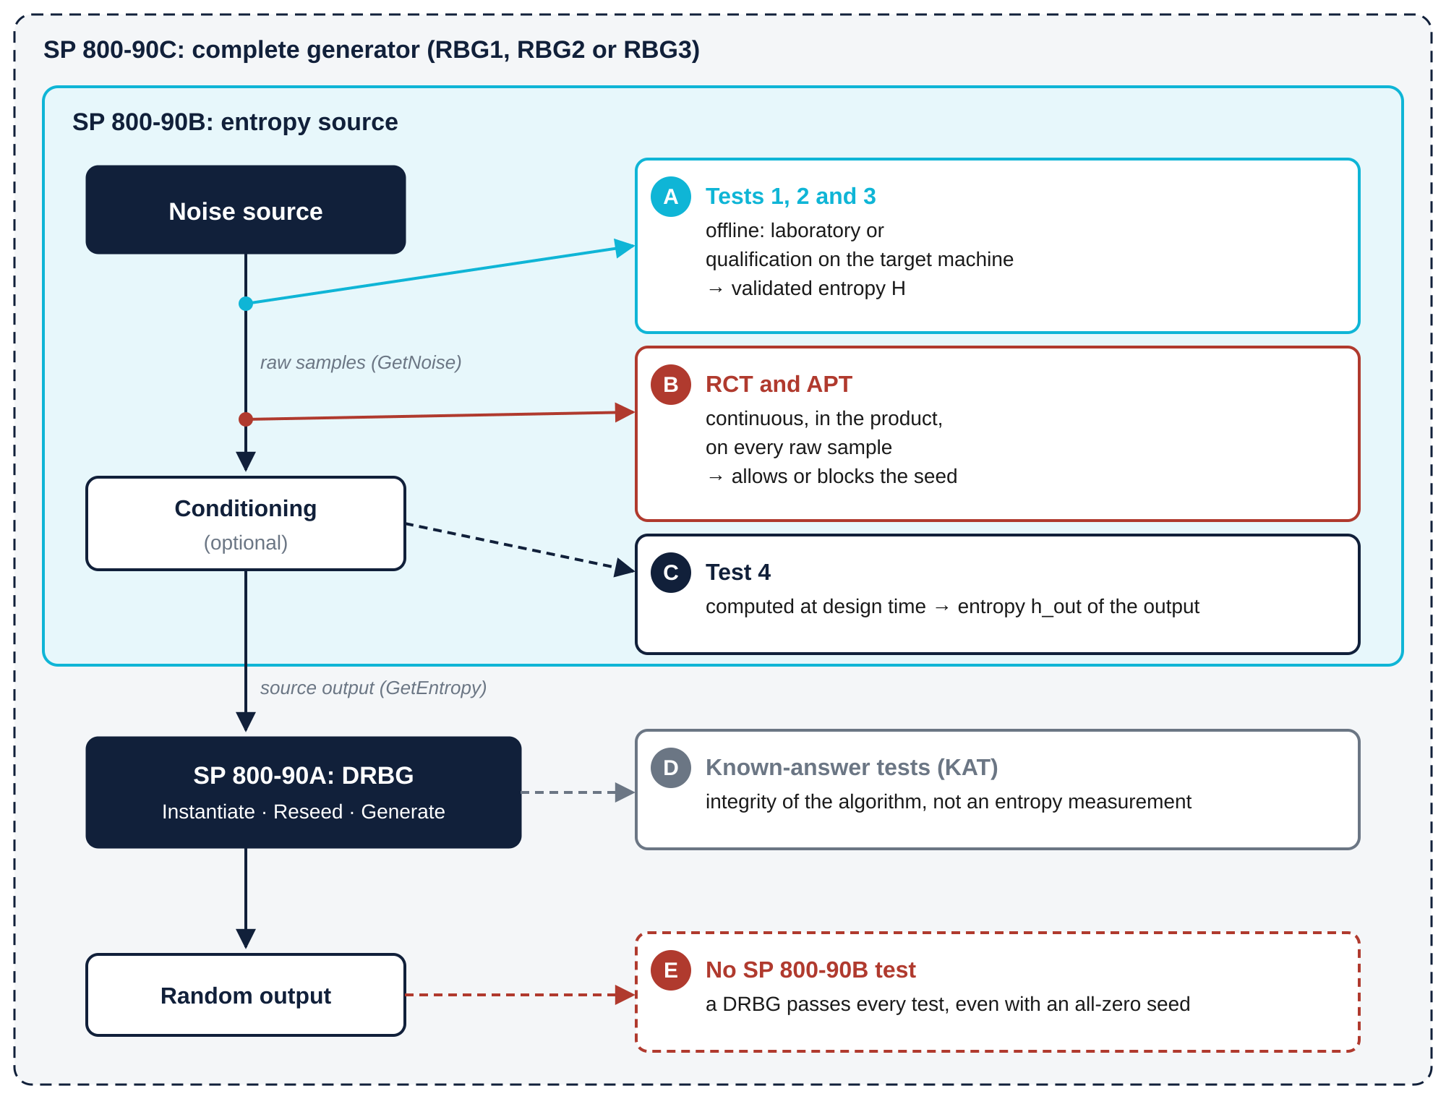
Figure 1. Place of the tests in the SP 800-90B, 90A and 90C chain: offline assessment in cyan, continuous monitoring in red.

3.1 Model first, then measure
NIST requires two complementary approaches [11]:
- The model. A physical justification of the noise, which sets an entropy claim H_{claim} per sample.
- The statistical estimate. A black-box check of the raw noise, performed by libsp80090b. Without knowing the inside of the source, it can be wrong: it checks the model, it does not replace it.
Rule. The entropy used to size the generator is always the lower of the two: H = min(H_{claim}, H_{measured}).

3.2 Offline assessment and continuous monitoring
Table 3. Offline assessment and continuous monitoring.
Criterion | Offline assessment (libsp80090b) | Continuous monitoring (RCT and APT)
Goal | Measure the min-entropy H of the source | Detect a failure of the source
Data | 1,000,000 samples and 1,000 restarts | Every sample, as it is produced
When | Qualification, installation, kernel or hardware update | All the time, from start-up
Cost | Heavy: about 250 MB, from a few seconds to 2 hours of computation | Very light: a few bytes, a few operations per sample
On failure | Source refused, or claim revised downwards | Current seed discarded, output stopped, alarm

The two families complement each other: offline assessment gives the value H, continuous monitoring checks that the source does not fall below that value, since its cutoffs are computed from H.

4 The four tests of SP 800-90B

4.1 Test 1: the IID assumption (section 5)
- Goal. Check that the samples are independent and identically distributed. If they are, a single estimator is enough: the most common value (MCV).
- Data. At least 1,000,000 consecutive raw samples.
- Method. Two chi-square tests, independence and goodness of fit (§5.2.1 to §5.2.4); the longest repeated substring test (§5.2.5); finally 10,000 random permutations of the file (§5.1), on which 19 statistics are recomputed: excursion, increasing and decreasing runs, runs around the median, collisions, periodicity, covariance and bzip2 compression.
- Decision. For each statistic i, the counters C_{i,0}, C_{i,1} and C_{i,2} count the permutations whose statistic is greater than, equal to or smaller than that of the data. If C_{i,0} + C_{i,1} ≤ 5 or C_{i,1} + C_{i,2} ≤ 5, the IID assumption is rejected and the source moves to test 2.
- Run time. Under a minute for an IID source; 40 minutes to 2 hours for a non-IID source, which runs all 10,000 permutations.
Warning. A source only follows the IID track if its designer has justified this assumption. Passing the IID tests does not prove independence [11]: when in doubt, apply test 2.

4.2 Test 2: the non-IID estimators (section 6.3)
- Goal. Estimate the min-entropy without any independence assumption: the case of almost every physical source.
- Method. Ten estimators, each looking for one form of regularity; four of them are predictors, which try to guess the next sample [7].
Table 4. The ten non-IID estimators.
Estimator | § | Principle | Applied to
Most common value (MCV) | 6.3.1 | Frequency of the most common symbol | Samples and bits
Collision | 6.3.2 | Mean time before a value repeats | Bits only
Markov | 6.3.3 | First-order Markov chain | Bits only
Compression | 6.3.4 | Maurer statistic on 6-bit blocks | Bits only
t-tuple | 6.3.5 | Frequency of the most repeated t-tuples | Samples and bits
Longest repeated substring (LRS) | 6.3.6 | Collisions of long substrings, through a suffix array [8] | Samples and bits
MultiMCW | 6.3.7 | Predictor: majority value over four sliding windows | Samples and bits
Lag | 6.3.8 | Predictor: value observed d positions earlier (d ≤ 128) | Samples and bits
MultiMMC | 6.3.9 | Predictor: Markov models of orders 1 to 16 | Samples and bits
LZ78Y | 6.3.10 | Predictor: LZ78-type dictionary | Samples and bits

- Result. H_{original} and H_{bitstring} are the minimum of the applicable estimators; the initial entropy is H_{I} = min(H_{original}, n × H_{bitstring}).
- Run time. 5 seconds to 1 minute for 10⁶ samples.

4.3 Test 3: restart (section 3.1.4)
- Goal. Check that the entropy measured in steady state is really present from power-up: no frozen or recurring initial state.
- Data. A matrix M of r = 1,000 real restarts and c = 1,000 samples per restart. Row i holds restart i; column j gathers the j-th sample of every restart.
- Sanity check (§3.1.4.3). The count of the most common value in each row and each column must not exceed a cutoff X_{cutoff}, obtained by simulation for an overall risk of 0.01 [6]. A source that always restarts in the same state gives a constant column and fails.
- Validation (§3.1.4.2). The estimates on the rows (H_{r}) and on the columns (H_{c}) must satisfy min(H_{r}, H_{c}) ≥ H_{I} / 2.
- Result. The validated entropy is H = min(H_{r}, H_{c}, H_{I}).

4.4 Test 4: conditioning (section 3.1.5)
- Goal. Compute the entropy h_{out} left after a conditioning function, for example SHA-256.
- Vetted function (HMAC, CMAC, CBC-MAC, SHA-2, SHA-3, Hash_df). h_{out} is computed with the Output_Entropy(n_{in}, n_{out}, nw, h_{in}) formula of the standard, from the input entropy h_{in}.
- Non-vetted function. h_{out} is further capped at 0.999 × n_{out} and at h′ × n_{out}, where h′ is the entropy per bit measured on one million outputs: h_{out} = min(Output_Entropy, 0.999 n_{out}, h′ n_{out}).
- Full entropy (FIPS 140-3 IG D.K [4], SP 800-90C [3]). An output has full entropy if h_{out} equals n_{out} to within ε ≤ 2⁻³²; this requires a vetted function and a margin of at least 64 bits: h_{in} ≥ n_{out} + 64.

5 Deciding whether a source conforms
A source is declared conforming if the following five criteria are met:
- Data (§3.1.1). At least 1,000,000 consecutive raw samples, with more than one symbol: a stuck source is rejected outright.
- Initial entropy H_{I}. Through the IID track if it is justified and the assumption holds, otherwise through the ten non-IID estimators.
- Restart sanity. X_{max} ≤ X_{cutoff} on every row and column.
- Restart entropy. min(H_{r}, H_{c}) ≥ H_{I} / 2; the validated entropy is H = min(H_{r}, H_{c}, H_{I}).
- Claim. H is at least equal to the claim H_{claim} of the model; the lower of the two values is then credited.

6 Integration into a hybrid generator
A hybrid generator combines an entropy source, assessed according to SP 800-90B, with a DRBG that stretches its seed: this is the RBG2 construction of SP 800-90C [3]. For a security strength s = 256 bits, sizing takes three steps.

6.1 Entropy to supply to the DRBG
Table 5. Entropy to supply to the DRBG for a 256-bit strength.
Operation | Required entropy E | Reason
Instantiation | 384 bits (3s/2) | s bits of entropy and s/2 bits of nonce
Reseed | 256 bits (s) | Restores the security strength after a compromise of the state
Full-entropy output (RBG3) | 320 bits (s + 64) per 256-bit block | 64-bit margin of FIPS 140-3 IG D.K

6.2 Number of raw samples
From the validated entropy H, output of test 3, the number of samples to collect is N = ⌈E / H⌉.
Table 6. Number of raw samples per operation.
Source and entropy credited | H (bit/sample) | Instantiation 384 | Reseed 256 | Full entropy 320
jitterentropy [9], design claim (osr = 3) | 0.3333 | 1,152 | 768 | 960
Thermal noise of Lab 3, validated H (NT-03) | 4.0927 | 94 | 63 | 79

6.3 Health test cutoffs
The cutoffs of the health tests are computed from the credited entropy H, for a false alarm rate α = 2⁻²⁰:
- RCT (Repetition Count Test, §4.4.1): the test fails if the same value repeats C = 1 + ⌈20 / H⌉ times in a row;
- APT (Adaptive Proportion Test, §4.4.2): in a window of W = 512 samples (1,024 for a binary source), the test fails if a value appears at least C times, C being the smallest integer whose probability is ≤ 2⁻²⁰.
Table 7. Health test cutoffs (α = 2⁻²⁰).
Source and credited entropy H | RCT: C | APT: W | APT: C
jitterentropy, claim (1/3 bit) | 61 | 512 | 449
Thermal noise of Lab 3 (4.0927 bits) | 6 | 512 | 59
Ideal binary source (1 bit) | 21 | 1,024 | 589

No sample enters the seed without passing these tests; at the first failure, the current seed is discarded.

7 Lessons from the labs
The NT-03 campaign applies the four tests to 22 datasets: healthy sources, design defects, environmental effects, failures and DRBG outputs. The "physical" sources are simulated from a model whose entropy is known, so that the measurement can be checked against the theory: 5.618 bits measured for 5.65 expected on thermal noise. Six lessons emerge.
- The tests do not see determinism. An AES-256 stream with an all-zero key passes the IID tests with 7.87 bits per byte, and still gets 7.15 bits through the non-IID track, for a real entropy of zero. Rule: never assess a DRBG or hash output.
- IID does not mean high entropy. A saturated converter passes the IID tests with only 1.92 bits of entropy out of 8.
- A single test is enough to reject the IID assumption. A slowly read oscillator passes the chi-square and longest repeated substring tests, but a single permutation statistic out of 19 rejects it.
- The IID tests have a false rejection rate. A truly IID source is rejected in 2 to 3 % of cases, because of the permutation threshold (C ≤ 5 out of 10,000 for each of the 19 statistics); the standard then requires the non-IID track.
- Only the restart test sees some defects. A source whose first samples are identical at every start-up looks normal in steady state; only test 3 rejects it.
- The conditioning margin is essential. SHA-256 receiving exactly 256 bits of entropy outputs only 251.69 bits; with 320 input bits, the output has full entropy.

8 Conclusion
libsp80090b makes it possible to industrialise the qualification of entropy sources directly on their execution platform. It performs the four tests of SP 800-90B with the same results as the NIST tool, and provides the parameters of the hybrid generator: the number of seed samples N and the cutoffs of the RCT and APT health tests.
The measurement remains a check: the claimed entropy comes first from the model of the source, and a DRBG output fools every test. For an ESV validation submission, the NIST tool remains the reference.

9 References
[1] M. Sönmez Turan, E. Barker, J. Kelsey, K. McKay, M. Baish, M. Boyle. Recommendation for the Entropy Sources Used for Random Bit Generation. NIST SP 800-90B, January 2018.
[2] National Institute of Standards and Technology. SP800-90B_EntropyAssessment. Source code, github.com/usnistgov/SP800-90B_EntropyAssessment.
[3] E. Barker, J. Kelsey, K. McKay, A. Roginsky, M. Sönmez Turan. Recommendation for Random Bit Generator (RBG) Constructions. NIST SP 800-90C, September 2025.
[4] National Institute of Standards and Technology. Security Requirements for Cryptographic Modules. FIPS PUB 140-3, 2019; Implementation Guidance, D.K.
[5] NIST CMVP. Entropy Source Validation (ESV) Program. ESV program documentation.
[6] P. Hagerty, T. Draper. Entropy Bounds and Statistical Tests. NIST Random Bit Generation Workshop, 2012.
[7] J. Kelsey, K. A. McKay, M. Sönmez Turan. Predictive Models for Min-Entropy Estimation. CHES 2015, LNCS 9293.
[8] Y. Mori. libdivsufsort — suffix-sorting library. Source code, version 2.0.
[9] S. Müller. Jitter RNG (jitterentropy). Documentation and source code, version 3.7.1, 2026.
[10] EPI Quantum Crypto team. entropy-lab — collect, test and assess the entropy of a PC. Entropy/entropy-lab/README.md, 2026.
[11] T. Hall, J. Kelsey, M. Sönmez Turan. Entropy Sources — Importance and testing. NIST, Information Security and Privacy Advisory Board, 26 October 2022.
[12] E. Barker, J. Kelsey. Recommendation for Random Number Generation Using Deterministic Random Bit Generators. NIST SP 800-90A Rev. 1, June 2015.

