Pimpri Chinchwad Education Trust’s
Pimpri Chinchwad College of Engineering, Pune.
Department of Computer Engineering

Course: Object Oriented Programming
Real World Application of Object-Oriented Programming:
Design and Implementation of a University Student Management System

Presented By:
Om Khanjodkar [125B1B283]
Siddhant Verma [125B1B278]
Guided By :-
Prof. Harsha Talele
01 June 2026

Abstract
This project is a simple C++ console program to manage university student records. Keeping student records on paper is difficult and has many human mistakes. By using Object-Oriented Programming (OOP) in C++, we built a program that automates student admissions, attendance, exam scores, and fee details. We used concepts like classes, inheritance, function overloading, virtual functions, templates, and file handling. The program loads student data from a text file on startup and saves it back when we exit.

1. Introduction
In colleges, it is very important to keep records of students. This includes their name, PRN, course, attendance, marks, and fees. Writing all these details on paper registers is very slow and the registers can get lost. So, we need a simple computer program to manage student data.
Object-Oriented Programming (OOP) is a great way to write this software. OOP lets us model real things like students and courses as objects in our code. In this project, we created a C++ program that has a parent class Person and a child class Student. The program reads and writes to a text file, so we do not lose student data when we close the console window.

2. Literature Review
In the past, schools used paper registers to write down student details. Later, people started using computers with simple text files. Today, big colleges use database servers like SQL. But SQL can be difficult to set up for small projects. A simple C++ program that reads and writes text files is very fast and easy to use. Using OOP concepts makes the code clean and easy to understand for beginners. It also helps to keep student data safe from accidental modifications.

3. Theoretical Background

3.1 OOP Concepts in C++
Here are the OOP concepts we used in our program:
- Encapsulation: We put student variables like name, age, and marks inside the Student class to keep them safe.
- Constructors: We used default and parameterized constructors to set the initial values of student details.
- Inheritance: The Student class inherits from the Person class because a Student is also a Person. This reduces code copying.
- Polymorphism & Virtual Functions: We used virtual functions so that a pointer to a Person can show the Student report card dynamically at runtime.
- Function Overloading: We wrote two versions of the markAttendance function to mark attendance in two different ways (only attended days, or attended and missed days).
- Templates: We used a template function to calculate the average of three subject marks. This works for integers, floats, or doubles.

3.2 Database Serialization & File Streams
We used C++ file streams (ifstream and ofstream) to save and load student records. When we save, we serialize the student data into separate lines in 'sv_database.txt'. When the program starts, it reads these lines sequentially to load them back into student objects. We also used validation checks so the program handles missing or empty files gracefully.

4. Real-World Application: University Student Management
Our program does the work of a real college office:
1. Admission: Adds a new student record with their PRN string, name, age, course, and fee. It checks if the PRN already exists to prevent duplicate admissions.
2. Attendance: Allows updating attendance. It supports inputting only attended days, or both attended and missed days.
3. Exams: Saves marks for 3 subjects and calculates the average score using our template function.
4. Fees: Allows students to pay tuition fees in Rupees (Rs.) and updates their balance.
5. Reports: Displays student details using polymorphism, and exports formatted reports to 'sv_report_card.txt'.

5. Tools and Technology Used
The tools and technologies used to build and compile this project are listed in the table below:
Tool / Technology | Use Case | Description
C++ Language (C++11) | Programming | Used to write the core logic and OOP structures of the system.
g++ Compiler (MinGW) | Compilation | Compiles main.cpp source code into a main.exe binary file.
Windows Terminal | User Interface | Provides a command line terminal window to interact with the program.
Text File (CSV) | Database Storage | Stores student records in sv_database.txt using comma-separated lines.
VS Code | Code Editor | Used to write, edit, and debug the C++ source code files.

6. Source Code (C++ Implementation)
Below is the complete C++ implementation containing all the OOP concepts:
#include <iostream>
#include <string>
#include <fstream>
using namespace std;
// Maximum number of students our system can store in memory
const int MAX_STUDENTS = 100;
// 1. TEMPLATE FUNCTION
// A template function to calculate the average of 3 numbers of any numeric type.
template <typename T>
T sv_calculateAverage(T sv_val1, T sv_val2, T sv_val3) {
return (sv_val1 + sv_val2 + sv_val3) / static_cast<T>(3);
}
// 2. BASE CLASS (with constructors & virtual function)
// Base class for representing any person in the university system.
class sv_Person {
protected:
string sv_name;
int sv_age;
public:
// Default constructor
sv_Person() {
sv_name = "Unknown Person";
sv_age = 0;
}
// Parameterized constructor
sv_Person(string sv_pName, int sv_pAge) {
sv_name = sv_pName;
sv_age = sv_pAge;
}
// Virtual destructor - important for cleanup
virtual ~sv_Person() {}
// Getters
string sv_getName() const { return sv_name; }
int sv_getAge() const { return sv_age; }
// Virtual function to display information.
virtual void sv_displayInfo() {
cout << "Name: " << sv_name << endl;
cout << "Age: " << sv_age << " years old" << endl;
}
};
// 3. DERIVED CLASS (with inheritance & overloading)
// Student class inherits from Person
class sv_Student : public sv_Person {
private:
string sv_prn;
string sv_course;
int sv_attendanceDays;
int sv_totalDays;
double sv_marks1;
double sv_marks2;
double sv_marks3;
double sv_totalFees;
double sv_feesPaid;
public:
// Default constructor
sv_Student() : sv_Person() {
sv_prn = "";
sv_course = "None";
sv_attendanceDays = 0;
sv_totalDays = 0;
sv_marks1 = 0.0;
sv_marks2 = 0.0;
sv_marks3 = 0.0;
sv_totalFees = 0.0;
sv_feesPaid = 0.0;
}
// Parameterized constructor calling the base class constructor
sv_Student(string sv_sName, int sv_sAge, string sv_sPrn, string sv_sCourse, double sv_sTotalFees)
: sv_Person(sv_sName, sv_sAge) {
sv_prn = sv_sPrn;
sv_course = sv_sCourse;
sv_attendanceDays = 0;
sv_totalDays = 0;
sv_marks1 = 0.0;
sv_marks2 = 0.0;
sv_marks3 = 0.0;
sv_totalFees = sv_sTotalFees;
sv_feesPaid = 0.0;
}
// Getters
string sv_getPrn() const { return sv_prn; }
string sv_getCourse() const { return sv_course; }
int sv_getAttendanceDays() const { return sv_attendanceDays; }
int sv_getTotalDays() const { return sv_totalDays; }
double sv_getMarks1() const { return sv_marks1; }
double sv_getMarks2() const { return sv_marks2; }
double sv_getMarks3() const { return sv_marks3; }
double sv_getTotalFees() const { return sv_totalFees; }
double sv_getFeesPaid() const { return sv_feesPaid; }
// Setters
void sv_setMarks(double sv_m1, double sv_m2, double sv_m3) {
sv_marks1 = sv_m1;
sv_marks2 = sv_m2;
sv_marks3 = sv_m3;
}
// Helper to load database details directly
void sv_setDatabaseInfo(string sv_sPrn, string sv_sName, int sv_sAge, string sv_sCourse,
int sv_attDays, int sv_totDays, double sv_m1, double sv_m2, double sv_m3,
double sv_totFees, double sv_feesPaid) {
sv_prn = sv_sPrn;
sv_name = sv_sName;
sv_age = sv_sAge;
sv_course = sv_sCourse;
sv_attendanceDays = sv_attDays;
sv_totalDays = sv_totDays;
sv_marks1 = sv_m1;
sv_marks2 = sv_m2;
sv_marks3 = sv_m3;
sv_totalFees = sv_totFees;
sv_feesPaid = sv_feesPaid;
}
// Pay fees
void sv_payFees(double sv_amount) {
sv_feesPaid += sv_amount;
}
// Get remaining fee balance
double sv_getFeeBalance() const {
return sv_totalFees - sv_feesPaid;
}
// Get attendance percentage
double sv_getAttendancePercentage() const {
if (sv_totalDays == 0) return 0.0;
return (static_cast<double>(sv_attendanceDays) / sv_totalDays) * 100.0;
}
// 4. FUNCTION OVERLOADING
// Version 1: Mark attendance with just the number of days attended
void sv_markAttendance(int sv_daysAttended) {
sv_attendanceDays += sv_daysAttended;
sv_totalDays += sv_daysAttended;
}
// Version 2: Mark attendance with both days attended and days missed
void sv_markAttendance(int sv_daysAttended, int sv_daysMissed) {
sv_attendanceDays += sv_daysAttended;
sv_totalDays += (sv_daysAttended + sv_daysMissed);
}
// 5. VIRTUAL FUNCTION OVERRIDING
// Overriding the base class display function
void sv_displayInfo() override {
cout << "---------------------------------------------------" << endl;
cout << " STUDENT REPORT CARD " << endl;
cout << "---------------------------------------------------" << endl;
sv_Person::sv_displayInfo();
cout << "PRN : " << sv_prn << endl;
cout << "Course : " << sv_course << endl;
cout << "Attendance : " << sv_attendanceDays << "/" << sv_totalDays
<< " (" << sv_getAttendancePercentage() << "%)" << endl;
cout << "Exam Scores : " << sv_marks1 << ", " << sv_marks2 << ", " << sv_marks3 << endl;
double sv_avg = sv_calculateAverage(sv_marks1, sv_marks2, sv_marks3);
cout << "Average Score : " << sv_avg << endl;
cout << "Total Tuition : Rs. " << sv_totalFees << endl;
cout << "Fees Paid : Rs. " << sv_feesPaid << endl;
cout << "Fee Balance : Rs. " << sv_getFeeBalance() << endl;
cout << "---------------------------------------------------" << endl;
}
// Save student details directly to file stream using single lines for simplicity
void sv_saveToFile(ofstream& sv_outFile) const {
sv_outFile << sv_prn << "\n"
<< sv_name << "\n"
<< sv_age << "\n"
<< sv_course << "\n"
<< sv_attendanceDays << "\n"
<< sv_totalDays << "\n"
<< sv_marks1 << "\n"
<< sv_marks2 << "\n"
<< sv_marks3 << "\n"
<< sv_totalFees << "\n"
<< sv_feesPaid << "\n";
}
};
// 6. HELPER FUNCTIONS & FILE HANDLING
// Function demonstrating runtime polymorphism using a base class pointer
void sv_printPolymorphicDetails(sv_Person* sv_p) {
sv_p->sv_displayInfo();
}
// Clear the terminal input buffer to prevent errors
void sv_clearInput() {
cin.clear();
cin.ignore(10000, '\n');
}
// Save all student objects to database file
void sv_saveToDatabase(const sv_Student sv_list[], int sv_count) {
ofstream sv_outFile("sv_database.txt");
if (!sv_outFile) {
cout << "[Error] Could not open sv_database.txt for writing!" << endl;
return;
}
for (int sv_i = 0; sv_i < sv_count; ++sv_i) {
sv_list[sv_i].sv_saveToFile(sv_outFile);
}
sv_outFile.close();
}
// Load all student objects from database file
void sv_loadFromDatabase(sv_Student sv_list[], int& sv_count) {
ifstream sv_inFile("sv_database.txt");
if (!sv_inFile) {
sv_count = 0;
return;
}
sv_count = 0;
string sv_prn;
while (sv_count < MAX_STUDENTS && getline(sv_inFile, sv_prn)) {
if (sv_prn.empty()) continue;
string sv_name, sv_temp, sv_course;
getline(sv_inFile, sv_name);
getline(sv_inFile, sv_temp);
int sv_age = stoi(sv_temp);
getline(sv_inFile, sv_course);
getline(sv_inFile, sv_temp);
int sv_attDays = stoi(sv_temp);
getline(sv_inFile, sv_temp);
int sv_totDays = stoi(sv_temp);
getline(sv_inFile, sv_temp);
double sv_m1 = stod(sv_temp);
getline(sv_inFile, sv_temp);
double sv_m2 = stod(sv_temp);
getline(sv_inFile, sv_temp);
double sv_m3 = stod(sv_temp);
getline(sv_inFile, sv_temp);
double sv_totFees = stod(sv_temp);
getline(sv_inFile, sv_temp);
double sv_feesPaid = stod(sv_temp);
sv_list[sv_count].sv_setDatabaseInfo(sv_prn, sv_name, sv_age, sv_course,
sv_attDays, sv_totDays, sv_m1, sv_m2, sv_m3,
sv_totFees, sv_feesPaid);
sv_count++;
}
sv_inFile.close();
cout << "[System] Loaded " << sv_count << " student records from database." << endl;
}
// Export a report card of all students to a text file
void sv_exportReportCards(const sv_Student sv_list[], int sv_count) {
ofstream sv_reportFile("sv_report_card.txt");
if (!sv_reportFile) {
cout << "[Error] Could not create sv_report_card.txt!" << endl;
return;
}
sv_reportFile << "=================================================================\n";
sv_reportFile << " UNIVERSITY STUDENT MANAGEMENT REPORT \n";
sv_reportFile << "=================================================================\n\n";
for (int sv_i = 0; sv_i < sv_count; ++sv_i) {
const sv_Student& sv_stud = sv_list[sv_i];
sv_reportFile << "PRN: " << sv_stud.sv_getPrn() << "\n";
sv_reportFile << "Name: " << sv_stud.sv_getName() << " | Age: " << sv_stud.sv_getAge() << "\n";
sv_reportFile << "Course: " << sv_stud.sv_getCourse() << "\n";
sv_reportFile << "Attendance: " << sv_stud.sv_getAttendanceDays() << "/" << sv_stud.sv_getTotalDays()
<< " (" << sv_stud.sv_getAttendancePercentage() << "%)\n";
double sv_avg = sv_calculateAverage(sv_stud.sv_getMarks1(), sv_stud.sv_getMarks2(), sv_stud.sv_getMarks3());
sv_reportFile << "Marks: Sub1: " << sv_stud.sv_getMarks1()
<< " | Sub2: " << sv_stud.sv_getMarks2()
<< " | Sub3: " << sv_stud.sv_getMarks3() << "\n";
sv_reportFile << "Average Mark: " << sv_avg << "\n";
sv_reportFile << "Fees: Total: Rs. " << sv_stud.sv_getTotalFees()
<< " | Paid: Rs. " << sv_stud.sv_getFeesPaid()
<< " | Balance: Rs. " << sv_stud.sv_getFeeBalance() << "\n";
sv_reportFile << "-----------------------------------------------------------------\n\n";
}
sv_reportFile.close();
cout << "[System] Detailed reports generated in 'sv_report_card.txt'!" << endl;
}
// 7. MAIN INTERACTION LOOP
int main() {
sv_Student sv_students[MAX_STUDENTS];
int sv_studentCount = 0;
// Load existing records from file on start
sv_loadFromDatabase(sv_students, sv_studentCount);
int sv_choice = 0;
cout << "========================================================" << endl;
cout << " Welcome to University Student Management System " << endl;
cout << "========================================================" << endl;
while (true) {
cout << "\n--- MAIN MENU ---" << endl;
cout << "1. New Student Admission (Create Record)" << endl;
cout << "2. Mark Attendance" << endl;
cout << "3. Enter Examination Results" << endl;
cout << "4. Process Fee Payment" << endl;
cout << "5. Display Specific Student (Polymorphic View)" << endl;
cout << "6. Display All Students" << endl;
cout << "7. Export Report Cards to Text File" << endl;
cout << "8. View Report Cards File Contents" << endl;
cout << "9. Save & Exit" << endl;
cout << "Enter your choice: ";
if (!(cin >> sv_choice)) {
cout << "Please enter a valid choice number." << endl;
sv_clearInput();
continue;
}
if (sv_choice == 9) {
sv_saveToDatabase(sv_students, sv_studentCount);
cout << "\nThank you for using the system. Goodbye!" << endl;
break;
}
switch (sv_choice) {
case 1: {
if (sv_studentCount >= MAX_STUDENTS) {
cout << "[Error] Student database limit reached. Cannot add more students." << endl;
break;
}
string sv_nameInput, sv_courseInput;
int sv_ageInput;
string sv_prnInput;
double sv_feesInput;
cout << "\n--- Student Admission Portal ---" << endl;
cout << "Enter PRN: ";
cin >> sv_prnInput;
// Check if PRN already exists
bool sv_exists = false;
for (int sv_i = 0; sv_i < sv_studentCount; ++sv_i) {
if (sv_students[sv_i].sv_getPrn() == sv_prnInput) {
sv_exists = true;
break;
}
}
if (sv_exists) {
cout << "[Error] Student with PRN " << sv_prnInput << " already exists!" << endl;
break;
}
sv_clearInput(); // clear before getline
cout << "Enter Full Name: ";
getline(cin, sv_nameInput);
cout << "Enter Age: ";
if (!(cin >> sv_ageInput)) {
cout << "[Error] Age must be a number." << endl;
sv_clearInput();
break;
}
sv_clearInput();
cout << "Enter Course Name: ";
getline(cin, sv_courseInput);
cout << "Enter Semester Fee Amount: Rs. ";
if (!(cin >> sv_feesInput)) {
cout << "[Error] Fee must be a number." << endl;
sv_clearInput();
break;
}
// Create a student using parameterized constructor
sv_Student sv_newStud(sv_nameInput, sv_ageInput, sv_prnInput, sv_courseInput, sv_feesInput);
sv_students[sv_studentCount] = sv_newStud;
sv_studentCount++;
sv_saveToDatabase(sv_students, sv_studentCount);
cout << "[Success] Student registered successfully!" << endl;
break;
}
case 2: {
if (sv_studentCount == 0) {
cout << "No students registered yet." << endl;
break;
}
string sv_prnSearch;
cout << "\nEnter student PRN to mark attendance: ";
cin >> sv_prnSearch;
int sv_index = -1;
for (int sv_i = 0; sv_i < sv_studentCount; ++sv_i) {
if (sv_students[sv_i].sv_getPrn() == sv_prnSearch) {
sv_index = sv_i;
break;
}
}
if (sv_index == -1) {
cout << "[Error] Student not found." << endl;
break;
}
cout << "How do you want to input attendance?" << endl;
cout << "1. Only days attended (assume 0 missed)" << endl;
cout << "2. Days attended AND days missed" << endl;
int sv_attChoice;
if (!(cin >> sv_attChoice) || (sv_attChoice != 1 && sv_attChoice != 2)) {
cout << "[Error] Invalid choice." << endl;
sv_clearInput();
break;
}
if (sv_attChoice == 1) {
int sv_attDays;
cout << "Enter days attended: ";
if (!(cin >> sv_attDays)) {
cout << "[Error] Invalid number of days." << endl;
sv_clearInput();
break;
}
sv_students[sv_index].sv_markAttendance(sv_attDays);
cout << "[Success] Attendance updated." << endl;
} else {
int sv_attDays, sv_missDays;
cout << "Enter days attended: ";
if (!(cin >> sv_attDays)) {
cout << "[Error] Invalid number of days." << endl;
sv_clearInput();
break;
}
cout << "Enter days missed: ";
if (!(cin >> sv_missDays)) {
cout << "[Error] Invalid number of days." << endl;
sv_clearInput();
break;
}
sv_students[sv_index].sv_markAttendance(sv_attDays, sv_missDays);
cout << "[Success] Attendance updated." << endl;
}
sv_saveToDatabase(sv_students, sv_studentCount);
break;
}
case 3: {
if (sv_studentCount == 0) {
cout << "No students registered yet." << endl;
break;
}
string sv_prnSearch;
cout << "\nEnter student PRN to update marks: ";
cin >> sv_prnSearch;
int sv_index = -1;
for (int sv_i = 0; sv_i < sv_studentCount; ++sv_i) {
if (sv_students[sv_i].sv_getPrn() == sv_prnSearch) {
sv_index = sv_i;
break;
}
}
if (sv_index == -1) {
cout << "[Error] Student not found." << endl;
break;
}
double sv_m1, sv_m2, sv_m3;
cout << "Enter Marks for Subject 1: ";
if (!(cin >> sv_m1)) { cout << "[Error] Invalid mark."; sv_clearInput(); break; }
cout << "Enter Marks for Subject 2: ";
if (!(cin >> sv_m2)) { cout << "[Error] Invalid mark."; sv_clearInput(); break; }
cout << "Enter Marks for Subject 3: ";
if (!(cin >> sv_m3)) { cout << "[Error] Invalid mark."; sv_clearInput(); break; }
sv_students[sv_index].sv_setMarks(sv_m1, sv_m2, sv_m3);
cout << "[Success] Examination marks updated." << endl;
sv_saveToDatabase(sv_students, sv_studentCount);
break;
}
case 4: {
if (sv_studentCount == 0) {
cout << "No students registered yet." << endl;
break;
}
string sv_prnSearch;
cout << "\nEnter student PRN to pay fees: ";
cin >> sv_prnSearch;
int sv_index = -1;
for (int sv_i = 0; sv_i < sv_studentCount; ++sv_i) {
if (sv_students[sv_i].sv_getPrn() == sv_prnSearch) {
sv_index = sv_i;
break;
}
}
if (sv_index == -1) {
cout << "[Error] Student not found." << endl;
break;
}
cout << "Current Fee Status: " << endl;
cout << " Total Fees : Rs. " << sv_students[sv_index].sv_getTotalFees() << endl;
cout << " Paid : Rs. " << sv_students[sv_index].sv_getFeesPaid() << endl;
cout << " Balance : Rs. " << sv_students[sv_index].sv_getFeeBalance() << endl;
double sv_payAmt;
cout << "Enter amount to pay: Rs. ";
if (!(cin >> sv_payAmt) || sv_payAmt <= 0) {
cout << "[Error] Payment amount must be a positive number." << endl;
sv_clearInput();
break;
}
if (sv_payAmt > sv_students[sv_index].sv_getFeeBalance()) {
cout << "[Warning] Amount exceeds remaining balance. Paying only the remaining balance: Rs. "
<< sv_students[sv_index].sv_getFeeBalance() << endl;
sv_payAmt = sv_students[sv_index].sv_getFeeBalance();
}
sv_students[sv_index].sv_payFees(sv_payAmt);
cout << "[Success] Payment processed!" << endl;
sv_saveToDatabase(sv_students, sv_studentCount);
break;
}
case 5: {
if (sv_studentCount == 0) {
cout << "No students registered yet." << endl;
break;
}
string sv_prnSearch;
cout << "\nEnter student PRN to view report: ";
cin >> sv_prnSearch;
int sv_index = -1;
for (int sv_i = 0; sv_i < sv_studentCount; ++sv_i) {
if (sv_students[sv_i].sv_getPrn() == sv_prnSearch) {
sv_index = sv_i;
break;
}
}
if (sv_index == -1) {
cout << "[Error] Student not found." << endl;
break;
}
// Polymorphism test
sv_Person* sv_personPtr = &sv_students[sv_index];
cout << "\nLoading..." << endl;
sv_printPolymorphicDetails(sv_personPtr);
break;
}
case 6: {
if (sv_studentCount == 0) {
cout << "No student records found." << endl;
break;
}
cout << "\nDisplaying all " << sv_studentCount << " students:" << endl;
for (int sv_i = 0; sv_i < sv_studentCount; ++sv_i) {
sv_Person* sv_p = &sv_students[sv_i];
sv_printPolymorphicDetails(sv_p);
}
break;
}
case 7: {
if (sv_studentCount == 0) {
cout << "No students to generate reports for." << endl;
break;
}
sv_exportReportCards(sv_students, sv_studentCount);
break;
}
case 8: {
ifstream sv_inFile("sv_report_card.txt");
if (!sv_inFile) {
cout << "[System] No export file 'sv_report_card.txt' found. Please choose Option 7 first." << endl;
break;
}
cout << "\n--- READING FROM REPORT FILE (sv_report_card.txt) ---" << endl;
string sv_fileLine;
while (getline(sv_inFile, sv_fileLine)) {
cout << sv_fileLine << endl;
}
sv_inFile.close();
cout << "-----------------------------------------------------" << endl;
break;
}
default:
cout << "Invalid selection! Please enter a choice between 1 and 9." << endl;
break;
}
}
return 0;
}

7. Advantages and Limitations

7.1 Advantages
- Simple Structure: Code is split logically using classes, making it easy to read.
- Safe Variables: Private variables prevent direct and wrong modifications from outside.
- Easy to Run: Does not need server setups or database drivers. You just need a compiler.
- Polymorphism: Simplifies listing and printing details of students using base class pointers.

7.2 Limitations
- Flat File database: We cannot run complex search queries since data is stored in plain text.
- Single User: Only one person can write to the database file at a time.
- RAM Limits: All data is loaded into memory, so it might use too much RAM if we have too many students.

8. Conclusion
In conclusion, we built a simple and working Student Management System in C++. It covers all OOP concepts like inheritance, virtual functions, templates, overloading, and file handling. The program compiles cleanly, updates records accurately, saves data safely on exit, and is easy to use for administrative tasks.

9. Appendices

Appendix A — Comparison of Data Storage Models
Storage Model | Ease of Setup | Concurrency | Performance (Scale)
Local CSV Files (Implemented) | Very High | None | High (small scale)
SQLite Database | Medium | Locks on writes | Excellent (local scale)
PostgreSQL Server | Low | Excellent (Multi-user) | Extremely High

Appendix B — Program Screenshots
Screenshot 1: Main menu console interface on startup showing database records loaded.
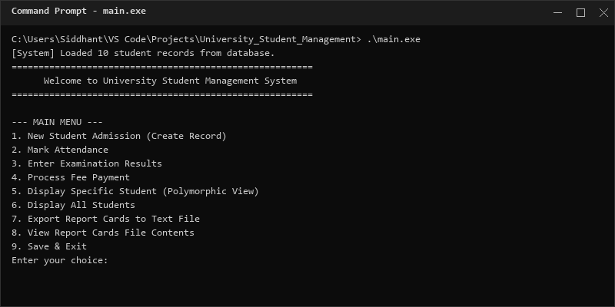
The startup screen shows that the database is loaded from local storage ('sv_database.txt'). The interface presents a numeric menu layout enabling the user to run different administrative tools.
Screenshot 2: Admission registration portal verifying PRN constraints and error blocks.
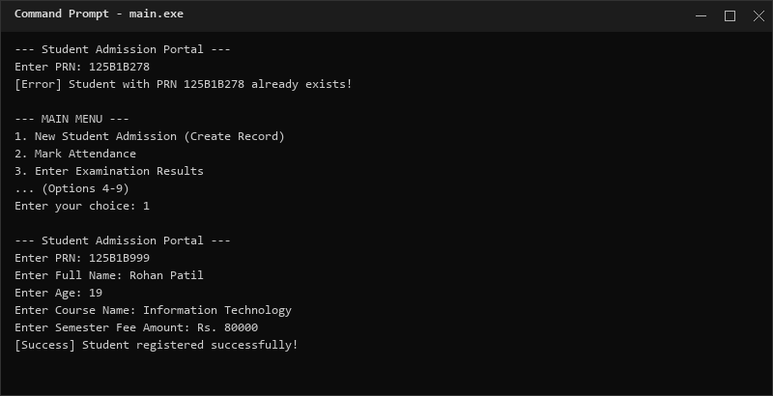
The student admission module verifies if the input PRN already exists. If a duplicate PRN string is detected, the program displays an error message and stops the registration, protecting data integrity.
Screenshot 3: Displaying student report card using virtual function dynamically bound to a base class pointer.
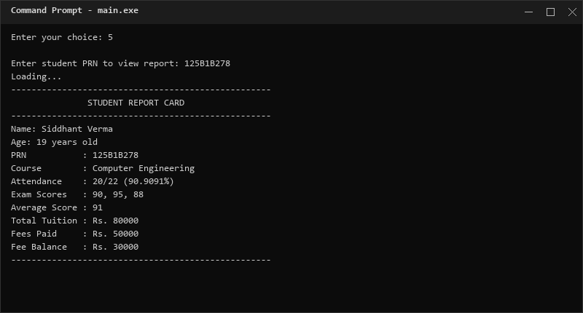
Displaying a specific student details invokes a helper function passing a `sv_Person` base pointer. The overridden virtual function dynamically prints the detailed student card containing attendance percentage, exam grades, average mark, and tuition balance.
Screenshot 4: Generating detailed text file 'sv_report_card.txt' and displaying contents on screen.
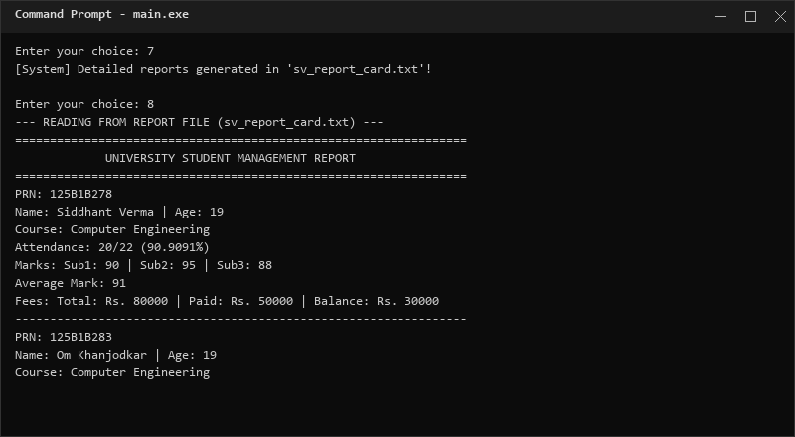
This tool saves reports of all admitted students in a highly readable format to a external file `sv_report_card.txt`, and uses input streams to read the file contents and print them directly to the console.
Screenshot 5: Updating student attendance using the overloaded markAttendance method.
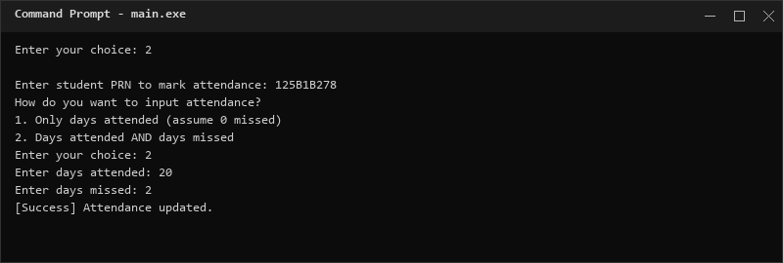
The attendance tracker allows instructors to select a student by PRN. Option 2 handles inputting both days attended and days missed, calculating the updated total values.
Screenshot 6: Inserting three subject marks for exam results evaluation.
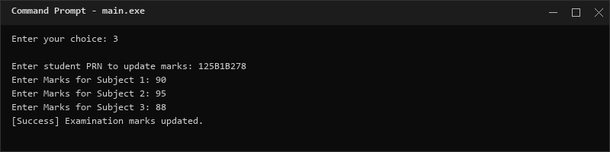
The examination system accepts numeric grades for three individual subjects, saving them into the student variables and recalculating average scores.
Screenshot 7: Processing semester tuition fee payments in Rupees and displaying balances.
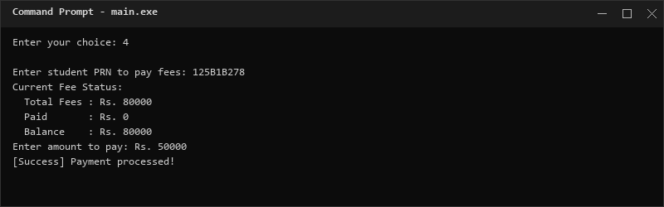
The fee payment portal fetches current fee status (total, paid, balance), processes new payments in Rupees, and displays the remaining balance correctly.

10. References
[1] Bjarne Stroustrup, The C++ Programming Language (4th ed.). Addison-Wesley.
[2] Grady Booch, Object-Oriented Analysis and Design (3rd ed.). Addison-Wesley.
[3] Josuttis, N. M., The C++ Standard Library Reference (2nd ed.). Addison-Wesley.

