Game Design Document
Fill up the following document

- Write the title of your project.
Terminator

- What is the goal of the game?
To destroy the main boss and protect the world.

- Write a brief story of your game.
The player is a normal person. But one day he has been granted powers by the god for his honesty and innocence. As he got the powers he missused and which caused him for a curse by the god that he would be having the powers but for limited time. That’s the logic going to be used in the game that the players gonna fight the enemy with his powers for a limited time but as soon as the powerbar or the time limit of the power will be empty, the player should guard himself from the enemy. There is the main boss of the game who has came to destroy the world, so as the player is the only person who is having the powers. The player should try to destroy the enemy and protect the world. The player has to fight all the 11 bosses including the main boss and more 10 bosses because the enemy is also having companions or the servants who is living to serve the main boss from any opponents who tries to defeat the main boss. There are stages in the game and in each stage the player has to obtain the gems by defeating the companion one by one which lead to the main boss by unlocking the main boss stageand by collecting all the 10 gems.
- Which are the playing characters of this game?
- Playing characters are the ones who respond to the user based on the input from the user.
- Cars, monkeys, dinos, wizards, etc., are the playing characters in the game.

Number | Character Name | What can this character do?
1 | The main player of the Game | Use his power to protect the world
2 | The power star | The main powers which has been given to the player
3 | The gems | Which leads to the main stage or the last stage of the game
4 | Etc.
5
6
7
8

- Which are the Non-Playing Characters of this game?
- Non-Playing characters are the ones that don't have an action or behavior when the user interacts with the game.
- Hurdles, stones, bananas, coins, etc., are non-playing characters in the game.

Number | Character Name | What can this character do?
1 | Main boss | Using the main power
2 | Companions | Using there unique powers
3 | Wizards | One of the power used by the enemies
4 | Power gems | The gems are used which are not obtained yet by the player
5 | Etc.
6
7
8

Draw your imagination of this game. What does this game look like?
- Draw the game either on your computer or on paper.
- Add images of the game scenes to show each of the playing and non-playing characters at least once.

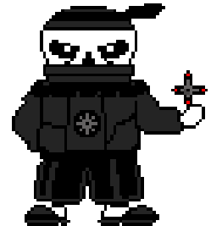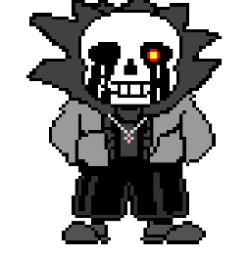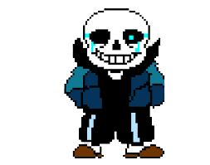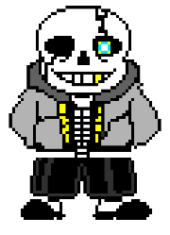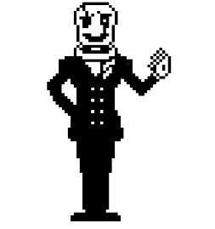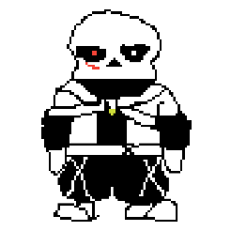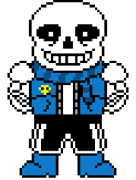ETC.

How do you plan to make your game engaging?
As this an action game, the game would be intresting and the story might also be intresting. Soon if the game is enjoyable and reaches the expectation of the gamers, in future the game would also be added some multiplayer features so that player would also engage with the other player by creating their own character.

