Broadwick

User & Developer Guide

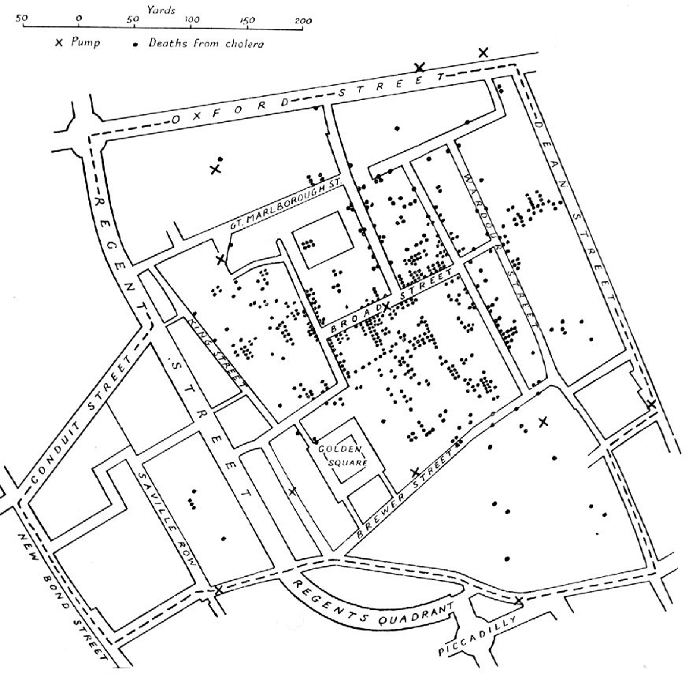
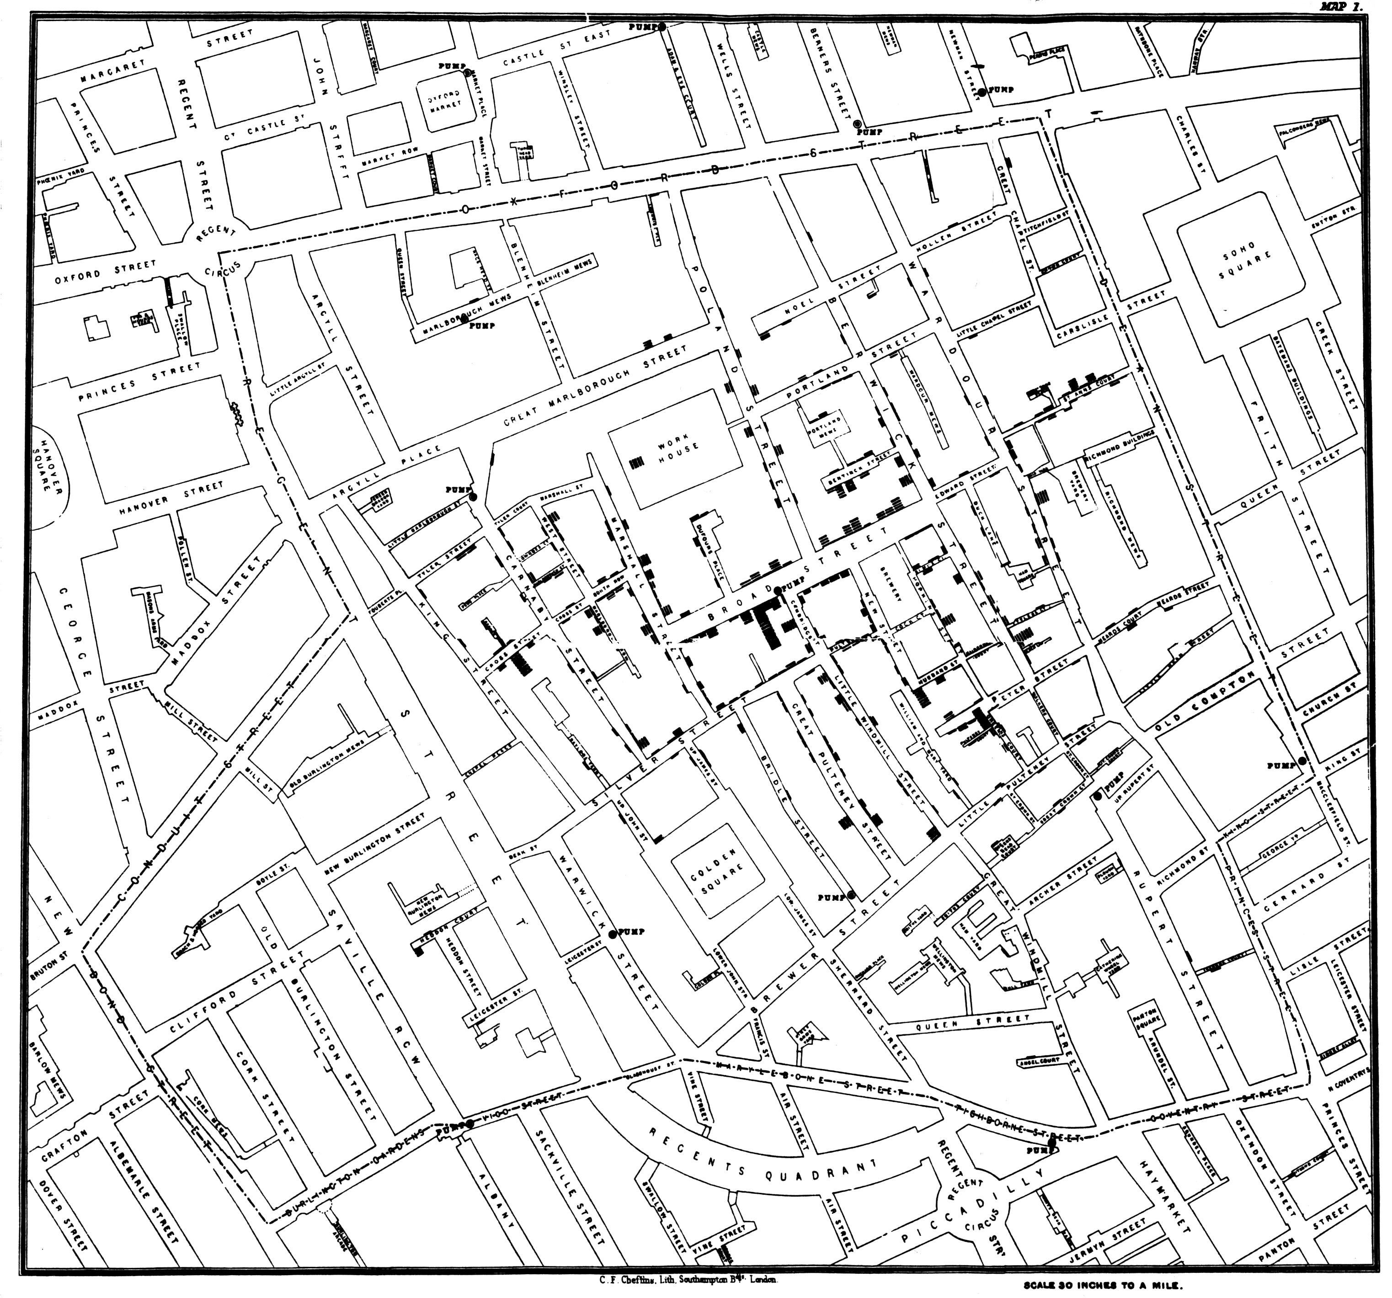
Published by C.F. Cheffins, Lith, Southhampton Buildings, London, England, 1854 in Snow, John. On the Mode of Communication of Cholera, 2nd Ed, John Churchill, New Burlington Street, London, England, 1855.

(This image was originally from en.wikipedia; description page is/was here.

Cover Picture

A variant of the original map drawn by Dr. John Snow (1813-1858), a British physician who is one of the founders of medical epidemiology, showing cases of cholera in the London epidemics of 1854, clustered around the locations of water pumps.

This image is in the public domain because its copyright has expired.
This applies to Australia, the European Union and those countries with a copyright term of life of the author plus 70 years.

Table of Contents
1. Introduction 4
2. Overview 4
Creating Models 4
Configuration files 4
Databases 4
3. Packages 4
4. Algorithms 4
Approximate Bayesian Computation (ABC) 4
Markov Chain Monte Carlo (MCMC) methods 4
Stochastic Models 4

Introduction

Broadwick is a computational framework written in Java for epidemiological computation. It removes the boilerplate code so that users can be more productive in developing models.

Overview

Creating Models

package custom;

public class myModel extends broadwick.model.Model {

@Override
public void init() {
throw new UnsupportedOperationException("Not supported yet.");
}

@Override
public void run() {
throw new UnsupportedOperationException("Not supported yet.");
}

@Override
public void finalise() {
throw new UnsupportedOperationException("Not supported yet.");
}
}

Configuration files

<?xml version="1.0" encoding="UTF-8" standalone="yes"?>
<project>
<logs>
<console>
<level>info</level>
<pattern>[%thread] %-5level %msg %n</pattern>
</console>
<file>
<name>MyModel.log</name>
<level>debug</level>
<pattern>[%thread] %-5level %msg %n</pattern>
<overwrite>true</overwrite>
</file>
</logs>
<models>
<model id="My custom model">
<classname>custom.MyModel</classname>
</model>
</models>
</project>

Databases

Packages

Algorithms

Approximate Bayesian Computation (ABC)

Markov Chain Monte Carlo (MCMC) methods
simulation = new MySimulation();

final MonteCarlo mc = new MonteCarlo(simulation);
mc.setWriter(new FileOutput(“myMCMC.dat”);
mc.run();

Stochastic Models

