Abstract:
With the push for better energy efficiency incandescent lighting is no longer an option but in a lab environment this poses a challenge. Replacements to incandescent lighting use various means and construction techniques to save efficiency while reducing unit costs but they can unintentionally produce noise of various kinds for laboratory apparatus. The challenge is not just identifying a fixture that is not incandescent and low noise, it must also be long life or the time invested in finding it will only be multiplied with every unit replacement cycle.

Specification:
The fixtures in the lab area in question were originally 2”x2” troffers which used long neck frosted end 150W incandescent bulbs which were individually vented for long life and wired to dimmers. It is worth noting that these were used only at full power and that the dimmer was not only never touched but until the time of this project forgotten. For a typical 150W incandescent lamp from Sylvania (model #13125) the output is 2780 lumens. The new fixture must have at least the same number or higher.

Immediately all florescent lighting is ruled out. Florescent lighting works by sustaining an arc inside a special gas environment. The arc by it’s very nature emits far to much noise to be any where near our equipment because of the radio interference it generates. For more on this look up arc gap transmitters. Florescent lighting is also ruled out because the ballasts used to power the florescent bulbs are themselves sources of noise. For more on this see Appendix A – Florescent Lighting. Add to this that florescent lighting is rapidly being replaced by LED and will probably be made illegal just like incandescent in another few years we basically ignored florescent as an option. Finally the space we were investigating this for has a PI (Sunil) who specifically did not want anything but LED.

LED lighting seems the best option. There are however areas we have to look out for…...#########################

The magnetic noise limit exists because people use conductive cabling at distances close to that when they connect to hardware in relay racks (also know as 19” rack) in the top most available position. The cables can inductively couple to the wiring, inductors, and transformers in the electronics of the troffer bringing magnetic noise in the troffer into the apparatus as electrical noise. The magnetic noise limit was established by using our standard search coil at a distance of 2”. We established the limit on magnetic noise using our search coil. The coil was wound of a known number of turns on a coil form of known geometry so that we can calculate all of it’s relevant properties. It also has a measured inductance. It was originally created to help us search for sources of magnetic noise and is to be considered more sensitive than any single cable in a lab environment (outside of a chamber) ever typically would be. This is because of it’s turns ratio.

Electrical noise limit

Electrostatic noise limit

Optical noise limit

RF noise limit

Appendix A – Florescent Lighting

There are two common types of Florescent ballasts. They are semi-resonant start and solid state other wise known as electronic. This appendix explores them and why they are not suited for use in the project.

A semi-resonant ballast of the type shown in Figure 1 can produce noise acoustically via magnetostriction in the transformer (here called an “SRS Unit”). The magnetic field from the transformer could also radiate outside of the unit. Later we will illustrate this with the data collected from EPL’s Room X which uses Florescent lighting. Depending on how this device was constructed there may also be electrical noise because of the wiring is carrying higher frequencies than 60Hz and can start to radiate this into the lab. 60Hz is ubiquitous in laboratory control room environments and so we can for the most part filter it but out of that frequency there are problems.

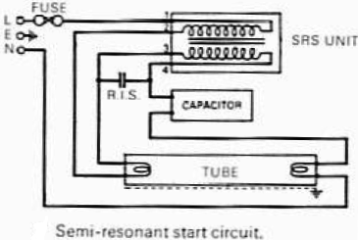
Fig. 1 – A ballast schematic using a semi-resonant configuration from the Thorn Electrical Industries 1972 lighting catalog (found on wikipedia)

The ballast shown in Figure 2 is typical of the solid state variety. It suffers from other noise causing design choices. Mainly it’s use of semiconductor diodes which clip the flow of electricity to flat edges. The 60Hz sine wave used to transmit conventional AC power typically only carries 60Hz and a few harmonics of 60Hz in what is commonly referred to as a “picket fence” patter. The Fourier series of anything signal with a vertical or horizontal edge is a sum of sinewaves the composition and frequency of which vary off into infinity. In real life as opposed to theory this does not mean we get a infinite number of anything but you get the idea. Filtering this onslaught of noise is often done poorly to save cost on the ballast in our observation.

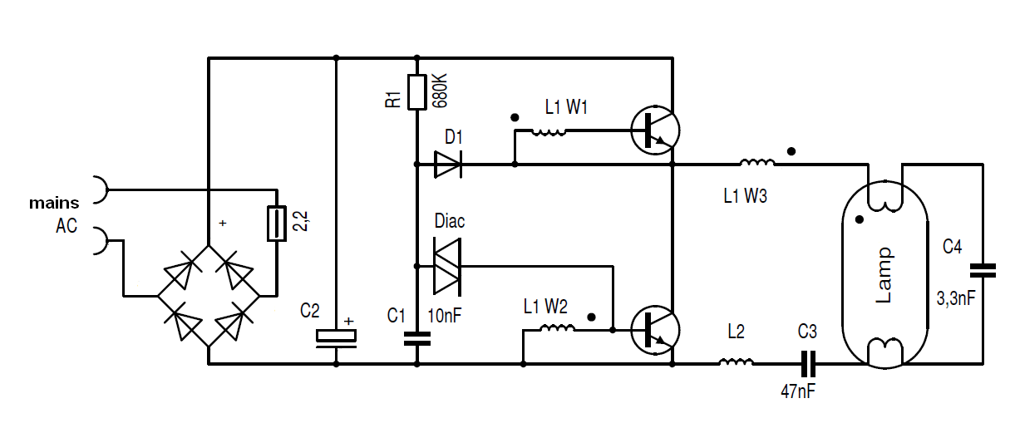
Fig. 2 – A ballast schematic using a solid state configuration a.k.a. electronic ballast By Neotesla - Own work, CC BY-SA 3.0, https://commons.wikimedia.org/w/index.php?curid=4250568

