Hello, my name is Scott. I was a postdoc with Julie Arenberg. Here I have detailed how I attempted to calibrate digital sound files to an equivalent dB SPL for Cochlear devices for Bluetooth experiments.

Cochlear Device

I used the Nucleus MATLAB toolbox to get a basic idea of what values we’d be working with.

https://www.mathworks.com/matlabcentral/fileexchange/159688-nucleus-toolbox

In the file Ensure_amplitude_params.d, we get this information:

Pure tone amplitude | Digital Amplitude | Digital RMS | dB SPL
+/-1.0 | 0 dB | -3 dB | 95

Likewise, C and T levels for speech are defined as follows:

 | dB SPL
Comfort (C) Speech | 71
Comfort (C) Pure Tone | 65
Threshold (T) | 25

The speech comfort value is 65 + 6, the 6 is from speech_bandwidth_factor_dB which reads in a comment: A reference pure tone will achieve C-level stimulation at a lower RMS level than a speech signal. It is basically irrelevant for this, since we work in pure tones.

To recap my understanding: I’ll send digital dB FS values through the Bluetooth set up to the Cochlear device. These values should disappear at 25 dB SPL equivalent and saturate at the 65 dB SPL equivalent.

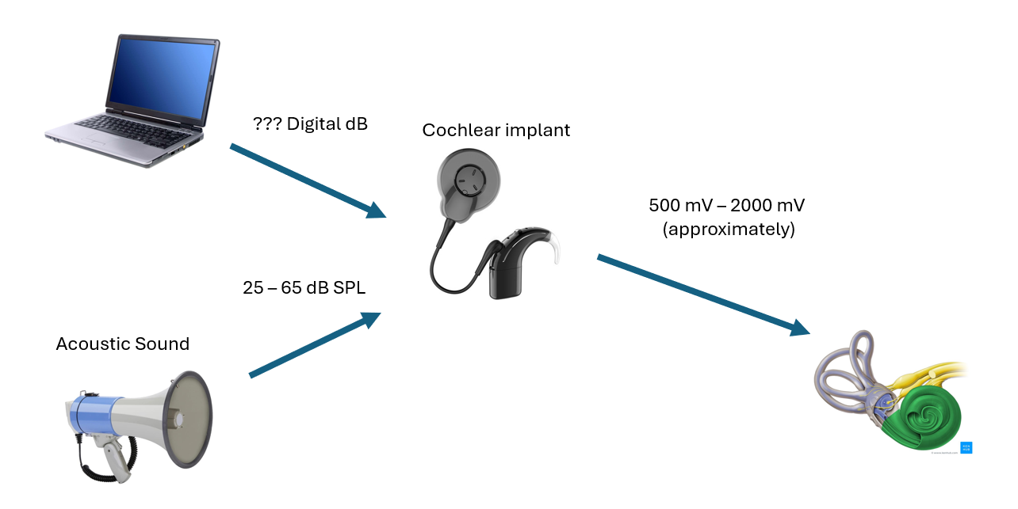

The trick is that “dB SPL” measures physical, acoustic sound level. But the sound we use is never physical- it goes from the computer, to the TV Streamer, to the implant directly. Therefore, we need to figure out two things:
- What acoustic dB SPL the implant will process a given digital dB FS (fullscale, measured on the computer), i.e. a digital dB FS <-> acoustic dB SPL relationship
- What we need to adjust each electrode by so that they receive the same pulse amplitude regardless of which electrode we stimulate, i.e. equalization.
Sanity Check
We could probably guess the answer to 1), based on table 1. We would guess that if a 0 dB FS sine is supposed to be 95 dB SPL, then 65 dB SPL is probably -30 dB FS, and 25 dB SPL is probably -70 dB FS.
But let’s do it properly.
Modeling These Values

I have painstakingly gathered as much data as I could from a flat map (100 on every electrode, if I remember) on the Cochlear implant-in-a-box for every electrode frequency from a variety of digital dB FS values. This information is stored in Input-Values.xlsx.

One could easily redo these values on a different system to make sure it works, such as through the MOTU.

I then run the script “run_this.m” which will model these values, to figure out what’s the best way to equalize a digital dB FS to what mV output.

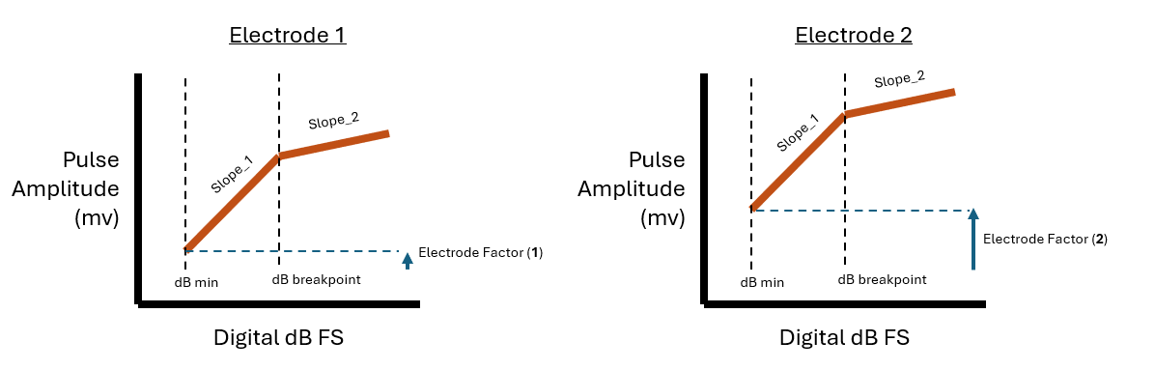
Here is a diagram of how I model it, and how you can interpret the results of running “run_this.m”. Slope_2 is meant to take into account AGC, and will probably be close to zero. The dB breakpoint is the value that should map to 65 dB SPL (when AGC kicks in, I think).

When I run the model, my dB breakpoint is about -35 dB FS. That means according to my model, a zero dB FS digital signal would map to about 100 dB SPL. That is not that same as 95 dB SPL as written in “Sanity Check,” but it’s close enough.

Electrode_factors_fit is then a 22 length array that contains an “offset” value for each electrode. This answers our question 2. These values get saved into Cochlear_Filter.mat which the program uses to adjust digital signal dB FS based on the electrode.

Testing These Values

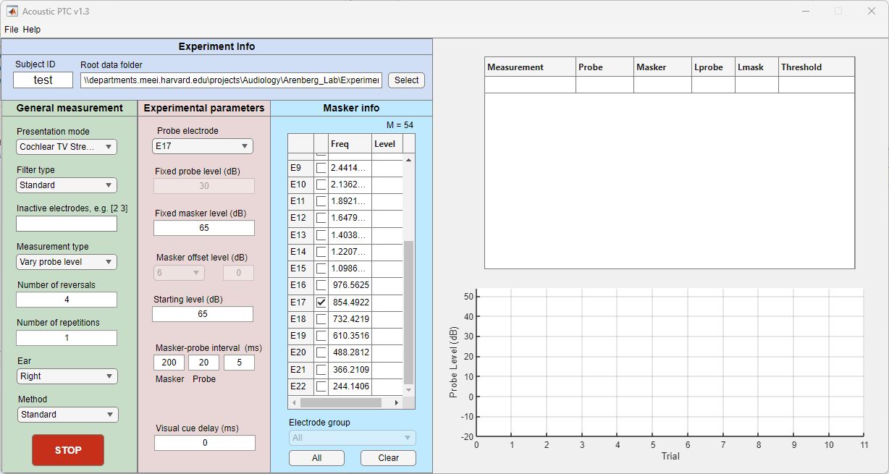

I’ll use 100 as the Lmax for Cochlear TV Streamer in the Acoustic PTC code, taken from the previous step. (65 dB SPL – dB_break_fit = 99.5916, rounding up)


If I put 65 dB masker in Acoustic PTC for electrode 17 (which has no electrode adjustment factor), then pause the output, the max digital DB FS is -35 dB FS. That’s about what we wanted.

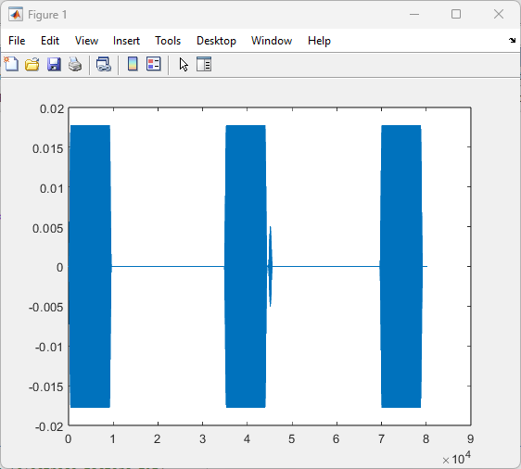

Implementing These Values

Basically, with a dB SPL full scale reference of 100 dB SPL, and the Cochlear_Filter.mat file which gets added to each electrode value, we should have all the information we need. It has been implemented in the AcousticPTC program in the GetFullScaleSPL function (Lmax = ) and reading the Cochlear_Filter.mat instead of the AB_Preemphasis_Filter.mat for AB.

Note: AB_Preemphasis_Filter gets SUBSTRACTED from values, while Cochlear_Filter gets ADDED to the values.

Note again: You might prefer to have Lmax as 95 dB SPL, as Cochlear says in the Nucleus toolbox. You could also use the Microphone filter in the nucleus toolbox. I decided to do everything experimentally, with a the implant in a box, to be totally sure I knew which values were peak vs RMS, etc.

