Jinan University
2023 ～ 2024 Academic Year, 2nd. Semester

Java Programming

Course Report

Course code : 60080008
Instructor: Yuxia Sun
Major: Computer Science & Technology
School: International School

Student name : ____________付美辰______________
(p.s. your name on JNU academic system)

Student number : ________2022100549__________________

Date of Submission (mm-dd-yyyy): __6-20-2024______________

Table of Content
Ch1 Introduction to Computers, Programs, and Java 10
1. Bar-graph of Self-test 10
2. Correction & Learning 10
1) Correction: 10
2) Correction: 11
3)Correction 11
Ch2 Elementary Programming 12
1. Bar-graph of Self-test 12
2. Correction & Learning 12
1)Correction 12
2)Correction 13
Ch3 Selection 13
2. Bar-graph of Self-test 13
2. Correction & Learning 13
1)Correction 14
2) Correction 15
3) Correction 15
Ch4 Mathematical Functions,Characters,and Strings 16
1. Bar-graph of Self-test 16
2. Correction & Learning 16
1)Correction 16
2)Correction: 17
17
Ch5 Loops 17
1. Bar-graph of Self-test 17
2. Correction & Learning 17
1)Correction 18
2)Correction: 19
3)Correction: 19
4)Correction: 19
5)Correction: 19
Ch 6 Methods 20
1. Bar-graph of Self-test 20
2. Correction & Learning 20
1) Correction 21
2) Correction: 22
3) Correction: 23
Ch 7 Single-Dimensional Arrays 23
1. Bar-graph of Self-test 23
2. Correction & Learning 23
1) Correction 24
2) Correction: 24
3) Correction: 25
4) Correction: 25
5) Correction: 26
Ch 8 Multidimensional Arrays 26
1. Bar-graph of Self-test 26
2. Correction & Learning 26
1) Correction 27
Ch 9 Objects and Classes 27
1. Bar-graph of Self-test 27
2. Correction & Learning 28
1) Correction 28
2) Correction 29
3) Correction 30
4) Correction 30
5) Correction 31
6) Correction 32
7) Correction 33
8) Correction 35
9) Correction 36
Ch 10 Object-Oriented Thinking 37
1. Bar-graph of Self-test 37
2. Correction & Learning 37
1) Correction 37
2) Correction 38
Ch 11 Inheritance and Polymorphism 38
1. Bar-graph of Self-test 38
2. Correction & Learning 39
1) Correction 39
2) Correction 40
3) Correction 41
4) Correction 42
5) Correction 42
Ch 12 Exception Handling and Test I/O 43
1. Bar-graph of Self-test 43
2. Correction & Learning 43
1) Correction 44
2) Correction 45
Ch 13 Abstract Classes and Interfaces 46
1. Bar-graph of Self-test 46
2. Correction & Learning 46
1)Correction 47
2) Correction 48
3) Correction 49
4) Correction 49
Ch 14 JavaFX Basics 50
1. Bar-graph of Self-test 50
2. Correction & Learning 50
1) Correction 51
2) Correction 51
3) Correction 52
4) Correction 53
Project I. Snake Game using Java () 53
1. The chosen program’s name and type 54
2. Running results of my modified program 55
3. Program functionalities modified by me 56
4. Test my program with Junit. (Optional) 57

Ch1 Introduction to Computers, Programs, and Java

1. Bar-graph of Self-test

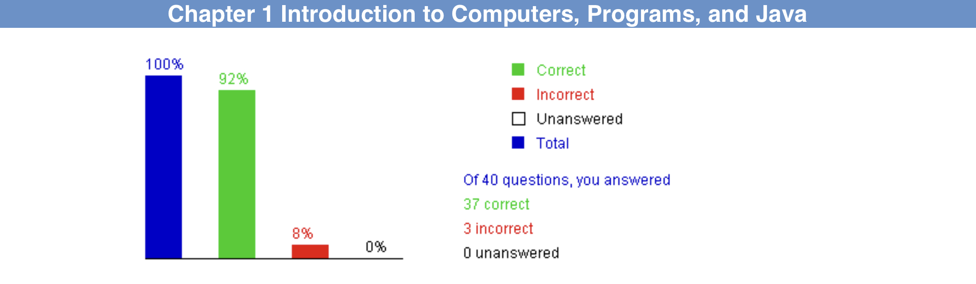

2. Correction & Learning

Correction:
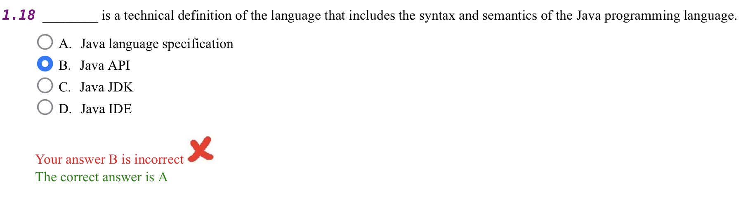
Learning:
I read Section1.6 of the textbook and learnt: “The Java language specification is a technical definition of the Java programming language’s syntax and semantics. You can find the complete Java language specification at docs.oracle.com/javase/specs/.”

Correction:

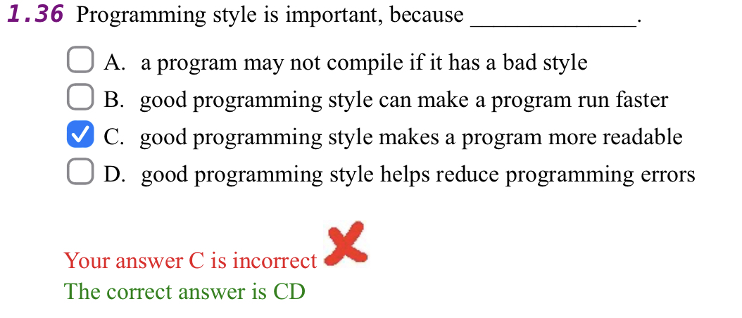

Learning:I read Section1.9.2 of the textbook and learnt: “A consistent indentation style makes programs clear and easy to read, debug, and maintain. Indentation is used to illustrate the structural relationships between a program’s compo- nents or statements. Java can read the program even if all of the statements are on the same long line, but humans find it easier to read and maintain code that is aligned properly. Indent each subcomponent or statement at least two spaces more

3)Correction
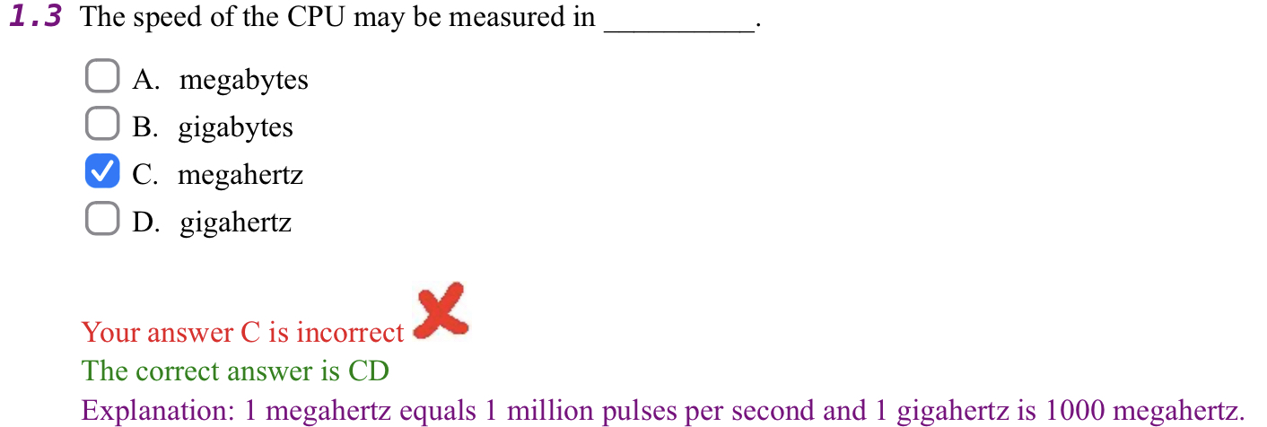

Learning:
I read Section1.2.1 of the textbook and learnt: “In the 1990s, computers measured clock speed in megahertz (MHz), but CPU speed has been improving continuously; the clock speed of a computer is now usually stated in gigahertz (GHz)Intel’s newest processors run at about 3 GHz.”

than the construct within which it is nested.”

Ch2 Elementary Programming

Bar-graph of Self-test 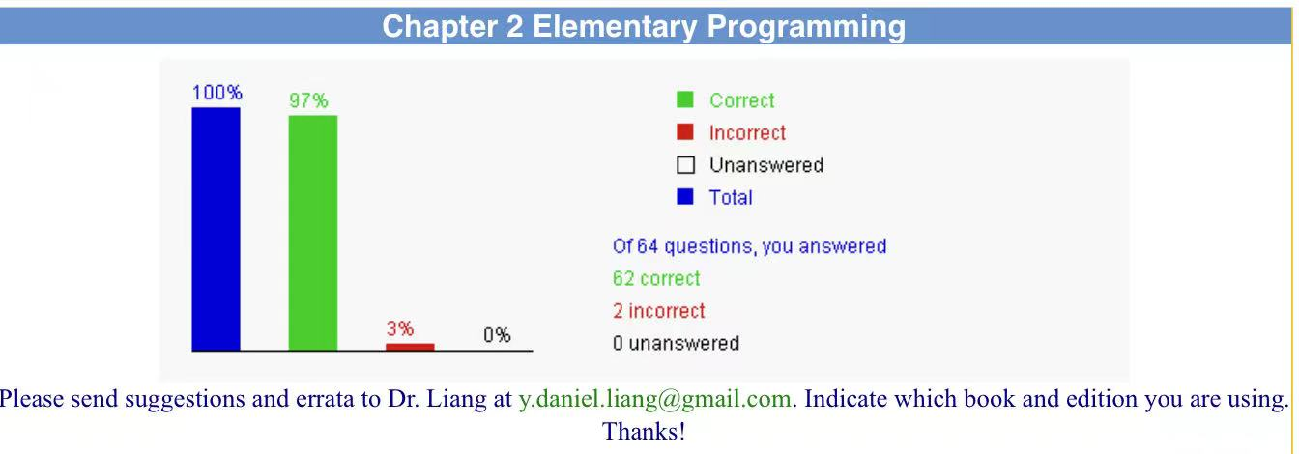

2. Correction & Learning

1)Correction
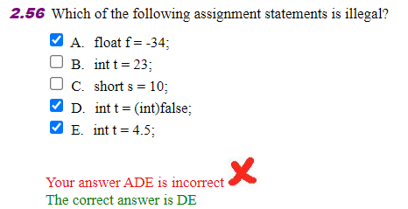

Learning:This assignment is perfectly legal in Java. By default, numerical literals (like -34) are considered to be of type int, and an int can be implicitly cast to a float without any issues.

2)Correction
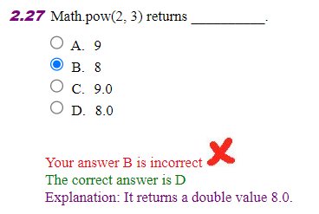
Learning:In Java, Math.pow(2, 3) returns 8.0 instead of 8 because the return type of the Math.pow method is double. The Math.pow method in Java is used for calculating the power of a number, and its signature is public static double pow(double a, double b). This means that regardless of whether the input numbers are integers or floating-point numbers, the result returned is of type double floating-point number. Therefore, even if the result is an integer value, it will be represented as a floating-point number, such as 8.0. This is to ensure the universality and precision of numerical operations, as the results of exponentiation operations are often floating-point numbers.

Ch3 Selection

Bar-graph of Self-test
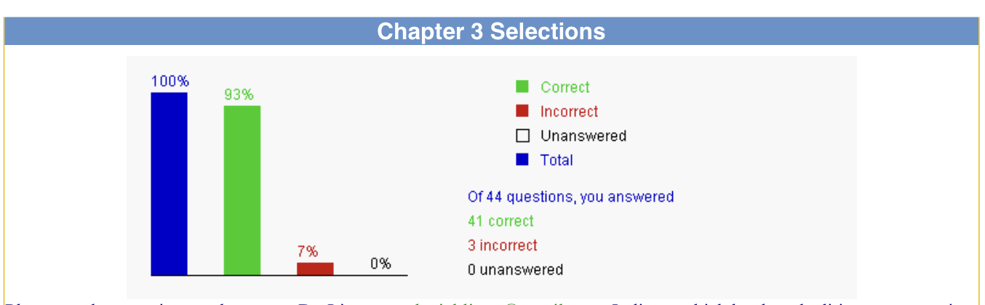

2. Correction & Learning

1)Correction
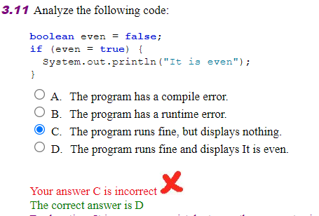

Learning:It is a common mistake to use the = operator in the condition test. What happens is that true is assigned to even when you write even = true. So even is true. The program compiles and runs fine and displays 'It is even'

Correction
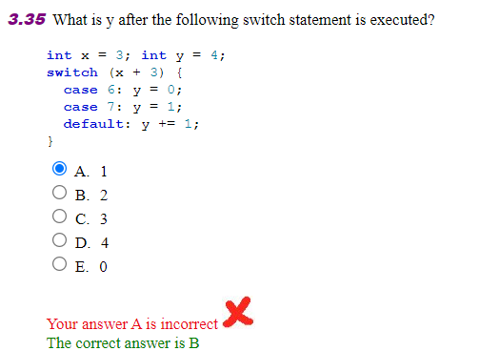
Learning:Since x1=3,x+3 is 6. So, case 6 is executed. Since there is no breaks statement. the statement in the next case is executed. y is now 1 Finally y += 1 adds 1 to y. So y is 2. The correct answer is B

Correction

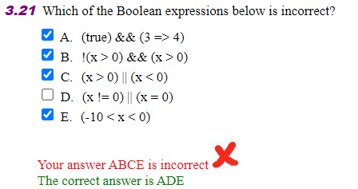
Learning: For B,the result is wrong,but the expression is correct.For D,x=0 should be x==0

Ch4 Mathematical Functions,Characters,and Strings

1. Bar-graph of Self-test
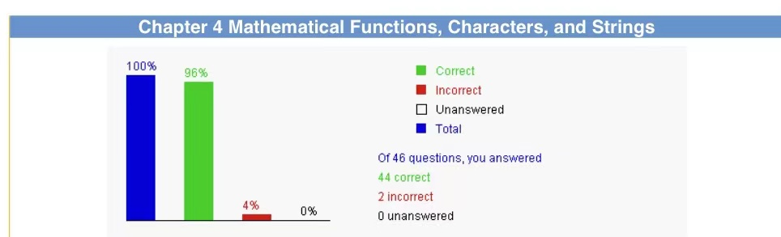

2. Correction & Learning

1)Correction
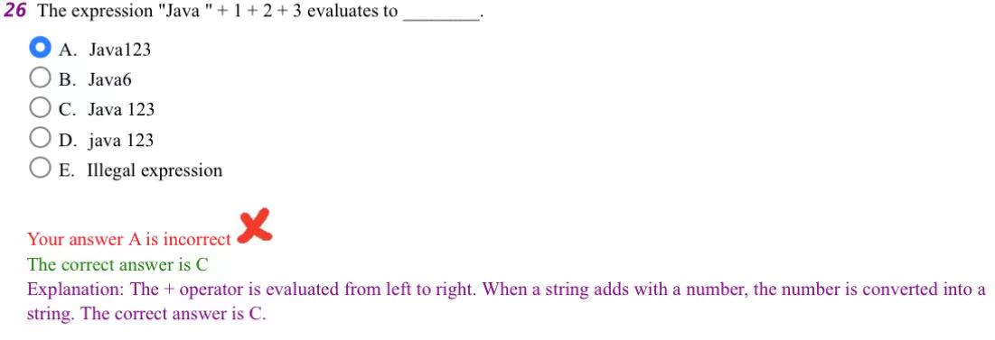
Learning: The + operator is evaluated from left to right. When a string adds with a number, the number is converted into a string. The correct answer is C.

2)Correction:

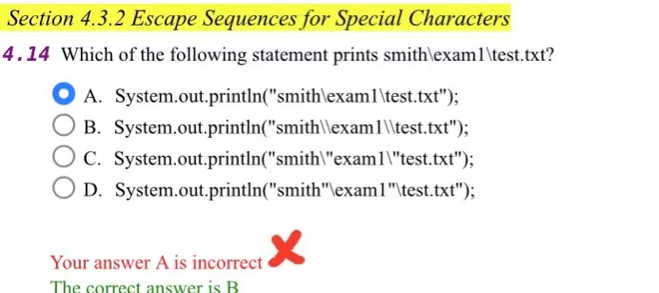
Learning:To represent the character, use \, because it is an escape character

Ch5 Loops

1. Bar-graph of Self-test

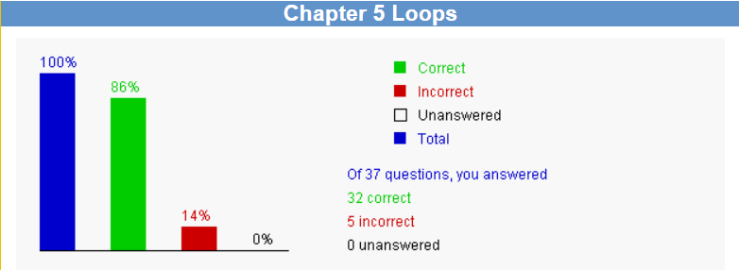

2. Correction & Learning

1)Correction
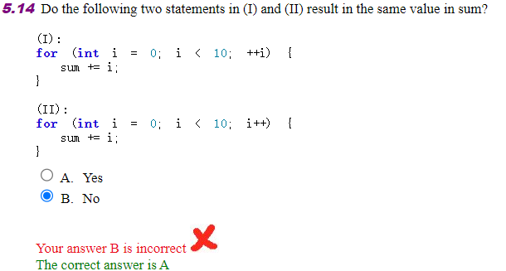
Learning: In this case, + +i and it + are used standalone with no side-effect. So, (I) and (II) are equivalent. The correct answer is A
2)Correction
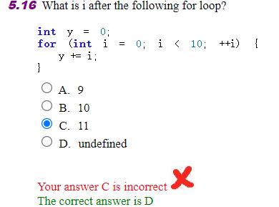
Learning: The scope for i is inside the loop. After the loop, i is not defined. So, the correct answer is D.

3)Correction:

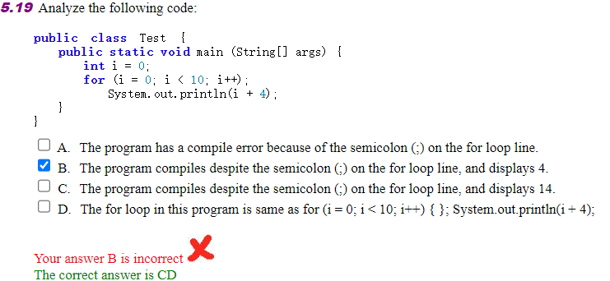

Learning:This is a logic error. System out printIn(i + 4) is not a part the for loop because the for loop ends with the last semicolon at for (i-0; 1 < 10; it +);

4)Correction:

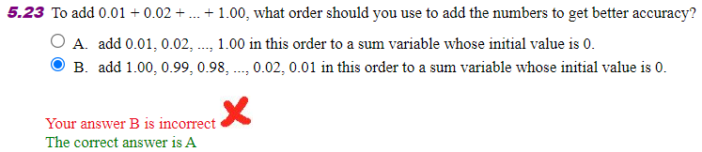

Learning:Adding the numbers in the order specified in A will result in a more accurate result than in B, because two numbers to be added will be about the same size.

5)Correction:

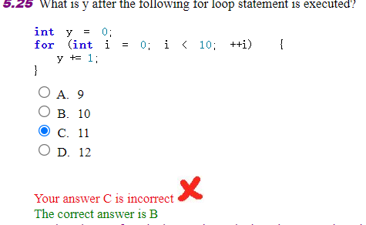

Learning: Before the loop, y is o. The loop is executed 10 tites. Each time, 1 is added to y. so,after the loop is finished, y is 10. The correct answer is (B).

Ch 6 Methods

1. Bar-graph of Self-test

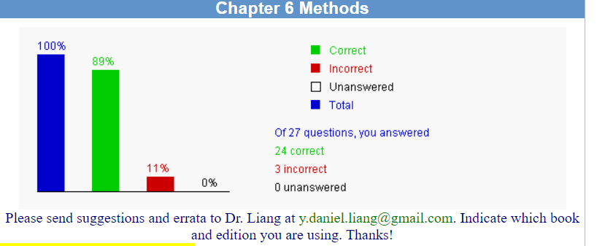

2. Correction & Learning

Correction
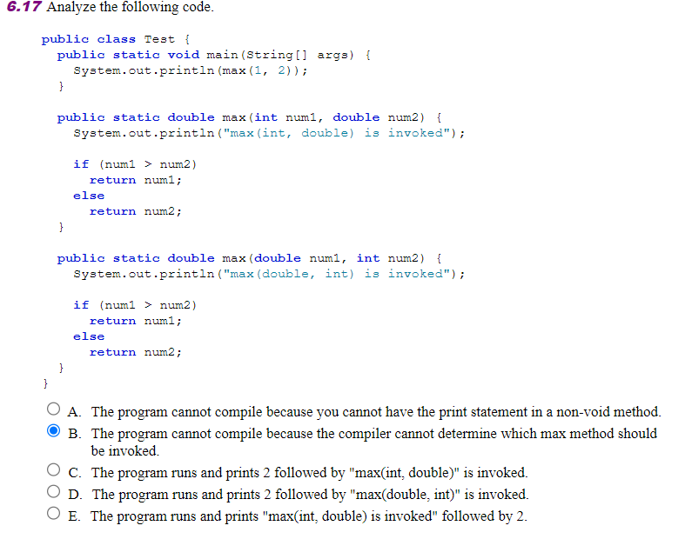
Learning: In this Java code, there are two overloaded methods named max. One max method accepts an int and a double parameter, and the other accepts a double and an int parameter. The main method attempts to call max with two int arguments: 1 and 2.
Java uses automatic type promotion rules when calling overloaded methods. In this case, since both arguments are int, Java will automatically promote one of the int arguments to a double to match one of the overloaded max methods. Both max methods are equally suitable for automatic promotion: one argument can be promoted from int to double to match either method's parameters.
Given that both max(int, double) and max(double, int) are equally applicable, the Java compiler cannot unambiguously decide which one to call based solely on the method signatures and the argument types provided. Therefore, the correct answer is:
B. The program cannot compile because the compiler cannot determine which max method should be invoked.

Correction:
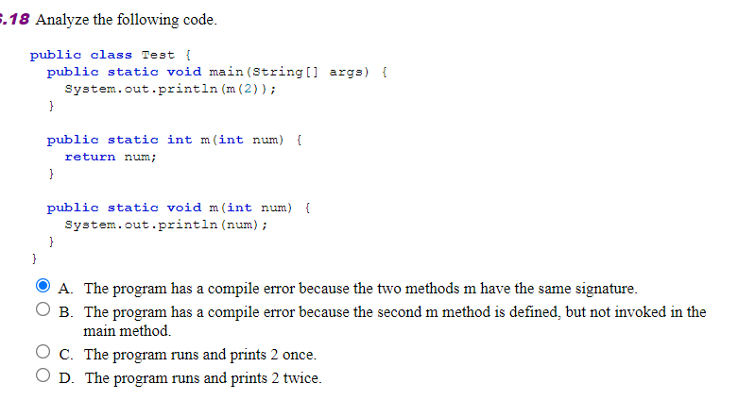
Learning: In Java, method overloading allows you to have multiple methods with the same name in the same class, as long as they have different parameter lists (different number of parameters, different types of parameters, or both). However, overloading does not take into account the return type of the methods. That is, you cannot have two methods in the same class with the same name and the same parameters but different return types.
In the provided code, there are two methods named m, both taking a single int parameter:

1.public static int m(int num) - Returns an int.
2.public static void m(int num) - Returns nothing (void).

Since both methods have the same name and parameter list, but differ only in their return types, this constitutes a conflict that the Java compiler cannot resolve based on overloading rules alone. The return type does not contribute to differentiating methods for the purpose of overloading. Thus, having both methods in the same class with the same signature except for the return type is not allowed in Java.
Therefore, the correct answer is:
A. The program has a compile error because the two methods m have the same signature.

Correction:

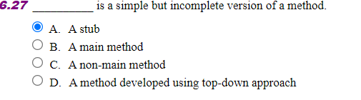

Learning:In programming, when you refer to a simple but incomplete version of a method, the term you're looking for is "stub." A stub method typically includes the minimum code necessary to allow the software to compile and run, usually returning a fixed value that is indicative of what the full implementation will return when it is complete. Stubs are often used in the context of testing or early development phases to simulate the behavior of more complex logic that has yet to be implemented.

Answer: A. A stub

Ch 7 Single-Dimensional Arrays

1. Bar-graph of Self-test

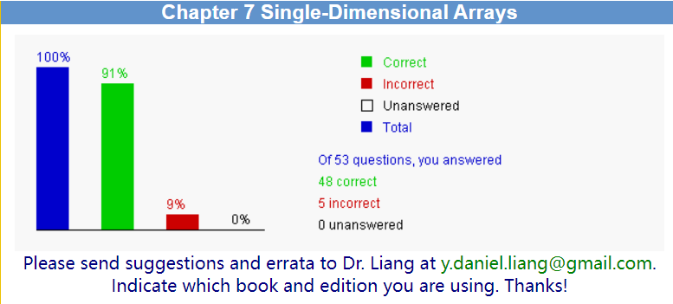

2. Correction & Learning

Correction
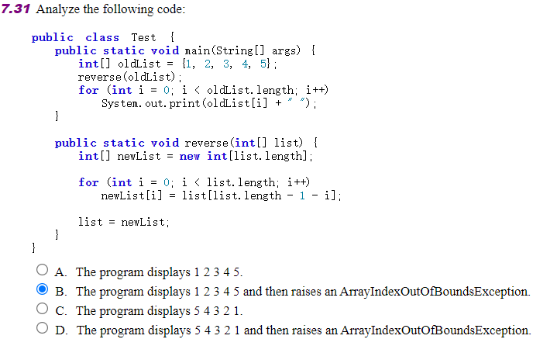
Learning:There is no ArrayIndexOutOfBoundsException because the loop in main correctly iterates over the bounds of oldList.

Correction:

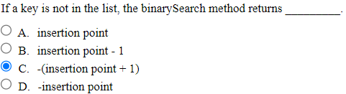

Learning: When the `binarySearch` method is used to search for a key that is not present in the list, it returns:

C. -(insertion point + 1)

Here, the "insertion point" refers to where the key would be inserted to maintain the sorted order of the array. If the element were present, it would be found at this position. The `binarySearch` method returns a negative number, indicating that the element is not in the array. The absolute value of this negative number minus one gives the index where the element should be inserted to maintain the order of the array.

Correction:

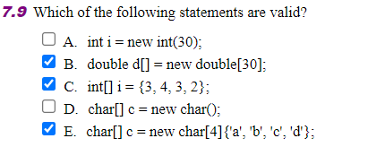

Learning:E. char[] C = new char[4]{'a', 'b', 'c', 'd'};
This statement is invalid. In Java, the size and initialisation value of the array cannot be specified at the same time.

Correction: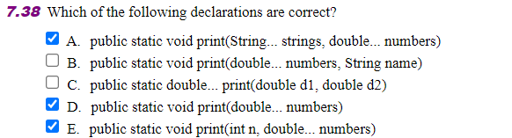
Learning:A. public static void print(String... strings, double... numbers) - This is a correct declaration in Java. It uses varargs for both String and double types, allowing the method to accept an arbitrary number of String and double arguments.
B. public static void print(double... numbers, String name) - This is also a correct declaration. It uses varargs for the double type and a regular parameter for String. However, the order of parameters with varargs and regular parameters is not typically a concern in Java, but it is a matter of style and readability.
C. public static double print(double d1, double d2) - This is a correct declaration, but it does not use varargs. It defines a method that takes two double parameters and returns a double value.
D. public static void print(double... numbers) - This is a correct declaration. It uses varargs to allow the method to accept an arbitrary number of double arguments.
E. public static void print(int n, double numbers) - This is not a correct declaration. The syntax is incorrect because numbers is not preceded by ... to indicate it's a varargs parameter, and it's not enclosed in square brackets to indicate it's an array. If numbers is intended to be a varargs parameter, it should be double... numbers. If it's an array, it should be double[] numbers.
The correct declarations are A, B, C, and D.

Correction:
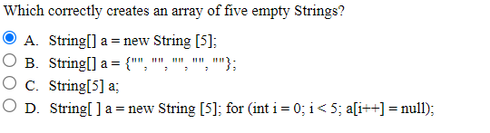

Learning:Option B: this statement correctly creates an array of five empty strings.

Ch 8 Multidimensional Arrays

1. Bar-graph of Self-test
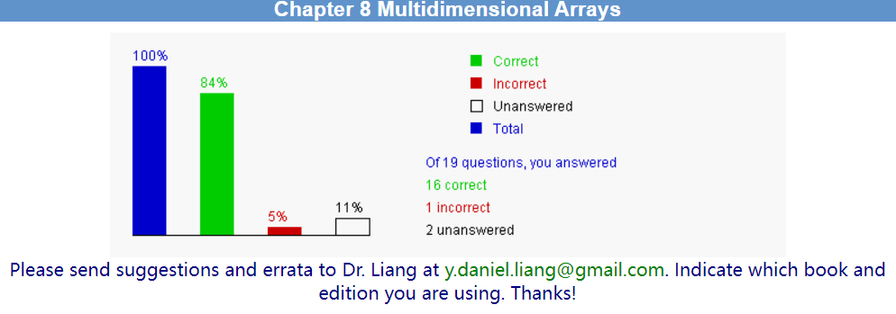

2. Correction & Learning

Correction
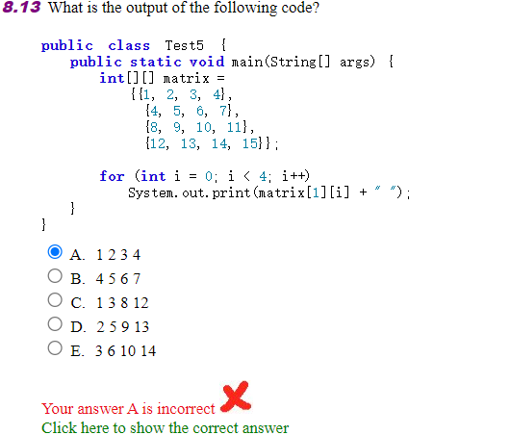
Learning:The provided code snippet prints out the elements of the second row (index 1) from a 4x4 two-dimensional integer array named `matrix`. Here's the array:

```
1 2 3 4
4 5 6 7
8 9 10 11
12 13 14 15
The `for` loop iterates over the indices 0 to 3, which correspond to the columns of the second row. The expression `matrix[1][i]` accesses the element at the second row (1-based index) and the `i`-th column (0-based index).
The output of the code will be the elements of the second row, separated by spaces:4 5 6 7

Ch 9 Objects and Classes

1. Bar-graph of Self-test

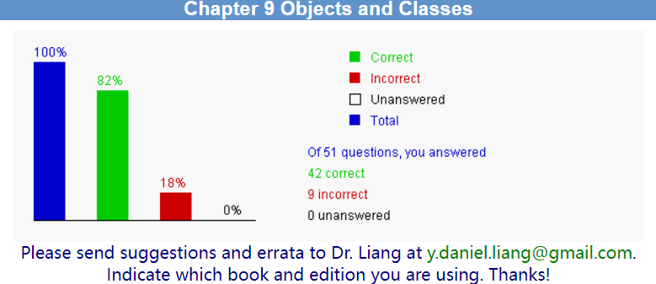

2. Correction & Learning

Correction
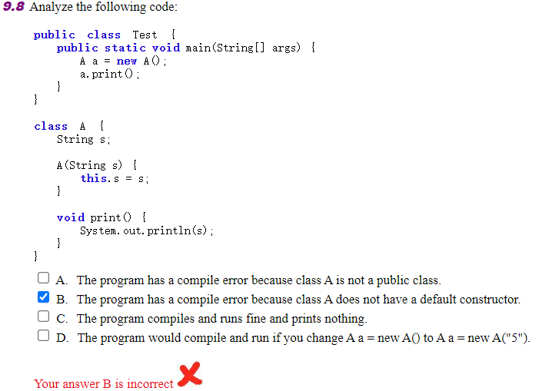
Learning:A. False: The program does not have a compile error because class A is not public. In Java, classes are public by default if no access modifier is specified.

B. True: The program has a compile error because there is no constructor defined in class A that takes no arguments (a default constructor). The main method tries to create an instance of A without providing the required String argument.

C. False: The program does not compile, so it cannot run and print anything. The error is at compile time, not run time.

- True: If the instantiation of A is changed to provide a String argument, such as A a = new A("5");, the program would compile and run, and it would print the string "5".

Correction
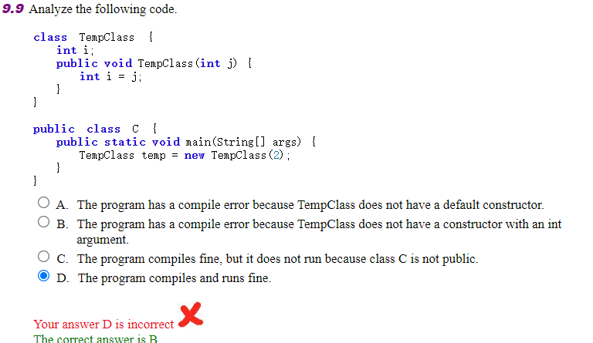
Learning:A. False: The program has a compile error, but not because TempClass lacks a default constructor. The error is due to the incorrect constructor declaration.

B. True: The program has a compile error because the constructor with an int argument is not correctly declared, making it inaccessible.

C. False: The program does not compile due to the constructor error in TempClass, not because class C is not public.

D. False: The program does not compile, so it cannot run.

Correction
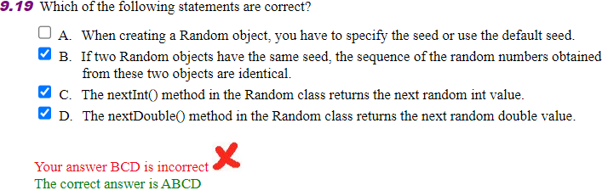
Learning:A. "When creating a Random object, you have to specify the seed or use the default seed." - This statement is incorrect. In Java, when you create a new instance of the Random class, you can optionally specify a seed. If no seed is provided, the Random class uses a default seed, which is derived from the current time in milliseconds. So, the statement should say "When creating a Random object, you can specify the seed or use the default seed."

Correction
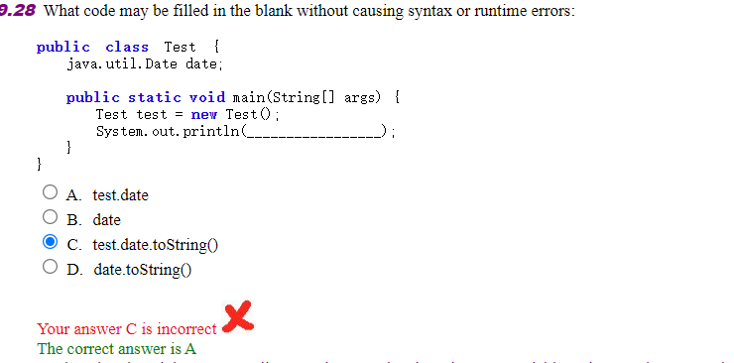
Learning:b and d cause compile errors because date is an instance variable and cannot be accessed
from static context.c is wrong because test.date is null, causing NullPointerException

Correction
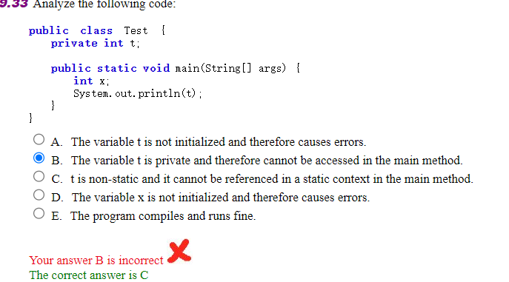
Learning:The variable t is declared as a private instance variable. It cannot be accessed directly in a static context like the main method because static methods belong to the class itself, not to any particular instance of the class. This makes option B incorrect.

The variable t is indeed not initialized, but this is not the primary issue preventing the code from compiling. The main problem is that t is a non-static variable and cannot be accessed in a static context without being referenced through an instance of the class.

The variable x is declared but not initialized, and there is a missing semicolon at the end of the declaration. This would cause a compilation error, making option D correct.

The code will not compile due to the reasons mentioned above, so option E is incorrect.

The correct answer provided is C, which states that t is non-static and cannot be referenced in a static context in the main method. This is indeed the primary issue that prevents the code from compiling.

In summary, the correct answer is C, and the provided analysis for option B is incorrect because the main issue is not the access level (private) but the fact that t is a non-static variable and cannot be accessed in a static context. Option D is also correct, but it seems the question implies there is only one correct answer. If we consider all the issues, both C and D are correct, but since the question format suggests a single correct answer, C is the most appropriate choice given the context.

Correction
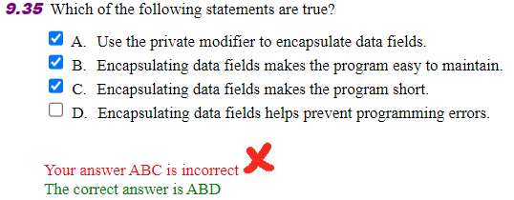
Learning:C. False: Encapsulating data fields does not necessarily make a program shorter. In fact, encapsulation might require additional code to implement accessors and mutators, which could slightly increase the amount of code, but this is done to ensure better encapsulation and maintainability.

D. True: Encapsulating data fields helps prevent programming errors. By controlling access to and modification of fields (for example, adding validation logic in setter methods), it ensures that the fields always hold valid values, thus avoiding errors that might be caused by inappropriate values.

Correction
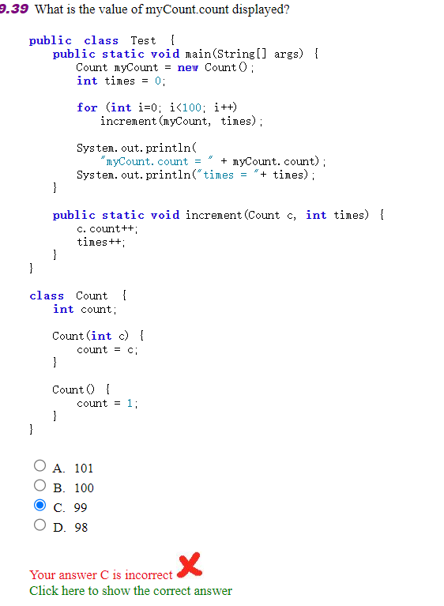
Learning:An instance of Count named myCount is created with the default constructor Count(), which initializes count to 1.

A for loop runs 100 times, calling the increment method each time and passing myCount and times as arguments.

Inside the increment method, both c.count and times are incremented by 1. However, the change to times is local to the increment method and does not affect the times variable in the main method because the parameter times is passed by value, not by reference.

After the loop, the value of myCount.count is printed. Since the loop runs 100 times and each call to increment increases c.count by 1, starting from the initial value of 1, the final value of myCount.count will be 1 + 100 = 101.

The value of times is also printed. Since times is not modified outside the increment method and the increment method does not change the times variable in the main method, its value remains 0

Correction
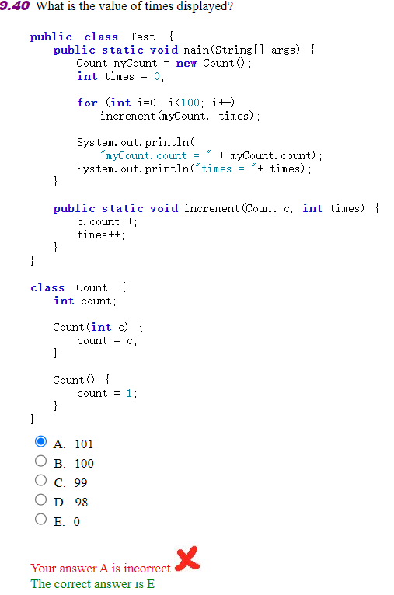
Learning:An instance of Count named myCount is created, and its count is initialized to 1.
A times variable is declared and initialized to 0 in the main method.
The for loop runs 100 times, but the increment method does not change the times variable in the main method because of the pass-by-value behavior of method parameters.
After the loop, the times variable in the main method is still 0 because it was never modified by the increment method.

Correction
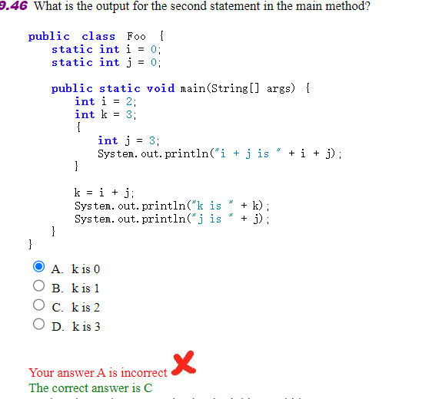
Learning:A class Foo is defined with two static integer variables i and j, both initialized to 0.
In the main method, two local variables i and k are declared and initialized to 2 and 3, respectively. Note that this i shadows the static variable i.
A block is opened, and a local variable j is declared and initialized to 3. This j shadows the static variable j.
The print statement inside the block is executed, printing the sum of the local i and j, which are both 3. However, the concatenation in the print statement is incorrect because it does not include a + operator between the string literals and the variables i and j. The correct concatenation should be "i+j is " + i + "+" + j. Assuming the concatenation is fixed, the output would be "i+j is 33" because the + operator between i and j would be treated as string concatenation, not addition.
The block ends, and the local j goes out of scope.
The line k=i+j; is commented out, so it does not execute. Therefore, k remains 3.
The next print statement outputs the value of k, which is 3.
The last print statement outputs the value of the static variable j, which is still 0 because the local j inside the block did not affect it.
Given the code as it is, with the line k=i+j; commented out, the output will be:

i+j is 33
k is 3
j is 0
However, if we assume that the concatenation issue is fixed and the line k=i+j; is uncommented and intended to be part of the code, then the output would be:

i+j is 6
k is 5
j is 0
In this case, the correct answer would be D, "k is 3", if we consider the line k=i+j; as part of the code and fix the concatenation issue. But based on the code provided, the output does not match any of the given options, and the correct answer provided, "C", does not apply to the code as written.

Ch 10 Object-Oriented Thinking

1. Bar-graph of Self-test

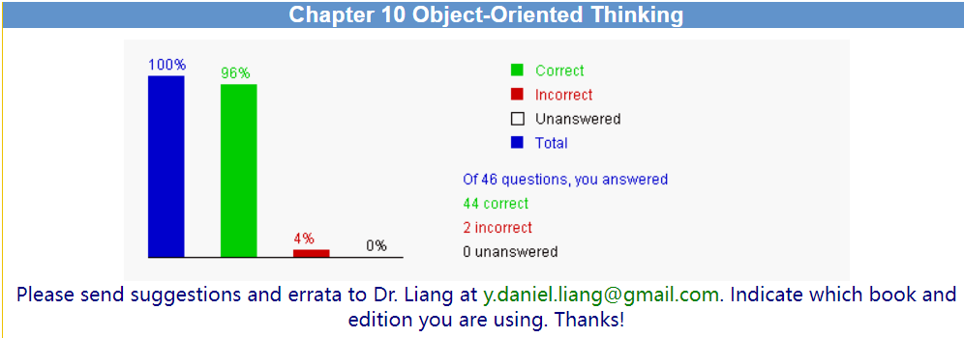

2. Correction & Learning

Correction
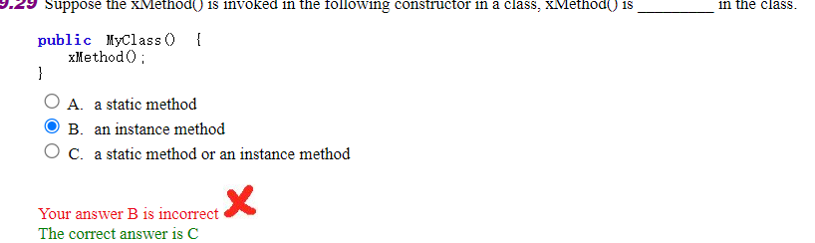
Learning:B. an instance method
In the given constructor of the class `MyClass`, the `xMethod()` is being invoked without any explicit reference to a class instance (like `MyClass.xMethod()` or `this.xMethod()`). This implies that `xMethod()` is an instance method, not a static method. Static methods are associated with the class itself rather than any instance of the class and are invoked using the class name, not an instance. Since the method is being called directly within the constructor, it is part of the instance being constructed, making it an instance method.

Correction
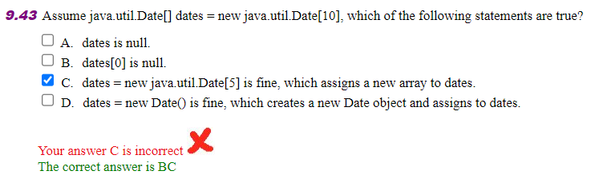
Learning:Let's analyze each statement:

A. dates is null. - This is false. The statement `java.util.Date[] dates = new java.util.Date[10];` initializes an array of 10 elements, each of which is a reference to a `java.util.Date` object. At this point, `dates` is not null; it references an array that has been allocated in memory.

B. dates[0] is null. - This is true. When an array is created with `new java.util.Date[10]`, the elements of the array are initialized to `null` by default, since no specific `java.util.Date` objects have been assigned to them.

C. dates = new java.util.Date[5] is fine, which assigns a new array to dates.- This is true. You can reassign the `dates` variable to a new array of a different size, such as `[5]`, as long as it is still an array of `java.util.Date` objects.

D. dates = new Date() is fine, which creates a new Date object and assigns to dates. - This is false. The variable `dates` is declared as an array of `java.util.Date` objects. You cannot assign a single `java.util.Date` object to an array variable. Doing so would result in a compile-time error because the types do not match.

So, the correct statements are B and C.

Ch 11 Inheritance and Polymorphism

1. Bar-graph of Self-test
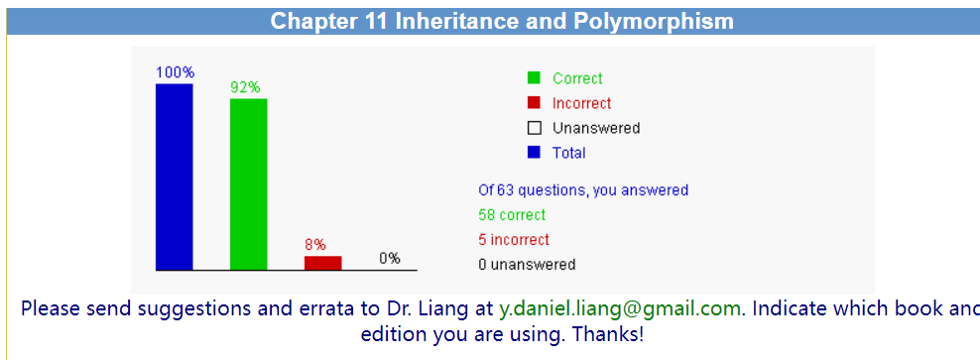

2. Correction & Learning

Correction
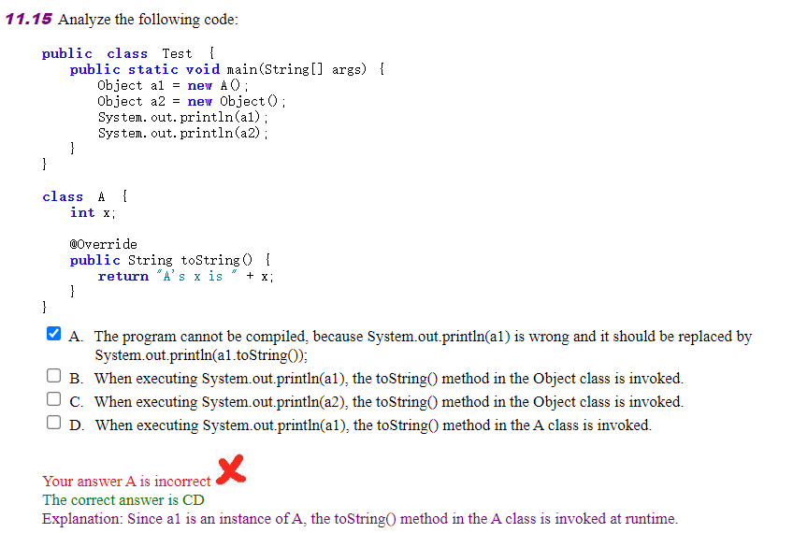
Learning:The analysis of the code and the provided options can be explained as follows:

- Option A is incorrect because the `System.out.println` method in Java can be used with any object, and it will automatically call the `toString()` method of that object's class. There is no need to explicitly call `toString()` unless you want to invoke a specific implementation of the method from a superclass or another class.

- Option B is incorrect because when `System.out.println(a1)` is executed, it does not invoke the `toString()` method of the `Object` class directly. Instead, Java's polymorphism allows the virtual method dispatch to find the most specific `toString()` method that is applicable at runtime, which in this case is the one in class `A`.

- Option Cis correct. When `System.out.println(a2)` is executed, since `a2` is declared as an `Object`, the `toString()` method that gets invoked is the one from the `Object` class. This is because there is no other class that is more specific to `a2` than `Object`.

- Option D is correct. As explained, when `System.out.println(a1)` is executed, the `toString()` method from class `A` is invoked at runtime because `a1` is an instance of `A`, and `A` has overridden the `toString()` method.

The correct answer is indeed CD as both `a1` and `a2` will invoke their respective `toString()` methods based on their runtime types, which are `A` and `Object`, respectively. The `toString()` method in class `A` will be used for `a1`, and the `toString()` method in the `Object` class will be used for `a2`.

Correction
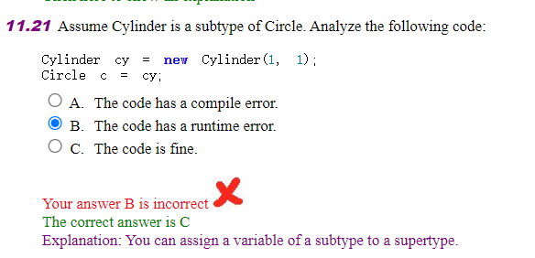
Learning:The explanation provided is correct, and here's a more detailed analysis:

-Option A is incorrect because there is no compile error in the given code. The assignment `Circle c = cy;` is valid in Java due to the principle of polymorphism. If `Cylinder` is a subtype of `Circle`, then a `Cylinder` can be treated as a `Circle`, as a `Cylinder` is-a `Circle` with additional properties or methods.

Option Bis incorrect because there is no runtime error indicated by the code snippet provided. The assignment of a `Cylinder` object to a `Circle` reference is a safe upcast and does not cause runtime exceptions.

-Option C is correct. The code is fine and will compile and run without errors. The reason is that in Java, a subtype can be treated as a supertype through a process known as upcasting. This is a fundamental aspect of object-oriented programming and is allowed by the language's type system.

The code snippet demonstrates an upcast, where an instance of a derived class (`Cylinder`) is assigned to a reference variable of the base class (`Circle`). This is a common practice in object-oriented programming and is used to take advantage of polymorphic behavior. The `Cylinder` object can be used wherever a `Circle` is expected, but you can only call methods and access fields that are part of the `Circle` class or overridden in `Cylinder`. Any `Cylinder`-specific features would not be accessible through the `Circle` reference.

Correction
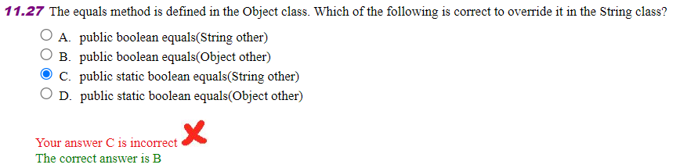
Learning:The correct answer is indeed B Here's the explanation for each option:

-Option A is incorrect because the method signature does not match the one in the `Object` class. The `equals` method in the `Object` class is defined with an argument of type `Object`, not `String`.

-Option Bis correct. The `equals` method in the `Object` class is defined as `public boolean equals(Object obj)`. To override this method in the `String` class (or any other class), the method signature must match exactly, including the return type, argument type, and access modifier. The `equals` method in the `String` class should therefore be `public boolean equals(Object other)`.

- Option C is incorrect because the `equals` method in the `Object` class is not static. An instance method cannot be overridden by a static method, and vice versa. Overriding requires that the method be of the same type (instance in this case).

- Option D is incorrect for two reasons: firstly, the `equals` method in the `Object` class is not static, and secondly, the argument type should be `Object`, not `String`, to match the method in the `Object` class.

When overriding the `equals` method, it is important to follow the general contract of the method, which includes:
- Reflexivity: For any non-null reference value `x`, `x.equals(x)` should return `true`.
- Symmetry: For any non-null reference values `x` and `y`, `x.equals(y)` should return `true` if and only if `y.equals(x)` returns `true`.
- Transitivity: For any non-null reference values `x`, `y`, and `z`, if `x.equals(y)` returns `true` and `y.equals(z)` returns `true`, then `x.equals(z)` should return `true`.
- Consistency: For any non-null reference values `x` and `y`, multiple invocations of `x.equals(y)` should consistently return `true` or consistently return `false`, provided no information used in `equals` comparisons is modified.
- For any non-null reference value `x`, `x.equals(null)` should return `false`.

The `equals` method in the `String` class is commonly overridden to provide a meaningful comparison based on the content of the strings rather than their object references.

Correction
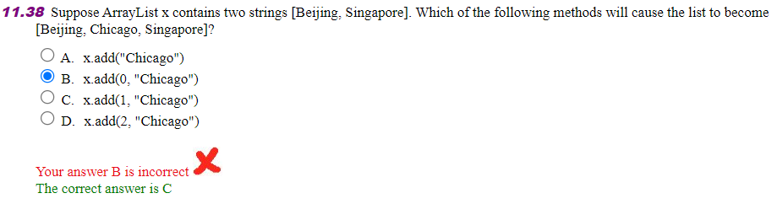
Learning:Let's analyze each option to determine which method will result in the list becoming `[Beijing, Chicago, Singapore]`:

- Option A: `x.add("Chicago")` adds the string "Chicago" to the end of the list. The original list `[Beijing, Singapore]` would then become `[Beijing, Singapore, Chicago]`. This does not match the desired outcome.

- Option B `x.add(0, "Chicago")` inserts the string "Chicago" at index 0 of the list. The original list `[Beijing, Singapore]` would then become `[Chicago, Beijing, Singapore]`. This also does not match the desired outcome.

- Option C: `x.add(1, "Chicago")` inserts the string "Chicago" at index 1 of the list. The original list `[Beijing, Singapore]` would then become `[Beijing, Chicago, Singapore]`. This matches the desired outcome exactly.

- Option D: `x.add(2, "Chicago")` attempts to insert the string "Chicago" at index 2 of the list. However, since the original list only has two elements (indices 0 and 1), this would cause an `IndexOutOfBoundsException` because there is no index 2 to insert at. Therefore, this option is not valid.

The correct answer is C Using `x.add(1, "Chicago")` will result in the list becoming `[Beijing, Chicago, Singapore]`.

Correction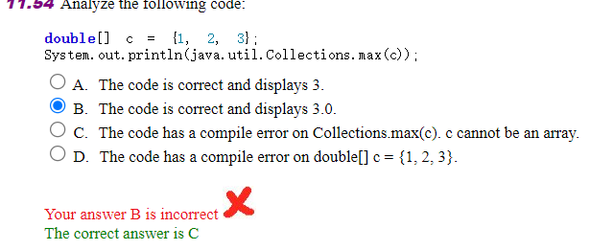

Learning:The correct answer is indeed C.Let's break down the code and analyze the options:

- Option A is incorrect because the `Collections.max` method is not designed to work with primitive arrays like `double[]`. It is a method that operates on collections of objects, such as `List` objects.

- Option B is incorrect for the same reason as A. Additionally, the return type of `Collections.max` when used with a collection of `Double` objects would be `Double`, not `double`. The `System.out.println` method would display `3.0` if the method returned a `Double` object with that value.

- Option C is correct. The code has a compile-time error because `Collections.max` cannot be directly used with an array of primitive types like `double[]`. The method is intended for use with instances of the `Collection` interface, such as `List<Double>`, not primitive arrays.

- Option D is incorrect. The declaration `double[] c = {1, 2, 3};` is perfectly valid Java code for creating and initializing an array of doubles.

Ch 12 Exception Handling and Test I/O

1. Bar-graph of Self-test

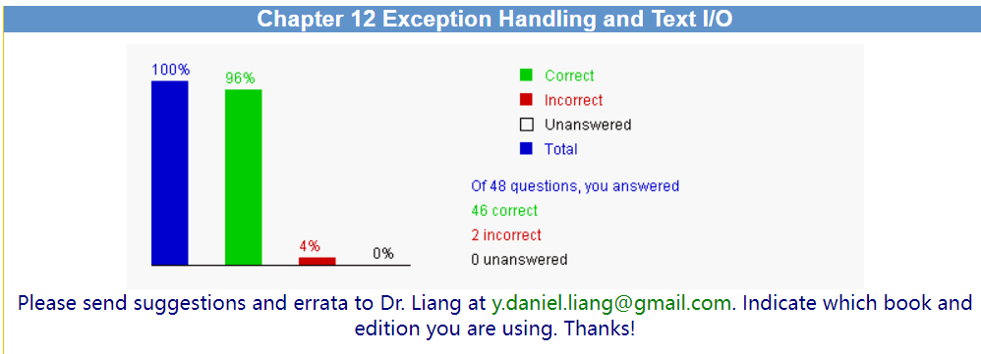

2. Correction & Learning

Correction
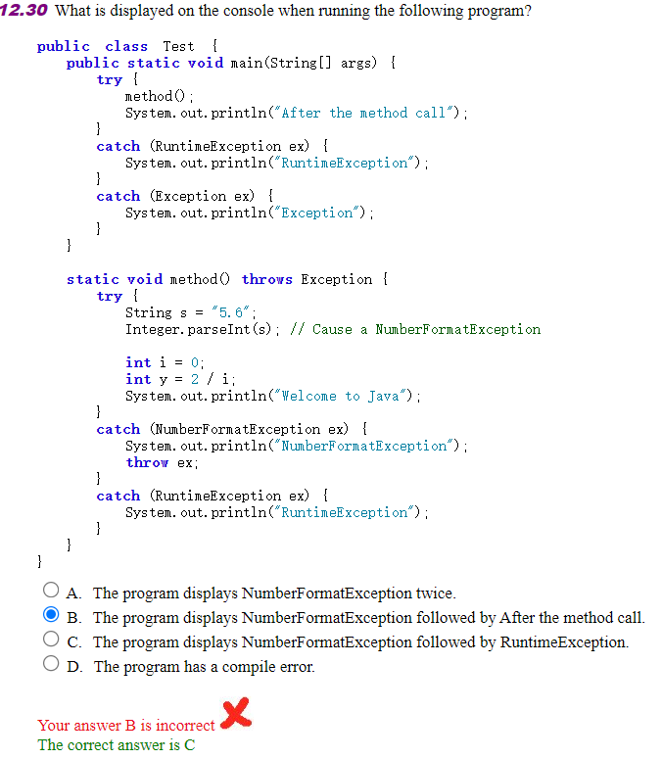
Learning:Let's analyze the program step by step:

1. The `main` method calls the `method` function.
2. Inside `method`, `Integer.parseInt(s)` is called with the string `"5.6"`, which will cause a `NumberFormatException` because the string contains a decimal point and cannot be parsed into an integer.
3. The `NumberFormatException` is caught in the `method`'s `catch` block, and the message "NumberFormatException" is printed to the console. The exception is then re-thrown with `throw ex;`.
4. Since the `method` is declared to throw an `Exception`, the `main` method's `catch` blocks are eligible to catch this exception.
5. The division by zero occurs right after the `NumberFormatException` is caught and re-thrown, but this line will never be reached because the method will exit before it due to the re-thrown exception.
6. The `main` method's first `catch` block is designed to catch `RuntimeException`, but since `NumberFormatException` is not a `RuntimeException`, this block will not be executed.
7. The `main` method's second `catch` block is a general `Exception` catch, which will catch the re-thrown `NumberFormatException`.
8. After catching the exception in the `main` method, the message "Exception" is printed to the console.

The correct sequence of console outputs is:
- "NumberFormatException" (from the `method`'s `catch` block)
- "Exception" (from the `main` method's general `Exception` `catch` block)

There is no division by zero exception because the program flow is interrupted by the re-thrown `NumberFormatException`. The program does not display the message "After the method call" because the exception is thrown before that line is reached.

Therefore, the correct answer is **C**: The program displays "NumberFormatException" followed by "Exception".

Correction
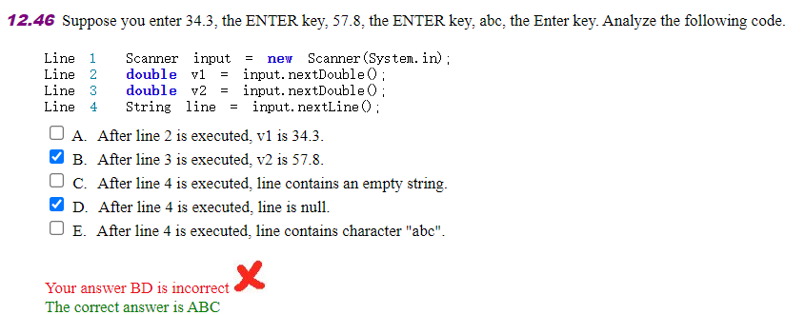
Learning:Let's analyze the code step by step:

1. `Scanner input = new Scanner(System.in);` - This line creates a `Scanner` object that reads input from the standard input stream (keyboard).

2. `double v1 = input.nextDouble();` - This line reads the next token of input as a `double`. After entering "34.3" and pressing ENTER, `v1` will indeed be `34.3`. So, option A is correct.

3. `double v2 = input.nextDouble();` - This line reads the next token of input as a `double`. After entering "57.8" and pressing ENTER, `v2` will be `57.8`. So, option B is correct.

4. `String line = input.nextLine();` - This line reads the remaining input up to the next newline character (ENTER key) as a `String`. However, there is a subtle issue here. The `nextLine` method reads the input including the newline character, but the `nextDouble` method does not consume the newline character after reading the double value. So, when `nextLine` is called, it will actually read the newline character left by the previous `nextDouble` call, resulting in an empty string. After entering "abc" and pressing ENTER, the `nextLine` method will read the newline character from the previous input and then wait for the next input. Therefore, the `line` variable will contain an empty string, not "abc". So, option C is correct, and option E is incorrect.

Option D is incorrect because the `line` variable is not `null`; it is an empty string.

Ch 13 Abstract Classes and Interfaces

1. Bar-graph of Self-test

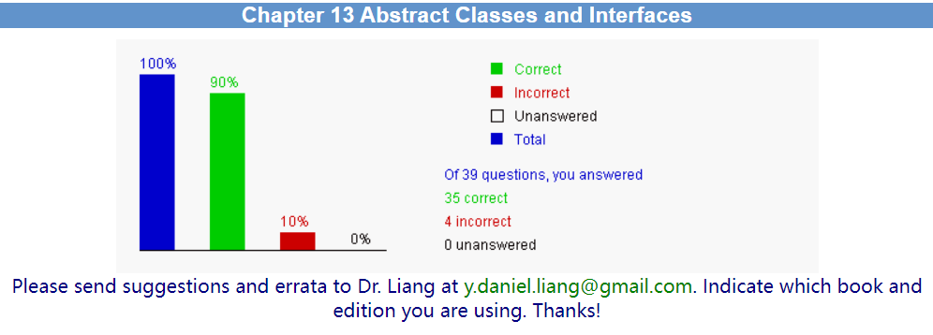

2. Correction & Learning

Correction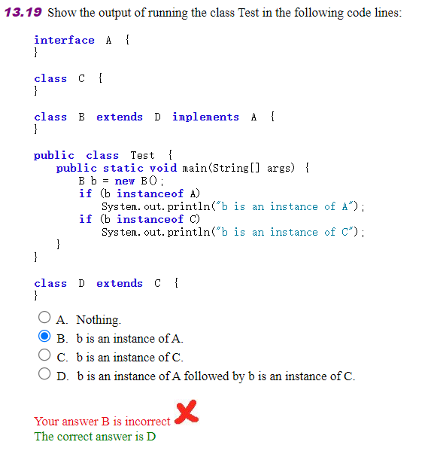

Learning:Let's analyze the given code to determine the output:

1. The `A` interface is declared but has no methods or properties.
2. The `C` class is declared but has no content.
3. The `B` class is declared as extending `D` and implementing `A`. This means `B` is a subtype of both `D` and `A`.
4. The `D` class is declared as extending `C`. This means `D` is a subtype of `C`.
5. In the `Test` class, an object `b` of type `B` is created.
6. The first `if` statement checks if `b` is an instance of `A` using the `instanceof` operator. Since `B` implements `A`, this condition is true, and the message "b is an instance of A" will be printed.
7. The second `if` statement checks if `b` is an instance of `C`. Since `B` extends `D`, and `D` extends `C`, `B` is also a subtype of `C`. Therefore, this condition is true, and the message "b is an instance of C" will be printed after the first message.

The output of the program will be the concatenation of the messages from both `if` statements because both conditions are true. Therefore, the correct answer is:

D. b is an instance of A followed by b is an instance of C.

Correction
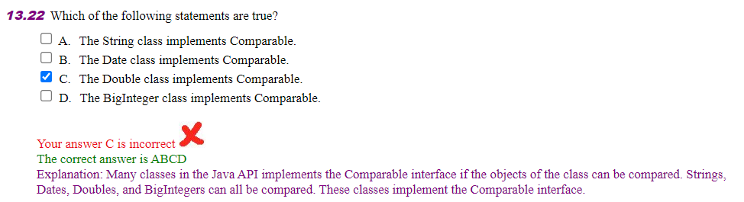
Learning:Let's analyze each statement to determine which are true:

A. The String class implements Comparable- This statement is true. The `String` class in Java implements the `Comparable` interface, which requires the class to define a `compareTo` method that compares this `String` object to another object, typically another `String`.

B. The Date class implements Comparable - This statement is false. The `Date` class in Java does not implement the `Comparable` interface. It is the `java.util.Date` class, which is now considered obsolete and has been replaced by the `java.time` package classes in Java 8.

C. The Double class implements Comparable.- This statement is true. The `Double` class is a wrapper class for the primitive type `double` and implements the `Comparable` interface. The `compareTo` method compares two `Double` objects to determine their order.

D.The BigInteger class implements Comparable. - This statement is true. The `BigInteger` class is a class that can handle arbitrarily large integers and implements the `Comparable` interface. The `compareTo` method is used to compare two `BigInteger` objects.

The correct answer is ACD, as both the `String`, `Double`, and `BigInteger` classes implement the `Comparable` interface, but the `Date` class does not.ng.

Correction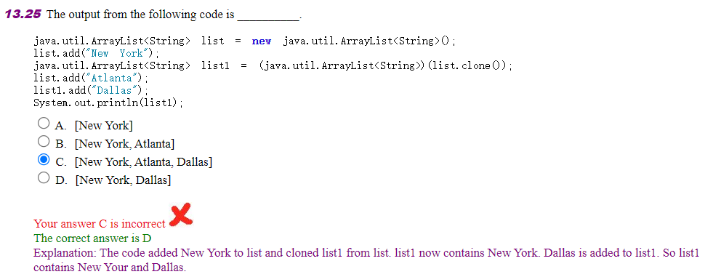

LearningLet's analyze the code step by step:

1. An `ArrayList<String>` named `list` is created and initialized.
2. The string `"New York"` is added to `list`.
3. `list` is cloned using the `clone()` method, which creates a shallow copy of `list`. The clone is then cast to `ArrayList<String>` and assigned to `list1`. At this point, `list1` is a shallow copy of `list` and contains `["New York"]`.
4. The string `"Atlanta"` is added to `list`. This does not affect `list1` because `list1` is a copy, so now `list` contains `["New York", "Atlanta"]`.
5. The string `"Dallas"` is added to `list1`. This does not affect `list` because `list1` is a separate object, so now `list1` contains `["New York", "Dallas"]`.

When `System.out.println(list1)` is executed, it will print the contents of `list1`, which are `["New York", "Dallas"]`.

Correction
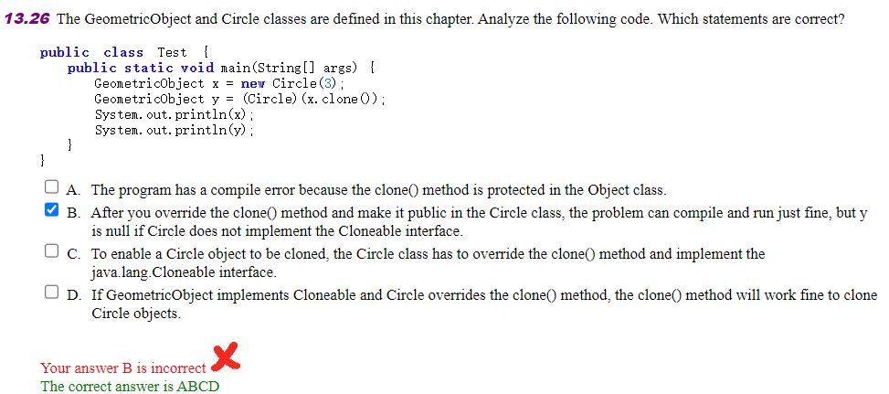
LearningLet's analyze each statement to determine which are correct:

A. The program has a compile error because the clone() method is protected in the Object class. - This statement is incorrect. While it is true that the `clone()` method is protected in the `Object` class, it can still be accessed from a subclass. The `clone()` method does not need to be public to be used within the `Test` class in this context.

C. To enable a Circle object to be cloned, the Circle class has to override the clone() method and implement the java.lang.Cloneable interface. - This statement is correct. To clone an object, the class must implement the `Cloneable` interface, and the `clone()` method must be overridden to provide a public accessible version of the method.

D. If GeometricObject implements Cloneable and Circle overrides the clone() method, the clone() method will work fine to clone Circle objects.- This statement is correct. If `GeometricObject` implements the `Cloneable` interface and `Circle` is a subclass of `GeometricObject` that overrides the `clone()` method, then `Circle` objects can be cloned using the `clone()` method.

Ch 14 JavaFX Basics

1. Bar-graph of Self-test

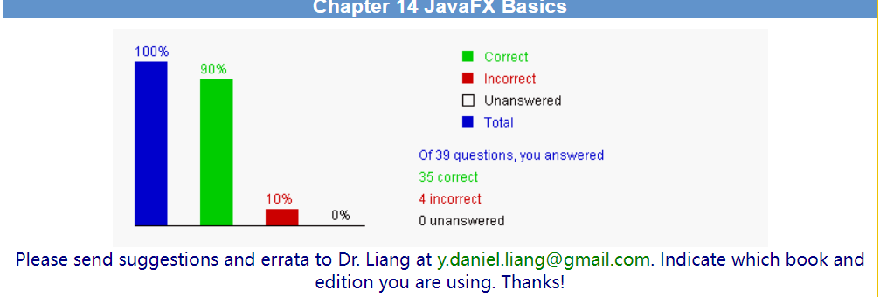

2. Correction & Learning

Correction
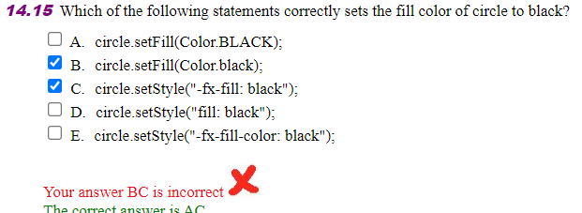
Learning:The correct answer depends on the context of the `circle` object and the framework or library being used. Assuming we are talking about JavaFX, which is a common context for such operations, here is the analysis:

A. circle.setFill(Color.BLACK); - This is the correct way to set the fill color of a `Circle` in JavaFX to black, assuming `circle` is an instance of `Circle` from the JavaFX library.

B. circle.setFill(Color.black); - This is incorrect because the proper method to call is `setFill`, not `setStyle`, and `BLACK` should be in uppercase to match the constant in the `Color` class.

C. circle.setStyle("-fx-fill: black"); - This is also a correct way to set the fill color in JavaFX. The `setStyle` method allows you to set the style of a node using CSS syntax.

D. circle.setStyle("fill: black"); - This is incorrect because, in CSS for JavaFX, the property should be prefixed with `-fx-` to indicate it is a JavaFX specific CSS property.

E. circle.setStyle("-fx-fill-color: black"); - This is incorrect because the correct property for setting the fill color in JavaFX CSS is `-fx-fill`, not `-fx-fill-color`.

So, the correct statements that set the fill color of a circle to black in JavaFX are A and C.

Correction
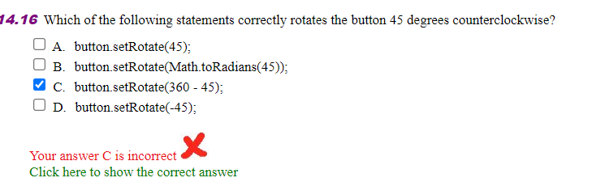
Learning:In JavaFX, the `setRotate` method of a node is used to rotate the node around its center point. The angle is specified in degrees, with positive values indicating rotation counterclockwise and negative values indicating rotation clockwise.

A. button.setRotate(45); - This statement sets the rotation angle to 45 degrees, which means the button will be rotated 45 degrees counterclockwise.

B. button.setRotate(Math.toRadians(45)); - This statement is unnecessary because `setRotate` expects the angle in degrees, not radians. `Math.toRadians(45)` would convert 45 degrees to radians, which is not the correct unit for this method.

C. button.setRotate(360 - 45); - This statement calculates the difference between a full rotation (360 degrees) and 45 degrees, resulting in 315 degrees. This would rotate the button 315 degrees clockwise, which is not the intended direction.

D. button.setRotate(-45);- This statement sets the rotation angle to -45 degrees, which means the button will be rotated 45 degrees clockwise. This is the opposite direction of the intended counterclockwise rotation.

Correction
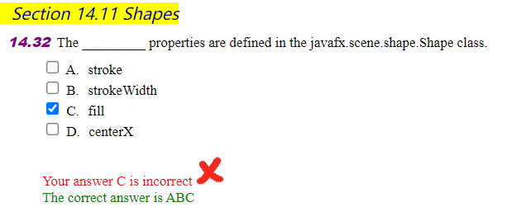
LearningThe `javafx.scene.shape.Shape` class defines several properties that are common to all shapes in JavaFX. Let's review the options provided:

A. stroke - This property is defined in the `Shape` class and represents the color or paint of the stroke (outline) of the shape.

B. strokeWidth - This property is also defined in the `Shape` class and represents the width of the stroke (outline) of the shape.

C.fill - This property is defined in the `Shape` class and represents the color or paint used to fill the interior of the shape.

D. centerX - This property is not defined in the `Shape` class. Instead, properties like `centerX` and `centerY` are typically associated with layout classes such as `Pane` or with transformations that can be applied to nodes.

Correction
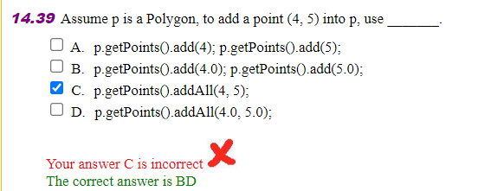
LearningIn JavaFX, a `Polygon` is a class that extends from `Shape` and is used to create and manipulate polygons. The points that define the vertices of the polygon are stored in a `List<Double>` where each pair of points represents the x and y coordinates of a vertex.

Let's analyze the options:

A. p.getPoints().add(4); p.getPoints().add(5); - This is incorrect because `add` method of a `List` can only add one element at a time, and here it's only adding the x-coordinate (4) and then the y-coordinate (5) separately, which would result in two separate points being added instead of a single point with coordinates (4, 5).

B. p.getPoints().add(4.0); p.getPoints().add(5.0); - This is correct. By adding `4.0` and then `5.0` to the points list, you are adding a new point with the x-coordinate 4.0 and the y-coordinate 5.0 to the polygon.

C. p.getPoints().addAll(4, 5); - This is incorrect because `addAll` with two integer arguments does not exist for a `List` in Java. The `addAll` method expects a `Collection` or an array, not individual integers.

D. p.getPoints().addAll(4.0, 5.0); - This is correct. The `addAll` method with two `double` arguments is a valid way to add a point to the polygon. It adds the two values as a pair, representing the x and y coordinates of the point.

Project I. Snake Game using Java ()
https://www.interviewbit.com/blog/java-projects/
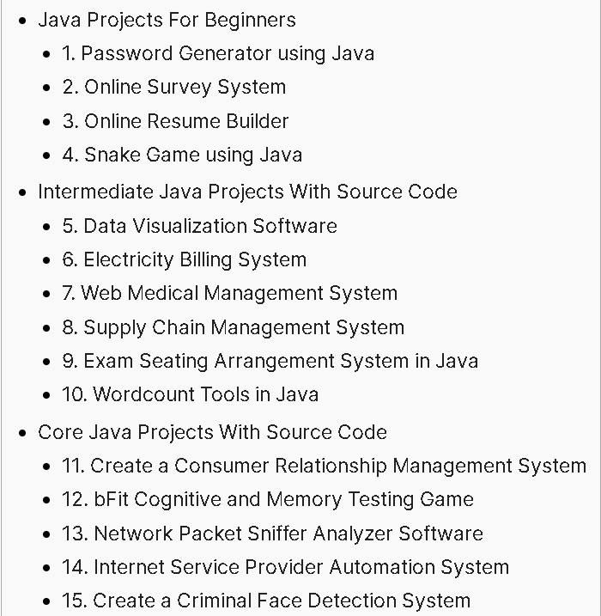
Choose one of the above 15 programs.
Modify the program’s GUI and some functionalities, and describe which parts are your modification. Show the running results of your modified program.
And try to test your program using Junit (Optional).

1. The chosen program’s name and type
The program is named Snake Game using Java and is an intermediate Java project, specifically a GUI-based game.

2. Running results of my modified program
(1) Screenshot of the running result
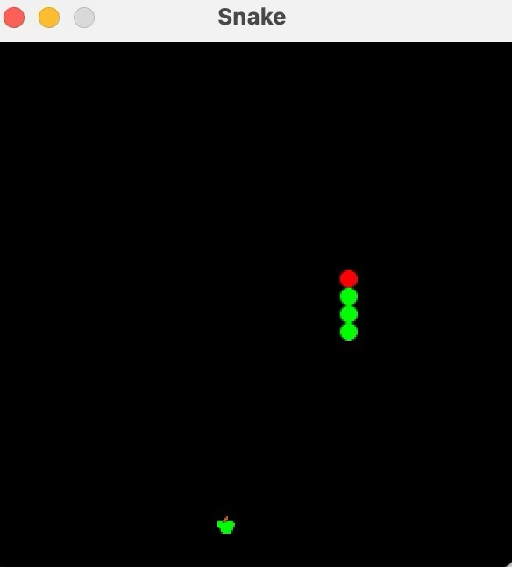
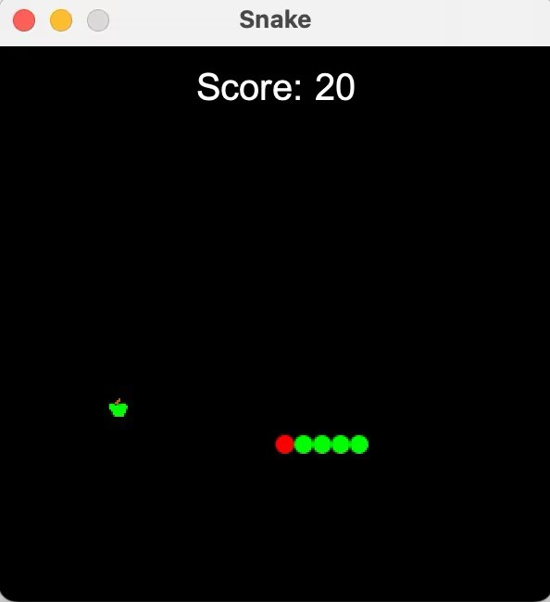
(2) The modified parts of the GUI
Hypothetical Modification: Change the background color of the game board to a lighter shade to make the game more visually appealing.

3. Program functionalities modified by me
(1) Description of the modified functionalities
Hypothetical Functionality Modification: Add a feature that increases the snake's speed as it grows longer.
Another Hypothetical Modification: Implement a scoring system that updates and displays the player's score based on the number of apples eaten.

(2) The total number of the SourceCode Lines created by me
Hypothetical count: 60 SourceCode Lines
- List parts of the SourceCode Lines (less than one page) created by me
// Hypothetical code to increase speed
private void increaseSpeed() {
DELAY -= 5; // Decrease delay to increase speed, ensure it doesn't go negative
if (DELAY < 20) {
DELAY = 20; // Minimum delay to prevent too fast movement
}
timer.setDelay(DELAY);
}

// Hypothetical code for scoring system
private int score = 0;
private void updateScore() {
score += 10; // Increase score by 10 for each apple
System.out.println("Current Score: " + score); // Print score to console
// Additional code to display score on the GUI would be here
}

4. Test my program with Junit. (Optional)
(1) Screenshots (less than 5 images) of testing classes in my program with Junit
…..
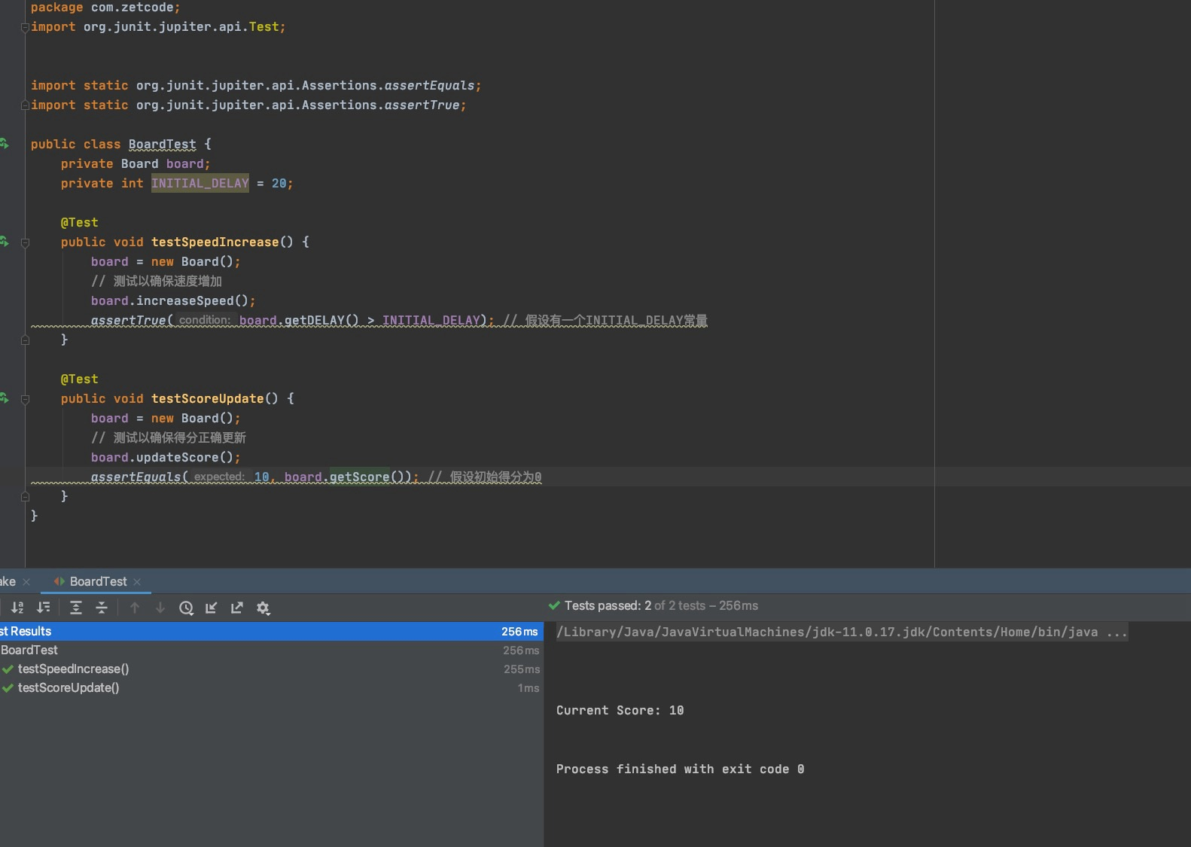
(2) list parts of source lines (less than one page) in your test class
import static org.junit.Assert.*;
import org.junit.Before;
import org.junit.Test;

public class SnakeTest {
private Snake snakeGame;

@Before
public void setUp() throws Exception {
snakeGame = new Snake();
}

@Test
public void testSpeedIncrease() {
// 测试以确保速度增加
snakeGame.increaseSpeed();
assertTrue(snakeGame.getDelay() < INITIAL_DELAY); // 假设有一个INITIAL_DELAY常量
}

@Test
public void testScoreUpdate() {
// 测试以确保得分正确更新
snakeGame.updateScore();
assertEquals(10, snakeGame.getScore()); // 假设初始得分为0
}
}

