**ERIC SHENG - SOFTWARE DEVELOPER**

Greater Seattle Area • 253-313-8263 • [eshengdev@gmail.com](mailto:eshengdev@gmail.com) • [linkedin.com/in/ericsheng21](https://www.linkedin.com/in/ericsheng21) • [github.com/EPS21](https://github.com/EPS21)

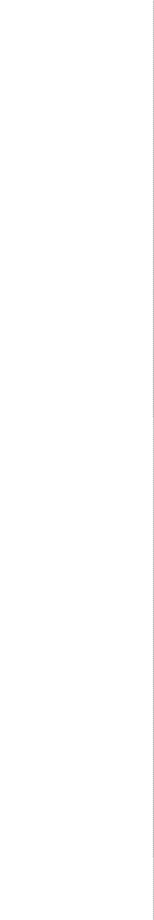

**SUMMARY OF SKILLS**

**EXPERIENCE**

**DECEMBER 2018 - PRESENT**

**OCTOBER 2018 - DECEMBER**

**2018**

**JUNE 2018**

**PROJECTS**

**PYTHON WITH AZURE**

**PYTHON/FLASK**

**ASP.NET MVC (C# AND RAZOR PAGES)**

**EDUCATION**

**JAN 2018 - JUNE 2018**

**GRADUATED JULY 2012**

**GRADUATED JUNE 2010**

Programming/Development: Python, C#, HTML5/CSS3/JavaScript, jQuery, Ajax, Java, SQL, T-SQL, Git/Github, Microsoft TFS

Frameworks: Flask, Anaconda, Pandas, .NET Framework, ASP.NET MVC, ASP.NET Core, Entity Framework 6.0 and Core, Microsoft Azure, AWS, React, Telerik Kendo UI Methodologies: Full-Stack Web Development, Excel Spreadsheet Automation, Front-End UI/UX, Back-End, Scrum, Agile, Continuous Integration

# Software Development Engineer

**People Tech Group**

**1+ years experience in Python, C#, JavaScript Full-Stack Development**

**Quickly picked up new technologies, as well as extrapolating requirements** from client and product owner needs

# UI Developer Intern

**People Tech Group**

## Developing as part of a small UI team under guidance, making company webpages and creating webapps with best practices

**Python, Flask**, React, JavaScript, jQuery

# Software Developer Intern

**Prosper IT Consulting**

## Capstone Tech Academy project that went on to be deployed as production enterprise software, working as part of a small Scrum team working on various tickets

**People Tech Applicant Tracking System**

**Using Python, NLP Textract, and Azure Storage libraries** to extract fields such as phone number and skills from resume

Full-Stack web application running on XAMPP stack creating/rewriting PHP modules and writing custom SQL queries in MySQL Database

# Elliptica Website and Demo Products

**Liberty Chatbot**: An informational chatbot for HR needs, implemented UI and behaviors from scratch to appear as a live instant messenger

**Briefer**: A text summarizer web app with additional features, bringing summarized and entity data from documents into a presentable tables and forms of information. Demo can upload from multiple file formats or user inputted text

[**Monster Database Importer**](https://github.com/EPS21/Tech-Academy-Projects/tree/master/ASP.NET%20C%23%20and%20MVC/MonsterDB)

Website application with the ability to **import data from Excel spreadsheets, automating mass excel manual work**

**Microsoft Azure** deployed, **CRUD** operations, **Sorting**, and written with **Entity Framework Code First methodology** to update future models easily

**Exception handling** is used to watch out for **edge cases and incorrect file types** to securely upload data to the database without storing potentially malicious files

# Full-Stack Web Development (20-Week Program)

The Tech Academy, Seattle

# Bachelor of Arts in International Studies (Asian Studies Minor)

University of Washington, Tacoma

# Associate of Sciences in Computer Engineering

Tacoma Community College, Tacoma

Courses included **Java Programming I, II and III, Electrical Circuits,** Calculus, Linear Algebra, Differential Equations