Short title: Can nodule branching traits tell anything new about the legume-rhizobia symbiosis?

Running Title:
`WHERE to submit: ?

Authors: Elizabeth L. Paillan¹, Alejandra Gil-Polo¹, Sohini Guha¹, Andy Swartley¹, and Liana T. Burghardt¹
¹The Pennsylvania State University, Department of Plant Science University Park, Pennsylvania
ORCID
E. Paillan 0000-0001-7159-4721
Alejandra Gil-Polo 0000-0001-8715-5176
S. Guha
A. Swartly
L. Burghardt 0000-0002-0239-1071

Keywords: Medicago, Rhizobia,

Article type: Short Piece???

Author for correspondence: Name, University Affiliation, email, number

Authorship Credits:

Data Accessibility:

Acknowledgments:

Abstract:
Introduction:
Soil microbes face various selective pressures ranging from other microbes in the environment and resource competition to the target host itself. They can participate in symbiotic relationships face additional pressures applied by the host plant (). The symbiotic relationship between legumes and nitrogen-fixating bacteria, Rhizobia, has been a target of interest as an alternative to commercial nitrogen fertilizers. Efforts to improve the performance of this symbiotic relationship are focused on the microbial side in terms of understanding competitive edge and survivability; there’s a gap in understanding both the host and microbial aspects and the emergence of compatibility and performance between the two (). Looking at the legume-rhizobia symbiosis, we sought to answer whether the host applies selective pressure to rhizobia by allowing high performers to inhabit, produce, or dominate more nodules and whether this pressure is specific to host variety.

NEW OUTLINE in DRAFT_OUTLINE
Legume-rhizobia symbiosis results in producing root nodules that are shown to have an ecological niche for rhizobial bacteria and non-rhizobial endophytes. INSERT INFORMATION: numbers and description of where the rhizobia lives in a nodule infection thread vs bacteroid, difference between differentiated and non differentiated rhizobia, undifferentiated rhizobia are realsed into the soil
Root nodules are capable of being used as a place of selection for endophytes in their microbial community, and the host plant’s developmental stage is a key factor in microbiome shifts. *Keep, delete, move to discussion?? Nodule architecture
    - Determinant vs indeterminant
      - ‘Indeterminant nodules are of graded age with younger cells near the meristem.’
      - Indeterminate nodule cell division occurs in the inner cortex/pericycle.
      - Determinate nodule cell division is restricted to the middle or outer cortex.
      - “Then transition to the next section on what we know about nodule morphology (shape and size). In Determinate nodules X and Y, HOWEVER legumes with Indeterminate nodules, meristematic cells keep dividing, allowing for nodules to increase in size by increasing in length and by branching to create multiple lobes. “

Here, we used a collection of 117 Sinorhizobium strains isolated from a single alfalfa variety trial to perform a single-isolate inoculation experiment on three Medicago sativa varieties in the greenhouse. We asked: 1) Is there evidence that the host plant adjusts resource allocation to their symbiotic partners in nodules based on the total amount of nodules produced, 2) Does the total area of the nodule correlate with the amount of rhizobia inhabiting the inside of the nodule, and 3) How does the occurrence of nodule traits affect host benefit phenotypes like aboveground biomass/total biomass?
Liana’s musings on introduction structure [avoid mucoidy and local adaptation]

Materials and methods:
Site of Rhizobial Isolates
We developed a collection of 117 Sinorhizobium meliloti strains sources from Alfalfa, Medicago sativa, varieties Oneida, Vernal, and SW402 planted in 2016 in a varietal trial block design growing within 5 meters of each other at the Pennsylvania State University, Russel E Larson Agricultural Station in Rocksprings, PA.
Experimental Design & Plant Preparation
Four replicates of 480 plants of the same Alfalfa varieties, Oneida, Vernal, and SW0402, were arranged in a randomized block design and grown at greenhouse conditions of 18 °C to 23 °C during the daytime and a minimum temperature of 12°C. 1,200 M. sativa seeds of each variety were sterilized in 10% commercial bleach for 90 seconds and washed five times with de-ionized (DI) water before germinating in glass Petri dishes on top of filter paper soaked in DI water. The petri dishes were wrapped in aluminum foil and held at 4 °C for three days. Each pot was washed and bleached before being filled with 50:50 sand calcined clay, sown with two seeds of the same variety, and covered with ½ to ¼ inch of sterile vermiculite. All pots were kept moist and covered with a clear plastic tarp to promote humidity before being randomized.
Preparation of Sinorhizobium Inoculation
Rhizobial isolates were streaked in plates with Yeast Mannitol agar from glycerol stocks stored at –80 °C, and placed on an incubator and grown for four days at 28 °C. Then, the bacteria were transferred to Tryptone Mannitol (TY) media and grown overnight. The optical density (OD) 600 of the culture was adjusted to 0.1 OD600. The inoculum was prepared by diluting 4mL of OD600 0.1 with DI water in a 1:25 ratio. A total of (xx Patrick should have this number) was applied to each pot eight days after sowing started seeds.

Plant Care
We fertilized our alfalfa with 2x Fahräeus medium from the 2019 Medicago truncatula handbook Appendix 2 three weeks post-inoculation and then doubled the amount of fertilizer every following week. Four weeks post-inoculation, we thinned all our pots to one plant per pot using sterile scissors and tweezers to remove the excess plant, re-sterilizing after each pot. Each pot was watered moderately as needed to prevent cross-contamination of inoculated isolates.

Measurement of Host and Nodule Traits
Eight weeks post-inoculation, we collected the aboveground biomass, stored it in orange envelopes, and dried it in a drying oven at X °C for a minimum of X days. We gently removed the roots from the growing media and briefly suspended them in water to remove any residue from sand and calcified clay. They were temporarily covered in a wet paper towel and sealed in a Ziplock bag at X °C as we manually counted the number of branched and unbranched nodules using a clicker. After recording the nodule information, we stored the roots in orange envelopes for drying in a drying oven for a minimum of X days at X °C. Both the aboveground and belowground biomass were measured on a VWR® P2 balance (VWR-203P2/C).

Measurement of nodule branching and size, and number of rhizobia released for a subset of host x strain combinations
We selected eight isolates based on their colony morphology on agar plates; six isolates produced mucoid colonies, and two demonstrated dry morphology, after XX weeks post-inoculation. We collected six nodules from each of the selected isolate-plant combinations varying in size from small to large and photographed them. We then sterilized individual nodules with a solution comprised of 20% commercial bleach, sterile water, and 5% Polysorbate 20 for two to four minutes inside of 1.7 mL Eppendorf tubes, lightly tapping the tube to ensure contact with all of the nodule surface area, adjusting bleach concentration based on nodule size. Each individual nodule was rinsed three times with sterile water and stored in 0.85% NaCl at 4°C.
Using a sterile pestle, we crushed the sterile nodules in 0.85% NaCl and diluted the solution with more sterile 0.85% NaCl to 1 mL before diluting more based on nodule size for colony counting. Small to medium nodules were diluted to 10³ and 10^{4,} while larger nodules were diluted to 10⁵ and 10⁶ before being spot-plated through five spots. We averaged the amount of colonies formed on each spot and used this formula to calculate the amount of rhizobia released:
(Spot colony number average divided by 2) *10^(Plated dilution+1)
From our photographs of the nodules, we recorded the number of nodule branches on each nodule and used ImageJ to measure the average nodule area by isolating the nodules from the background via a red color threshold and manual cleanup and using the “analyze particle” tool.

Statistical Analyses
Statistical analyses of this data were performed using R environment (R Core Team, 2016) to test for correlations between measured phenotypic traits. Linear models were used and tested for significance (ANOVA) on the average values for nodule number and proportion of branched nodules to assess the relationship between total nodule number and proportion of branched nodules: lm(mean nodule number ~ mean proportion of branched nodules * host variety), the average number of Sinorhizobium colonies formed and nodule surface area to evaluate the amount of Sinrhizobium inhabiting nodules of varied sizes: lm(Rhizobia Released ~ number of nodule branches * nodule area* host plant variety + replicate), and the average values of host biomass and proportion of branched nodules to assess the relationship between response to the occurrence of branched nodules: lm(average host biomass ~ average proportion of branched nodules * host variety + isolate identity).

Results
The sinorhizobium isolates we sourced from field Alfalfa varietal trials that have undergone five years of selection within three meters of each other are not filtered to high performers of that variety within those parameters. However, certain isolates contributed to higher biomass, nodule counts, or proportion of branched nodules on multiple alfalfa varieties.
Occurrence of Branched Nodules
A linear model was used on the mean of four replicates of each host variety-isolate combination to examine the relationship between the total number of nodules and the proportion of branched nodules. Mean Nodule Number ~ Mean proportion of branch nodules (p < 0.0001) * Host Variety (p <0 .0001)+ Isolate Identity (p = 0.00015). An ANOVA was used to examine the fitness of the model (R2=0.617), indicating that 61.7% of the variability in the total nodules found on the host is accounted for in this model.
The commercially improved variety (SW402) produced more nodules and branched nodules in general in comparison to the ancestral varieties (Oneida, Vernal) but still exhibited a negative correlation between total nodule count and the proportion of branched nodules (fig. #). The pattern of producing more branched nodules instead of more nodules, in general, is consistent across all host genotypes; demonstrating a trade-off between the proportion of branched nodules and the total number of nodules a host has.
Rhizobia Released by Area
Perhaps unsurprisingly, we found that nodule branching and nodule size were strongly correlated/associated (p=) with each other… suggesting that forming branching potentially increases the nodule area that rhizobia could inhabit. Thus Were curious if nodules that are bigger nodules or more branched tend to support larger population of rhizobia. We found that regardless of host identity bigger nodules (p_{df=X}= XXXX) and more branched nodules (p_{df=X}= XXXX) released far more rhizobia (See Table SX for model results) suggesting that rhizobia that inhabit branched nodules receive more fitness benefit. Take together…

Looking into the relationship between the nodule surface area and the amount of rhizobia released, a linear model was employed on a dataset of six nodules of varied sizes from a subset isolate and host combination. Rhizobia Release ~ Number of Nodule Branched (p < 0.0001) * Nodule area (p = 0.582) * Host plant (p = 0.449) * Isolate identity (p = 0.029) + Replicate. An ANOVA was used to examine the model's fitness (R2=0.546), indicating that 54.6% of the variability in the amount of rhizobia released from individual nodules is accounted for in this model.
Across alfalfa host varieties, Oneida, SW402, and Vernal, the rhizobia released from nodules of varying sizes increases logarithmically as the surface area of nodules increases, implying an optimum capacity of active bacteroids in the nitrogen fixation zone (fig. #). Larger and more branched nodules tended to release more rhizobia regardless of host variety or isolate identity.
Host Benefits from Branched Nodules
To understand what the presence and occurrence of branched nodules attribute to host benefit signs, this relationship was examined with a liner model applied to the mean dried host biomass and the mean proportion of branched nodules of each host-isolate combination across four replicates. Mean Host Biomass (g) ~ mean proportion of branched nodules (p < 0.0001) * host variety (p < 0.0001) + isolate identity (p < 0.0001). An ANOVA was used to examine the model’s fitness (R2=0.675), indicating 67.5% of the variability in the resulting host biomass eight weeks post-inoculation.
Isolates that contribute to a higher proportion of branched nodules provide greater benefit to their host. Compared to other traits we accounted for, the proportion of branched nodules was a stronger predictor of plant benefits of an isolate than a nodule number.

Discussion
In agricultural fields, legumes encounter diverse soil microbial communities and enforce selection through different host niches like root nodules. Microbial access and enrichment in those nodules are assumed to be a mix of factors between the plant host, associated microbe, and environment. Here, we present an analysis of root nodule number and branching traits and their relation to host benefit traits in a single-isolate experiment to get a glimpse into the potential impact nodule shape and size have on symbiosis benefits strain at a host-to-single isolate level in a controlled nitrogen-limited environment.
Our results reveal that rhizobia benefit traits like nodule occurrence/number and proportion of branched nodules are negatively correlated to each other, revealing that they are not interchangeable proxies. Leaving room for the proportion of branch nodules to be a separate proxy of symbiotic benefit. A larger nodule area that can be caused by branching is positively associated with increased rhizobia inhabiting the nodule. This solidifies the idea that a larger root nodule has more occupants within it, but there is a suggestion that there could be a nodule carrying capacity/optimum nodule size as the number of rhizobia released does not boundlessly increase with the amount of space and instead levels off (fig #). The proportion of branched nodules does affect host benefit traits, like host biomass, in contributing more resources.
However, it is worth looking at what contributes to the number of nodules produced, the proportion of them that are branched, and the roles the host plant and the isolate play. There could be net benefits or losses that influence the hosts’ resource allocations between starting newer nodules versus directing them to already established active nodules. While we did examine a subset of isolates and host combinations for the amount of rhizobia released, we did not examine how it ties directly to host traits like biomass or chlorophyll content; it does provide some support into the possible host rationale for investing resources into larger nodules.
From examining the performance of isolates sourced from the field at a host to a single isolate level, familiar rhizobial benefit traits like nodule number can be used along with newer benefit traits like the proportion of branched nodules can differ based on unknown factors. We approached examining branched nodules as a newer trait with an ecological perspective, resulting in solidifying that the host plant resources allocated to nodules can change based on the amount of branched nodules present; nodules house more rhizobia the larger area/more branched they are; the prevalence of branched nodules contributes to greater host biomass via fixed nitrogen being used in key plant compounds like chlorophyll. It is possible to expand our understanding of the significance of branched nodules versus an unbranched nodule from different backgrounds, like a microbial or plant nutrition perspective.

Figures
Figure 1:
Figure 2:
A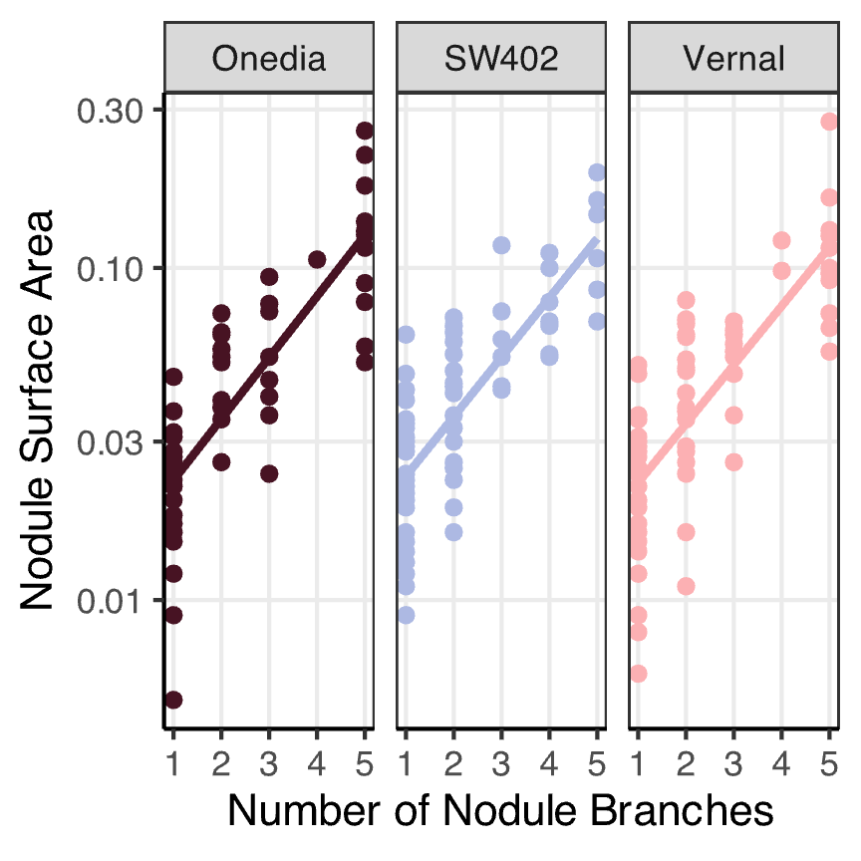 B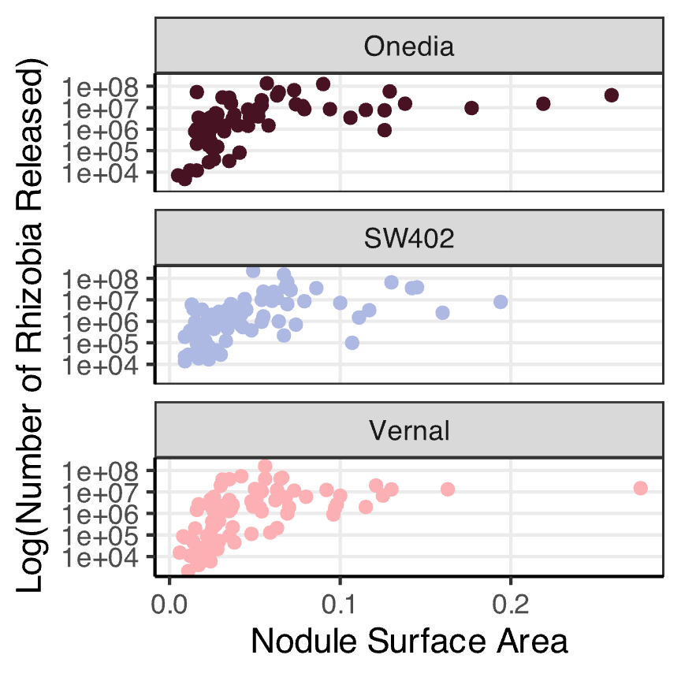
C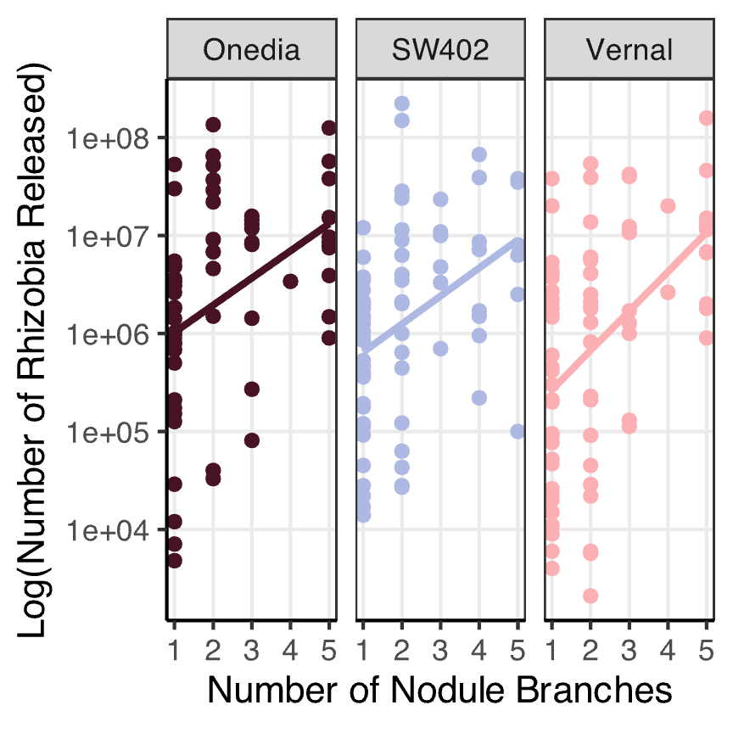
Summary figure:
 | Trait | Branched Nodules | Unbranched nodules
HOST Benefit | Plant Biomass | ^ | ∨
 | Nodule Count | ∨ | ^
RHIZOBIAL Benefit | Nodule Area | ^ | ∨
 | Rhizobia Released | ^ | ∨

Figure 3:
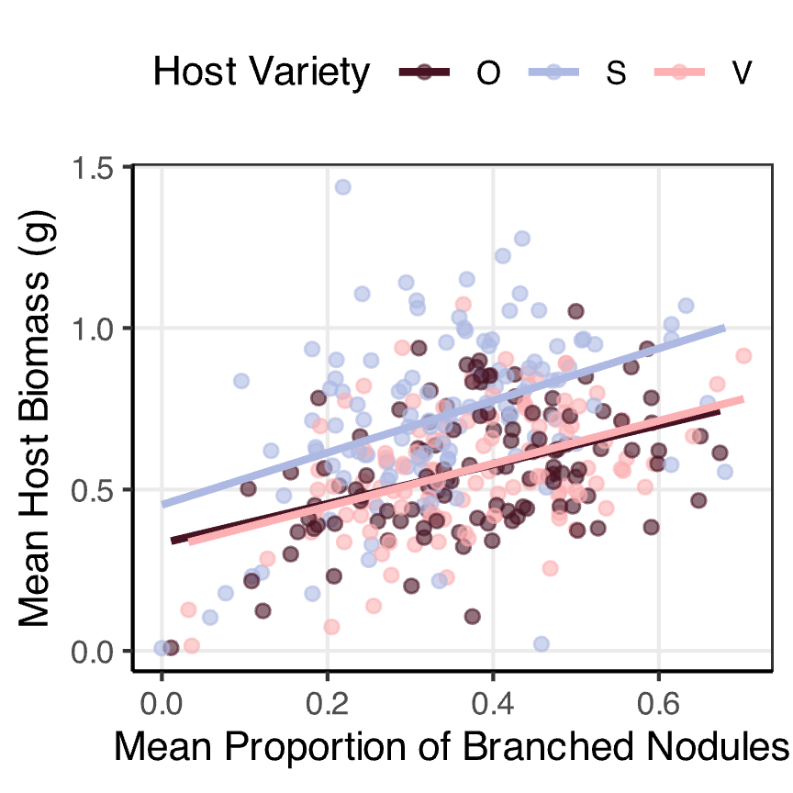
A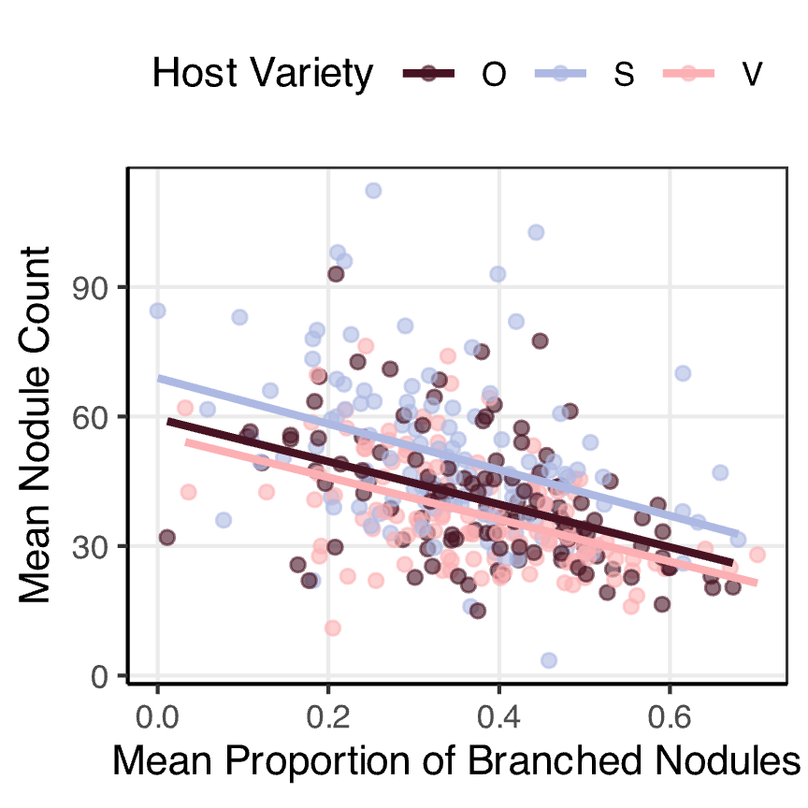 B
Tables?
Model Results?

Supplemental Figure:
FigureX???:
A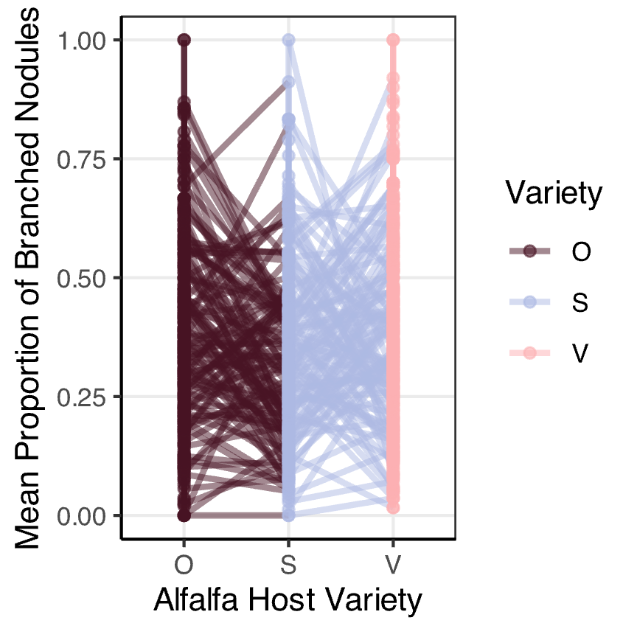 B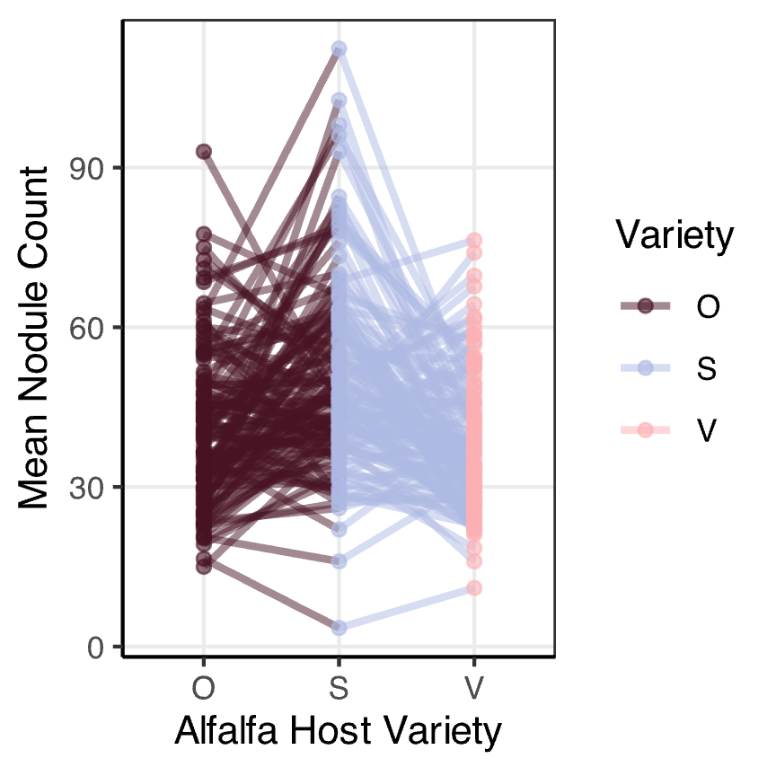

Data Availability
References

