## **HUMAN FOLLOWING ROBOT**

## A course project report submitted in partial fulfillment of the requirement of

**SMART SYSTEM DESIGN**

by

PAVAN KUMAR (2203A51631)

M.BHAVEETHA (2203A51644)

V.SRESHTHA (2203A51655)

MD.AZHAD AHMED (2205A11003)

Under the guidance of

**Mr. Y. SRIKANTH,**

Asst. Prof., Department of ECE

**Mr. P.RAMACHANDAR RAO,**

Asst. Prof., Department of ECE



**ABSTRACT**

Humanoid robotics is an emerging research field that has received significant attention during the past years and will continue to play an important role in robotics research and many applications of the 21st century and beyond. In this rapid moving world, there is a need of robot such a **“A Human Following Robot”** that can interact and co-exist with them. Because of its human following capability, these robots can work as assistants for humans in various situations and it can also acquire or monitor certain information associated with the human subject. In this paper we present a prototype that uses Arduino Uno along with basic sensors such as **ultrasonic** and **IR sensor**. All the processing is carried out by the microprocessor while the control of the motors is carried out by the controller. This robot can further be modified by using many technologies such as Bluetooth, PixyCamera etc.

**CONTENTS**

***ABSTRACT ii***

**Chapter No. Title Page No.**

**1. INTRODUCTION**

1.1 About the project 04

1.2 Objectives 04

**2. Project description**

2.1 Block diagram of project 05

2.2 Description of block diagram 05

2.3 Hardware description 06

2.3.1 Arduino Uno 06

2.3.2 DC sensor 06

2.3.3 Motor Sheild 06

2.3.4 Ultrasonic sensor 06

2.3.5 IR sensor 06

2.4 Software description 07

**3. PROJECT IMPLEMENTATION**

3.1 Working 08

3.2 Results 08

3.3 Advantages 09

3.4 Disadvantages 09

**4. CONCLUSION**

4.1 Conclusion 09

4.2 Future scope 10

**5 BIBLIOGRAPHY** 10

**6 APPENDIX**  11

**CHAPTER 1**

1. **INTRODUCTION**
   1. **About the project**

Robotic technology has increased appreciably in past couple of years. Such innovations were only a dream for some people a couple of years back. But in this rapid moving world, now there is a need of robot such as “A Human Following Robot” that can interact and co-exist with them. The development of robot technology had increased significantly due to industrial, medical and military applications. In various fields with harsh environment such as underground mining, war-zones, medical, construction, space exploration etc. the work done by one is extremely dangerous. Life of individuals assisting are also put at risks. Tasks performed by humans have its own limitations in many ways. In order to perceive beyond the human limitation in vision, speed, consistency, flexibility, quality e.tc we should make use of robots. A key requirement for these robots is the ability to detect humans and to interact with the min non-technical way. The main objective of this dissertation is to make a robot that can help humans with various tasks.. In this paper, we present a prototype of a human following robot that uses Arduino Uno and different sensors for detection and following an object.

**1.2 Objectives**

The Robot must follow the following objectives: •

* The robot must be capable of accurately follow a person. •
* It should be capable of taking various degrees of turns. •
* The robot must be insensitive to environmental factors such as noise. •
* The robot must be capable to avoid collision.

**CHAPTER 2**

1. **Project description**
   1. **Block diagram of project**

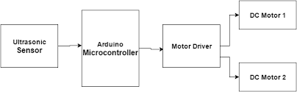

Fig.2.1(BLOCK DIAGRAM)

* 1. **Description of block diagram**

When you come near to the robot starts to follow you. there are 4 wheels in the robot. and 4 motors attached to the chassis. now there are three sensors on the robot one is an [ultrasonic sensor](https://techatronic.com/what-is-ultrasonic-sensor-ultrasonic-sensor-working-hc-sr-04/) and two [IR sensor](https://techatronic.com/what-is-an-ir-sensor/) which arranges like two sensors left and right to the ultrasonic sensor. and when you put your hand near to the ultrasonic sensor the robot will start forward. If you turn your hand to the left side the ****Arduino robot**** moves on the left side, and if you put your hand in the right the robot will move in the right direction. so, how the whole system works we will talk about this. when you put your hand in from of the ultrasonic sensor then the sensor detects you and sends this information to the Arduino. there is some distance prefix in the Arduino so if your hand is away from the sensor it will not read that. and if your hand is near to the sensor it will read it. Now Arduino knows that there is something in front of the sensor and [Arduino send](https://techatronic.com/what-is-arduino-brief-description/) some instruction to the motor driver and motor driver trigger the motors. and the Arduino robot starts to move forward we need to run all motor forward. Now, what about the sensors. [Ir sensor works](https://techatronic.com/what-is-an-ir-sensor/) on infrared light which can also detect the object near to it. so there is two IR sensor one is at the left side of ultrasonic sensor and other is at the right side of the ultrasonic sensor. when anything comes near to the left sensor Arduino got the information that there is something is near to the left sensors and according to the code, the robot will turn to the left. and the same process for the right sensor. so this is how the ****human following robot**** works.

* 1. **Hardware description**

**2.3.1 ArduinoUno :**

It is the brain of our project. It can give all the command to their sub ordinate components which should by operated by the human behavior. And it also give feedback to the other components and human. So that it can be the used as a medium of communication between human and robots & vice versa. It has specification of 8 bit CPU, 16 MHZ clock speed, 2 KB SRAM 32 KB flash Memory, 1 KB EEPROM.

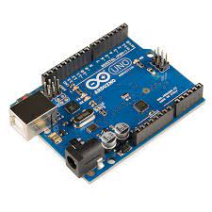

FIG 2.3.1(ARDUINOUNO)

**2.3.2 DC Motors:**

DC Motor is a device that converts any form of energy into mechanical energy or imparts motion. In constructing a robot, motor usually plays an important role by giving movement to the robot. Here 4 DC motor are used to drive the robot.

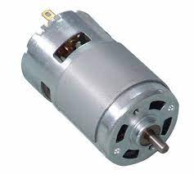

FIG 2.3.2(DC MOTORS)

**2.3.3 Motor Shield:**

The Motor Shield is a driver module for motors that allows you to use Arduino to control the working speed and direction of the motor.The Motor Shield can either be powered by Arduino directly or by an external 6V~15V power supply via the terminal input. Here Motor Driver Board is designed to Work with L293D IC.

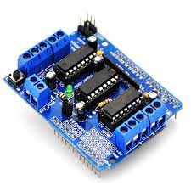

FIG 2.3.3(MOTOR SHIELD)

**2.3.4 Ultrasonic sensor:**

An ultrasonic sensor is an instrument that measures the distance to an object using ultrasonic sound waves.The working principle of this module is simple, it sends an ultrasonic pulse out at 40kHz which travels through the air and if there is an obstacle or object, it will bounce back to the sensor. By calculating the travel time and the speed of sound, the distance can be calculated.

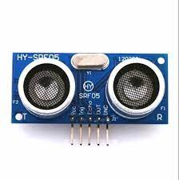

FIG 2.3.4(ULTRASONIC SENSOR)

**2.3.5 IR Sensor:**

IR sensor is an electronic device, that emits the light in order to sense some object of the surroundings. An IR sensor can measure the heat of an object as well as detects the motion.Usually, in the infrared spectrum, all the objects radiate some form of thermal radiation. These types of radiations are invisible to our eyes, but infrared sensor can detect these radiations. The emitter is simply an IR LED (Light Emitting Diode) and the detector is simply an IR photodiode.

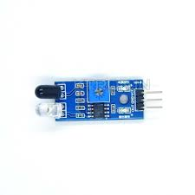

FIG 2.3.5(IR SENSOR)

* 1. **Software description**

This project named called human following robot because it can follow humans with the help of IR sensors and can co-exist with humans and help humans in any kind of work with more accuracy and in lesser time. The human following robot can use in the defense sector also to carry weapons for the soldiers. To make it, we need only one rectangular plate, on which lower side should be glued the engines, and on the upper surface are mounted other elements. You can use discontinued L293D motor driver shield like in my case, but also and Adafruit motor shield as is presented on the schematic diagram without any changes.

**PROGRAMMING ON ARDUINO UNO**

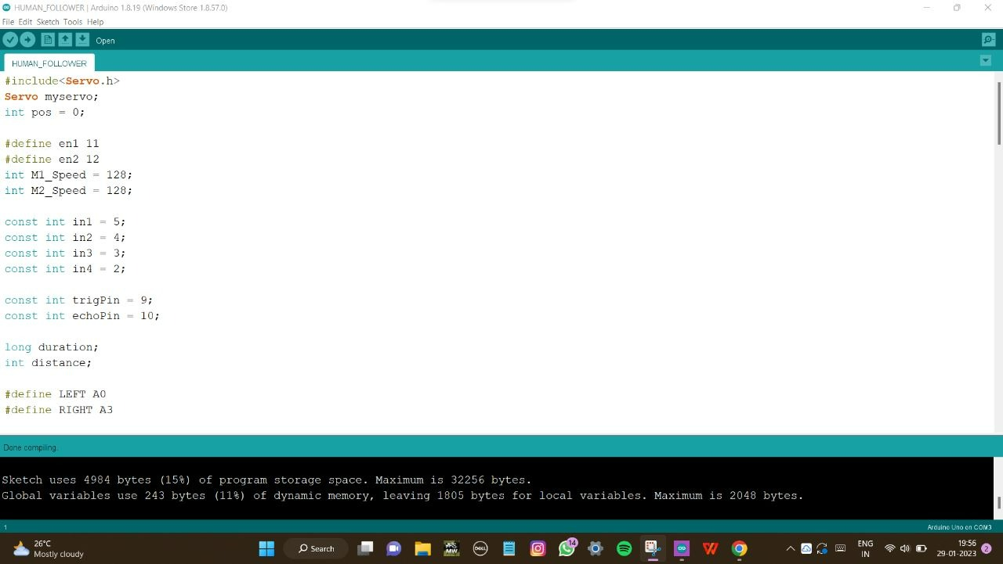

Fig.2.4(SOFTWARE IDE)

**CHAPTER 3**

1. **PROJECT IMPLEMENTATION**
   1. **Working**

Our system consists of a four wheel robotic vehicle mounted with a separate microprocessor and control unit along with different sensors and modules i.e. ultrasonic sensor, infrared sensors which helps them to move with respect to people and objects in their surroundings. The above sensors work in unison with each other and helps the robot in its operation and to navigate its path by avoiding the obstacles and maintaining a specific distance from the object. We used ultrasonic sensor for obstacle avoidance and to maintain a specific distance for the object.The ultrasonic sensor works accurately works accurately within a range of 4 meters.

**3.2. RESULTS**

Different experiments were conducted and the performance of the human following robot was tested. Test was performed on the ultrasonic and infrared sensor. It was noted that the sensor was working accurately within a range of 4 meters. Then we performed the test to check whether the robot maintains a specific distance with the target object. Then we checked the serial communication between Arduino, motor shield and various motors. On the basis of results obtained from these tests and experiments, we made the necessary changes in the processing and control algorithm. After the completion, we observed that the results produced were very satisfying the robot was perfectly following the person wherever it goes. Hence the objective of implementing a good Human-Robot interaction was achieved.

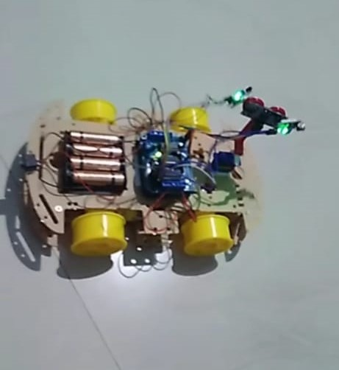

Fig.3.2(RESULT PICTURE)

**3.3 Advantages**

* Code compatibility and expandability across different Arduino boards.
* Cost is less as Arduino is open source.
* The schematic of Arduino is open source. So for future enhancement of the project the board can be extended to add more hardware features.
* Ultrasonic sensor has large range and can be used in any lighting conditions.

**3.4 Disadvantages**

* Robot always needs a path to run from the particular path.
* Robot has slow speed and instability on different line thickness or hard angles.

**CHAPTER 4**

1. **CONCLUSION**

**4.1 Conclusion**

Designed human follower robot using both automatically and manually operating methods with the help of AVR atmega32 micro controller, android camera and ultrasonic sensors. It can follow a human whenever the person moves in that direction. The robot should also be able to exhibit an effective obstacle avoidance with target following and exploration behaviors. The human follower robot can help us in domestic environment as well as in an industrial area.

**4.2 Future Scope**

There are many interesting applications of this research in different fields whether military or medical. A wireless communication functionality can be added in the robot to make it more versatile and control it from a large distance. This capability of a robot could also be used for military purposes. By mounting a real time video recorder on top of the camera, we can monitor the surroundings by just sitting in our rooms. We can also add some modifications in the algorithm and the structure as well to fit it for any other purpose. Similarly it can assist the public in shopping malls. So there it can act as a luggage carrier, hence no need to carry up the weights or to pull that. Similarly, ample amount of modifications could be done to this prototype for far and wide applications.

**CHAPTER 5**

1. **BIBLIOGRAPHY**
2. K. Morioka, J.-H. Lee, and H. Hashimoto, “Human-following mobile robot in a distributed intelligent sensor network,” IEEE Trans. Ind. Electron., vol. 51, no. 1, pp. 229–237, Feb. 2004.
3. Y. Matsumoto and A. Zelinsky, “Real-time face tracking system for human-robot interaction,” in 1999 IEEE International Conference on Systems, Man, and Cybernetics, 1999. IEEE SMC ’99 Conference Proceedings, 1999, vol. 2, pp. 830– 835 vol.2.
4. T. Yoshimi, M. Nishiyama, T. Sonoura, H. Nakamoto, S. Tokura, H. Sato, F. Ozaki, N. Matsuhira, and H. Mizoguchi, “Development of a Person Following Robot with Vision Based Target Detection,” in 2006 IEEE/RSJ International Conference on Intelligent Robots and Systems, 2006, pp. 5286–5291.

**CHAPTER 6**

1. **APPENDIX**

**//CODE:**

#include<NewPing.h>

#include<Servo.h>

#include<AFMotor.h>

#define RIGHT A2

#define LEFT A3

#define TRIGGER_PIN A1

#define ECHO_PIN A0

#define MAX_DISTANCE 100

NewPing sonar(TRIGGER_PIN, ECHO_PIN, MAX_DISTANCE);

AF_DCMotor Motor1(1,MOTOR12_1KHZ);

AF_DCMotor Motor2(2,MOTOR12_1KHZ);

AF_DCMotor Motor3(3,MOTOR34_1KHZ);

AF_DCMotor Motor4(4,MOTOR34_1KHZ);

Servo myservo;

int pos =0;

void setup() {

// put your setup code here, to run once:

Serial.begin(9600);

myservo.attach(10); {

for(pos = 90; pos <= 180; pos += 1){

myservo.write(pos);

delay(15);

} for(pos = 180; pos >= 0; pos-= 1) {

myservo.write(pos);

delay(15);

}for(pos = 0; pos<=90; pos += 1) {

myservo.write(pos);

delay(15);

} }

pinMode(RIGHT, INPUT);

pinMode(LEFT, INPUT); }

void loop() {

delay(50);

unsigned int distance = sonar.ping_cm();

Serial.print("distance");

Serial.println(distance);

int Right_Value = digitalRead(RIGHT);

int Left_Value = digitalRead(LEFT);

Serial.print("RIGHT");

Serial.println(Right_Value);

Serial.print("LEFT");

Serial.println(Left_Value);

if((Right_Value==1) && (distance>=10 && distance<=30)&&(Left_Value==1)){

Motor1.setSpeed(120);

Motor1.run(FORWARD);

Motor2.setSpeed(120);

Motor2.run(FORWARD);

Motor3.setSpeed(120);

Motor3.run(FORWARD);

Motor4.setSpeed(120);

Motor4.run(FORWARD);

}else if((Right_Value==0) && (Left_Value==1)) {

Motor1.setSpeed(200);

Motor1.run(FORWARD);

Motor2.setSpeed(200);

Motor2.run(FORWARD);

Motor3.setSpeed(100);

Motor3.run(BACKWARD);

Motor4.setSpeed(100);

Motor4.run(BACKWARD);

}else if((Right_Value==1)&&(Left_Value==0)) {

Motor1.setSpeed(100);

Motor1.run(BACKWARD);

Motor2.setSpeed(100);

Motor2.run(BACKWARD);

Motor3.setSpeed(200);

Motor3.run(FORWARD);

Motor4.setSpeed(200);

Motor4.run(FORWARD);

}else if((Right_Value==1)&&(Left_Value==1)) {

Motor1.setSpeed(0);

Motor1.run(RELEASE);

Motor2.setSpeed(0);

Motor2.run(RELEASE);

Motor3.setSpeed(0);

Motor3.run(RELEASE);

Motor4.setSpeed(0);

Motor4.run(RELEASE);

}else if(distance > 1 && distance < 10) {

Motor1.setSpeed(0);

Motor1.run(RELEASE);

Motor2.setSpeed(0);

Motor2.run(RELEASE);

Motor3.setSpeed(0);

Motor3.run(RELEASE);

Motor4.setSpeed(0);

Motor4.run(RELEASE);

} }