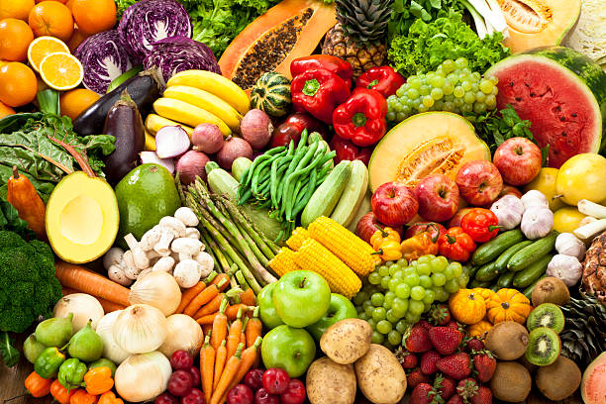

**Healthy Eating Habits are Essential**

**to the Maintenance of Health**

According to the Classics of Chinese Medicine, the origin of the energy of life (**Qì)** begins with the air we breathe and the food we eat. The energy we inherit from our parents (*Ancestral Qì*) is what determines longevity and aids in the maintenance of health.

The two main energies which sustain life are ***Nutritive Qì***(*Yíng* Qì) which nourishes the body and ***Defensive Qì*** (Wèi Qì) which supports the immune system and protects us from disease, neither of which can develop without **the food we eat!**

The Classics point out that the best way to stay healthy and strong is to maintain a lifestyle which is conducive to health and wellbeing. This means essentially to get adequate sleep, rest and exercise and above all nourish our bodies and minds. Good nutrition is the ultimate in preventive health care.

*To wait for the illness to develop*

*Before remedying it,*

*For the disorder to form*

*Before taking care of it,*

*Is to wait until one is thirsty*

*Before digging the well,*

*To wait for the battle*

*Before forging the weapons…*

(Larre, *The Way of Heaven*, p. 143

Ch 1 & 2, *Su Wen Nei Jing*)

During **Nutritional counseling sessions** we will examine your dietary habits (food diary submitted in advance) to determine whether your food intake and eating habits support your health, based upon traditional Chinese theory and modern nutrition science. Also we will examine life style issues which may be having a negative impact on your immune system, energy, or presenting symptomatology. Recommendations will be made and courses of actions discussed.

**Sessions** are by appointment and take 1-1/2 hours,

**Fee** is $140 (cash or check only).

**For appts contact:** Ian Barbara Florian, M.Ac.(US), M.Ac.(UK), PhD, Holistic Nutrition

(919) 416-0675