# ***SMART PUBLIC RESTROOM***

Phase – 5 Documentation Submission Pugazhenthi.E(510421106034)

# CONTENT

| S.NO; | TOPICS | PAGE NUMBER |
| --- | --- | --- |
| 01 | INTRODUCTION | 01 |
| 02 | ABSTRACT | 01 |
| 03 | DEVELOPMENT | 02 |
| 04 | DIAGRAM | 08 |
| 05 | SCHEMATICS | 09 |
| 06 | ALGORITHM | 10 |
| 07 | CODE IMPLEMENTATION | 11 |
| 08 | CONCLUSION |  |

# **INTRODUCTION:**

Smart restrooms often incorporate automated cleaning systems that can detect when a restroom stall or sink area needs cleaning and dispatch cleaning staff or robotic devices accordingly. Sensors can also monitor restroom usage to optimize cleaning schedules.

IoT, with its network of interconnected devices and sensors, allows for the collection, analysis, and utilization of real-time data to create smart and efficient solutions. When applied to public restrooms, this technology can bring about a myriad of benefits, enhancing the overall user experience while making maintenance and management more cost-effective.

Smart restrooms can optimize energy usage by controlling lighting and ventilation systems based on occupancy. When no one is in the restroom, lights can be dimmed or turned off, and ventilation can be reduced, saving energy and reducing operational costs.

# **ABSTRACT:**

The concept of a "Smart Restroom" represents a modern approach to enhancing the user experience and improving the overall efficiency and hygiene of public and private restroom facilities. By integrating advanced technologies such as IoT sensors, automated sanitation systems, touchless fixtures, and real-time monitoring, smart restrooms aim to provide a seamless and comfortable experience for users while optimizing resource management for facility operators. This abstract explores the key components and benefits of smart restrooms, highlighting their potential to revolutionize the way we interact with these essential facilities, promoting hygiene, sustainability, and user satisfaction.

01

# **DEVELOPMENT:**

**Generation of Ultrasonic Waves:** The sensor generates a high-frequency sound wave, typically in the ultrasonic range (around 40 kHz), using a piezoelectric transducer. This transducer converts electrical energy into mechanical vibrations, creating the sound wave.

**Transmission of Sound Waves**: The sensor emits these sound waves into the environment, usually in a specific direction. The sound waves travel through the air until they encounter an object.

**Reflection of Sound Waves:** When the sound wave hits an object, it gets reflected back towards the sensor. The time it takes for the sound wave to travel to the object and back is recorded.

**Time Measurement:** The sensor measures the time it takes for the sound wave to return, and this time is typically measured in microseconds. This time is directly related to the distance between the sensor and the object. The longer it takes for the sound wave to return, the farther the object is from the sensor.

**Conversion to Distance**: Using the measured time, the sensor's microcontroller or processor converts this into a distance measurement. The speed of sound in the air (approximately 343 meters per second or 1125 feet per second at room temperature) is used to calculate the distance. The formula for distance calculation is typically something like: Distance = (Time * Speed of Sound) / 2.

**Data Processing**: The collected distance data can be further processed by a microcontroller or a computer to perform various tasks, such as controlling the movement of a robot, detecting obstacles in a car, or triggering an alarm.

02

# **SENSORS USING IN SMART RESTROOM:**

**Motion Sensors**: Motion sensors, often based on passive infrared (PIR) technology, are used to detect the presence of users in the restroom. They trigger actions like turning on lights or activating ventilation when someone enters the restroom. Motion sensors are commonly used for lighting control to conserve energy.

**Occupancy Sensors**: These sensors go beyond motion detection and provide more detailed information about restroom occupancy. They can count the number of users in the restroom and provide data on usage patterns. This information is valuable for optimizing cleaning schedules and resource allocation.

**Proximity Sensors**: Proximity sensors use infrared or ultrasonic technology to detect the presence or proximity of an object, such as a user's hand. They are often used for touchless fixtures, including automatic faucets, soap dispensers, and flush valves. Proximity sensors trigger these fixtures when a user's hand is near, reducing the need for physical contact.

**Toilet and Urinal Sensors**: Sensors can be integrated into toilets and urinals to detect when they need to be flushed automatically. These sensors monitor water levels and trigger flushes as needed, helping conserve water.

**Toilet Seat Sensors**: Some smart restrooms have sensors on toilet seats to determine whether they are occupied. These sensors can indicate whether a stall is in use and provide occupancy data for facility management.

**Air Quality Sensors**: Air quality sensors monitor various parameters, such as temperature, humidity, and air quality, within the restroom. They help control ventilation and air purification systems to ensure a comfortable and healthy environment for users

03

# **COMPUTATIONAL TECHNOLOGY OF SMART RESTROOM:**

**Sensor Technology:** Smart restrooms rely heavily on sensors to detect user presence and trigger various actions. Common sensors include motion sensors for lighting control, occupancy sensors for ventilation and maintenance alerts, and proximity sensors for touchless fixtures like faucets, soap dispensers, and flush valves.

**Internet of Things (IoT):** IoT technology connects various restroom fixtures and components to the internet. This enables real-time data collection and remote control. IoT devices can communicate with a central management system to provide insights into restroom usage and status.

**Integration with Building Management Systems**: Smart restrooms are often integrated into the larger building management system, enabling coordinated control of all building systems for optimized resource use and user comfort.

**Machine Learning and Artificial Intelligence:** AI and machine learning algorithms can be applied to analyze data and predict usage patterns, optimizing resource allocation and maintenance schedules.

**Remote Monitoring and Control**: Facility managers and maintenance personnel can remotely monitor and control various aspects of the smart restroom using mobile apps or web interfaces. This remote access allows for quick responses to issues and maintenance needs.

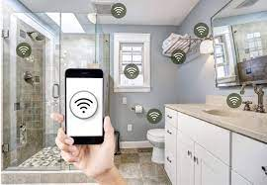

04

# **OVERVIEW OF SMART RESTROOM:**

**Automated Sensors**: Smart restrooms often feature automated sensors for toilets, urinals, sinks, and soap dispensers. These sensors detect motion, proximity, or touch to trigger actions, reducing the need for physical contact and minimizing the spread of germs.

**Energy Efficiency**: To conserve energy and reduce operational costs, smart restrooms may use LED lighting, occupancy sensors, and timers to control lighting and ventilation systems. These systems can adjust settings based on usage patterns and natural light levels.

**Water Conservation**: Water-saving fixtures like low-flow toilets and waterless urinals are common in smart restrooms. Sensor-based faucets and flush valves also contribute to water conservation by minimizing water wastage

**Real-time Monitoring**: Restroom operators can monitor the status of restroom fixtures and equipment in real-time through a central management system. This allows for proactive maintenance and resource management.

**Maintenance Alerts**: Smart restrooms can send maintenance alerts when fixtures require servicing or replenishment, reducing downtime and improving overall cleanliness.

**Smart Dispensers**: Automated soap and hand sanitizer dispensers help promote hand hygiene. They can be refilled more efficiently, and usage data can be collected to ensure proper maintenance

# **WORKING OF SMART RESTROOM:**

**Generation of Ultrasonic Waves:** The sensor generates a high-frequency sound wave, typically in the ultrasonic range (around 40 kHz), using a piezoelectric transducer. This transducer converts electrical energy into mechanical vibrations, creating the sound wave.

**Transmission of Sound Waves**: The sensor emits these sound waves into the environment, usually in a specific direction. The sound waves travel through the air until they encounter an object.

05

**Reflection of Sound Waves:** When the sound wave hits an object, it gets reflected back towards the sensor. The time it takes for the sound wave to travel to the object and back is recorded.

**Time Measurement:** The sensor measures the time it takes for the sound wave to return, and this time is typically measured in microseconds. This time is directly related to the distance between the sensor and the object. The longer it takes for the sound wave to return, the farther the object is from the sensor.

**Conversion to Distance**: Using the measured time, the sensor's microcontroller or processor converts this into a distance measurement. The speed of sound in the air (approximately 343 meters per second or 1125 feet per second at room temperature) is used to calculate the distance. The formula for distance calculation is typically something like: Distance = (Time * Speed of Sound) / 2.

**Data Processing**: The collected distance data can be further processed by a microcontroller or a computer to perform various tasks, such as controlling the movement of a robot, detecting obstacles in a car, or triggering an alarm.

Touchless interfaces: Implement touchless entry systems, such as automatic doors or QR code access, to minimize physical contact.

Hygiene monitoring: Use sensors to monitor soap and hand sanitizer levels, restroom occupancy, and air quality.

IoT devices: Connect restroom facilities to the Internet of Things (IoT) for real-time monitoring and data analysis to improve maintenance and cleanliness.

Smart toilet fixtures: Install self-cleaning toilets, bidets, and heated seats for enhanced comfort and hygiene.

06

Queue management: Use digital signage or mobile apps to inform users about restroom availability and estimated wait times.

Smart mirrors: Incorporate mirrors with integrated displays for information, advertisements, or weather updates.

Waste management: Deploy smart trash cans with sensors that signal when they need emptying to optimize cleaning schedules.

Accessibility features: Ensure inclusivity with features like accessible toilets, audio announcements, and braille signage.

Energy-efficient design: Use energy-efficient lighting and ventilation systems to reduce energy consumption.

Feedback mechanisms: Provide users with a way to report issues or provide feedback for continuous improvement.

Security and privacy: Implement security measures to protect user data and ensure privacy, especially when using IoT devices.

Data analytics: Collect and analyze data from restroom sensors to improve maintenance, resource allocation, and user experience.

Smart public restrooms are a modern solution to address the need for cleanliness and hygiene in public spaces. One such system, called “Smart Public Toilets using IoE,” was proposed to improve the condition of public toilets and make them accessible to every citizen in a hygienic way. This system utilizes various technologies, including proximity sensors, biometric systems, gas sensors, and a dashboard, to monitor cleanliness, autonomously flush toilets, and prevent bad odors. The goal is to maintain public toilets effectively and ensure a pleasant experience for users.

07

# **DIAGRAM:**

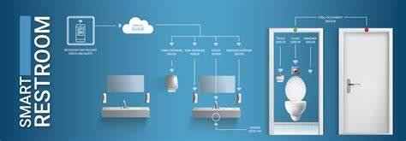

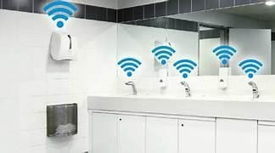

# 

08

# **SCHEMATICS DIAGRAM:**

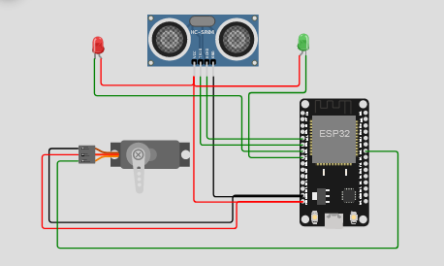

SENSING OF HEIGHT MEASUREMENT

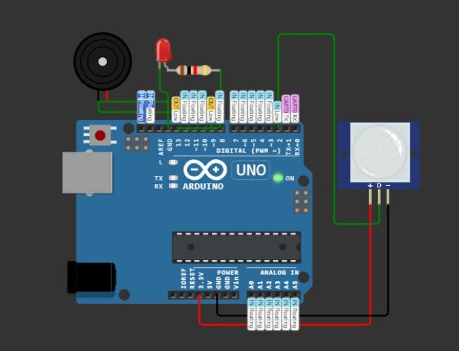

SENSIGN OF WHETHER RESTROOM OCCUPIED OR NOT

09

# **ALGORITHM:**

**Initialization:**

Initialize variables for restroom occupancy status, sensor inputs, and user input.

**Check for User Input:**

Continuously check for user input, such as a button press or motion sensor activation, to indicate that someone wants to use the restroom.

**Check Restroom Occupancy:**

Check the occupancy status of the restroom. If it's vacant, proceed to step 4. If it's occupied, inform the user that the restroom is currently in use, and wait for them to leave.

**Activate Entry Procedure:**

If the restroom is vacant, activate the entry procedure:

Lock the restroom door to prevent others from entering.

Turn on the restroom lights.

Start a timer to monitor the user's restroom usage.

**User Inside Restroom:**

Continuously monitor the restroom using sensors to detect any activity.

If no activity is detected for a specified period, assume the user has left.

**Deactivate Entry Procedure:**

Once the user leaves, deactivate the entry procedure:

Unlock the restroom door.

Turn off the lights.

Reset the occupancy status to vacant.

Stop the timer.

**Repeat:**

Repeat the process from step 2 to accommodate the next user

10

# **CODE IMPLEMENTATION:**

#include<ESP32Servo.h>

| #define | TRIGGERPIN | 32 |
| --- | --- | --- |
| #define | ECHOPIN | 35 |
| #define | RED_LED | 33 |
| #define | GREEN_LED | 25 |

Servo servo_1; long duration;

int pos, distance, i=0; void setup()

{

servo_1.attach(18); **Serial**.begin(115200); pinMode(TRIGGERPIN, OUTPUT); pinMode(ECHOPIN, INPUT); pinMode(RED_LED, OUTPUT); pinMode(GREEN_LED, OUTPUT);

**Serial**.println(" "); **Serial**.println("Sensing the Height"); digitalWrite(RED_LED, HIGH); digitalWrite(GREEN_LED, LOW);

pos = 0; servo_1.write(pos);

}

11

void loop()

{

digitalWrite(TRIGGERPIN, LOW); delayMicroseconds(3); digitalWrite(TRIGGERPIN, HIGH); delayMicroseconds(12); // it may be 10 us digitalWrite(TRIGGERPIN, LOW);

// Reads the echoPin, returns the sound wave travel time in microseconds duration = pulseIn(ECHOPIN, HIGH);

// Calculating the distance distance = (duration/2) / 29.1;

if (distance >= 100 && distance <= 150)

{

i = 1;

if (pos != 180)

{

servo_1.write(180); pos = 180;

i = 1;

}

}

// for Child

else if (distance >= 200 && distance <= 250)

{

i = 1;

if (pos != 0)

{

servo_1.write(0); pos = 0;

i = 1;

12

}

else if (distance > 300 && i == 1)

{

digitalWrite(RED_LED, LOW); digitalWrite(GREEN_LED, HIGH); delay(5000); digitalWrite(RED_LED, HIGH); digitalWrite(GREEN_LED, LOW); i = 0;

}

delay (500);

**Serial**.println(" "); **Serial**.print("Free Level : "); **Serial**.print(distance); **Serial**.print(" "); **Serial**.print("Position : "); **Serial**.print(pos);

delay (500);

}

# **OUTPUT:**

Sensing the Height

| Free | Level : | 140 | Position : | 180 |
| --- | --- | --- | --- | --- |
| Free | Level : | 140 | Position : | 180 |
| Free | Level : | 140 | Position : | 180 |
| Free | Level : | 140 | Position : | 180 |

13

const int occupancySensorPin = 2; const int motionSensorPin = 3; const int waterLevelSensorPin = 4;

const int lightPin = 5; const int pumpPin = 6;

bool restroomOccupied = false;

void setup() { pinMode(occupancySensorPin, INPUT); pinMode(motionSensorPin, INPUT); pinMode(waterLevelSensorPin, INPUT);

pinMode(lightPin, OUTPUT); pinMode(pumpPin, OUTPUT);

Serial.begin(9600);

}

void loop() {

// Simulated sensor readings

int occupancySensorValue = digitalRead(occupancySensorPin); int motionSensorValue = digitalRead(motionSensorPin);

int waterLevelSensorValue = digitalRead(waterLevelSensorPin);

14

// Simulated smart restroom logic

if (occupancySensorValue == HIGH) { restroomOccupied = true;

// User detected, turn on lights digitalWrite(lightPin, HIGH); restroomOccupied = true;

} else if (restroomOccupied && waterLevelSensorValue == LOW) {

// No motion, water level low, turn on pump digitalWrite(pumpPin, HIGH);

} else {

// No occupancy, turn off lights and pump digitalWrite(lightPin, LOW); digitalWrite(pumpPin, LOW); restroomOccupied = false;

}

Serial.print("Restroom Status: "); Serial.println(restroomOccupied ? "Occupied" : "Vacant");

delay(1000); // Simulated loop delay

}

# **OUTPUT:**

Restroom Status: Vacant Restroom Status: Occupied Restroom Status: Occupied Restroom Status: Vacant

15

# **SCREENSHOT:**

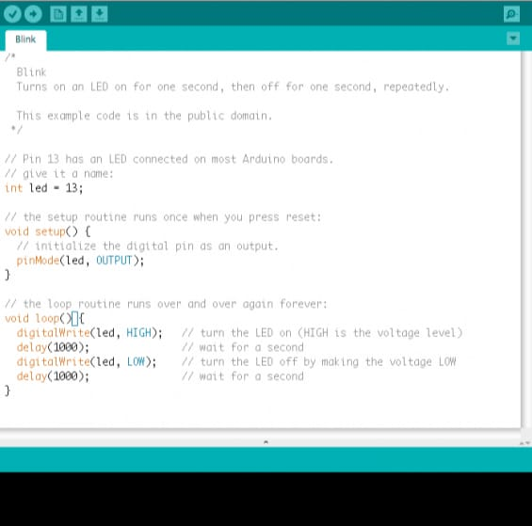

16

# **REAL TIME DATA:**

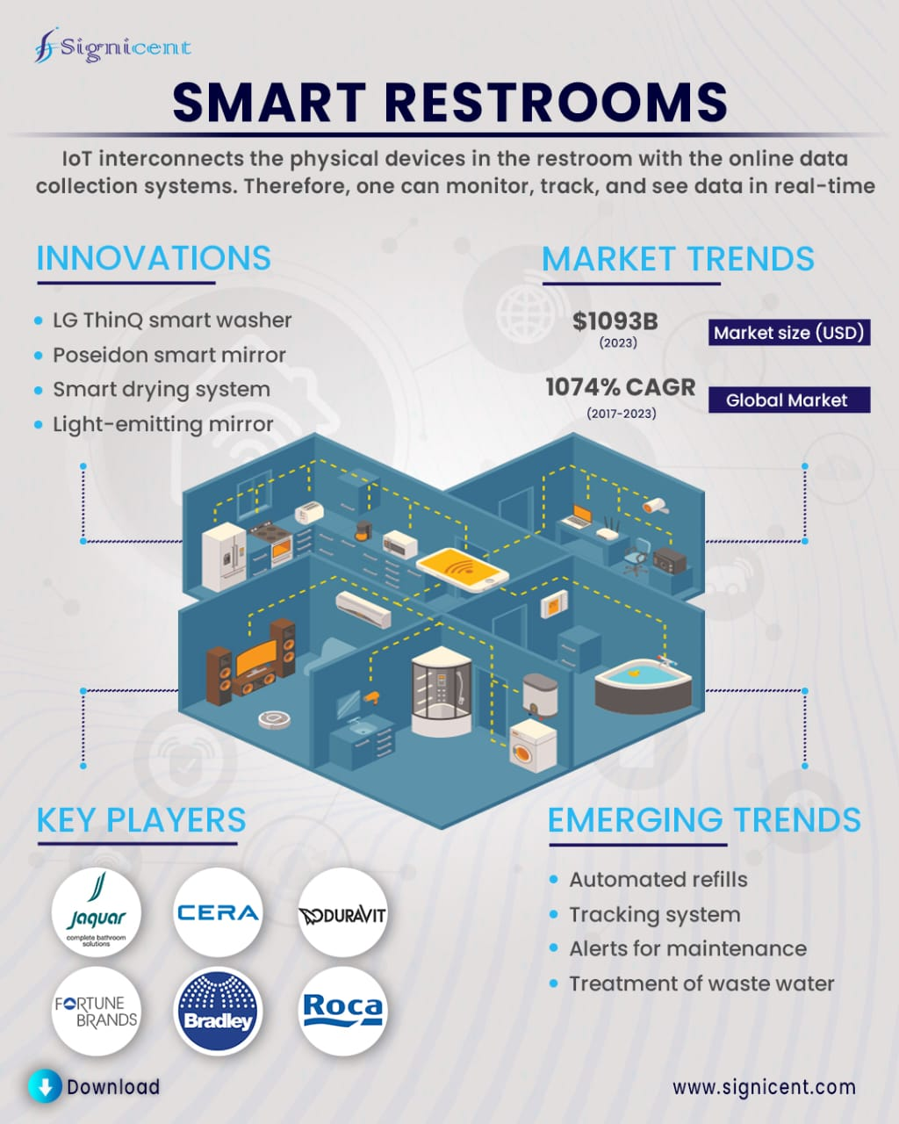

17

# **ADVANCEMENT:**

**1.Smart Toilets**

According to real estate experts, smart toilets are the most desired devices when it comes to restroom renovations. Top features include:

Automatic lid

Seat warmers

Dual-flush, touchless flush actuators

Night lights

Speakers for music

And more

Smart toilets tend to be more compact, with improved design elements that make them space-saving while remaining comfortable. This feature makes the toilets easier to clean and keep clean. Although, self-cleaning is another feature of a smart toilet.

**2. Occupancy Monitoring**

These smart monitors let people know what stalls are available by using lights as indicators, activated when the user locks the stall. Patrons also receive alerts outside of the restroom on a touchscreen to let them know their place in line. That way, no one is waiting in a germ-filled or crowded bathroom.

**3. Touchless Fixtures and Digital Faucets**

Touchless fixtures allow users to go to the restroom without touching these contaminated surfaces. Public restroom surfaces contain pathogens that cause illnesses and diseases, such as (but not limited to):

E. coli

Legionella

Shigella

Norovirus

Salmonella

18

Automatic toilets, touchless faucets, and hands-free soap and paper towel dispensers, among others, reduce these risks and promote public health.

Sensor technology isn't the only advance in faucets that make them Fixtures of the Future. You can find faucets that are fully programmable, allowing you to control water temperature, usage, flow rates, and even metering functions.

**4. Smart Mirrors**

The restroom of the future includes mirrors that can broadcast the weather, daily news, and traffic updates.

While most smart technologies for commercial restrooms inspire residential applications (think hands-free faucets), some began as residential fixtures and made their way to commercial building installations.

Brands began by manufacturing smart mirrors for residential applications. However, it is one of the advances in restroom technologies that originated for home use and has evolved into a commercial restroom tech device.

**5. Water Reclamation Devices**

Water recyclers can save potable water that would typically go down the drain and enter the public water system. Instead, these recyclers collect the water and reuse it for non-potable purposes, like irrigation or cooling systems.

These systems are better known as Fit-For-Purpose Treatment when used in public water systems. The image below shows how water reuse works.

19

# **CONCLUSION:**

In conclusion, the concept of a smart restroom represents a promising and innovative approach to enhancing the user experience in public and private facilities. By integrating cutting-edge technologies such as IoT devices, sensors, and automation systems, smart restrooms aim to improve hygiene, efficiency, and convenience for users while also optimizing resource usage and maintenance for facility managers.

The integration of sustainable materials, energy-efficient lighting, and eco-friendly cleaning solutions aligns with modern environmental and sustainability goals. By reducing the environmental footprint of restroom facilities, this project demonstrates a commitment to responsible and eco-conscious design

20