
ESPACOMP Medication Adherence Reporting Guideline (EMERGE)
Version 1 – 2018
De Geest S, Zullig LL, Dunbar-Jacob J, Helmy R, Hughes DA, Wilson IB, Vrijens B. ESPACOMP Medication Adherence Reporting Guideline (EMERGE).
Ann Intern Med. 2018 Jul 3;169(1):30-35. doi: 10.7326/M18-0543.
The ESPACOMP Medication Adherence Reporting Guidelines (EMERGE) aim at guiding researchers to report relevant aspects of medication adherence research in a standard manner. EMERGE guidelines are meant to be an addition to the existing guidelines for health research reporting such as STROBE1, CONSORT1, STaRI1, and TIDier1 guidelines.
The ABC taxonomy of medication adherence² was used as the conceptual basis for the guidelines (see figure below). This taxonomy defines medication adherence as the process by which patients take their medications as prescribed, composed of (A) initiation,
(B) implementation, and (C) persistence. Each phase has its specific characteristics and requires a precise operational definition, adequate measurement, and a suitable approach for data analysis, elements also reflected in the EMERGE sections.

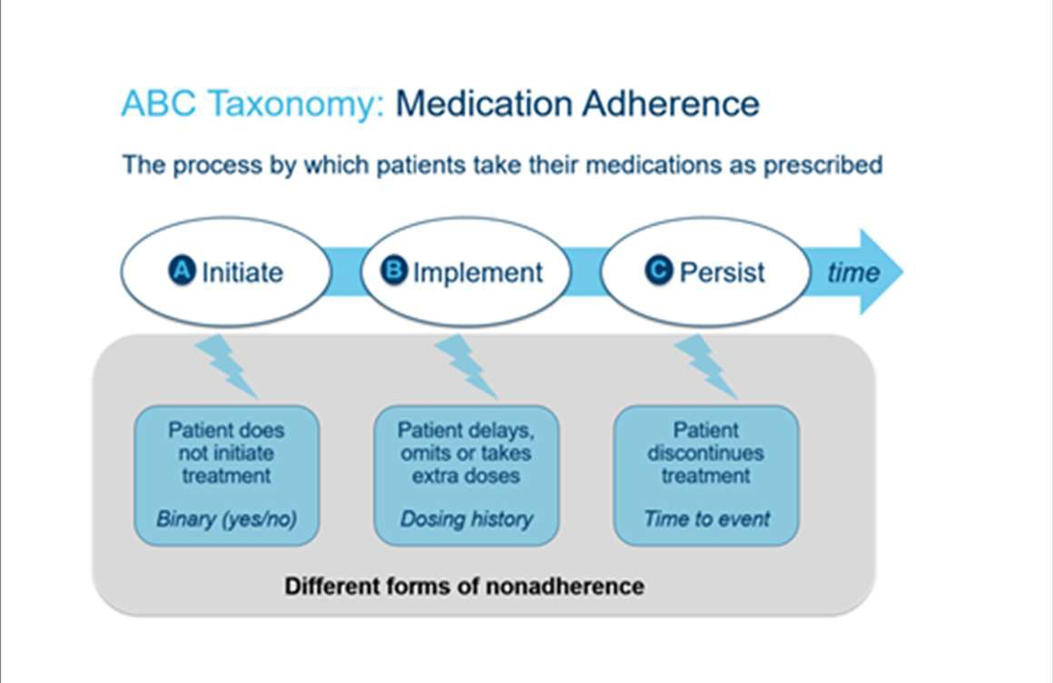
- The process starts with initiation of the treatment, when the patient takes the first dose of a prescribed medication.
- The process continues with the implementation of the dosing regimen, defined as the extent to which a patient's actual dosing corresponds to the prescribed dosing regimen, from initiation until the last dose is taken.
- Discontinuation marks the end of therapy, when the next dose to be
taken is omitted and no more doses are taken thereafter (without a prescriber's order). Persistence is the length of time between initiation and the last dose, which immediately precedes discontinuation.
Non-adherence to medications can thus occur in the following situations or combinations thereof: late or non-initiation of the prescribed treatment, sub-optimal implementation of the dosing regimen or early discontinuation of the treatment.
ESPACOMP Medication Adherence Reporting Guidelines (EMERGE) were developed using the ABC taxonomy for medication adherence as the conceptual basis. An initial item list was developed by the EMERGE steering committee through an iterative process (i.e. an in-person meeting for initial item generation followed by structured review rounds via email and conference calls) followed by 2 Delphi rounds with 26 international adherence experts from 15 countries and from different disciplines^{3,4}.
EMERGE^{4,5} consists of 21 items organized in 2 sections: the first section includes 4 items reflecting the conceptualization of medication adherence as put forward by the ABC taxonomy for medication adherence. These items represent the minimum reporting criteria that are considered crucial to be reported in each publication, regardless of the format of the publication, in order for medication adherence research to advance benefiting from the conceptualization provided by the ABC taxonomy.
The second section consists of 17 items specific to medication adherence reporting and organized in a way congruent with the sections of reporting guidelines for observational and experimental study types (i.e. STROBE and CONSORT). Redundancy with existing guidelines has been avoided by only including items that are specific to medication adherence. Authors therefore will need to use the main reporting guidelines for their study type (e.g. STROBE and CONSORT) and combine these with EMERGE. Items included in EMERGE are thus applicable to different types of methodologies.
We hope that the implementation of the ESPACOMP Medication Adherence Reporting Guidelines (EMERGE) will enhance the quality of reporting relevant aspects of medication adherence research in a standard manner and ultimately advance the adherence field towards achieving its ultimate goal of improved outcomes.

The EMERGE steering committee:
Sabina De Geest¹, PhD, RN; Leah L. Zullig ², PhD, MPH; Jackie Dunbar-Jacob³, PhD, RN; Dyfrig Hughes⁴, MRPharmS, PhD; Ira B. Wilson⁵, MD, PhD, Bernard Vrijens⁶, PhD.

¹ University of Basel, Basel, Switzerland, and Academic Centre for Nursing and Midwifery, KU-Leuven, Leuven, Belgium
² Durham Centre of Innovation to Accelerate Discovery and Practice Transformation (ADAPT) and Duke Department of Population Health Sciences, Durham, North Carolina
³ University of Pittsburgh School of Nursing, Pittsburgh, Pennsylvania
⁴ Centre for Health Economics and Medicines Evaluation, Bangor University, Bangor, Gwynedd, North Wales, UK
⁵ Brown University School of Public Health, Providence, Rhode Island
⁶ University of Liège, Liège, Belgium, and AARDEX Group, Liège, Belgium
Address of correspondence: emerge@espacomp.eu; sabina.degeest@unibas.ch

ESPACOMP Medication Adherence Reporting Guideline (EMERGE)^{4,5}
Version 1 – 2018
Section | Item No | Recommendation | Reported on  page No /  line No

Minimum reporting criteria
 | 1a | Phases of medication adherence: State the phase(s) of medication adherence studied (i.e. initiation, implementation, and persistence) and justify, where possible, the reasons the study focuses on this/these phase(s). | ……
 | 1b | Operational definition: Provide the precise operational/working definition for each phase of medication adherence studied (i.e., initiation, implementation, and persistence). | ……
 | 1c | Measurement: Specify the methods of measuring medication adherence (e.g., self-report, claims data, blood sampling, electronic monitoring). Consider each phase studied (i.e., initiation, implementation, and persistence), with details on the performance of the measures (e.g., validity, reliability, and potential bias). | ……
 | 1d | Results: Describe the results of the analysis appropriate to each phase of medication adherence studied (i.e., initiation, implementation, and persistence). | ……

Abstract
 | 2a | Present in the abstract, in as much detail as space permits, information on the 4 minimum reporting criteria (i.e., items 1.a- 1.d). | ……

Background/introduction
 | 3a | Summarize what is known about the topic with appropriate reference to the phase(s) of medication adherence (i.e., initiation, implementation, and persistence). | ……
 | 3b | Describe the rationale and/or framework guiding the medication adherence study (e.g., theoretical framework and implementation science model). | ……

Study objectives or hypotheses
 | 4a | State the study objectives or hypotheses with reference to the phase(s) of medication adherence studied and context (patient population and setting). | ……

Methods
Design & participants | 5a | Describe the setting in which the study was done. Refer to factors relevant to medication adherence, such as characteristics of the healthcare system, organization, and the team. | ……
 | 5b | State whether medication adherence was an eligibility criterion (e.g., inclusion/exclusion). If so, define the measures and rules used. | ……
 | 5c | Describe routine care related to the management of medication adherence, if applicable (e.g. routine assessment of medication adherence, adherence support programs, and provider training). | ……
Measurement | Please refer to item 1.c. in addition to the “Measurement” item below
 | 6a | Measurement methods can themselves affect medication adherence (e.g., questionnaires, blood sampling, and electronic monitoring). Address this problem as appropriate. | ……
Intervention (where applicable) | 7a | For intervention and comparator groups, describe each relevant level of the medication adherence intervention (e.g., healthcare system, organization, and provider and patient/caregiver). | ……
 | 7b | Describe any implementation strategy that contributes to the translation (e.g., uptake, delivery, and sustainability) of the medication adherence intervention in clinical practice, if applicable. | ……
Statistical analysis | 8a | If medication adherence is an outcome variable, justify the statistical methods, given the characteristics of the variable (e.g., phases of medication adherence, data type, statistical distribution, data censoring, longitudinal dependence). | ……
 | 8b | If medication adherence is an explanatory variable, describe how it is related to the outcome(s) (e.g., causal pathway, temporal sequence). | ……

Results
 | Please refer to item 1.d in addition to the “Results” items below
 | 9a | Determine whether non-participation and/or dropout are associated with non-adherence, and provide any relevant data. | ……
 | 9b | Present sample characteristics relevant to medication adherence (e.g., those related to socio-demographics and therapy, condition, patient, caregiver, healthcare team/healthcare system). | ……

Discussion
 | 10a | Discuss study strengths and limitations with reference to the phase(s) of medication adherence, where applicable (i.e., initiation, implementation, and persistence). | ……
 | 10b | Discuss the study findings in the context of existing evidence on medication adherence (e.g., theory, measurement, intervention effects). | ……
 | 10c | Discuss the generalizability (external validity) of the study findings with reference to the phase(s) of medication adherence, where applicable (i.e., initiation, implementation, and persistence). | ……

References

¹ Equator Network. https://www.equator-network.org/ (accessed 25.12.2018)
² Vrijens B, De Geest S, Hughes DA, et al. A new taxonomy for describing and defining adherence to medications. British journal of clinical pharmacology. 2012;73(5):691-705.
³ Helmy R, Zullig LL, Dunbar-Jacob J, et al. ESPACOMP Medication Adherence Reporting Guidelines (EMERGE): a reactive-Delphi study. protocol. BMJ Open 2017;7: e013496. doi:10.1136/bmjopen-2016-013496

⁴ De Geest S, Zullig LL, Dunbar-Jacob J, Helmy R, Hughes DA, Wilson IB, Vrijens B. ESPACOMP Medication Adherence Reporting Guideline (EMERGE).
Ann Intern Med. 2018 Jul 3;169(1):30-35. doi: 10.7326/M18-0543.

⁵ Equator Network. http://www.equator-network.org/reporting-guidelines/espacomp-medication-adherence-reporting-guideline-emerge/ (accessed 30.12.2018)

