**Go-To-Market (GTM) Strategy for Zepto**

Zepto, a quick-commerce platform, leverages data-driven decision-making to optimize inventory management, enhance delivery efficiency, personalize customer experiences, and improve operational efficiency. This GTM strategy outlines a comprehensive approach using analytics to drive business growth.

Schema of GTM Strategy:

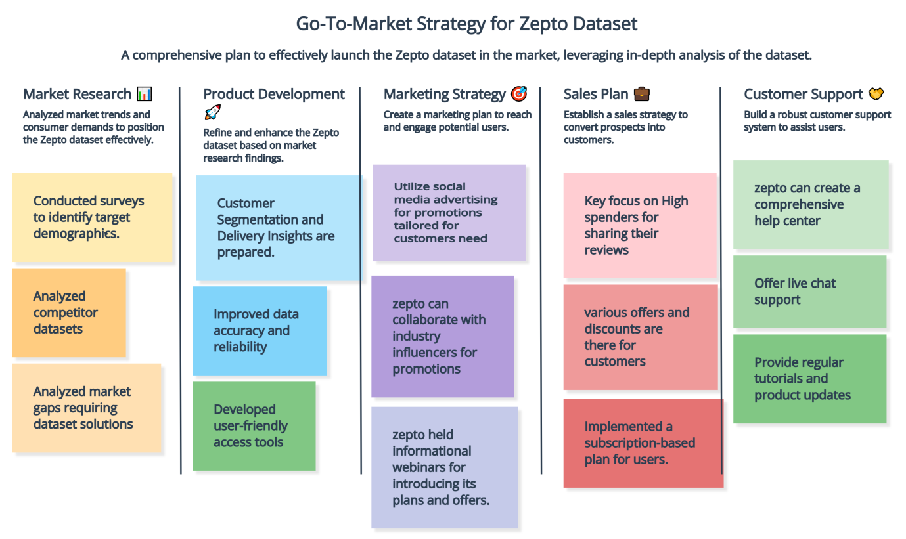

*Fig. GTM Workflow*

1. **Market Approach**

Zepto aims to achieve rapid scalability and customer satisfaction by leveraging data analytics in the following areas:

1. **Inventory Management:**

Zepto optimizes inventory levels to prevent stockouts and overstocking through:

* **Historical Purchase Data:**

Monthly purchase quantities across five cities reveal trends and individual city contributions throughout the year.

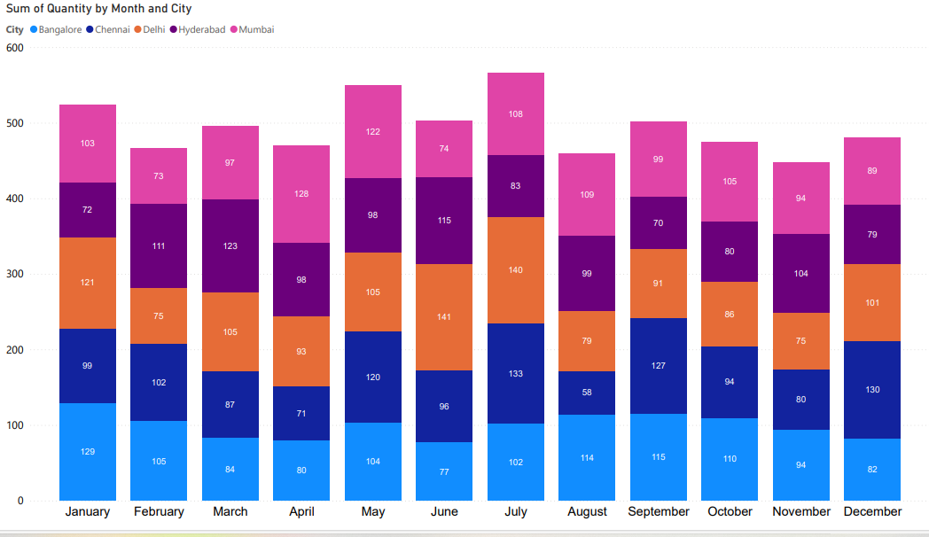

*Fig. Monthly and City-wise Quantity Distribution*

This plot gives us an idea of how the distribution of product purchases varies across each city. This helped us to monitor the inventory management related tasks.

Insights from it:

1. In the month of July, the product sales are the highest. Also, the maximum sales appear to have occurred in Delhi.
2. November sees the lowest sales, with Chennai experiencing the sharpest drop.

All other details will be clearer in the upcoming plots and analysis.

* **Seasonal Trends & Local Preferences:**

stock availability based on region-specific trends.

Monthly purchase quantities across four cities reveal seasonal variations and preferred product categories in each location.

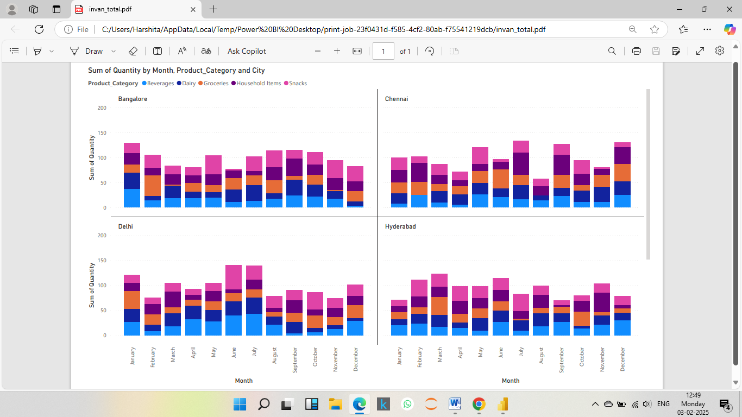

*Fig. Quantity Sum by Product Category & City*

On the basis of these plots we can see and make strategy for inventory management for zepto. These inventory management tasks are well performed in our code files. *(Ref. Inventory Management Folder)*

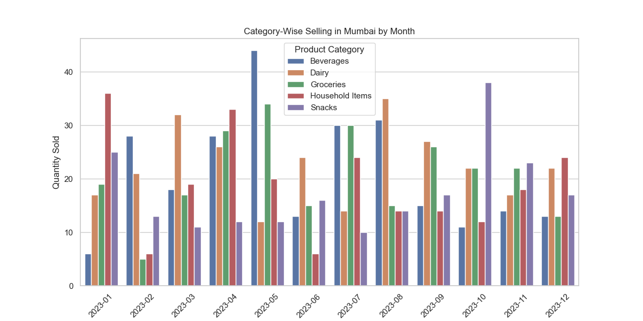

*Fig. Category-wise Selling in Mumbai by Month*

Specific plots like this are there in the code file and by analysing them the inventory related assistance is available there.

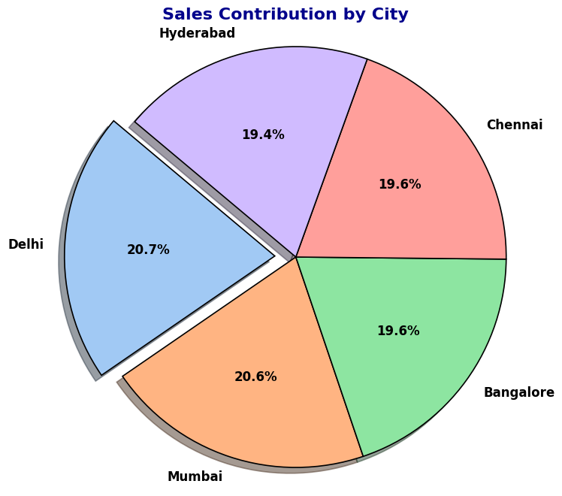

*Fig. Pie chart for sales by city*

>The distribution of customers from each city is somehow approximately equal in total.

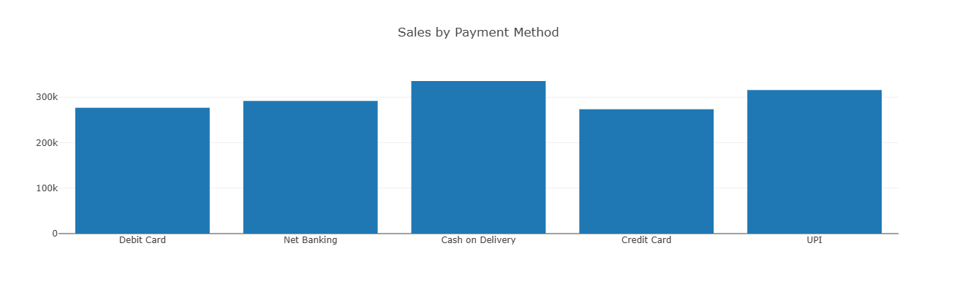

*Fig. Sales by Payment Method*

>The customers prefer cash on delivery most of the time but the UPI is also in demand.

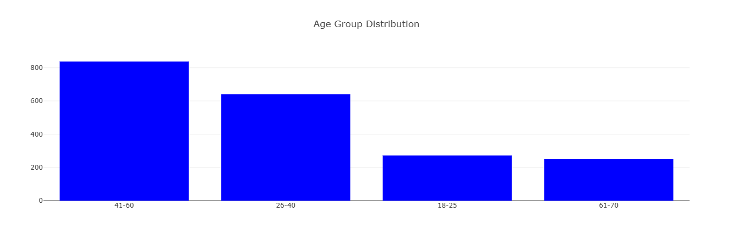

*Fig. Age Group Distribution*

>The people of adult category (coming under 41-60 age group) are highly engaged in purchasing products from zepto.

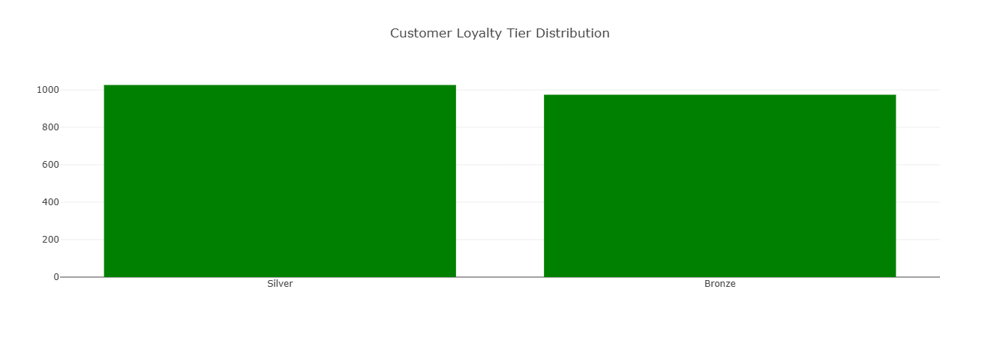

*Fig. Customer Loyalty Tier Distribution*

>Both the Silver and Bronze loyalty having customers are equally engaged on our quick commerce website.

* **Dynamic Stock Management:** Efficient Stocking and De-Stocking of Products

The in-depth analysis of city-wise demand for specific products each month enabled us to accomplish this task.

This work is efficiently executed using ML logic and is available in the code files within the respective folders. *(Ref Inventory Management Folder)*

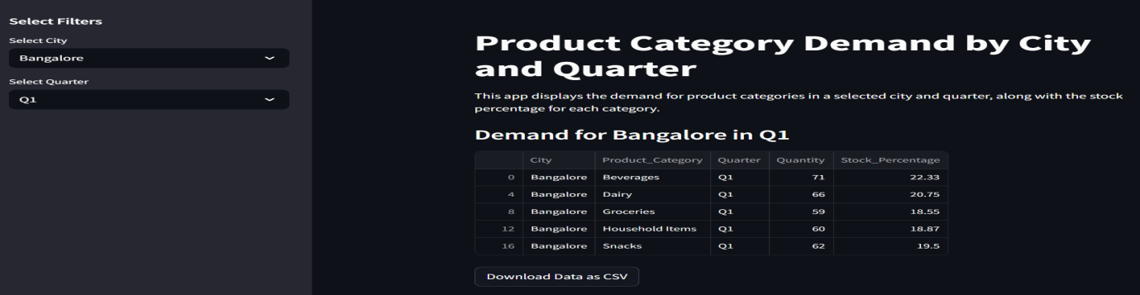

*Fig. Inventory Inspect GUI*

1. **Delivery Optimization:**

* **Key Factors Influencing Delivery Time:**

Analysed delivery time (in minutes) to determine the impact of each feature. A complete analysis, including plots and dashboards, is available in the files. Below is a plot showcasing importance of each feature on time taken to make a delivery.

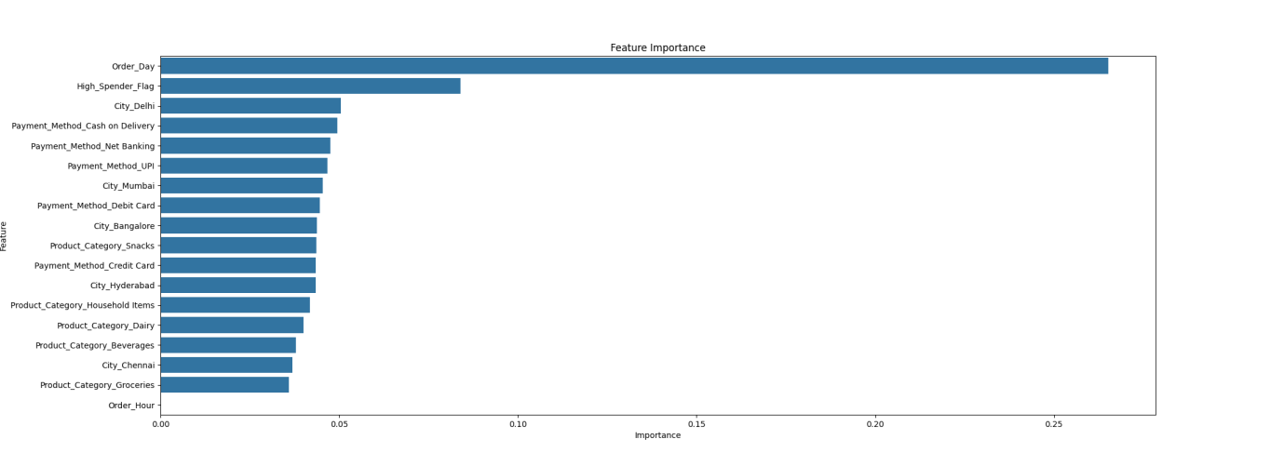

*Fig. Feature importance for Delivery time*

The plot indicates that the delivery speed largely depends on the delivery day.

By Analysing delivery insights from Power BI dashboards and Matplotlib plots *(Ref. Dashboards/Zepto Dashboards & Delivery Optimization Folder)*, we identified that:

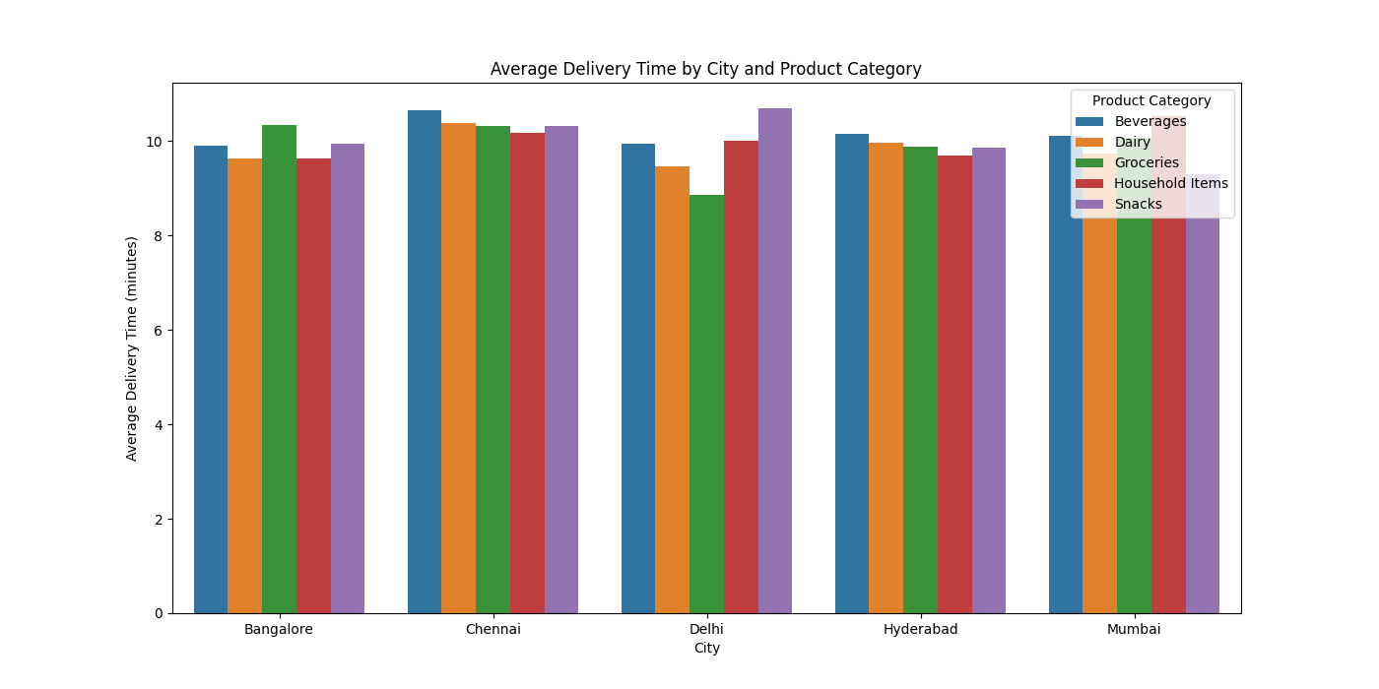

*Fig. Average Delivery Time by City and Product category*

1. In the city Chennai, almost all category deliveries occur after 10 minutes.
2. Friday sees the highest number of on-time deliveries.
3. In Mumbai, deliveries are generally completed within 10 minutes.
4. Groceries are the most consistently delivered on time.

* **Approach to optimize delivery time:**

In the code files *(Ref. Delivery optimization folder)*, we’ve provided various approaches to optimize delivery time, including:

1. Optimized delivery time with route optimization algorithms for riders.
2. Adapted delivery routes in real-time with traffic data monitoring.
3. **Customer Insights & Personalization:**

Zepto can enhance customer engagement through:

* **Personalized Recommendations:**

Used purchase behaviour to suggest relevant products.

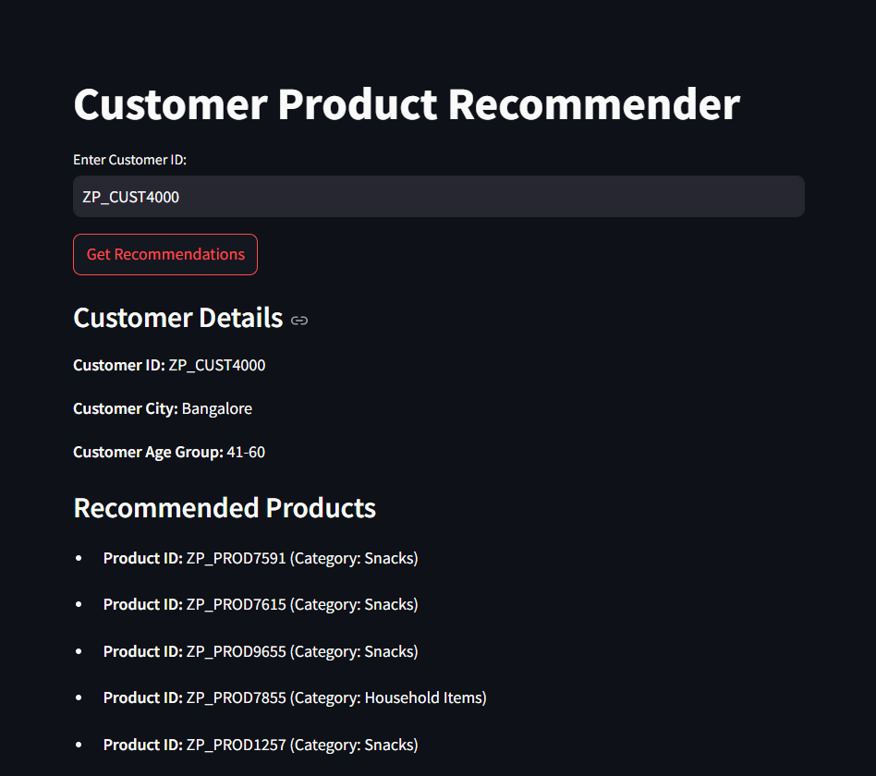

*Fig. GUI for Product Recommendations for Customers*

This and more incredible analysis are accessible through the dashboards (ref. Dashboards folder), with all essential behavioural suggestions in the code files, featuring GUIs and interactive demonstrations. *(Ref. Customer_insights_and_personalization/insights_recommender/recommender.py)*

* **Targeted Promotions & Discounts:** Providing exclusive offers based on customer segmentation.

All targeted promotions can be accessed and reviewed through the models in the code files. The demonstration of personalized discounts is available in the code files *(Ref. Customer_insights_and_personalization/offer-discount/discount.py)*, while the metrics used and their impact on discount applied are detailed in the dashboard. Here is a glimpse of one plot:

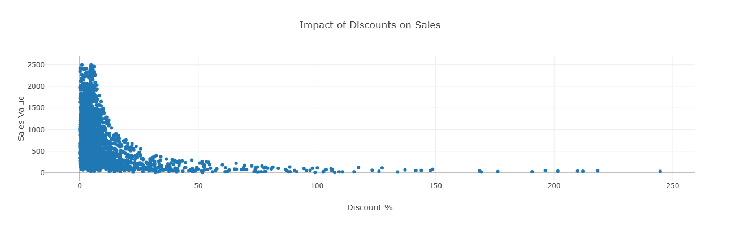

*Fig. Impact of Discount on Sales*

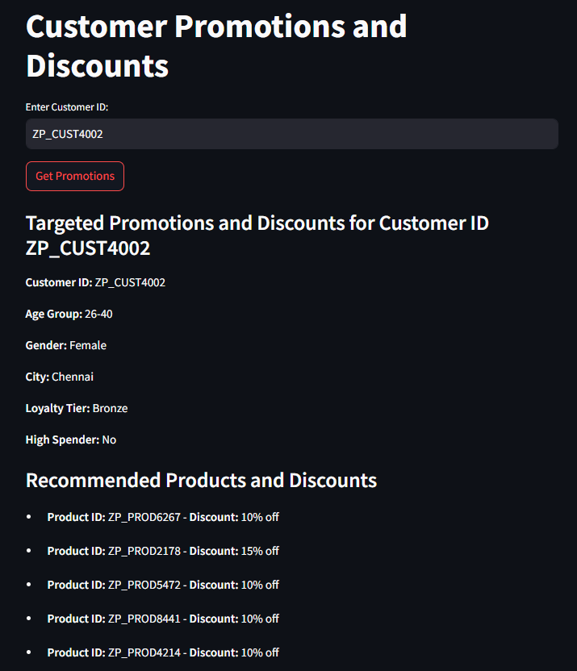

*Fig. GUI of Discounts for Customers*

* **Subscription Plans:** Offering tailored plans for customer retention.

Unlocked all targeted promotions effortlessly through the models in the code files, designed to boost customer retention with tailored subscription plans.

For this also we have designed and hosted a model using Streamlit to replicate the work done, allowing users to get outcomes based on their desired features.

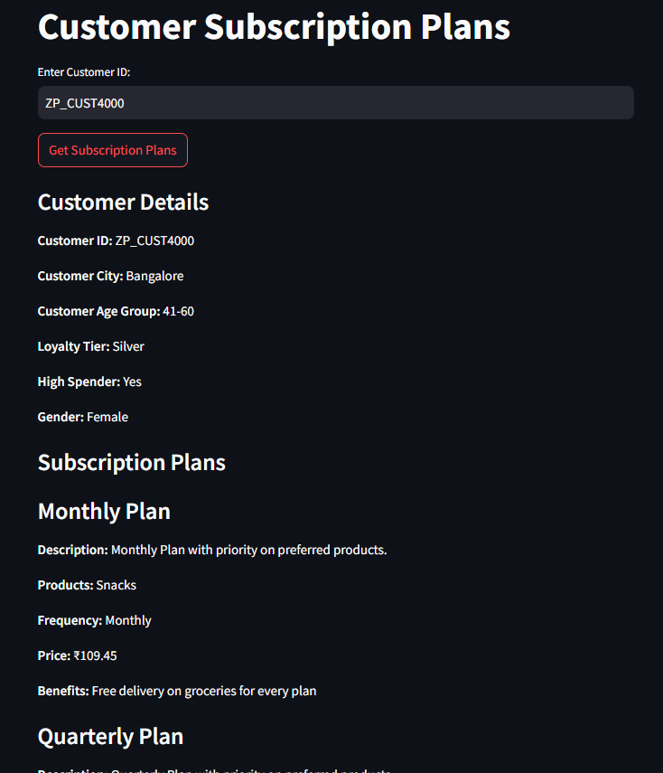

*Fig. GUI of Subscription Plans for customers*

1. **Operational Efficiency:**

* **Analysis of Peak and Off-Peak Hours:**

This analysis helps identify peak and off-peak hours for optimized rider scheduling. Based on this analysis, we've developed a model hosted on Streamlit, with the file available in our respective folder. You can modify the predicted peak hours or use real-time data within the model to adjust rider scheduling for upcoming days.

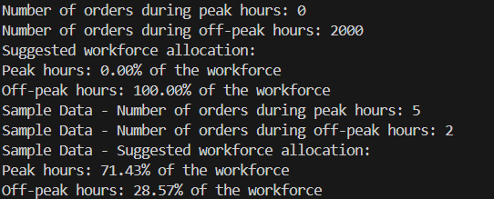

*Fig. Peak hours*

* **Incentive Allocation for High-Performing Riders:**

Zepto promises deliveries within 10 minutes, and we aim to incentivize riders who meet this target to encourage them and motivate others. We've analysed deliveries across various cities that fulfilled this promise and assigned incentives to the riders based on their performance. Since we lack rider IDs and other details in the dataset, we’ve categorized them based on the deliveries they made.

Using the model available in your folder for this task, you can determine which riders are eligible for incentives. By applying this model to real-time data, incentives can be automatically added to the riders' accounts.

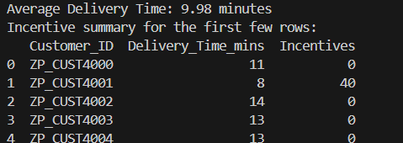

*Fig. Incentives for riders*

1. **Marketing Analytics**

Zepto tracks key marketing KPIs to enhance performance:

* **Market Insights Powered by Power BI Dashboards:**

All insights are powered by Power BI dashboards, offering a clear view of what's working and what needs attention. These dynamic visuals drive actionable decisions, showcasing exactly what needs to be done for optimal results.

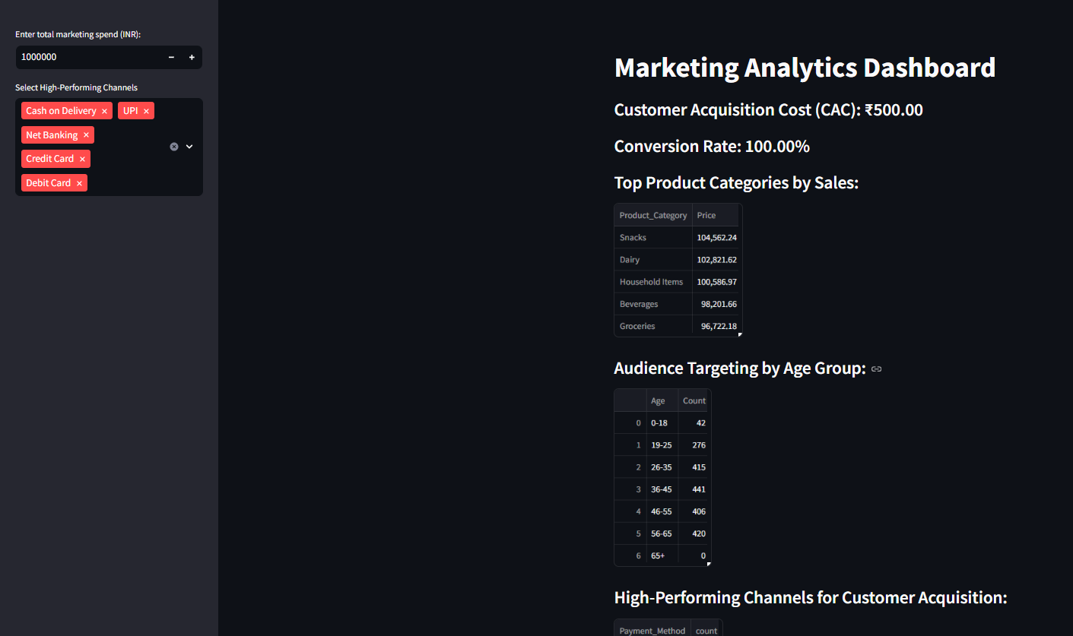

*Fig. Marketing Analytics Dashboards*

* **CAC and ROI Calculations**: Use Cases and Implementation Guide:

In our code files, CAC and ROI calculations are implemented, along with use cases and guidelines on where and how to apply them. Check them out to access all the deliverables.

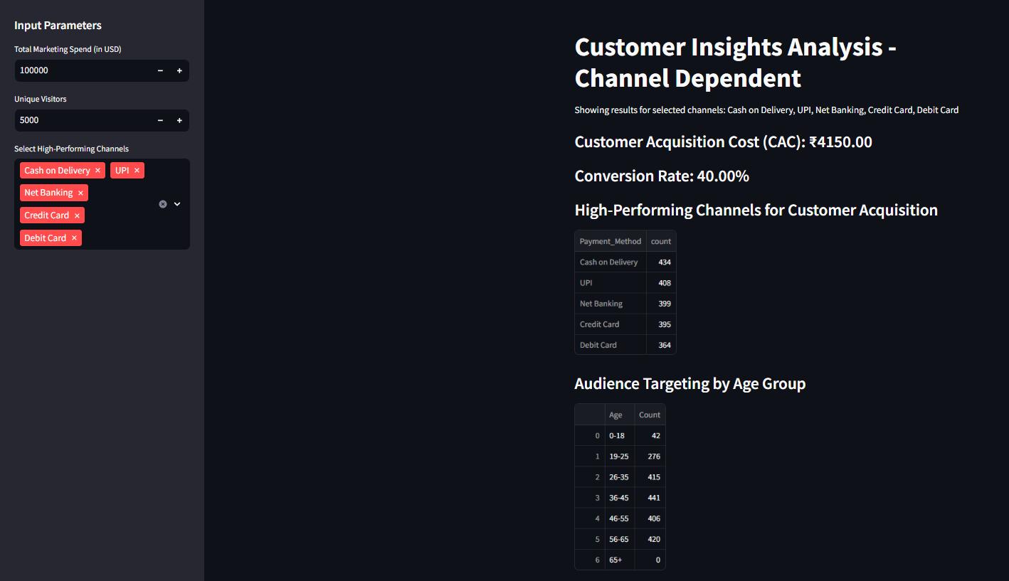

*Fig. Customer Insights Analysis*

**Final outcomes for zepto GTM strategy:**

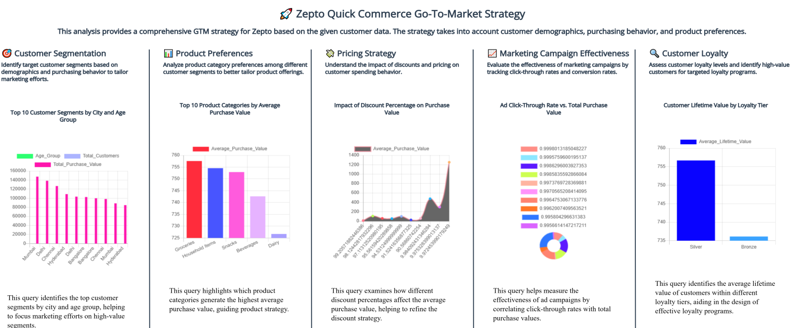

*Fig. Final Features for zepto GTM strategy*

**Execution Roadmap:**

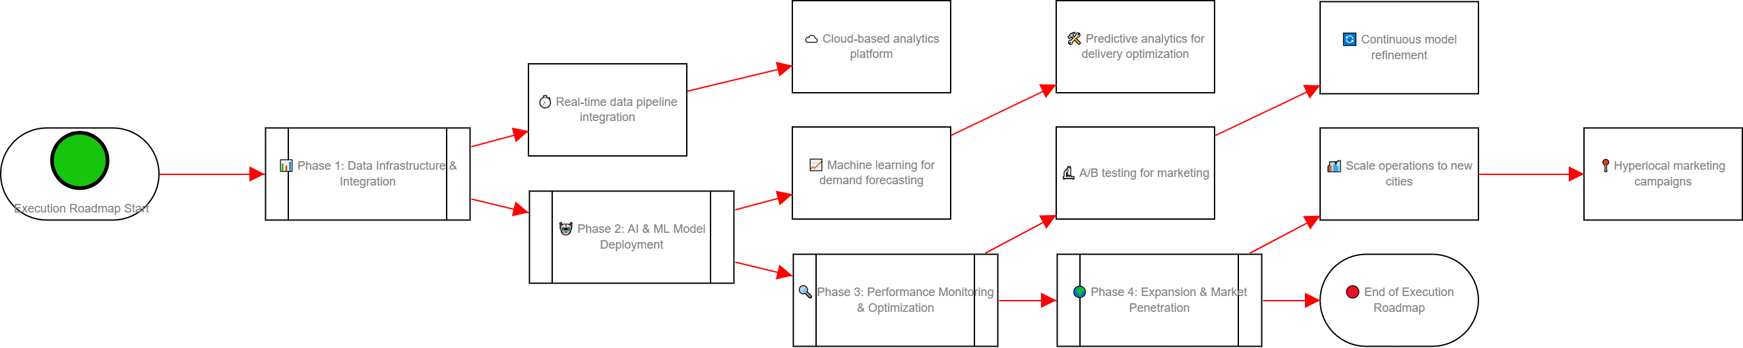

*Fig. Execution Roadmap for GTM strategy*

### ****5. Conclusion****

Data-Driven Strategy: Zepto’s go-to-market (GTM) strategy is powered by data, ensuring a seamless customer experience through predictive analytics, optimized operations, and targeted marketing.

Predictive Analytics: By leveraging demand forecasting and real-time data, Zepto optimizes delivery times, enhances inventory management, and personalizes customer experiences.

Operational Efficiency: Machine learning models for route optimization and AI-driven performance monitoring refine delivery processes, ensuring efficiency and reducing costs.

Targeted Marketing: Zepto uses market insights, personalized discount strategies, and performance tracking to drive customer acquisition and retention, along with smart incentive allocation for high-performing riders.

Continuous Improvement: By utilizing A/B testing and monitoring key metrics, Zepto adapts its approach to improve customer acquisition cost (CAC), conversion rates, and overall performance.

Scalability: The roadmap for scaling operations into new cities, supported by hyperlocal marketing campaigns and cloud-based infrastructure, positions Zepto for sustainable growth in the quick-commerce industry.

Easy Accessibility: All respective folders contain "read me" files for easy access to the tasks, ensuring users can quickly understand and implement the models, strategies, and optimizations discussed.

By continuously refining its approach, Zepto ensures it remains at the forefront of the industry, maintaining its competitive edge while scaling effectively.

In conclusion, Zepto’s innovative, data-driven approach has revolutionized the quick-commerce experience, enabling faster deliveries, smarter inventory management, and personalized customer interactions. With continuous optimization through AI, machine learning, and real-time analytics, Zepto is well-positioned to scale its operations and maintain a competitive edge in the industry. By staying agile and focused on data-backed decisions, Zepto ensures its ability to meet customer demands efficiently while driving sustainable growth and success in the ever-evolving market.