**Appendix C. Intratooth curve plots**

Original curves derived from enamel intratooth sampling on enamel carbonate. Provided by sites. In blue, oxygen stable isotope composition (δ18O), and, in brown, carbon stable isotope composition (δ13C). In the x-axis, the distance from Enamel Root Junction (ERJ). Notice that the y-axis can experience some variations between sites.

**Axlor**

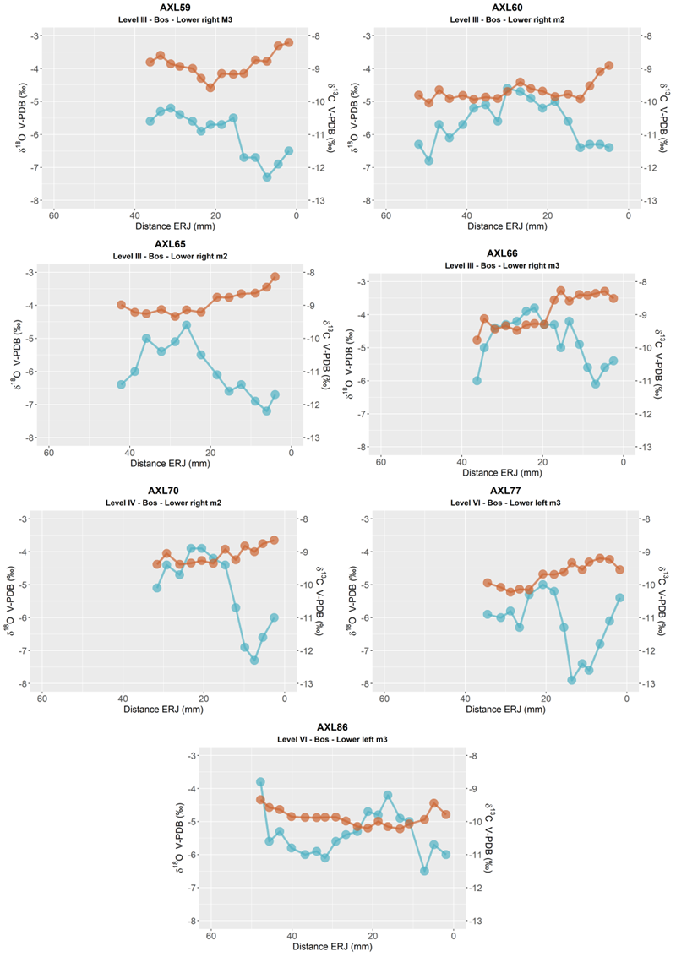

**El Castillo**

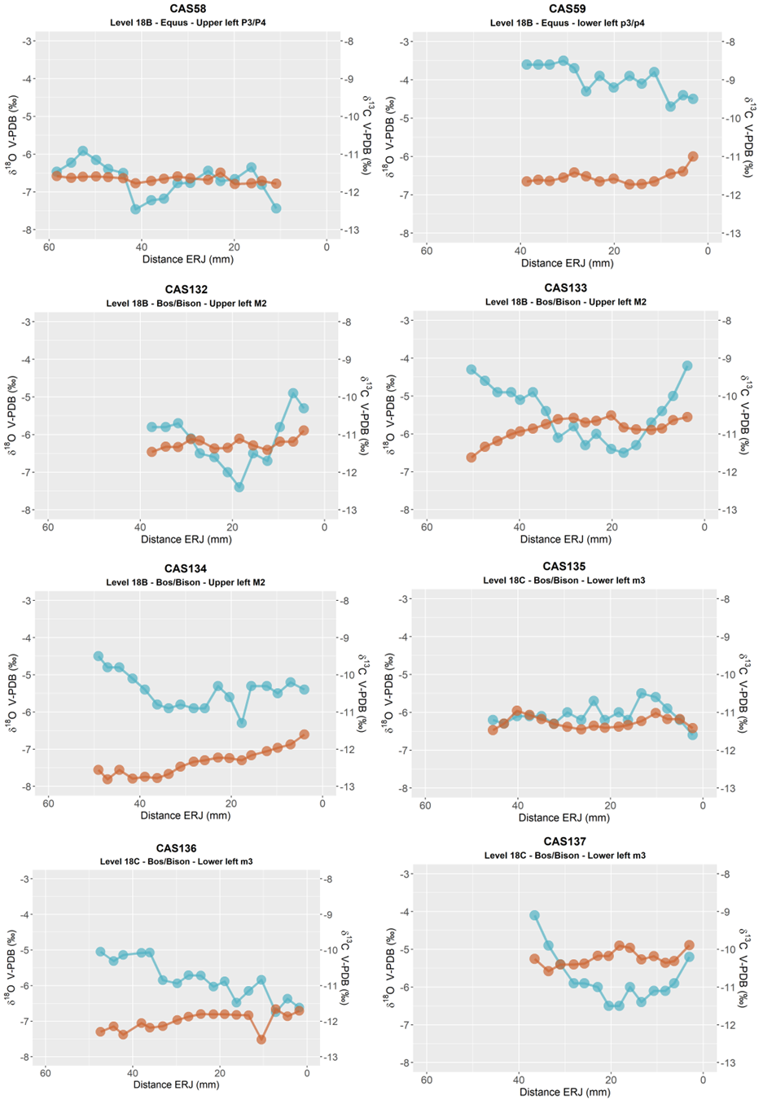

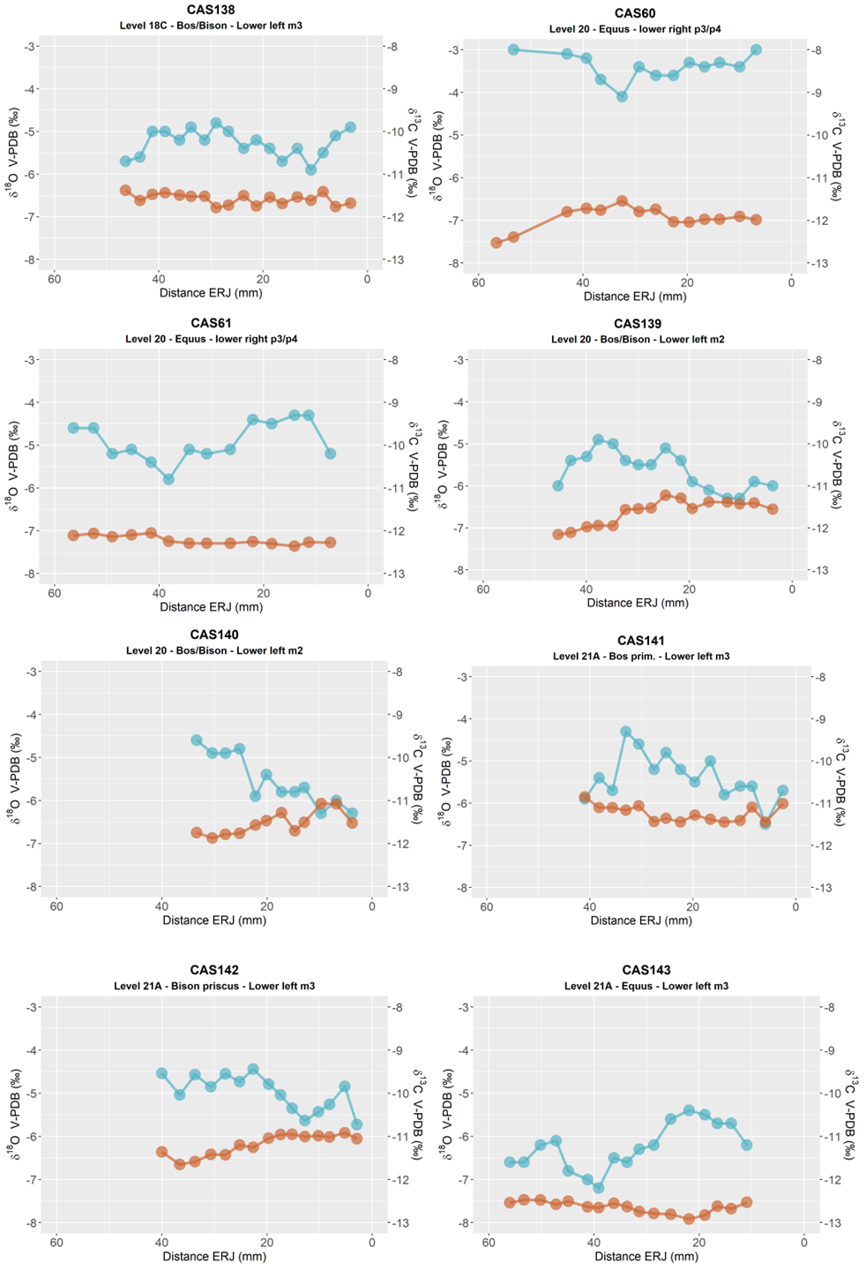

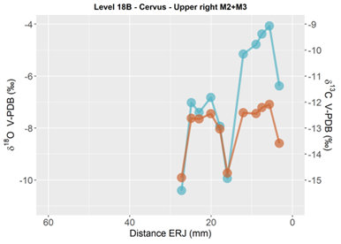

**Labeko Koba**

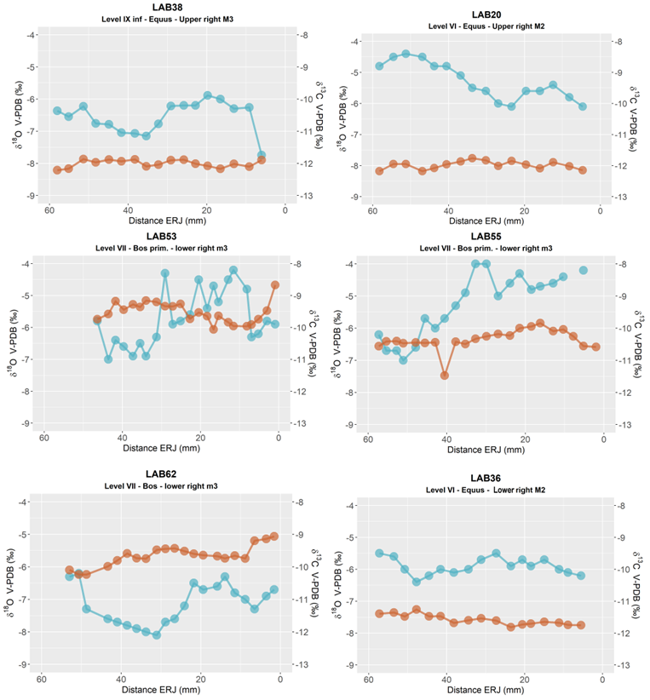

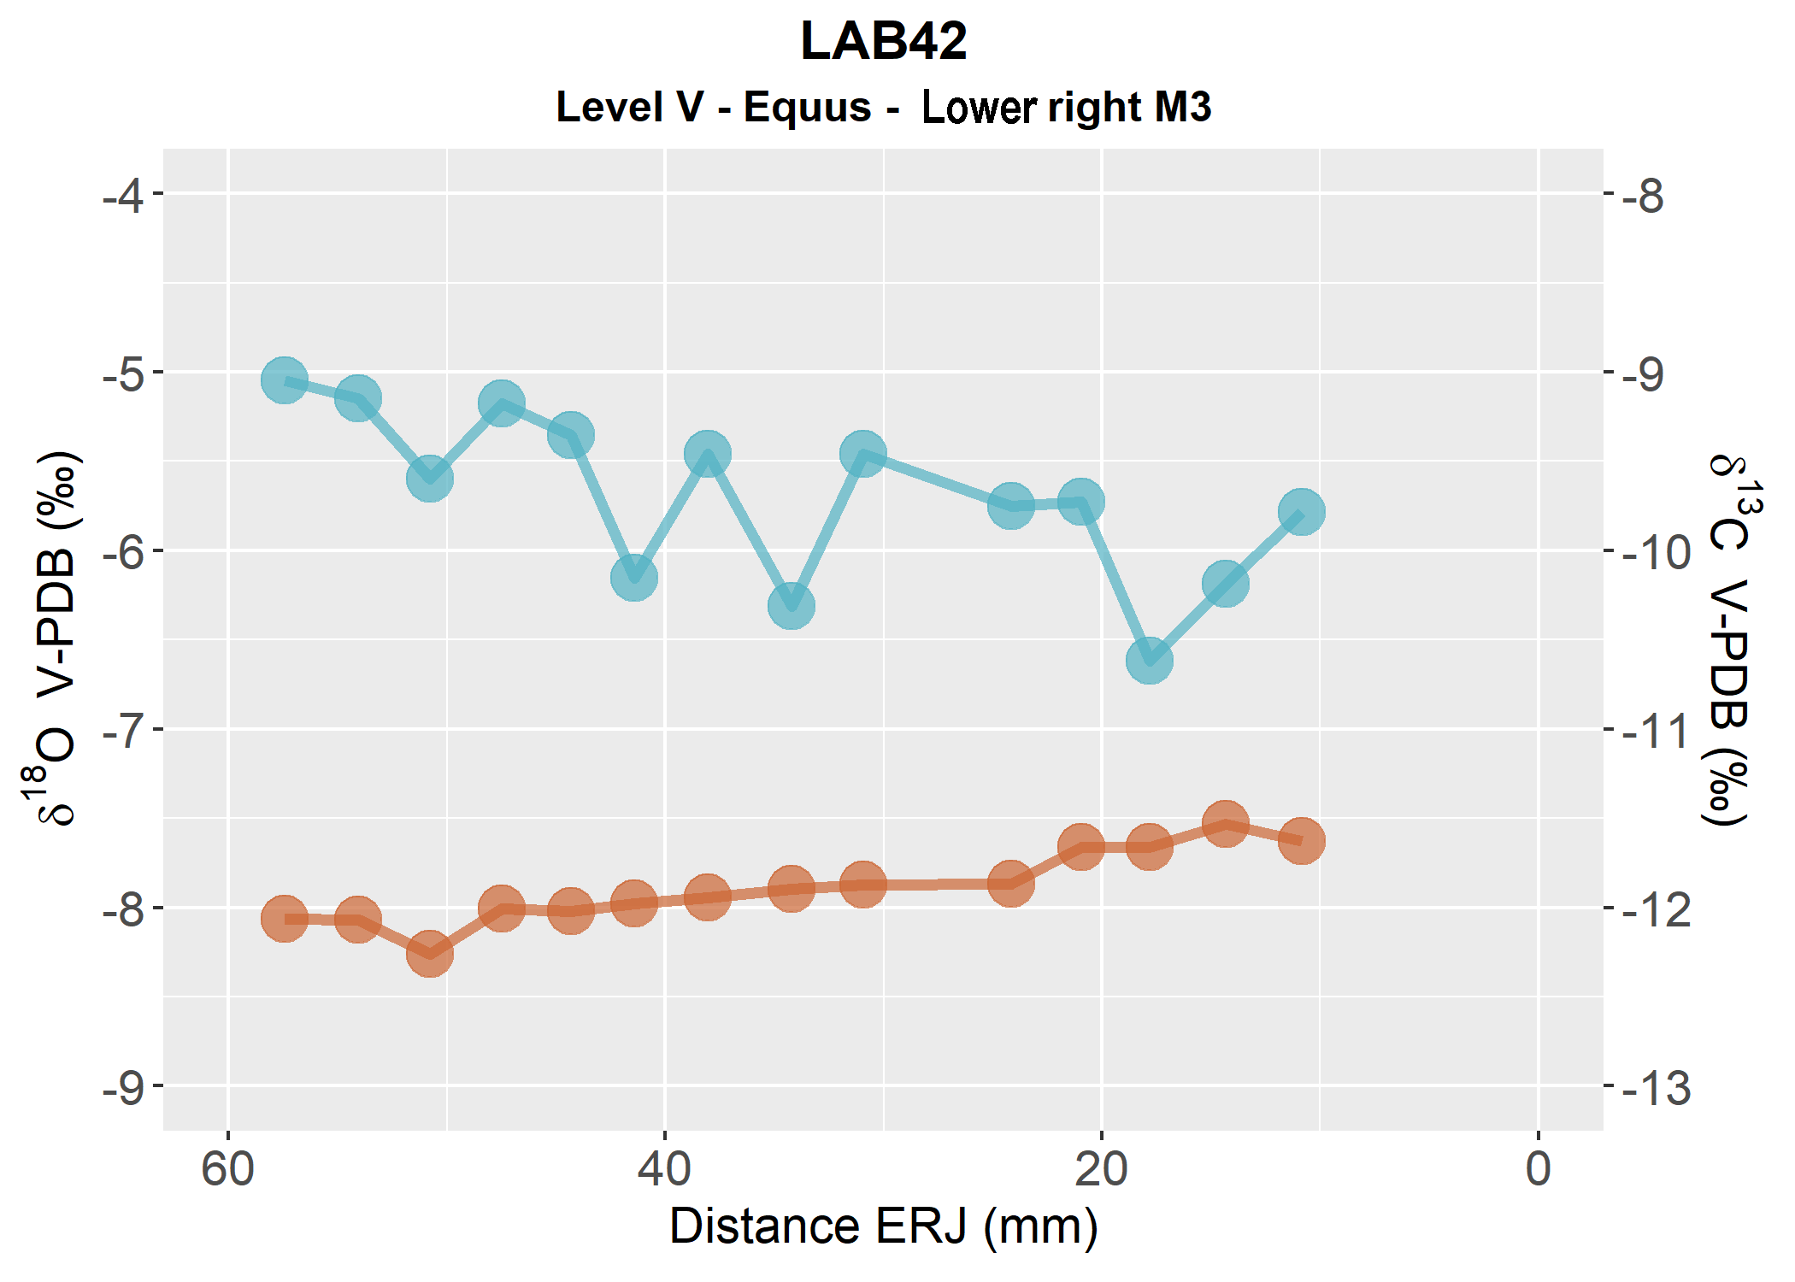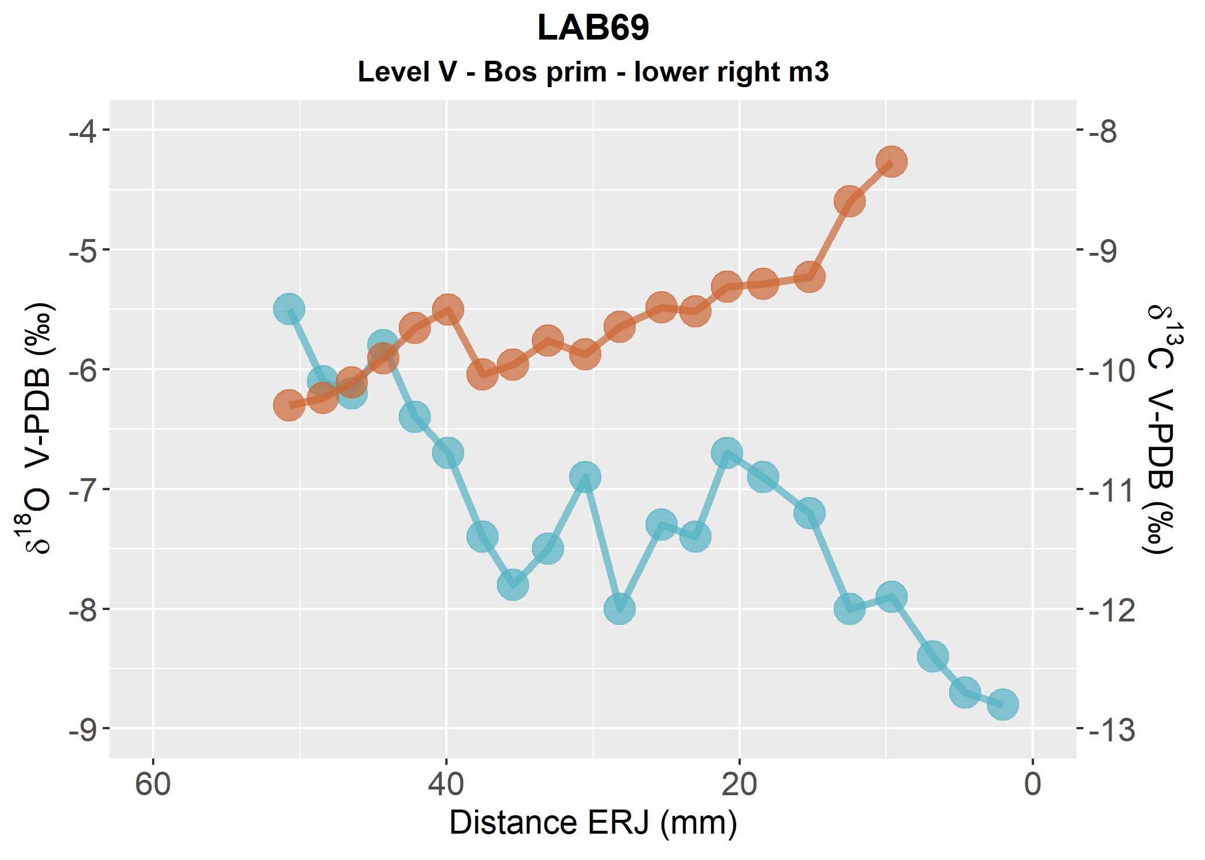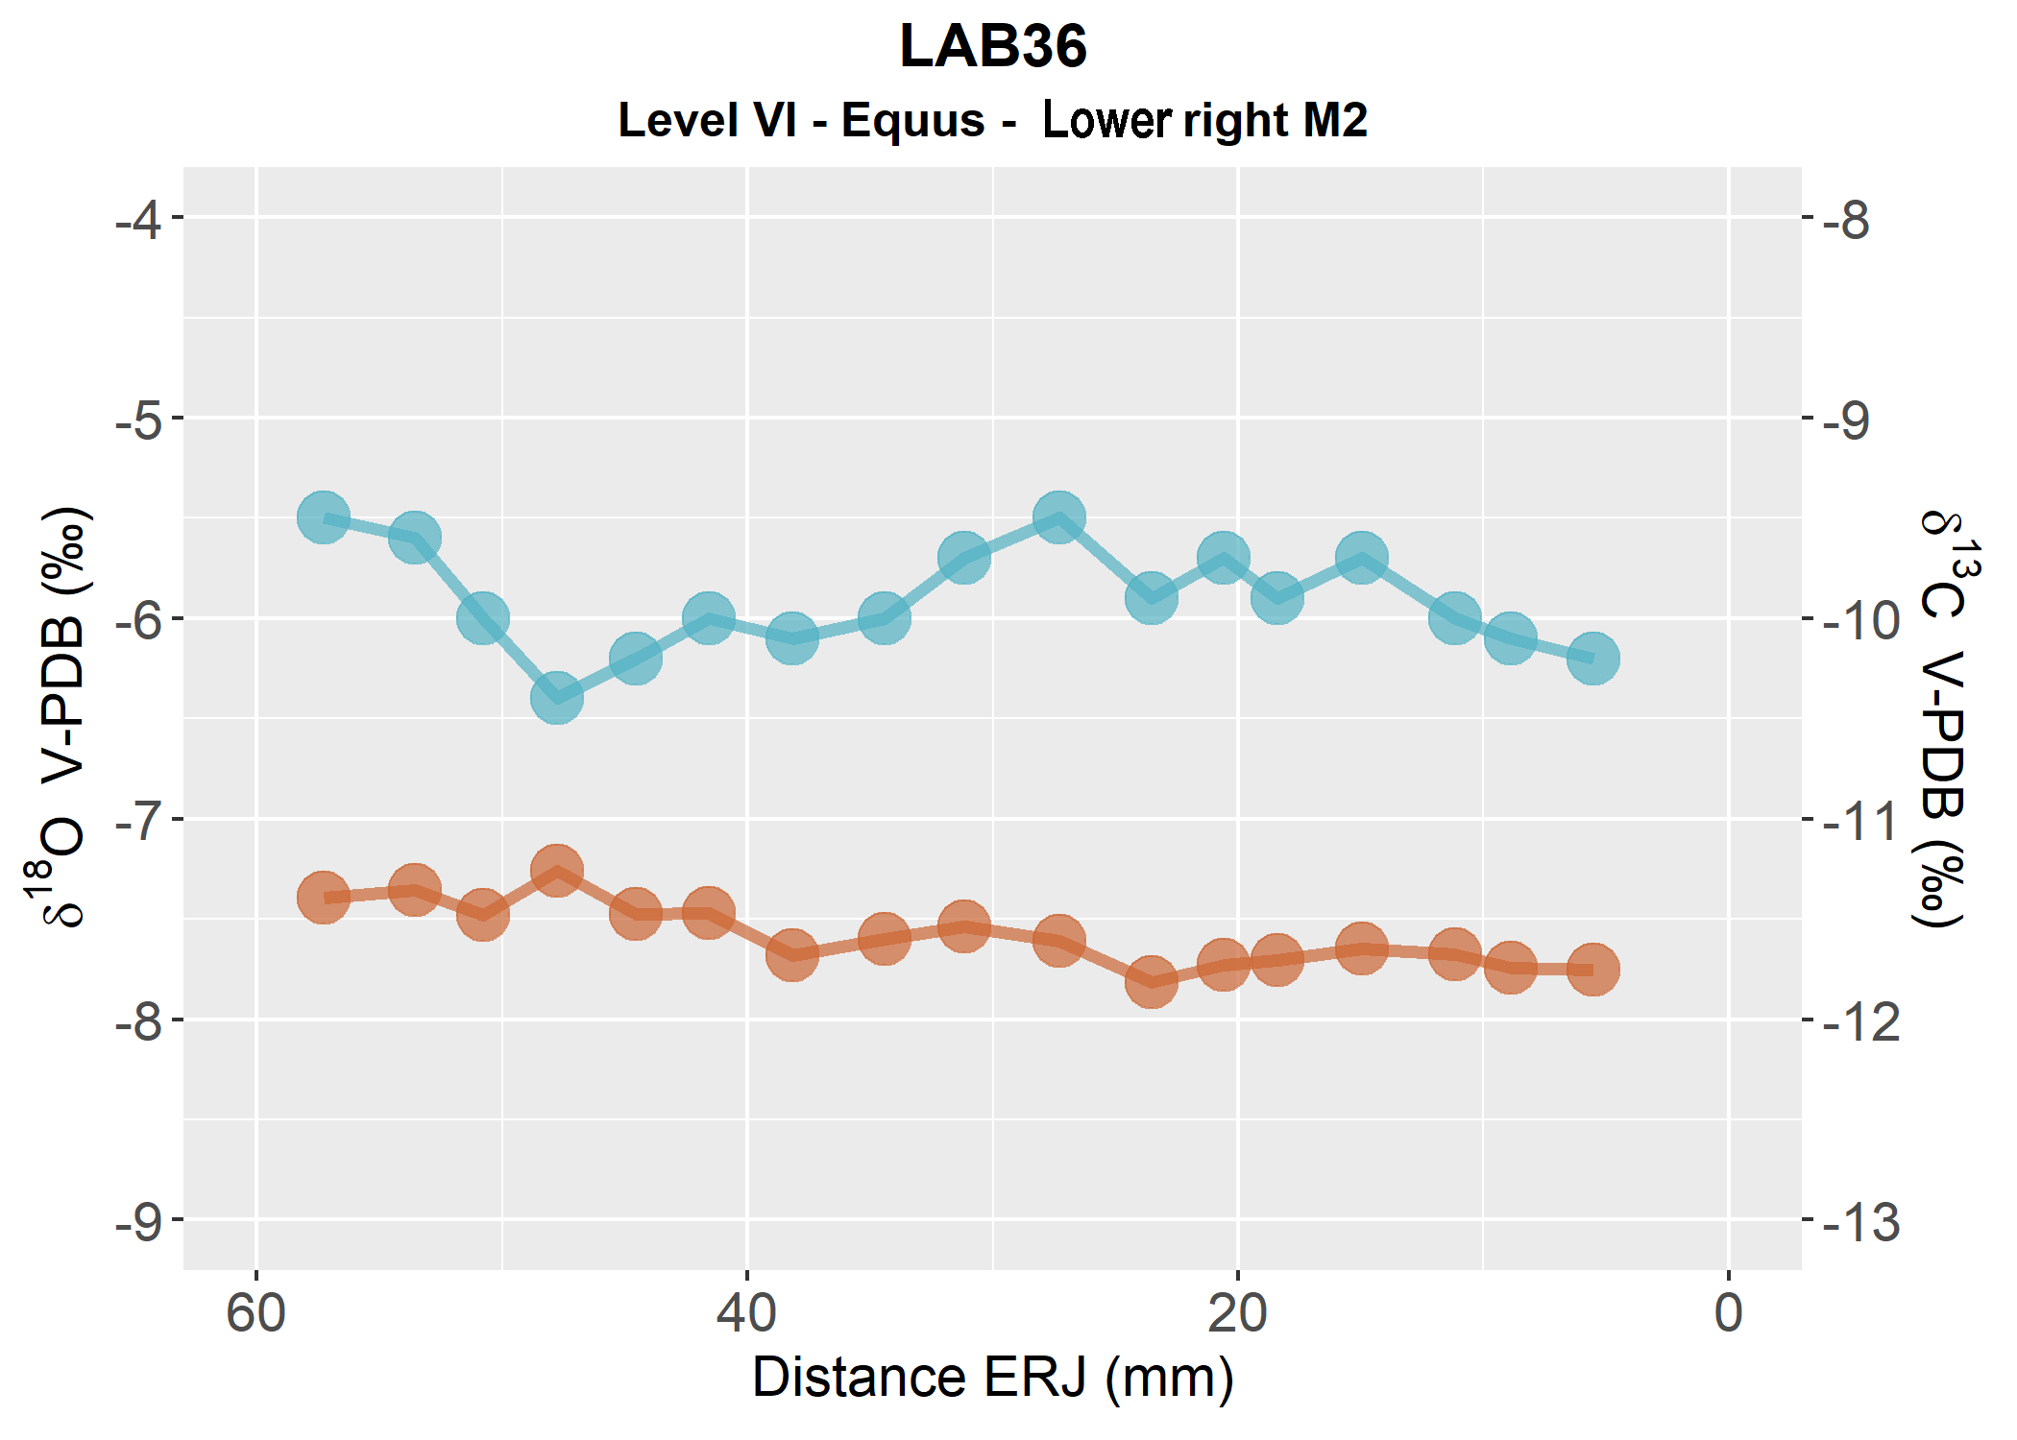

**Canyars**

**Aitzbitarte III**

**Otero**

